**Source Code :**

# scaling  
import cv2  
import numpy as np  
  
img = cv2.imread('lord_hanuman_angry_image.jpg')  
  
res = cv2.resize(img,None,fx=2, fy=2, interpolation = cv2.INTER_CUBIC)  
  
#OR  
  
height, width = img.shape[:2]  
res = cv2.resize(img,(2*width, 2*height), interpolation = cv2.INTER_CUBIC)  
cv2.imwrite('scaling_output.jpg', res)  
  
#---------------------------------------------------------------------------------#  
# Translation  
  
import cv2  
import numpy as np  
  
img = cv2.imread('lord_hanuman_angry_image.jpg',0)  
rows,cols = img.shape  
  
M = np.float32([[1,0,100],[0,1,50]])  
dst = cv2.warpAffine(img,M,(cols,rows))  
  
cv2.imshow('img',dst)  
cv2.waitKey(0)  
cv2.destroyAllWindows()  
  
#---------------------------------------------------------------------#  
# Rotation  
import cv2  
  
img = cv2.imread('lord_hanuman_angry_image.jpg',0)  
rows,cols = img.shape  
  
M = cv2.getRotationMatrix2D((cols/2,rows/2),90,1)  
dst = cv2.warpAffine(img,M,(cols,rows))  
cv2.imshow('Rotation Result', dst)  
cv2.waitKey(0)  
cv2.destroyAllWindows()  
  
#--------------------------------------------------------------#  
# Affine Transformation  
import cv2  
import numpy as np  
import matplotlib.pyplot as plt  
  
img = cv2.imread('lord_hanuman_angry_image.jpg')  
rows,cols,ch = img.shape  
  
pts1 = np.float32([[50,50],[200,50],[50,200]])  
pts2 = np.float32([[10,100],[200,50],[100,250]])  
  
M = cv2.getAffineTransform(pts1,pts2)  
  
dst = cv2.warpAffine(img,M,(cols,rows))  
  
plt.subplot(121),plt.imshow(img),plt.title('Input')  
plt.subplot(122),plt.imshow(dst),plt.title('Output')  
plt.show()  
  
  
#------------------------------------------------------------------------------#  
# perspective transformation  
import cv2  
import numpy as np  
import matplotlib.pyplot as plt  
img = cv2.imread('lord_hanuman_angry_image.jpg')  
rows,cols,ch = img.shape  
  
pts1 = np.float32([[56,65],[368,52],[28,387],[389,390]])  
pts2 = np.float32([[0,0],[300,0],[0,300],[300,300]])  
  
M = cv2.getPerspectiveTransform(pts1,pts2)  
  
dst = cv2.warpPerspective(img,M,(300,300))  
  
plt.subplot(121),plt.imshow(img),plt.title('Input')  
plt.subplot(122),plt.imshow(dst),plt.title('Output')  
plt.show()

**Output :**

**Scaling : input Output**

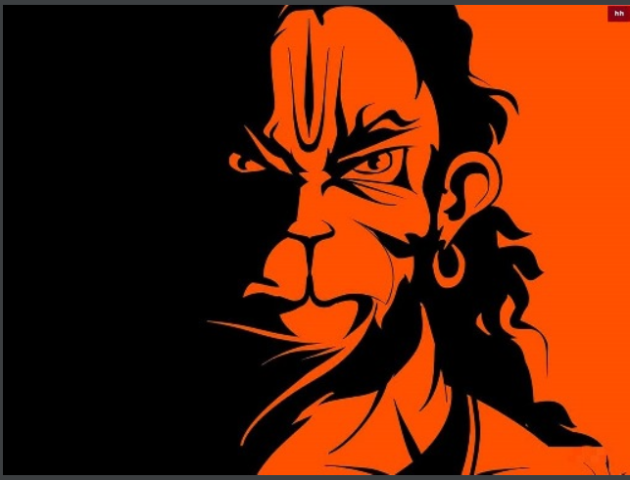 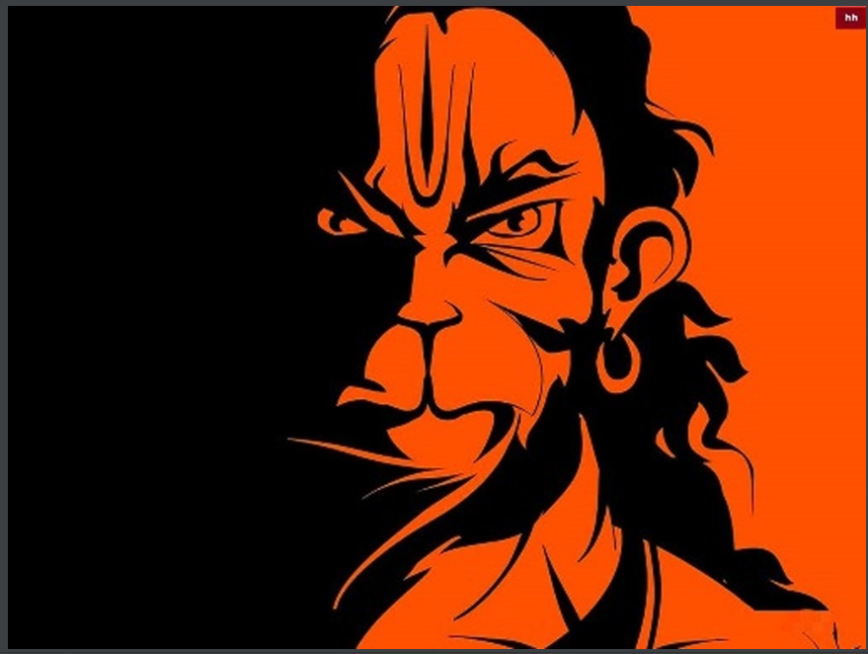

**Translation**

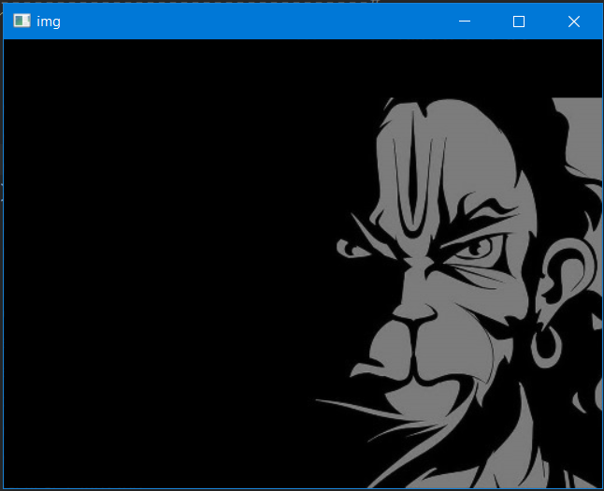

**Rotation**

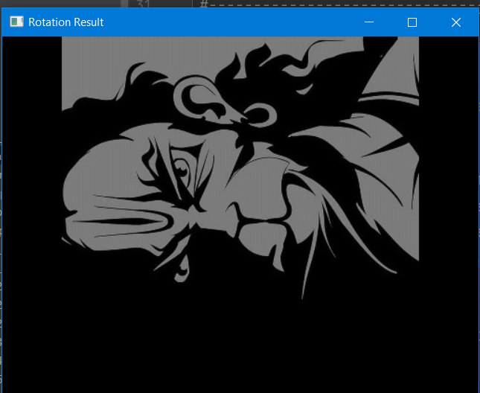

**Affine Transformation :**

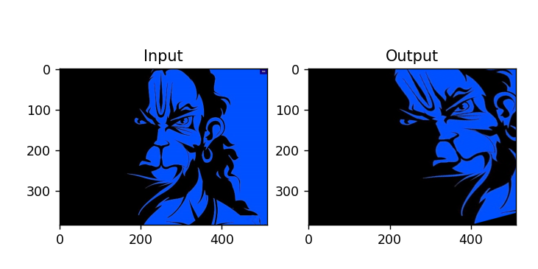

**Perspective transformation:**

