**Government College of Engineering (GCOEJ), Jalgaon**

**(An Autonomous Institute of Government of Maharashtra)**

****

**DEPARTMENT OF COMPUTER ENGINEERING**

**INDUSTRIAL LECTURE REPORT ON**

**CUSTOMER SUCCESS**

(Academic Year 2023-24)

**Submitted by:**

Bhargav Shamuvel Gurav (2041009)

**Government College of Engineering (GCOEJ), Jalgaon**

**(An Autonomous Institute of Govt. of Maharashtra)**



**DEPARTMENT OF COMPUTER ENGINEERING**

## CERTIFICATE

This is to certify that the ***Industrial Lecture*** report**, “Customer Success”**, which is being submitted here with for the award of ***LY Computer Engineering (7th Semester)*** is the result of the work completed by ***Bhargav Gurav (2041009)*** under my supervision and guidance within offline mode of classes of the institute, in the academic year 2023-24.

.

**Head of Department**

**Dr. D. V. Chaudhari**

**INDEX**

|  |  |  |
| --- | --- | --- |
| **CONTENTS**  **TITLE** | **Page no.** | |
| COVER PAGE | 1 | |
| CERTIFICATE | 2 | |
| ABSTRACT | 4 | |
| **1.INTRODUCTION** | **5** | |
| **2.KEY ASPECTS OF A STELLAR**  **CUSTOMER SUCCESS STRATEGY** | **6** | |
| **3.Technologies and Tools for Customer Success** | | **9** |
| **4.Challenges and Solutions** | | **12** |
| **5.Conclusion** | | **14** |
| **6.References** | | **14** |

# 

**ABSTRACT**

In the landscape of contemporary business, customer success stands as a pivotal paradigm that transcends conventional customer support, fostering proactive engagement, and ensuring sustained value realization for clients. This report navigates the multifaceted terrain of customer success, elucidating its diverse dimensions, from the fundamental principles to the implementation strategies adopted across industries. It encompasses the holistic approach to cultivating enduring relationships, driving customer satisfaction, and achieving mutual growth between businesses and their clientele. By delving into the core tenets, case studies, and evolving trends, this report illuminates the significance of customer success as a cornerstone in today's competitive market, shedding light on its transformative impact on businesses and customer experiences.

**INTRODUCTION**

Customer success is the effort a business undertakes to help its customers be most successful, both with its product and in their own business operations.

However, it is no longer sufficient to assume that the company as a whole will take on customer success management; for your customers to shine, you'll need someone (or a team) to be wholly focused on it. Dedicated customer success teams take a proactive, data-led approach to helping customers more effectively use a product.

Depending on the structure and maturity of the team, it may handle everything from trial user engagement through renewal. This comprehensive approach helps businesses reach several top-level goals, including:

* Increasing renewal sales and revenue.
* Inspiring customer loyalty and retention.
* Boosting lifetime customer value and annual recurring revenue (ARR).
* Reducing churn.

Customer success increases the likelihood that users will stick around by maximizing their mastery of the product. For subscription-based businesses, that's a vital component of growing monthly recurring revenue (MRR). For companies that don't follow that particular model, the value of customer success shows itself with leading product insights and word-of-mouth marketing.

However, customer success experiences overlap with other customer-facing functions, such as customer support, customer experience, and even account management. As easy as it is to talk about what customer success is, it's equally important to distinguish what it isn't.

### Customer success vs. customer support

Many customer success teams report through the same structure as support or service and exhibit the same customer focus, but there is at least one key difference.

Customer service and support are primarily reactive, meaning they respond to a customer or user after an issue has occurred. Customer success is proactive in that they try to anticipate and address needs before customers ever reach out.

Here's an example Ryan Engley, VP of Customer Success for [Unbounce](https://unbounce.com/" \t "_blank), shared that exemplifies the difference between customer success and customer support in practice:

"A customer may email the support team about their landing pages and say, 'Hey, I need help implementing a sticky navigation bar. How do I do that?' They'll jump in and help them figure out the code to set up. A conversation with the customer success team, on the other hand, might start with, 'Why is that something that you think you need? Let's talk about your bigger strategy.'"

Another key difference is the metrics that customer support and customer success use to determine success. Customer support uses metrics like:

* Time to response
* Customer satisfaction
* Handle time
* First response resolution

Customer success teams typically take a different approach and use metrics like:

* Expansion rate
* Churn rate
* Average MRR
* Customer health

While there may be some overlap between teams, customer service is primarily focused on metrics at an email level, whereas customer success works at a relationship or lifecycle level.

**KEY ASPECTS OF A STELLAR CUSTOMER SUCCESS STRATEGY**

**1. Understand your customers**

How much do you already know about your customers? Do you know your customers' demographics, why they are using your product, and what they are looking to get out of it? Before embarking on building any customer success strategy, it's essential to know who you are trying to serve. The same approach will not work for all of your customers, and it's doubtful that they want you to treat them all the same way.

For instance, a large enterprise customer will likely want and expect a more personalized touch than a user in your trial experience would. Here are a few ways to get the ball rolling on knowing your customers:

* Evaluate data around your customers and create customer segments.
* Work with your sales and marketing teams to understand who they are trying to attract and why.
* Acknowledge your company's motivations around attracting specific types of customers, and determine how your customer-facing teams can help drive those purchases.
* Create segments of your customers. Having a few specific demographics you are working to understand and address makes your work at hand much easier to define.

**2. Develop processes**

After you've defined more specific groups that you are trying to attract and understand, you can start to create internal processes to make sure that's happening. Not all customers, for instance, should have a customer success manager (CSM).

Look at your segments and start to brainstorm on what each of them needs to be successful. For instance, some of your customers may be working with sales before becoming a customer, while some may go through a low-touch purchase process. Some other things to consider are:

* What does conversation escalation look like? Does it happen faster for some customers than others?
* What do the pricing tiers for your customers have to do with the level of service that you provide? Are you comfortable giving everyone the same service?
* Which deals are your sales team involved in, and what does the handover look like when they transition to support or success?
* Do you offer [customer success](https://www.helpscout.com/helpu/customer-success/) to everyone?
* Which support or success channels are available with which of your plans?

Creating more defined processes as part of your customer success strategy sets up both your internal and external teams for victory.

**3. Get a CRM**

If you don't already have a way to understand a customer's individual experience with your company, it's time to get one. A customer relationship management (CRM) tool helps keep everything organized and ensures that you have a full overview of how your customers are being reached out to and when.

Beyond that, CRMs help your sales team understand how many contacts they've already engaged and how the responsiveness to their outreach is going, and it lets your support team get an overall context of how the customer is doing more holistically.

Some great CRMs to consider if you aren't already using one are:

* [HubSpot](https://www.hubspot.com/products/crm)
* [Pipedrive](https://www.pipedrive.com/)
* [Salesforce](https://www.salesforce.com/crm/)
* [Zoho CRM](https://www.zoho.com/crm/)
* [Insightly](https://www.insightly.com/)

**4. Proactively educate**

One of the best things you can do to cultivate success in your customers is to incorporate [proactive support](https://www.helpscout.com/blog/proactive-customer-service/) into your customer success strategy. Proactive support is anything that allows your customers to get information about their problems before they need to reach out to your support or customer success team.

Some examples of this are:

* Documentation.
* Webinars.
* Quizzes or interactive guides to help individuals select the right product for themselves.
* Case studies and social proof.
* Best practices guides.
* In-app onboarding experiences.
* Triggered email campaigns.
* Support autoresponders.

Educating your customers allows them to get the most out of your product and creates a sense of loyalty.

Most people are happiest if they never have to reach out to support. Before reaching out for help, [81% of all customers](https://hbr.org/2017/01/kick-ass-customer-service) try to find the answers to their inquiries themselves. If you can educate them before they even need to start looking for answers, imagine how empowered they would feel?

[You Need a Budget](https://www.youneedabudget.com/) does a great job of proactively educating its customers, with two whole separate tabs in their main navigation for education and inspiration.

Make it easy for people to get their answers, yes, but educate them before they need answers, and you've got a winning customer success strategy.

**5. Use automation**

The more you can free up the humans on your team to do impactful human work, the stronger your customer success strategy will be. Use automation wherever you can to take menial work out of the day-to-day of your team.

Leverage your data and processes from the first few steps of this post to create scaling communications. Trigger emails off usage patterns, behaviors in the product, or even place in the customer lifecycle.

Automation takes the guesswork out from your CSMs and sales team and gives the right communication to the right people at the right time.

**6. Find your value realization moment**

When is your customer’s "Ah ha!" moment about why they are using your product and how valuable it is? There are likely a few of them that lead up to eventual customer success. If you don't already have them documented, you should. They are integral to the ongoing productivity of your customer success strategy.

Everything in your customer success strategy should be driving individuals to these moments of value realization. These moments could be anything from someone becoming a customer to creating a website — or even taking action within a specific segment of your product for the first time.

Create content and processes within your customer success strategy that drive your customers to these moments as quickly and readily as possible.

**7. Listen to what your customers say**

Which parts of your customer experience do people love, and which do they hate? Chances are you are already aggregating the feedback that you need to know this.

Look at the input points and correlate the data with where you aggregated them in the [customer journey](https://www.helpscout.com/blog/customer-success-journey/) and which types of customers are leaving them. [Segmenting your data](https://www.helpscout.com/helpu/humanize-service-with-data/) in this way helps to pinpoint where your customer effort and customer satisfaction scores are along the customer journey and which parts of it affect your customers the most.

For instance, if your [customer effort score](https://www.helpscout.com/helpu/high-effort-customer-experiences/) is low (on average) at the start of a customer's journey and spikes after the two-month mark, you can identify unique opportunities within that time to make things better. Be targeted with your improvements rather than scattershot.

When asking for feedback, remember to:

Make it easy for customers to reach out. They shouldn't have to wait for you to ask them. Create feedback forms and email addresses, and make it so customers can reach out no matter where they are.

Respond personally to anything a customer sends to you. Whether that’s sending a "thanks" or asking for more information, always respond to customer feedback and acknowledge it.

Try to automate feedback aggregation if you can. Send a quarterly CSAT or NPS survey automatically.

Ask about how your customers use the product. Ask where they experience pain and what they love most instead of asking about their specific feature requests.

Along with the traditional places where you ask for and offer the availability to leave feedback, remember to ask when customers stop using your product, too. Exit feedback can help you understand what you can do to prevent churn and improve customer experience.

Organize the data regularly and correlate the amount of revenue that you lose for each churn reason. Share the information about primary churn reasons, and prioritize them by the amount of revenue lost to each reason.

This information is useful for both your customer success strategy and for your company strategy as well. Everyone cares about losing money.

**TECHNOLOGY AND TOOLS FOR CUSTOMER SUCCESS**

**1. Zendesk**

One of the current leaders in all-around, cloud-based customer support software, [Zendesk](https://www.zendesk.com/" \t "_blank) made a name for itself by offering straightforward management of customer help desk interactions. They excel in this regard, especially with their help desk ticketing system.

Their [ticket forms](https://www.zendesk.com/service/ticketing-system/) allow you to create different types of support requests that cater to your customers’ specific needs. You can even add custom fields to your forms, ensuring you collect all the actionable data you need.

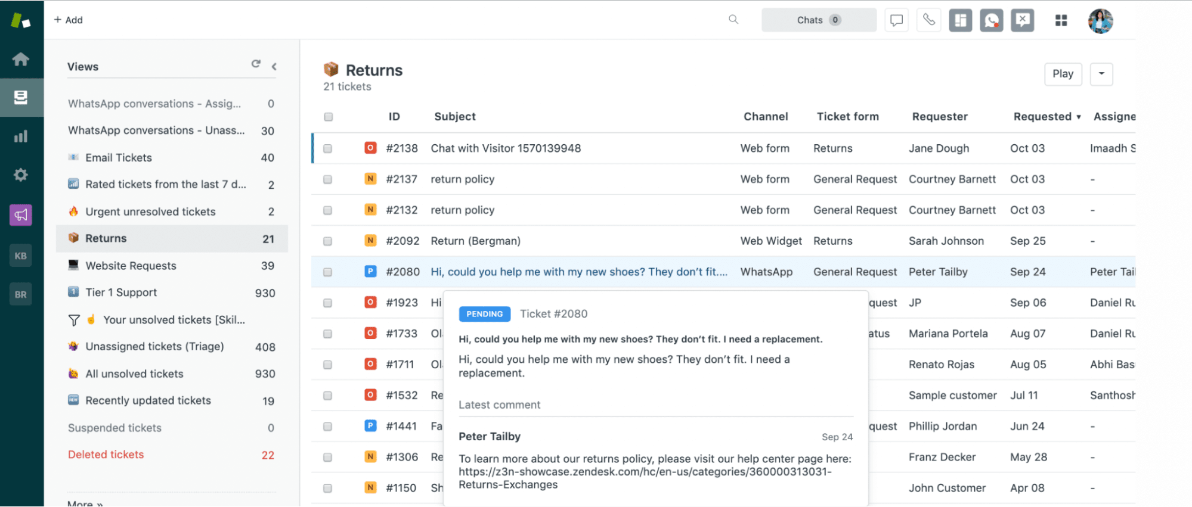

It’s one of the most robust systems, so if your business uses support tickets to resolve customer issues, Zendesk is a straightforward option for you. The [Zendesk and Calendly integration](https://zapier.com/apps/calendly/integrations/zendesk" \t "_blank) make creating support appointments easy without back-and-forth messaging.

Even if you don’t use support tickets, Zendesk still offers plenty of features that will help you refine your customer service performance. The app has live chats, appointment management, social media integrations, and knowledge base maintenance.

**2. ChurnZero**

If you want a robust and data-driven customer success tool that helps you understand customers, consider [ChurnZero](https://churnzero.net/features/" \t "_blank). The company breaks its features into a [few key categories](https://www.g2.com/products/churnzero/reviews) for CS teams: understand, communicate, automate, and collaborate. Across these functions, you’ll find features like health scores, user segmentation for customer data analytics, and customer feedback surveys to help you make informed decisions.

A [G2 Review](https://www.g2.com/products/churnzero/reviews) from Kenny P., a customer success manager,  said, “I like the ability to track a customer's progress. Knowing where things could be stuck, and the next steps to take is key for success with a customer.”

Other features aimed at reducing churn include customizable in-app messages and walkthroughs so you can help new users onboard quickly and consistently. Churnzero even has a member-led community space to learn from your peers.

**3. Gainsight**

Gainsight offers a central dashboard that acts as a customer success command center and [serves companies](https://www.gainsight.com/customers/) like Box, WeWork, and Dell Boomi. From the main page of Gainsight, customer success teams can keep tabs on user trends via CSAT, sentiment ratings, and NPS, or focus on particular customer segments.

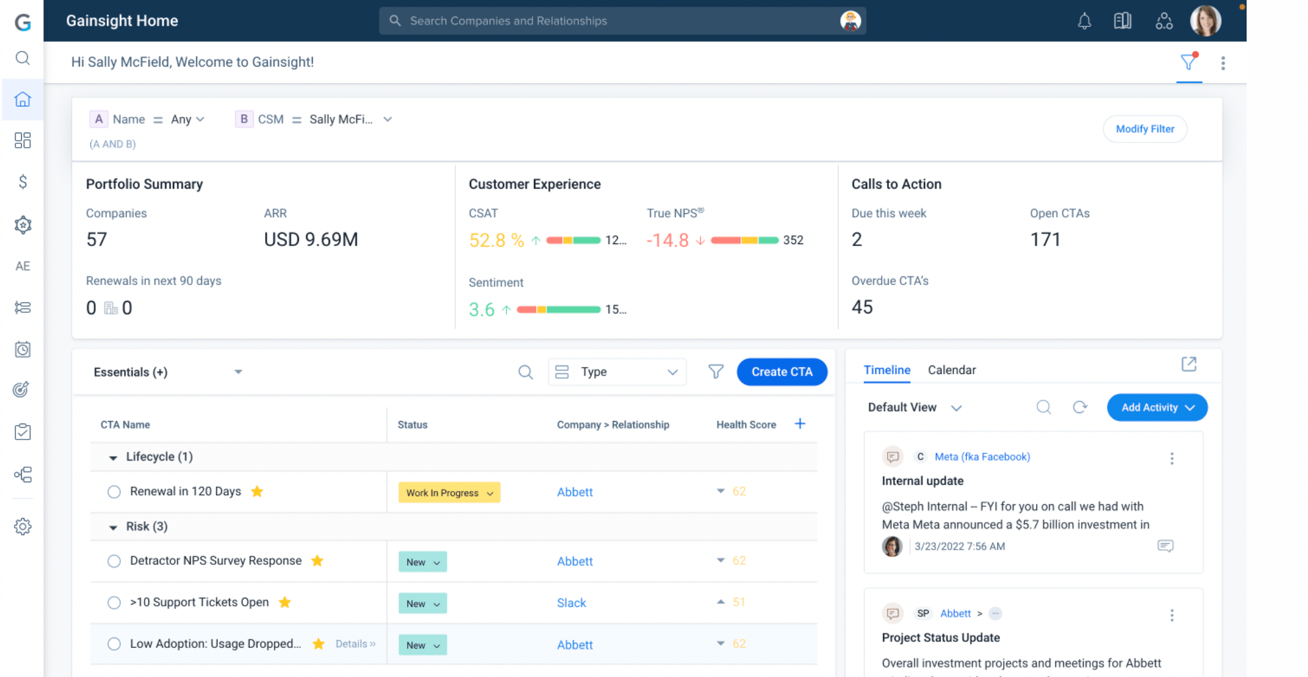

To support your revenue goals, the dashboard highlights annual recurring revenue (ARR) and upcoming user account renewals. There’s also a drag-and-drop onboarding editor that lets you automate customer journeys. Gainsight is helpful for teams because it has [Success Plans](https://support.gainsight.com/SFDC_Edition/Success_Plans/About/Success_Plans_Overview) to collaborate on projects and monitor progress toward goals. The company also has [helpful content for teams](https://info.gainsight.com/customer-success-playbook-to-expansion-ebook.html), such as customer success playbooks.

If you set up [customer calls via Calendly](https://calendly.com/solutions/customer-success), you can automatically update your database using this [Calendly + Gainsight integration](https://zapier.com/apps/calendly/integrations/gainsight" \t "_blank).

**4. HubSpot Service Hub**

Most know HubSpot for its marketing solutions, but they also offer a robust customer service platform in [HubSpot Service Hub](https://www.hubspot.com/products/service" \t "_blank).

This all-in-one customer success platform includes a ticketing system that allows you to field customer support issues. It has some common-sense features, like the ability to associate tickets with CRM records, giving you the edge in managing support issues across your client base.

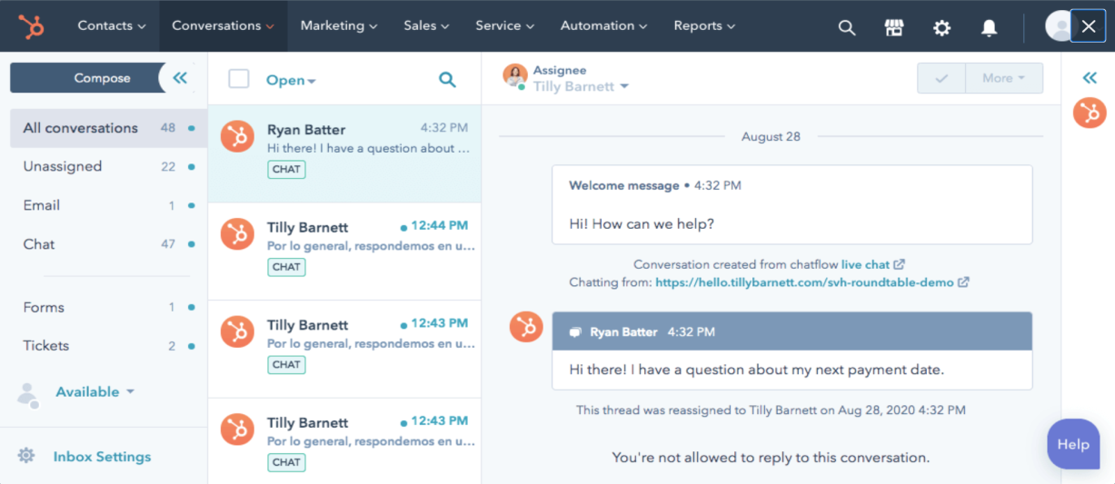

What’s even more impressive about Service Hub is how it streamlines your customer service practices and allows your entire team to get on the same page.

Features like feedback management and performance metrics indicate the efficacy of your current customer service efforts. This feature lets you quickly evaluate and improve your customer service best practices.

Check out [Calendy’s native HubSpot integration](https://calendly.com/integration/hubspot): When meetings are scheduled using Calendly, new leads or contacts and activities are created in HubSpot. If the record already exists, the lead or contact is updated and the new activity added to the existing record. Create or add Service tickets directly from your HubSpot contacts.

**5. Help Scout**

When it comes to customer service solutions, [Help Scout](https://www.helpscout.com/) sits atop an interesting email-based premise. The platform provides you with mailboxes linked through a central dashboard that you can use to keep track of all your support requests.

The idea is to provide a human-centered customer experience for support (with your team checking those emails) while simultaneously keeping your team on the same page and preventing instances of duplication.

Help Scout integrates customer information and history with considerable speed, enabling you to provide more customized service with less effort.

While email communication is Help Scout’s central selling point, that’s not the only customer channel you’ll be able to manage using their platform. The software also includes live chat, knowledge base, and phone support, granting the sort of all-in-one functionality you’ll need as a growing business.

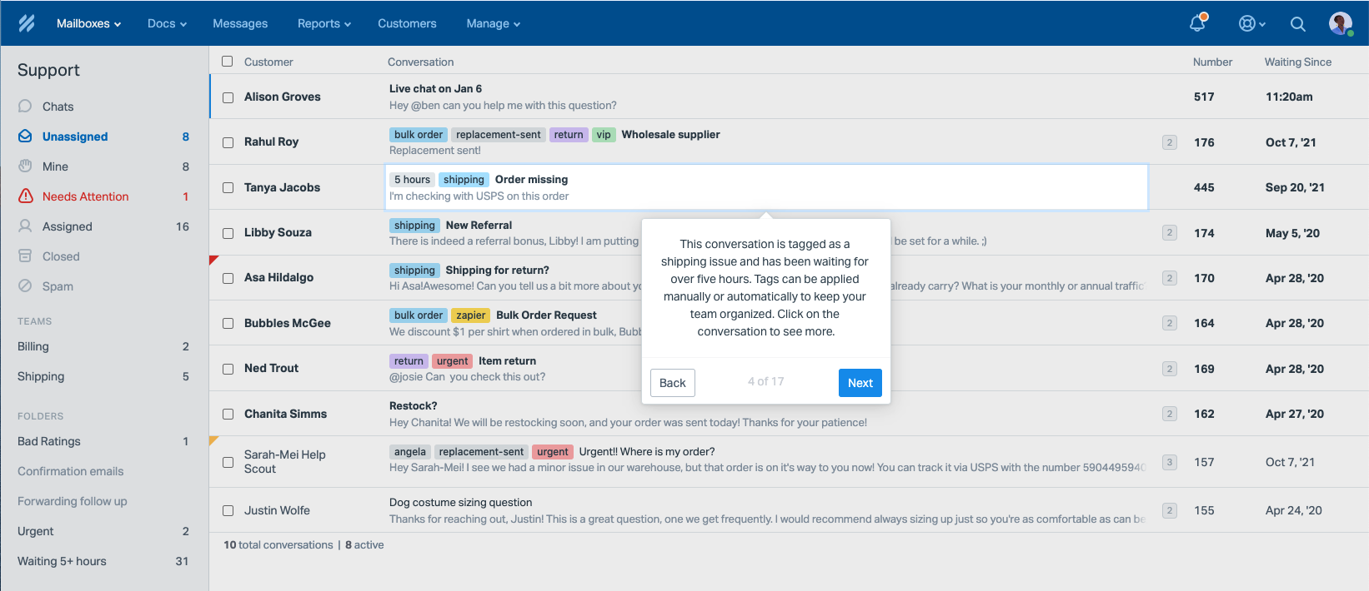

**CUSTOMER SUCCESS CHALLENGES & SOLUTIONS**

**1. Onboarding and training new customers**

One of the biggest challenges for customer success teams is onboarding and training new customers. This process can be time-consuming and resource-intensive, and it can also be challenging to ensure that customers retain the information they need to succeed with your product. One solution to this problem is to create a comprehensive and interactive onboarding program that includes a mix of online resources, in-person training, and ongoing support. Another solution is to use technology, such as online tutorials and training modules, to make the onboarding process more efficient and effective.

**2. Keeping customers engaged**

Another major challenge for customer success teams is keeping customers engaged with your product. This is particularly important for businesses that sell subscriptions, as customer churn can significantly impact revenue. One solution to this problem is to create a customer engagement program that includes regular check-ins, personalized content, and incentives for customers to continue using your product. Another solution is to leverage data and analytics to identify at-risk customers and intervene before they churn.

**3. Dealing with support tickets**

Customer success teams often must deal with a high volume of support tickets, which can be overwhelming and time-consuming. One solution to this problem is investing in customer service software to help manage and prioritize tickets. Another solution is to hire more support staff or outsource customer service to a third-party provider.

**4. Managing customer expectations**

Another major challenge for customer success teams is managing customer expectations. Customers may have unrealistic expectations about the capabilities of your product, or they may not fully understand the limitations of your service. One solution to this problem is to set clear and realistic expectations during the sales process and to communicate regularly with customers to ensure they understand your product’s value. Another solution is to offer a money-back guarantee or a free trial period, which can help manage expectations and reduce the risk of dissatisfaction.

**5. Addressing customer complaints**

Dealing with customer complaints is a common challenge for customer success teams. Complaints can be difficult to handle, especially if they are related to a sensitive issue or if they reflect poorly on the company. One solution to this problem is to train customer success team members on how to handle complaints in a professional and empathetic manner. Another solution is creating a complaint escalation process that allows customers to speak with a higher-level representative if they are unsatisfied with the initial response.

**6. Identifying customer needs**

Another major challenge for customer success teams is identifying customer needs. This can be difficult, especially when customers may not be aware of the full range of solutions that your company can provide. One solution to this problem is to conduct regular customer surveys and interviews to gain insight into customer needs and pain points. Another solution is to use data and analytics to track customer behaviour and identify patterns that can indicate areas where customers may need more support or solutions.

**7. Cross-selling and upselling**

Customer success teams also face the challenge of cross-selling and upselling to existing customers. Identifying the right time and opportunity to introduce additional products or services can be difficult. One solution to this problem is to use data and analytics to identify customer needs and pain points that additional products or services can address. Another solution is to create targeted marketing campaigns that highlight the benefits of your additional products and services.

**8. Managing customer data**

As businesses collect more data on their customers, they also face the challenge of managing and protecting that data. This includes everything from ensuring data is stored securely to complying with privacy regulations. One solution to this problem is to invest in data management and security tools and to create strict internal policies and procedures around data handling. Another solution is to work with third-party data privacy experts to ensure compliance with regulations and that customers’ data is secure.

**9. Addressing customer churn**

Customer churn, or the loss of customers, is another major challenge for customer success teams. This can happen for various reasons, from competitors offering better products to customers not finding value in your company’s offering. One solution to this problem is to create a customer retention strategy that includes regular check-ins and personalized support. Another solution is to use data and analytics to identify at-risk customers and proactively address their issues before they decide to leave.

**10. Scaling customer success operations**

As a business grows, customer success teams may struggle to scale their operations to keep up with the increasing number of customers. One solution to this problem is to invest in customer success software and tools that can automate and streamline operations. This can include managing a more extensive customer base to building new teams and processes. Another solution is to hire more customer success staff and train them to handle increased workloads.

**CONCLUSION**

The landscape of modern business is inexorably tethered to the pivotal paradigm of customer success. As this report illuminates, customer success transcends the traditional confines of customer service, embodying a proactive and holistic approach aimed at not just addressing needs but exceeding expectations. It stands as the linchpin for sustainable growth, fostering enduring relationships that drive mutual value creation between businesses and their clientele.

In closing, customer success is not merely a departmental function but an organizational philosophy that propels businesses towards sustained growth and success. By nurturing enduring relationships, delivering value, and adapting to dynamic customer landscapes, businesses not only thrive but pave the way for a future where customer-centricity remains the cornerstone of success.

**REFERENCES**

1. https://emailgistics.com/

2. www.custify.com

3. https://front.com/

4. https://www.cognisaas.com/

5. ChatGPT