## DEPARTMENT OF COMPUTER ENGINEERING

## GOVERNMENT COLLEGE OF ENGINEERING, JALGAON

(An Autonomous Institute of Government of Maharashtra) (2023-24)

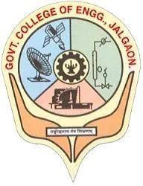

## INDUSTRIAL LECTURE REPORT

## (CO410U)

## BACHLORE OF TECHNOLOGY

## COMPUTER ENGINEERING

**GUIDED BY**

### Prof. D. V. Chaudhari

**SUBMITTED BY**

### Bhargav Shamuvel Gurav

### (2041009)

**Government College of Engineering, Jalgaon**

**(An Autonomous Institute of Government of Maharashtra)**

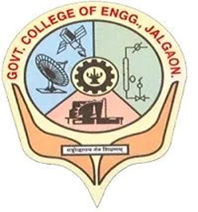

**DEPARTMENT OF COMPUTER ENGINEERING**

**CERTIFICATE**

This is to certify that the *Industrial Lecture* report of *series of 5 industrial lectures*, which are held in this semester, is being submitted here with for the award of LYComputer Engineering (7th Semester) is the result of the work completed by Bhargav Shamuvel Gurav (2041009)under my supervision and guidance in the academic year 2023-24

**Prof. S. D. Cheke                         Prof. D. V. Chaudhari**

**Co-ordinator Co-ordinator and Head of Department**

**CONTENTS**

|  |  |  |
| --- | --- | --- |
| **Sr. No** | **Title** | **Page no.** |
|  | Certificate | ii |
|  | Lecture on Customer Success | 1 |
|  | Lecture on Journey To Master Machine Learning | 5 |
|  | Lecture on Generative A.I. | 12 |
|  | Lecture on Time & Space Complexity Analysis of Algorithms | 16 |
|  | Lecture on Open Source and GSoC | 22 |