Introduction:
The purpose of this is to download a custom (shared/ private) report without having to login to the Kony Fabric console. The program expects couple of parameters as input to be run .
Configuring the Jar:
- Open the CustomReports.jar using any archive program like Winrar or WinZip. Navigate to /src/main/resources. You will find a properties file named credentials.properties.
- Open that in any text editor. Modify the username and password fields to your Kony Fabric console credentials and save. Ensure that the properties file is updated post the changes in the jar.

username=<useremail> // username@kony.com
password=<password> // password
account_id=<account_id> //Kony account Id

Running the jar:
- Navigate to the target folder.
cd target
- Execute the following command.
java -jar CustomReports.jar "{Report-Name}" {input-controls-list} {report-type} {folder}

Report Name- The name of the Report that you see in the console.
Input-controls-list- Comma separated list of input control keys and values.
{key1}={value1},{key2}={value2}…..
Put na if default controls are to be considered.
Report-type – custom, dashboard, funnel
folder – The folder in which the report resides. It can be either private or shared. If nothing is mentioned, it takes shared by default. Optional for dashboard and funnel

For Eg:
- For Single input Control
java -jar CustomReports.jar "Demo Report" appname=test custom shared

- For Multiple Input Controls
java -jar CustomReports.jar "Demo Report" appname=test,channel=mobile custom shared

- For No input Controls or to use the default Input controls.
java -jar CustomReports.jar "Demo Report" na custom shared

- To get funnel report
java -jar CustomReports.jar “Event_Funnel_View” na funnel

- To get dashboard reports
java -jar CustomReports.jar “ErrorSummaryTable” na dashboard
java -jar CustomReports.jar "RequestsPerServiceTable” startdate=2015-01-01,enddate=2017-07-05,appname=0All dashboard

- A file with name report_name.csv will be created.

How to know the input controls of the Report:

Now comes the question – How do we know the input controls of that Report. It is very simple.

- Log into the Kony Fabric console from a browser. Navigate to the Reports Section. Click on Custom reports. You will hopefully see the report you created and want to download.
- Press F12 to open the developer Console. This will open up a Developer Console. Go to Network tab.
- Now click on the report whose input controls are required. In the report you will find a network call made with the controls. Click on the request and then on Headers. Scroll Down till you find the QueryStringParameters . Under which you will a param filters.
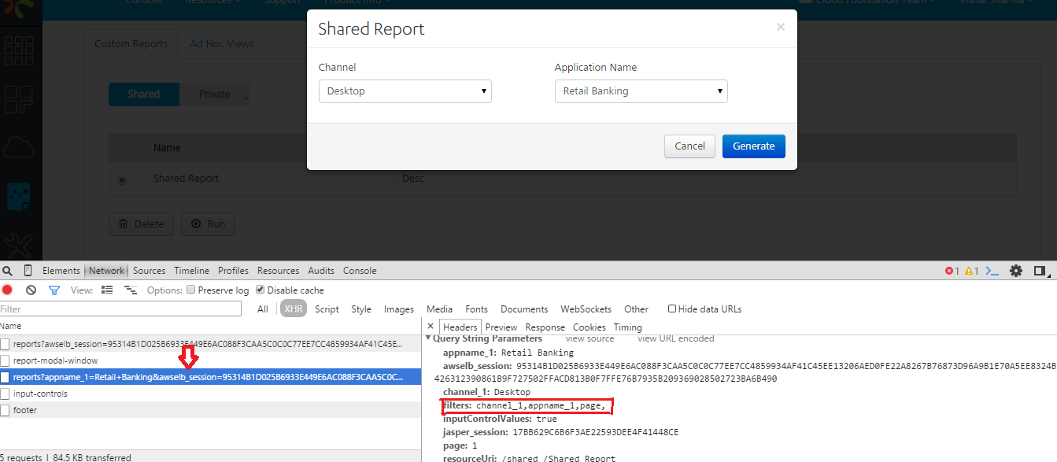
All the values except page are your input control keys. Please have a look at the image below for reference.

- Take those input controls and use them in the jar execution.
For eg:
java -jar CustomReports.jar "Shared Report" appname_1=”Retail Banking”,channel_1=Mobile custom shared

NOTE: The following process is required only if the code has to be customized or extended depending on the requirements.

Make the required changes in the code, build the jar and then follow the steps mentioned above. The process for building the jar is given below

How to build the Jar:
- Open a command prompt/Terminal. Navigate to the folder where the project exists.
For eg:
cd C:\<path-to-project>\CustomReports

- Run the following command.
mvn clean compile assembly:single

This will generate the CustomReports.jar in the target folder. That is the executable jar.

