

**Tutorial –5**

**Here's how a Wireless router works:**

**A router is a device that communicates between the internet and the devices in your home that connect to the internet. With the right kind of router, you may be able to enjoy faster internet service, help protect your family from cyberthreats, and avoid those maddening Wi-Fi dead spots.**

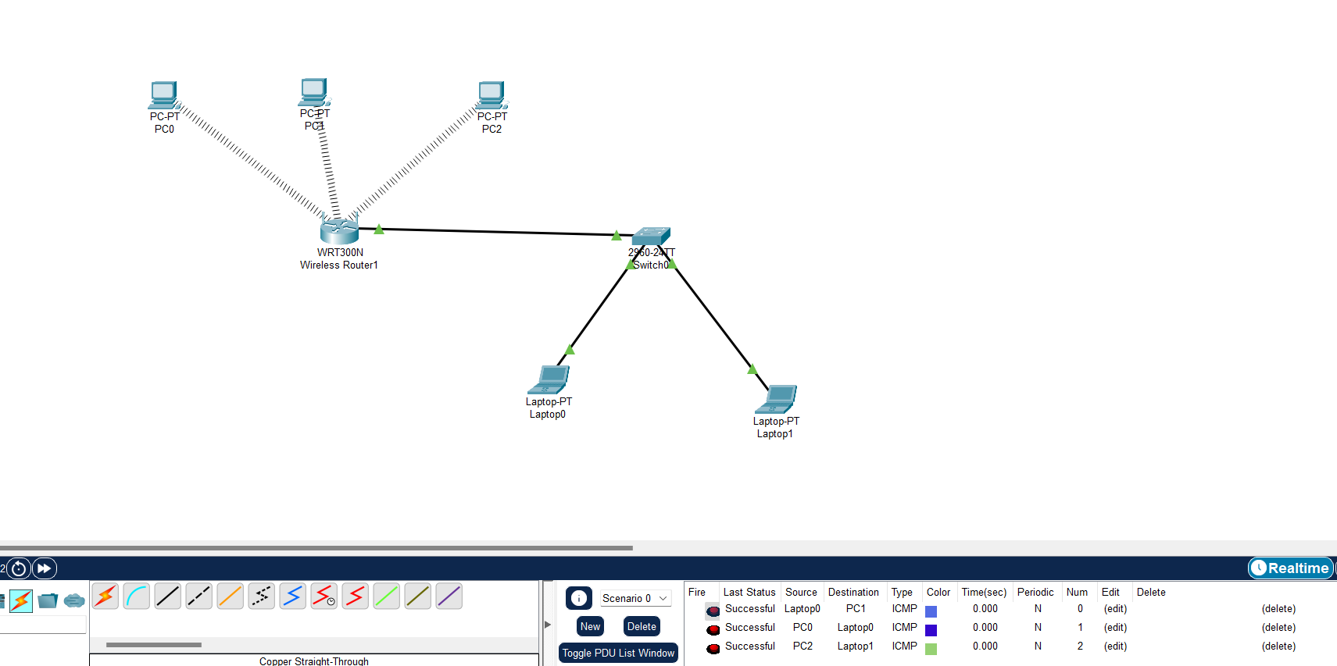

1. **First, I have taken three individual PC ‘s assigned Ip addresses 192.168.0.2, 192.168.0.3, 192.168.0.4 respectively.**
2. **Next, I set up network address of wireless router as 192.168.0.1, disable DHCP server**
3. **Naming the network SSID by some random name**
4. **To ensure security write Passphrase as gateway for ensuring connection established successfully.**
5. **Connect the PCs to wireless router by passphrase**
6. **Sent payloads from one pc to another pc.**
7. **Extend the network by connecting router to switch which in turn connected to two laptops.**
8. **Sent payloads from one pc to laptop**