Lab-4 :

1.Model Summary:

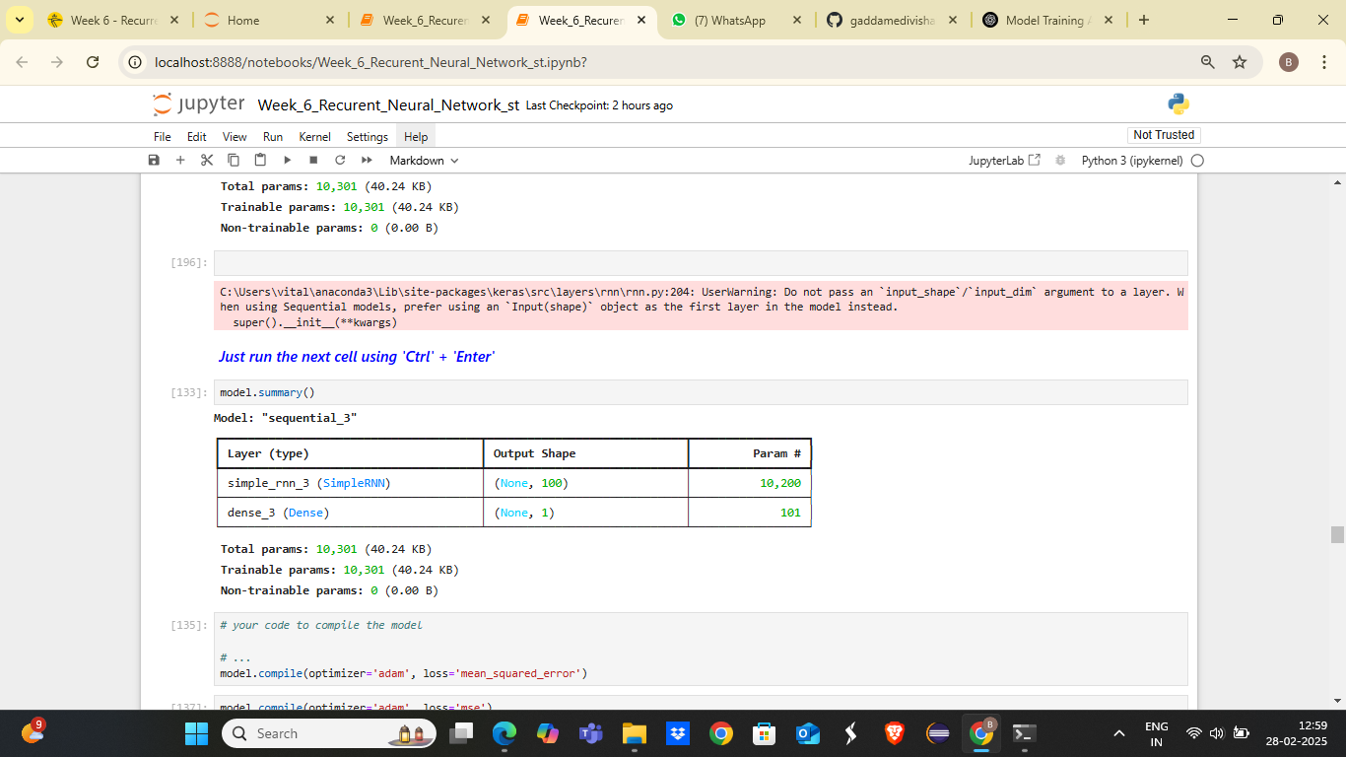

2.early-stop code and history_2 fit-training-process:

early_stop = EarlyStopping(mo nitor='val_loss',patience=2)

history_2 = model.fit(generator, epochs=30,

validation_data=validation_generator,

callbacks=[early_stop])

3.The plot of validation and test loss of history_2:

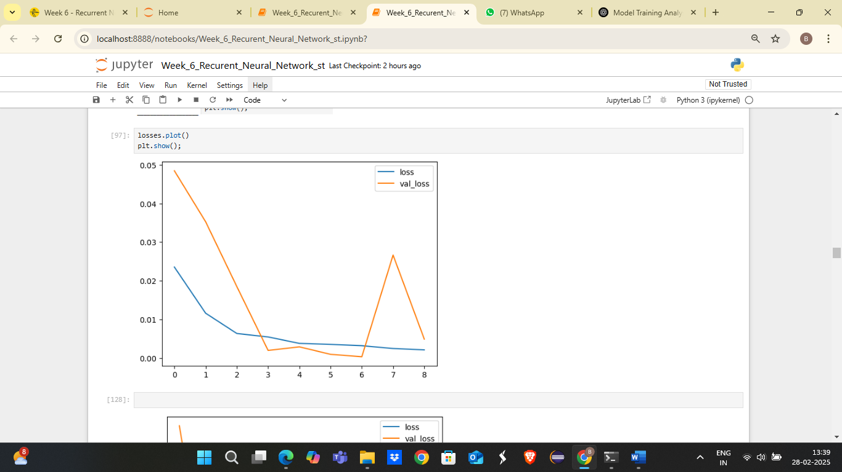

4.determine the optimal number of epochs for training your model:

