Lab-8 :

1. LSTM architecture using model.summary():

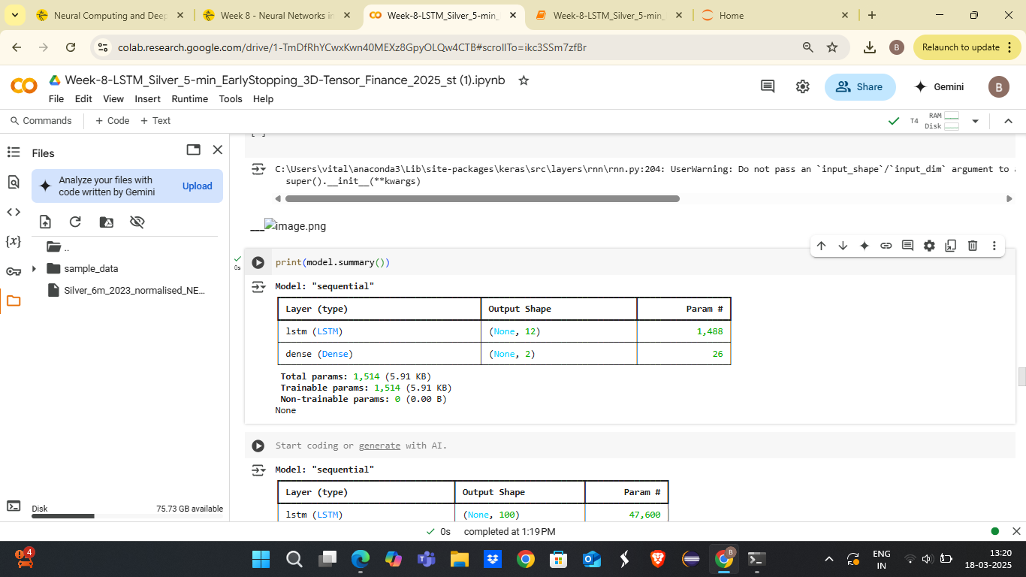

2. code and training result using model.fit():

history=model.fit(X_train,y_train,batch_size=20,epochs=10,

                  validation_split=0.1,

                  verbose=1,callbacks=[es,mc])

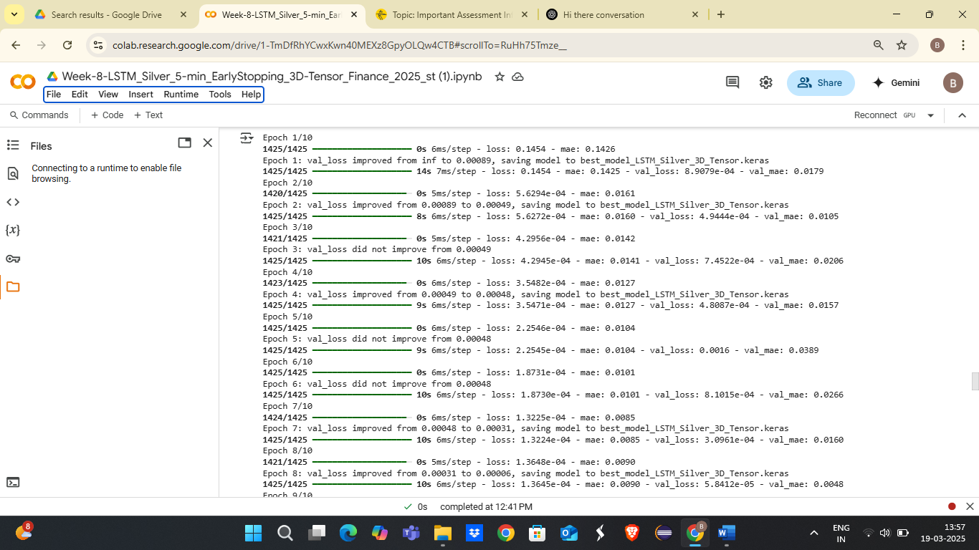

3. The resulting test MSE & MAE:

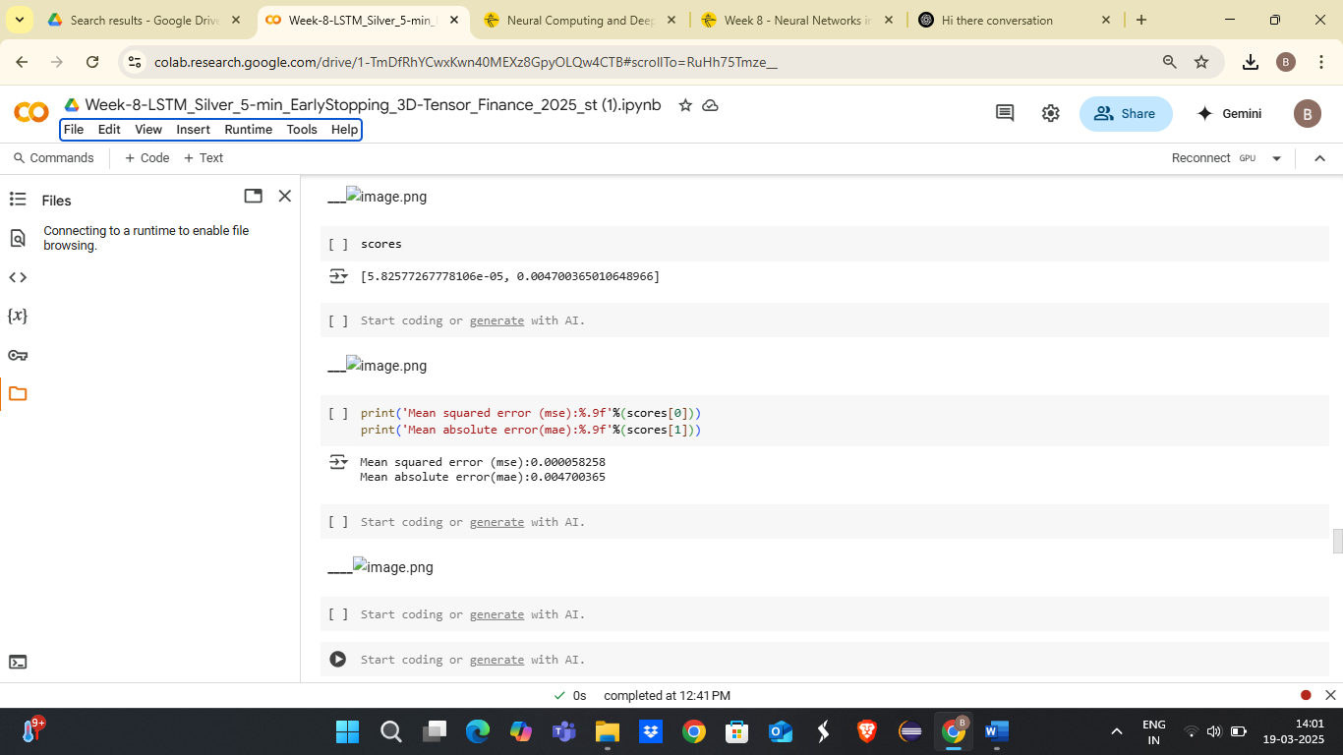

4. MAE detailed graph:

