Lab-9 :

1. EarlyStopping() and ModelCheckpoint() functions:

es=EarlyStopping(monitor='val_loss', mode='min', verbose=1, patience=10)

mc=ModelCheckpoint('best_Trand-Flat_model_LSTM_GOLD.keras',monitor='val_loss',mode='min',verbose=1,save_best_only=True)

2. code and training result using model.fit():

history=model.fit(X_train,y_train,batch_size=12,epochs=32,

                  validation_split=0.2,shuffle=True,

                  verbose=1,callbacks=[es,mc],

                  class_weight=class_weight_dict

)

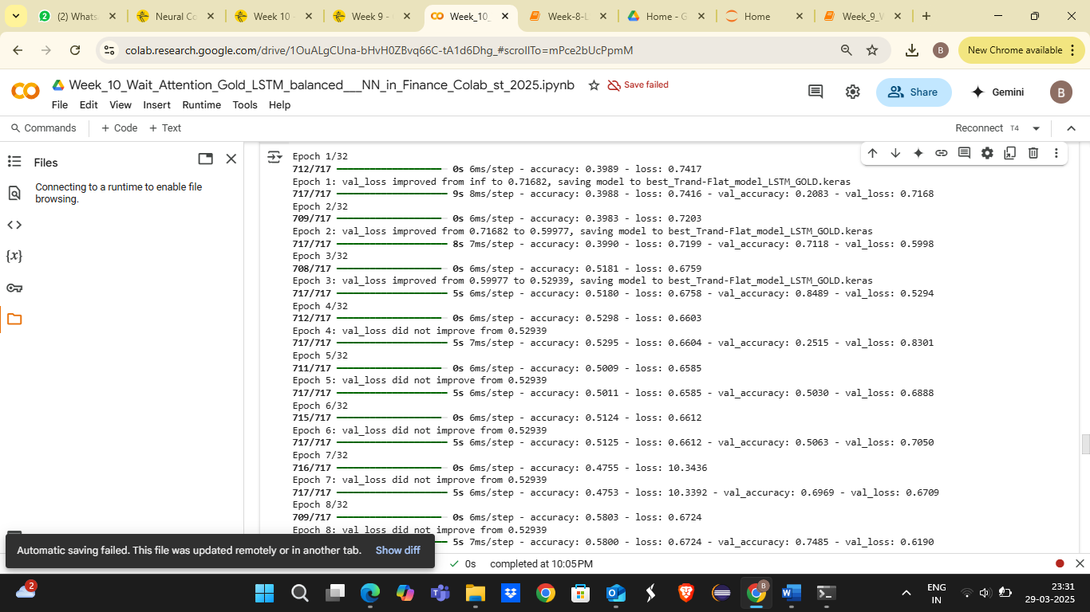

3. The resulting test Accuracy and other error metrics for the classification task using classification_report():

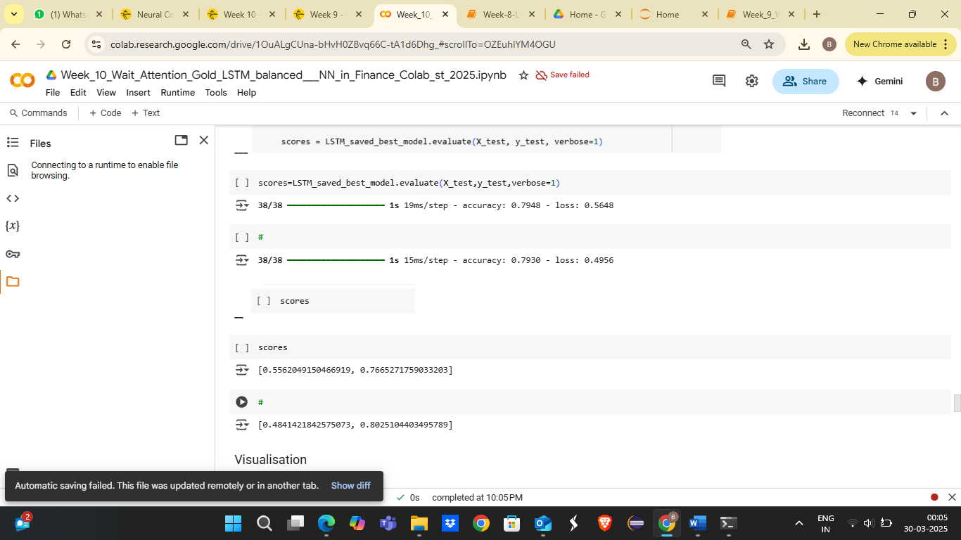

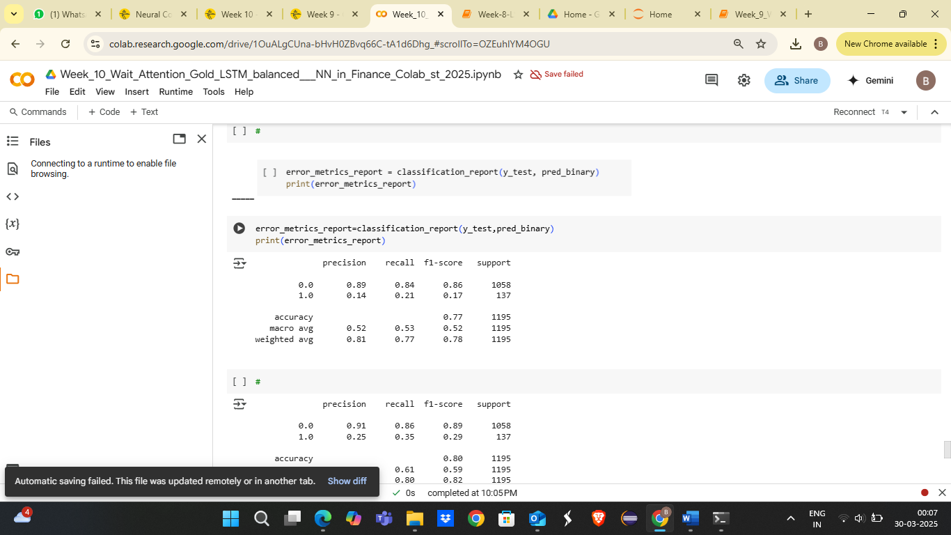

4. Accuracy detailed graph:

