"PROMPTCRAFT: AI PROMPT GENERATOR TOOL"
Application Development-2 Project Report Submitted
In partial fulfillment of the requirement for the award of the degree of

Bachelor of Technology
In
Computer Science and Engineering -Artificial Intelligence and Machine Learning by

D BHARGAV RAM - 22N31A6644

A PAVAN KUMAR - 22N35A6606

A VARUN KUMAR - 22N31A6612

Under the Guidance of
Mrs Ruquia Khatoon
ASSISTANT PROFESSOR

Computational Intelligence Department MRCET

DEPARTMENT OF COMPUTATIONAL INTELLIGENCE MALLA REDDY COLLEGE OF ENGINEERING AND TECHNOLOGY
(Affiliated to JNTU, Hyderabad)
ACCREDITED by AICTE-NBA
Maisammaguda, Dhulapally post, Secunderabad-500014.
2022-2026

DECLARATION

We hereby declare that the project entitled "Promptcraft: Ai Prompt Generator Tool" submitted to Malla Reddy College of Engineering and Technology, affiliated to Jawaharlal Nehru Technological University Hyderabad (JNTUH) for the award of the degree of Bachelor of Technology in Computer Science and Engineering- Artificial Intelligence and Machine Learning is a result of original research work done by me.
It is further declared that the project report or any part thereof has not been previously submitted to any University or Institute for the award of degree or diploma.

BY
D Bhargav Ram - 22N31A6644

A Pavan Kumar - 22N35A6606

A Varun Kumar - 22N31A6612

i



CERTIFICATE

This is to certify that this is the bonafide record of the project titled "Promptcraft: Ai Prompt Generator Tool" submitted by D. Bhargav Ram-(22N31A6644), A. Pavan Kumar-(22N31A6606), A. Varun Kumar- (22N31A6612) of B.Tech in the partial fulfillment of the requirements for the degree of Bachelor of Technology in Computer Science and Engineering- Artificial Intelligence and Machine Learning, Dept. of CI during the year 2023-2024. The results embodied in this project report have not been submitted to any other university or institute for the award of any degree or diploma.

MRS RUQUIA KHATOON DR. D. SUJATHA
ASSISTANT PROFESSOR PROFESSOR
INTERNAL GUIDE HEAD OF THE DEPARTMENT

EXTERNAL EXAMINER

ii
ACKNOWLEDGEMENT

We feel honored and privileged to place our warm salutation to our college Malla Reddy College of Engineering and technology (UGC-Autonomous), our Director Dr. VSK Reddy who gave us the opportunity to have experience in engineering and profound technical knowledge.

We are indebted to our Principal, Dr. S. Srinivasa Rao for providing us with facilities to do our project and his constant encouragement and moral support which motivated us to move forward with the project.

We would like to express our gratitude to our Head of the Department, Dr. D. Sujatha for encouraging us in every aspect of our system development and helping us realize our full potential.

We would like to thank our application development guide as well as our internal guide
Mrs Ruquia Khatoon, Assistant Professor for her structured guidance and never-ending encouragement. We are extremely grateful for valuable suggestions and unflinching co-operation throughout application development work.

We sincerely thank all the teaching and non-teaching staff of the Department of Computational Intelligence, for their timely suggestions, healthy criticism and motivation during the course of our work.

We would also like to thank our friends for providing help and moral support at the right timing. With great respect and obedience, we thank our parents who were the backbone behind our deeds.

Not but the least, we would like to thank the Almighty for constantly being with us in each and every crucial point of our life.

Finally, we express our immense gratitude with pleasure to all individuals who have either directly or indirectly contributed to our need at right time for the development and success of our project work.

By
D Bhargav Ram - 22N31A6644

A Pavan Kumar - 22N35A6606

A Varun Kumar - 22N31A6612

iii

ABSTRACT

PromptCraft is a handy tool that helps users create detailed and engaging prompts for AI applications.Built using Python and the Tkinter library, it features a simple, user-friendly interface that makes prompt creation quick and easy. Whether you're a developer, writer, or AI enthusiast, PromptCraft is designed to save you time and effort. The tool allows users to input descriptions and instantly turn them into polished AI prompts, which can be copied to the clipboard with just one click. It ensures accuracy with input validation, so you don’t miss any important details while crafting prompts. PromptCraft’s interface is clean and intuitive, with organized buttons and labels that make it easy to use, even for beginners. This tool is perfect for tasks like training chatbots, generating creative content, or working on AI projects that require well-structured inputs.

.

iv

TABLE OF CONTENTS

S. No Topic Page No

CHAPTER 1: INTRODUCTION ------------------------------------------------------------------------ 1-2
1.1: Purpose-----------------------------------------------------------------------------1
1.2: Background of project------------------------------------------------------------1
1.3: Scope of project-------------------------------------------------------------------1
1.4: Project features------------------------------------------------------------------- 2
CHAPTER 2: SYSTEM REQUIREMENTS----------------------------------------------------------- 3-6
2.1 Hardware & Software Requirements--------------------------------------------3
2.2 Functional Requirements----------------------------------------------------------4
2.3 Existing System-------------------------------------------------------------------- 4-5
2.4 Proposed System------------------------------------------------------------------- 6
CHAPTER 3: TECHNOLOGIES USED--------------------------------------------------------------- 7-9
3.1 Android------------------------------------------------------------------------------ 7
3.2 Java-----------------------------------------------------------------------------------7-8
3.3 Global Positioning System-------------------------------------------------------- 9
CHAPTER 4: SYSTEM DESIGN ----------------------------------------------------------------------- 10-14
4.1 System Architecture--------------------------------------------------------------- 10
4.2 Data Flow Diagram--------------------------------------------------------------- 10
4.3 UML Diagrams--------------------------------------------------------------------11-14
CHAPTER 5: IMPLEMENTATION ------------------------------------------------------------------ 15-28
5.1 Source Code------------------------------------------------------------------------15-24
5.2 Output Screens---------------------------------------------------------------------24-28
CHAPTER 6: CONCLUSION----------------------------------------------------------------------------29

REFERENCES ---------------------------------------------------------------------------------------------- 29

CHAPTER-1

1.INTRODUCTION

  - Purpose

PromptCraft is an AI-powered platform designed to enhance the efficiency and effectiveness of prompt generation for AI models. As AI-generated content continues to gain prominence, the quality of prompts directly impacts the relevance, accuracy, and usability of AI responses. The primary purpose of PromptCraft is to streamline the prompt creation process by providing users with intelligent assistance, structured guidance, and real-time feedback to refine their inputs. Additionally, PromptCraft integrates with multiple AI APIs, such as Ollama and GPT-based models, ensuring compatibility and scalability. With features like automated prompt refinement, system logging, and interactive UI elements, PromptCraft aims to simplify AI interactions, reducing trial and error while enabling users to generate high-quality content efficiently.
  - Background of project:

With the increasing adoption of AI-based text generation models like OpenAI's GPT, businesses and individuals struggle to craft effective prompts. Inefficient or ambiguous prompts often lead to suboptimal AI responses. PromptCraft was developed to address this challenge by providing users with a structured, guided approach to prompt generation. By leveraging AI-powered prompt optimization, the platform ensures that users receive high-quality AI-generated outputs with minimal effort.
  - Scope of project:

The scope of PromptCraft focuses on developing an efficient system for handling user input and generating structured prompts through automated processing. It streamlines prompt creation by managing user requests, processing API interactions, and generating refined outputs. The platform ensures seamless user interaction, system logging, and management for scalability and reliability. Designed for various use cases, it allows users to input data, process requests efficiently, and receive well-structured prompts while maintaining security and performance standards.

  - Project Features:

The system features are as follows:
- Simple and intuitive interface, accessible for beginners and non-technical users.
- Does not require internet connectivity, offering offline functionality.
- Quickly generates polished AI prompts with minimal effort.
- Ensures accuracy and completeness of descriptions before generating prompts.
- One-click prompt generation and copy-to-clipboard features save time.
- Built using Python and Tkinter, requiring no complex installations or integrations.
- Can be easily enhanced to include additional features or integrate with external APIs if needed.

CHAPTER-2

2.SYSTEM REQUIREMENTS

2.1 Hardware Requirements:
Processor: intel i5 11th Gen and above
Memory: 8GB RAM
Storage: 512GB SSD

2.2 Software requirements:
OS: Windows 10 or advanced
IDE: Visual Studio Code 1.96
Python 3.12
Libraries: Tkinter, TextBlob, OpenAI

2.3 Existing System:

- OpenAI Playground:
  - An interactive platform for testing and refining AI prompts in real-time using OpenAI models.
- LangChain:
  - A framework designed to build applications with large language models by integrating prompts into workflows and pipelines.
- PromptLayer:
  - A tool that tracks, manages, and optimizes prompts for language models, focusing on prompt engineering and analysis.

2.3.1 Drawbacks of existing system:

  - OpenAI Playground
- Limited to OpenAI models, restricting flexibility with other platforms.
- Requires an internet connection and may incur usage costs.
  - LangChain
- Complex to set up and use, requiring programming knowledge.
- Dependency on external libraries and APIs increases complexity.
  - PromptLayer
- Focuses primarily on tracking and optimization, not prompt creation.
- Requires integration with existing workflows, which may not suit all users.
- Limited user interface, making it less accessible for non-technical users.

2.4 Proposed System:

The proposed system, PromptCraft, is a standalone desktop application designed to streamline the creation of structured AI prompts. Built for efficiency and ease of use, it features a user-friendly interface that allows users to input descriptions, validate their content, and generate refined AI-ready prompts. Unlike online tools that require internet connectivity, PromptCraft operates offline, ensuring privacy, security, and accessibility for users in various environments.
The system is designed to generate polished AI prompts by guiding users through a structured input process, minimizing errors and improving prompt effectiveness. It allows for quick modifications, ensuring flexibility and adaptability based on user needs. Additionally, it features one-click copy-to-clipboard functionality, enabling seamless integration with AI applications, chatbots, or content generation tools.
With its simple and efficient design, PromptCraft caters to developers, writers, researchers, and AI enthusiasts who require well-structured prompts for various applications. By focusing on automation, accuracy, and ease of use, the system enhances AI interactions while reducing manual effort, making prompt engineering more accessible and efficient.

CHAPTER-3

3.TECHNOLOGIES USED:

3.1 ANDROID:

Android apps are written in the Java programming language. The Android SDK tools compile your code—along with any data and resource files—into an APK: an Android package, which is an archive file with an .apk suffix. One APK file contains all the contents of an Android app and is the file that Android-powered devices use to install the app. Once installed on a device, each Android app lives in its own security sandbox: The Android operating system is a multiuser Linux system in which each app is a different user.
In this way, the Android system implements the principle of least privilege. That is, each app, by default, has access only to the components that it requires to do its work and no more. This creates a very secure environment in which an app cannot access parts of the system for which it is not given permission. However, there are ways for an app to share data with other apps and for an app to access system services: It's possible to arrange for two apps to share the same Linux user ID, in which case they are able to access each others files. To conserve system resources, apps with the same user ID can also arrange to run in the same Linux process and share the same VM (the apps must also be signed with the same certificate).

3.2.JAVA:
Java is a general purpose, high-level programming language developed by Sun Microsystems. The Java programming language was developed by a small team of engineers, known as the Green Team, who initiated the language in 1991. The language was originally called OAK, and at the time it was designed for handheld devices and set-top boxes. Oak was unsuccessful and in 1995 Sun changed the name to Java and modified the language to take advantage of the burgeoning World Wide Web.
The Java programming language is a high-level language that can be characterized by all of the following buzzwords:
    - Simple

    - Architecture neutral
    - Object oriented
    - Portable
    - High performance
    - Interpreted
    - Multithreaded
    - Robust
    - Dynamic
    - Secure
The following figure illustrates how this works.
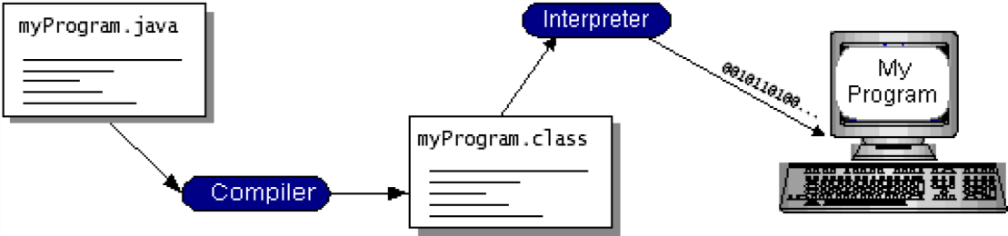

Fig 3.2(a) Working of Java Program
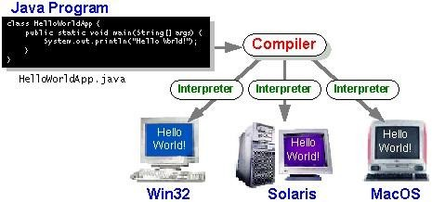

Fig 3.2(b) Compilation of Java

3.3. GLOBAL POSITIONING SYSTEM

GPS (Global Positioning System) is a satellite navigation system that uses a network of 24 satellites to determine the exact location of objects on Earth. Originally developed for military use in the 1960s, it is now widely used in civilian applications such as smartphones, vehicles, and fitness devices. GPS works by receiving signals from satellites, which provide data on location, speed, and direction.
GPS tracking systems can operate in two ways:
- Passive Tracking – Stores data on location at regular intervals or when specific changes are detected.
- Active (Real-time) Tracking – Sends location data to a central system in real-time.
GPS is commonly used for tracking vehicles, assets, and even people, providing valuable information for navigation, route monitoring, and safety.
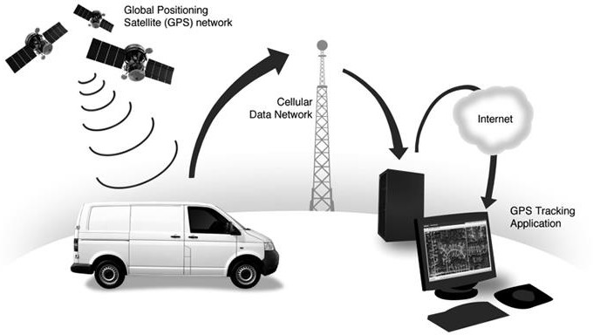

Fig 3.3 GPS Trackinng System

CHAPTER-4

4.SYSTEM DESIGN

4.1 System Architecture

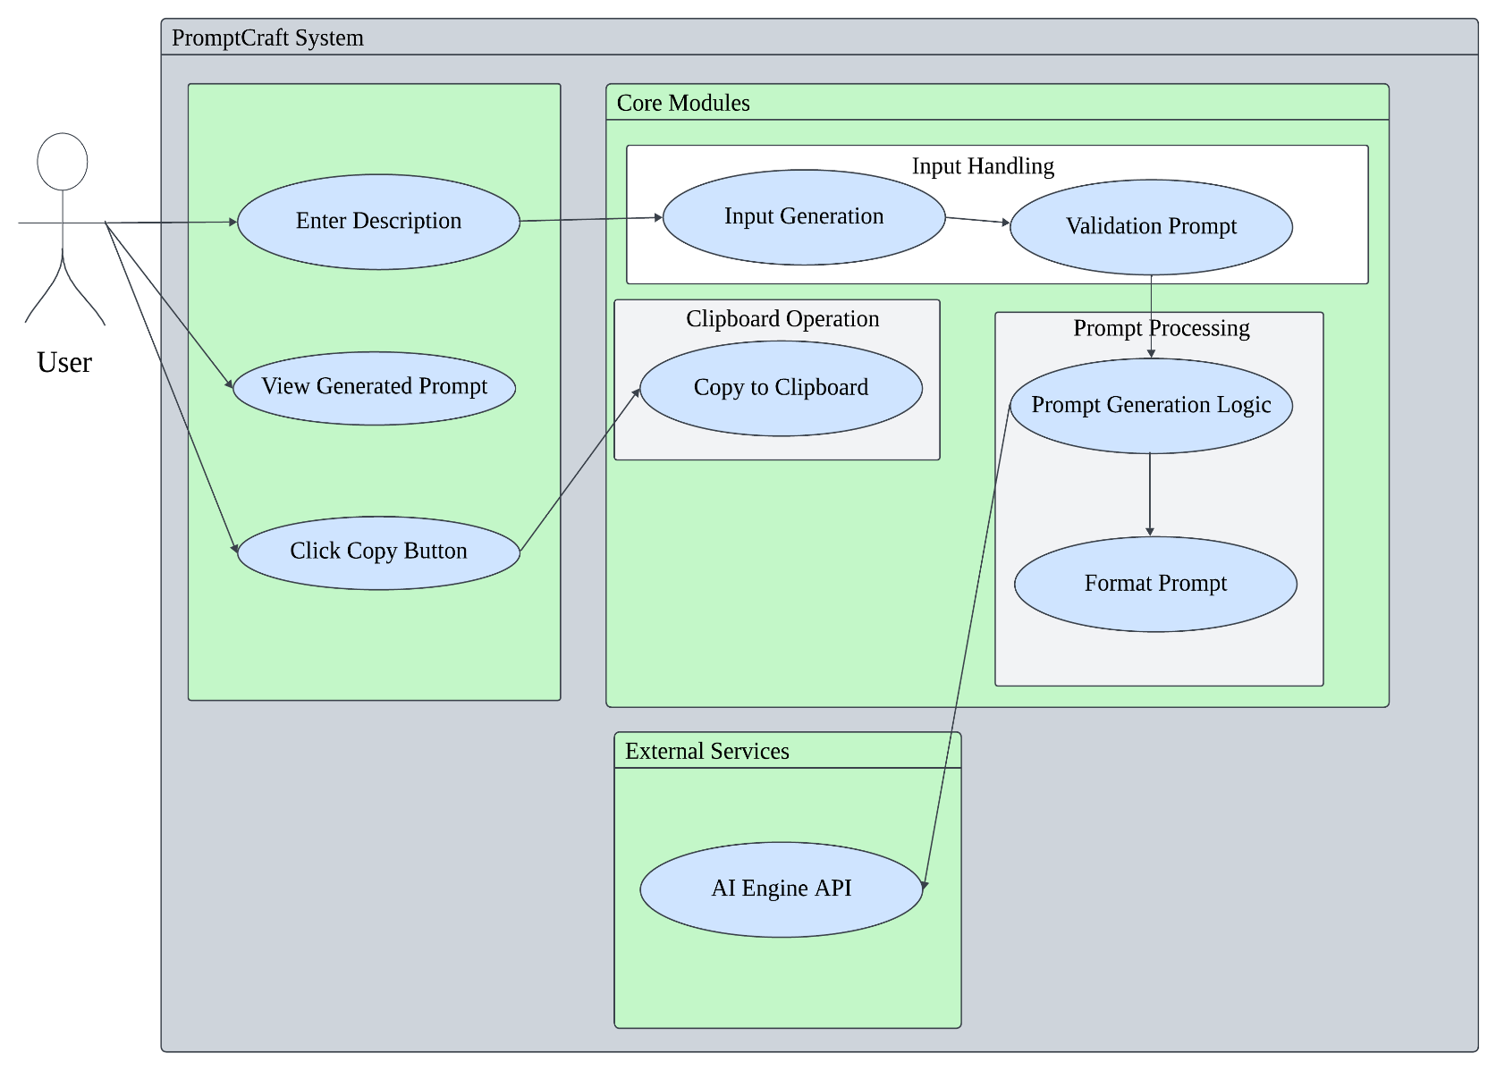

Fig 4.1 System Architecture for PromptCraft

4.2 Data flow diagram
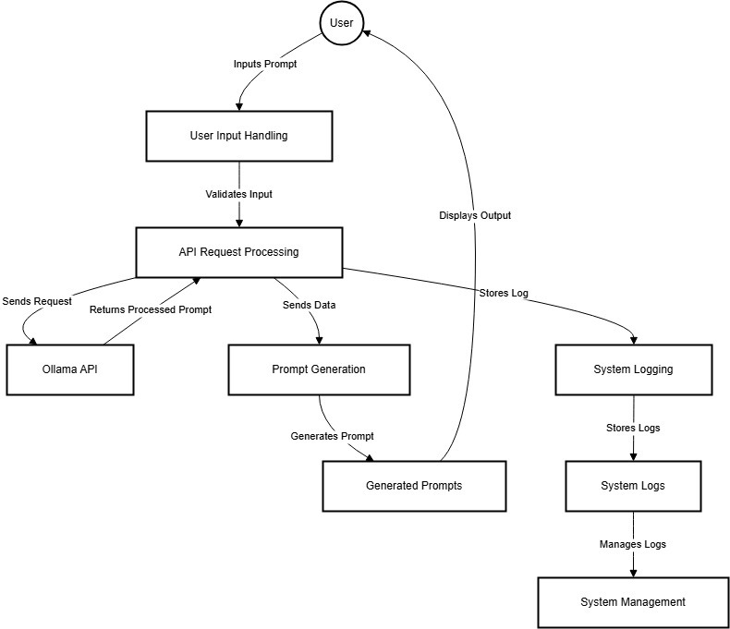

Fig 4.2 Data Flow Diagram for PromptCraft

4.3 UML Diagrams

The unified modeling is a standard language for specifying, visualizing, constructing and documenting the system and its components is a graphical language which provides a vocabulary and set of semantics and rules. The UML focuses on the conceptual and physical representation of the system. It captures the decisions and understandings about systems that must be constructed. It is used to understand, design, configure and control information about the systems.

4.3.1 Use case diagram

A use case diagram is a graph of actors set of use cases enclosed by a system boundary, communication associations between the actors and users and generalization among use cases. The use case model defines the outside (actors) and inside (use case) of the system’s behavior.
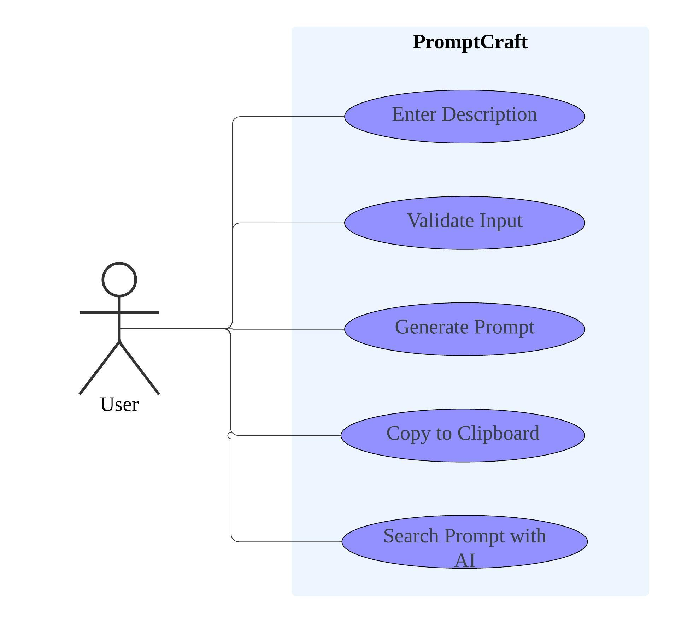

Fig 4.3.1(a) Use Case for PrmptCraft

4.3.2 Class Diagram

A class is a representation of an object and, in many ways; it is simply a template from which objects are created. Classes form the main building blocks of an object-oriented application. Although thousands of students attend the university, you would only model one class, called Student, which would represent the represent the entire collection of students.

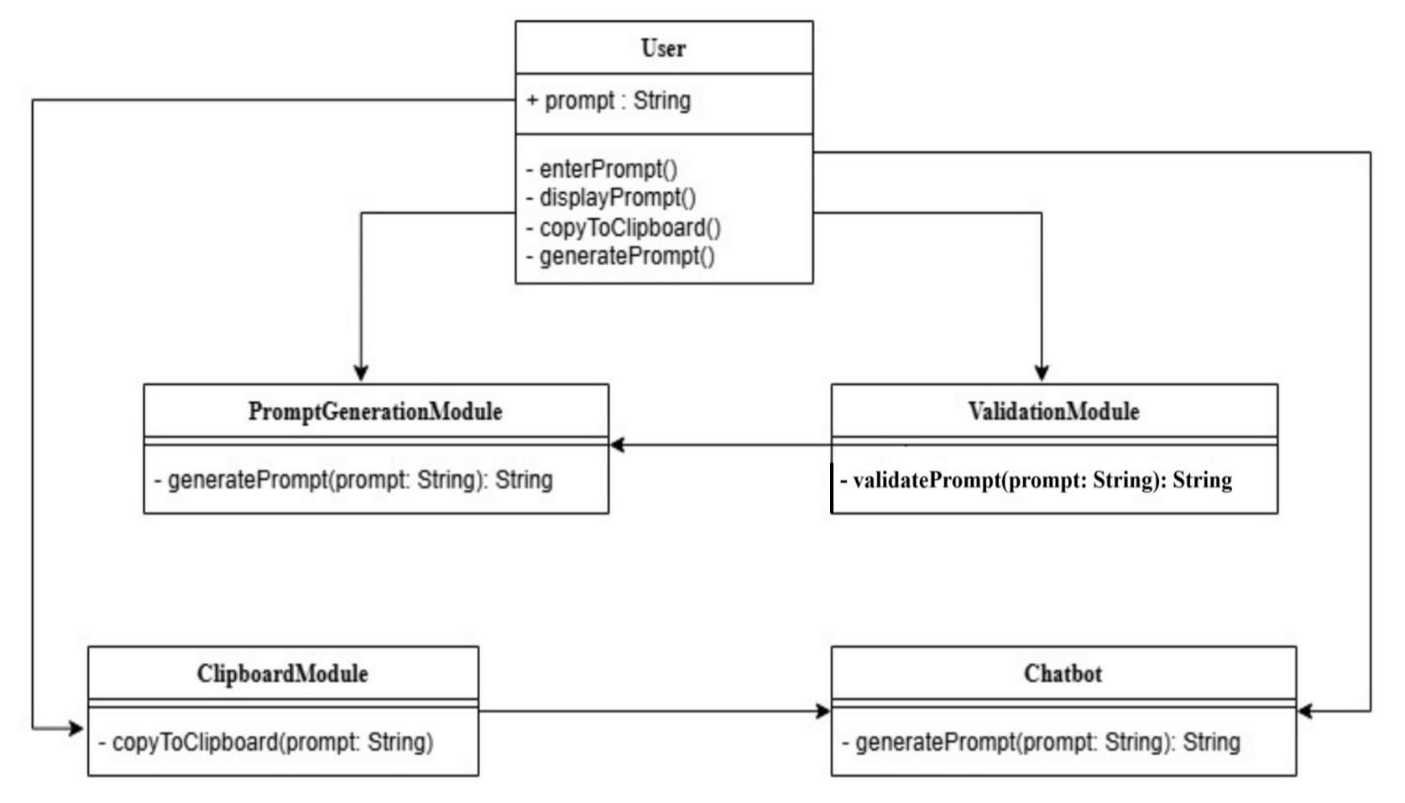

Fig 4.3.2 (b) Class Diagram for PromptCraft

4.3.3 Sequence Diagram

Sequence diagram is used to represent the flow of messages, events and actions between the objects or components of a system. Time is represented in the vertical direction showing the sequence of interactions of the header elements, which are displayed horizontally at the top of the diagram.

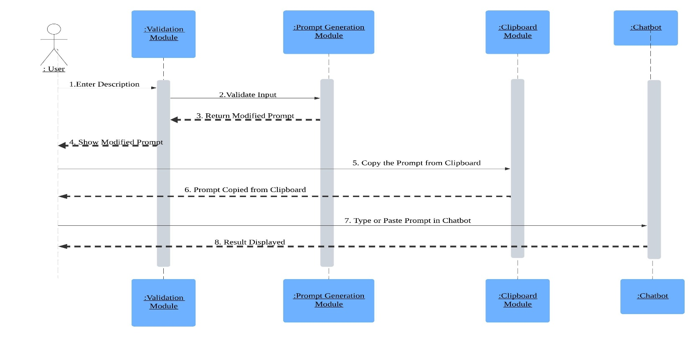

Fig 4.3.3(c) Activity Diagram for PromptCraft

4.3.4 Activity Diagram

Activity diagram represents the business and operational workflows of a system. An Activity diagram is a dynamic diagram that shows the activity and the event that causes the object to be in the particular state.
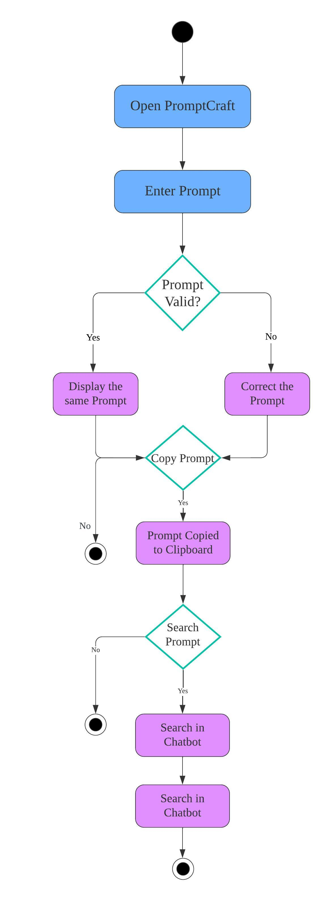

Fig 4.3.4(d) Activity Diagram for PromptCraft

CHAPTER-5

5.IMPLEMENTATION

5.1: Source Code
Prompt.py
import tkinter as tk
from tkinter import messagebox
from threading import Thread
import customtkinter as ctk
import requests
import subprocess
import time
import psutil
import sys

class OllamaPromptGenerator:
def __init__(self, model_url="http://localhost:11434/api/generate"):
self.model_url = model_url
self.ollama_process = None
self.start_ollama_server()
self.ensure_model_loaded()

def start_ollama_server(self):
if not self.is_ollama_running():
try:
print("Starting Ollama server...")
self.ollama_process = subprocess.Popen(
[r"C:\\Users\\Bhargav\\AppData\\Local\\Programs\\Ollama\\ollama.exe", "serve"],
stdout=subprocess.DEVNULL, stderr=subprocess.DEVNULL
)
for attempt in range(20):
if self.is_ollama_running() and self.is_ollama_ready():
print(f"Ollama is ready after {attempt + 1} attempts.")
return
time.sleep(1)
messagebox.showerror("Error", "Ollama did not start in time.")
except FileNotFoundError:
messagebox.showerror("Error", "Ollama executable not found. Ensure it's installed and added to PATH.")

def is_ollama_running(self):
for process in psutil.process_iter(['name']):
if "ollama" in process.info['name'].lower():
return True
return False

def is_ollama_ready(self):
try:
response = requests.get("http://localhost:11434/api/tags", timeout=5)
return response.status_code == 200
except requests.RequestException:
return False

def ensure_model_loaded(self):
model_name = "tinyllama"
try:
response = requests.get("http://localhost:11434/api/tags", timeout=10)
if response.status_code == 200:
models = response.json().get("models", [])
if not any(model.get("name") == model_name for model in models):
print(f"Model '{model_name}' is not detected, but skipping download as per user request.")
except requests.RequestException as e:
print(f"Error ensuring model is loaded: {e}")

def generate_prompt(self, description):
structured_prompt = f"""
### Task:
Generate a **concise and thought-provoking writing prompt** based on the following description.

### Description:
{description}

### Instructions:
- **Only output a single, creative writing prompt.**
- Do **NOT** generate exercises or story outlines.
- The prompt should be **under 50 words** and **spark imagination and storytelling.**
- **Strictly avoid adding additional guidance or tips.**
"""

payload = {
"model": "tinyllama",
"prompt": structured_prompt,
"stream": False,
"options": {
"num_predict": 100,
"temperature": 0.5,
"top_k": 30,
"top_p": 0.8,
}
}

try:
response = requests.post(self.model_url, json=payload, timeout=30)
response.raise_for_status()
print(response.status_code)
print(response.json())
return response.json().get("response", "No response generated.")
except requests.RequestException as e:
return f"Error: {e}"

def stop_ollama_server(self):
if self.ollama_process:
self.ollama_process.terminate()

class PromptChatApp:
def __init__(self, root):
self.root = root
self.root.title("PromptCraft")
self.root.geometry("900x600")
self.root.resizable(False, False)

ctk.set_appearance_mode("Dark")
ctk.set_default_color_theme("dark-blue")

self.prompt_generator = OllamaPromptGenerator()
self.create_ui()
self.root.protocol("WM_DELETE_WINDOW", self.on_close)

def create_ui(self):
frame = ctk.CTkFrame(self.root, corner_radius=20)
frame.pack(fill=tk.BOTH, expand=True, padx=20, pady=20)

ctk.CTkLabel(frame, text="PromptCraft", font=("Arial", 24, "bold")).pack(pady=10)

self.description_input = ctk.CTkTextbox(frame, height=100, width=600, corner_radius=15, fg_color="#2A2D3E", text_color="white")
self.description_input.pack(pady=10)

self.generate_button = ctk.CTkButton(
frame, text="Generate Prompt", command=self.generate_prompt, corner_radius=25, height=40, width=200, fg_color="#007BFF"
)
self.generate_button.pack(pady=10)

self.output_text = ctk.CTkTextbox(frame, height=200, width=600, state=tk.DISABLED, corner_radius=15, fg_color="#1E1E2E", text_color="white")
self.output_text.pack(pady=10)

self.copy_button = ctk.CTkButton(
frame, text="Copy to Clipboard", command=self.copy_to_clipboard, state=tk.DISABLED, corner_radius=25, height=40, width=200, fg_color="#28A745"
)
self.copy_button.pack(pady=5)

self.status_label = ctk.CTkLabel(frame, text="Ready", font=("Arial", 10))
self.status_label.pack(pady=5)

def generate_prompt(self):
description = self.description_input.get("1.0", tk.END).strip()
if not description:
messagebox.showerror("Input Error", "Please enter a description.")
return

self.status_label.configure(text="Generating prompt...")
self.generate_button.configure(state=tk.DISABLED)
self.root.update()

def run_generation():
prompt = self.prompt_generator.generate_prompt(description)
self.root.after(0, lambda: self.display_prompt(prompt))

Thread(target=run_generation).start()

def display_prompt(self, prompt):
self.output_text.configure(state=tk.NORMAL)
self.output_text.delete("1.0", tk.END)
self.output_text.insert("1.0", prompt)
self.output_text.configure(state=tk.DISABLED)
self.copy_button.configure(state=tk.NORMAL)
self.generate_button.configure(state=tk.NORMAL)
self.status_label.configure(text="Ready")

def copy_to_clipboard(self):
prompt = self.output_text.get("1.0", tk.END).strip()
self.root.clipboard_clear()
self.root.clipboard_append(prompt)
self.root.update()
messagebox.showinfo("Success", "Prompt copied to clipboard!")

def on_close(self):
self.prompt_generator.stop_ollama_server()
self.root.destroy()

if __name__ == "__main__":
root = ctk.CTk()
app = PromptChatApp(root)
root.mainloop()

5.2 Output Screens:

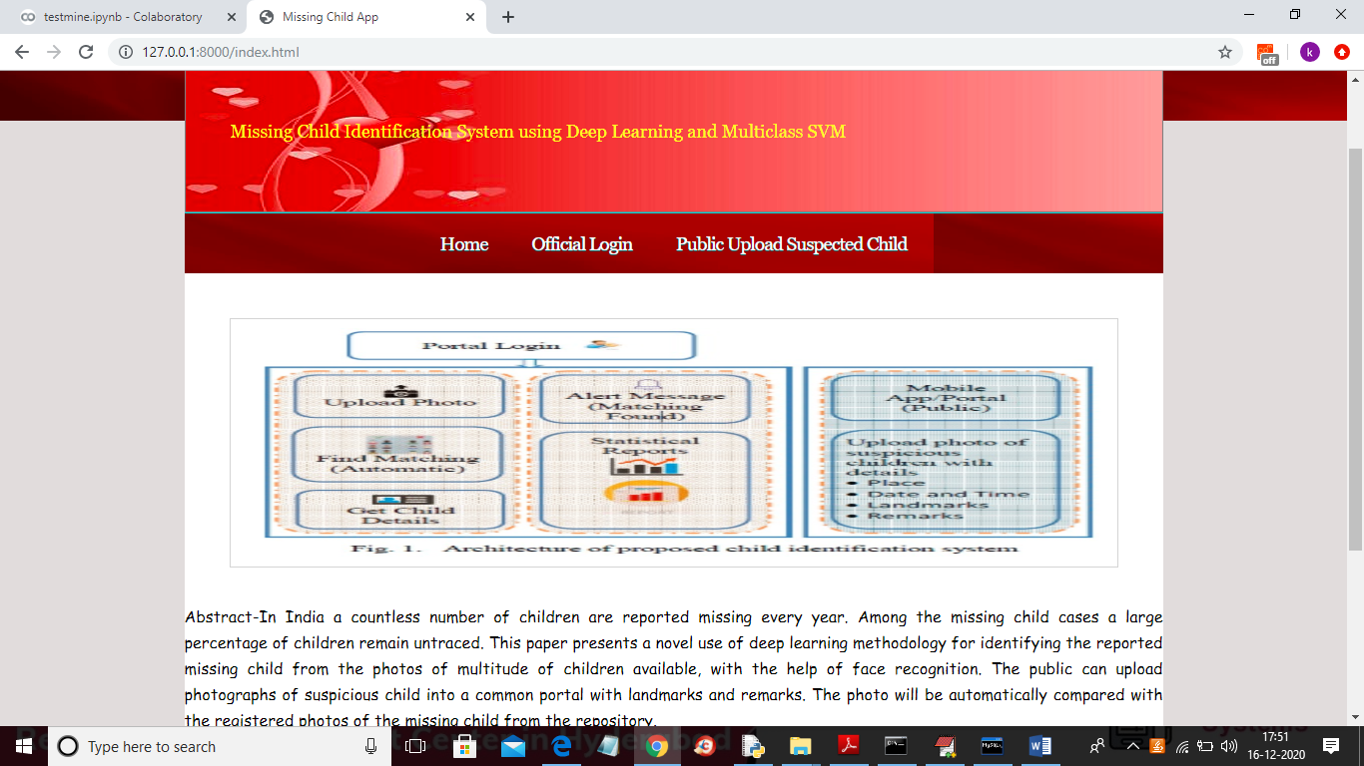

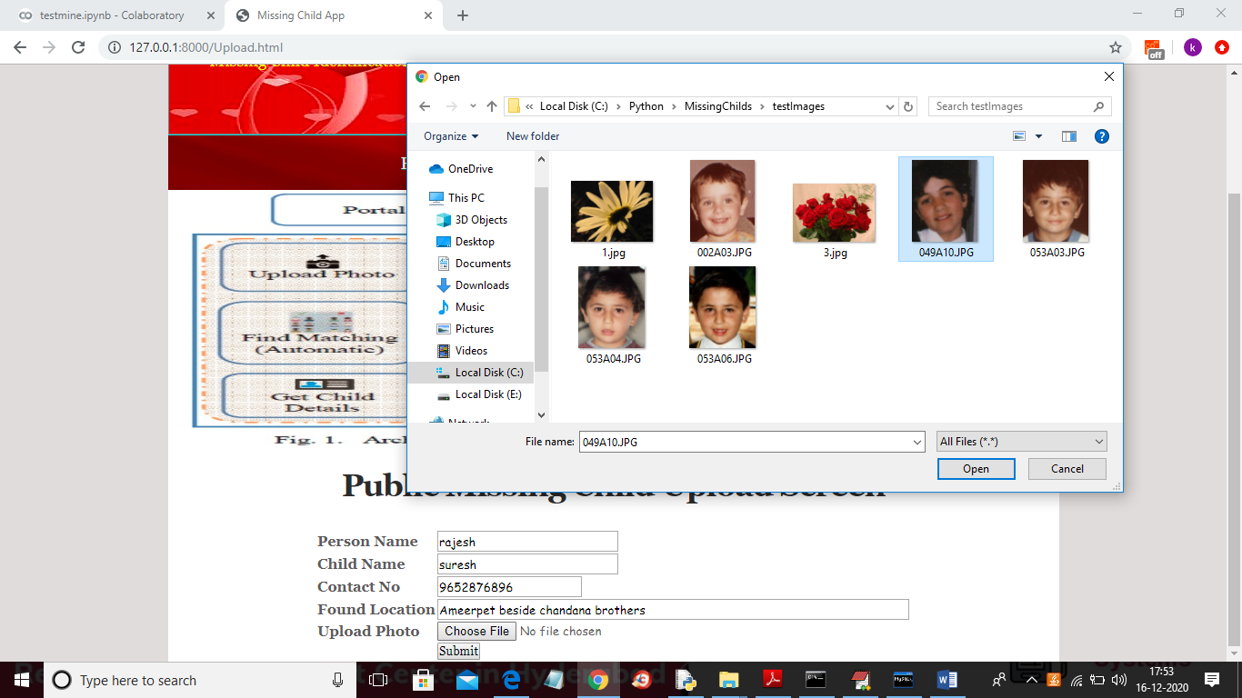

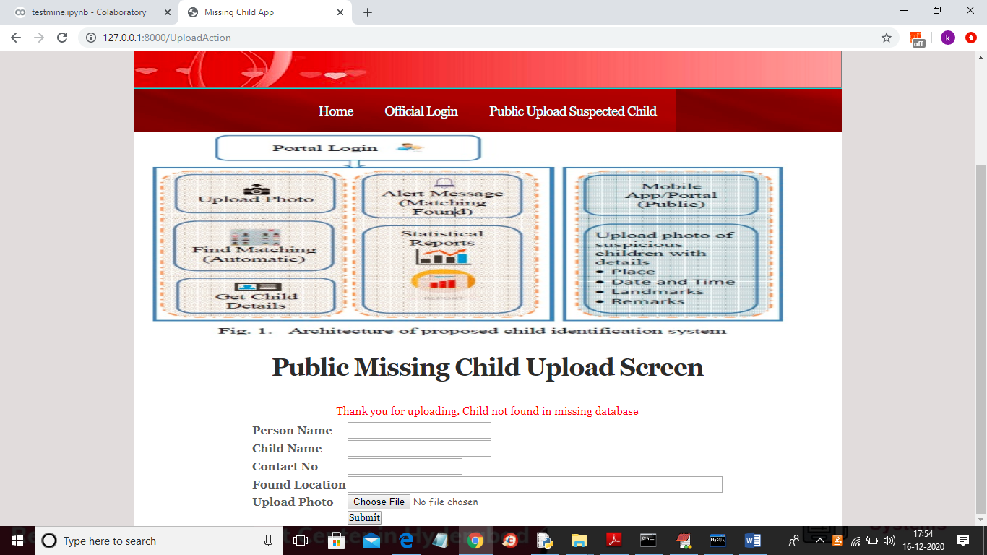

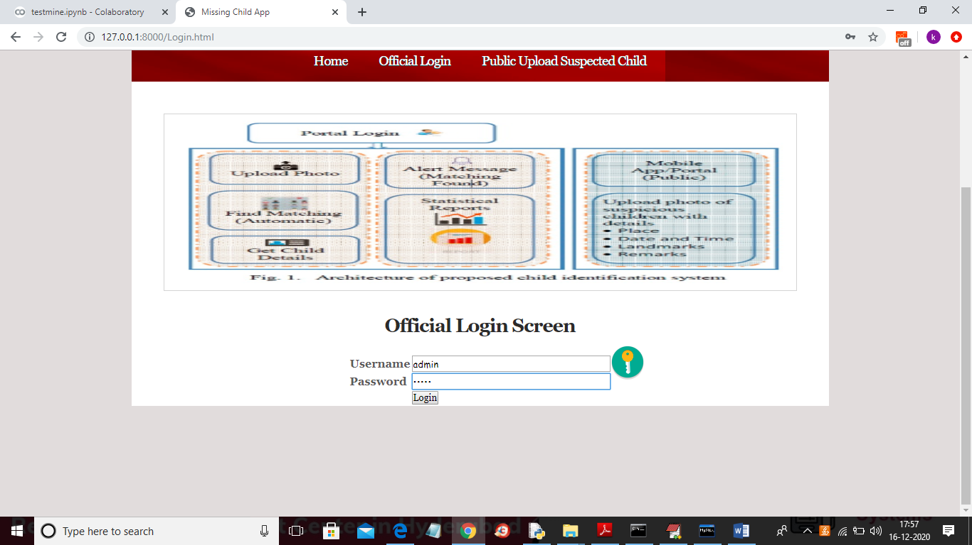

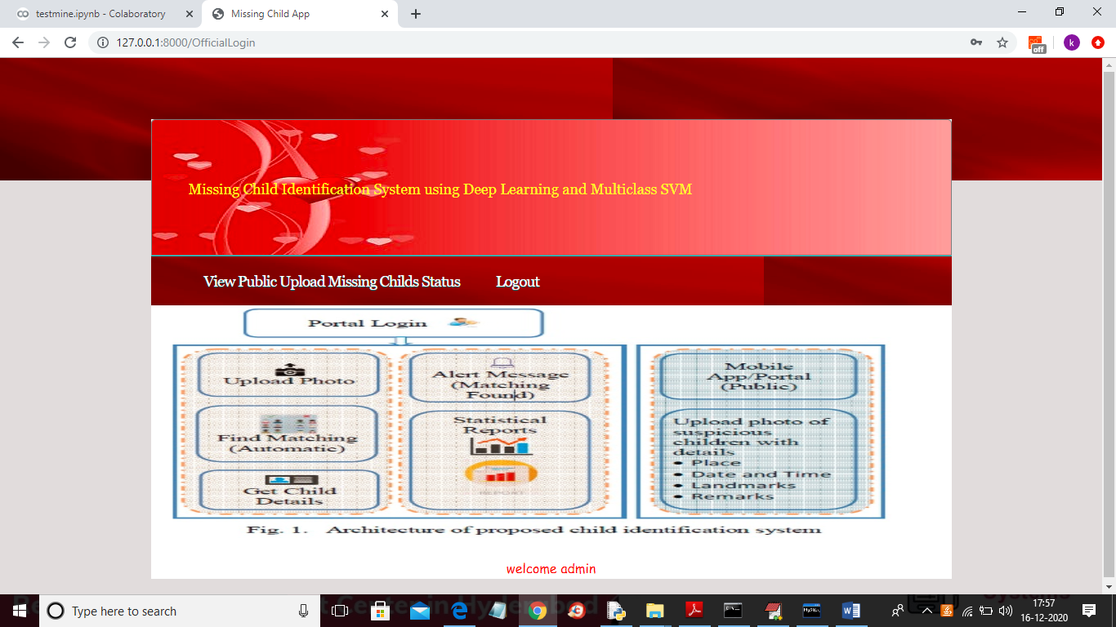

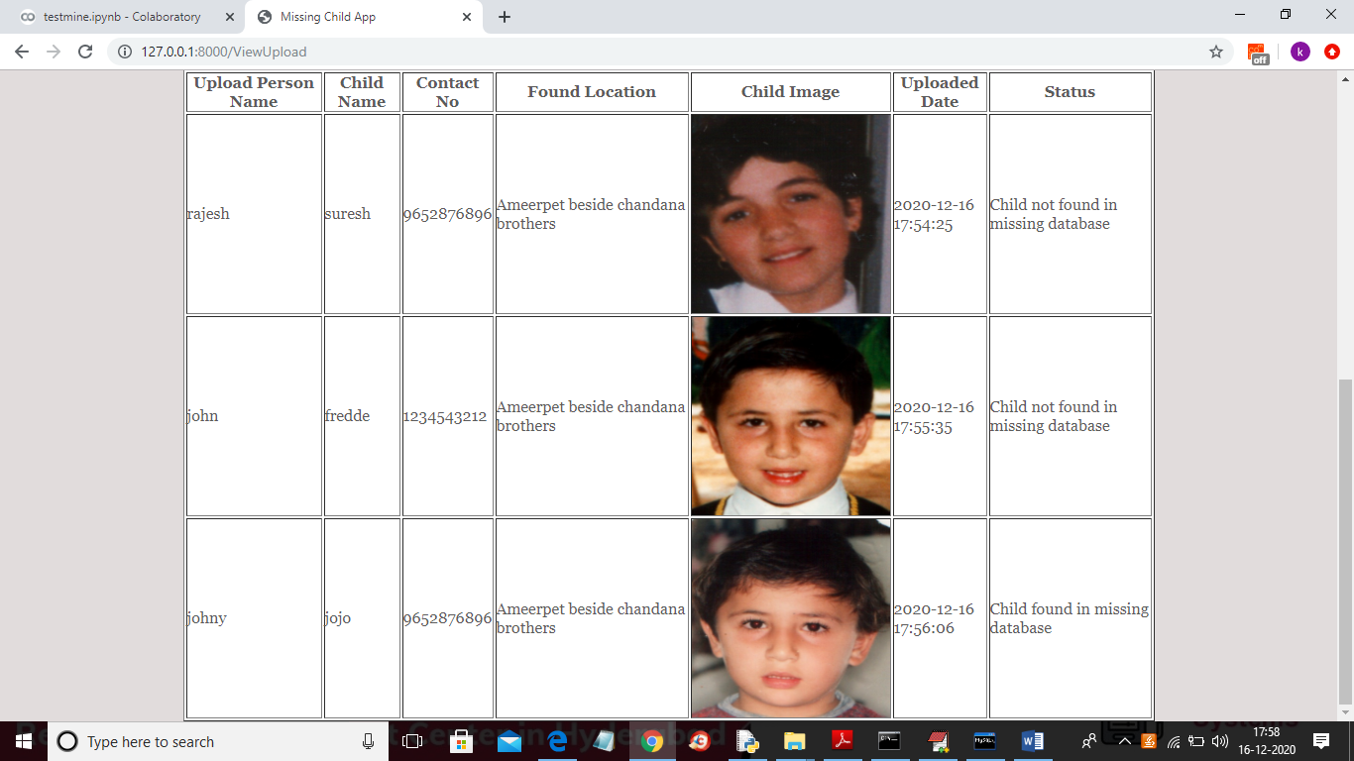

6.CONCLUSION :

A missing child identification system is proposed, which combines the powerful CNN based deep learning approach for feature extraction and support vector machine classifier for classification of different child categories. This system is evaluated with the deep learning model which is trained with feature representations of children faces. By discarding the softmax of the VGG-Face model and extracting CNN image features to train a multi class SVM, it will be possible to achieve superior performance. Performance of the proposed system is tested using the photographs of children with different lighting conditions, noises and also images at different ages of children.

REFERENCES

•Python Software Foundation. (n.d.). Tkinter – Python’s Standard GUI Toolkit. Retrieved from https://docs.python.org/3/library/tkinter.html
•Sustainable Development Goals. (n.d.). United Nations SDGs. Retrieved from https://sdgs.un.org/goals
•AI Writing Tools and Resources. (2023). Jasper AI, Copy.ai, Writesonic. Retrieved from respective product websites.

