**Topics: Descriptive Statistics and Probability**

1. Look at the data given below. Plot the data, find the outliers and find out $μ, σ, σ^{2}$

|  |  |
| --- | --- |
| **Name of company** | **Measure X** |
| Allied Signal | 24.23% |
| Bankers Trust | 25.53% |
| General Mills | 25.41% |
| ITT Industries | 24.14% |
| J.P.Morgan & Co. | 29.62% |
| Lehman Brothers | 28.25% |
| Marriott | 25.81% |
| MCI | 24.39% |
| Merrill Lynch | 40.26% |
| Microsoft | 32.95% |
| Morgan Stanley | 91.36% |
| Sun Microsystems | 25.99% |
| Travelers | 39.42% |
| US Airways | 26.71% |
| Warner-Lambert | 35.00% |

Ans)

Mean of given data is $μ=$ 0.332713.

Median for given data is 0.2671.

Standard Deviation is $σ$ = 0.163708.

Standard Deviation Square is $σ^{2 }$ = 0.0268.

Outliers is Morgan Stanley = 91.36%.

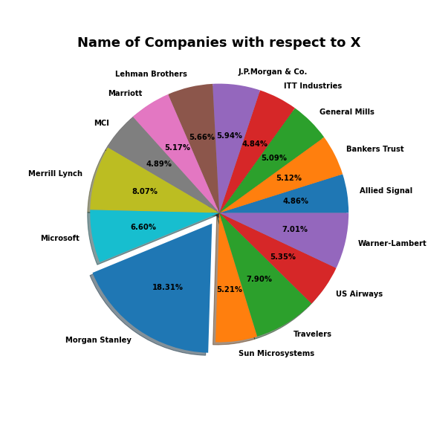



Answer the following three questions based on the box-plot above.

1. What is inter-quartile range of this dataset? (please approximate the numbers) In one line, explain what this value implies.

Ans:

Approximately (First Quantile Range) Q1 = 5

(Third Quantile Range) Q3 = 12,

Median (Second Quartile Range) = 7

(Inter-Quartile Range) IQR = Q3 – Q1 = 12 – 5 = 7

Second Quartile Range is the Median Value

1. What can we say about the skewness of this dataset?

Ans:

Right or Positively Skewed median is towards the left side it is not normal distribution

1. If it was found that the data point with the value 25 is actually 2.5, how would the new box-plot be affected?

Ans:

If the data point with the value 25 is actually 2.5 then the outlier which lies on the value 25 will be in the boxplot towards the lower extreme.



Answer the following three questions based on the histogram above.

1. Where would the mode of this dataset lie?

Ans: The mode of this data set lies in between 5 to 10 and approximately between 4 to 8

1. Comment on the skewness of the dataset.

Ans: Right-Skewed. Mean>Median>Mode

1. Suppose that the above histogram and the box-plot in question 2 are plotted for the same dataset. Explain how these graphs complement each other in providing information about any dataset.

Ans: The histogram shows whether the data is symmetric or not and the box will show the outlier and IQR of the given data. We can see median in boxplot and mode in histogram.

Histogram provides the frequency distribution so we can see how many times each data point is occurring however boxplot provides the quantile distribution i.e., 50% data lies between 5 and 12.

Boxplot provides whisker length to identify outliers, no information from histogram. We can only guess looking at the gap that 25 may be an outlier.

1. AT&T was running commercials in 1990 aimed at luring back customers who had switched to one of the other long-distance phone service providers. One such commercial shows a businessman trying to reach Phoenix and mistakenly getting Fiji, where a half-naked native on a beach responds incomprehensibly in Polynesian. When asked about this advertisement, AT&T admitted that the portrayed incident did not actually take place but added that this was an enactment of something that “could happen.” Suppose that one in 200 long-distance telephone calls is misdirected. What is the probability that at least one in five attempted telephone calls reaches the wrong number? (Assume independence of attempts.)

Ans:

If 1 in 200 long-distance telephone calls are getting misdirected.

Probability of call misdirecting = 1/200

Probability of call not Misdirecting = 1- 1/200 = 199/200

The probability for at least one in five attempted telephone calls reaches the wrong number of Calls = 5

n = 5

p = 1/200

q = 199/200

P(x) = at least one in five attempted telephone calls reaches the wrong number

= 1 - none of the call reaches the wrong number

= 1 - P (0)

= 1   - (1/200) (199/200) ^5

= 1 - (199/200) ^5

= 0.02475.

The probability that at least one in five attempted telephone calls reaches the wrong number 0.02475.

1. Returns on a certain business venture, to the nearest $1,000, are known to follow the following probability distribution

|  |  |
| --- | --- |
| x | P(x) |
| -2,000 | 0.1 |
| -1,000 | 0.1 |
| 0 | 0.2 |
| 1000 | 0.2 |
| 2000 | 0.3 |
| 3000 | 0.1 |

1. What is the most likely monetary outcome of the business venture?

Ans:

Max. P = 0.3 for P (2000). So, most likely outcome is 2000

1. Is the venture likely to be successful? Explain

Ans:

Yes, the probability that the venture will make more than 0 or a profit

p(x>0) +p(x>1000) +p(x>2000) +p(x=3000)

= 0.2+0.3+0.1

= 0.6 this states that there are a good 60% chances for this venture to be making a profit.

1. What is the long-term average earning of business ventures of this kind? Explain

Ans:

Weighted average = x*P(x) = 900. This means the average expected earnings over a long

period of time would be 900$

1. What is the good measure of the risk involved in a venture of this kind? Compute this measure

Ans:

P(loss) = P (x= -2000) +P(x=-1000) =0.2.

So, the risk associated with this venture is 20%.