Artificial Intelligence Engineering Handbook
A Practical Foundation for Building Real-World AI Systems
INFILTRIX
Version 2.0
Table of Contents

About This Handbook
INFILTRIX is an AI-first cybersecurity company building autonomous cyber defense systems, combining machine learning, deep learning, large language models, agentic AI, and explainable AI into next-generation security platforms. This handbook is one of our core educational resources: a self-contained introduction to AI engineering for engineers, researchers, and students who want to understand how modern AI systems are actually built, trained, evaluated, and operated in production — not just how they are described in theory.
Each chapter builds on the last, moving from foundational concepts through classical machine learning, deep learning, transformers and large language models, retrieval-augmented generation, autonomous agents, and the engineering discipline required to run all of it reliably at scale. Cybersecurity examples appear throughout because they are an unusually good testing ground for AI ideas — the data is adversarial, the costs of error are asymmetric, and the systems must work under real attack, not just on a benchmark.

Chapter 1 — AI Foundations
Artificial Intelligence has moved from research curiosity to core infrastructure. Recommendation engines, autonomous vehicles, medical diagnostics, and modern cybersecurity platforms all depend on systems that can analyze information, recognize patterns, make decisions, and improve as they see more data. This chapter lays out the vocabulary and mental models the rest of the handbook builds on: what AI, machine learning, and deep learning actually mean relative to each other, how AI systems are typically classified, and why these techniques matter specifically for security.

1.1 AI, Machine Learning, and Deep Learning
The three terms are often used interchangeably, but they describe nested fields, not synonyms.
Term | Definition
Artificial Intelligence (AI) | The broad field of building machines that perform tasks normally requiring human intelligence.
Machine Learning (ML) | A subset of AI in which systems learn patterns from data instead of following explicit, hand-written rules.
Deep Learning (DL) | A subset of ML that uses multi-layer neural networks to learn highly complex representations from large datasets.
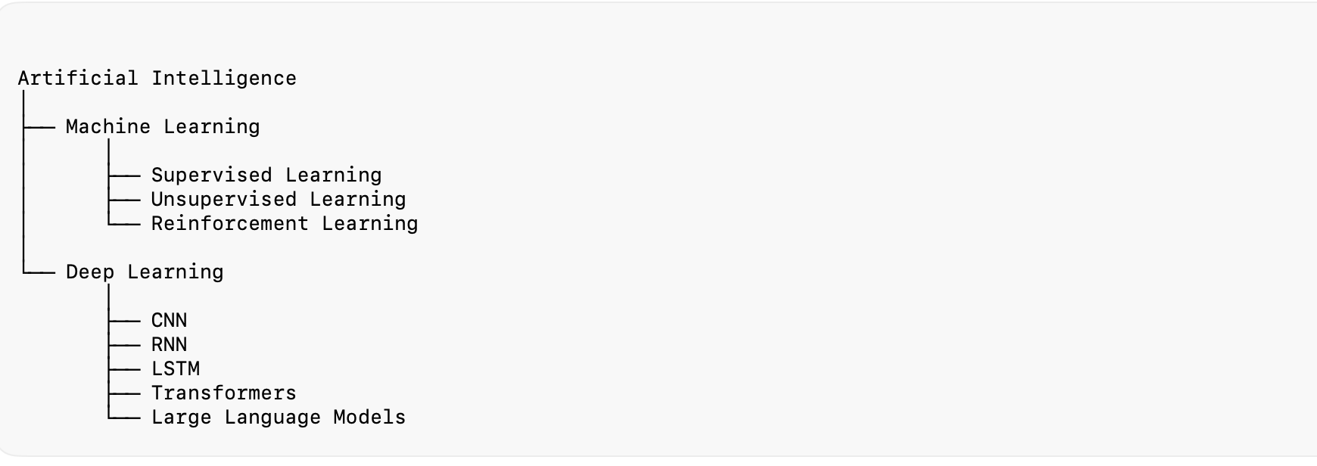
AI, ML, and DL as nested fields
Every deep learning system is a machine learning system, and every machine learning system is an AI system — but the reverse isn’t true. A rule-based expert system is AI without being ML; a decision tree is ML without being DL.

1.2 Types of AI, by Capability
- Artificial Narrow Intelligence (ANI) — systems designed to perform one task extremely well: spam filtering, face recognition, fraud detection, network intrusion detection. Virtually every deployed AI system today, including every AI component inside a cybersecurity platform, is Narrow AI.
- Artificial General Intelligence (AGI) — a hypothetical system capable of human-level reasoning across arbitrary domains. No such system currently exists.
- Artificial Super Intelligence (ASI) — a theoretical intelligence exceeding human capability across every field. Purely speculative at this point.

1.3 The Three Ways Machines Learn
Most AI systems fall into one of three learning paradigms, each covered in depth in Chapter 3:
- Supervised learning — the model learns from labeled examples (e.g., network traffic pre-labeled as Normal, DDoS, Malware, or Port Scan) and is judged on how well it labels new, unseen data.
- Unsupervised learning — the model receives no labels and instead discovers structure or anomalies on its own (e.g., flagging network behavior that has never been seen before).
- Reinforcement learning — an agent learns by acting in an environment and receiving rewards or penalties, gradually discovering the policy that maximizes long-term reward (e.g., an autonomous response agent learning which containment action works best against a given attack pattern).

1.4 Why AI Matters in Cybersecurity
Traditional, rule-based security tools rely on predefined signatures and thresholds. They are precise against known threats and blind to anything new. Modern attacks evolve too quickly, and in too many variations, for hand-written rules to keep up — nobody can enumerate every malware family, every phishing template, or every zero-day technique in advance.
AI changes the equation by learning from data rather than from fixed rules. That enables security systems to:
- Detect previously unseen attacks by recognizing similar underlying patterns, not exact signatures
- Identify subtle behavioral anomalies across users, devices, and network traffic
- Reduce false positives by learning what “normal” actually looks like for a given environment
- Process volumes of logs and telemetry no human team could review manually
- Prioritize the alerts most likely to represent real risk
- Support autonomous detection and response, escalating to a human only when needed
Infiltrix in Practice — Infiltrix’s platform embeds AI throughout the detection-to-response pipeline: intelligent intrusion detection, behavioral analysis, threat-intelligence correlation, adaptive risk scoring, retrieval-augmented reasoning over security knowledge, and agentic workflows for automated investigation. Every later chapter in this handbook maps to a real component of that pipeline.

1.5 A Brief History of AI’s Progress
AI has advanced in bursts rather than a straight line, and understanding that history clarifies why deep learning and LLMs represent such a significant break from what came before. Early AI research (1950s–1980s) centered on symbolic, rule-based systems — expert systems that encoded human knowledge as explicit logical rules. These systems worked well in narrow, well-defined domains but could not learn from data or handle the ambiguity of real-world input, and progress stalled during periods now known as “AI winters,” when funding and interest receded after inflated expectations went unmet.
The shift toward statistical machine learning in the 1990s and 2000s — the algorithms covered in Chapter 3 — replaced hand-coded rules with patterns learned from data, and delivered real, if modest, gains on structured problems: spam filtering, credit scoring, early recommendation systems. The deep learning breakthrough of the 2010s, catalyzed by larger datasets, GPU acceleration, and architectural advances like those in Chapter 4, then delivered a qualitative jump — first in image recognition and speech, later in language. The 2017 introduction of the Transformer architecture (Chapter 5) and the large language models built on it mark the most recent inflection point, and are the direct reason AI capability has expanded so quickly in the last several years.
Each of these transitions shares a pattern worth internalizing: the field advances when a new technique unlocks the ability to learn from more data, more efficiently, or with less manual engineering — not simply from having more computing power alone, though compute has been a necessary enabler of every recent leap. This handbook follows that same progression, chapter by chapter, from classical ML through deep learning to Transformers, RAG, and agents.

Key Takeaways
- AI, ML, and DL are nested, not interchangeable — DL ⊂ ML ⊂ AI.
- Nearly all deployed AI today is Narrow AI, built for one task.
- Supervised, unsupervised, and reinforcement learning solve different classes of problems and are often combined.
- AI is valuable in cybersecurity precisely because attacks are too varied and too fast-moving for static, rule-based systems to keep up.
- The field’s major advances have each come from learning more effectively from data — statistical ML, then deep learning, then Transformers — a progression this handbook follows chapter by chapter. # Chapter 2 — Data Engineering for AI
“Garbage in, garbage out.” No matter how advanced an algorithm is, poor-quality data produces poor-quality predictions. Data engineering — collecting, cleaning, structuring, and preparing data — is the foundation every model is built on, and it is where AI engineers spend most of their time.

2.1 Data, Information, and Datasets
Data is raw, unprocessed facts — an IP address, a byte count, a protocol name — with no inherent meaning on its own. Information is data with context: “this IP transferred 5,000 packets over HTTPS in one minute, well above its historical baseline” is information a human or a model can act on. AI systems learn by turning large volumes of data into statistical patterns that function as usable information.
A dataset is simply a structured collection of observations used to train and evaluate a model. Each row is one observation; each column is one feature (an input variable, such as source IP, packet size, or connection duration); and, in supervised settings, each row also carries a label — the correct answer the model is meant to learn, such as Benign, DDoS, or Port Scan.

2.2 Types of Data
Type | Description | Examples
Structured | Rows and columns, rigid schema | SQL tables, CSVs, NetFlow records
Unstructured | No predefined format | Images, audio, emails, threat reports — the domain of LLMs
Semi-structured | Tagged or key-value, no fixed table | JSON, XML, YAML, log files
Classical ML tends to work best on structured data; modern LLMs are built to work directly with unstructured text; and security platforms generate enormous volumes of semi-structured log data ({"ip":"192.168.1.25","attack":"DDoS","confidence":0.98}) that has to be parsed before either can use it.

2.3 Data Collection
The goal of data collection isn’t to gather the largest dataset possible — it’s to gather one that is representative, balanced, and reliable. A model trained only on benign traffic will never learn to recognize an attack, no matter how much benign traffic it sees.
Common sources include databases, APIs, IoT sensors, system logs, documents, and network traffic. In cybersecurity specifically: firewall logs, IDS/IPS alerts, authentication logs, DNS logs, endpoint telemetry, cloud audit logs, SIEM logs, and threat intelligence feeds. No single source tells the whole story — modern platforms correlate several of them to build a coherent picture of what’s actually happening on a network.

2.4 Data Quality
An AI system has no way to know whether the data it’s learning from is correct — it simply learns whatever patterns are present, errors included. High-quality training data should be accurate, complete, consistent, relevant, current, and representative of real-world conditions. The most common problems an engineer will encounter, and how they’re typically handled:
Problem | What it looks like | Typical fix
Missing values | Sensor dropouts, incomplete records | Remove, impute statistically, or predict via a model
Duplicates | Identical rows from repeated logging | Deduplicate unless the repetition is itself meaningful
Incorrect data | Negative packet counts, invalid IPs, impossible timestamps | Validate and correct or discard
Inconsistent formatting | TCP, tcp, Tcp treated as different categories | Normalize before training
Class imbalance | 990,000 benign events vs. 10,000 malware events | Oversampling, undersampling, SMOTE, class weighting, or reframe as anomaly detection
Class imbalance deserves special attention in security contexts: a model trained on a 99%-benign dataset can achieve 99% accuracy by predicting “benign” every time — and still miss every single attack. This is the core reason Chapter 3 spends real time on metrics beyond accuracy.
Engineering Insight — A well-prepared dataset routinely improves model performance more than switching algorithms does. Experienced AI engineers spend a disproportionate share of project time on data, not modeling.

2.5 From Raw Data to Model-Ready Data
A typical preprocessing pipeline moves through several stages, each of which corrects a specific problem raw data has:
Cleaning — deduplicating, correcting invalid values, standardizing formats (folding DDoS/ddos/DDOS into one category the model doesn’t have to relearn as three).
Feature engineering — deriving new, more informative variables from raw ones. Duration, Bytes Sent, and Bytes Received on their own are less useful than derived features like bytes per second, upload/download ratio, failed-login rate, or DNS query entropy — the kind of behavioral signal Infiltrix builds into features like Device Risk Score and Login Anomaly Score, rather than relying on raw event counts alone.
Feature selection — dropping features that are redundant, irrelevant, or noisy. Fewer, better features generally train faster, generalize better, and are easier to interpret than throwing every available column at the model.
Encoding — converting categorical values (TCP, UDP, ICMP) into numbers the model can use. Label encoding (TCP→0, UDP→1, ICMP→2) is compact but implies an ordering that may not exist; one-hot encoding avoids that by giving each category its own binary column, at the cost of more columns.
Scaling — bringing features with very different ranges (a packet size of 1500 vs. a duration of 2) onto comparable scales, so no single feature dominates training by magnitude alone. Normalization rescales to a fixed range (typically 0–1); standardization rescales to mean 0 and standard deviation 1. Neural networks and distance-based algorithms are particularly sensitive to unscaled inputs.
Splitting — dividing the dataset so the model is never evaluated on data it trained on. A common split is 70% training / 15% validation (for tuning) / 15% test (untouched until final evaluation, to give an unbiased read on real-world performance).
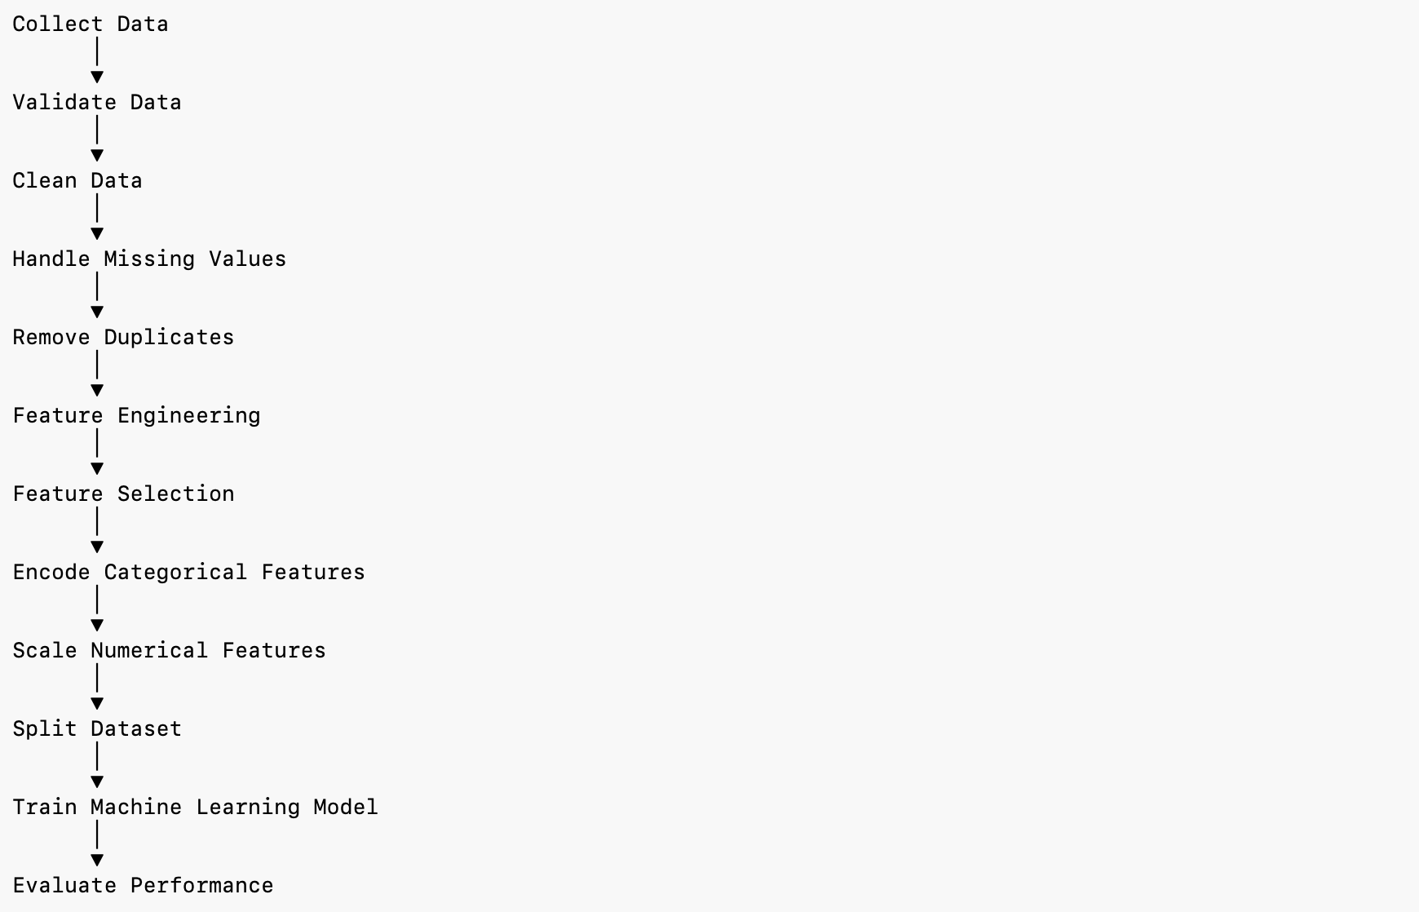
The complete data pipeline, from raw data to a model-ready dataset

Chapter Summary
Data quality and preparation — not algorithm choice — determine most of an AI system’s real-world performance. Every project should move data through the same disciplined pipeline: collect representatively, clean rigorously, engineer meaningful features, encode and scale appropriately, and hold out a genuine test set. Chapter 3 picks up from here: once data is model-ready, which algorithm should actually learn from it? # Chapter 3 — Machine Learning
“Machine learning is the science of enabling computers to learn patterns from data instead of having every rule explicitly programmed.”

3.1 What Is Machine Learning?
Traditional software executes rules a developer wrote in advance: IF login_attempts > 5 THEN block_user. The program cannot improve unless a person rewrites the code. Machine learning inverts this: instead of writing the rule, an engineer provides examples, and the algorithm infers the rule itself.
Consider phishing detection. A rules-based approach might flag emails containing “Congratulations” or “Free Money” — rules that work only until attackers change their wording. A machine learning approach instead trains on hundreds of thousands of labeled phishing and legitimate emails, and the model learns writing patterns, word frequencies, sender characteristics, and URL structures on its own — including combinations no engineer would have thought to hand-code.
This matters most exactly where rules break down: nobody can enumerate every malware family, every phishing template, or every zero-day technique in advance. ML instead learns the statistical signature of “malicious” from historical examples and generalizes to variations it has never seen.
Training vs. inference. Every ML system has two phases. During training, the model studies historical data and learns the relationship between features and outcomes — a process usually done periodically as new data arrives. During inference (or prediction), the trained model is applied to new, unseen data — in a platform like Infiltrix, this happens continuously against live telemetry to support near-real-time detection.
The four building blocks of any ML system are data (raw information — logs, packets, images), features (the measurable inputs derived from it), an algorithm (the learning method — Decision Tree, XGBoost, Logistic Regression, etc.), and the model (the trained artifact that results, ready to make predictions). ML already runs quietly behind Netflix recommendations, Gmail’s spam filter, bank fraud detection, and — the domain of this handbook — cybersecurity threat detection; the underlying process is the same in every case: learn from historical examples, apply the pattern to new data.

3.2 The Three Learning Paradigms
Supervised learning trains on labeled data — every example includes both the input and the correct answer, so the model can be scored directly against ground truth and improved through repeated exposure. It splits into classification (predicting a category — Benign/Malicious, Spam/Not Spam, attack family) and regression (predicting a continuous number — bandwidth usage, price, temperature). It is the most widely used paradigm because labeled data, where available, gives the clearest evaluation signal — but labeling is often expensive, and performance depends heavily on how representative the labels are.
Unsupervised learning works with unlabeled data and asks not “what’s the correct answer?” but “what structure exists here?” Its two major tasks are clustering (grouping similar observations — via K-Means, DBSCAN, hierarchical clustering) and anomaly detection (flagging observations that don’t fit the learned baseline — via Isolation Forest, One-Class SVM, autoencoders). This is what lets a security platform flag a device suddenly talking to unfamiliar external servers at unusual times, even though that exact attack pattern was never labeled as an example during training. The trade-off is that results are harder to validate — there’s no ground truth to score against.
Reinforcement learning trains an agent that takes actions in an environment and receives a reward or penalty for each one, gradually learning a policy — the strategy that maximizes long-term reward — through repeated interaction rather than from static examples. An autonomous response agent deciding whether to block an IP, isolate a device, or escalate to a human analyst is a natural RL formulation, though RL remains less common in production enterprise security systems today because it requires many interactions to converge and reward design is genuinely difficult to get right.
 | Supervised | Unsupervised | Reinforcement
Needs labels? | Yes | No | No
Learns from | Correct answers | Hidden structure | Rewards & penalties
Typical task | Classification, regression | Clustering, anomaly detection | Sequential decision-making
Security example | Phishing email classifier | Novel-behavior detection | Autonomous containment policy
Modern AI systems frequently combine all three — a supervised classifier for known attack types, an unsupervised layer for novel behavior, and (increasingly) reinforcement learning for autonomous response policy.

3.3 The Machine Learning Workflow
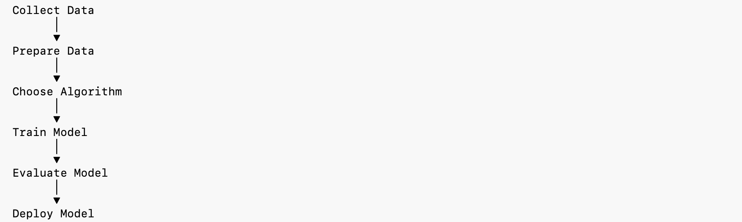
The core machine learning workflow
Building a model is an iterative engineering process, not a single step. The ten stages below apply to almost any ML project, whether predicting stock prices or detecting intrusions:
- Problem definition — “We want to use AI” is not a goal. “Classify network traffic as Benign or Malicious with ≥95% precision” is. A precise problem statement determines every downstream decision about data, algorithm, and metrics.
- Data collection — gather data that represents real-world conditions with enough diversity to generalize (see Chapter 2).
- Preprocessing — clean, deduplicate, encode, scale, split (see Chapter 2).
- Feature engineering — derive higher-signal inputs; e.g., packets ÷ duration as packets-per-second often outperforms either raw value.
- Algorithm selection — depends on problem type, dataset size, need for explainability, latency budget, and accuracy target. There is no universally best algorithm.
- Model training — the algorithm compares its predictions to the labels, computes error, and adjusts its internal parameters, repeating until performance stabilizes.
- Evaluation — always on data the model has never seen (Section 3.4 covers this in depth).
- Hyperparameter tuning — adjusting settings chosen before training (tree count, learning rate, max depth) via grid search, random search, or Bayesian optimization.
- Deployment — the model starts making predictions on live data: filtering incoming email, scoring transactions, classifying traffic in a SOC.
- Monitoring & retraining — as attacker techniques, user behavior, and traffic patterns evolve, model performance degrades (model drift). Production systems need continuous monitoring and periodic retraining to stay accurate — deployment is the midpoint of the lifecycle, not the end.
Infiltrix in Practice — ML in the Infiltrix platform doesn’t operate as an isolated step; its output (a risk score, a classification, an anomaly flag) becomes an input to downstream RAG retrieval and agentic workflows described in Chapters 6 and 7.

3.4 Evaluating a Model: Beyond Accuracy
Training a model is only half the job — the next question is whether it’s actually good. In security specifically, relying on accuracy alone is dangerous: imagine a network where 99,000 of 100,000 connections are legitimate and 1,000 are malicious. A model that predicts “legitimate” for every single connection scores 99% accuracy while catching zero attacks. High accuracy is not the same as a good model.
The confusion matrix. Nearly every classification metric is derived from four counts, computed by comparing predictions against ground truth:
 | Predicted Positive | Predicted Negative
Actual Positive | True Positive (TP) — attack correctly caught | False Negative (FN) — attack missed
Actual Negative | False Positive (FP) — false alarm | True Negative (TN) — benign correctly cleared
In security, a false negative (a missed attack) is typically the most consequential error; a false positive (a false alarm) is costly mainly in analyst time.
Using a worked example of 1,000 connections with TP=180, FP=20, FN=10, TN=790:
- Accuracy = (TP+TN)/(TP+TN+FP+FN) = 970/1000 = 97% — overall correctness; misleading on imbalanced data.
- Precision = TP/(TP+FP) = 180/200 = 90% — of everything flagged as an attack, how much really was one. High precision means analysts waste less time on false alarms.
- Recall = TP/(TP+FN) = 180/190 = 94.7% — of everything that was actually an attack, how much got caught. High recall means fewer attacks slip through.
- F1-Score = 2·(Precision·Recall)/(Precision+Recall) — a single number balancing both, most useful when classes are imbalanced and both error types matter.
Precision and recall trade off against each other, and the right balance is application-specific. In cybersecurity, missing an attack is usually costlier than investigating a false alarm, so many detection systems are deliberately tuned to favor recall, accepting somewhat lower precision (and the analyst workload that comes with it) as the price of catching more real threats.
Scenario | Metric to prioritize
Spam filtering | Precision
Cancer / disease detection | Recall
Fraud detection | Recall + F1
Intrusion / malware detection | Recall + F1
Recommendation systems | Precision
Infiltrix Perspective — Production evaluation goes beyond a single metric. Infiltrix weighs recall (catch real threats), precision (limit analyst fatigue), F1 (balance both), inference latency (fast enough for near-real-time response), and resource efficiency (scales across enterprise environments) together — a slightly less accurate model with low latency is often more valuable in production than a marginally more accurate one that’s too slow or too expensive to run at scale.

Section Takeaways
- ML replaces hand-written rules with patterns learned from data — most valuable exactly where rules can’t keep up.
- Supervised, unsupervised, and reinforcement learning solve different problems and are often combined.
- The ML workflow is a ten-stage engineering discipline, not a single modeling step; deployment is the midpoint, not the end.
- Accuracy alone is insufficient, especially on imbalanced data; precision, recall, and F1 — evaluated together — give a much more honest picture of real-world performance. ## 3.5 Machine Learning Algorithms
No single algorithm performs best in every situation — the right choice depends on the problem type, dataset size, need for interpretability, and computational budget. Choosing well is one of the most important skills an AI engineer develops. The algorithms below are grouped by task and treated at a consistent depth: what it is, how it works, its trade-offs, and where it fits in a security pipeline.

3.5.1 Regression & Classification Baselines
Linear Regression predicts continuous numerical values by fitting the best straight line (or hyperplane, with multiple features) through the data — e.g., estimating expected network bandwidth from historical traffic trends. It’s fast, highly interpretable, and an excellent baseline, but it assumes a linear relationship and is sensitive to outliers, so it fails on genuinely nonlinear patterns. In Infiltrix, it’s used for operational forecasting (traffic volume, storage growth) rather than threat classification, since threats are rarely linearly separable.
Logistic Regression, despite its name, is a classification algorithm — it uses a sigmoid function to convert a weighted combination of inputs into a probability between 0 and 1 (e.g., probability of attack = 0.92 → classify as Attack), compared against a decision threshold (default 0.5, though security systems often lower it to favor recall). It handles binary problems (Attack/Benign), multinomial ones (DDoS/Port Scan/SQL Injection/Malware), and ordinal ones (Low/Medium/High Risk). It’s simple, fast, and interpretable, and a common lightweight baseline classifier — but it assumes a linear decision boundary and underperforms ensemble methods on large, complex datasets.

3.5.2 Tree-Based Methods
Decision Trees split data repeatedly on feature thresholds (e.g., “packets > 5000?”) until reaching a decision — structurally similar to a flowchart, and about as easy to read and explain to a non-technical stakeholder. That interpretability is the main draw; the main risk is overfitting to training data on deep, unconstrained trees. Useful wherever explainability matters, such as producing an audit trail for why traffic was flagged.
Random Forest trains many decision trees on random subsets of data and features, then combines their votes — an ensemble that is dramatically more robust to overfitting and noise than any single tree, at the cost of interpretability and higher compute. It’s a strong general-purpose default for structured tabular data and is widely used in Infiltrix for traffic classification and risk scoring where a single tree would be too brittle.
XGBoost and LightGBM are gradient-boosted tree ensembles: rather than training trees independently (as Random Forest does), each new tree is trained specifically to correct the errors of the ones before it. Both are exceptionally strong on structured, tabular security data and dominate many ML competition leaderboards; LightGBM’s leaf-wise, histogram-based growth makes it faster and more memory-efficient on very large datasets, while XGBoost tends to be slightly more robust on smaller ones. Both require more careful hyperparameter tuning than a Random Forest and are more prone to overfitting if left unconstrained.
 | Random Forest | XGBoost / LightGBM
Tree training | Independent, parallel | Sequential, error-correcting
Typical accuracy | Strong | Usually higher
Tuning difficulty | Low | Higher
Best for | Robust general baseline | Maximum accuracy on tabular data

3.5.3 Distance & Margin-Based Methods
Support Vector Machines (SVM) find the decision boundary (hyperplane) that maximizes the margin between classes, using the closest points (support vectors) to define it. With a kernel trick, SVMs can also model nonlinear boundaries by implicitly projecting data into higher dimensions. They perform well on small-to-medium, high-dimensional datasets (e.g., malware classification from binary feature vectors) but scale poorly to very large datasets and require careful kernel/parameter selection.
K-Nearest Neighbors (KNN) classifies a new point by majority vote among its k closest training examples — there is no real “training” phase, just distance computation at inference time. Small k values are sensitive to noise; large k values smooth over meaningful local structure. KNN is simple and requires no training, but inference gets slow at scale and it is highly sensitive to unscaled features, so scaling (Section 2.5) is mandatory.
Naive Bayes applies Bayes’ theorem with a “naive” (and usually false) assumption that features are independent of each other — an assumption that works surprisingly well in practice, particularly for text classification. Gaussian, Multinomial, and Bernoulli variants handle continuous, count-based, and binary features respectively. It’s extremely fast, needs comparatively little training data, and remains a strong baseline for spam and phishing filtering, though it underperforms on datasets where features are genuinely correlated.

3.5.4 Unsupervised Methods
K-Means Clustering partitions data into k groups by iteratively assigning points to the nearest cluster center and recalculating centers until they stabilize — useful for device grouping or malware-family clustering when no labels exist. Choosing k requires judgment (commonly via the “elbow method”), and K-Means assumes roughly spherical, similarly-sized clusters, which real security data doesn’t always provide.
Principal Component Analysis (PCA) reduces a large number of correlated features down to a smaller set of uncorrelated principal components that preserve most of the original variance — useful for visualization, noise reduction, and speeding up downstream training. It trades some interpretability (components are combinations of original features, not the features themselves) for major dimensionality reduction.
Isolation Forest detects anomalies by randomly partitioning data and measuring how few splits it takes to isolate a point — outliers, being different, isolate faster than normal points. It scales well to high-dimensional data and needs no labels, which makes it a natural fit for zero-day and insider-threat detection where labeled examples of “the next attack” don’t exist yet by definition.
Algorithm | Type | Best For | Key Limitation
Linear Regression | Supervised (regression) | Numeric forecasting, simple baselines | Assumes linearity
Logistic Regression | Supervised (classification) | Fast, interpretable baseline classifier | Linear decision boundary only
Decision Tree | Supervised (classification) | Explainable single-tree decisions | Overfits if unconstrained
Random Forest | Supervised (classification) | Robust general-purpose tabular model | Less interpretable than one tree
XGBoost / LightGBM | Supervised (classification) | Maximum accuracy on tabular data | Needs careful tuning
SVM | Supervised (classification) | High-dimensional, smaller datasets | Scales poorly to huge datasets
KNN | Supervised (classification) | Simple, no-training baseline | Slow at inference, scale-sensitive
Naive Bayes | Supervised (classification) | Text/spam classification | Independence assumption often false
K-Means | Unsupervised (clustering) | Grouping unlabeled observations | Requires choosing k upfront
PCA | Unsupervised (reduction) | Compressing correlated features | Components aren’t directly interpretable
Isolation Forest | Unsupervised (anomaly detection) | Zero-day / novel threat detection | No ground-truth validation

Chapter Summary
Machine learning replaces hand-coded rules with patterns learned from labeled or unlabeled data, following a disciplined ten-stage workflow from problem definition through monitoring and retraining. Evaluation must go beyond raw accuracy — precision, recall, and F1 together give a far more honest read on real-world performance, especially on the imbalanced data typical of security problems. No algorithm from the catalog above is universally “best”; tree-based ensembles (Random Forest, XGBoost, LightGBM) dominate most structured tabular security problems, while unsupervised methods like Isolation Forest fill the gap where labels for “the next new attack” simply don’t exist yet. The next chapter turns to deep learning — the family of techniques that scales this same learn-from-data philosophy to unstructured data like images, audio, and language. # Chapter 4 — Deep Learning

4.1 Why Deep Learning?
Classical machine learning algorithms — Decision Trees, Random Forest, SVMs, Logistic Regression — perform well on structured data, but they depend on manually engineered features. Detecting malware with a classical model, for instance, requires an engineer to hand-select measurable characteristics: file size, number of imported functions, API call patterns, entropy. The model only ever learns from what a human already decided was relevant.
Deep Learning removes that bottleneck. Inspired loosely by the brain’s layered structure, it stacks many simple computational layers — Artificial Neural Networks (ANNs) — so that each layer learns increasingly abstract representations directly from raw data, without a human pre-selecting features. This is what makes deep learning the technology behind image recognition, speech recognition, autonomous vehicles, and every modern large language model.
 | Machine Learning | Deep Learning
Features | Manually engineered | Learned automatically
Best for | Structured, tabular data | Structured and unstructured data (images, audio, text)
Data needs | Works with smaller datasets | Typically needs large datasets
Compute | Lower (CPU often sufficient) | Higher (GPU/TPU commonly required)
Interpretability | Generally easier | Often a “black box”
Deep learning now underpins medical imaging, fraud detection, predictive maintenance, autonomous driving, machine translation — and, in security specifically, malware classification from raw binaries, intrusion detection from network telemetry, behavioral anomaly detection, and zero-day pattern recognition, where hand-engineering every relevant feature simply isn’t feasible. The trade-off is real: deep learning needs more data, more compute, longer training time, and is harder to interpret and tune than classical ML — which is exactly why Chapter 3’s classical toolkit remains the right default for many structured, well-understood problems, and deep learning earns its cost primarily on unstructured or extremely complex data.

4.2 The Artificial Neuron and Network Structure
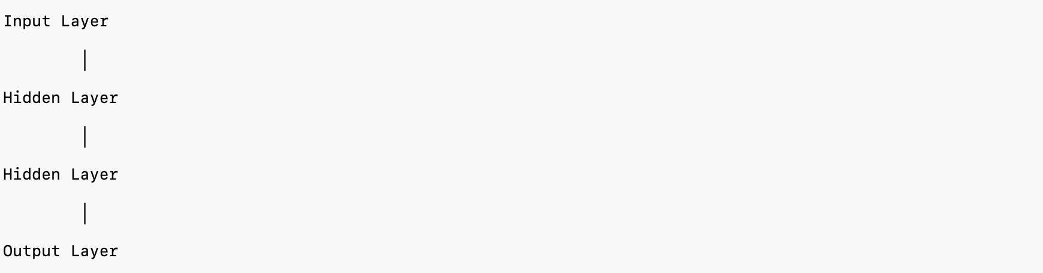
Structure of a neural network: input, hidden, and output layers
A neural network is built from neurons arranged in layers: an input layer that receives raw features (packet statistics, image pixels, login attempts) with no computation of its own; one or more hidden layers that do the actual learning, each extracting increasingly abstract patterns from the layer before it (in malware detection, an early layer might pick up on file size and entropy, a middle layer on suspicious API sequences, a deep layer on malware-family-level characteristics); and an output layer producing the final prediction — a binary class (Benign/Attack), a multi-class distribution (Benign/Malware/DDoS/Ransomware), or a continuous value (predicted CPU usage).
Each neuron performs the same simple computation: it takes its inputs, multiplies each by a learned weight (representing how much that input matters), adds a bias (which lets the model shift its decision boundary rather than being forced through the origin), sums the result, and passes that sum through an activation function. Training a neural network is, mechanically, the process of finding the weight and bias values that make its predictions accurate.
Activation functions matter enormously. Without one, stacking any number of layers is mathematically equivalent to a single linear model — activation functions are what introduce the non-linearity that lets deep networks learn genuinely complex relationships.
Function | Output range | Typical use | Key trade-off
Sigmoid | 0 to 1 | Binary classification, probabilities | Vanishing gradients, slow convergence
Tanh | −1 to 1 | Legacy hidden layers, sequence models | Zero-centered, but still vanishing-gradient prone
ReLU | 0 to ∞ | Default for most hidden layers | Fast and effective, but can “die” (stuck outputting zero)
Leaky ReLU | small negative to ∞ | Deep networks where dying ReLU is a concern | Small negative slope keeps gradients flowing
Softmax | Probabilities summing to 1 | Multi-class output layers | Only meaningful as an output-layer function
ReLU is the default choice for hidden layers precisely because it’s cheap to compute and largely avoids vanishing gradients; Softmax is reserved for multi-class output layers, converting raw scores into a probability distribution — e.g., Attack 0.82 / Benign 0.10 / Port Scan 0.05 / Malware 0.03 — from which the highest probability becomes the prediction.

4.3 Forward Propagation, Loss, and Backpropagation
Forward propagation is how a trained (or untrained) network turns an input into a prediction: data enters the input layer, each hidden layer applies its weights/bias/activation in sequence, and the output layer produces the final result. In a phishing detector, for example, sender reputation, URL reputation, suspicious keyword count, and attachment type flow forward through the network until it outputs Phishing probability = 0.98.
Early in training, that output is usually wrong — the network started with random weights. A loss function quantifies exactly how wrong, by comparing the prediction to the true label. The choice of loss depends on the task:
- Mean Squared Error (MSE) — for regression (price prediction, traffic forecasting)
- Binary Cross-Entropy — for binary classification (malware vs. benign, phishing vs. legitimate)
- Categorical Cross-Entropy — for multi-class classification (malware family, attack type)
Training’s entire objective is to minimize this loss. Backpropagation is the algorithm that makes that possible at scale: starting from the known error at the output layer, it works backward through the network (hence the name), using calculus’s chain rule to compute exactly how much each individual weight — of the millions or billions a modern network may contain — contributed to that error. Gradient descent then uses those computed gradients to update every weight in the direction that reduces the loss, repeating the forward-pass → loss → backward-pass → update cycle until performance stabilizes. Together, backpropagation and gradient descent are the mechanism that turns an untrained network of random weights into an accurate model.
The size of each weight update is controlled by the learning rate — arguably the single most important hyperparameter in deep learning. Too small, and training crawls, taking far longer than necessary to converge; too large, and the model overshoots the minimum loss and may never stabilize; well-tuned, it converges efficiently. In practice, weights are updated not on the whole dataset at once (batch gradient descent — stable but slow and memory-heavy) or one sample at a time (stochastic gradient descent — fast but noisy), but on small groups of examples at a time — mini-batch gradient descent, using batch sizes like 32, 64, or 128 — which is the default in virtually every modern framework because it balances training speed, memory use, and stable convergence.

4.4 Optimizers
Gradient descent defines the general strategy for reducing loss; optimizers are the specific algorithms that make this process faster and more stable in practice.
- SGD — the baseline: fast, memory-light, but noisy and prone to oscillation.
- Momentum — carries the direction of previous updates forward (like a ball rolling downhill gaining speed), smoothing out oscillations and accelerating convergence.
- RMSProp — adapts the learning rate per-parameter based on recent gradient magnitude, giving frequently-updated parameters smaller steps and rarely-updated ones larger steps; particularly effective for recurrent networks.
- Adam — combines Momentum’s directional memory with RMSProp’s adaptive per-parameter rates, and is the default optimizer in most modern deep learning frameworks because it converges quickly, requires minimal manual tuning, and performs well across a wide range of problems — at the cost of somewhat higher memory use than plain SGD.
Optimizer | Speed | Adaptive rate? | Typical use
SGD | Moderate | No | Simple baselines, very large datasets
Momentum | Faster | No | Reduces oscillation vs. plain SGD
RMSProp | Fast | Yes | Recurrent networks, non-stationary problems
Adam | Fast | Yes | Default choice for most modern architectures
Infiltrix in Practice — Every deep-learning-based model in the platform — malware classifiers, behavioral anomaly detectors, threat-attribution networks — is trained through exactly this loop: forward propagation to predict, a loss function to measure error, backpropagation to assign blame, and an optimizer (almost always Adam) to update weights. Retraining on new telemetry or fresh threat intelligence uses the identical mechanism. ## 4.5 Epochs, Batch Size, and Regularization
Three terms describe the training cycle’s rhythm. An epoch is one complete pass through the entire training dataset — models typically train for 10 to 100 epochs, since a single pass is rarely enough to learn meaningful patterns. A batch is a subset of the data processed together before a weight update (commonly 16–256 samples). An iteration is one such update. With a 12,000-sample dataset, a batch size of 200, and 20 epochs: 12,000 ÷ 200 = 60 iterations per epoch, and 60 × 20 = 1,200 total weight updates over the full training run.
Smaller batches use less memory, generalize slightly better, and can escape shallow local minima, but train more slowly with noisier updates; larger batches compute faster on a GPU with more stable gradients, but need more memory and can generalize somewhat worse. Too few epochs leaves the model underfit (high error on both training and test data); too many lets it overfit — memorizing training examples rather than learning generalizable patterns, which shows up as excellent training accuracy alongside poor test accuracy.
Regularization is the collection of techniques used to close that gap between training and test performance:
Technique | What it does | Where it’s used
L1 regularization | Penalizes the absolute size of weights, pushing many to exactly zero | Automatic feature selection, sparse models
L2 regularization (weight decay) | Penalizes large weights without zeroing them out | Nearly every deep learning model
Dropout | Randomly disables a fraction of neurons on each training pass | Hidden layers, especially in large networks
Early stopping | Halts training once validation performance stops improving | Universal — the simplest overfitting guard
Batch normalization | Normalizes each layer’s outputs to a stable range | Standard in almost every modern architecture
Data augmentation | Creates modified copies of training examples (rotations/crops for images; simulated attack traffic or log perturbation for security data) | Computer vision, cybersecurity
A representative example: a malware classifier trained on 20,000 samples with no regularization might hit 99.8% training accuracy but only 84% on held-out test data — a clear overfitting signature. Adding dropout, early stopping, and L2 regularization together typically narrows that gap substantially (e.g., 96% training / 94% test) — worse on paper, but a genuinely more useful model, since the real test is unseen attack traffic, not the training set.

4.6 Frameworks and Hardware
Building a neural network from scratch — implementing matrix multiplication, automatic differentiation, and gradient computation by hand — is possible but impractical. Deep learning frameworks handle this automatically and add GPU acceleration, distributed training, and deployment tooling on top.
- TensorFlow (Google) — scales well to production, has mature deployment tooling (TensorFlow Serving) and strong mobile/edge support, at the cost of a steeper, more verbose learning curve. Common in large-scale enterprise AI, healthcare AI, and autonomous systems.
- PyTorch (Meta) — the dominant framework for research and modern development, thanks to a Pythonic, dynamic-graph programming model that’s markedly easier to debug. Most current LLMs and cutting-edge research are implemented in PyTorch, and its production tooling has largely caught up to TensorFlow’s in recent years.
- Keras — a high-level API (running primarily on TensorFlow) that trades flexibility for simplicity, making it a strong choice for education and rapid prototyping rather than highly customized architectures.
Hardware matters just as much as the framework. CPUs handle general-purpose computation well but are too slow for large-scale neural network training. GPUs parallelize the matrix operations that make up most of deep learning’s compute cost, and are the default choice for both training and (increasingly) inference — NVIDIA’s CUDA platform underlies most GPU-accelerated deep learning today. TPUs (Google’s custom accelerator) push this further for very large-scale training, at the cost of being tied to Google’s cloud ecosystem. In production, training typically runs on powerful multi-GPU or TPU clusters, while inference — the ongoing, latency-sensitive job of scoring live data — often runs on smaller, cost-optimized hardware, since a production system needs to serve predictions continuously rather than train once.
Infiltrix in Practice — Framework and hardware choice directly shapes what’s operationally possible: a model good enough on paper is only useful if it can score live network telemetry within the latency budget a SOC actually needs, which is why inference efficiency gets weighed alongside raw accuracy when choosing an architecture.

Section Takeaways
- Deep learning trades classical ML’s hand-engineered features for automatically learned representations, at the cost of more data, more compute, and less interpretability.
- Every neuron computes a weighted sum plus bias, passed through a non-linear activation function; stacking these into layers is what lets a network learn complex patterns.
- Training is a loop: forward propagation predicts, a loss function scores the error, backpropagation assigns blame to each weight, and an optimizer (usually Adam) updates them.
- Regularization — L1/L2, dropout, early stopping, batch normalization, data augmentation — is what keeps a large network from memorizing training data instead of generalizing.
- PyTorch and TensorFlow are the two dominant frameworks; GPUs (and, at large scale, TPUs) are the hardware that makes modern deep learning computationally feasible. ## 4.7 Convolutional Neural Networks (CNN)
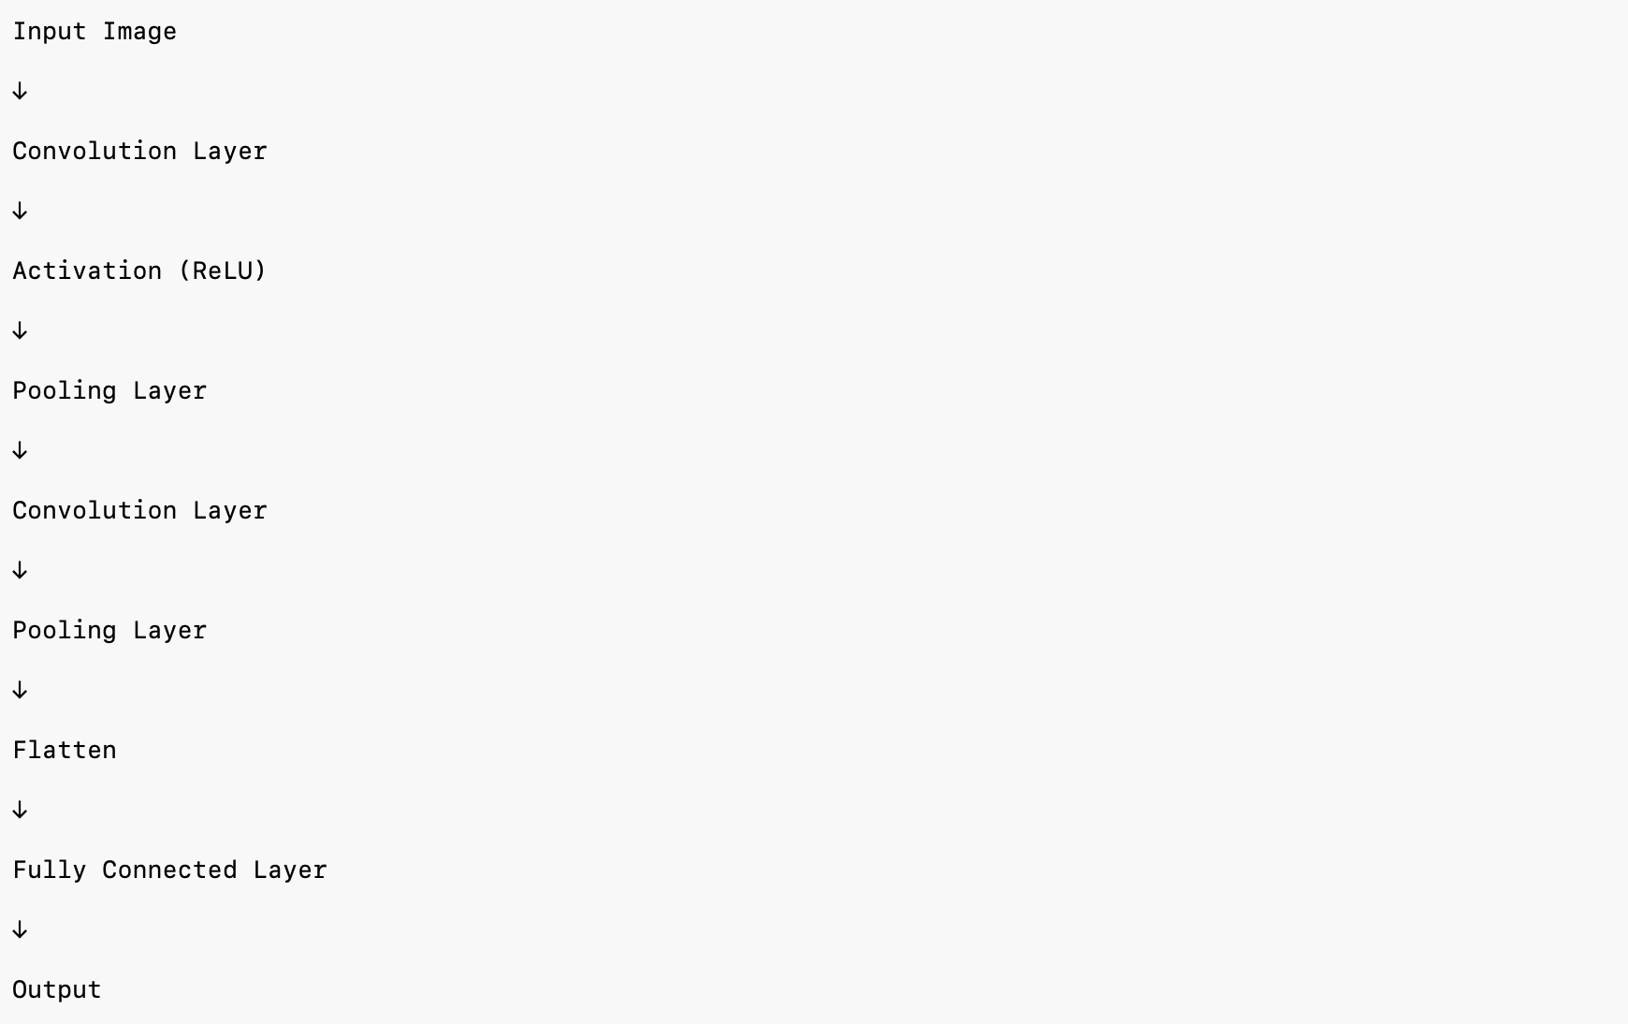
A typical CNN architecture
A CNN is a deep learning architecture purpose-built for grid-like data, above all images. Where a fully connected network would need to connect every single pixel to every neuron — impossibly expensive at any real image resolution, and prone to severe overfitting — a CNN learns small, local patterns instead, exploiting the spatial relationships between neighboring pixels the way a human eye first notices edges and corners before recognizing whole objects.
The core operation is convolution: a small matrix called a filter (or kernel) slides across the image, and at each position produces one value in the output feature map, highlighting where a particular pattern (an edge, a texture, a curve) appears. A CNN learns many filters simultaneously; early layers detect simple features like edges, while deeper layers combine them into increasingly abstract concepts — textures, parts, whole objects. Two parameters control how the filter moves: stride (how many pixels it shifts each step — larger strides are cheaper but lose fine detail) and padding (whether to pad the image border so the output doesn’t shrink after every convolution).
After convolution, a ReLU activation adds non-linearity, and a pooling layer (most commonly max pooling, which keeps only the largest value in each region) reduces the spatial size of the feature maps — cutting compute cost, reducing overfitting, and making the model more robust to small shifts in the image. After several convolution/pooling stages, the resulting feature maps are flattened into a single vector and passed to a standard fully connected layer that produces the final classification.
Landmark CNN architectures mark the field’s progression: LeNet (1998) proved the concept on handwritten digits; AlexNet (2012) won ImageNet and ignited the deep learning boom, popularizing ReLU and Dropout at scale; VGGNet (2014) went deeper using small, uniform 3×3 filters; ResNet (2015) introduced residual (skip) connections, solving the vanishing-gradient problem for very deep networks and enabling architectures over 100 layers deep; EfficientNet (2019) achieved comparable accuracy with far fewer parameters by jointly optimizing depth, width, and input resolution — a better fit for production environments where efficiency matters as much as raw accuracy.
Though best known for computer vision, CNNs have real security applications: classifying malware by rendering its raw binary as a grayscale image, CAPTCHA and QR-code verification, visualizing network traffic as image-like heatmaps for IoT intrusion detection, and hardware side-channel analysis.

4.8 Recurrent Networks: RNN, LSTM, GRU
CNNs excel at spatial data; Recurrent Neural Networks (RNNs) are built for sequential data — text, time series, and (critically for security) event sequences, where order carries meaning. A single failed login is meaningless; a failed login followed by a privilege escalation followed by unusual data transfer is an attack chain. An RNN captures this by maintaining a hidden state that carries information from each time step into the next, so each prediction is conditioned on everything the network has seen in the sequence so far, not just the current input — with the same weights reused at every step (“unrolled” across time), letting it handle sequences of varying length.
RNN architectures are classified by their input/output shape: one-to-many (a single input generating a sequence, e.g., image captioning), many-to-one (a sequence collapsed into one output, e.g., classifying a whole session as an attack or not), and many-to-many (sequence to sequence, e.g., machine translation, log annotation).
The core weakness of a vanilla RNN is the vanishing gradient problem: over long sequences, the gradients used in training shrink until earlier information effectively gets forgotten — an RNN analyzing a long authentication log might lose track of the original login event by the time it reaches a much later exfiltration event, even though that original event is exactly what explains the later one.
LSTM (Long Short-Term Memory) networks solve this with a dedicated memory cell and three gates — a forget gate (what to discard), an input gate (what new information to store), and an output gate (what to expose to the next layer) — that together let the network selectively retain information across hundreds or thousands of time steps, rather than being forced to remember (or forget) everything uniformly. This made LSTMs the standard sequence-modeling architecture for years, well suited to full attack-chain reconstruction from authentication sequences, command histories, and process execution traces.
GRU (Gated Recurrent Unit) is a simplified LSTM variant — it merges the forget and input gates into a single update gate and adds a reset gate, resulting in fewer parameters and faster training with comparable accuracy on many tasks, though LSTMs can still edge it out on very long or complex sequences.
 | Vanilla RNN | LSTM | GRU
Long-range memory | Poor (vanishing gradients) | Strong | Strong
Parameters | Fewest | Most | Fewer than LSTM
Training speed | Fastest | Slower | Faster than LSTM
Typical choice | Short sequences, simple baselines | Long, complex sequences | Good default — nearly LSTM’s accuracy, less compute
In practice, both LSTMs and GRUs have been substantially displaced by Transformers (Chapter 5) for the largest-scale sequence modeling tasks, but they remain efficient, well-understood choices for streaming telemetry and moderate-length sequences where a full Transformer is more compute than the problem warrants.

4.9 Autoencoders and Generative Models
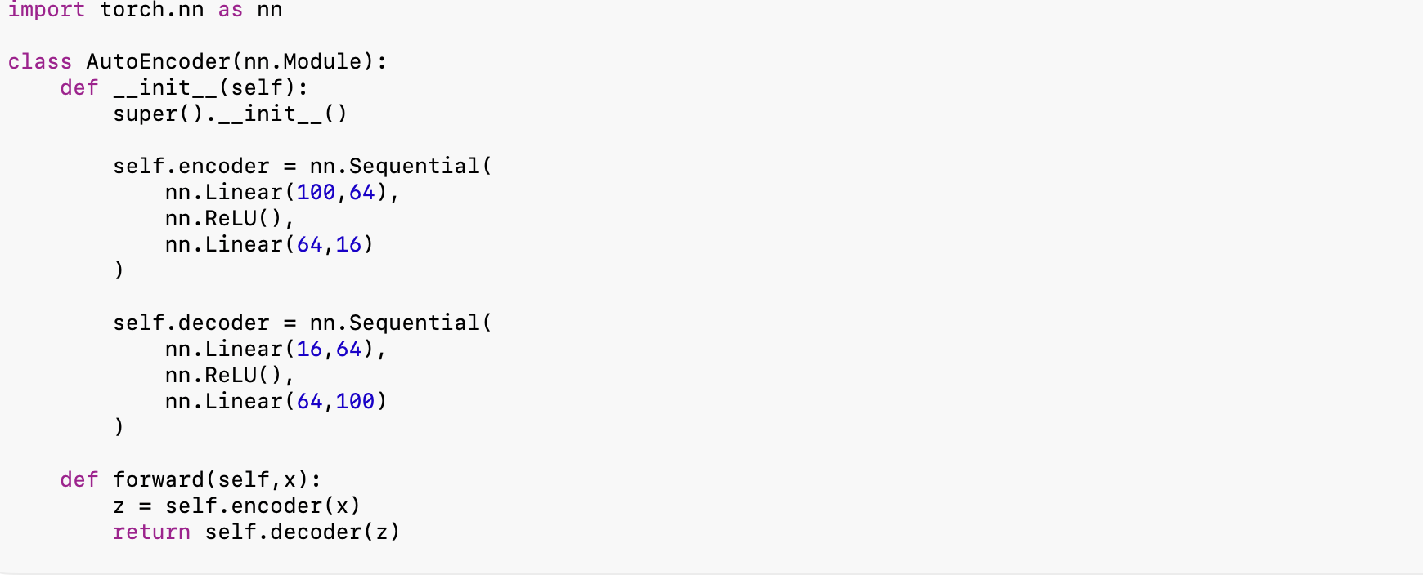
Autoencoder architecture: encoder, latent space, decoder
Autoencoders learn to compress data and reconstruct it: an encoder maps the input down into a compact latent space representation, and a decoder reconstructs the original input from that compressed form. The network is trained purely to minimize reconstruction error — the difference between input and output — with no labels required.
This makes autoencoders a natural anomaly detector: trained only on normal traffic, an autoencoder reconstructs normal patterns well (low error) and struggles to reconstruct genuinely novel, anomalous patterns (high error) — that reconstruction error itself becomes the anomaly signal, valuable precisely because it needs no labeled examples of “the next new attack.” Variants include the sparse autoencoder (encourages a compact, sparse latent representation), denoising autoencoder (trained to reconstruct clean data from a deliberately corrupted input, forcing more robust features), and Variational Autoencoder (VAE), which learns a smooth, continuous, probabilistic latent space suited to generating new samples rather than only reconstructing existing ones.
Generative Adversarial Networks (GANs) take a different approach to generation: two networks compete — a Generator that tries to produce realistic fake data, and a Discriminator that tries to distinguish real data from generated fakes — trained together until the Generator produces outputs the Discriminator can no longer reliably tell from real. GANs are best known for image synthesis, but in security they have a specific and useful role: generating synthetic malware or attack-traffic samples to augment scarce training data, and adversarial testing — probing a detection model with GAN-generated evasive samples to find its blind spots before an attacker does.
Graph Neural Networks (GNNs) extend deep learning to data that is naturally structured as a graph — nodes and the relationships between them — rather than a grid (image) or sequence (text). A GNN learns by having each node aggregate information from its neighbors, layer by layer, building a representation that reflects both a node’s own features and its position in the broader network. This is a natural fit for security: modeling a corporate network as a graph of devices and connections lets a GNN flag suspicious relationship patterns (e.g., unusual lateral movement between hosts) that node-by-node analysis would miss entirely, and GNNs are increasingly used for fraud-ring detection and identifying coordinated botnet infrastructure from connection topology alone.

Section Takeaways
- CNNs learn local spatial patterns via convolution and pooling, making them the standard architecture for image data and a viable one for security data that can be represented visually (binary-as-image malware classification, traffic heatmaps).
- RNNs, LSTMs, and GRUs are built for sequential data; LSTMs and GRUs solve the vanishing-gradient limitation of vanilla RNNs and remain efficient choices for streaming security telemetry.
- Autoencoders enable label-free anomaly detection via reconstruction error; GANs generate synthetic data and stress-test detection models; GNNs model relationship structure directly, which is often exactly the signal that matters in network security.
- All of these architectures were, until recently, the state of the art for their respective data types — Chapter 5 covers the architecture that has since displaced most of them for language and, increasingly, other domains too: the Transformer. # Chapter 5 — Transformers and Large Language Models
The 2017 paper “Attention Is All You Need” introduced the Transformer architecture and fundamentally redirected the trajectory of AI. Earlier deep learning models — CNNs, RNNs, LSTMs — each excelled in a specific domain; Transformers introduced a general-purpose mechanism that processes information more efficiently, captures long-range relationships better, and scales to billions of parameters. That breakthrough is what makes today’s foundation models and Large Language Models (LLMs) — GPT, Claude, Gemini, Llama, Mistral, and others — possible, and what now powers AI assistants, code generation, scientific research tools, autonomous agents, and enterprise knowledge systems.

5.1 Why Transformers Replaced RNNs
RNNs and LSTMs (Chapter 4) process sequences one token at a time, which creates three compounding problems at scale: training is inherently sequential (each step depends on the last, so GPUs — built for parallel computation — sit underutilized), very long sequences remain hard to model even with LSTM’s gating, and none of this scales gracefully to the size of modern training corpora — books, code, the web, images, video.
The Transformer’s answer was to replace recurrence with attention: instead of reading a sequence one token at a time, it examines the entire sequence at once and learns which elements are most relevant to each other, directly and in parallel. Every token can interact with every other token regardless of distance, which is what enables both genuinely long-range understanding and full parallelization during training — the combination that let Transformers scale to a size no RNN-based architecture could reach in practice.

5.2 The Attention Mechanism
Attention lets a model decide, for each token, which other tokens matter most to interpreting it. In the sentence “The server blocked the attacker because it detected malicious behavior,” resolving what “it” refers to requires attending back to “server” rather than “attacker” or “malicious behavior” — a connection humans make instantly and a model must learn to make too.
Mechanically, attention is built from three learned vectors per token: a Query (what this token is looking for), a Key (what each other token offers), and a Value (the actual information each token carries). A token’s Query is compared against every other token’s Key to produce a relevance score, normalized so all scores for a given token sum to 1; those scores then weight how much each token’s Value contributes to the current token’s updated representation. This is computed as scaled dot-product attention: softmax(QKᵀ/√d)·V, where the √d scaling factor prevents the dot products from growing too large and destabilizing training.
When every token attends to every other token within the same sequence, this is called self-attention — the core innovation that lets Transformers capture long-range dependencies, resolve ambiguity, and process the whole sequence in parallel. Analyzing a chain of security events (privilege escalation → firewall disabled → data exfiltration), a Transformer can assign high attention from the final event back to both earlier ones simultaneously, recognizing the full attack chain rather than just the immediately preceding step — the kind of holistic, cross-signal reasoning that’s valuable when correlating authentication logs, network traffic, and threat intelligence feeds together rather than in isolation.
Multi-head attention runs several attention mechanisms in parallel, each free to specialize in a different type of relationship — one head might track grammatical structure, another long-range dependencies, another local context. It’s the same principle as ten cybersecurity analysts each specializing in a different domain (network traffic, malware, authentication, cloud security) and combining their findings into one assessment; multiple heads let a single layer build a substantially richer representation than one attention mechanism could alone.
Because attention itself has no built-in sense of sequence order — every token is processed simultaneously, unlike an RNN’s inherently ordered processing — Transformers add positional encoding: information injected before the first layer that tells the model where each token sits in the sequence, so that “AI protects cybersecurity” and “Cybersecurity protects AI” are correctly recognized as different despite using the same words.

5.3 Transformer Architecture and Model Families
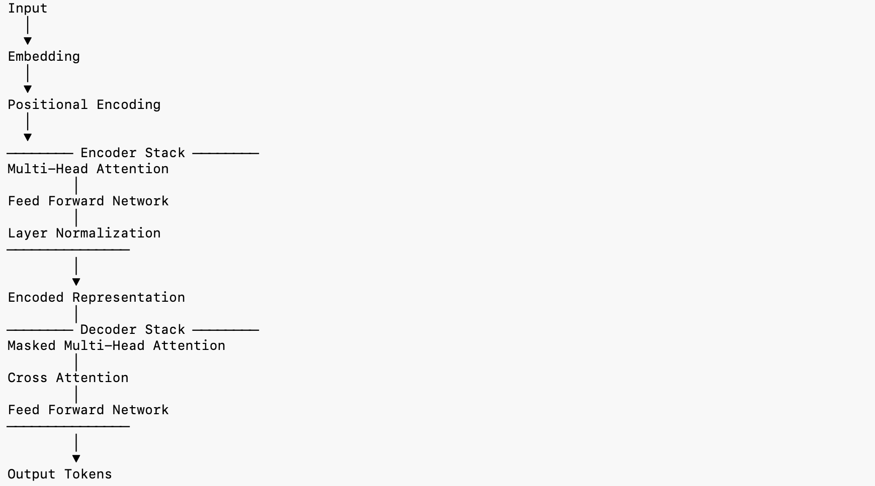
The Transformer architecture: encoder and decoder stacks
A full Transformer has two halves: an encoder, which converts an input sequence into contextual representations (via stacked blocks of multi-head attention, feed-forward layers, residual connections, and layer normalization), and a decoder, which generates output one token at a time using masked self-attention and cross-attention back to the encoder’s output.
Modern models typically use one half or the other, depending on the task:
Model type | Specializes in | Examples | Applications
Encoder-only | Understanding text | BERT, RoBERTa, DistilBERT | Classification, search, extraction, Q&A
Decoder-only | Generating text | GPT, Llama, Mistral, DeepSeek, Claude | Chatbots, code generation, writing, assistants
Encoder-decoder | Transforming text | T5, BART, FLAN-T5 | Translation, summarization
A foundation model is a large model trained on massive, diverse data that can then be adapted to many downstream tasks with little or no further training; a Large Language Model (LLM) is specifically a Transformer-based foundation model trained on natural language, capable of question answering, summarization, translation, code generation, and reasoning. Training typically proceeds through pre-training (learning general language patterns from massive raw text), fine-tuning (learning to follow instructions), and alignment (improving helpfulness and safety, typically via human or AI feedback).

5.4 Working With LLMs: Prompting and Fine-Tuning
Prompt engineering — designing effective instructions to get accurate, well-structured output from an LLM without changing the underlying model — is a core, high-leverage skill precisely because it’s cheap to iterate on. Common techniques include zero-shot prompting (no examples), few-shot prompting (a handful of examples in the prompt), chain-of-thought prompting (asking the model to reason step by step), role prompting, and explicit output-format instructions. A well-specified security prompt looks less like “check these logs” and more like: “Analyze the following firewall logs, identify suspicious activity, explain the reasoning, assign a severity level, and recommend remediation steps in a Markdown table.”
Fine-tuning goes further, adapting a pretrained model’s weights to a specific domain using additional training data — full fine-tuning updates all weights, while parameter-efficient approaches like LoRA and QLoRA update a much smaller set of additional parameters, dramatically reducing the compute cost of specialization. Fine-tuning an LLM on CVE records, MITRE ATT&CK data, incident-response playbooks, and internal security documentation produces a genuinely specialized cybersecurity assistant, distinct from a general-purpose model that merely has broad but shallow security knowledge.

5.5 LLM Limitations
LLMs are powerful but imperfect: they hallucinate (state incorrect information with unwarranted confidence), carry outdated knowledge frozen at their training cutoff, have finite context windows, can encode bias present in training data, raise privacy concerns around what they were trained on or might leak, and are computationally expensive to run at scale. Because of these limits, no serious enterprise AI system relies on an LLM’s unaided judgment for consequential decisions — instead, LLM reasoning gets combined with verified telemetry, retrieval over trusted knowledge sources, and deterministic systems that can validate or override the model’s output. Retrieval-Augmented Generation, covered next, is the primary architecture for grounding an LLM in real, current, organization-specific information rather than relying purely on what it memorized during training.

Chapter Summary
Transformers replaced recurrence with attention, enabling full parallelization and much better long-range understanding — the combination that made today’s Foundation Models and LLMs possible. Self-attention, multi-head attention, and positional encoding are the mechanism’s three pillars; encoder-only, decoder-only, and encoder-decoder variants specialize in understanding, generation, and transformation respectively. Prompt engineering and fine-tuning are the two primary levers for shaping LLM behavior toward a specific task or domain. But even the best LLM cannot reliably access private, current, or constantly-changing knowledge on its own — which is exactly the gap Retrieval-Augmented Generation is built to close. # Chapter 6 — Retrieval-Augmented Generation (RAG)
LLMs generate responses based on what they learned during training and cannot reliably access private or constantly-changing information — the exact limitation Chapter 5 closed on. Retrieval-Augmented Generation (RAG) solves this by combining an LLM with an external knowledge base: rather than answering from memory alone, the system first retrieves relevant information, then generates a response grounded in what it found. RAG is now the standard architecture behind enterprise AI assistants, knowledge management systems, and domain-specific copilots, precisely because it sidesteps the retraining cost of keeping a model’s knowledge current.

6.1 Why RAG, and How It Works
Without retrieval, an LLM’s knowledge is frozen at its training cutoff, prone to hallucination when asked about anything outside it, and has no access whatsoever to private, proprietary, or customer-specific data. RAG fixes all three: responses are grounded in real, retrievable documents; the knowledge base can be updated continuously without retraining the model; and it extends naturally to enterprise and proprietary data the model never saw during training. Instead of asking an LLM to explain a CVE from memory (risking a stale or fabricated answer), a RAG system first retrieves the actual advisory, relevant threat-intelligence reports, and MITRE ATT&CK mappings, then generates a response grounded in that retrieved material.

6.2 Embeddings and Vector Search
The retrieval half of RAG depends on embeddings — numerical vectors that represent the semantic meaning of text (or images, or other data), such that “Malware Detection” might map to something like [0.12, -0.84, 1.25, ...]. The key property: texts with similar meaning produce vectors that sit close together in that vector space, which is what enables semantic search — matching by meaning rather than exact keyword overlap. Common embedding models include OpenAI’s text-embedding family, BAAI BGE, E5, Sentence Transformers, Jina Embeddings, and Voyage AI.
A vector database (Pinecone, Milvus, Weaviate, ChromaDB, Qdrant, or the FAISS library) stores these embeddings and performs efficient nearest-neighbor search instead of traditional SQL queries — the infrastructure that lets a system search, say, incident reports, threat intelligence, CVEs, and internal documentation by semantic similarity rather than exact string matching.
Before embedding, documents are split into smaller chunks, since LLMs can’t process entire books or massive documents at once. Chunking strategy — fixed-size, sentence-based, paragraph-based, or semantic chunking — has a real, measurable effect on retrieval quality; chunks that are too large dilute relevance, while chunks that are too small lose context.

6.3 The Retrieval Pipeline
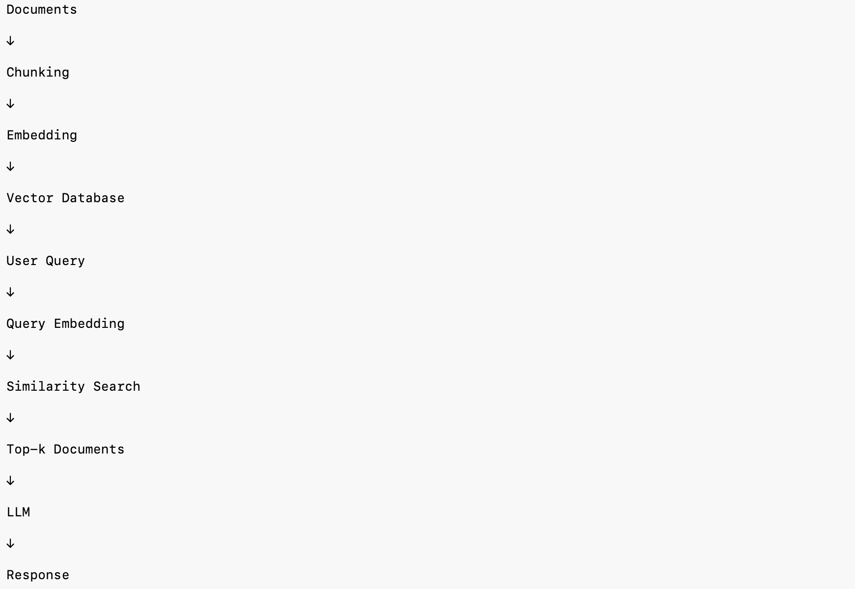
A typical RAG retrieval pipeline
A production RAG pipeline typically layers several techniques on top of basic vector search:
- Hybrid search — combining semantic (embedding) search with traditional keyword search (BM25) and metadata filters, which improves both precision and recall over vector search alone.
- Re-ranking — after an initial broad retrieval (e.g., top 20 candidates), a re-ranker (Cohere Rerank, BGE Reranker, Jina Reranker, or a cross-encoder model) re-scores them and keeps only the most relevant (e.g., top 5) before passing them to the LLM — trading a small amount of latency for a meaningful boost in answer quality.
- Context compression — trimming retrieved content down to what’s actually relevant before it reaches the model’s context window, reducing both cost and noise.

6.4 RAG vs. Fine-Tuning
RAG and fine-tuning (Chapter 5) solve related but distinct problems, and most serious enterprise AI systems end up using both together rather than choosing one exclusively.
 | RAG | Fine-Tuning
Mechanism | Uses external knowledge at query time | Changes the model’s weights
Updating knowledge | Easy — update the knowledge base | Requires retraining
Best for | Dynamic, frequently-changing information | Specialized behavior or style
Cost | Lower | Higher
Hallucination | Reduces it | Doesn’t inherently reduce it

6.5 Cybersecurity Applications
RAG lets a security AI reason over threat intelligence feeds, CVE databases, security policies, SOC playbooks, SIEM logs, incident reports, compliance frameworks, MITRE ATT&CK, and NIST guidelines — grounding analyst-facing answers in trusted organizational knowledge rather than a model’s general, possibly-outdated training data.
Infiltrix in Practice — Connecting the AI reasoning layer to proprietary security knowledge — threat-intelligence repositories, telemetry summaries, incident-response playbooks, customer-specific policies, historical investigations — lets analysts get answers that are accurate, explainable, and specific to their own environment, instead of generic AI output disconnected from what’s actually happening on their network.

6.6 Evaluating a RAG System
A RAG system can fail in two distinct places, and it’s important to evaluate them separately rather than judging only the final answer. Retrieval quality asks whether the system found the right material at all — measured by metrics like context precision (how much of what was retrieved is actually relevant) and context recall (how much of the relevant material in the knowledge base was actually retrieved). Generation quality asks whether the LLM used that retrieved material well — measured by faithfulness (does the answer stick to what was retrieved, or does it drift into unsupported claims?) and answer relevance (does the response actually address the question asked?).
This separation matters operationally: a RAG system that gives a wrong answer might have a perfectly good LLM working from poor retrieval (fixable by improving chunking, embeddings, or search), or good retrieval undermined by an LLM that ignores or misreads the retrieved context (a generation-side problem, often addressed through prompt design or a stronger model). Diagnosing which failure mode occurred — rather than only noting that the final answer was wrong — is what makes a RAG system’s problems actually fixable.

Chapter Summary
RAG combines retrieval with generation: embeddings and vector search find relevant material, hybrid search and re-ranking sharpen what gets retrieved, and the LLM generates a response grounded in that material rather than pure memory. It’s become the default architecture for enterprise AI because it’s cheaper to keep current than fine-tuning and directly addresses hallucination on private or fast-changing knowledge. Evaluating it well means separating retrieval quality from generation quality rather than judging only the final answer. But answering questions is only one capability. The next evolution — covered in Chapter 7 — is AI that can plan, use tools, maintain memory, and carry out multi-step tasks autonomously: AI Agents. # Chapter 7 — AI Agents and Agentic AI
An LLM on its own is fundamentally reactive — it waits for a prompt, produces a response, and stops. Real operational workflows need something that can plan, make decisions, call external tools, remember prior context, and carry out multi-step work with minimal human intervention. That’s what an AI Agent is: an LLM’s reasoning combined with memory, planning, and tool use, oriented toward completing an objective rather than just answering a question.
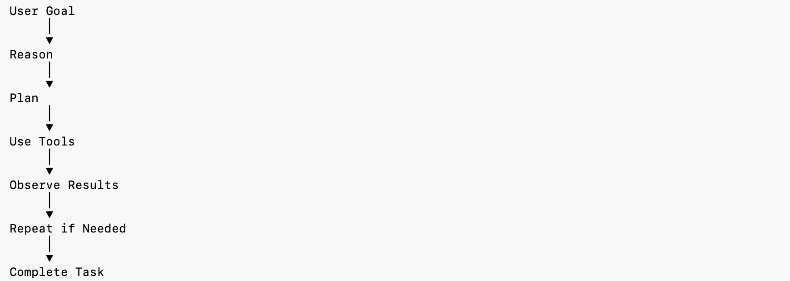
A goal-driven AI agent workflow

7.1 What Distinguishes an Agent from an LLM
 | LLM | AI Agent
Behavior | Reactive | Goal-driven
Output | A single response | A completed multi-step workflow
State | Stateless by default | Maintains memory across steps
Capability | Generates text | Uses tools, executes actions
Given “Analyze yesterday’s security logs, summarize critical alerts, map them to MITRE ATT&CK, and generate an incident report,” a chatbot explains how one would do this; an agent actually retrieves the logs, performs the analysis, and produces the report.

7.2 Components of an Agent
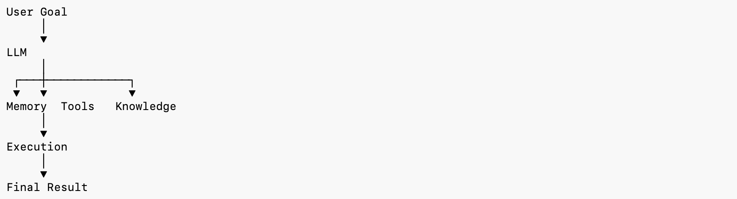
Components of an AI agent
A modern agent is generally composed of: an LLM as the reasoning engine; memory to retain context; a planner that breaks a high-level goal into concrete steps; tools — APIs, databases, web search, code execution — that let it act on the world; a knowledge base, often implemented as RAG (Chapter 6); and an execution engine that carries out actions and monitors their results.
Memory splits into two useful categories: short-term memory (the current conversation, active task context, temporary reasoning) and long-term memory (user preferences, historical tasks, organizational knowledge, past experience) — without either, an agent restarts from zero on every interaction.
Tool calling is what lets an LLM — which cannot directly touch external systems — act in the world: running a database query, executing Python, calling an email or calendar API, or querying a security platform. The model itself decides when and how to invoke each tool based on the user’s goal.
Planning breaks a complex objective into an ordered sequence of concrete steps — investigating a phishing incident, for instance, decomposes naturally into: retrieve email logs → extract suspicious URLs → check threat intelligence → analyze affected users → generate report → recommend remediation. This is what lets an agent solve genuinely multi-step problems systematically rather than attempting them in one shot.

7.3 Multi-Agent Systems
Rather than building one large, generalist agent, production systems increasingly deploy several specialized agents that collaborate toward a shared objective — each handling one part of a workflow it’s specifically tuned for, then handing off to the next. This mirrors how a human security team is organized: specialists in different domains, coordinating rather than any one person doing everything.

7.4 Agents in Cybersecurity
AI Agents can automate a meaningful share of routine security operations — threat hunting, incident triage, log analysis, vulnerability assessment, malware investigation, threat-intelligence correlation, compliance reporting, and general SOC assistance — functioning as intelligent collaborators that handle the repetitive, high-volume parts of investigation rather than replacing the analyst’s judgment on consequential decisions.
Infiltrix in Practice — A representative agentic workflow: Alert → Investigate → Retrieve Context (via RAG) → Analyze Evidence → Recommend Action → Generate Report — combining LLM reasoning, retrieval over security knowledge, threat-intelligence APIs, SIEM integration, and endpoint telemetry into one coordinated pipeline, producing faster and more consistent incident response than any single-step tool could.

7.5 Agentic AI
Agentic AI describes systems capable of autonomously pursuing goals through reasoning, planning, memory, and tool use — continuously evaluating progress, adapting to new information, and deciding what to do next, rather than responding to isolated prompts one at a time. Its defining characteristics are goal-oriented behavior, autonomous decision-making, multi-step reasoning, dynamic (not fixed) planning, and tool orchestration across a workflow, not just a single call. This represents the next major evolution beyond a standalone LLM or even a single-purpose agent — toward a platform of coordinated, specialized agents.
The long-term direction this points toward, for a cybersecurity platform specifically, is a fully agentic security operations model: specialized agents (SOC triage, threat intelligence, malware analysis, vulnerability assessment, compliance, incident response, executive reporting) working together to detect, investigate, and respond to threats with substantially less manual analyst effort per incident — while keeping a human in the loop for high-impact decisions, a principle covered in depth in Chapter 9.

7.6 Evaluating and Constraining Agents
Autonomy raises the stakes on evaluation. An agent that only answers questions can, at worst, give a wrong answer; an agent that takes actions can take the wrong action — deleting the wrong record, blocking a legitimate user, or escalating a false positive to a costly incident response. Evaluating an agent therefore needs to look beyond whether the final output looks reasonable, to whether each intermediate step — which tool it chose, what arguments it passed, whether it correctly interpreted a tool’s result — was actually correct along the way.
Production agent systems typically constrain autonomy deliberately rather than maximizing it: a permission boundary defines which tools and data an agent may access at all; an approval gate requires human sign-off before high-impact actions (blocking an IP range, disabling an account, deleting data) execute; and comprehensive action logging ensures every tool call an agent makes is auditable after the fact, not just its final summary. This is the practical expression of the “AI should augment, not replace, human judgment” principle covered in depth in Chapter 9 — an agent is trusted with exactly as much unsupervised authority as its track record and the stakes of the decision actually warrant, and not automatically more just because it’s technically capable of acting alone.

Chapter Summary
AI Agents extend LLMs with memory, planning, and tool use, turning a system that only answers questions into one that completes tasks. Multi-agent systems — specialized agents collaborating on a shared objective — are increasingly the production pattern of choice over a single monolithic agent. Agentic AI is the broader shift toward continuous, autonomous, goal-directed operation — one that requires evaluating not just final outputs but every intermediate action, and constraining autonomy with permission boundaries and approval gates in proportion to what’s actually at stake. As agents take on more of the workflow, they inevitably need to talk to more external systems — which is exactly the integration problem Chapter 8’s Model Context Protocol was built to solve. # Chapter 8 — Model Context Protocol (MCP)
As agents take on more real work, they need to talk to an ever-growing number of external systems — databases, APIs, cloud platforms, IDEs, security tools, enterprise applications, knowledge bases. Historically, every new integration meant custom code specific to that one tool, which scales badly and gets harder to maintain as the number of integrations grows. The Model Context Protocol (MCP) solves this with a single standardized way for AI models to discover, connect to, and interact with external tools and data sources — sometimes described as “USB-C for AI applications,” in that one interface replaces a different custom cable for every device.

8.1 What MCP Solves
Without a shared protocol, an LLM ends up with a separate, bespoke integration for every system it needs to reach — a custom database API, a custom GitHub API, a custom Slack API, a custom SIEM API, each maintained independently and each a potential point of failure. With MCP, that collapses into one path: LLM → MCP Client → MCP Server → Tools & Services. Developers implement MCP once per tool and gain interoperability with every MCP-compatible AI application, rather than building integration N times for N different AI systems.

8.2 Architecture
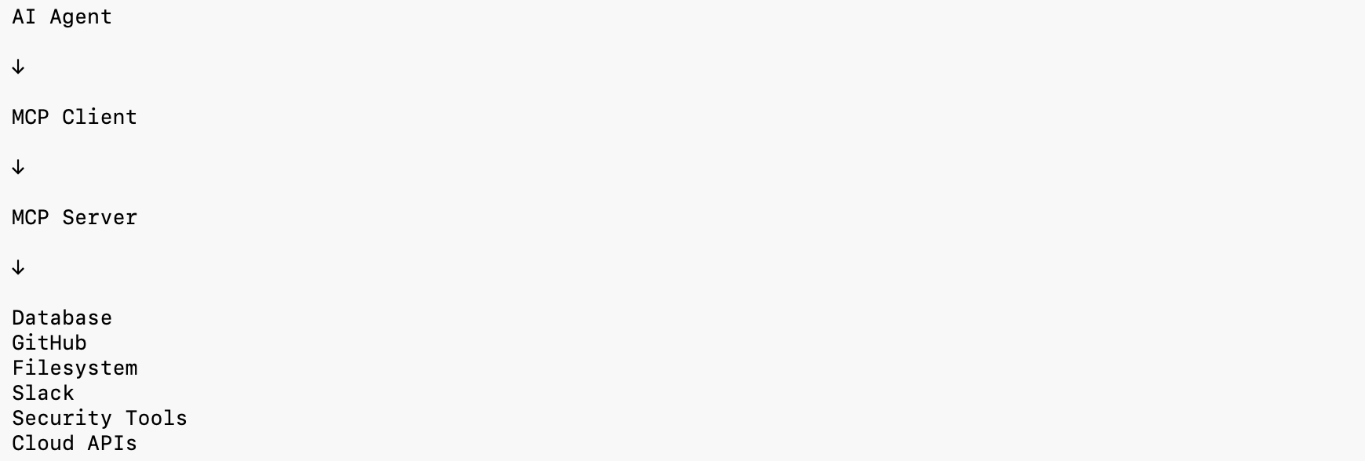
MCP architecture: Host, Client, and Server
An MCP system has three parts: the Host (the AI application itself), the Client (which sends MCP requests), and the Server (which exposes tools and resources, and advertises its capabilities so the AI can discover and use them dynamically rather than requiring hardcoded knowledge of what’s available). MCP servers expose three categories of capability: Resources — read-only information such as documents, databases, configuration files, or security reports; Tools — executable functions such as running a SQL query, creating a GitHub issue, executing code, or searching SIEM logs; and Prompts — reusable templates that standardize how an AI interacts with a given system.

8.3 MCP in Enterprise and Security Contexts
MCP lets AI systems connect securely to enterprise infrastructure — GitHub, Jira, Notion, Google Drive, PostgreSQL, Slack, Kubernetes, AWS, Azure, and specialized security platforms — without a bespoke integration for each. In a security operations context specifically, an agent using MCP could query SIEM logs, retrieve threat intelligence, analyze firewall alerts, check vulnerability scanners, access cloud audit logs, and generate incident reports — all through one standardized protocol rather than a patchwork of one-off connectors, each with its own authentication model and failure modes to maintain.
Infiltrix in Practice — MCP functions as the integration layer connecting agents to enterprise security infrastructure — SIEM platforms, EDR/XDR solutions, threat-intelligence platforms, vulnerability scanners, cloud security tools, internal knowledge bases, and customer dashboards — letting agents securely retrieve context, execute actions, and orchestrate workflows across many systems without a custom integration per system.

8.4 A Practical Example
Consider an agent tasked with investigating a suspicious login alert. Without MCP, reaching each relevant system — the SIEM for related events, the identity provider for the user’s login history, a threat-intelligence API for the source IP’s reputation, and a ticketing system to open an incident — would each require its own bespoke integration, authentication flow, and error handling, all maintained independently. With MCP, the agent instead discovers each system’s exposed Resources and Tools through the same standard interface: it reads the SIEM’s Resources for related events, calls the threat-intelligence server’s Tool to check the source IP, and calls the ticketing server’s Tool to open an incident — all through one consistent protocol, with one consistent authentication and permissions model to reason about and maintain, rather than four different ones.

8.5 Security Considerations
Standardizing integration also means standardizing what needs to be secured. Because an MCP server can expose powerful Tools — including ones that modify data or trigger real-world actions — production deployments need the same rigor applied to any privileged API: authentication and authorization on every server (never assume a request is trusted just because it arrived through MCP), the principle of least privilege (an agent investigating phishing shouldn’t have standing access to unrelated systems like payroll), and audit logging of every tool call, for exactly the same reason Chapter 7 emphasized action logging for agents generally — MCP is the layer those actions actually flow through, which makes it the natural place to enforce and record that discipline.

Chapter Summary
MCP standardizes how AI models and agents communicate with external tools and enterprise systems, replacing bespoke, per-tool integrations with one common interface. It’s a key enabler of genuinely production-ready AI, because it turns an isolated language model into a connected, action-capable system that can reach real infrastructure — the technical foundation that makes the agentic workflows from Chapter 7 practical to build and maintain at enterprise scale, provided the same access-control discipline applied to any privileged integration is applied here too. With the full technical stack now covered — from data, through classical ML and deep learning, to Transformers, RAG, agents, and integration — Chapter 9 turns to the engineering discipline required to run all of it reliably in production. # Chapter 9 — AI Engineering Best Practices
Building a model that performs well on a benchmark is a small part of building a system that performs well in production. Production AI demands discipline around architecture, evaluation, deployment, monitoring, security, and governance — the difference between a promising notebook experiment and a system an organization can actually depend on. This closing chapter lays out that engineering discipline, end to end.

9.1 The AI Development Lifecycle
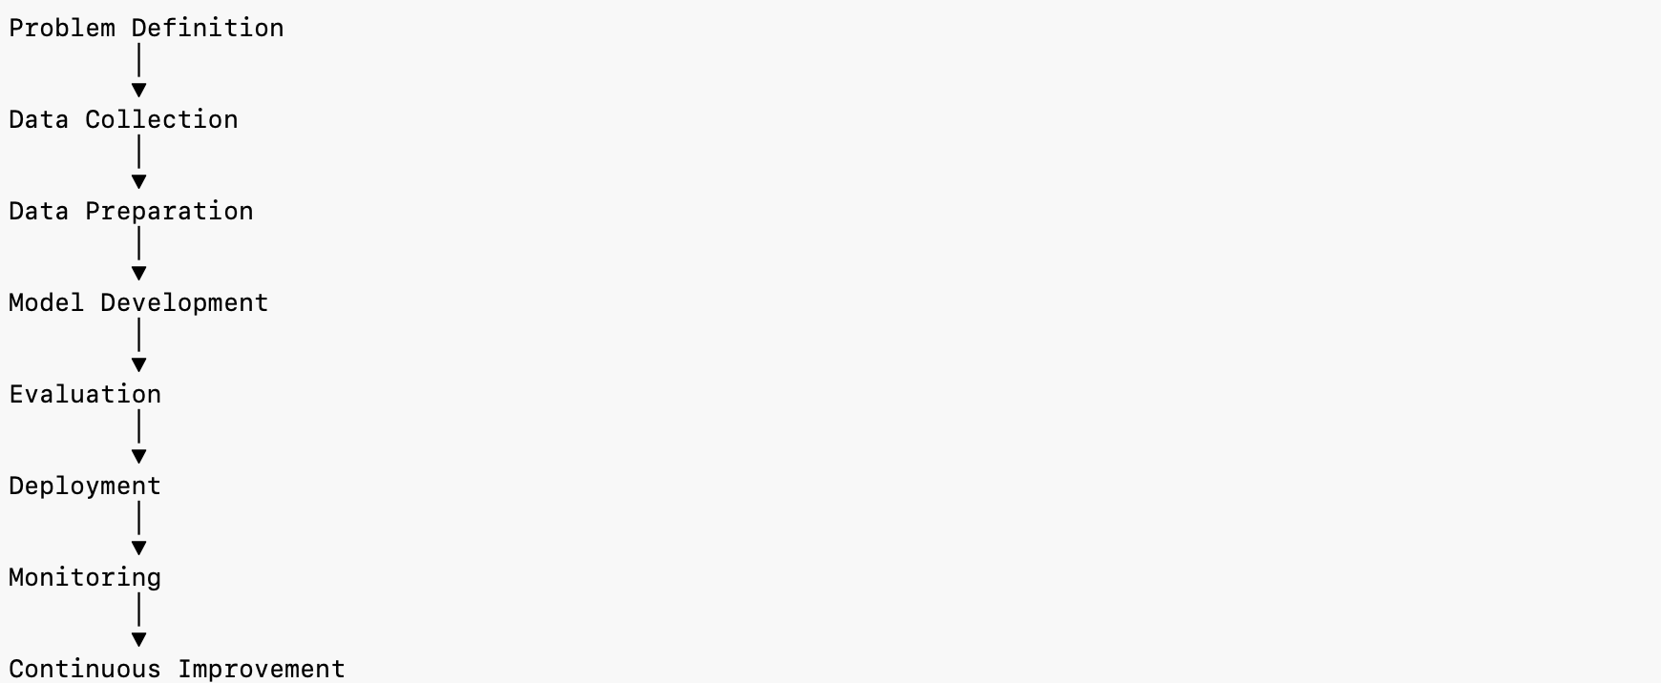
The AI development lifecycle
A production AI project moves through a lifecycle broader than model training alone: problem definition (a precise, measurable objective, as covered in Chapter 3); data engineering (Chapter 2); model development (Chapters 3–5); evaluation (rigorous testing against held-out and, ideally, adversarial data); deployment (integrating the model into a live system); monitoring (tracking real-world performance continuously); and retraining (updating the model as data and threats evolve) — which feeds back into data engineering, making the lifecycle a loop rather than a line. Skipping or shortcutting any one stage is where most production AI failures actually originate — not from a weak algorithm, but from a process gap: an unmonitored model silently degrading, or a model that was never tested against adversarial input before facing one.

9.2 MLOps: Operationalizing Machine Learning
MLOps applies the discipline of DevOps to machine learning: version control, automated testing, continuous integration and deployment, and reproducibility, extended to cover not just code but data and models too.
Versioning in an ML system means tracking three things together, not just code: the dataset version used for a given training run, the model version (and its exact hyperparameters), and the prompt or configuration version for any LLM-based component. Without this, a production incident becomes very difficult to root-cause — “which model, trained on which data, with which prompt, produced this specific bad output?” is often the first question that matters and the hardest to answer without disciplined versioning.
Automated pipelines should cover data validation (catching schema drift or corrupted inputs before they reach training), automated retraining triggers (scheduled, or triggered by a monitoring alert), automated evaluation against a fixed benchmark before any new model is promoted, and staged rollout (canary or shadow deployment) rather than an instant full-traffic cutover to a new model version.
Reproducibility means any team member can regenerate a given model from its recorded dataset version, code version, and configuration — a requirement that becomes essential the moment a model needs debugging, auditing, or regulatory review, and one that’s extremely difficult to retrofit if it wasn’t built in from the start.

9.3 Deployment Patterns
How a model reaches production affects both risk and rollback speed:
Pattern | What it does | Best for
Shadow deployment | New model runs alongside the current one, its predictions logged but not acted on | Validating a new model against real traffic with zero user-facing risk
Canary release | New model serves a small percentage of real traffic | Catching regressions before full rollout
Blue-green deployment | Two full environments run in parallel; traffic switches instantly | Fast, low-risk rollback if the new version underperforms
A/B testing | Two model versions served concurrently, compared statistically | Comparing genuinely different modeling approaches, not just versions
Latency and throughput requirements should shape architecture choices early, not be discovered after the fact. A model detecting network intrusions in near-real-time has a fundamentally different latency budget than one generating a weekly executive security report — and that budget should influence model choice (a smaller, faster model may beat a larger, marginally more accurate one that misses its window), hardware allocation, and whether inference happens on a live stream or in scheduled batches.
Scalability means the serving infrastructure can absorb traffic spikes — a sudden flood of security events during an active incident, for instance — without the detection system itself becoming the bottleneck at exactly the moment it’s needed most.

9.4 Monitoring and Observability
Deployment is the midpoint of a model’s life, not the end. Production models require continuous, structured observability:
- Data drift — the statistical distribution of incoming data shifts away from what the model was trained on (e.g., a new protocol becoming common on the network), degrading accuracy even though the model itself hasn’t changed.
- Concept drift — the relationship between features and the correct label changes over time (e.g., attackers adopting new techniques that don’t match historical attack signatures), which is a distinct failure mode from data drift and needs its own detection.
- Performance metrics in production — precision, recall, and F1 (Chapter 3) should be tracked continuously against ground truth as it becomes available, not just measured once at training time and assumed stable.
- Latency and error-rate monitoring — infrastructure-level metrics (response time, throughput, failure rate) that matter as much as model accuracy for a system’s real-world usefulness.
- Alerting — automated notification when any of the above crosses a defined threshold, so degradation is caught by monitoring rather than by a customer or an incident.
Engineering Insight — A model that is 2% less accurate on paper but degrades predictably and is caught early by monitoring is more valuable in production than a marginally more accurate model that fails silently. Observability is not optional tooling — it is what makes a model’s accuracy claims trustworthy over time rather than a one-time snapshot.

9.5 Explainable AI (XAI)
As models — especially deep learning models — grow more complex, understanding why they made a given prediction becomes both harder and more important, particularly in high-stakes domains like security and finance, where an unexplainable “trust me” from a model is rarely acceptable to an analyst, an auditor, or a regulator.
Common XAI techniques include feature importance (which inputs most influenced this specific prediction — most naturally available from tree-based models like Random Forest and XGBoost), SHAP (SHapley Additive exPlanations) (a game-theoretic method that attributes a prediction’s outcome fairly across all contributing features, applicable to nearly any model type), and LIME (Local Interpretable Model-agnostic Explanations) (approximating a complex model’s behavior locally, around one specific prediction, with a much simpler and more interpretable model).
In a security context, explainability isn’t a nice-to-have — an analyst deciding whether to act on an AI-flagged alert needs to know why the system flagged it: which features drove the score, which historical incidents it resembles, and how confident the model actually is. A risk score with no accompanying explanation is far less actionable, and far less trustworthy, than one that comes with its reasoning attached.

9.6 Responsible AI
Responsible AI is the umbrella term for building systems that are fair, safe, transparent, and accountable — not an afterthought bolted on before launch, but a design constraint carried through the whole lifecycle described in Section 9.1.
- Fairness and bias — training data reflects historical patterns, including historical biases; a model trained on skewed data will reproduce and can amplify that skew. Regular bias audits, especially on decisions that affect people, are a core responsibility, not an optional check.
- Privacy — models trained on sensitive data (personal information, proprietary telemetry, security incidents) must handle that data with the same care as any other sensitive system — data minimization, access controls, and awareness of what a model might inadvertently memorize and later reveal.
- Transparency — being clear with stakeholders about what a system can and cannot reliably do, and where a human decision is still required, rather than overstating an AI system’s autonomy or accuracy.
- Accountability — a clear line of human ownership for what an AI system does. “The model decided” is never an adequate explanation on its own for a consequential outcome.

9.7 AI Security: Protecting the System Itself
Production AI systems aren’t just tools for security — they are themselves a target that needs defending. Distinct attack categories on AI systems include:
- Adversarial examples — inputs deliberately crafted to fool a model (e.g., traffic engineered to evade a detection classifier while remaining functionally malicious).
- Data poisoning — corrupting training data so the model learns a subtly wrong pattern, often installed well before the attack it’s meant to enable.
- Model inversion / extraction — attempting to reconstruct training data, or the model’s own logic, from its outputs alone.
- Prompt injection (for LLM-based systems) — malicious instructions smuggled into content an LLM processes, attempting to override its intended behavior.
Defenses include adversarial training (deliberately training on adversarial examples so the model learns to resist them), input validation and sanitization, rate limiting and anomaly detection on the AI system’s own usage patterns, and — critically for any consequential decision — a human in the loop rather than fully autonomous action.

9.8 Core Engineering Principles
Drawing the chapter’s threads together, several principles apply across nearly every production AI system, and are the working principles behind the Infiltrix platform specifically:
- AI should augment, not replace, human judgment, especially for high-impact decisions.
- Every AI decision of consequence should be explainable — Section 9.5’s XAI techniques exist precisely to make this practical rather than aspirational.
- Combine LLM reasoning with deterministic systems — an LLM’s fluent reasoning paired with rule-based validation catches errors neither approach would catch alone.
- Use RAG for organization-specific, current knowledge rather than relying on what a model happened to memorize during training.
- Employ agents for workflow automation, not for unsupervised, high-stakes decision-making.
- Integrate systems through standardized protocols (MCP, Chapter 8) rather than accumulating bespoke point-to-point integrations that become a maintenance burden.
- Continuously monitor and adapt — data drift, concept drift, and an evolving threat landscape mean no production model is ever really “done.”

9.9 Looking Ahead
Several trends are shaping where AI engineering goes next: multimodal models that reason jointly across text, images, audio, and structured data in a single system, rather than separate models stitched together after the fact; smaller, more efficient models — distillation and quantization techniques narrowing the gap with far larger models at a fraction of the inference cost, which matters enormously for latency-sensitive, high-volume applications like live network monitoring; increasingly autonomous, multi-agent systems (Chapter 7) taking on progressively larger and more open-ended workflows; and tighter regulatory attention on AI safety, transparency, and accountability, particularly for consequential, high-stakes domains including security and critical infrastructure.
For a security-focused organization, the throughline across all of these trends is the same: AI capability is expanding quickly, and the engineering discipline in this chapter — rigorous evaluation, real observability, explainability, and a human retained in the loop for consequential decisions — is what keeps that expanding capability trustworthy rather than merely impressive on a demo.

Chapter Summary
Production AI is an engineering discipline, not a modeling exercise: a real lifecycle from problem definition through monitoring and retraining, MLOps practices that make models versioned and reproducible, deployment patterns that manage rollout risk, and continuous observability that catches drift before it becomes an incident. Explainability and responsible AI are not optional polish — they are what makes an AI system’s output something an analyst, an auditor, or a customer can actually act on and trust. And the AI system itself needs defending, not just deployed, against adversarial inputs, data poisoning, and prompt injection. These principles — not any single algorithm or architecture — are what separate a research demo from a system an enterprise can actually depend on.

Final Summary
This handbook traced the full path of modern AI engineering: the foundational vocabulary of AI, ML, and DL (Chapter 1); the data engineering discipline every model depends on (Chapter 2); the classical machine learning algorithms and evaluation methodology that still power most structured-data problems (Chapter 3); the deep learning architectures — from a single artificial neuron through CNNs, RNNs, LSTMs, GRUs, autoencoders, GANs, and GNNs — that handle unstructured data at scale (Chapter 4); the Transformer architecture and Large Language Models that now anchor most new AI systems (Chapter 5); Retrieval-Augmented Generation, which grounds those models in real, current, private knowledge (Chapter 6); AI Agents and Agentic AI, which turn language understanding into completed work (Chapter 7); the Model Context Protocol that lets agents reach real infrastructure safely and consistently (Chapter 8); and, finally, the engineering discipline — MLOps, deployment, monitoring, explainability, responsible AI, and AI security — that makes all of the above dependable in production rather than merely impressive in a demo (Chapter 9).
Whether the goal is a threat-detection classifier, an autonomous security agent, or an enterprise copilot, these are the same principles: start from a precise problem definition, respect the data, choose the simplest architecture that solves the problem, evaluate honestly, and never treat deployment as the finish line. Applied together — as they are throughout the Infiltrix platform — they are what turns AI from an interesting capability into dependable infrastructure.

