Jenkins is a powerful tool that simplifies the software delivery process. It’s a flexible platform used for a variety of software engineering tasks, but its main focus is managing CI/CD pipelines. Jenkins ensures that code changes are tested, validated, and deployed efficiently.
In this article, we’ll dive into the key features, benefits, and real-world uses of Jenkins in modern software development. We’ll also explore how it plays a crucial role in DevOps practices.

What is Jenkins?
- Jenkins is an open-source automation tool designed for Continuous Integration and Continuous Delivery (CI/CD).
- It automates tasks like building, testing, and deploying code, triggered by events such as commits, branch updates, or pull requests.
- Jenkins supports different environments, making it highly versatile for various development workflows.
- Its extensive plugin ecosystem allows easy integration with a wide range of tools and technologies.
- Built with Java, Jenkins works seamlessly across multiple operating systems, including Windows, Linux, and macOS.

What is Jenkins Used For?
- Build Automation: Jenkins automates the building of software projects, ensuring consistent and reliable results.
- Testing: It integrates with testing tools to automatically execute tests and validate code changes.
- Deployment: Jenkins simplifies the deployment of applications across different environments.
- CI/CD Pipelines: It orchestrates continuous integration and delivery pipelines, streamlining the software delivery process.
- Workflow Management: Jenkins handles complex workflows across multiple stages of development.
- Tool Integration: It integrates seamlessly with tools like Git, Maven, Docker, and Kubernetes, covering all phases of the software development lifecycle.
- Monitoring and Reporting: Jenkins monitors builds and deployments, providing detailed reports on successes, failures, and performance metrics.

Is Jenkins a CI or CD Tool?
Jenkins is primarily a Continuous Integration (CI) tool but is also widely used for Continuous Delivery (CD).
- Continuous Integration (CI):
  - CI focuses on automating the process of integrating code changes into a shared repository.
  - Jenkins helps development teams merge and test code in the version control system, triggering pipelines that build and run test cases automatically.
  - The main goal of CI is to provide developers with quick feedback to identify and fix bugs early, reducing risks before deploying to production.
- Continuous Delivery (CD):
  - CD ensures that software releases are prepared in a reliable and automated way, ready to be deployed into higher environments.
  - Jenkins supports CD by creating deployment artifacts, managing dependencies, and configuring environment-specific variables.
  - Unlike Continuous Deployment, CD typically involves a manual approval step before releasing builds to production, adding an extra layer of control.

How Jenkins Works in CI/CD Pipelines
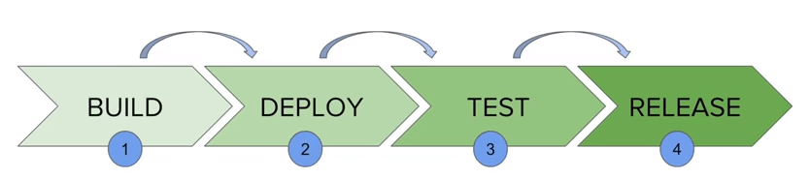
- Integration with Git: Jenkins integrates with Git repositories where developers collaborate and commit code changes.
  - It automatically detects changes in the repository and triggers the build process.
  - The build process includes compilation, testing, and error reporting, providing quick feedback to developers.
  - This ensures a faster development cycle without impacting the production environment.
- Automation in Continuous Delivery:
  - Jenkins automates tasks like managing dependencies and creating deployment artifacts.
  - Common artifacts include JAR files for Java applications and container images for containerized deployments.
  - These artifacts are pushed to appropriate repositories, ready for deployment.
- Robust Plugin Ecosystem:
  - Jenkins is open-source and extensible, supported by a large community.
  - Its extensive plugin library enables integration with tools for version control, source code management, testing frameworks, deployment, reporting, and more.
  - This modular design allows organizations to build flexible and highly customized pipelines tailored to their specific workflows.

Conclusion
Jenkins is a cornerstone tool in modern software development, empowering teams to automate and streamline their CI/CD workflows. By integrating with tools like Git and leveraging its extensive plugin ecosystem, Jenkins simplifies complex tasks such as building, testing, and deploying applications. Its flexibility, extensibility, and robust community support make it a reliable choice for organizations aiming to enhance their development pipelines. Whether it’s reducing errors, providing faster feedback, or enabling seamless delivery, Jenkins plays a crucial role in accelerating the software development lifecycle and supporting DevOps practices.

Integrating Git with Jenkins: A Complete Guide

Introduction
Continuous Integration (CI) is a core practice of modern DevOps. Integrating version control systems like Git with Jenkins empowers teams to automate code builds, tests & deployments seamlessly. In this article, we'll explore how to integrate Git with Jenkins and make the things automation.

Why Integrate Git with Jenkins?
- Automated Builds: Automatically trigger builds whenever code changes are pushed to the repository.
- Seamless Collaboration: Boost team productivity by catching and resolving issues early in the development pipeline, ensuring smoother workflows and fewer delays.
- Effortless Scalability: Streamline processes for large-scale projects, making it easier to manage distributed teams and complex workflows efficiently.

Prerequisites
- Jenkins installed and configured on your server.
- A Git repository (GitHub or BitBucket).
- Necessary Jenkins plugins (e.g., Git Plugin).

Step-by-Step Guide
STEP-1: Install Jenkins and setup dashboard
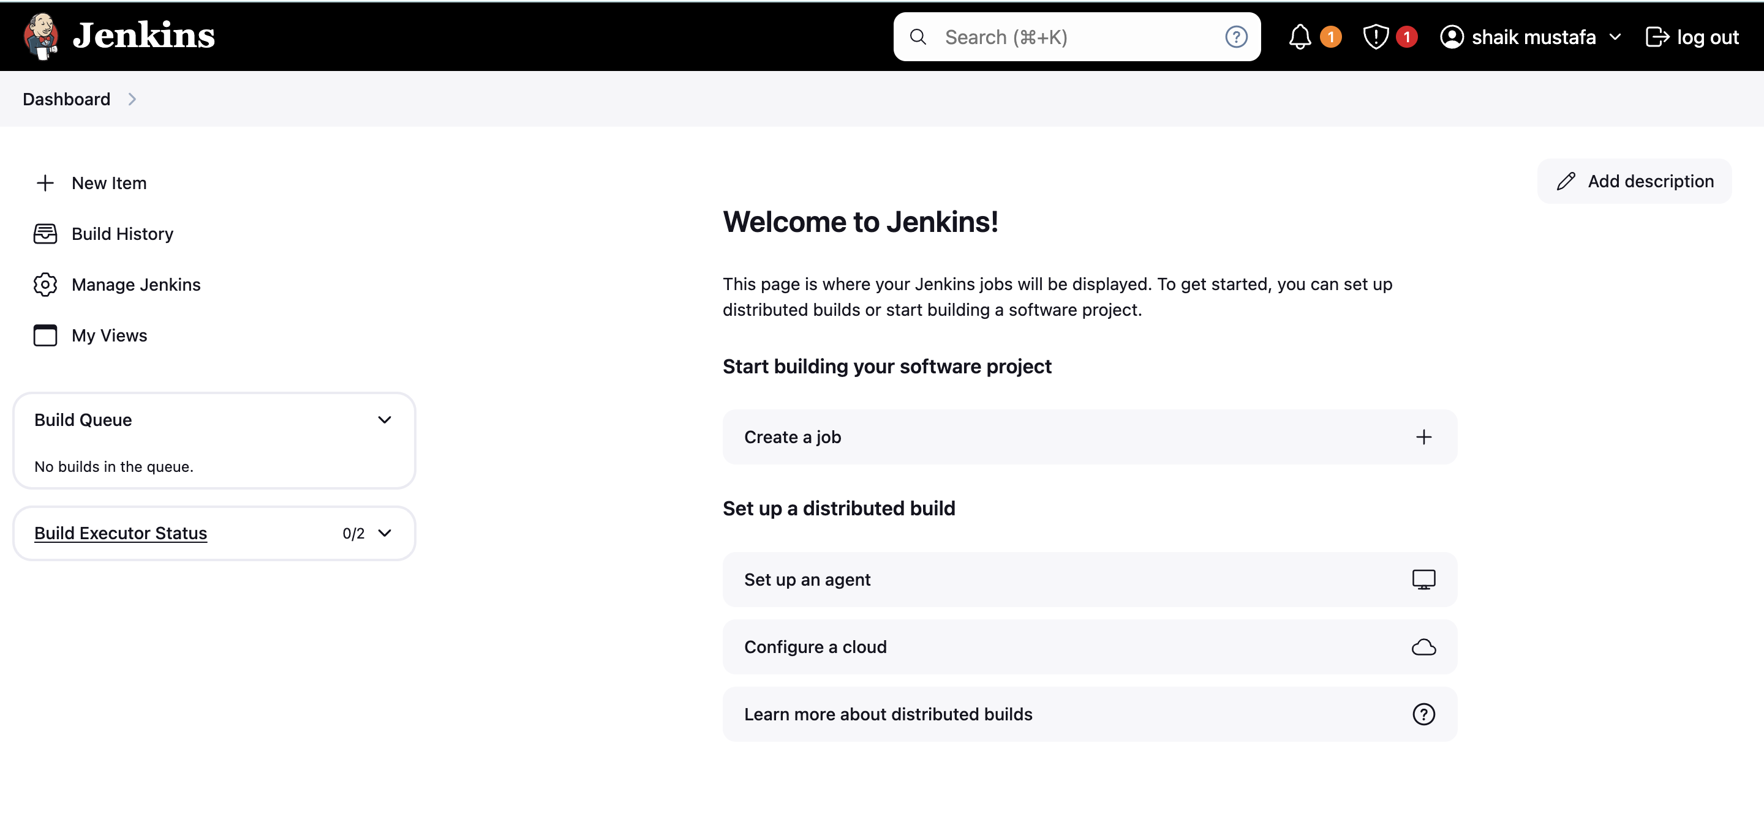
STEP-2: Install git on Jenkins server
Copy
Copy
yum install git -y
STEP-3: Open your github repo and copy https link (https://github.com/usubbu/one.git)
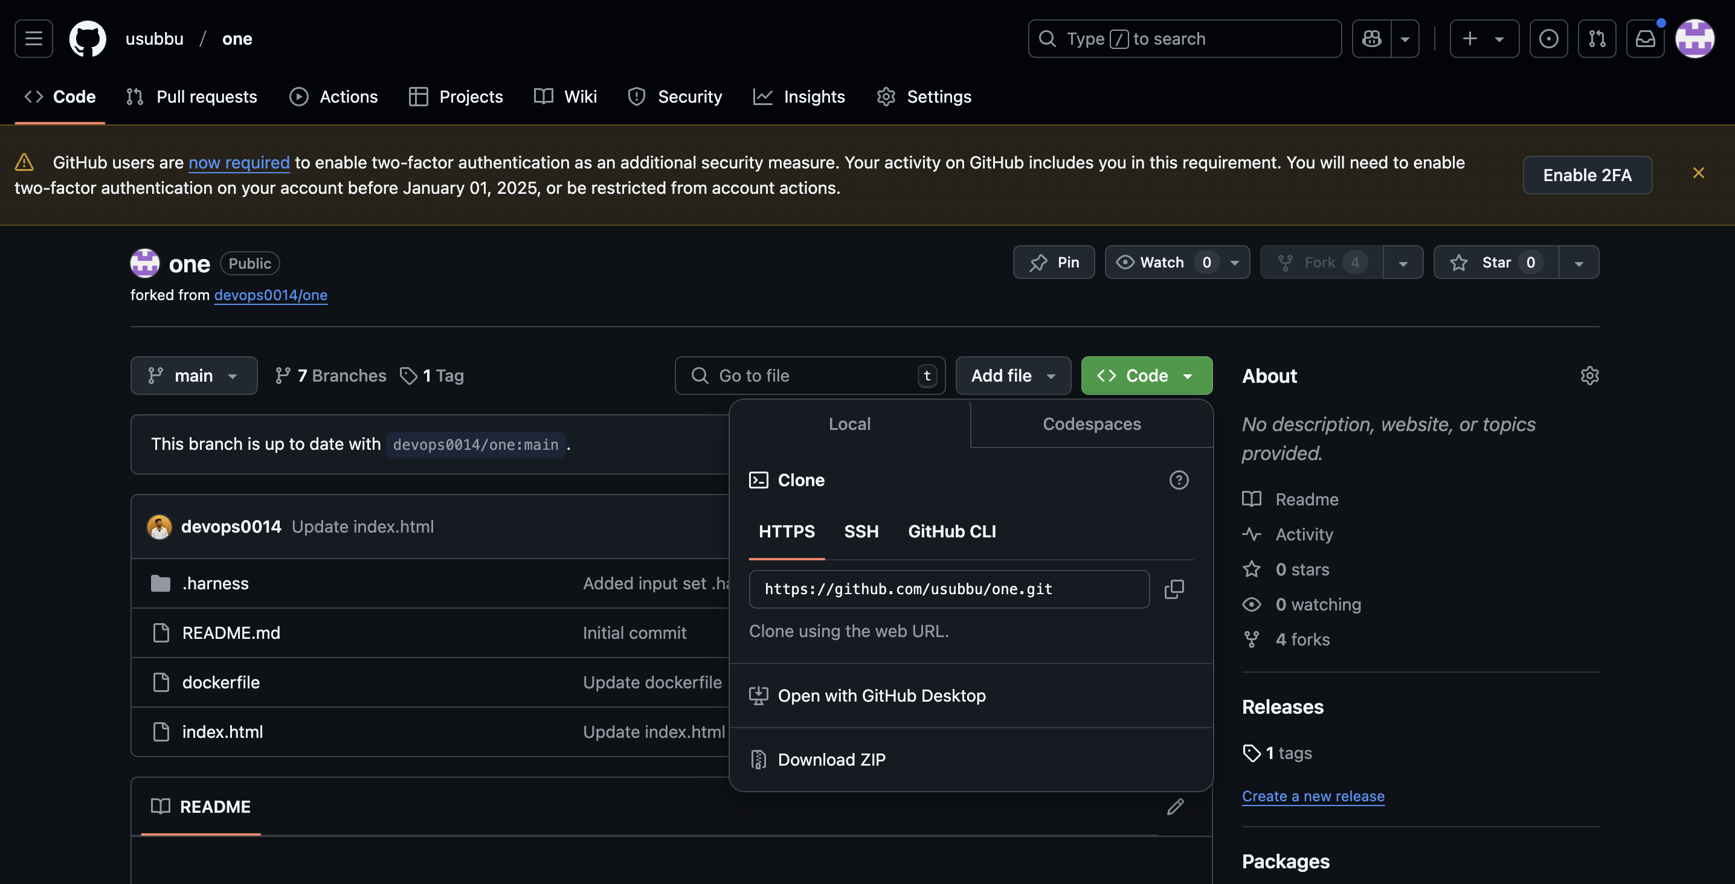
STEP-4: Go to jenkins dashboard, create a job
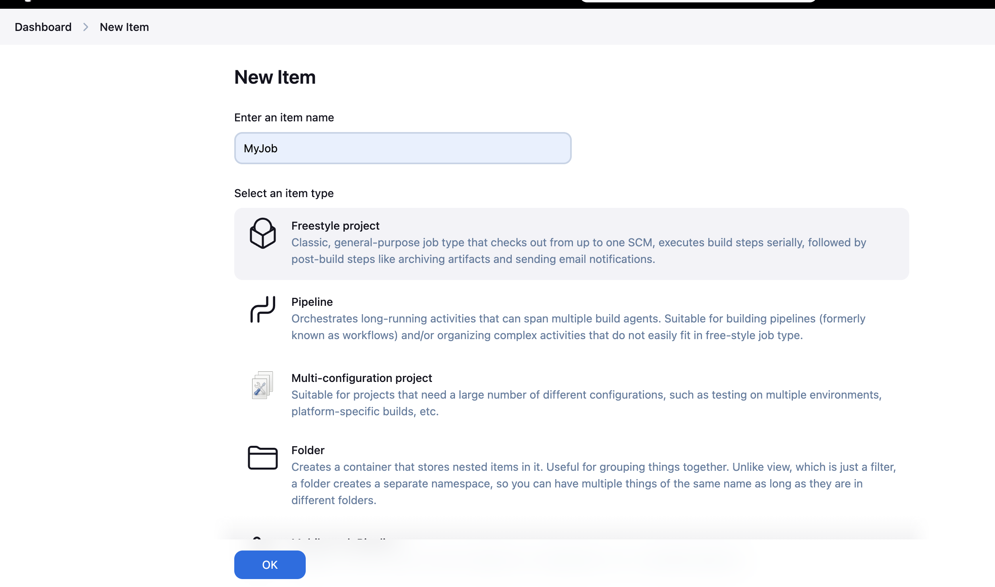
Now go to source code management and paste your repo-url and add the credentials
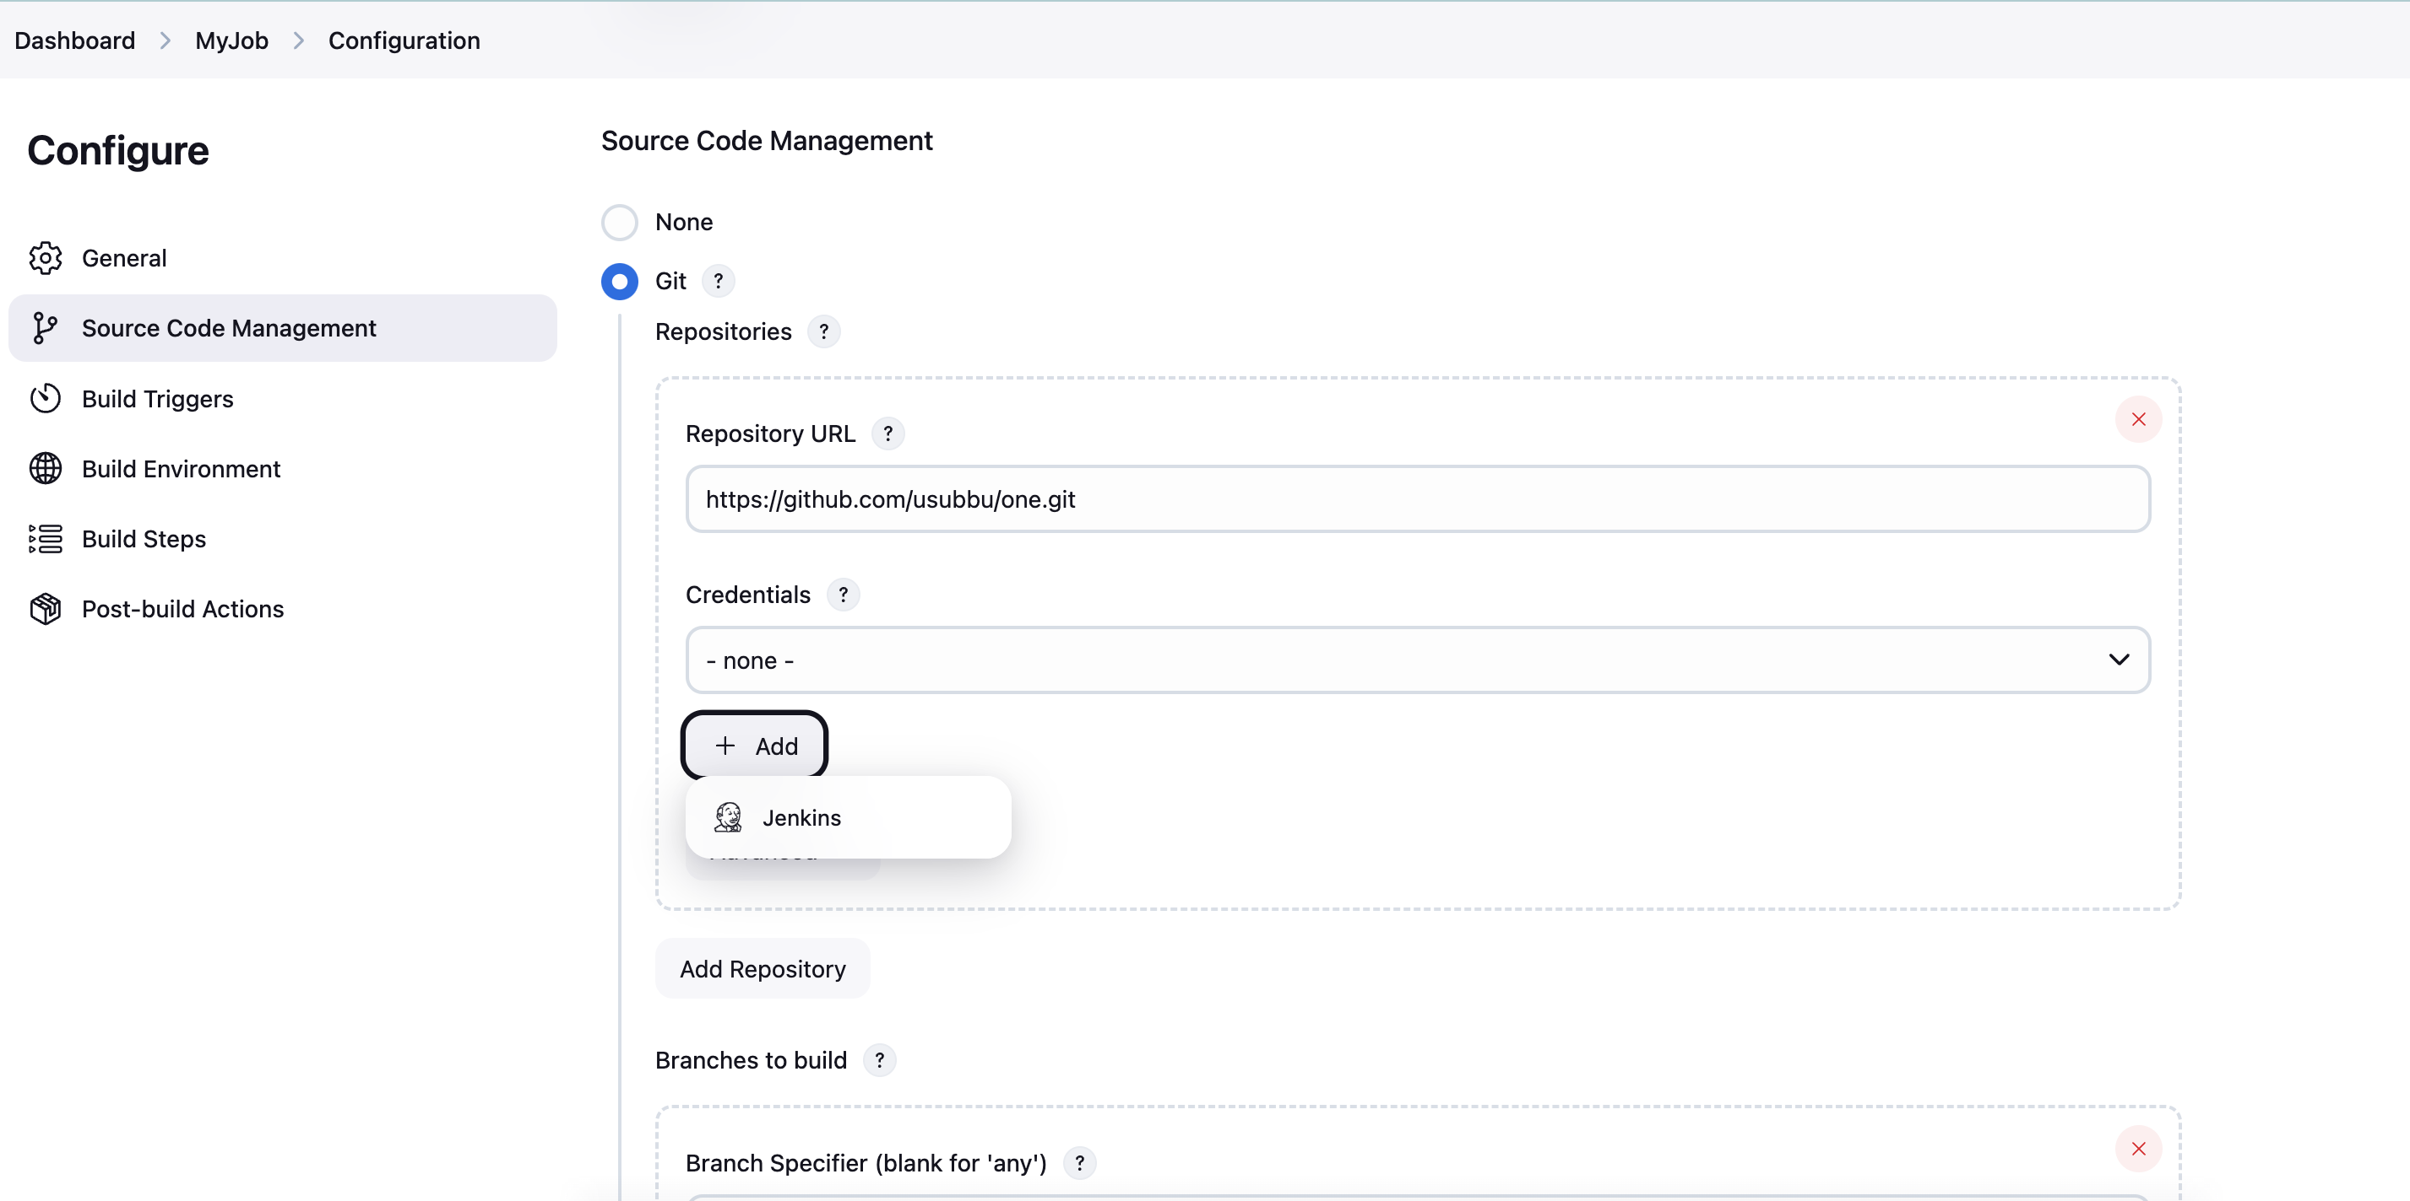
Username : <your github user-name>
Password: <Enter Github Token>
ID: github
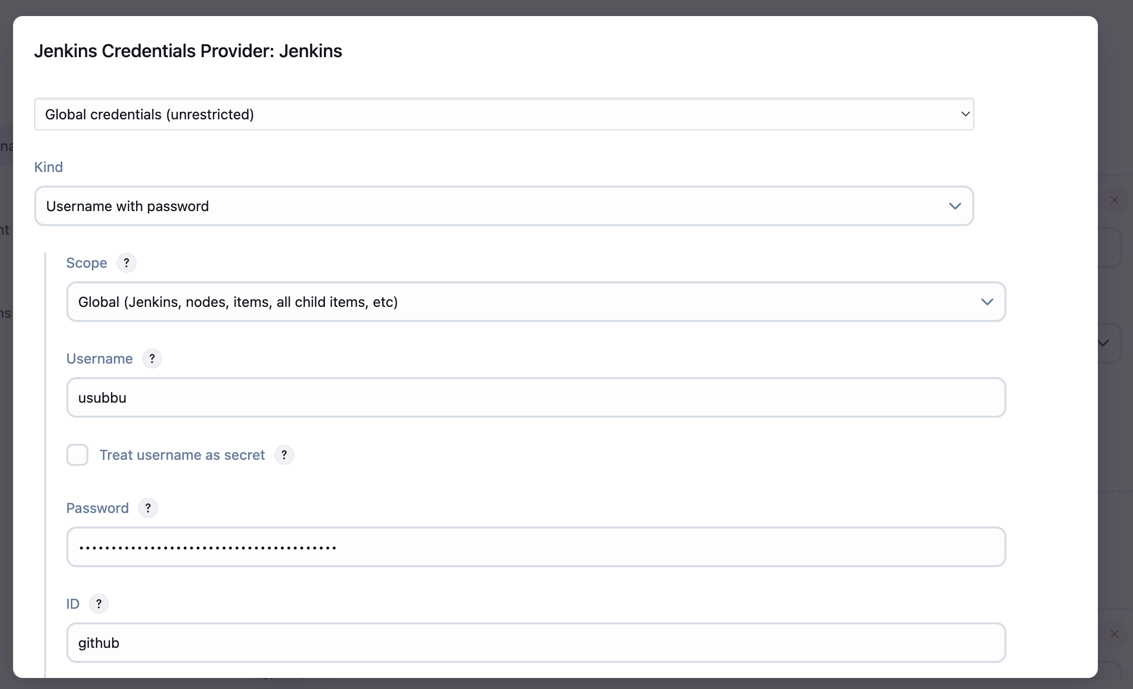
and click on add
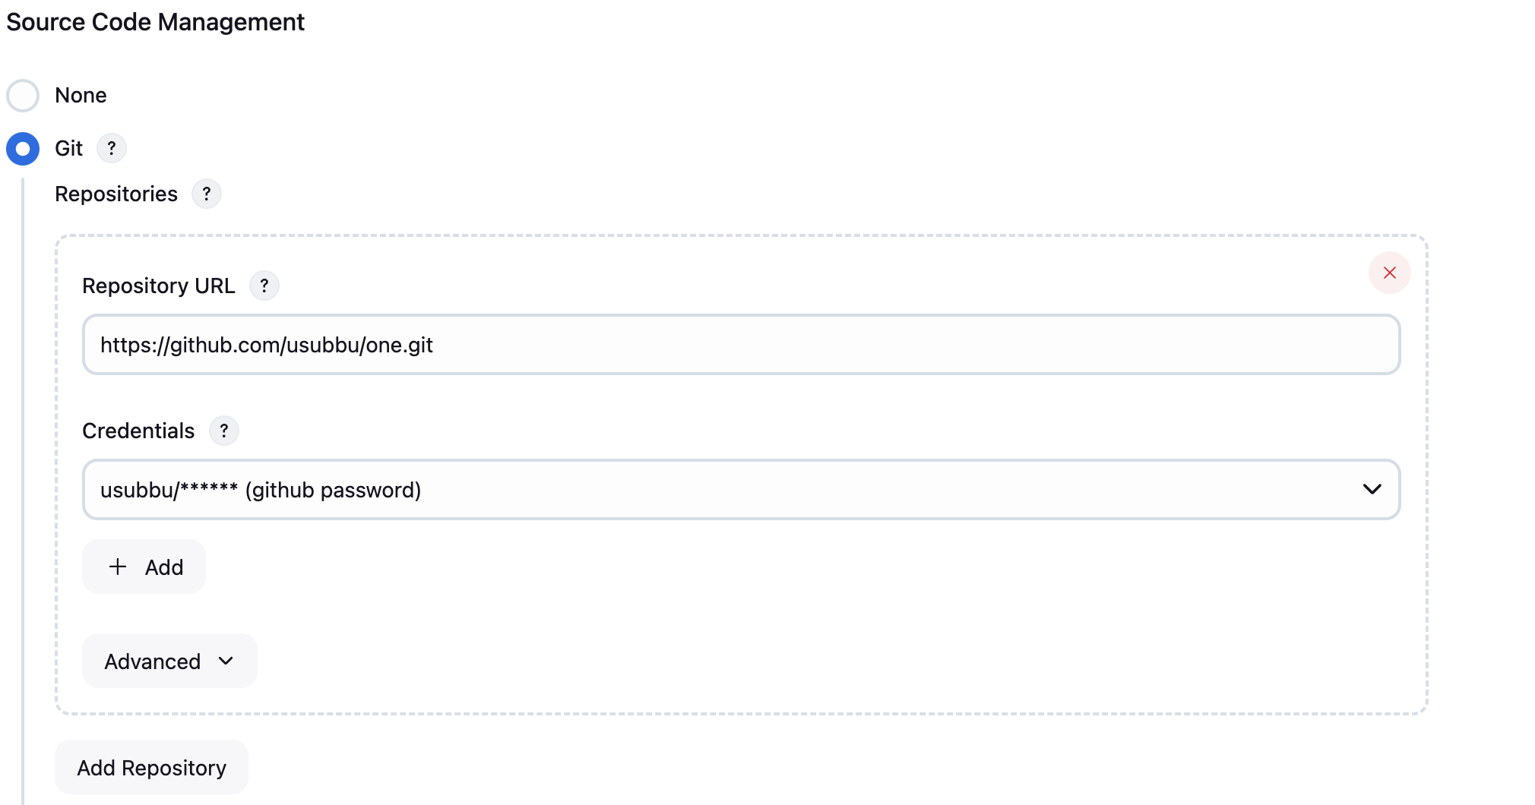
Now enter the branch name that you want to build. Bydefault it will be master, if you wish to build other branch make sure to change the branch name that you want to build.
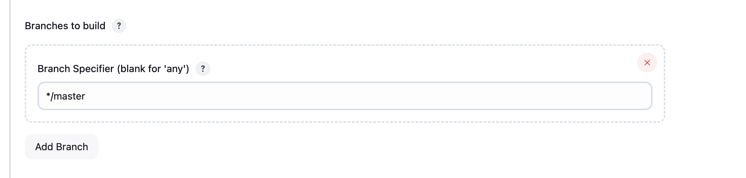
Now save the job and build it.
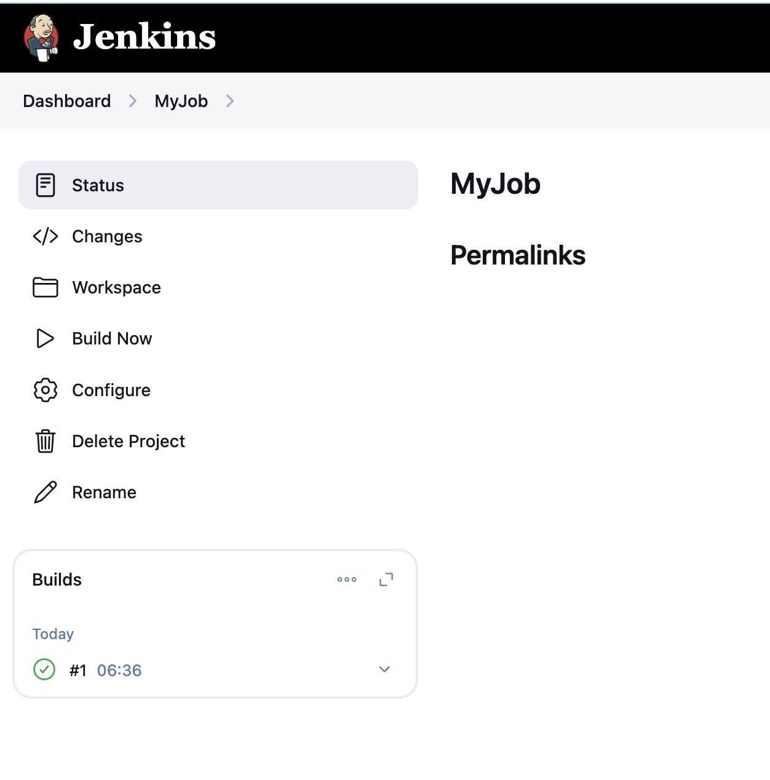
Hurray! Now we will get all the files from GitHub to CI Server. So developer make any changes in GitHub e have to build here in Jenkins.

Now lets make it automate - Whenever developer make some changes in GitHub, Jenkins has to trigger the build automatically. To implement it we can use the below concepts
- Webhooks
- Poll SCM
- Build Periodically

What is a Webhook?
A webhook is a way for one application to send real-time data to another application whenever a specific event occurs. In the context of Git and Jenkins, webhooks enable Jenkins to receive notifications from a Git repository (e.g., GitHub, GitLab) whenever a commit is pushed or a pull request is created.

How to Integrate Webhooks with Jenkins

Step 1: Configure Jenkins Job
- Go to the Jenkins dashboard and open the job configuration page.
- Scroll to the Build Triggers section.
- Select GitHub hook trigger for GITScm polling (if using GitHub).
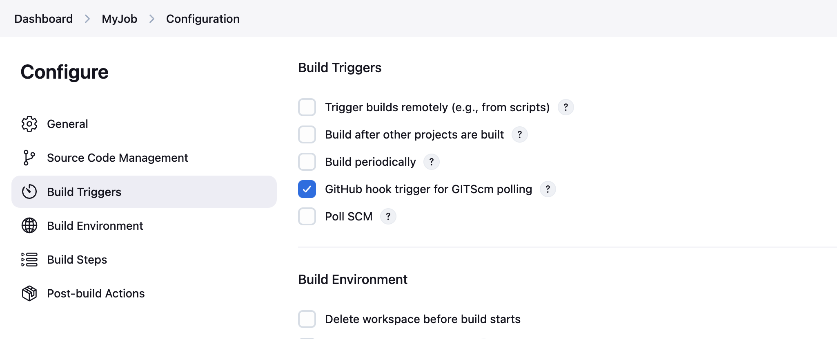
Now save the job

Step 2: Set Up Webhooks in the Git Repository
The process varies slightly depending on the Git platform (GitHub, GitLab, Bitbucket). Below is the guide for GitHub:
For GitHub:
- Go to your GitHub repository.
- Navigate to Settings > Webhooks.
- Click Add webhook.
- Fill out the form:
  - Payload URL: Enter the Jenkins webhook URL. It typically looks like this:
Copy
Copy
http://<JENKINS_URL>:<PORT>/github-webhook/
Example: http://192.168.1.100:8080/github-webhook/
  - Content Type: Select application/json.
  - Click Add webhook.
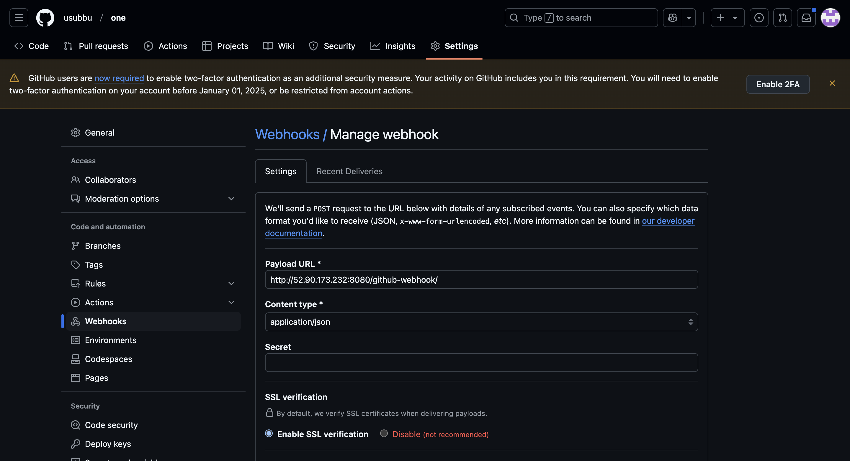
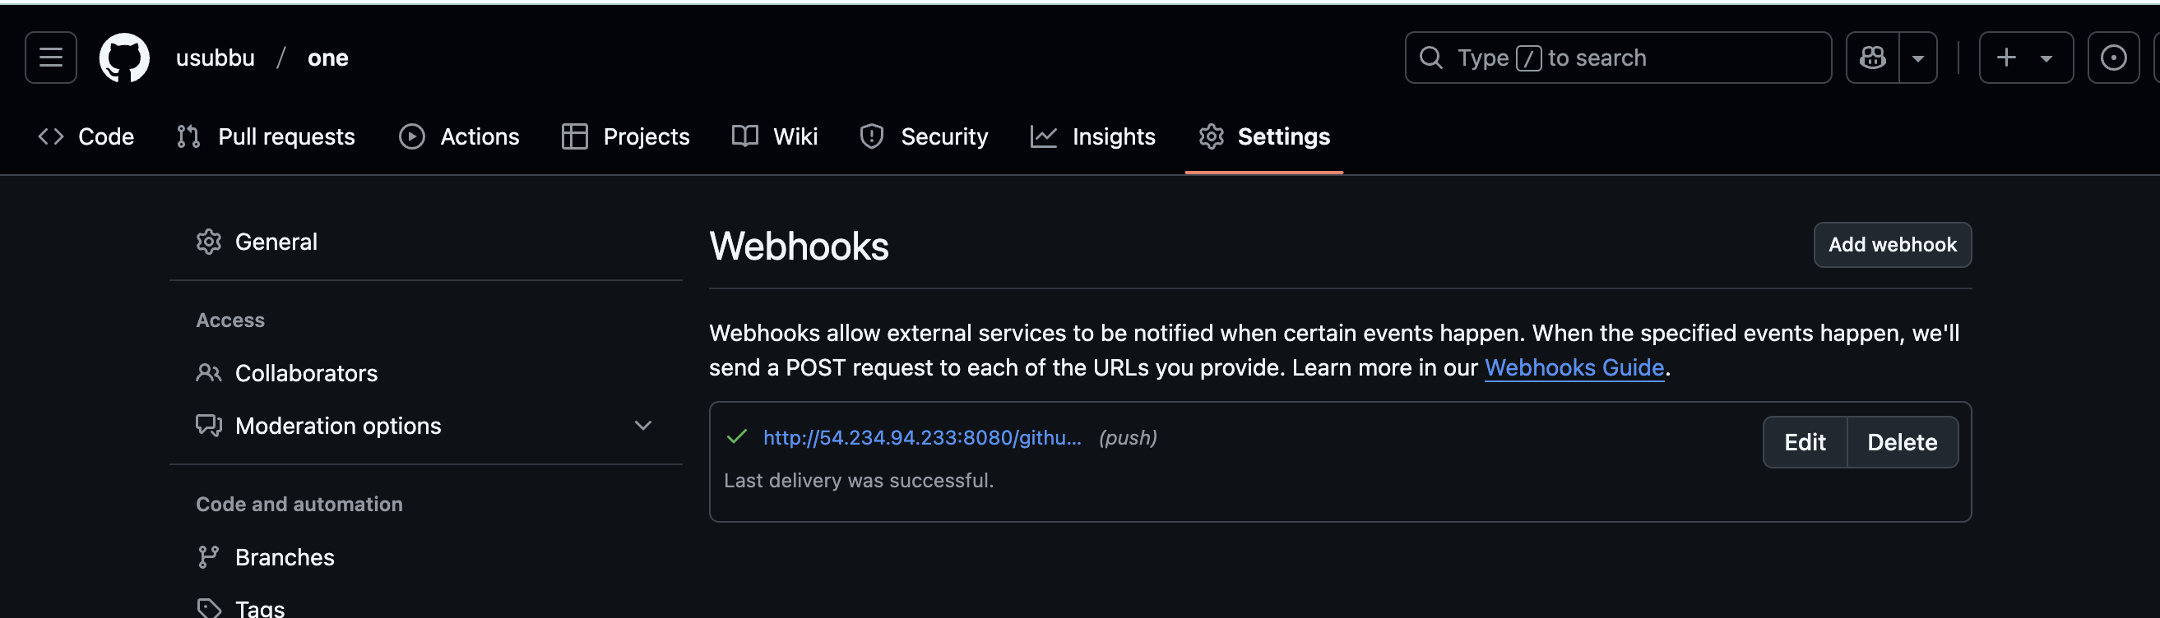
Now lets make some changes on GitHub, Jenkins will automatically trigger the job.
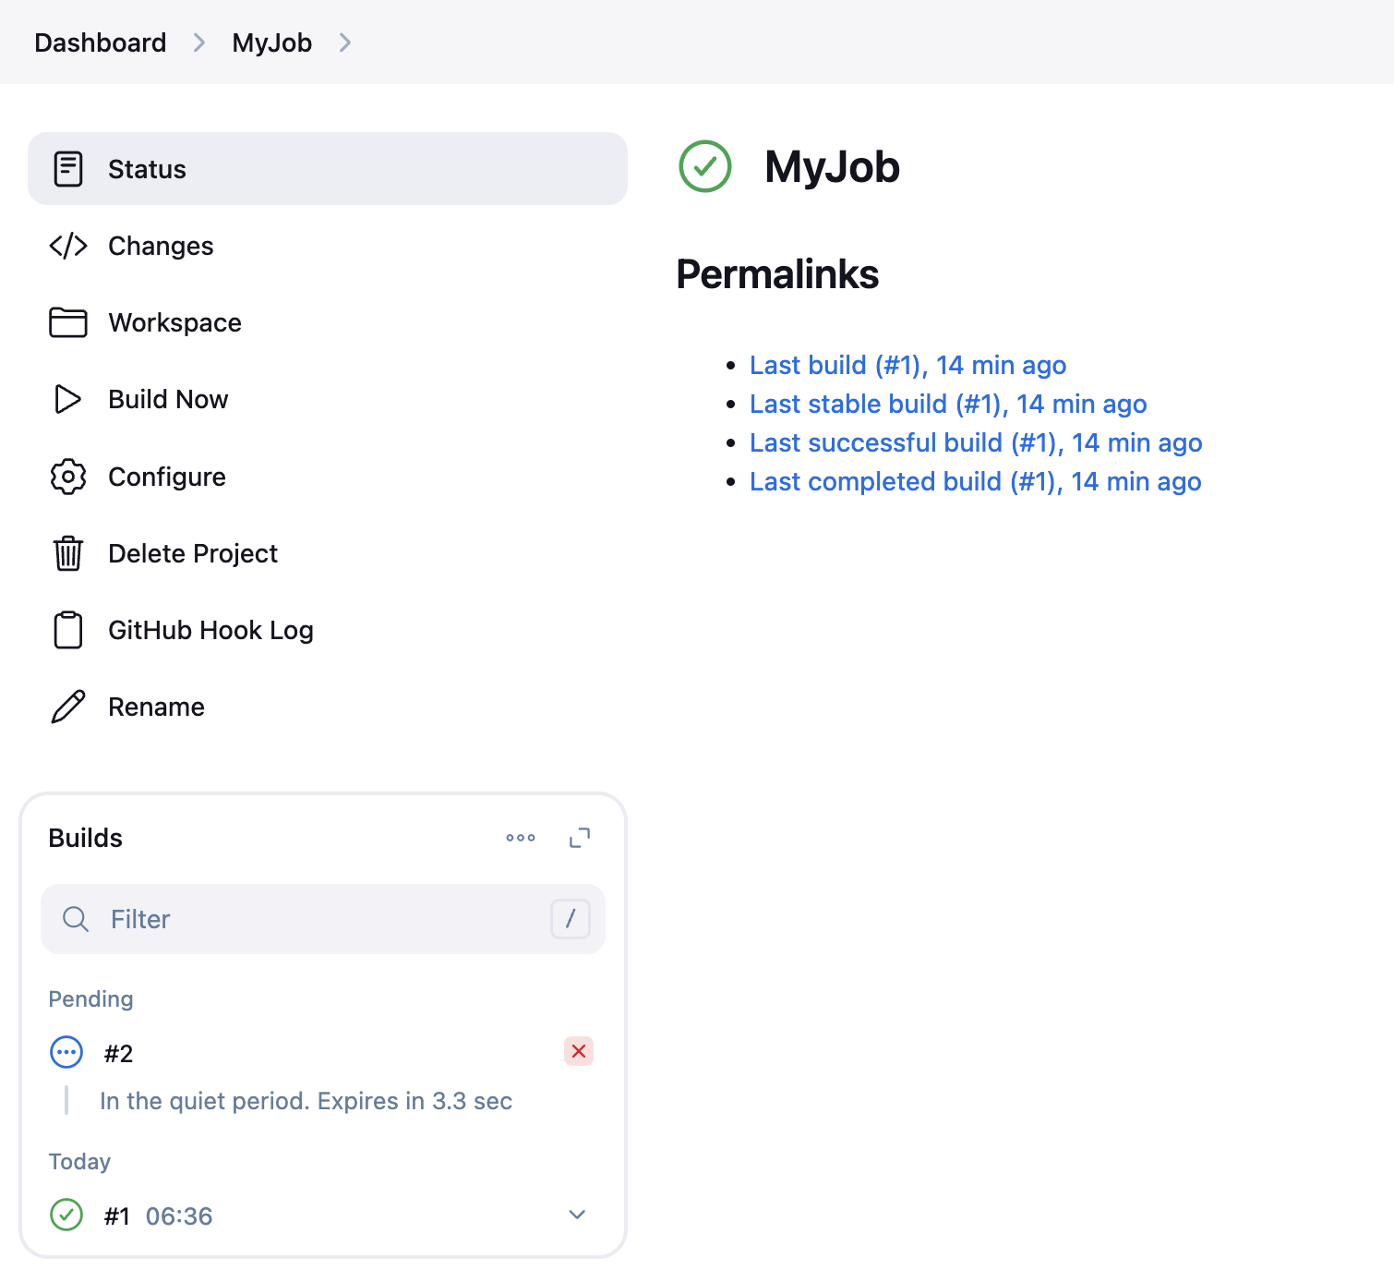
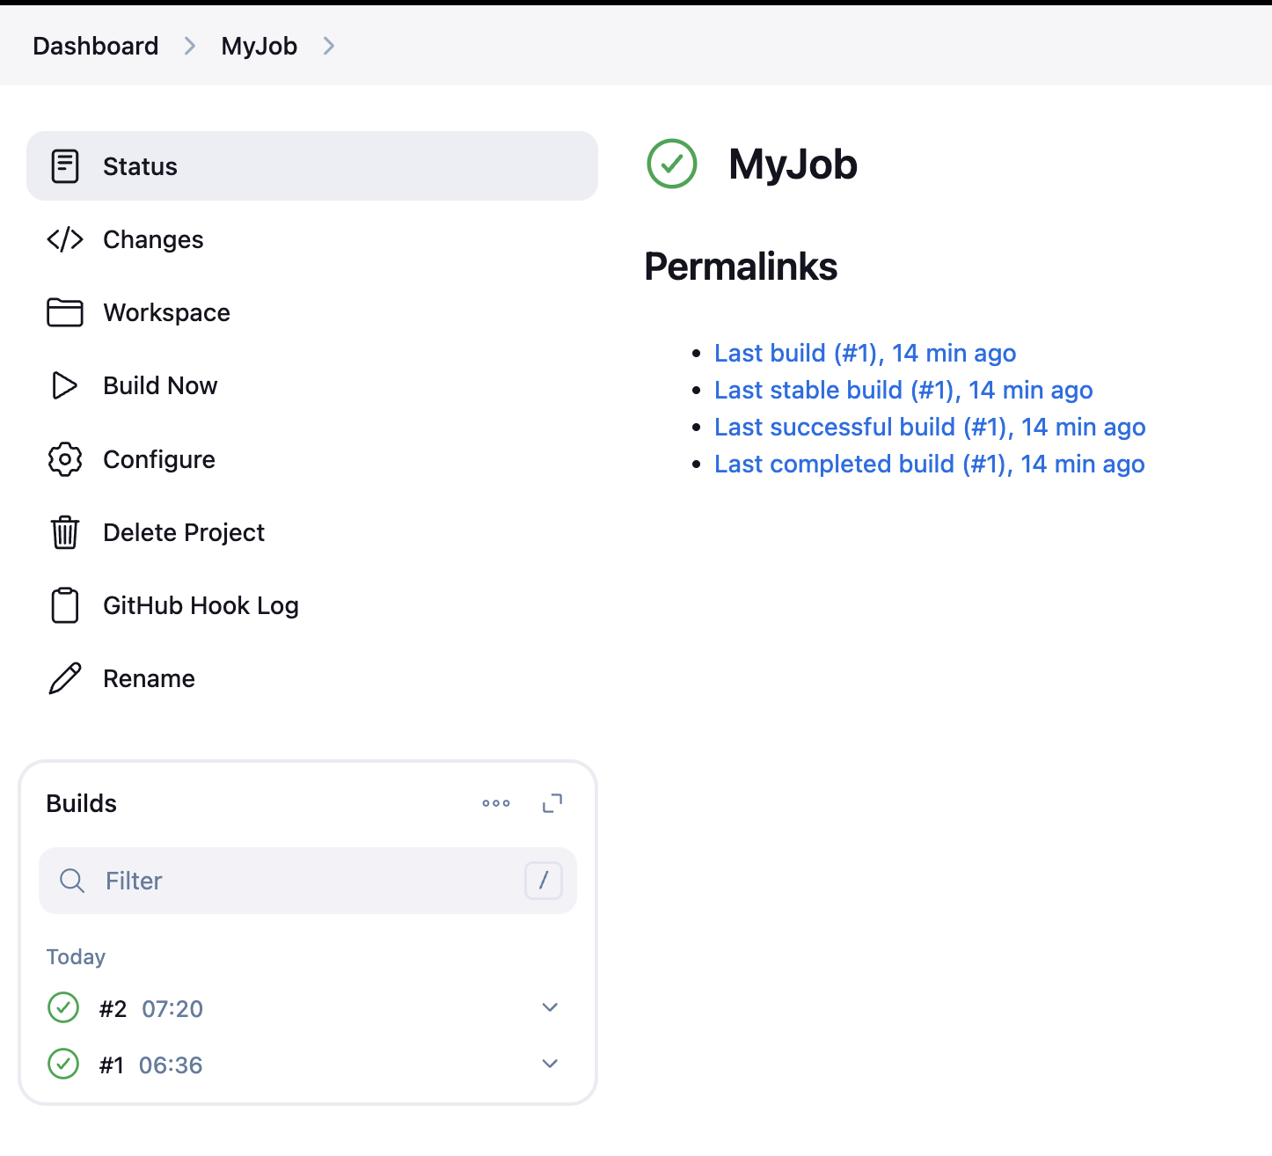

Benefits of Using Webhooks with Jenkins
- Instant Build Triggers: Eliminate delays caused by SCM polling.
- Resource Efficiency: Save CPU and bandwidth by avoiding periodic polling.
- Real-Time Feedback: Developers get faster feedback on code changes.

What is Poll SCM?
Poll SCM is a Jenkins feature used to periodically check a Source Code Management (SCM) repository (like Git) for changes. If any changes are detected, Jenkins triggers a build. Unlike webhooks (which push changes to Jenkins in real time), Poll SCM uses a schedule-based mechanism to pull updates from the repository.

How Does Poll SCM Work?
- Jenkins queries the repository at regular intervals (as per the configured schedule).
- It checks for new commits, branch updates, or tags.
- If a change is found, Jenkins triggers the associated job or pipeline.

Advantages of Poll SCM:
- Simple Setup: No external configurations like webhooks are needed.
- Supports All SCMs: Works with any source code management system supported by Jenkins.

How to Configure Poll SCM in Jenkins

Step 1: Configure Jenkins Job
- Go to the Jenkins dashboard and open the job configuration page.
- Scroll to the Build Triggers section.
- Select the checkbox for Poll SCM.
- In the Schedule field, define the polling schedule using Cron syntax.
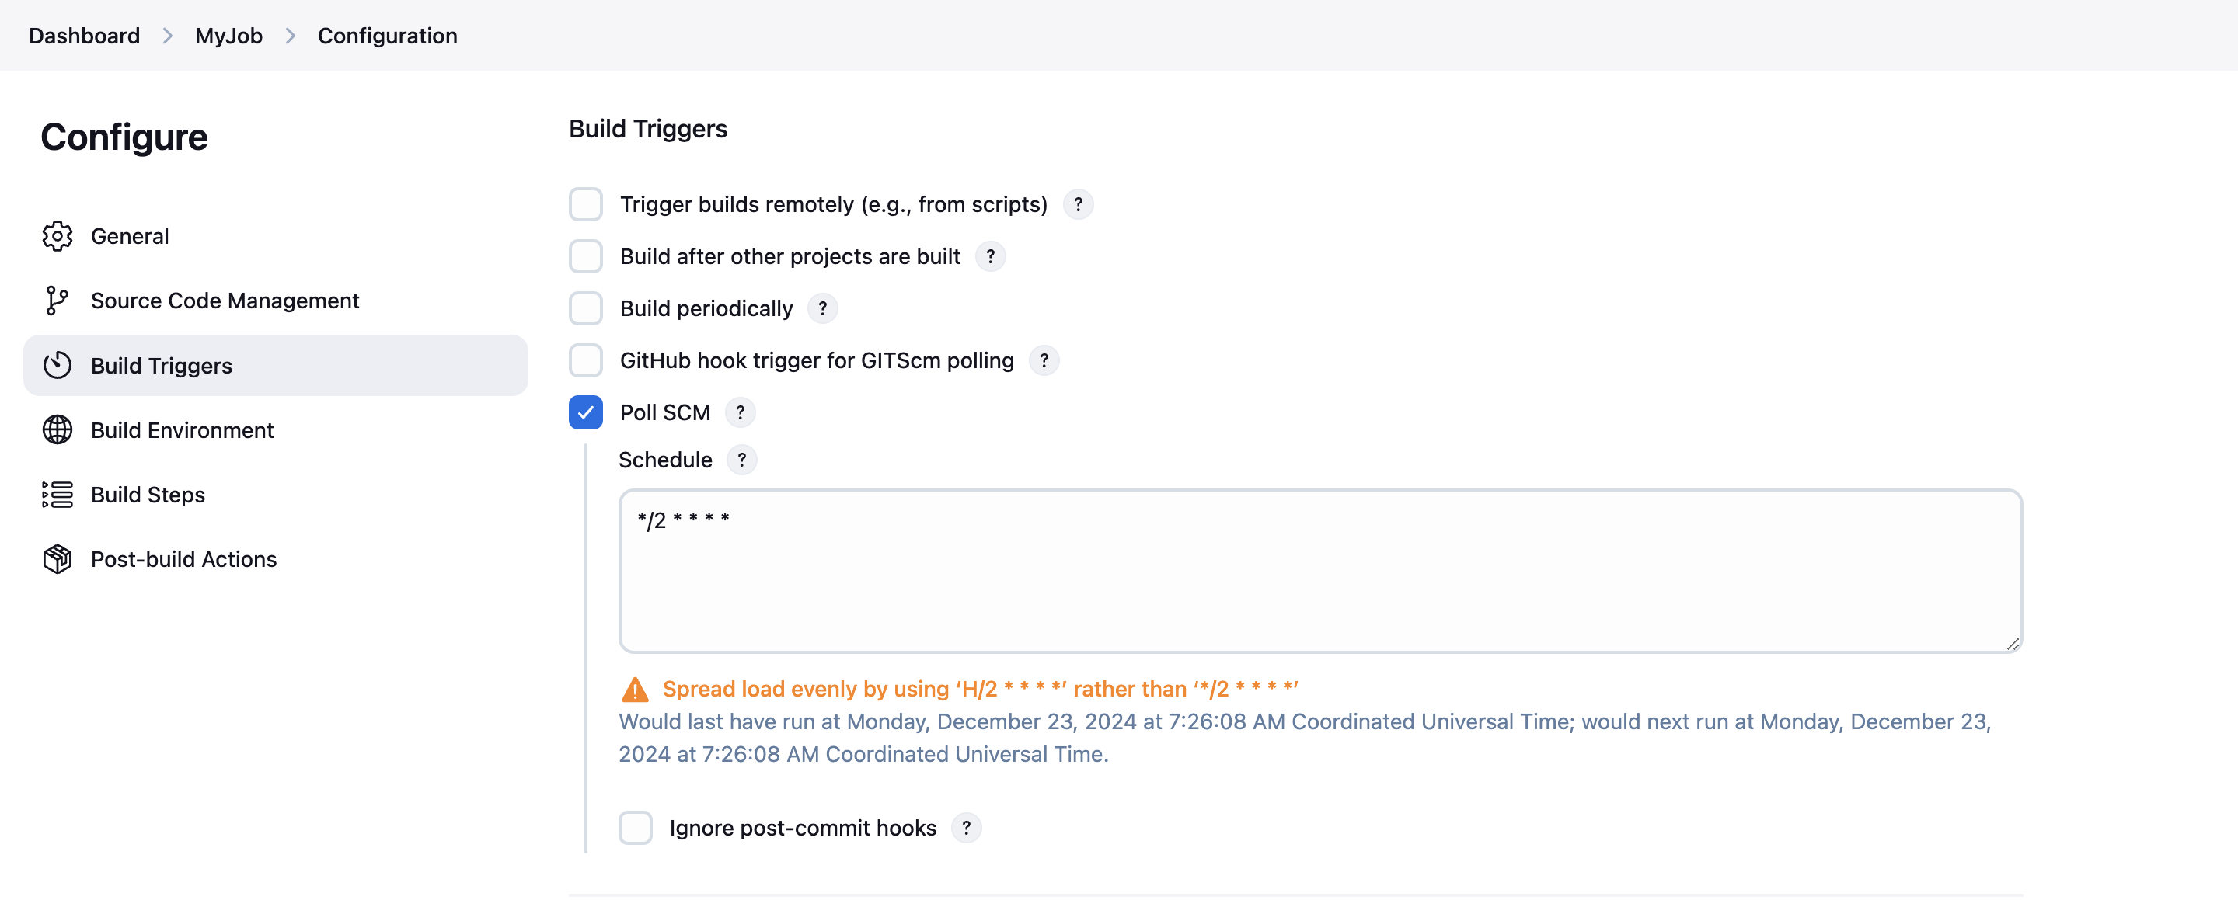
I have scheduled the job for every 2nd minute using Cron syntax, Now Jenkins automatically check for every 2 minutes weather any changes are available on GitHub or not. If Jenkins found new commits then it will trigger the jobs.

What is Cron Syntax?
Cron syntax is a format used to define schedules for recurring tasks. In Jenkins, it is used to schedule tasks like polling a source code repository or triggering builds at specific intervals.
A Cron expression consists of five fields that specify the time and frequency of execution:
Field | Allowed Values | Description
MINUTE | 0-59 | Minute of the hour
HOUR | 0-23 | Hour of the day
DOM | 1-31 | Day of the month
MONTH | 1-12 (or names) | Month (e.g., 1 = January, 2 = February)
DOW | 0-7 (or names) | Day of the week (0/7 = Sunday)
- Use * to represent "every value."
- Use H for hashed values (randomized to distribute workload).

Examples of Cron Syntax in Jenkins
- Every 5 minutes:
H/5 * * * *
- Every day at midnight:
0 0 * * *
- Every Monday at 9:00 AM:
0 9 * * 1
- Every 15 minutes during office hours (9 AM to 5 PM):
H/15 9-17 * * *
- On the 1st and 15th of every month at 6:00 PM:
0 18 1,15 * *
- At 3:30 PM on weekdays:
30 15 * * 1-5

What is Build Periodically in Jenkins?
Build Periodically is a feature in Jenkins that allows you to schedule builds at regular intervals without relying on external events like code changes in the repository or webhook triggers. It uses a cron-like syntax to define the schedule, enabling automated and recurring builds at specific times.

Key Use Cases of Build Periodically:
- Scheduled Jobs: Run nightly builds or periodic tasks, such as regression tests, backups, or report generation.
- Environment Maintenance: Schedule regular updates for infrastructure or deployment pipelines.
- Testing Pipelines: Continuously verify your builds and deployments even when there are no code changes.

How to Integrate Build Periodically with Jenkins

Step 1: Configure Jenkins Job
- Go to the Jenkins dashboard and open the job configuration page.
- Scroll to the Build Triggers section.
- Select the checkbox for Build periodically.

Step 3: Define the Schedule
- In the Schedule text box, specify the frequency using cron-like syntax.
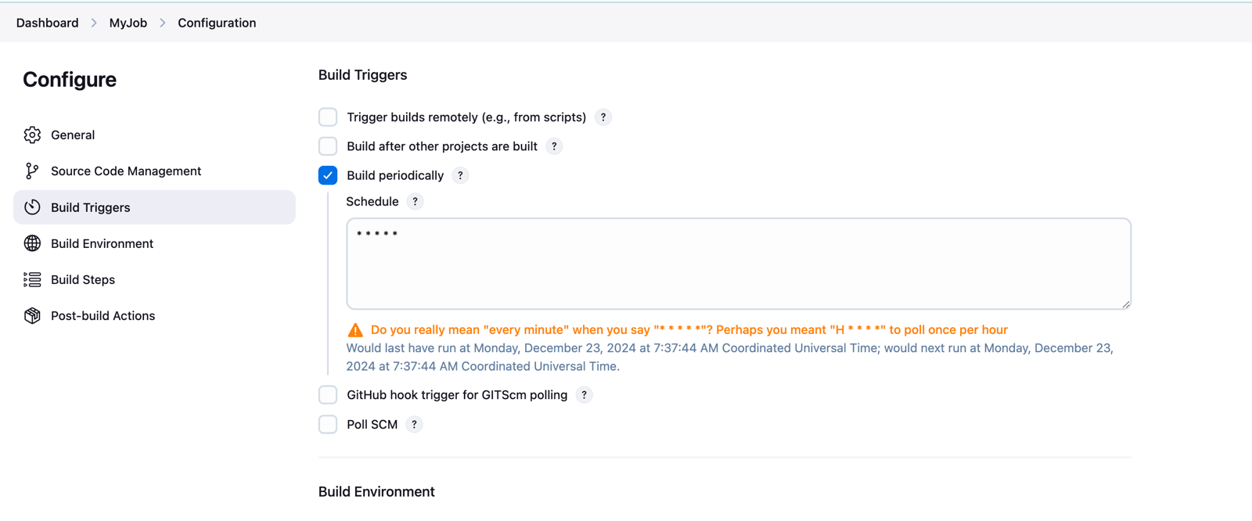
save the job.
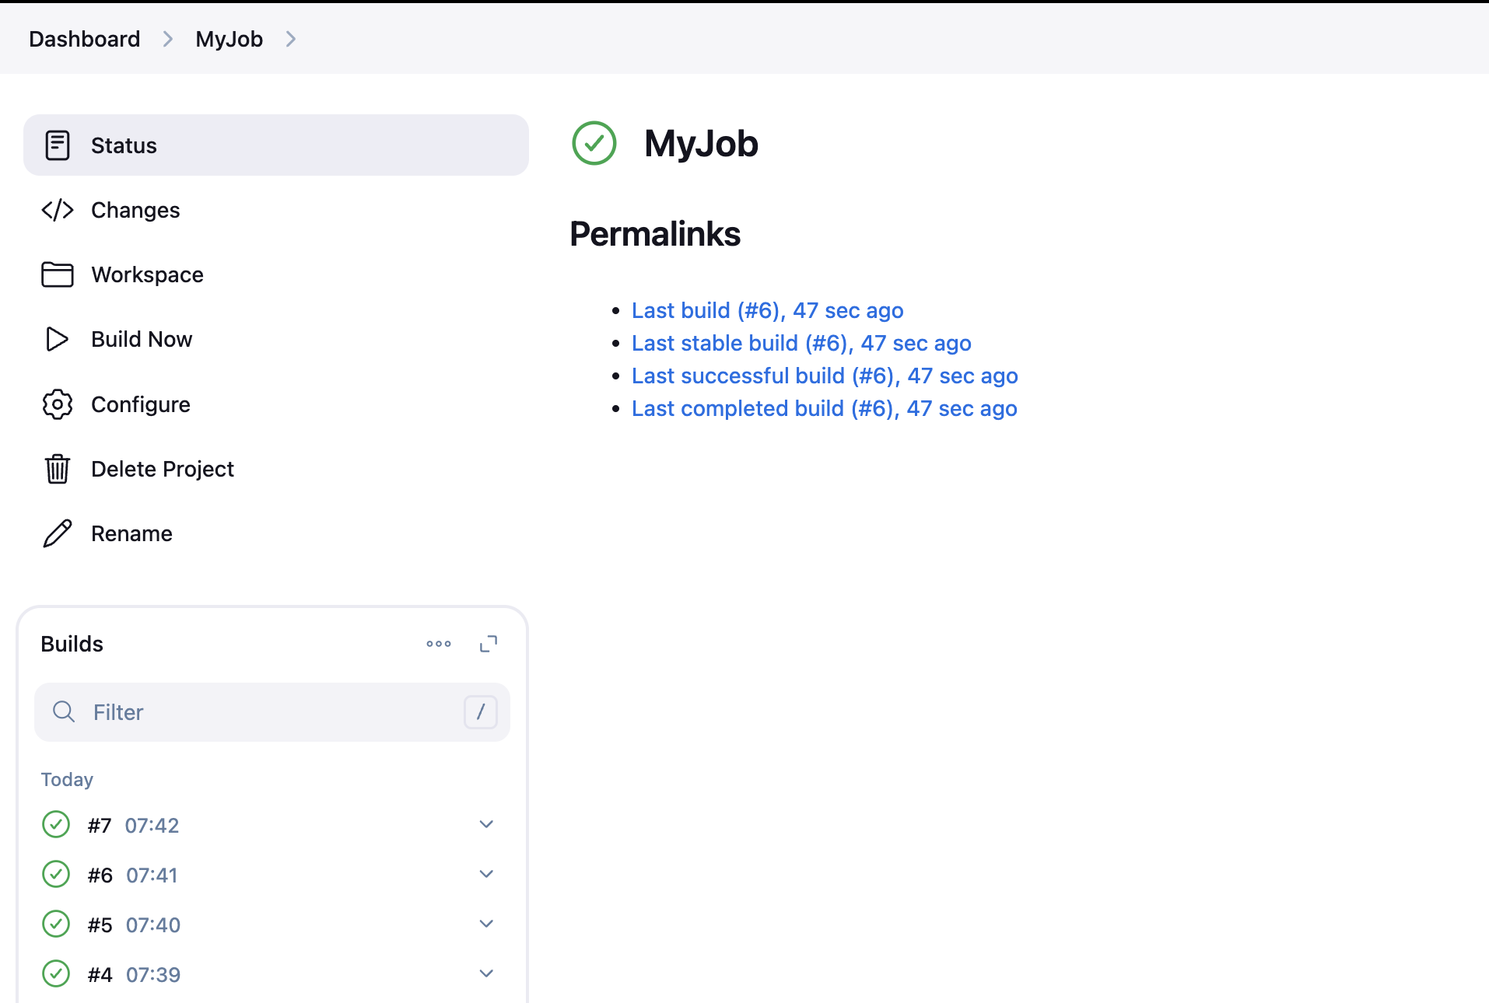
Now Jenkins will trigger the jobs automatically, it is independent of code i.e.. even if we will not make any changes in code, it will trigger the jobs based on the schedule.

Difference b/w Webhooks, Build Periodically & Poll SCM

Scenario: Automating Builds for a GitHub Repository
- Webhooks:
  - A developer pushes code to the main branch.
  - GitHub sends a webhook request to Jenkins, triggering an immediate build.
  - Ideal for active development teams.
- Poll SCM:
  - Jenkins checks the repository every 5 minutes.
  - If changes are detected in the main branch, it triggers a build.
  - Slight delay but works even if webhooks are unavailable.
- Build Periodically:
  - Jenkins triggers a build every night at midnight.
  - Useful for nightly regression testing or scheduled tasks unrelated to code changes.

Conclusion
Integrating Git with Jenkins is a game-changer for modern software development, enabling teams to streamline CI workflows. By following this guide, you

Deploy a Java Application using Jenkins

Introduction
In today’s fast-paced software development world, Continuous Integration and Continuous Deployment (CI/CD) streamline application delivery. In this blog, we’ll discuss how to deploy a Java-based application to an Apache Tomcat server using a CI/CD pipeline. We'll use Jenkins for automation, Maven for build management, and Git for version control.

Understanding the Tools
- Git: Stores your application code and tracks changes.
- Maven: Builds and manages Java projects by handling dependencies.
- Jenkins: Automates the CI/CD process by integrating code building, testing, and deployment.
- Tomcat: A popular server for hosting Java-based applications.
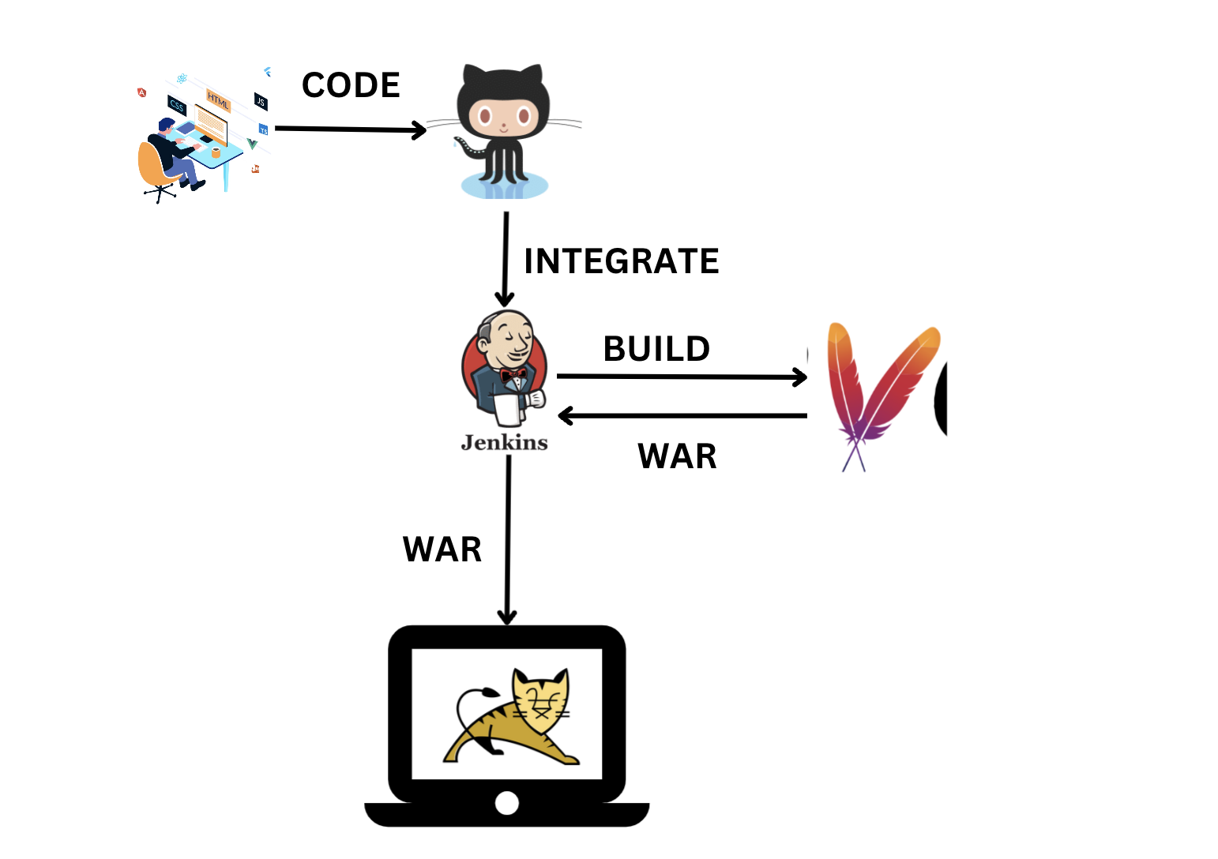

Real-Time Scenario
Imagine a software team working on an e-commerce web application. Every time a developer updates the product catalog, they push the changes to GitHub. Jenkins automatically:
- Pulls the updated code.
- Builds the application using Maven.
- Perform the unit test using Maven.
- Deploys the new version to Tomcat.
This process minimizes manual effort and ensures the application is always up-to-date.

Steps to Deploy a Java-Based Application Using CI/CD
STEP-1: Launch 2 EC2 Instances (Kernel 5.10)
- Jenkins Server
- Tomcat Server
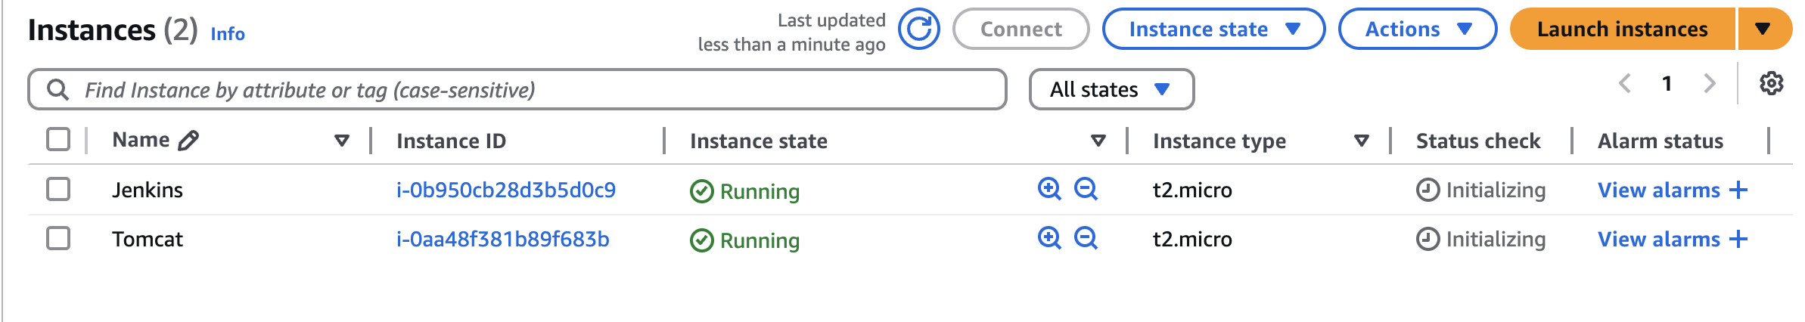
STEP-2: Connect Jenkins server and Install Jenkins & GIT
Copy
#STEP-1: INSTALLING GIT
yum install git -y

#STEP-2: GETTING THE REPO (jenkins.io --> download -- > redhat)
sudo wget -O /etc/yum.repos.d/jenkins.repo https://pkg.jenkins.io/redhat-stable/jenkins.repo
sudo rpm --import https://pkg.jenkins.io/redhat-stable/jenkins.io-2023.key

#STEP-3: DOWNLOAD JAVA17 AND JENKINS
yum install java-17-amazon-corretto -y
yum install jenkins -y

#STEP-4: RESTARTING JENKINS (when we download service it will on stopped state)
systemctl start jenkins.service
systemctl status jenkins.service
Now copy the public-ip of your system and access it with 8080 port.
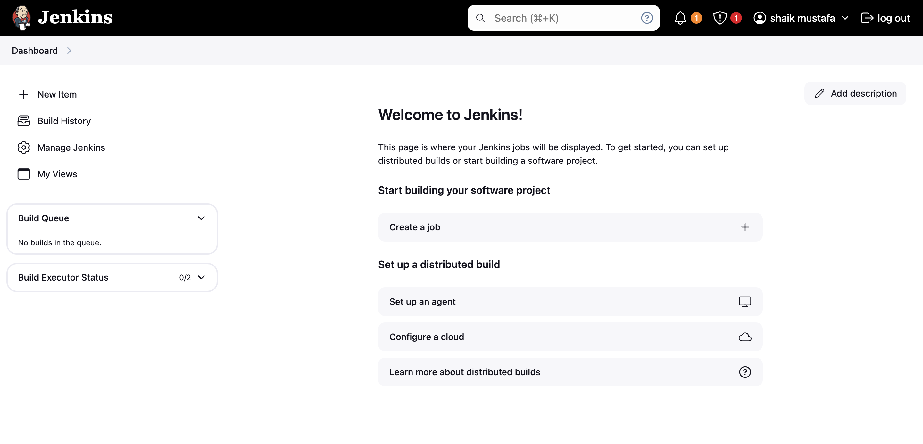
STEP-3: Now Install Deploy to container plugin
Go to Manage Jenkins » Plugins » Available Plugins » Deploy to container
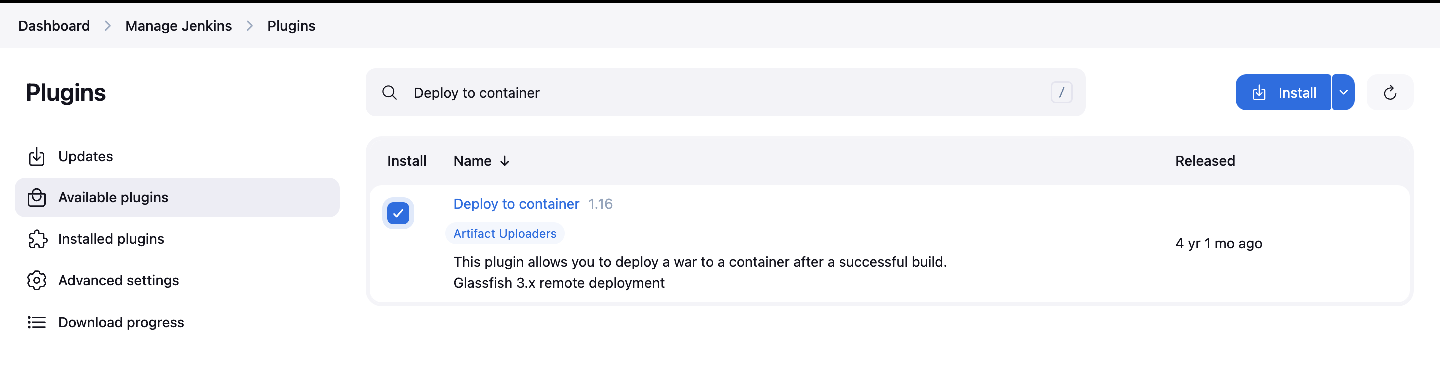
STEP-4: Integrate Maven
Go to Manage Jenkins » tools and select maven
under the Maven Installations click on Add Maven
Name: mymaven
Version: default (3.9.9)
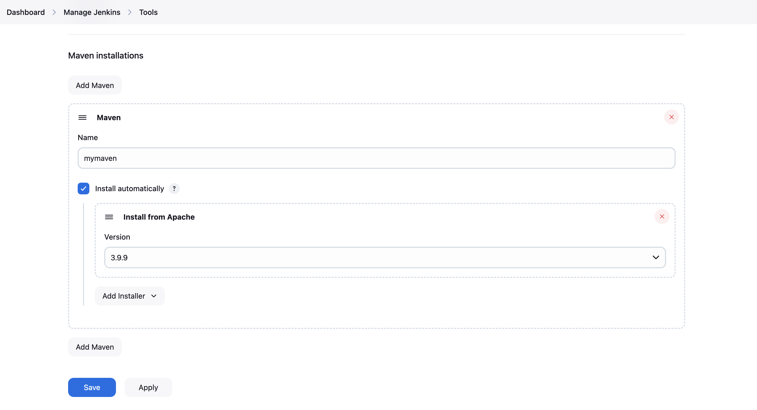
Now click on save
STEP-5: Create a Free Style Job
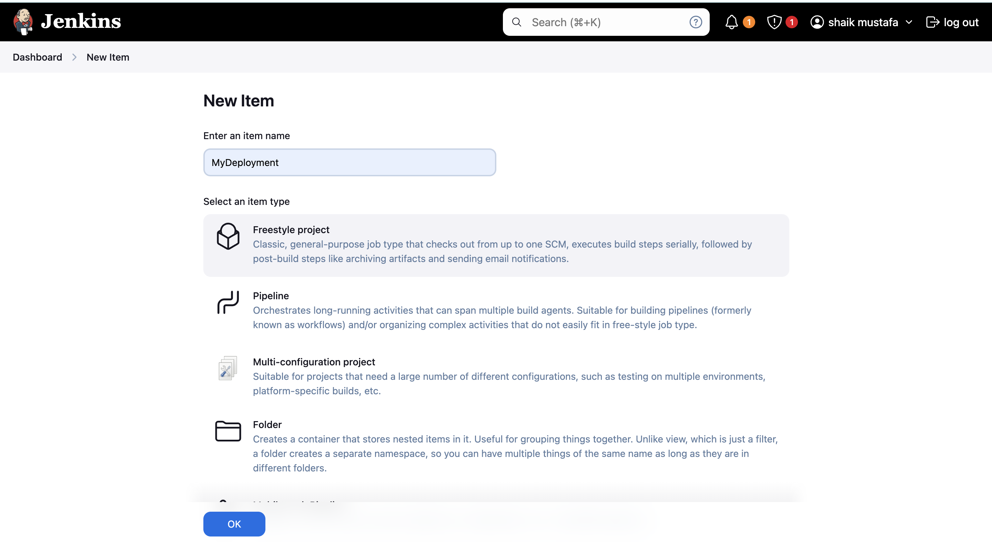
Go to Source Code Management and select Git and enter the repo-url (https://github.com/usubbu/one.git)
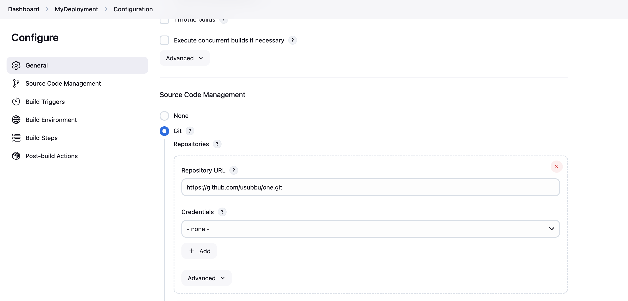
Go to Build Steps and select Invoke top-level Maven targets and select the Maven version as mymaven
Now enter the goal as clean package
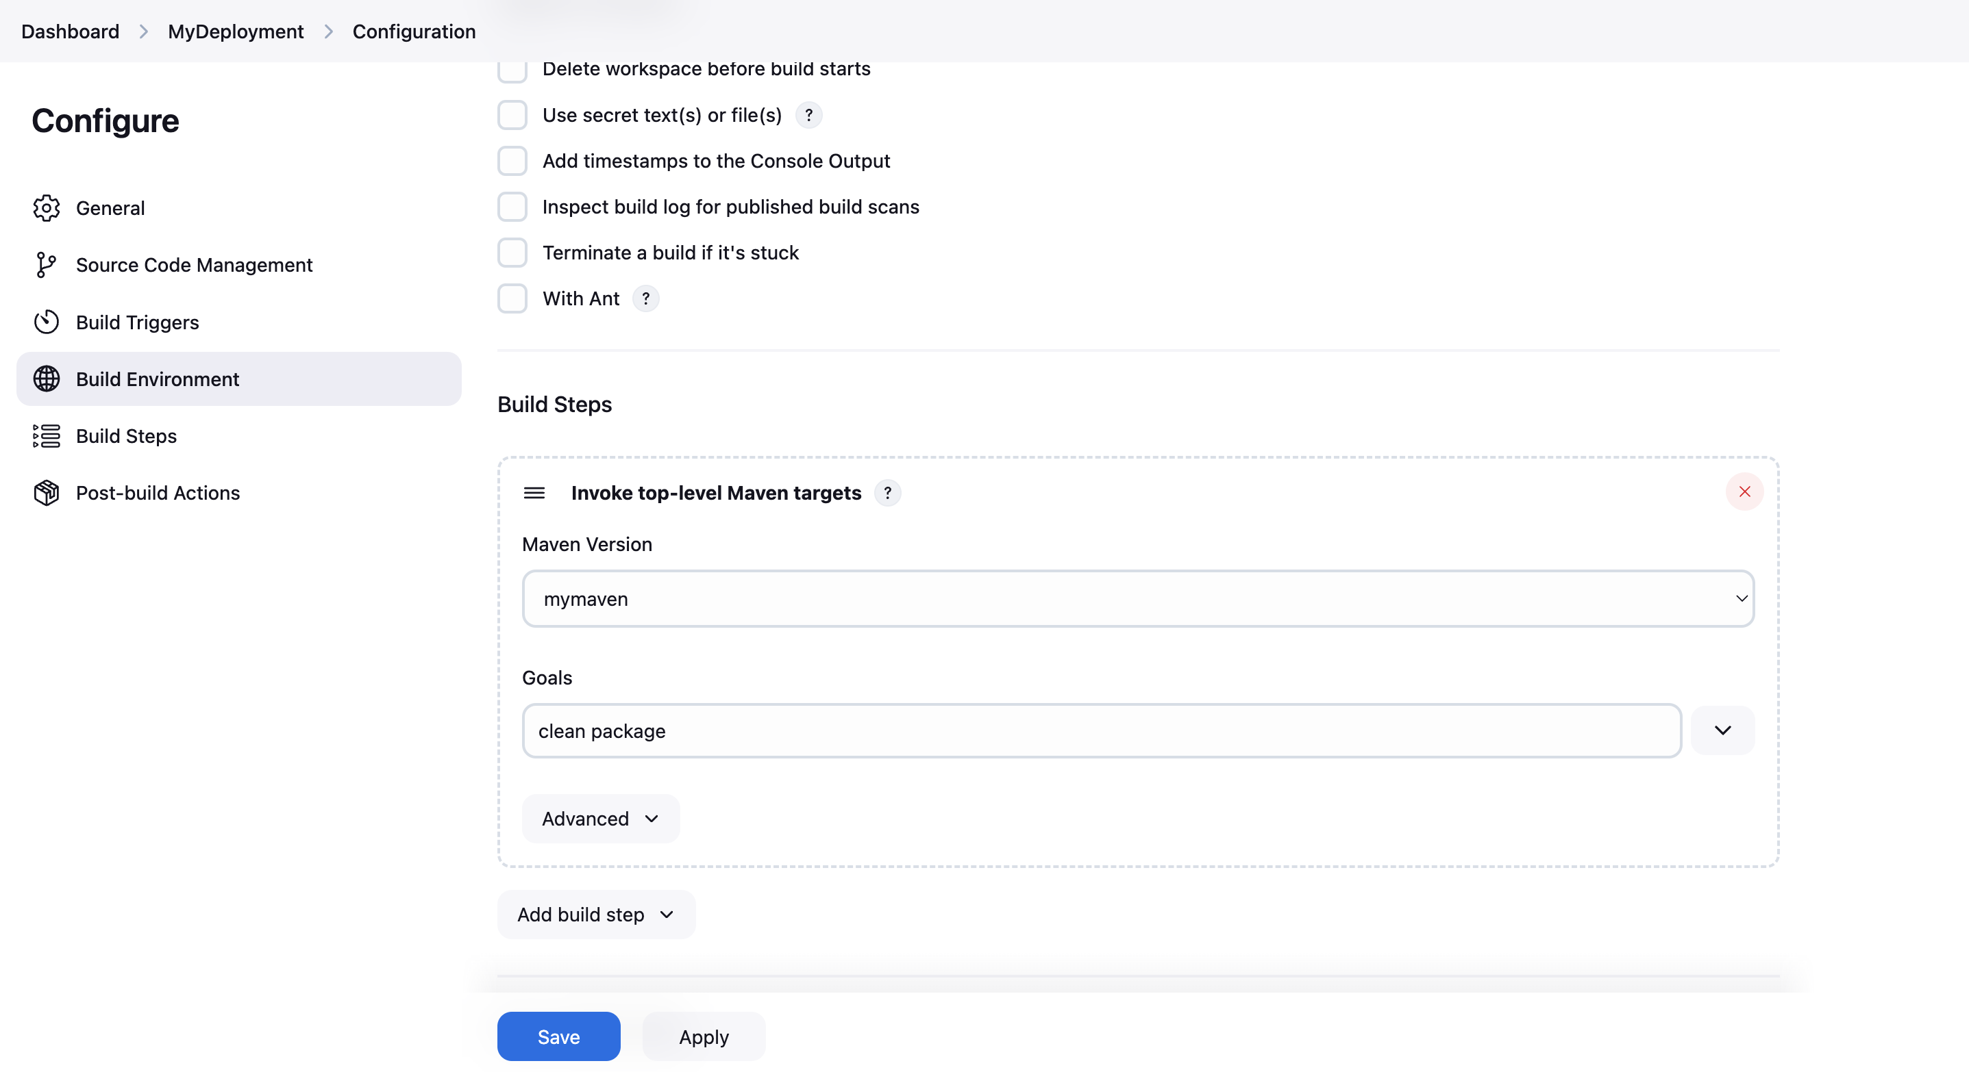
Save the job and click on Build Now
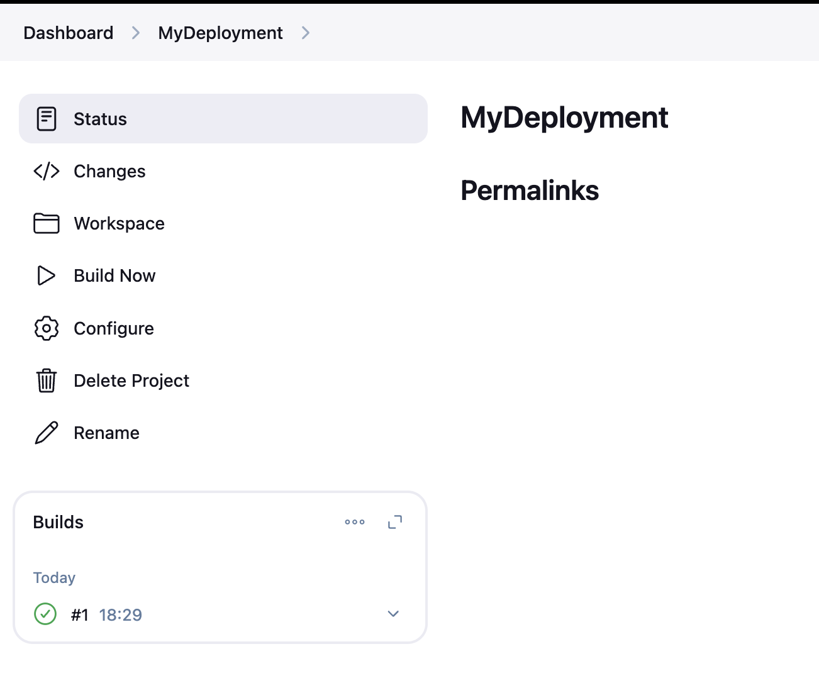
If the build gets success, go to workspace and open the target folder, we will get war file
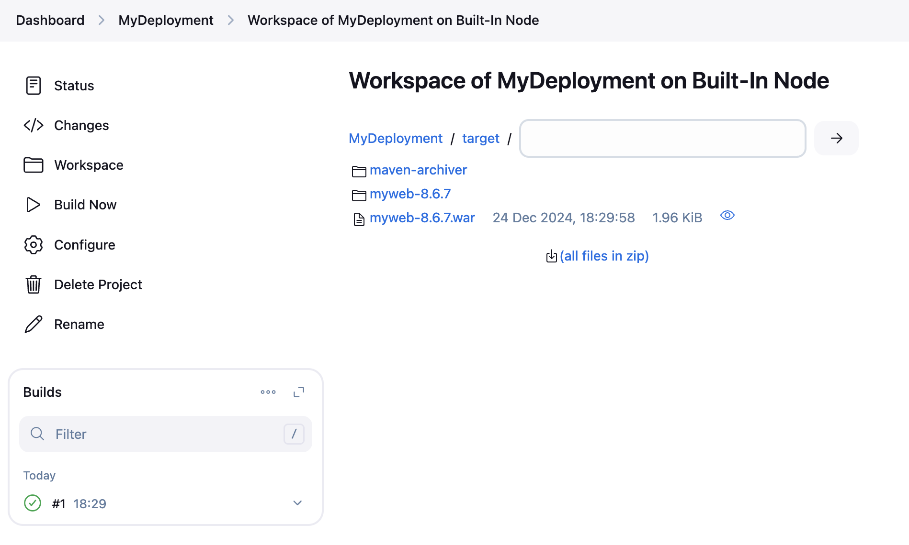
STEP-6: Deploy the application on Tomcat Server
connect the tomcat server and run the script to setup tomcat
Run the below script to setup tomcat
Copy
amazon-linux-extras install java-openjdk11 -y
wget https://dlcdn.apache.org/tomcat/tomcat-9/v9.0.102/bin/apache-tomcat-9.0.102.tar.gz
tar -zxvf apache-tomcat-9.0.102.tar.gz
sed -i '56 a\<role rolename="manager-gui"/>' apache-tomcat-9.0.102/conf/tomcat-users.xml
sed -i '57 a\<role rolename="manager-script"/>' apache-tomcat-9.0.102/conf/tomcat-users.xml
sed -i '58 a\<user username="tomcat" password="admin@123" roles="manager-gui, manager-script"/>' apache-tomcat-9.0.102/conf/tomcat-users.xml
sed -i '59 a\</tomcat-users>' apache-tomcat-9.0.102/conf/tomcat-users.xml
sed -i '56d' apache-tomcat-9.0.102/conf/tomcat-users.xml
sed -i '21d' apache-tomcat-9.0.102/webapps/manager/META-INF/context.xml
sed -i '22d' apache-tomcat-9.0.102/webapps/manager/META-INF/context.xml
sh apache-tomcat-9.0.102/bin/startup.sh
Remember the tomcat credentials
- username**:** tomcat
- password**:** admin@123
If you wish to modify, change the credentials on above script also.
Now access the tomcat dashboard with public-ip of tomcat server with 8080 port.
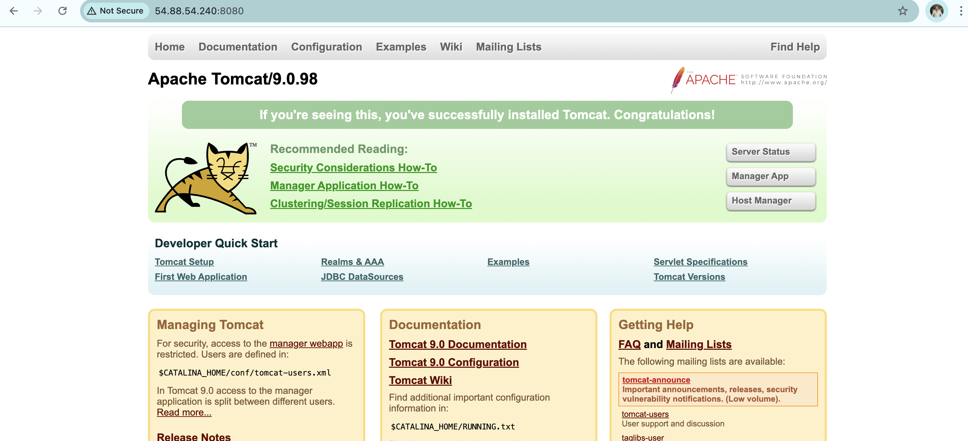
Now go to Manager App and enter the credentials, You will get the Tomcat Web Application Manager dashboard.
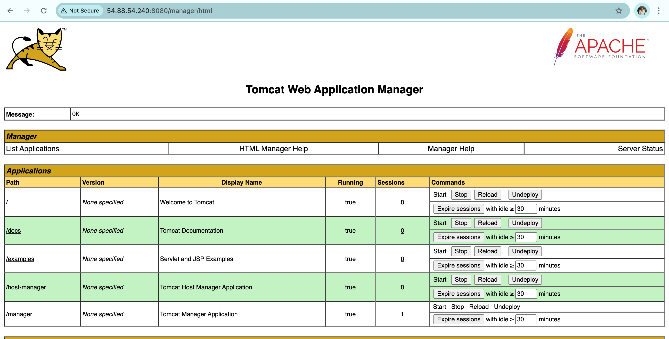
STEP-7: Integrate Tomcat with Jenkins
Configure the Jenkins job and select Post Build Actions and select Deploy war/ear to a container
WAR/EAR file: target/*.war
context path: swiggy
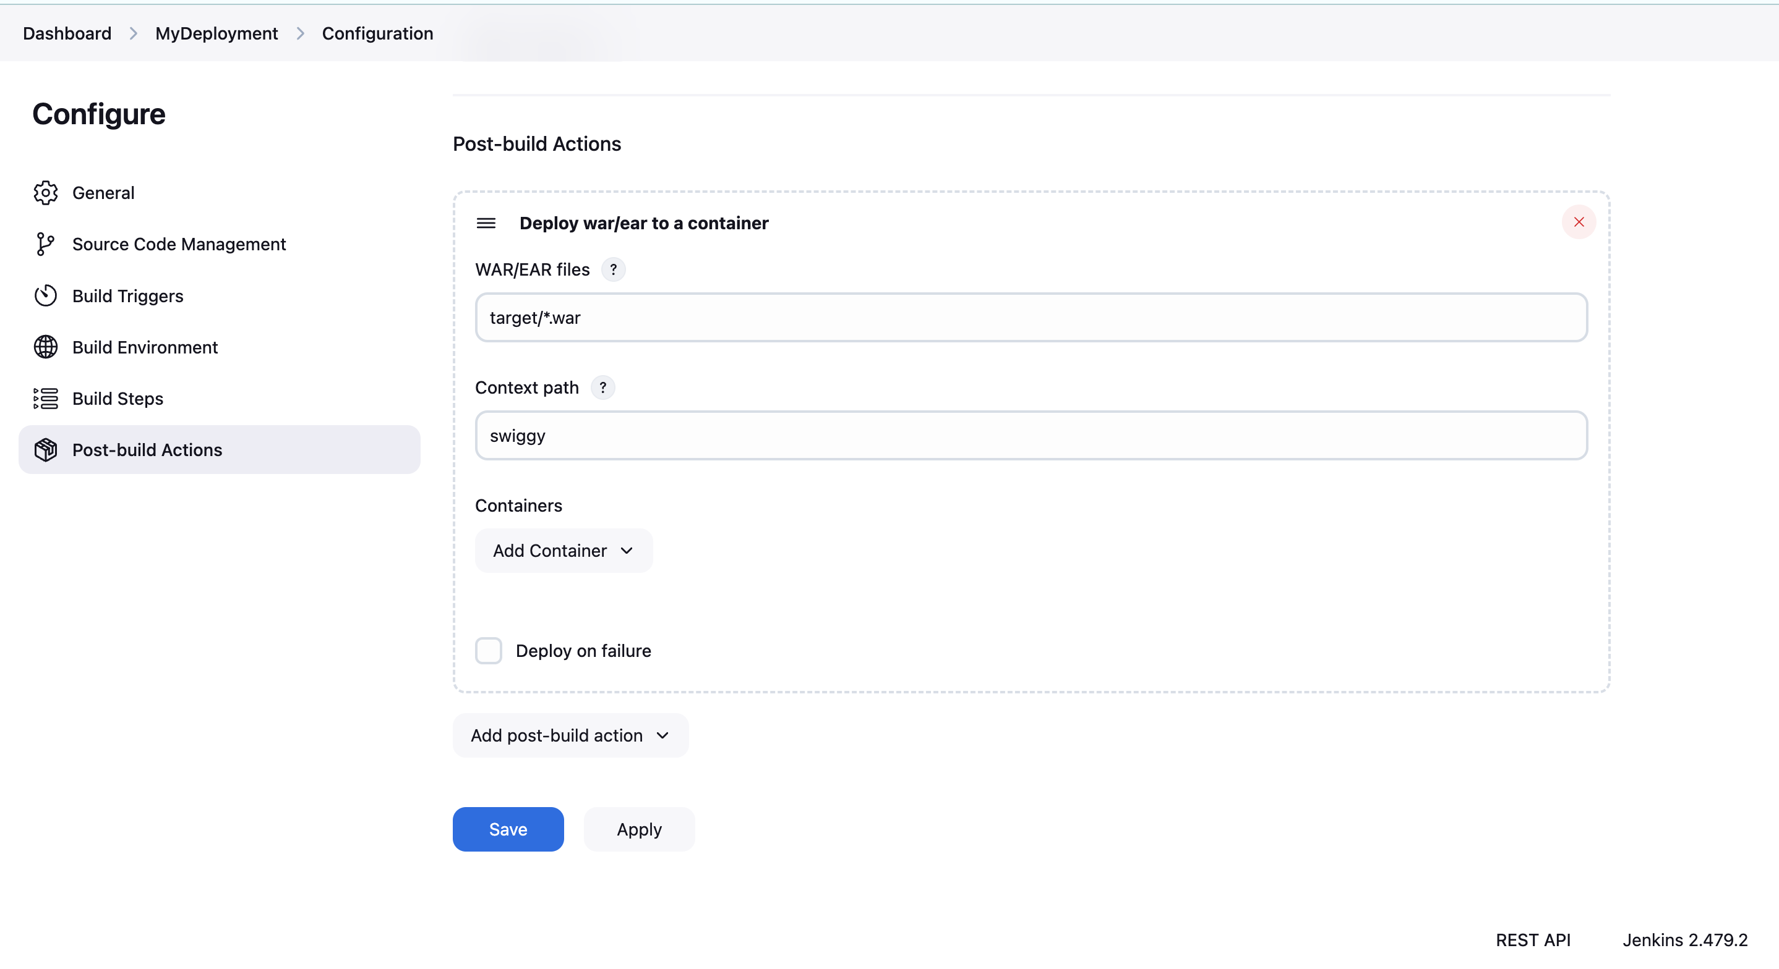
and click on add container and select Tomcat 9.x Remote
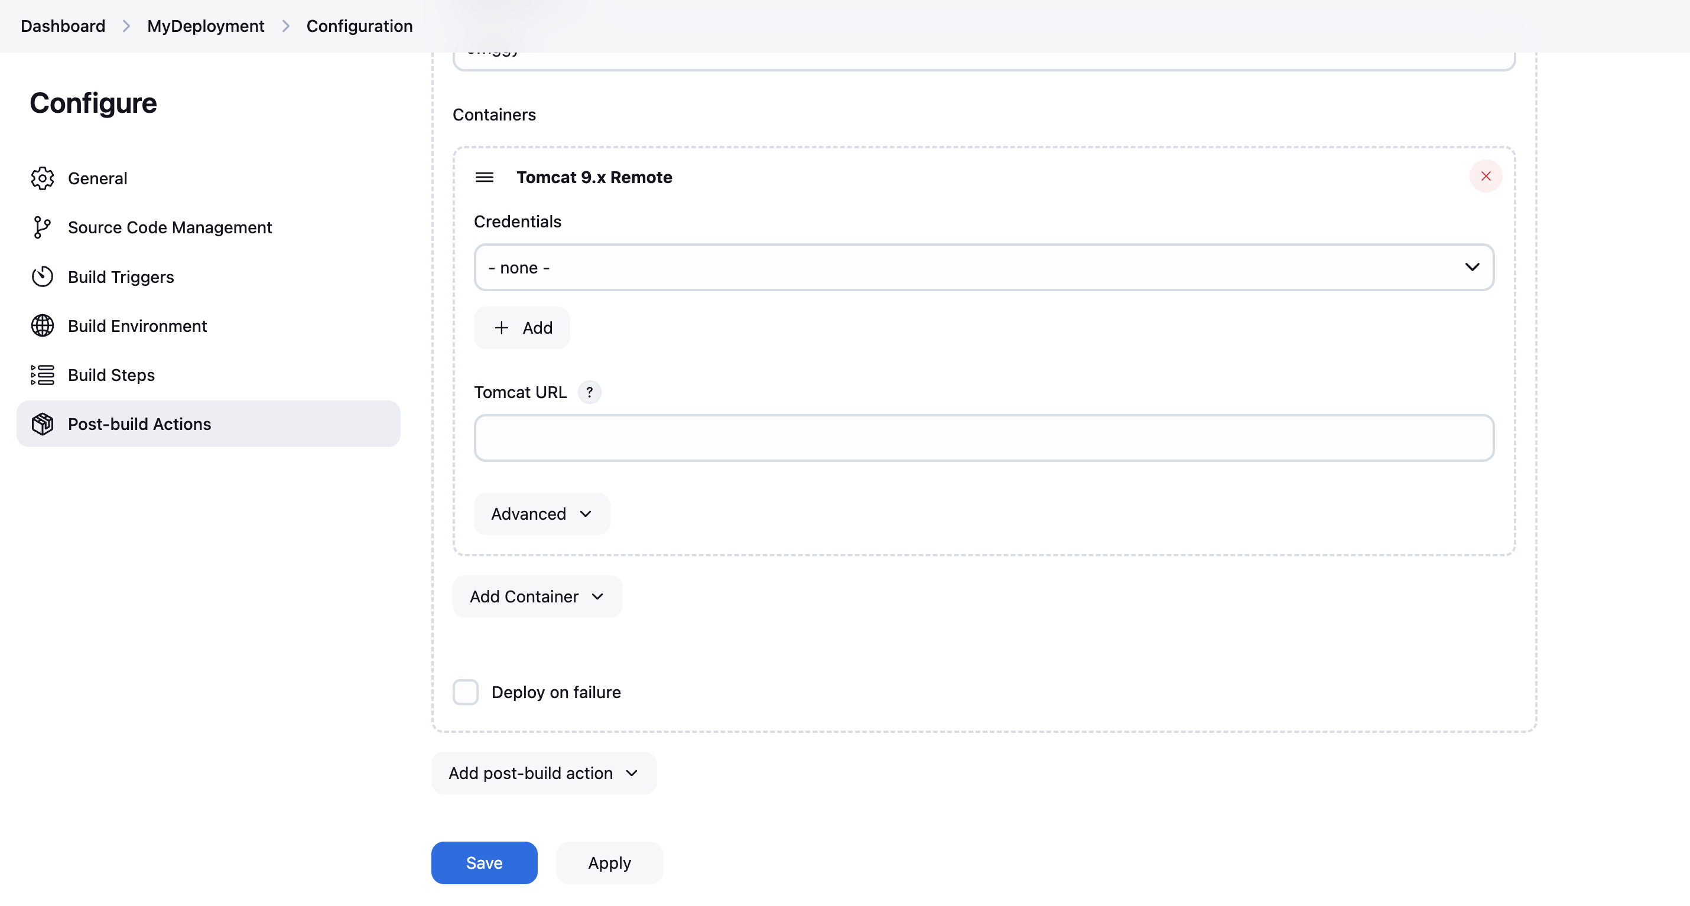
Now add the tomcat credentials, click on Add select Jenkins
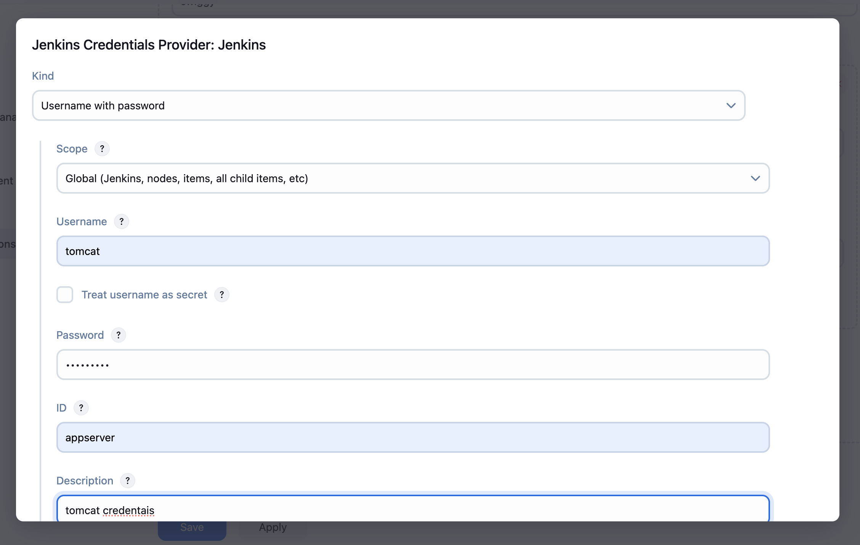
Now click on Add and select the credentials and enter the tomcat url
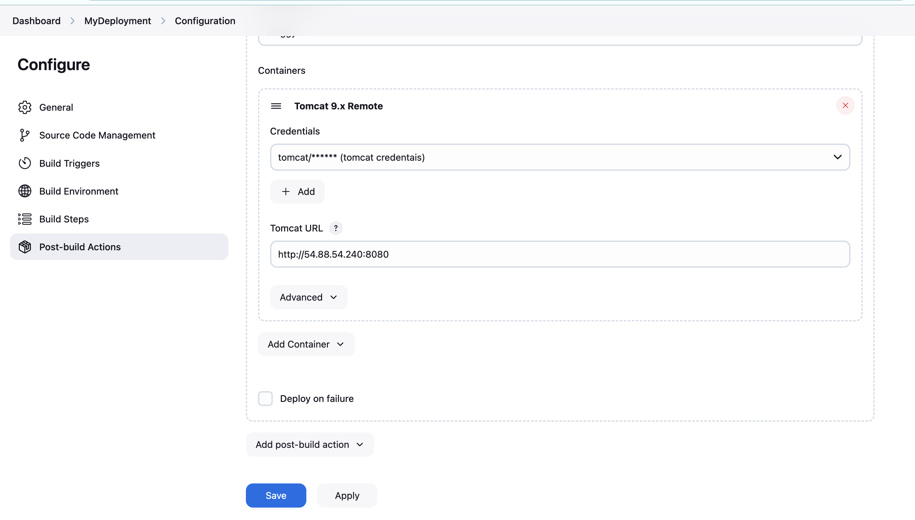
Now save the job and click on Build Now, If the build gets success then our application will be deployed on tomcat successfully.
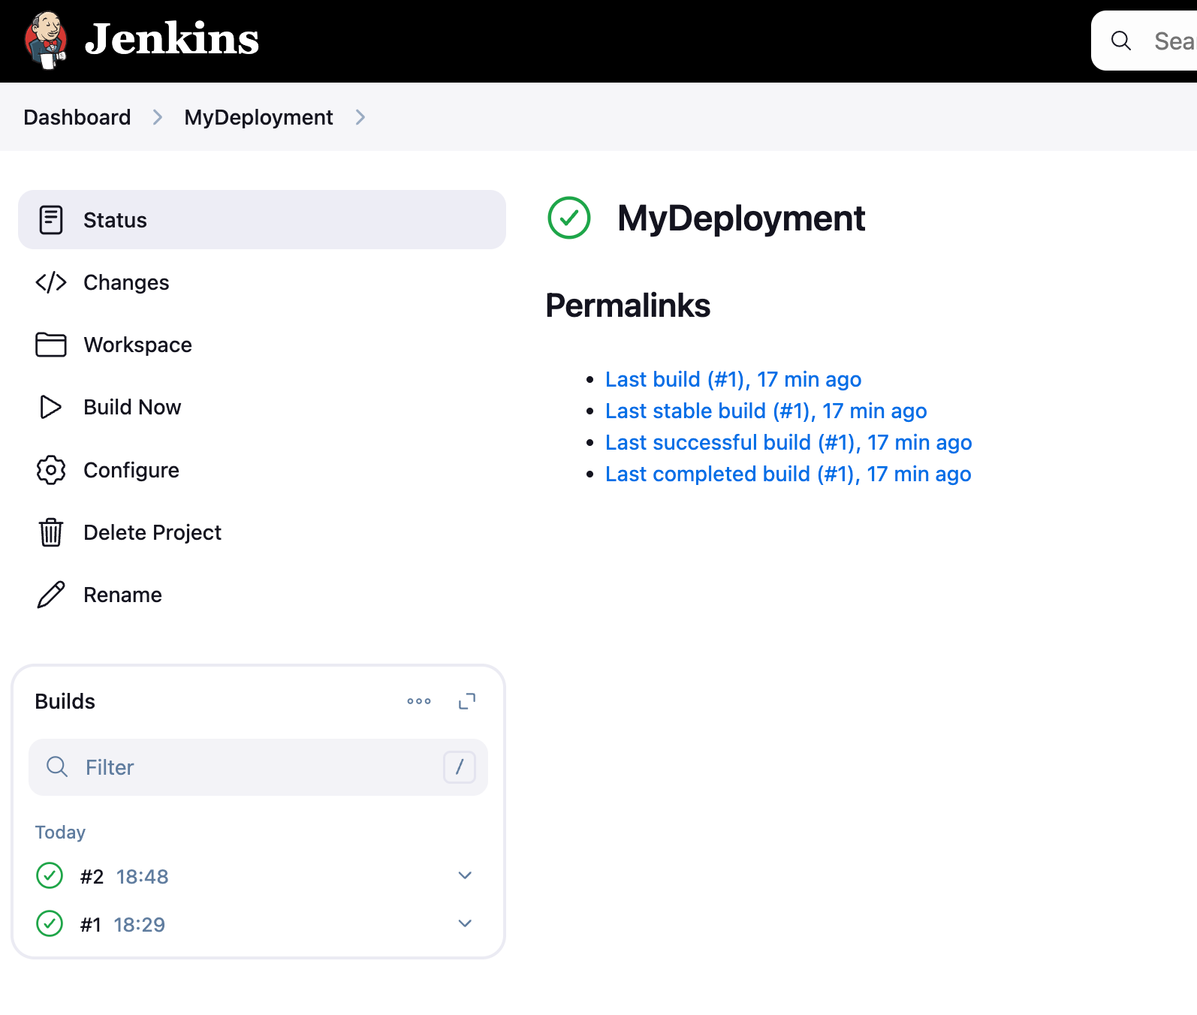
The build is success, Now lets refresh the tomcat page and we will see swiggy app is running
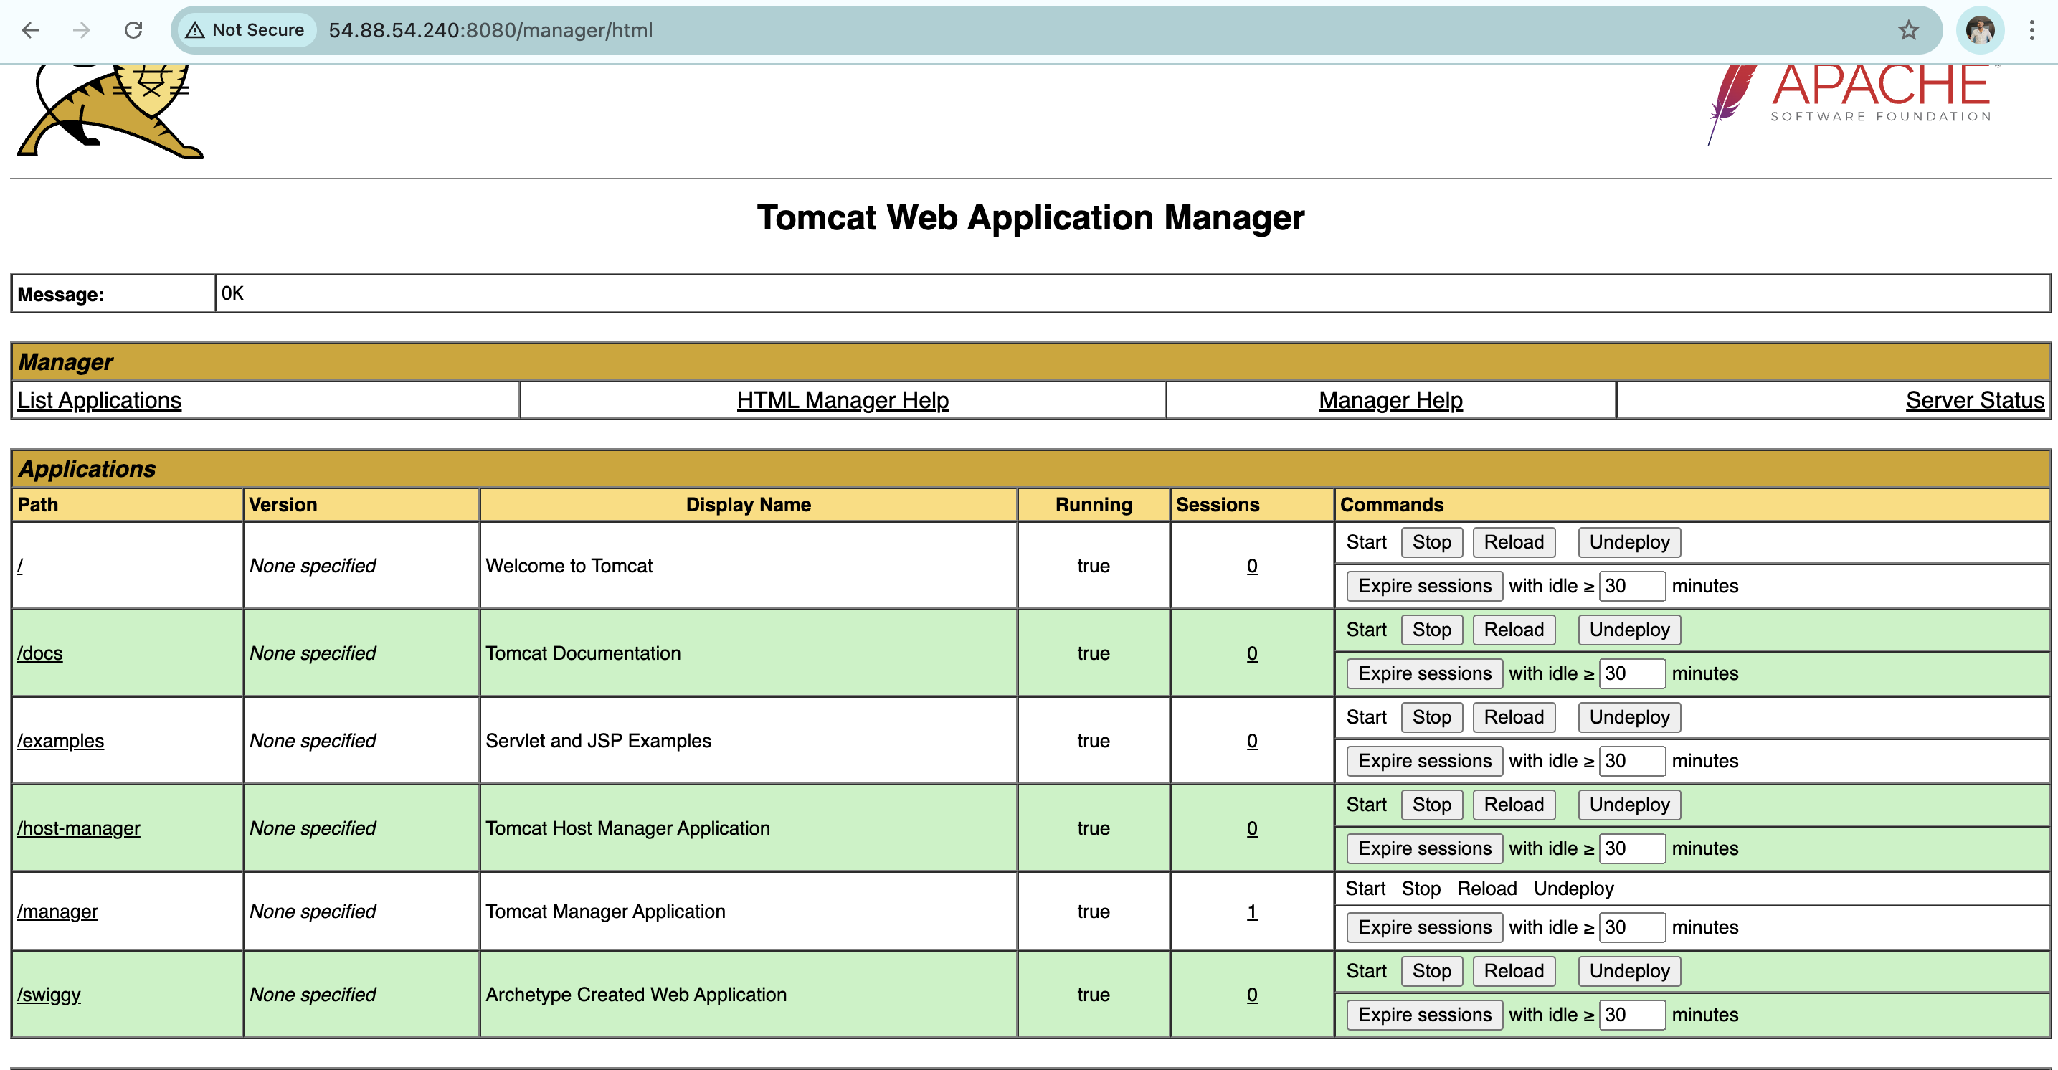
Open the swiggy app and check the output.
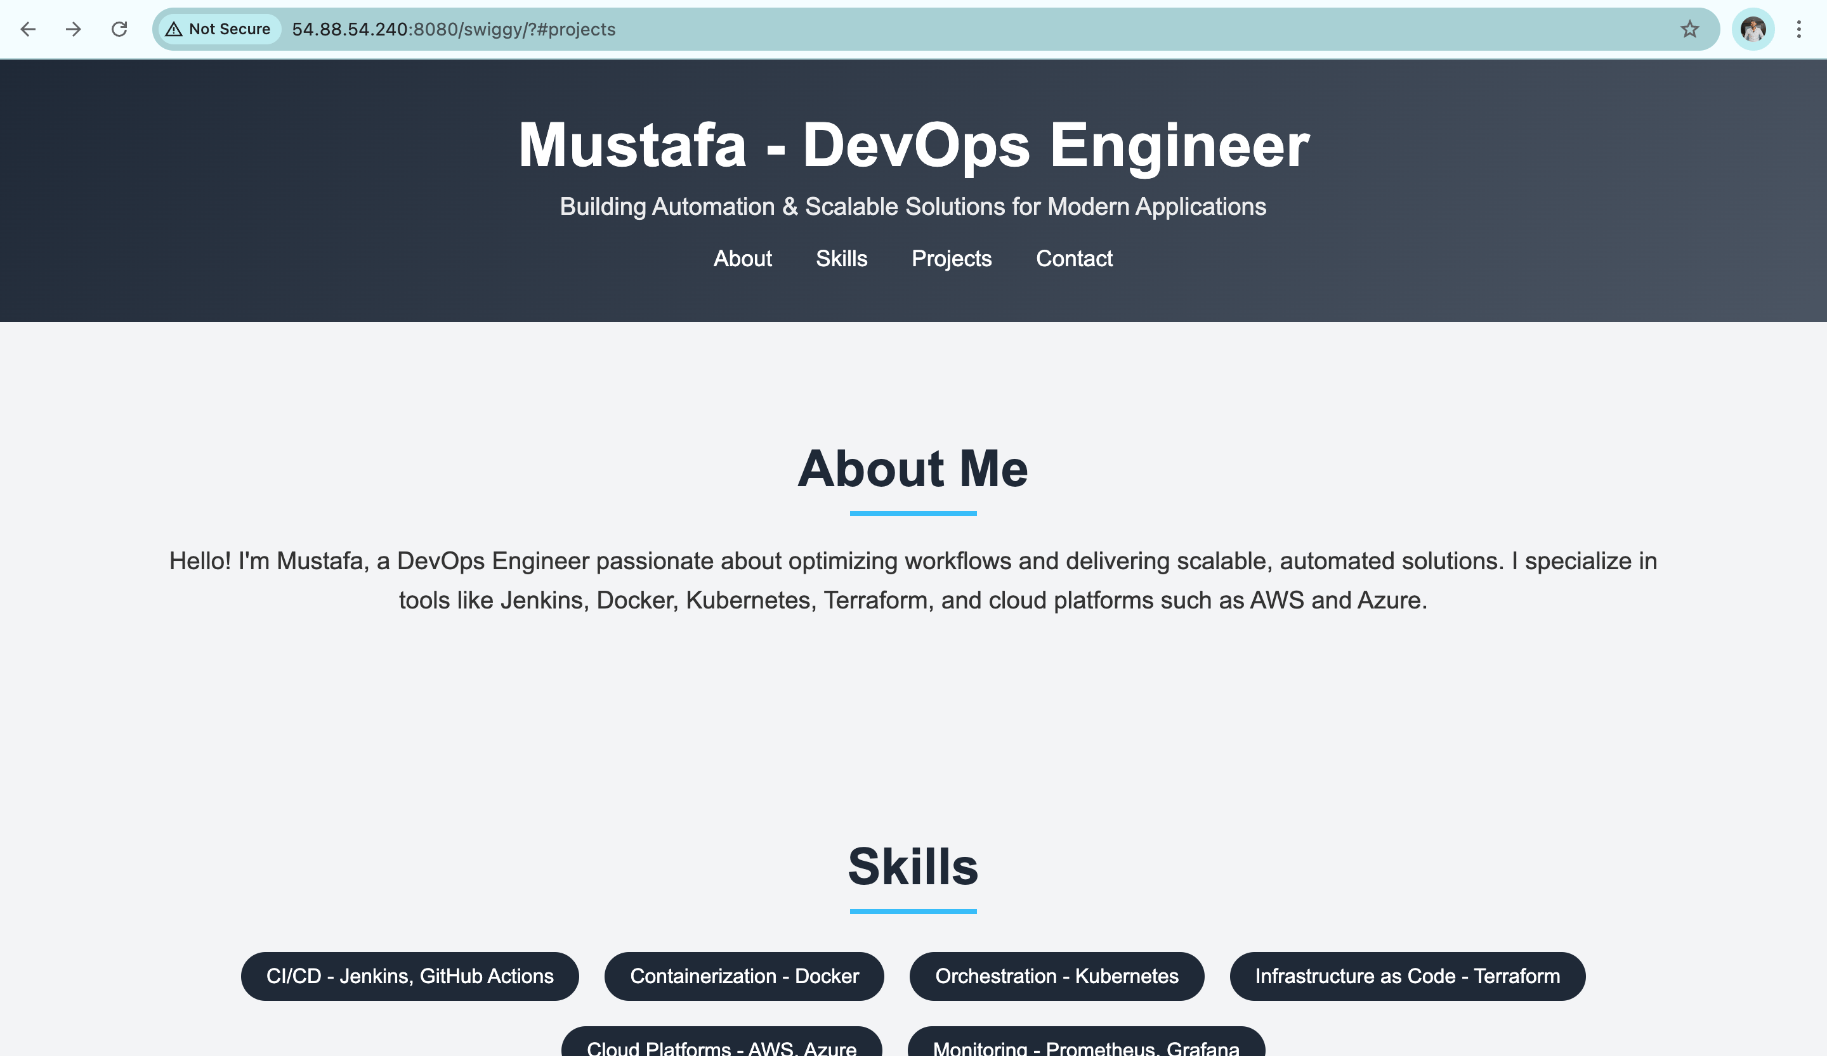
To automate the delivery process, we can also implement Webhooks!.

Best Practices
- Use a separate staging environment for testing deployments before pushing to production.
- Automate testing as part of the CI/CD pipeline to catch bugs early.
- Secure your Jenkins and Tomcat configurations to prevent unauthorized access.

Conclusion
By automating deployment with CI/CD, you save time, reduce errors, and deliver features faster. Deploying Java applications to Tomcat with tools like Jenkins and Maven is straightforward when done step-by-step. Start building your pipeline today to experience the power of automation.

Introducing the power of pipelines in Jenkins

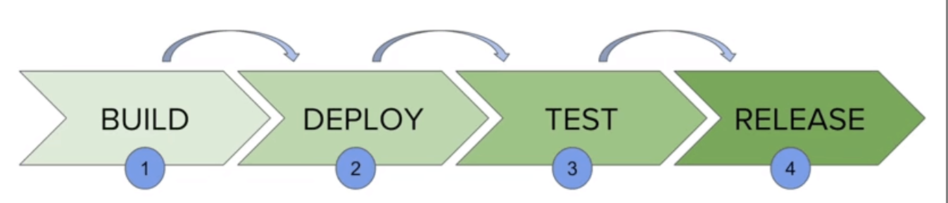
Now its time to explore the pipeline jobs in Jenkins
Software development moves fast, and keeping up means delivering updates quickly and reliably. Continuous Integration (CI) and Continuous Delivery (CD) are practices that help teams stay agile and produce high-quality applications efficiently. Jenkins, a top tool for CI/CD, simplifies this by automating workflows. One of its standout features is pipelines, which make these processes smoother and more adaptable. Let's explore Jenkins pipelines with simple examples to see how they can make your work easier.

What Are Jenkins Pipelines?
A Jenkins pipeline is a way to describe your entire CI/CD process as code. Think of it as a script that automates steps like building, testing, and deploying your application. For example, instead of manually running tests after every change, a pipeline ensures it happens automatically.
Jenkins pipelines can be written in two ways:
- Declarative Pipelines: These are simpler and easier to read, perfect for straightforward workflows.
- Scripted Pipelines: These offer more flexibility, suitable for complex setups.

Key Benefits of Jenkins Pipelines
- Automation:
  - Pipelines let you automate tasks, saving time and reducing errors. For instance, you can automatically deploy an app to a test server after a successful build.
- Version Control:
  - Pipeline scripts can be stored in the same repository as your code, ensuring changes are tracked and collaborative.
- Error Detection:
  - Pipelines provide detailed logs for each stage, helping you quickly identify and fix issues.
- Extensibility:
  - Jenkins pipelines integrate with popular tools like Docker, Kubernetes, and GitHub.

Declarative Pipeline Syntax:
Copy
pipeline {
agent any
stages {
stage('Code') {
steps {
echo 'Getting the project code'
}
}
stage('Build') {
steps {
echo 'Build the code'
}
}
stage('Deploy') {
steps {
echo 'Deploy the code.'
}
}
}
}

Scripted Pipeline Syntax:
Copy
node {
stage('Code') {
echo 'this is stage-1'
}
stage('Build') {

echo 'this is build stage.'
}
stage('Deploy') {
echo 'this is deploy.'
}
}

Difference Between Freestyle and Pipeline Jobs
- Freestyle Jobs:
  - Simple configurations without coding.
  - Example: A job that checks out code from GitHub and builds it.
  - Limitations: Hard to manage complex workflows.
- Pipeline Jobs:
  - Defined as code, stored in a Jenkins file.
  - Flexible, scalable, and better suited for modern DevOps practices.
  - Example: Automating a full CI/CD process with stages for build, test, and deploy.
In the next blog, I am going to reveal the fundamentals of pipelines.

Conclusion
Jenkins pipelines simplify and enhance CI/CD processes. Whether you're a developer building an app or an operations engineer managing deployments, pipelines provide consistency and scalability. Start using Jenkins pipelines today to save time, reduce errors, and deliver value faster.

How to write your first pipeline in Jenkins file

Jenkins file:
A Jenkins file is a text file that contains the definition of a Jenkins pipeline. It allows you to automate the steps in your Continuous Integration and Continuous Delivery (CI/CD) process by scripting them in Groovy. The Jenkins file is version-controlled alongside your project, ensuring transparency and consistency in your pipeline configuration.

Declarative Pipeline Syntax:
Copy
Copy
pipeline {
agent any
stages {
stage('Stage-Name') {
steps {
echo 'This is my first pipeline'
}
}
}
}

Pipeline Structure and Components

1. pipeline Block
The top-level block wraps the entire Jenkins file and defines the pipeline. It specifies the environment and stages of the process.

2. agent any
- Purpose: Specifies where the pipeline runs.
- any: The pipeline can execute on any available agent (node) in the Jenkins setup. This provides flexibility if there are multiple agents in the environment. By default it runs on master server.

Stages

3. stage('Code')
- Purpose: Represents the Build phase of the pipeline.
- steps:
  - echo 'this is my first pipeline': Outputs a message to the Jenkins console log, simulating the build step.
  - In a real pipeline, this step might include commands to compile code or install dependencies.

Real-time pipelines to get Source Code from GitHub:
This pipeline is used to get the code from GitHub to CI server.
Copy
Copy
pipeline {
agent any
stages {
stage('Code') {
steps {
git branch: "main", credentialsId: "github", url: 'https://github.com/devops0014/one.git'
}
}
}
}

Multi Stage pipeline:
This pipeline contains multiple stages like code, build, test and deploy.
Copy
Copy
pipeline {
agent any

stages {
stage('Hello') {
steps {
echo 'Hello World'
}
}
stage('Test') {
steps {
echo 'Hello World test'
}
}
stage('Deploy') {
steps {
echo 'Hello World deploy'
}
}
}
}

Pipeline as a Code:'
This pipeline is used to execute the commands.
Copy
Copy

pipeline {
agent any

stages {
stage('CMD') {
steps {
sh 'touch file1'
sh 'pwd'
}
}
}
}
This pipeline is used to execute multiple commands at a time:
Copy
Copy
pipeline {
agent any

stages {
stage('CMD') {
steps {
sh '''
touch file2
pwd
date
whoami
'''
}
}
}
}

Pipeline with variables:
This pipeline is used to define the variables.
Copy
Copy
pipeline {
agent any
environment {
name = 'Mustafa'
}
stages {
stage('ENV') {
steps {
echo "My name is $name"
}
}
}
}
This pipeline is used to print the build ID’s
Copy
Copy
pipeline {
agent any

stages {
stage('ENV') {
steps {
sh 'echo "${BUILD_ID}"'
}
}
}
}
In this pipeline, we can see local and global variables.
Copy
Copy
pipeline {
agent any
environment {
name = "Mustafa"
}
stages {
stage('one') {
steps {
echo "My name is $name"
}
}
stage('two') {
environment {
course = "DevOps"
}
steps {
echo "$name is a $course trainer"
}
}
}
}
In the above pipeline, we can see name = mustafa is a global variable, we can access this variable on any stage in the pipeline. course = DevOps is a local variable, we can use this only on stage-2.
NOTE:
If you want to access a variable on all pipelines, go to manage jenkins » system » select variables option and pass the values.

Jenkins Pipeline to deploy Java application | Git, Maven, Nexus & Tomcat

my pipeline contains 4 stages [code, build & Unit Test, Artifact, deploy]
Tools we used for each stage:
- code: GIT
- Build: Maven
- Unit Test: Maven
- Artifact: Nexus
- Deploy: Tomcat
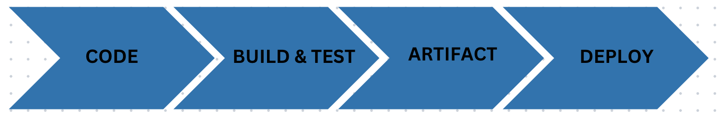

STEP BY STEP PROCESS TO DEPLOY THE APPLICATION:
STEP-1: Launch 3 Instances
- Jenkins
- Nexus
- Tomcat
STEP-2: refer the below scripts to install Jenkins, Tomcat and Nexus on respective servers.
Jenkins Script:
Copy
#STEP-1: INSTALLING GIT
yum install git -y

#STEP-2: GETTING THE REPO (jenkins.io --> download -- > redhat)
sudo wget -O /etc/yum.repos.d/jenkins.repo https://pkg.jenkins.io/redhat-stable/jenkins.repo
sudo rpm --import https://pkg.jenkins.io/redhat-stable/jenkins.io-2023.key

#STEP-3: DOWNLOAD JAVA17 AND JENKINS
yum install java-17-amazon-corretto -y
yum install jenkins -y

#STEP-4: RESTARTING JENKINS (when we download service it will on stopped state)
systemctl start jenkins.service
systemctl status jenkins.service
Tomcat Script:
Copy
yum install java-17-amazon-corretto -y
wget https://dlcdn.apache.org/tomcat/tomcat-9/v9.0.98/bin/apache-tomcat-9.0.98.tar.gz
tar -zxvf apache-tomcat-9.0.98.tar.gz
sed -i '56 a\<role rolename="manager-gui"/>' apache-tomcat-9.0.98/conf/tomcat-users.xml
sed -i '57 a\<role rolename="manager-script"/>' apache-tomcat-9.0.98/conf/tomcat-users.xml
sed -i '58 a\<user username="tomcat" password="admin@123" roles="manager-gui, manager-script"/>' apache-tomcat-9.0.98/conf/tomcat-users.xml
sed -i '59 a\</tomcat-users>' apache-tomcat-9.0.98/conf/tomcat-users.xml
sed -i '56d' apache-tomcat-9.0.98/conf/tomcat-users.xml
sed -i '21d' apache-tomcat-9.0.98/webapps/manager/META-INF/context.xml
sed -i '22d' apache-tomcat-9.0.98/webapps/manager/META-INF/context.xml
sh apache-tomcat-9.0.98/bin/startup.sh
Nexus Script:
Copy
yum install java-17-amazon-corretto -y
mkdir /app
cd /app
wget -O nexus.tar.gz https://download.sonatype.com/nexus/3/latest-unix.tar.gz
tar -zxvf nexus.tar.gz
mv nexus-* nexus
useradd nexus
chown -R nexus:nexus *
vim /app/nexus/bin/nexus.rc
sed -i '1s/.*/run_as_user="nexus"/' /app/nexus/bin/nexus.rc
./nexus/bin/nexus start
./nexus/bin/nexus status
STEP-3: Install the following plugins on Jenkins dashborad
- Nexus Artifact Uploader
- Deploy to Container
STEP-4: Create a Pipeline job and write the below Jenkinsfile
Copy
pipeline {
agent any
tools {
maven "mymaven"
}

stages {
stage('Code') {
steps {
git 'https://github.com/devops0014/one.git'
}
}
stage ("Build") {
steps {
sh 'mvn clean package'
}
}
stage ("Artifact") {
steps {
nexusArtifactUploader artifacts: [[artifactId: 'myweb', classifier: '', file: 'target/myweb-8.6.9.war', type: 'war']], credentialsId: 'nexus', groupId: 'in.javahome', nexusUrl: '54.227.157.176:8081', nexusVersion: 'nexus3', protocol: 'http', repository: 'myrepo', version: '8.6.9'
}
}
stage ("Deploy") {
steps {
deploy adapters: [tomcat9(credentialsId: 'tomcat', path: '', url: 'http://54.156.87.218:8080')], contextPath: 'myapp', war: 'target/*.war'
}
}
}
}
NOTE: use pipeline syntax for getting the scrips for each stage.

The Power of the Master-Slave Architecture

In the world of continuous integration and delivery (CI/CD), Jenkins stands as one of the most popular automation tools. One of the key features that make Jenkins powerful and scalable is its master-slave architecture. In this blog, we will delve into the concept, explain how it works, and provide real-world scenarios to make it easier to understand.

What is the Master-Slave Architecture in Jenkins?
The master-slave architecture is a distributed system setup in Jenkins where a master node delegates work to one or more slave nodes. The master node is the central controller, while the slave nodes are worker machines that perform the actual tasks. This design allows Jenkins to handle large and complex build processes by distributing the load across multiple machines.
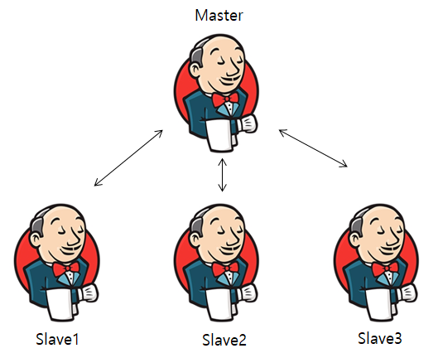

Components of the Architecture
- Master Node:
  - Responsible for scheduling jobs.
  - Maintains the build configurations, plugins, and user interfaces.
  - Delegates tasks to slave nodes when necessary.
- Slave Node:
  - A worker machine that performs tasks assigned by the master.
  - Runs build jobs in its environment (e.g., Linux, Windows, macOS).
  - Communicates with the master to send job statuses and logs.

How Does It Work?
When a build is triggered on the Jenkins master, it evaluates where the job can best be executed based on resource availability, node labels, or specific job configurations. If the job requires a specific environment, it will delegate the task to a slave node configured for that purpose.

Real-World Scenarios

Scenario 1: Cross-Platform Builds
Imagine a software product that needs to run on multiple platforms: Windows, Linux, and macOS. You can configure Jenkins with a master node and three slave nodes, each running a different operating system. When a build is triggered, Jenkins distributes the workload to the appropriate slave based on the target platform.
For example:
- Windows builds run on the Windows slave.
- Linux builds run on the Linux slave.
- macOS builds run on the macOS slave.
This setup ensures that you can test and build your software in multiple environments simultaneously, saving time and resources.

Scenario 2: High-Volume Builds
A large e-commerce company has multiple development teams working on various microservices. Each team triggers builds frequently, causing a bottleneck when all jobs are queued on a single master node. By setting up multiple slave nodes, Jenkins can distribute these builds across the slaves, significantly reducing build times.
For instance:
- Microservice A’s build runs on Slave 1.
- Microservice B’s build runs on Slave 2.
- Microservice C’s build runs on Slave 3.

Advantages of the Master-Slave Architecture
- Scalability: Add more slave nodes to handle increased workloads.
- Flexibility: Configure slaves with specific environments or tools.
- Efficiency: Parallel execution reduces build times.
- Fault Tolerance: If a slave fails, the master can redistribute tasks to other available slaves.

Setting Up a Master-Slave Configuration in Jenkins:
STEP-1: Launch 2 instances with key-pair (Master, Slave)
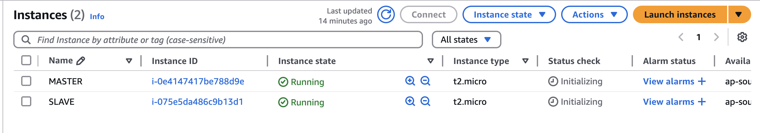
STEP-2: Install Jenkins on Master
Copy
#STEP-1: INSTALLING GIT
yum install git -y

#STEP-2: GETTING THE REPO (jenkins.io --> download -- > redhat)
sudo wget -O /etc/yum.repos.d/jenkins.repo \
https://pkg.jenkins.io/redhat-stable/jenkins.repo
sudo rpm --import https://pkg.jenkins.io/redhat-stable/jenkins.io-2023.key

#STEP-3: DOWNLOAD JAVA11 AND JENKINS
yum install java-17-amazon-corretto -y
yum install jenkins -y

#STEP-4: RESTARTING JENKINS (when we download service it will on stopped state)
systemctl start jenkins.service
systemctl status jenkins.service
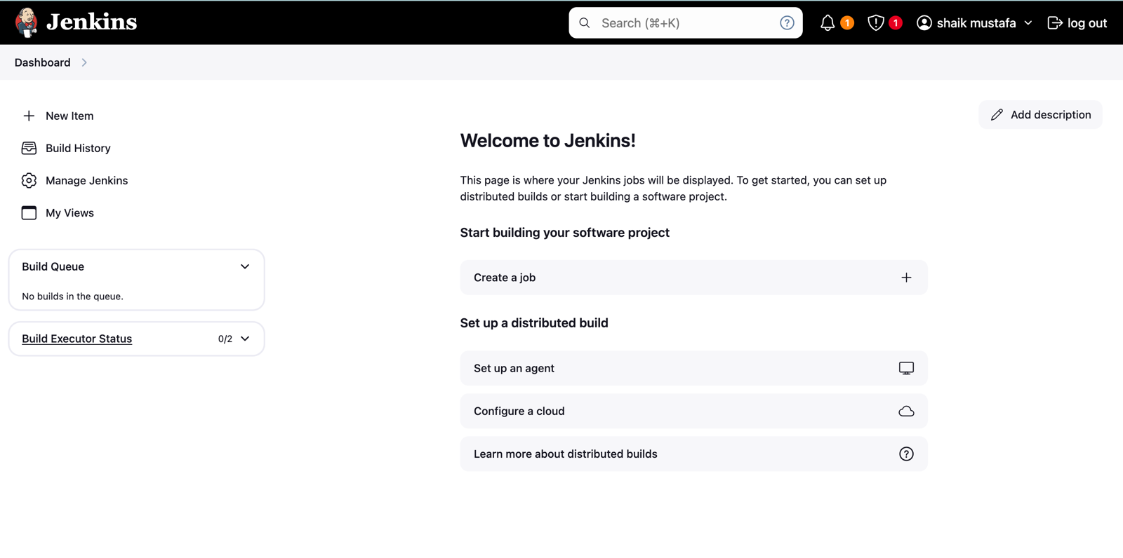
STEP-3: Install Java17 on Slave Server
Copy
yum install java-17-amazon-corretto -y
STEP-4: Go to Jenkins Dashboard » Manage Jenkins » Nodes
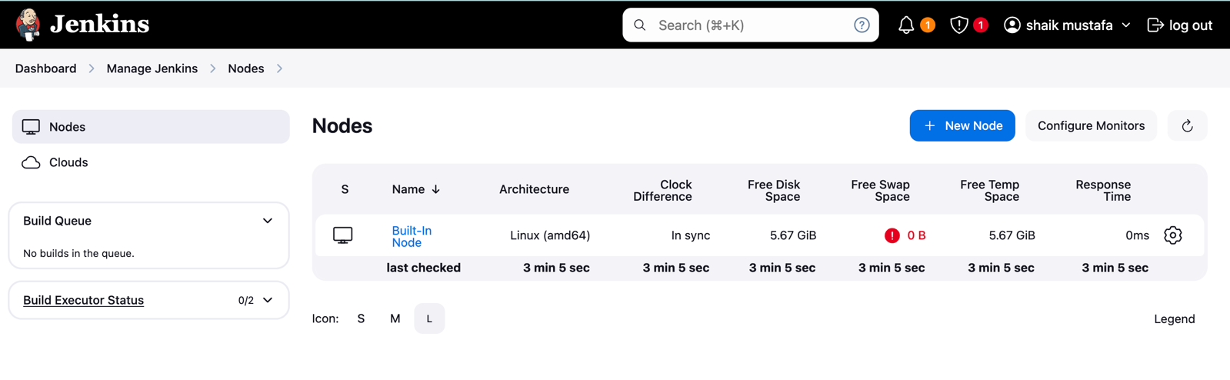
Click on New Node
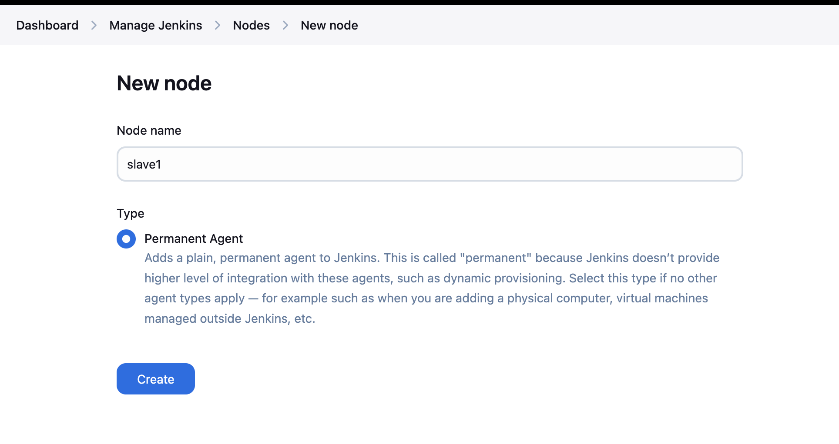
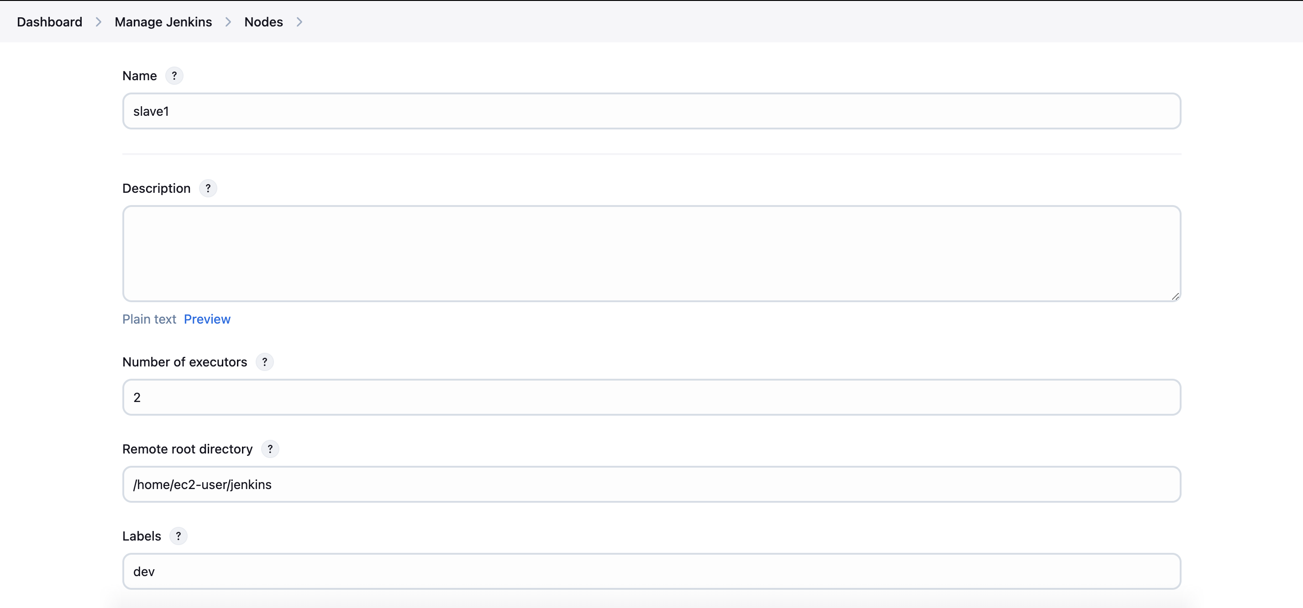
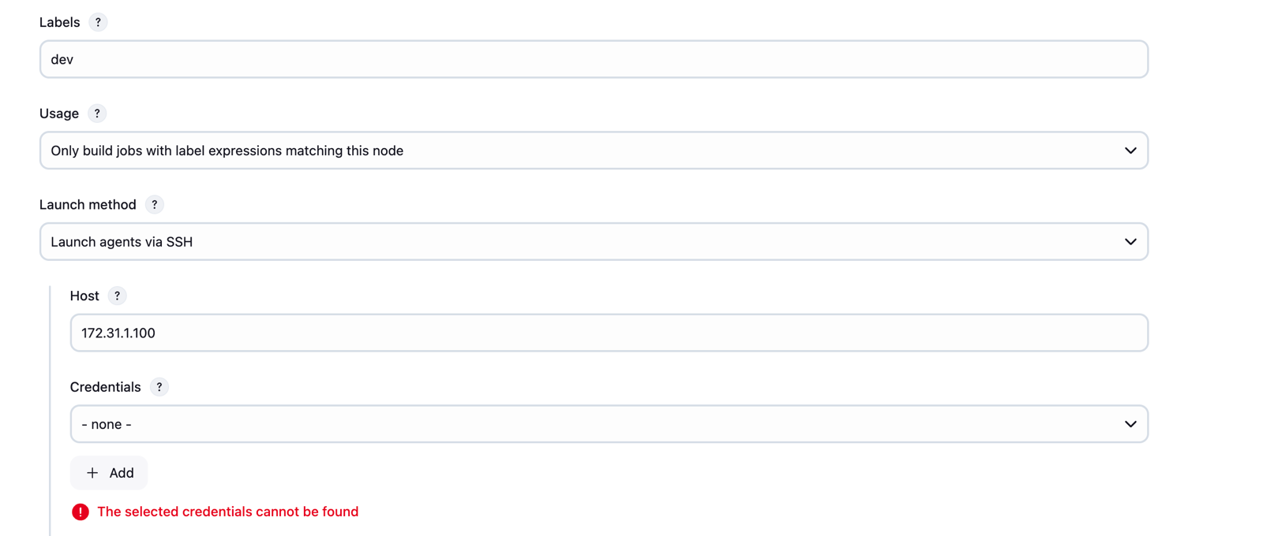
Host: Slave-server-Private-IP
Now click on Add credentials
Kind: SSH Username with Private Key
Username: ec2-user
Now add the Private Key (PEM file)
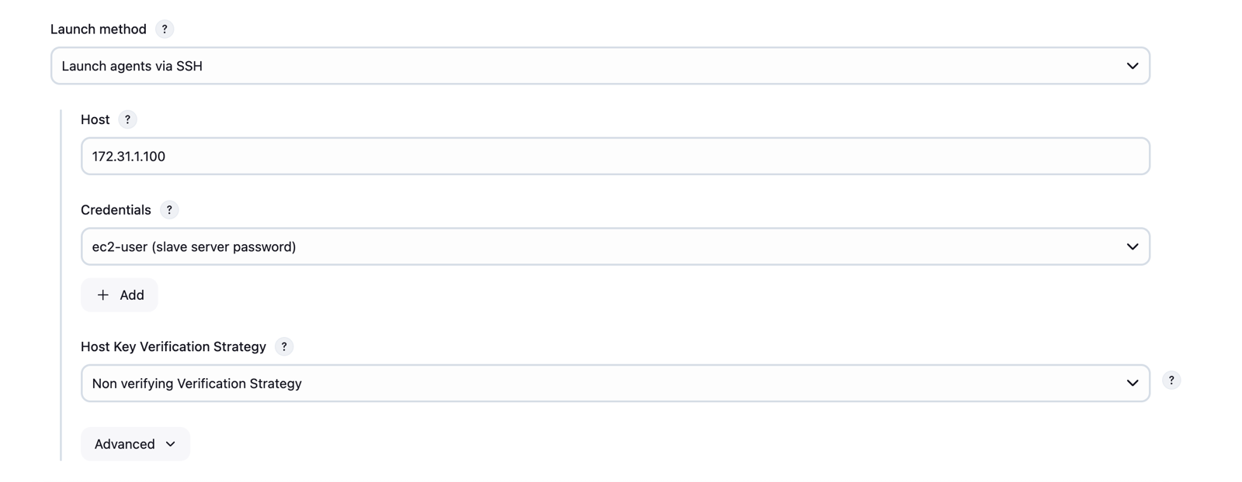
Now click on save
Now we have implemented Master-Slave Architecture, Lets build a job and execute it on slave-server
Go to Jenkins Dashboard and click on New Item
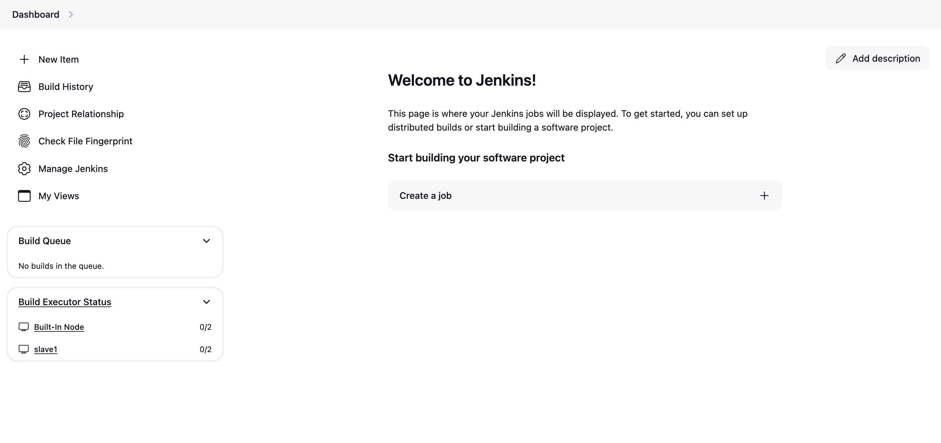
Enter the Job name and select the type
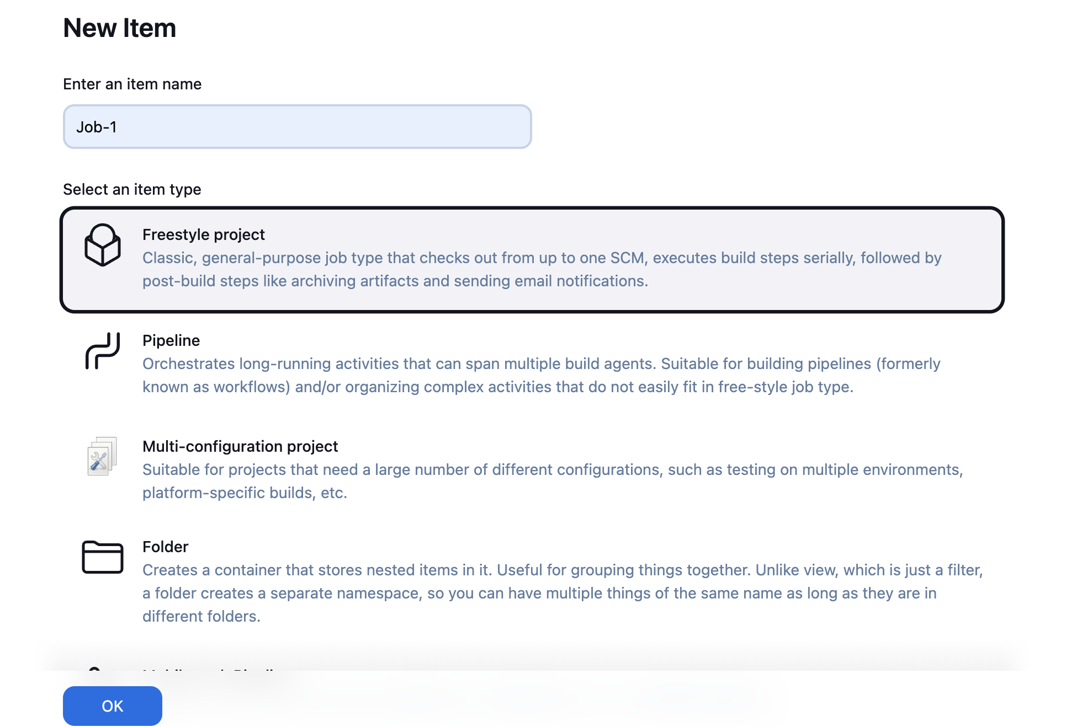
Now enter tyhe label name as dev
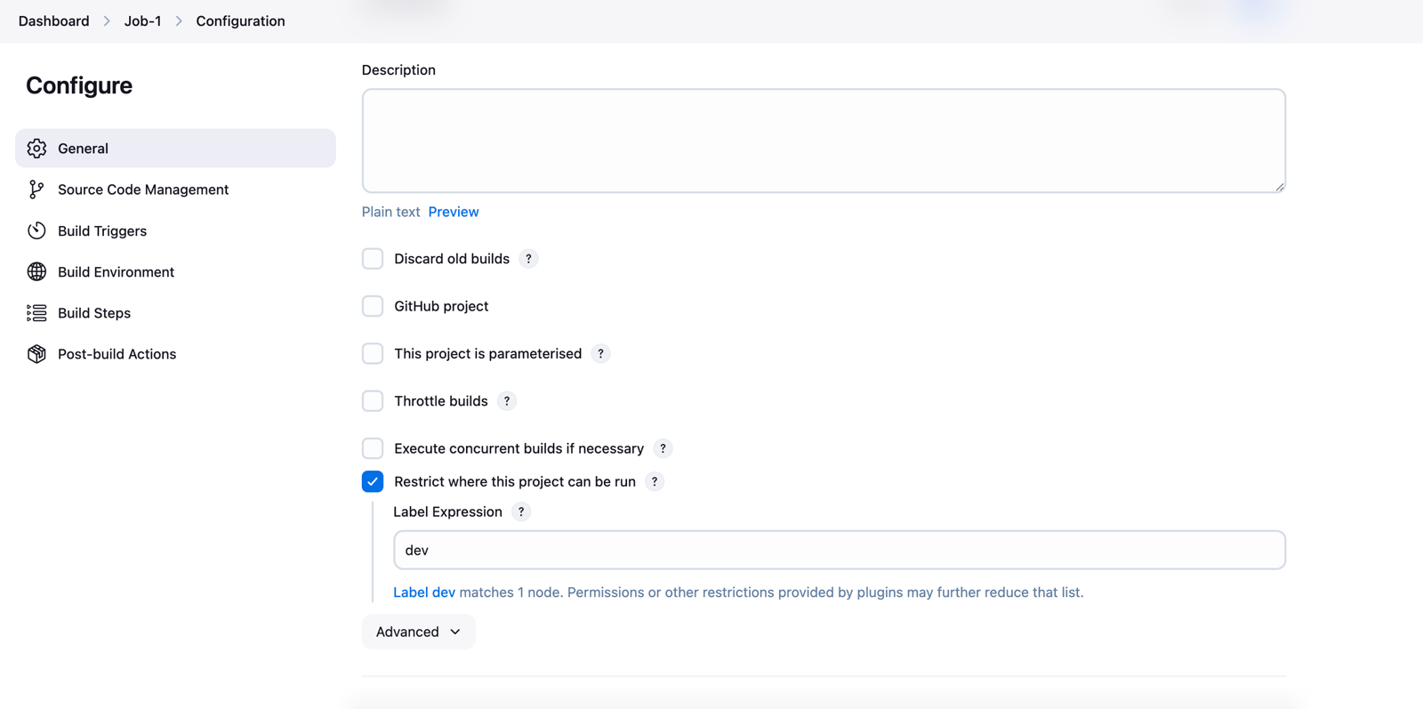
Save and build the job, it will be executed in slave server.
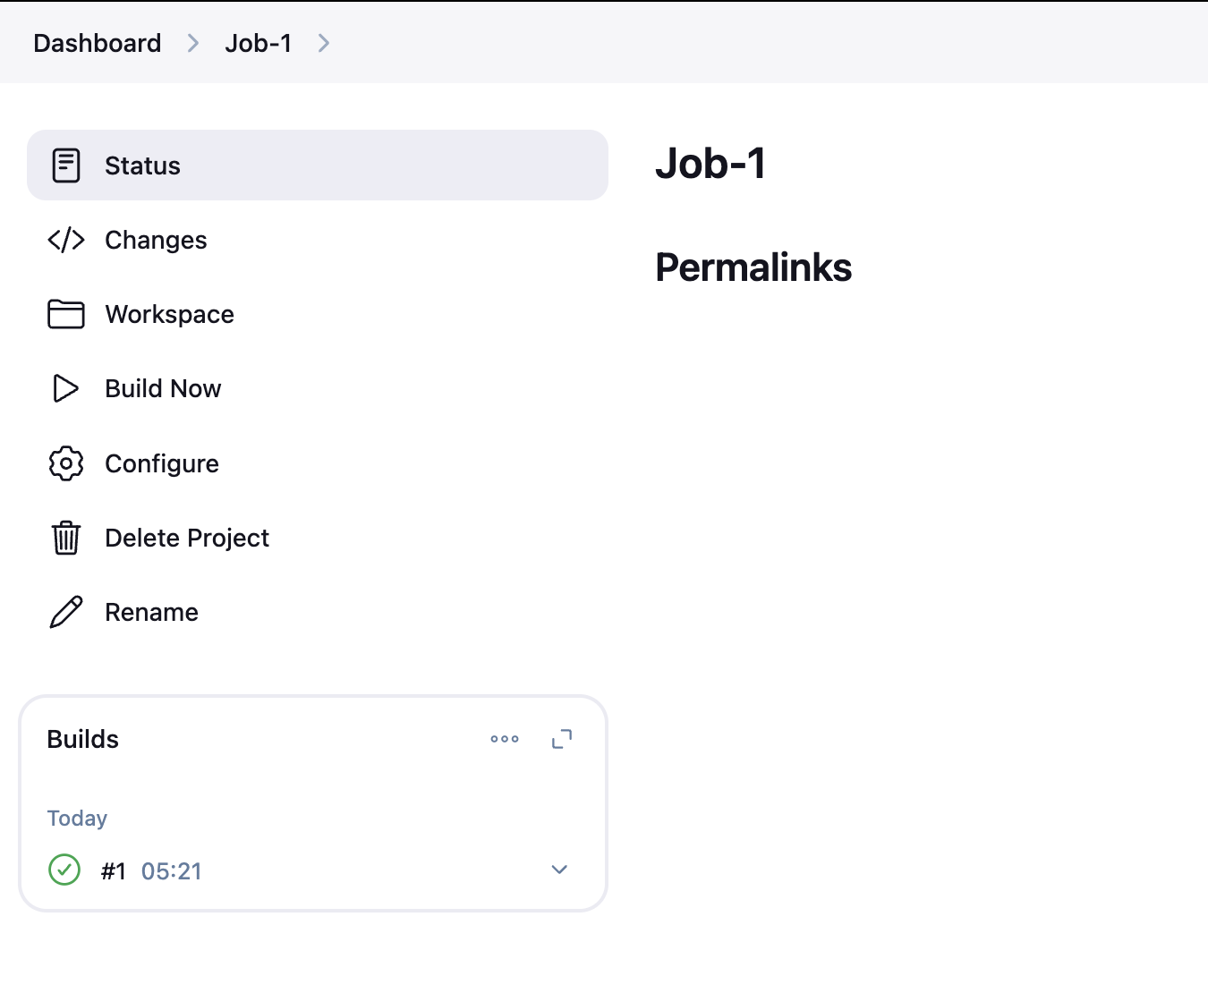
Lets Open the console output to confirm
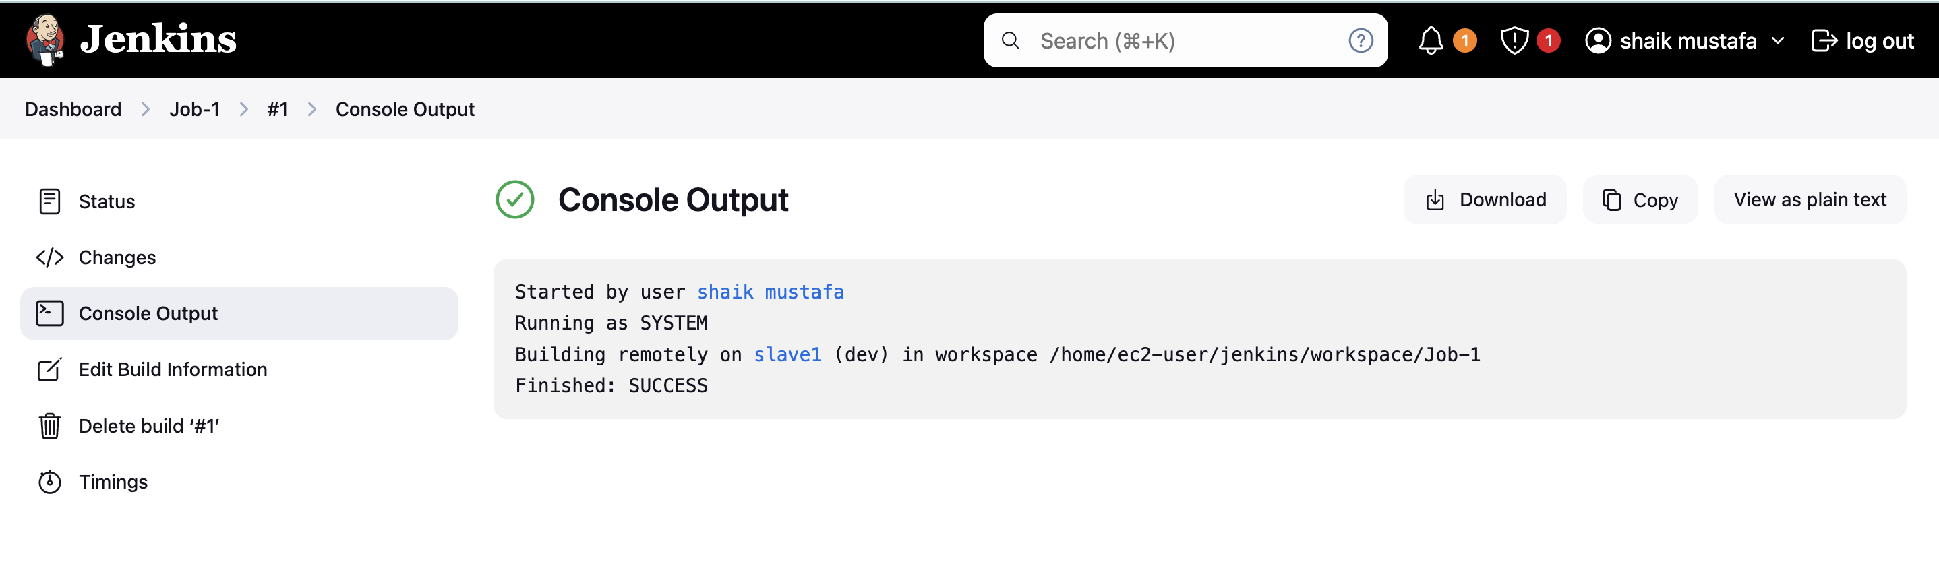
As you can observer, the job is executed on remotely (slave1).

Conclusion
The master-slave architecture in Jenkins is a robust solution for handling complex CI/CD workflows. By distributing tasks across multiple machines, it ensures efficient, scalable, and fault-tolerant operations. Whether you’re dealing with cross-platform builds, high-volume tasks, or resource-intensive processes, this architecture empowers you to optimize your development pipeline.

