StudyAI
Smart AI Study Companion & Quiz Generator
Generative AI Internship Project Submission

Project Links
GitHub Repository: https://github.com/Bhargavi-4405/StudyAI-Smart-AI-educate-Companion-Quiz-Generator
Google Drive (project files / demo / report): https://drive.google.com/file/d/1VCqA7cqzIt7PU8MmQefbrblr4CK8LH-s/view?usp=drivesdk

Project Description
StudyAI is a web-based AI-powered study companion and quiz generation platform designed to help students transform their notes, textbooks, and study materials into structured learning content in one place. The application was developed as a practical college project with a focus on personalized learning, exam preparation, and intelligent scheduling.
It provides a single dashboard where students can upload study material, generate concise summaries, create flashcards, take AI-generated quizzes, and receive adaptive study schedules.
The system is built using React.js for the frontend, Python Flask as the backend service, and Firebase as the cloud data store (with local JSON fallback storage when Firebase credentials are not configured). The application integrates the Groq API using the Llama 3.3 70B Versatile model for all AI-powered features including summarization, flashcard generation, quiz creation, adaptive recommendations, and personalized study plan generation.
The project evolved into a fully functional AI study platform that supports appointment management, performance analytics, weak topic identification, and exportable study schedules.

Scenarios
Scenario 1 — Upload:
A student uploads a PDF chapter, DOCX file, or pastes raw text into the upload interface. The system extracts the content, stores the material with a unique ID, and makes it available for all AI-powered processing features.
Scenario 2 — Summary:
A student generates a summary from uploaded material. The Groq-powered AI reads the full content and returns a structured markdown summary with a topic overview, key concepts, important definitions, core principles, and bullet-point revision notes.
Scenario 3 — Flashcards:
A student creates a set of flashcards from their study material. The AI generates question-and-answer pairs with topic labels and difficulty levels. The student flips through cards, marks known cards, shuffles the deck, and tracks mastered concepts.
Scenario 4 — Quiz:
A student selects a quiz type (MCQ, True/False, or Short Answer), chooses the number of questions, and takes an AI-generated quiz. The system calculates the score, displays correct answers with explanations, identifies weak topics, and saves performance data.
Scenario 5 — Schedule:
The student opens the Schedule page to generate a personalized 7-day study plan. The AI uses uploaded content and weak topics from quiz results to create a day-by-day schedule with tasks, time slots, focus topics, and study tips.

Technical Architecture
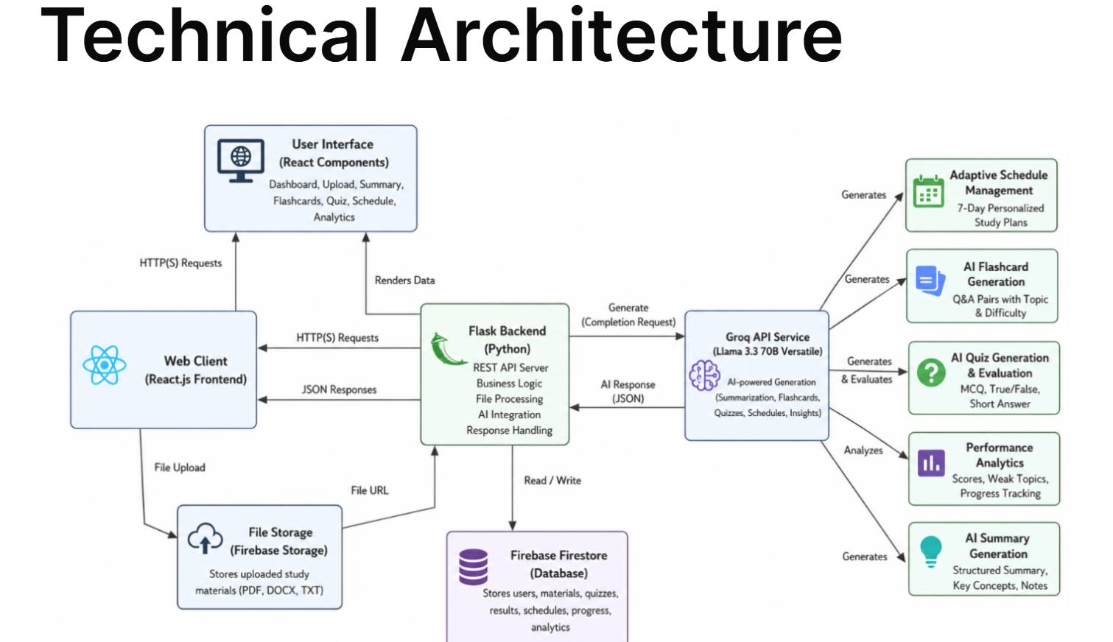
Figure 1: StudyAI system architecture — data and request flow between the React client, Flask backend, Groq AI service, and Firebase storage.
Layer | Technology
Frontend | React.js
Backend | Python Flask
Database | Firebase Firestore (local JSON fallback if not configured)
AI Engine | Groq API — Llama 3.3 70B Versatile
Core Libraries | Groq SDK, Firebase SDK, Axios, React Markdown, Chart.js

System Requirements

Hardware Requirements
- Processor: Intel Core i5 (10th Gen+) / AMD Ryzen 5 or equivalent
- RAM: Minimum 8 GB (16 GB recommended)
- Storage: 256 GB SSD minimum (512 GB recommended)
- GPU (optional): NVIDIA GTX 1650 or above for local AI/ML experimentation
- Internet: Stable connection, minimum 10 Mbps for API and cloud usage

Software Requirements
- OS: Windows 10/11, macOS (Monterey+), or Linux (Ubuntu 20.04+)
- Browser: Latest Chrome, Firefox, or Edge
- Node.js (LTS) and Python 3.11+ installed, or Docker Desktop as an alternative

Instructions
1. Environment Setup & AI Configuration
Set up the React.js frontend and Python Flask backend with all dependencies (Groq SDK, Firebase SDK, Axios, React Markdown, Chart.js). Configure secure API key management via environment variables and connect to the Groq AI platform. Prepare Firebase Firestore and local JSON fallback storage.
2. Prompt Engineering & AI Model Selection
Selected the Llama 3.3-70B Versatile model for its reasoning capability, content quality, and response speed. Designed structured prompts for summarization, flashcard generation, quiz creation, weak topic identification, and schedule generation.
3. Building the AI-Powered Learning Platform
Developed the Study Material Upload System, AI Summary Generator, Flashcard Generation Engine, Adaptive Quiz Generator, Personalized Study Schedule Planner, Learning Analytics Dashboard, Weak Topic Identification System, and Performance Tracking Module.
4. Secure Data Management & Input Validation
Implemented secure handling of uploaded study materials and learning records, with validation for PDF, DOCX, and TXT inputs, and secure communication across frontend, backend, database, and AI services.
5. AI-Powered Learning Content Engine
Integrated the Groq API to generate structured study summaries, interactive flashcards, MCQs, True/False assessments, short answer questions, weak topic analysis, and personalized recommendations.
6. Adaptive Quiz & Performance Assessment System
Built AI-powered quizzes across MCQ, True/False, and Short Answer formats, with automatic evaluation, scoring, weak concept identification, and detailed explanations.
7. Personalized Study Schedule Generator
Created intelligent 7-day study schedules incorporating weak topics, with day-wise tasks, focus topics, revision sessions, and priority-based tracking.
8. Learning Analytics & Interactive Dashboard
Built dashboards using Chart.js and React to display quiz performance trends, average scores, learning progress, and weak topic analysis through line, bar, and doughnut charts.
9. Dynamic User Experience & Responsive Design
Developed a modern, responsive UI with drag-and-drop uploads, markdown rendering, interactive flashcards, and dynamic quiz workflows across desktop, tablet, and mobile.
10. Deployment, Testing & Optimization
Deployed the React frontend and Flask backend (locally and via Docker), configured Firebase and Groq integrations, tested all core workflows, and optimized performance and response quality.

Outcome
By completing this project, the following was achieved:
- Built a Generative AI-powered educational platform using React.js, Flask, Firebase, and Groq AI
- Implemented intelligent study material processing and adaptive learning systems
- Integrated Large Language Models (LLMs) into a real-world educational application
- Developed a secure, cloud-connected learning platform with persistent storage and analytics
- Created AI-powered summarization, flashcard generation, quiz creation, and study planning systems
- Gained hands-on experience with Generative AI, Prompt Engineering, Educational Technology, Cloud Computing, Learning Analytics, and Full-Stack Development

