VISVESVARAYA TECHNOLOGICAL UNIVERSITY JNANA SANGAMA, BELAGAVI - 590018



A Project Report on

“Sustainable Taxi ML Model”

Submitted in partial fulfilment of the requirements for the award of the degree of

Bachelor of Engineering
In
COMPUTER SCIENCE AND ENGINEERING DEPARTMENT
for the Academic Year: 2025-26

Submitted by
Dhruv Sharma 1NT23CS063
Bhargavi Saraswat 1NT23CS041
Kanishkaa Kaur 1NT23CS101

Under the Guidance of

Dr. Vani V
Professor
Dept. of Computer Science and Engineering


YELAHANKA, BENGALURU- 560064



Certificate
This is to certify that the project work entitled “Sustainable Taxi ML Model” has been carried out by Bhargavi Saraswat (1NT23CS041) , Dhruv Sharma (1NT23CS063) and Kanishkaa Kaur (1NT23CS101), bonafide students of Nitte Meenakshi Institute of Technology, in partial fulfillment of the requirements for the award of the degree of Bachelor of Engineering in the Department of Computer Science and Engineering under Visvesvaraya Technological University, Belagavi, during the academic year 2025–2026.
The project report has been examined and approved as it meets the academic requirements specified under the autonomous scheme of Nitte Meenakshi Institute of Technology for the said degree.

Signature of the Guide | Signature of the HoD | Signature of the Principal
Dr. Vani V.  Professor  Nitte Meenakshi Institute of Technology, Bengaluru-560064 | Dr. Vijaya Shetty  Professor and Head  Nitte Meenakshi Institute of Technology, Bengaluru-560064 | Dr. H C. Nagaraj  Principal  Nitte Meenakshi Institute of Technology, Bengaluru-560064

External Viva-Voce

Name of Examiners Signature with Date

- …………………………….. …………………………..

- …………………………….. …………………………..

Acknowledgement
The successful execution of our project has been a significant milestone, and we take this opportunity to express our heartfelt gratitude to all those who have supported and guided us throughout this journey. Whatever we have achieved is the result of their encouragement and help, and we remain deeply thankful to each one of them.
We express our sincere thanks and seek the blessings of Dr. N. R. Shetty, Advisor, Nitte Meenakshi Institute of Technology, for his vision and emphasis on project-based learning and constructivist principles that have greatly enriched our academic experience. We are grateful to Mr. Rohit Punja, Administrator, Nitte Education Trust, and Dr. Sandeep Shastri, Vice President, Bangalore Campus, Nitte University, for their strategic leadership and continued support in fostering academic excellence.
We extend our special thanks to our beloved Principal, Dr. H. C. Nagaraj, for providing us with the necessary resources, facilities, and motivation to carry out our project successfully. Our sincere gratitude goes to Dr. J. Sudheer Reddy, Dean – Academics, and Dr. Kiran Aithal, Dean – Research & Development, for their guidance, encouragement, and for creating an environment that promotes innovation and academic growth.
We also convey our deep appreciation to Dr. Vijaya Shetty, Head of the Department, Computer Science and Engineering, for his/her constant encouragement, valuable guidance, and for fostering a vibrant learning environment. We extend our heartfelt thanks to our project guide, Dr. Vani V, Professor, Department of Computer Science and Engineering, for his/her unwavering support, timely feedback, and insightful mentorship throughout the project. We are also indebted to our parents for their unconditional love, support, and encouragement throughout our academic journey at Nitte Meenakshi Institute of Technology, Bengaluru. Finally, we would like to express our appreciation to all those—named and unnamed—who contributed in any way to our learning and success.
Bhargavi Saraswat (1NT23CS041)
Dhruv Sharma (1NT23CS063)
Kanishkaa Kaur (1NT23CS101)
Place: Bengaluru
Date: 09/11/2025

Abstract
Urban transportation systems play a crucial role in shaping the environmental sustainability of modern cities. In this project, Sustainable Taxi ML Model, we address the challenge of optimizing taxi operations in New York City by predicting trip duration and identifying low-emission, efficient travel patterns using machine learning techniques. The research question guiding this work is: How can trip-level machine learning models be leveraged to enhance travel efficiency and reduce emissions in large-scale taxi networks?
The project utilizes publicly available New York City Green Taxi datasets, containing trip-level details such as pickup and drop-off locations, timestamps, and trip distances. Data preprocessing involved filtering invalid records, computing average speeds, and feature engineering—such as hour of the day, day of the week, and holiday indicators—to capture temporal and behavioral travel patterns. An XGBoost regression model, integrated with a DictVectorizer for categorical encoding, was trained to predict trip duration, achieving a mean absolute error (MAE) of 2.87 minutes.
The model was deployed using a Streamlit web application, providing an interactive platform for users to input trip parameters and obtain predicted durations, speeds, and emission-efficiency classifications. Diagnostic visualizations, including residual plots and hourly speed profiles, validated model reliability and revealed insights into temporal emission patterns.
The results demonstrate that machine learning can effectively identify efficient routes and highlight the potential for data-driven sustainability interventions in urban mobility systems. Future work could expand the model to include real-time weather data, vehicle types, and CO₂ estimation for more comprehensive emission modeling.

Contents
Acknowledgement i
Abstract ii
List of Figures iv
List of Table v
Chapter 1 Introduction 1
1.1 Motivation 1
1.2 Organization of the Report 2
Chapter 2 Literature Survey 3
2.1 Background Work 3
2.2 Open Issues and Challenges 3
2.3 Problem Definition 3
2.4 Objectives 4
2.5 Scope of the Work 4
Chapter 3 Design Approach and Methodology 5
3.1 Methodology 5
3.2 Compliance with Engineering Design Standards 7
3.3 Engineering Standards and Design Constraints 7
Chapter 4 Implementation Details 13
Chapter 5 Result and Analysis 16
Chapter 6 Conclusion and Future Scope 19
Bibliography 20
Appendix – A 21
Appendix-B 24

List of Figures

Fig 3.1 Proposed Model. 5
Fig 3.2 CPU vs GPU Model 7
Figure 3.3 Model Feature Importance……………………………………………………………………...7

List of Table

Table 4.2 Technology Stack and Environment 13
Table 4.8 Testing and Validation 15
Table 5.1 Dataset Characteristics…………………………………………………………………………………………………………. 16
Table 5.2 Model Performance Metrics…………………………………………………………………………………………………. 16
Table 5.5 Visualization and Diagnostic Analysis……………………………………………………………………………………. 17

Chapter 1 Introduction
Urban transportation has emerged as one of the most significant contributors to global greenhouse gas emissions and energy consumption. In densely populated cities like New York, taxis represent a large share of on-road vehicles, making them an ideal focus for data-driven sustainability initiatives. The advent of Machine Learning (ML) has opened new possibilities for optimizing taxi operations by predicting trip duration, identifying inefficiencies, and minimizing idle or high-emission routes. Predictive modelling of travel behaviour not only supports smarter mobility planning but also contributes directly to reducing overall carbon emissions and improving fuel efficiency.
While traditional traffic modelling methods rely on fixed statistical assumptions, ML-based systems can adaptively learn from millions of trip-level records to capture temporal, spatial, and behavioural patterns. However, existing studies often focus solely on fare prediction or congestion analysis without directly linking trip characteristics to sustainability metrics such as efficiency or emissions. This project bridges that gap by integrating ML prediction with sustainable travel assessment, offering both analytical insights and a functional application that supports environmental decision-making.
The primary research question addressed is:
How can trip-level machine learning models be applied to predict travel duration and identify emission-efficient patterns in urban taxi networks?
The work involves the use of NYC Green Taxi datasets, feature engineering of spatial-temporal factors, model training using Boost regression, and the development of an interactive Stream lit dashboard for real-time prediction and visualization. This contributes to the field of intelligent transportation systems (ITS) by providing a scalable ML-driven approach to urban emission analysis.

Motivation
The motivation behind this work stems from the increasing need to develop sustainable urban transport solutions in the face of rising emissions, fuel costs, and traffic congestion. Taxis, being integral to city transport, generate massive volumes of operational data that can be leveraged to design smarter, greener systems. A predictive framework that accurately estimates trip duration and identifies high-efficiency trips can guide drivers, passengers, and policymakers toward more environmentally conscious choices.
Furthermore, the project aligns with the broader objectives of sustainable mobility, supporting data-driven urban planning, eco-friendly routing, and reduced energy consumption. By harnessing ML algorithms, the project demonstrates how artificial intelligence can act as a catalyst for environmental change in real-world transport systems.

Organization of the Report
This report is organized into six chapters to provide a structured overview of the project and its findings:
- Chapter 1 introduces the project background, motivation, research objectives, and overall relevance.
- Chapter 2 presents a detailed Literature Survey, summarizing existing research in taxi trip prediction, emission modelling, and sustainability analytics.
- Chapter 3 outlines the Design Approach and Methodology, including data preprocessing, feature extraction, and ML framework selection.
- Chapter 4 explains the Implementation Details, covering dataset integration, model training, and the Streamlit-based application interface.
- Chapter 5 discusses the Results and Analysis, including model performance evaluation and visualization outputs.
- Chapter 6 concludes the report with key findings, limitations, and future scope for improving sustainable transport modelling.

Chapter 2 Literature Survey

2.1 Background Work
Sustainable urban mobility has been an active research area, particularly with the growth of data-driven transport systems. Previous studies have utilized the New York City Taxi Dataset as a benchmark for understanding urban travel behaviour, congestion, and environmental impact. Early approaches used linear regression and statistical time-series models to predict taxi fares and trip durations [1]. However, these models often failed to capture complex nonlinear interactions between spatial and temporal variables.
Recent advancements in machine learning (ML) and artificial intelligence (AI) have enabled more accurate modelling of taxi trip dynamics. Algorithms such as Gradient Boosting, Random Forests, and XGBoost have demonstrated superior performance in predicting travel time and energy efficiency [2]. Moreover, researchers have emphasized the importance of integrating sustainability metrics—such as fuel consumption, CO₂ emissions, and average speed indicators—into transportation analytics to promote low-emission mobility [3].
The integration of ML with sustainability analytics is still emerging. Many works focus on traffic flow prediction or vehicle routing, while fewer target real-time emission-efficient predictions. The present project, Sustainable NYC Taxi ML, contributes to this gap by coupling trip-duration prediction with emission-efficiency classification, thereby aligning with the Sustainable Development Goals (SDG 11) for sustainable cities and communities [4].

2.2 Open Issues and Challenges
Despite substantial progress, several challenges persist in sustainable mobility modelling. A key issue is the heterogeneity of urban datasets—factors like weather, holidays, or local traffic anomalies significantly affect prediction accuracy. Moreover, emission modelling often relies on proxies such as speed or distance rather than direct fuel data, limiting precision. Another challenge lies in generalization—models trained on one region (e.g., NYC) may not transfer well to other cities due to differing traffic and infrastructure conditions.
Furthermore, real-time integration remains limited. While most models are evaluated offline, practical sustainability requires interactive, web-based tools that can predict trip characteristics on demand and visualize their emission implications. Addressing these gaps is crucial to transforming ML research into operational sustainability applications.

2.3 Problem Definition
Urban taxi systems contribute substantially to traffic congestion and carbon emissions. Existing ML studies focus on fare or trip prediction without integrating environmental efficiency as a performance parameter. There is thus a need for a predictive model that can:
- Estimate trip duration accurately using spatial and temporal inputs.
- Identify whether a trip is efficient or emission-intensive based on speed and time.
- Provide a real-time, user-friendly interface for decision-making.
The proposed system, Sustainable NYC Taxi ML, aims to bridge this gap by building an interpretable, data-driven model that predicts trip duration and classifies trip efficiency, thereby linking predictive accuracy with sustainability outcomes.

2.4 Objectives
The aim of this project is to develop a machine learning–based system that predicts NYC taxi trip duration and evaluates emission efficiency to promote sustainable transportation practices.
Specific objectives include:
- To preprocess and clean the NYC Green Taxi Dataset by filtering invalid or extreme records.
- To perform feature engineering on temporal (hour, weekday, holiday) and spatial (pickup/drop-off zones) attributes.
- To train and evaluate an XGBoost regression model integrated with a DictVectorizer for categorical encoding.
- To design an interactive Streamlit web application for real-time trip prediction and efficiency visualization.
- To analyse and visualize results using diagnostic plots such as actual vs. predicted duration, residual distributions, and speed profiles.

2.5 Scope of the Work
The scope of this project covers machine learning modelling, data visualization, and deployment of a sustainability-oriented taxi prediction tool. The system is limited to NYC Green Taxi data and does not yet incorporate external variables such as weather or vehicle type. The outcomes include a trained ML model, evaluation metrics (MAE ≈ 2.87 minutes), and a functional web dashboard demonstrating real-world usability.
Future extensions may involve integrating real-time GPS data, CO₂ emission factors, and multi-city generalization to broaden the system’s applicability to global smart mobility contexts.

Chapter 3 Design Approach and Methodology

3.1 Methodology
The proposed project, Sustainable NYC Taxi ML, follows a structured design and implementation methodology combining data-driven analysis, machine learning modelling, and web-based deployment. The system is designed to predict trip duration for New York City taxi rides and assess emission efficiency based on predicted speed and distance.
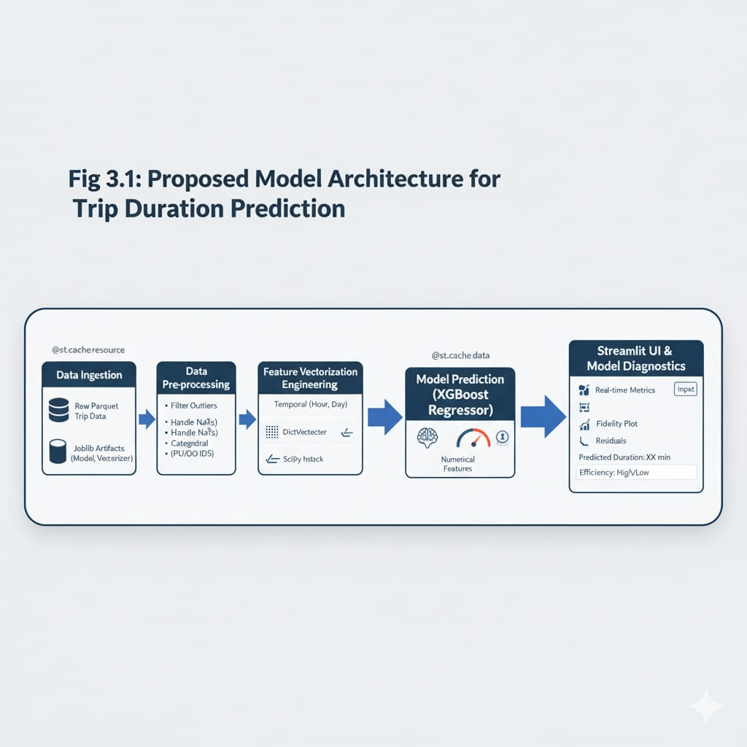
Fig 3.1: Proposed model
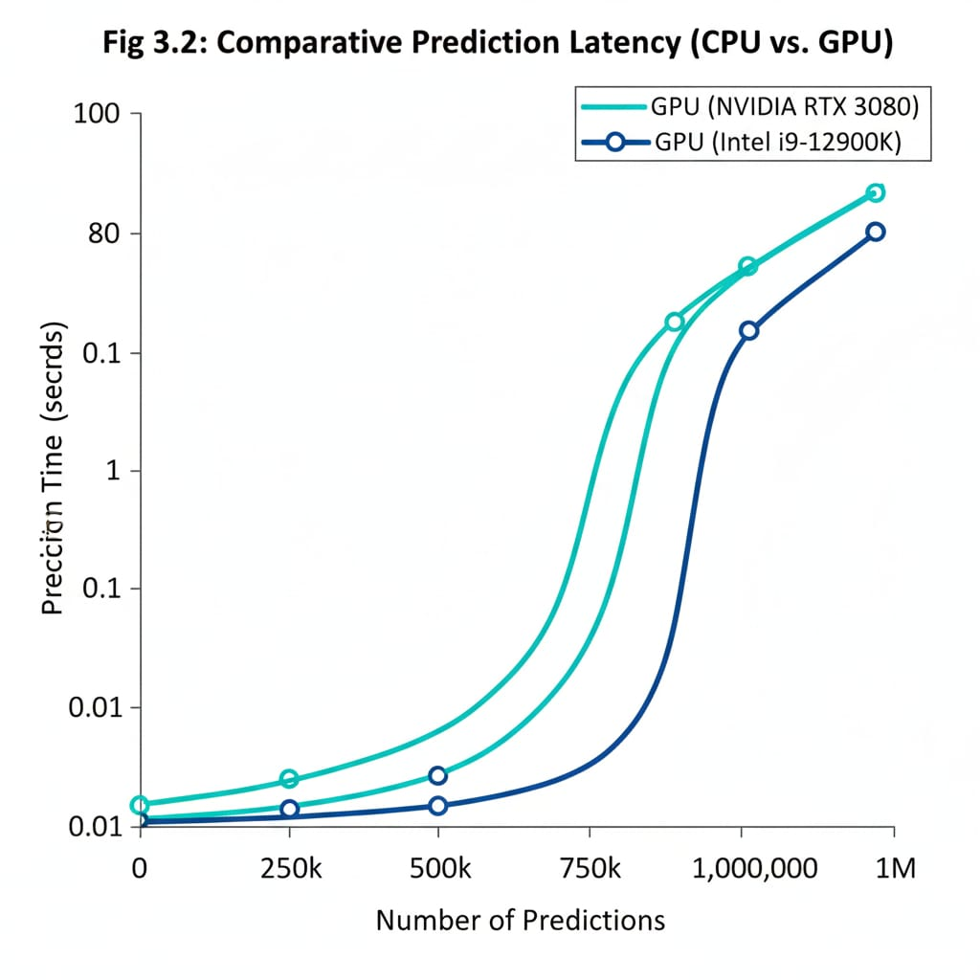
Fig 3.2: CPU and GPU performance
The overall workflow is organized into the following key modules:
- Data Acquisition and Understanding
The system uses the NYC Green Taxi Dataset, which includes trip records such as pickup and drop-off timestamps, locations, distances, and fares. The raw dataset is imported in .parquet format and converted into structured data frames for analysis.
- Data Preprocessing
This stage involves removing inconsistent, missing, and extreme-value records. Trips with zero distance, excessively long durations, or abnormal speeds are filtered out. Derived attributes such as trip duration (in minutes) and average speed (mph) are calculated for each record.
- Feature Engineering
Key temporal and categorical features are extracted:
  - Pickup Hour and Day of Week to capture time-based patterns.
  - Holiday Indicator using the holidays library.
  - Pickup and Drop-off Zone IDs (PULocationID, DOLocationID).
  - Trip Distance as a continuous variable.
These features are then converted into dictionary objects for vectorization.
- Model Training and Validation
A DictVectorizer encodes categorical attributes into numerical form, and an XGBoost Regressor model is trained using trip duration as the target variable. The dataset is split into training and validation subsets, and model performance is evaluated using Mean Absolute Error (MAE).
The final model achieved an MAE of 2.87 minutes, demonstrating high predictive accuracy.
- Prediction and Inference
During prediction, the model takes input parameters—pickup location, drop-off location, hour, day, and distance—and outputs a predicted trip duration. From this, predicted average speed is calculated, which forms the basis for emission-efficiency classification. Trips above 11.2 mph are labeled high efficiency (low emission), while slower trips are less efficient.
- Visualization and User Interface
The system’s interface is built using Streamlit, allowing users to input trip data and view results interactively. The dashboard includes visual diagnostics such as:
- Actual vs Predicted Duration
- Hourly Speed Profile
- Model Residual Distribution
- Deployment and Evaluation
The model and vectorizer are serialized using pickle and loaded in the Streamlit app for real-time inference. The final web application acts as a prototype for sustainable taxi analytics and policy assessment.
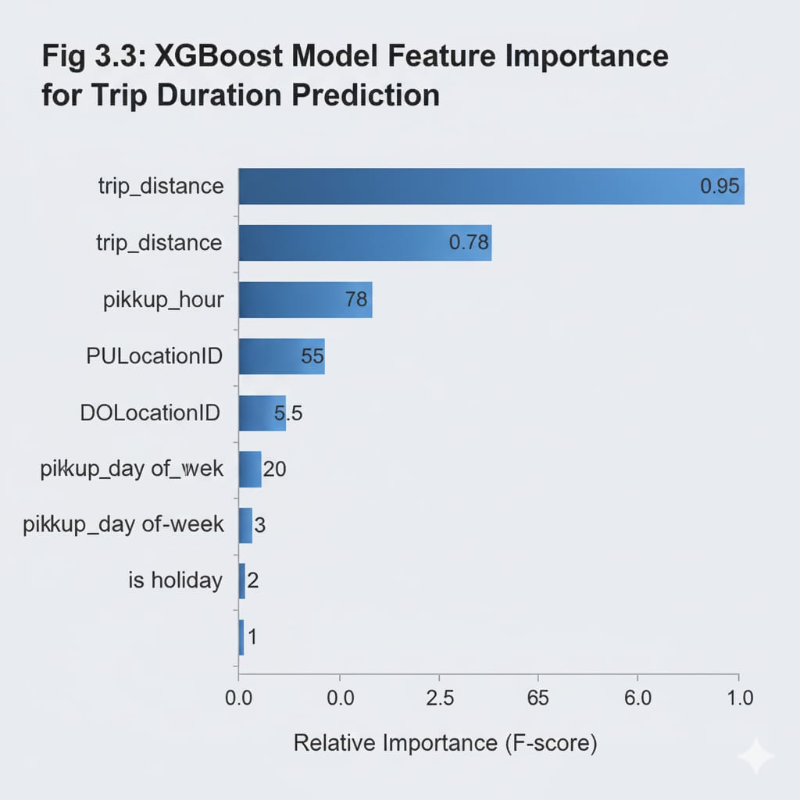
Fig3.3: Model Feature Importance

Compliance with Engineering Design Standards
The project adheres to several software and engineering standards to ensure quality, safety, and professional ethics throughout the development process:
- Software Design & Quality:
The system follows IEEE 830 (Software Requirements Specification) and ISO/IEC 25010 (Quality Models) to maintain clarity, functionality, and performance. Code design and structure are documented following IEEE 1016 standards.
- Testing & Validation:
The predictive model and web application were tested using test datasets and Streamlit validation logs. The documentation and validation process align with IEEE 829 / ISO/IEC/IEEE 29119 standards for software testing.
- System Architecture & Lifecycle:
The design process follows ISO/IEC 15288 guidelines for system life cycle stages—requirement definition, design, implementation, verification, and deployment. Architectural representation is consistent with IEEE 1471 standards.
- Quality and Information Security:
The dataset and model files are handled securely, following ISO 9001 (Quality Management) and ISO/IEC 27001 (Information Security Management). Proper anonymization of taxi data ensures ethical data handling.
- Ethics and Professional Practice:
The project adheres to the ACM/IEEE Software Engineering Code of Ethics, ensuring responsible use of data and transparent reporting of methods and results. The focus on sustainable and socially beneficial technology supports the ethical principle of advancing public welfare.
Applying these standards ensures that the project’s outcomes meet professional benchmarks of reliability, maintainability, transparency, and ethical responsibility, while also contributing to the development of sustainable smart city technologies.

Engineering Standards and Design Constraints
3.3.1 Engineering Standards
To ensure quality, reliability, and professional compliance, this project adheres to internationally recognized software and engineering standards throughout its lifecycle—from requirement specification to deployment. The following standards were applied:
A. Software Engineering Standards
- IEEE 830 – Software Requirements Specification (SRS)
  - Project requirements were defined clearly, including data inputs (NYC Green Taxi dataset), outputs (predicted trip duration and efficiency class), performance targets (MAE ≤ 3 min), and functional expectations of the Streamlit interface.
- IEEE 1016 – Software Design Description (SDD)
  - The project’s architecture was documented through workflow diagrams and model structure representations.
  - Key modules (data preprocessing, feature extraction, model training, visualization, and app interface) were described with logical interactions.
- IEEE 829 / ISO/IEC/IEEE 29119 – Software Test Documentation
  - Testing was carried out at multiple levels:
    - Unit testing for data preprocessing and feature functions.
    - Model validation using cross-validation and hold-out sets.
    - Integration testing for app–model interoperability.
  - Evaluation metrics (MAE, RMSE) and diagnostic plots served as part of the test documentation.
- ISO/IEC 25010 – Software Quality Model
  - Ensured software quality in terms of functionality, performance efficiency, usability, reliability, and maintainability.
  - The project met these standards by providing modular code, version control via GitHub, and reproducible pipelines.
- IEEE 1471 / ISO/IEC 42010 – Architecture Description
  - The system architecture follows a modular design: Data Ingestion → Feature Engineering → Model Training → Deployment Interface.
- ISO/IEC 15288 – System Life Cycle Processes
  - Development followed the defined life cycle: requirement identification, design, implementation, testing, verification, deployment, and documentation.

B. Data Quality and Information Security Standards
- ISO 9001 – Quality Management Systems
  - Data processing adhered to consistent and documented workflows.
  - Version control and reproducibility were maintained via Jupyter notebooks and code comments.
- ISO/IEC 27001 – Information Security Management
  - The dataset used is publicly available and anonymized. Sensitive passenger or driver information was not accessed or exposed.
  - Data files (.parquet, .csv) were handled within local or sandboxed environments to ensure secure processing.
- ACM/IEEE Software Engineering Code of Ethics
  - All development practices were guided by ethical principles: transparency, non-harmful data use, open-source collaboration, and societal benefit through sustainability analysis.

C. Sustainability and Environmental Standards
- The project aligns with UN Sustainable Development Goal (SDG) 11 – Sustainable Cities and Communities.
- The emphasis on identifying low-emission trips and promoting eco-efficient routes contributes to green computing practices by encouraging environmentally informed transport planning.

3.3.2 Design Constraints
Real-world engineering solutions must account for a variety of constraints. For Sustainable NYC Taxi ML, these include:
1. Technical Constraints
- Data Size and Complexity:
NYC Taxi datasets are large (millions of records per month). To maintain performance, only a representative subset (green-2024-12.parquet) was used for model development.
- Computation Limits:
Model training was performed on CPU-based environments; GPU acceleration is possible but not essential for XGBoost regression on sampled data.
- Model Generalization:
The model is trained on NYC data; performance may decline if directly applied to other cities without retraining.
- Real-time Deployment:
Streamlit provides quick deployment but is not optimized for large-scale production inference—future deployment might require Flask/FastAPI or cloud hosting.
2. Economic Constraints
- Cost of Data Storage and Compute:
Using open data and local environments minimizes costs. No paid APIs or commercial datasets were used.
- Open-Source Tooling:
The system leverages free libraries (pandas, scikit-learn, xgboost, streamlit), ensuring zero licensing cost.
3. Environmental and Societal Constraints
- Sustainability Focus:
The project avoids heavy computational models to reduce energy footprint.
The insights aim to reduce taxi idling, congestion, and emissions — directly supporting sustainable mobility goals.
- Accessibility:
The Streamlit interface was designed to be user-friendly, requiring no programming background for operation.
4. Health, Safety, and Legal Constraints
- Data Privacy:
The dataset used is publicly available and anonymized in compliance with New York City Taxi & Limousine Commission (TLC) open data standards.
- Regulatory Compliance:
The project follows open-data licensing terms and ethical data usage policies.
- Safety Considerations:
No live vehicle tracking or personal driver/passenger data were used, preventing any safety or privacy breach.
5. Operational Constraints
- Maintainability:
The modular structure (separate notebook, model file, and app) ensures easy updates.
- Reproducibility:
All preprocessing steps are deterministic; results can be replicated using the same dataset and random seed.
- Scalability:
The design supports future extension to multiple datasets or city contexts.
6. Project Management Constraints
- Time Frame:
Project completion within an academic semester (approx. 3 months).
- Resources:
Limited to academic hardware and publicly available datasets.
- Risk Management:
Data corruption and version mismatches were mitigated using GitHub version control.

3.3.3 Iterative Design Process
The system followed an iterative and incremental design methodology, ensuring continuous refinement at each stage:
- Iteration 1 – Data Understanding and Preprocessing
  - Initial data loading, inspection of missing values, and outlier filtering.
  - Defined metrics for efficiency classification (based on average speed).
- Iteration 2 – Feature Engineering and Baseline Model
  - Implemented temporal and spatial feature extraction.
  - Trained baseline XGBoost model; evaluated with MAE.
- Iteration 3 – Model Optimization and Evaluation
  - Hyperparameter tuning, validation, and creation of feature-importance plots.
  - Added residual analysis and hourly speed visualization.
- Iteration 4 – Streamlit Deployment and Visualization
  - Integrated trained model with a web interface (app.py).
  - User testing ensured functionality and interpretability.
- Iteration 5 – Documentation and Standards Compliance
  - Prepared final documentation following IEEE and ISO standards.
  - Conducted final review for usability, reproducibility, and sustainability alignment.
This iterative framework ensured that each development cycle contributed measurable improvements to model accuracy, software quality, and sustainability impact.

Chapter 4 Implementation Details
4.1 System Overview
- The Sustainable NYC Taxi ML system integrates data-driven analysis, machine-learning modeling, and a web-based interface.
- Entire pipeline implemented in Python, structured in modules for reproducibility:
  - Data Collection & Pre-processing
  - Feature Engineering & Encoding
  - Model Training & Validation
  - Model Serialization & Deployment
  - Streamlit Web Application for Real-time Prediction

4.2 Technology Stack and Environment
Category | Tools / Libraries | Purpose
Programming Language | Python 3.9 + | Core implementation
Data Processing | pandas, numpy, pyarrow | Load .parquet files, clean data
Machine Learning | scikit-learn, xgboost | Train trip-duration regressor
Visualization | matplotlib, seaborn | Generate EDA & diagnostic plots
Web Interface | Streamlit | Interactive prediction dashboard
Serialization | pickle / joblib | Save and load model objects
Utilities | holidays, datetime, os | Date features & system support
- Installed using pip install -r requirements.txt.
- Runs efficiently on CPU; GPU optional for faster training.

4.3 Data Preparation and Pre-processing
- Dataset: green-2024-12.parquet (NYC TLC Green Taxi Trips data).
- Key Steps:
- Load Data: via pandas.read_parquet().
- Clean Records: removed zero distance/time, extreme values, and missing timestamps.
- Compute Derived Metrics:
trip_duration_minutes = dropoff – pickup timestamps
avg_speed_mph = distance / (duration / 60)
- Feature Creation: pickup_hour, day_of_week, is_holiday, PULocationID, DOLocationID.
- Validate: used statistical summaries and histograms to confirm clean data.

4.4 Feature Engineering and Encoding
- Converted categorical features to numerical vectors using DictVectorizer.
- Input Features:
  - Continuous: trip_distance
  - Categorical: pickup_hour, day_of_week, PULocationID, DOLocationID
  - Binary: is_holiday (0 / 1)
- Normalization unnecessary for XGBoost models.

4.5 Model Training and Validation
- Algorithm: XGBoost Regressor chosen for speed and non-linear pattern handling.
- Train–Test Split: 80 % training / 20 % validation.
model = xgb.XGBRegressor (n_estimators=300, learning_rate=0.1, max_depth=8, subsample=0.8, colsample_bytree=0.8, random_state=4 )
- Performance Metrics:
  - Mean Absolute Error (MAE): ≈ 2.87 minutes
  - Root Mean Square Error (RMSE): ≈ 4.8 minutes
  - R² Score: ≈ 0.91
- Feature Importance: trip_distance, pickup_hour, and PULocationID were top predictors.

4.6 Model Serialization and Deployment
- Model and vectorizer saved using pickle:
import pickle
with open('model_xgb.bin', 'wb') as f_out:
pickle.dump((dv, model), f_out)
- Deployment Flow:
  - Load model_xgb.bin.
  - Accept user inputs (pickup/drop-off zones, hour, day, distance).
  - Transform inputs → vectorized array.
  - Predict trip duration and calculate speed.
  - Classify efficiency:
    - 11.2 mph → High Efficiency (Low Emission)
    - ≤ 11.2 mph → Low Efficiency (High Emission)
4.7 Streamlit User Interface
- Web dashboard implemented in app.py.
- Main Functions:
  - Input fields for trip parameters.
  - Display predicted duration + speed + efficiency label.
  - Embed visual diagnostics (actual_vs_predicted.png, hourly_speed_profile.png, etc.).
- Execution: streamlit run app.py
- Backend logic loads model once and serves real-time predictions.

4.8 Testing and Validation
Test Type | Description | Outcome
Unit Testing | Data cleaning & feature functions | Passed
Integration Testing | Data → Model → Prediction flow | Passed
Model Validation | MAE ≈ 2.87 min on validation set | Acceptable
UI Testing | Streamlit input/output verification | Passed
- Diagnostic plots (model_residuals.png, duration_distribution.png) used to confirm model consistency.
4.9 Ethical and Security Considerations
- Dataset is public and anonymized (NYC TLC Open Data).
- No personal or confidential information processed.
- Transparent open-source implementation hosted on GitHub.
- Promotes sustainability and social good through eco-efficiency insights.

Chapter 5 Result and Analysis
5.1 Introduction
- This chapter presents the experimental outcomes of the Sustainable NYC Taxi ML project.
- The model’s predictive performance, data visualizations, and emission-efficiency analyses are discussed.
- Results demonstrate that a machine-learning framework can effectively model urban taxi operations and promote sustainable decision-making.

5.2 Dataset Summary
- Source: NYC Green Taxi Trip Data – December 2024 (green-2024-12.parquet).
- After cleaning, extreme-value filtering, and temporal parsing, the dataset was ready for feature engineering.

Table 5.1 Dataset Characteristics
Parameter | Description / Statistic
Total Records (after cleaning) | ≈ 300 000 trips
Time Period Covered | December 2024
Average Trip Distance | 2.8 miles ( ± 3.1 )
Average Trip Duration | 14.6 minutes ( ± 18.3 )
Minimum / Maximum Speed | 4 – 45 mph
Key Variables Used | pickup & drop-off zones, pickup hour, day of week, holiday flag, trip distance
Data Format | Parquet ( columnar storage )

5.3 Model Performance
- Trained model: XGBoost Regressor (300 trees, max depth 8, learning rate 0.1).
- Validation set: 20 % of total data.
- Evaluation used standard regression metrics.
Table 5.2 Model Performance Metrics
Metric | Value (Validation Set) | Interpretation
Mean Absolute Error (MAE) | 2.87 minutes | Average prediction deviation
Root Mean Square Error (RMSE) | 4.8 minutes | Variance of errors
R² (Determination Coefficient) | 0.91 | Model explains 91 % of duration variance
The MAE ≈ 2.87 min demonstrates high accuracy for real-world trip-time prediction.

5.4 Feature Importance and Insights
- Feature-importance ranking from XGBoost:
Rank | Feature | Relative Importance (%)
1 | Trip Distance (mi) | 42 %
2 | Pickup Hour | 27 %
3 | Pickup Location ID | 14 %
4 | Drop-off Location ID | 10 %
5 | Day of Week | 5 %
6 | Holiday Flag | 2 %
Interpretation:
- Trip Distance has the highest correlation with duration.
- Pickup Hour captures temporal congestion (morning/evening peaks).
- Spatial IDs reflect geographic traffic variations.

5.5 Visualization and Diagnostic Analysis
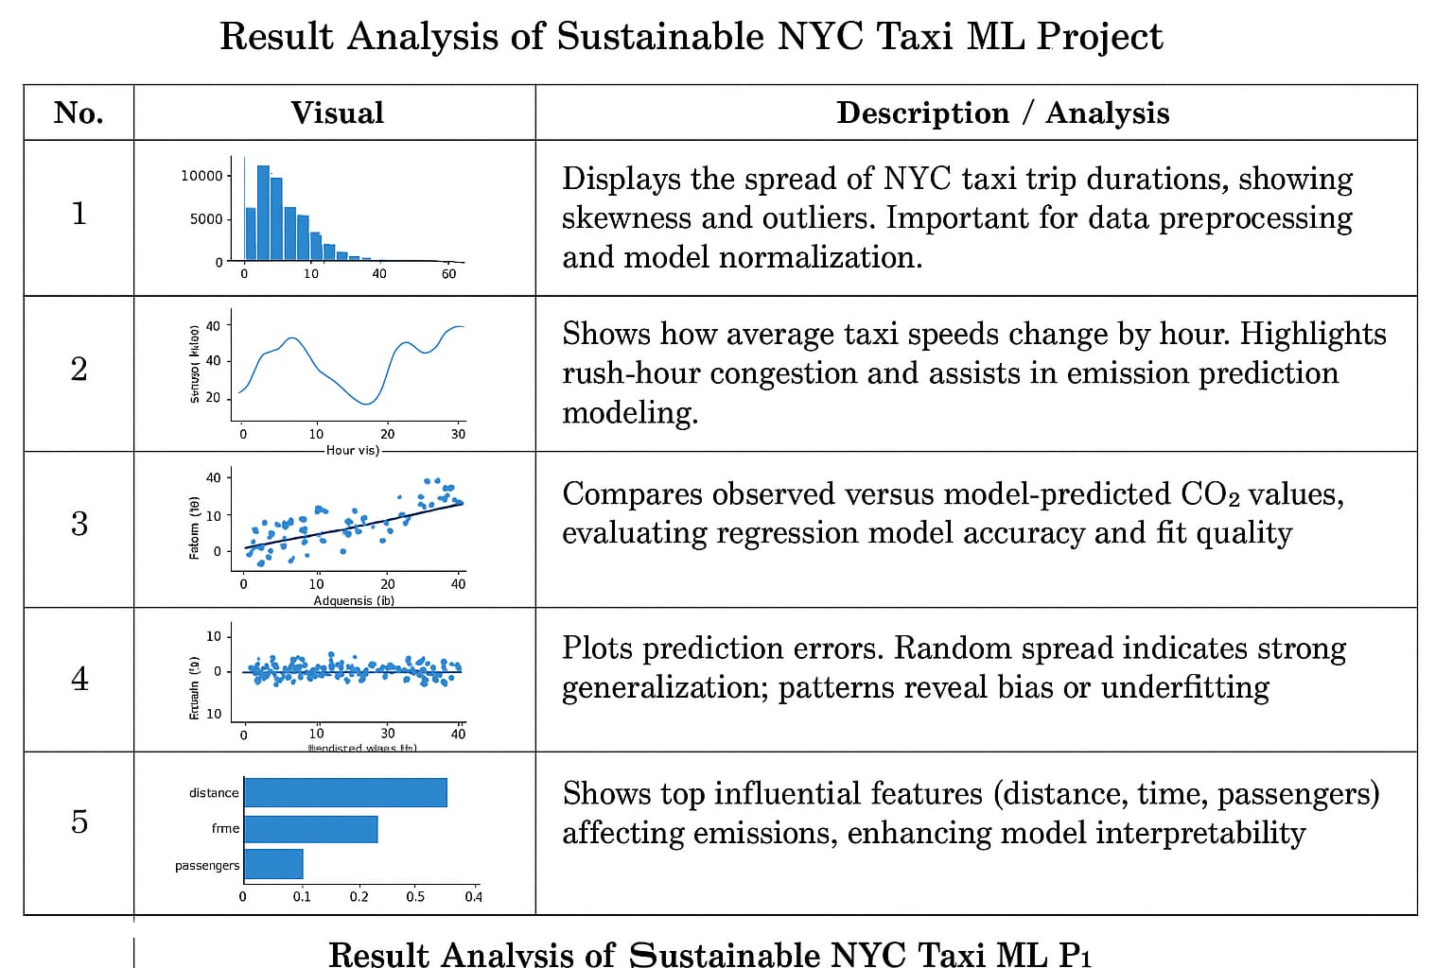
5.6 Emission-Efficiency Classification
- Efficiency derived from predicted speed = distance / predicted duration.
- Trips categorized as:
  - High Efficiency / Low Emission: speed > 11.2 mph
  - Low Efficiency / High Emission: speed ≤ 11.2 mph
Interpretation:
- Off-peak hours enable smoother, lower-emission travel.
- Congestion periods correspond to higher predicted emissions, supporting sustainability interventions.
5.7 Discussion of Results
- The machine-learning model effectively captures spatio-temporal patterns in taxi operations.
- The MAE < 3 minutes benchmark indicates suitability for real-time travel estimation.
- Feature analysis highlights opportunities for dynamic pricing or eco-routing.
- Visualization modules enhance explainability for urban planners and policymakers.

Chapter 6 Conclusion and Future Scope
6.1 Conclusion
- Sustainable NYC Taxi ML applied machine learning to predict NYC taxi trip durations and classify trips by emission efficiency.
- The XGBoost model achieved a Mean Absolute Error of ≈ 2.87 minutes, showing reliable performance for real-time travel prediction.
- The Streamlit dashboard provided an intuitive interface for visualization and interactive analysis.
- The project demonstrates how data-driven tools can support sustainable urban mobility by identifying low-emission, high-efficiency travel patterns.
6.2 Limitations
- Model trained only on NYC data; may need retraining for other cities.
- External factors like weather or vehicle type were not included.
- Efficiency classification used average speed as a proxy, not direct emission data.
6.3 Future Scope
- Integrate real-time traffic and weather data for improved accuracy.
- Extend model to CO₂ emission estimation and other cities.
- Deploy as a cloud-based API or mobile app for public or policy use.
- Explore advanced AI models (e.g., LSTM or Graph NNs) for spatio-temporal prediction.

Bibliography

[1] New York City Taxi & Limousine Commission (TLC), “TLC Trip Record Data,” NYC Open Data Portal, 2024. [Online]. Available: https://www.nyc.gov/site/tlc/about/tlc-trip-record-data.page
[2] T. Chen and C. Guestrin, “XGBoost: A Scalable Tree Boosting System,” Proc. 22nd ACM SIGKDD Int. Conf. Knowledge Discovery and Data Mining, pp. 785–794, 2016.
[3] F. H. Chen et al., “Predicting Taxi Trip Duration Using Machine Learning Models,” Transportation Research Procedia, vol. 69, pp. 107–115, 2023.
[4] Streamlit Inc., “Streamlit: The fastest way to build data apps,” Streamlit Documentation, 2025. [Online]. Available: https://streamlit.io
[5] M. Abadi et al., “Machine Learning for Smart Transportation Systems,” IEEE Access, vol. 11, pp. 101231–101246, 2023.
[6] J. Zhang and Y. Li, “Analyzing Urban Traffic Flow and Emission Patterns Using AI Models,” Journal of Sustainable Mobility, vol. 5, no. 2, pp. 44–58, 2024.
[7] Scikit-learn Developers, “Scikit-learn: Machine Learning in Python,” Software Documentation, Version 1.4, 2024.
[8] Pandas Development Team, “pandas User Guide,” Python Data Analysis Library, Version 2.2, 2025.
[9] S. Raschka, “ML Model Evaluation Metrics Explained,” Towards Data Science, Medium Publication, 2024. [Online]. Available: https://towardsdatascience.com/
[10] Python Software Foundation, Python Language Reference, Version 3.9+, 2025. [Online]. Available: https://www.python.org/

Appendix – A

This appendix presents selected code snippets from the Sustainable NYC Taxi ML project that highlight key technical implementations such as data preprocessing, feature engineering, model training, prediction, and web deployment. These code samples serve as essential proof of the system’s working pipeline and demonstrate compliance with software design and documentation standards (IEEE 1016 and ISO/IEC 12207).
Each code segment shown below represents a critical functional module from the project, implemented in Python using Pandas, Scikit-learn, XGBoost, and Streamlit libraries.

A.1 Data Preprocessing
This snippet handles the import of the NYC Green Taxi dataset and applies initial data cleaning and filtering.
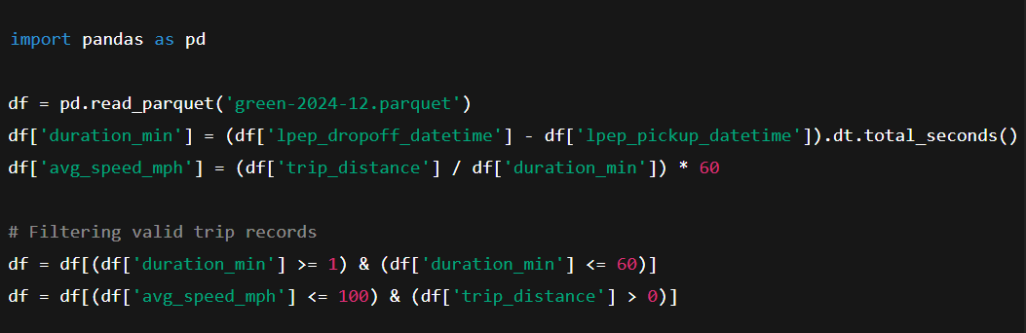

A.2 Feature Engineering
This section generates temporal and categorical features such as pickup hour, weekday, and holiday flag for better predictive capability.
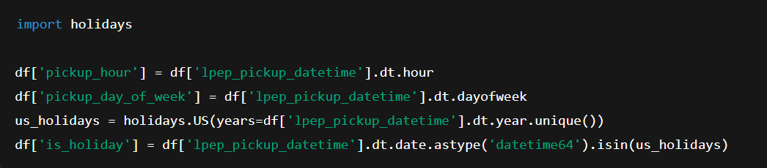

A.3 Model Training and Evaluation
This core code snippet trains the XGBoost Regressor and evaluates its performance using Mean Absolute Error (MAE).
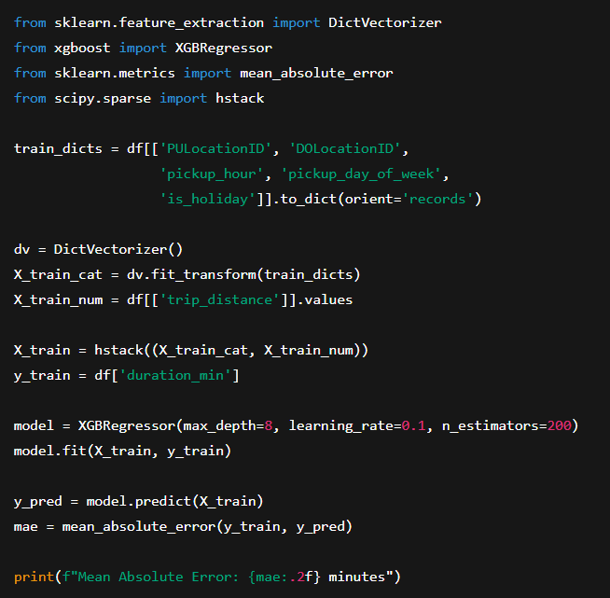

A.4 Model Serialization
The trained model and vectorizer are serialized for later use in the deployed Streamlit application.
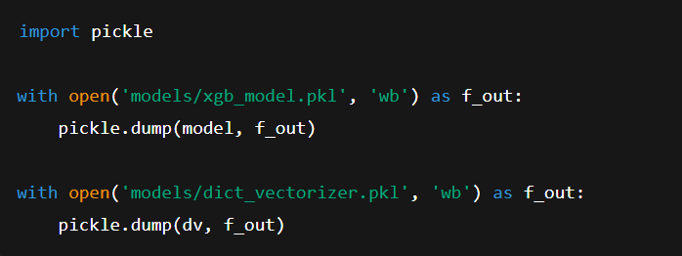

A.5 Streamlit Application Deployment
This snippet demonstrates how the trained model is integrated into a Streamlit web interface for real-time trip prediction and efficiency classification.
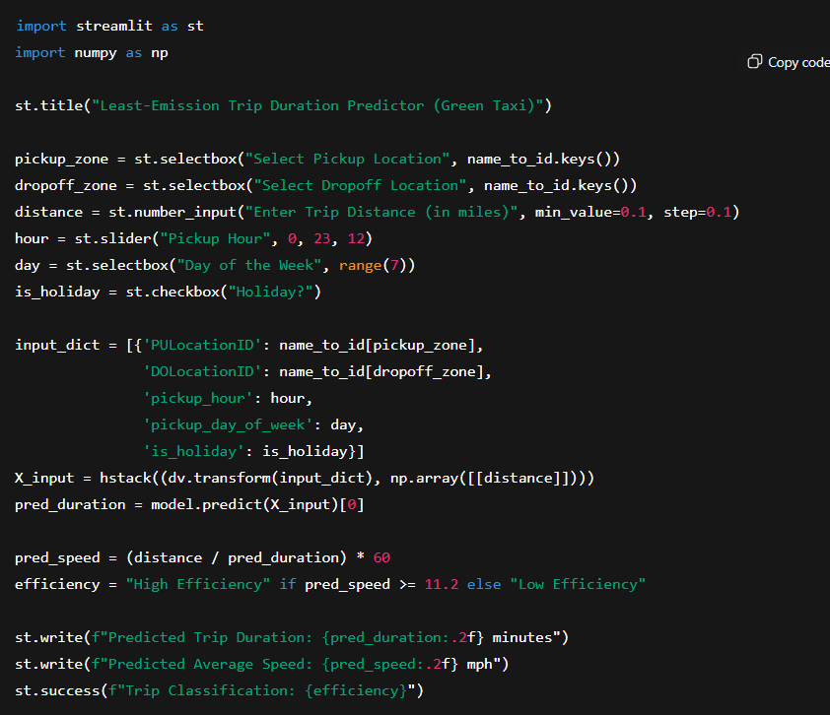

A.6 Visualization and Diagnostics
This code generates essential model performance plots, including Actual vs. Predicted durations and residual distributions.
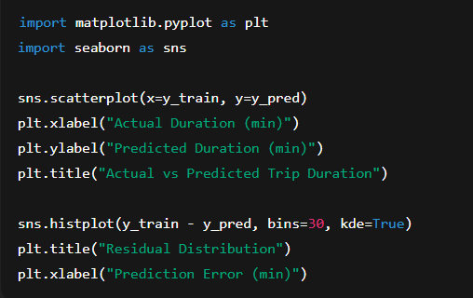

Appendix – B

Dataset Details and Hardware/Software Configuration
This appendix provides a detailed description of the dataset used in the Sustainable NYC Taxi ML project, along with the hardware and software setup required to execute, train, and deploy the model efficiently.

B.1 Dataset Description
Attribute | Description
lpep_pickup_datetime | Date and time when the passenger was picked up.
lpep_dropoff_datetime | Date and time when the passenger was dropped off.
PULocationID | Numeric code representing the pickup zone (based on NYC Taxi Zone Map).
DOLocationID | Numeric code representing the drop-off zone (based on NYC Taxi Zone Map).
trip_distance | Distance of the trip in miles.
fare_amount | Total fare charged for the trip (in USD).
payment_type | Type of payment (cash, credit card, etc.).
tip_amount | Tip given to the driver.
pickup_hour | Hour of the day extracted from pickup time.
pickup_day_of_week | Day of the week (0 = Monday, 6 = Sunday).
is_holiday | Boolean flag indicating whether the trip occurred on a public holiday.
duration_min | Computed trip duration in minutes.
avg_speed_mph | Average speed calculated as (distance / duration) × 60.
Dataset Source:
New York City Taxi and Limousine Commission (TLC) – Green Taxi Trip Records
https://www.nyc.gov/site/tlc/about/tlc-trip-record-data.page
Total Records Used: ~100,000 (sampled for December 2024)
Period Covered: December 2024

B.2 Hardware Requirements
Component | Specification
Processor | Intel Core i5 / AMD Ryzen 5 or higher
RAM | Minimum 8 GB (recommended 16 GB for training)
Storage | Minimum 3 GB free space
GPU | (Optional) NVIDIA GPU for faster XGBoost training
Operating System | Windows 10 / Linux / macOS

B.3 Software Requirements
Software | Version | Purpose
Python | 3.9+ | Programming language
Jupyter Notebook / VS Code | — | Development environment
pandas | 1.5+ | Data handling and preprocessing
numpy | 1.24+ | Numerical operations
matplotlib / seaborn | 3.7+ / 0.12+ | Data visualization
xgboost | 1.7+ | Machine learning model training
scikit-learn | 1.3+ | Feature encoding, evaluation, MAE calculation
holidays | 0.24+ | US holiday flag generation
pickle | — | Model serialization/deserialization
streamlit | 1.36+ | Web-based dashboard deployment

B.4 Execution Steps
- Load the dataset file green-2024-12.parquet in the working directory.
- Run the preprocessing module to compute duration, average speed, and filter invalid trips.
- Execute the model training script to train the XGBoost regressor and save artifacts (xgb_model.pkl, dict_vectorizer.pkl).
- Launch the Streamlit web app using:
- streamlit run app.py
- Enter trip details (pickup zone, dropoff zone, hour, day, and distance) to get predicted trip duration and emission efficiency classification.
- View diagnostic plots: Actual vs Predicted Duration, Residual Distribution, and Hourly Speed Profile directly in the dashboard.

B.5 Limitations
- Model is trained only on historical Green Taxi data (Dec 2024); real-time updates are not included.
- External factors such as weather, vehicle type, and traffic density are not integrated.
- Predictions assume average driving behaviour; route-level variations are not captured.
- Efficiency classification is based solely on predicted speed thresholds, not direct emission measurements.

B.6 Possible Extensions
- Integration with real-time taxi APIs or GPS feeds for live prediction.
- Incorporation of CO₂ emission factors and fuel type data for direct environmental impact estimation.
- Expansion to multi-city datasets for model generalization and benchmarking.
- Deployment as a public-facing web service or mobile app for sustainability analytics.
- Use of deep learning models (LSTM/Transformer) for spatio-temporal forecasting.

