**GIT Assignment**

Name:- Muttireddy Bhargavi

**GIT**:-

Q1:- Create a directory ‘project_dir’ & cd to ‘project_dir’.

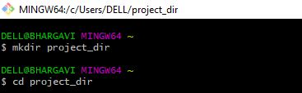

Q2:- Initialize git version database. (git init)



Q3:- Create a new file index.html.



Q4:- Check the git status. You should find index.html as untracked file.

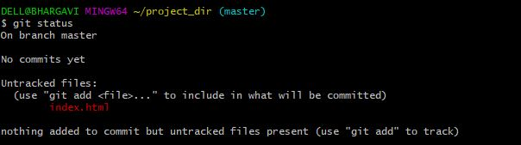

Q5:- Stage the index.html file.



Q6:- Commit index.html

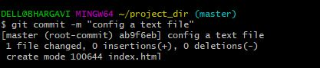

Q7:- Make few changes in index.html & create a new file info.txt file.

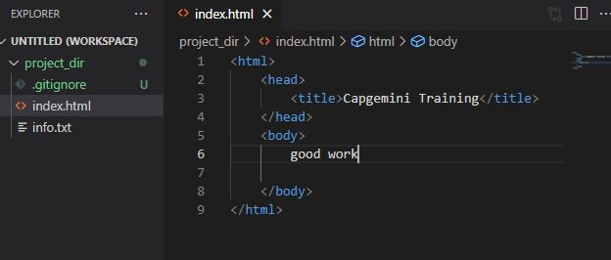

Q8:- Check git status. You should find index.html & info.txt as untracked files.

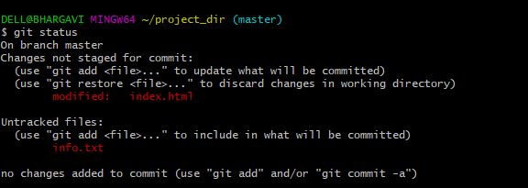

Q9:- Configure GIT to ignore all txt files.

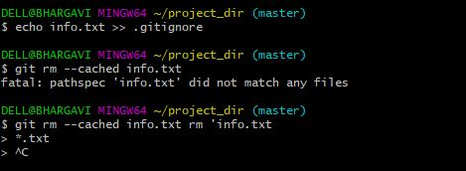

Q10:- Again check the git status. You should find only index.html as untracked file.

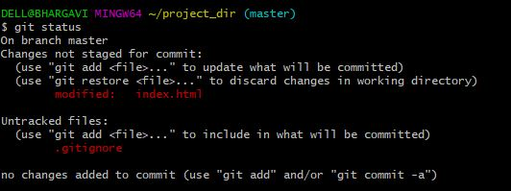

Q11:- State & commit index.html

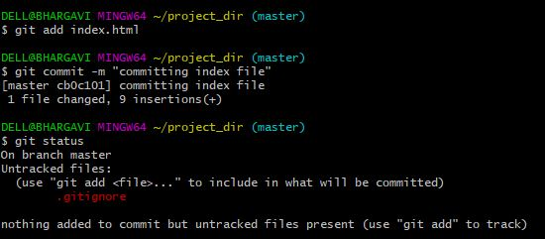

Q12:- Log all your comments so far.

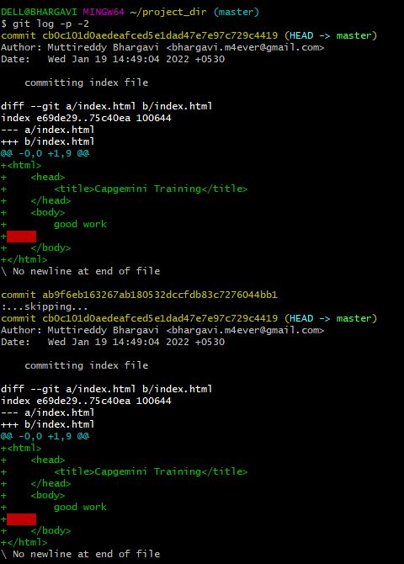

Q13:- Make some changes in index.html.

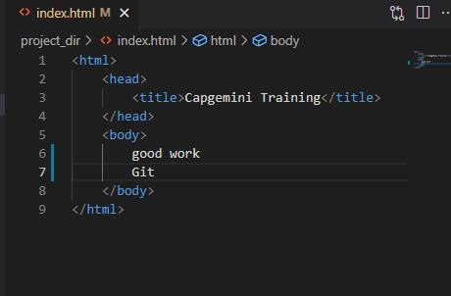

Q14:- Revert the change made in the previous step using git command.

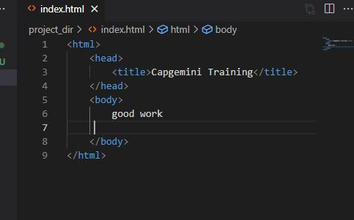

Q15:- Again change index.html.

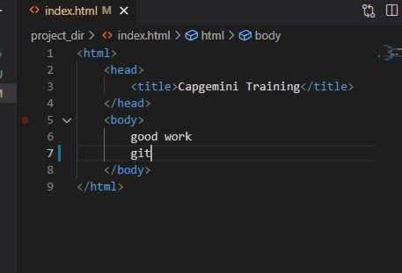

Q16:- Stage index.html



Q17:- Revert back the last stage.



Q18:- Rename ‘add’ command to ‘my-add’.



Q19:- Using my_add command Stage index.html again & commit the changes.

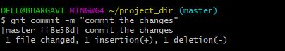

Q20:- Revert the last commit



**GIT Branching**

**SECTION 1**:-

Q21:- First take a backup of your assignments & projects. This is required because due to incorrect GIT operation you may lose your files.

Q22:- Create an empty directory ‘Assignments’ & cd to ‘Assignments’.

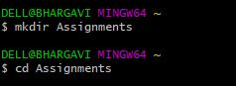

Q23:- Create a file README.txt inside ‘Assignments’ & write few lines about the contents of ‘Assignments’ folder.

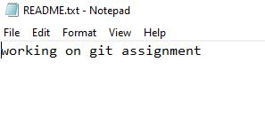

Q24:- Commit README.txt file.

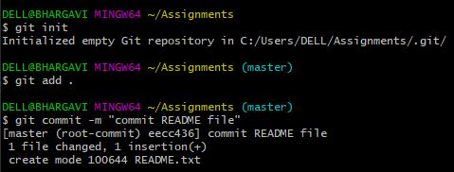

Q25:- Now create a new branch ‘html-assignments’



Q26:- Switch to ‘html-assignments’ branch.



Q27:- Copy all HTML assignments inside ‘Assignments’ folder.



Q28:- Commit HTML assignments into ‘html-assignments’ branch.

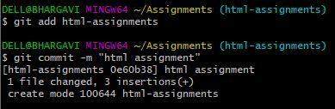

Q29:- Make minor changes into few files belonging to ‘html-assignments’ branch.

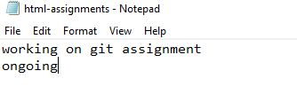

Q30:- Commit those changed files.



Q31:- Switch to master branch.



Q32:- Make minor changes into README.txt file & commit those changes into master.

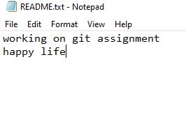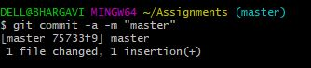

Q33:- Again switch to ‘html-assignments’ branch.



Q34:- Make minor changes into few files belonging to ‘html-assignments’ branch.

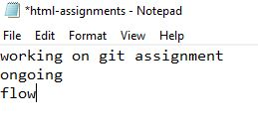

Q35:- Commit those changes.



Q36:- Switch to master.



Q37:- Merge ‘html-assignments’ branch into master. Confirm all html assignments are shown in master.

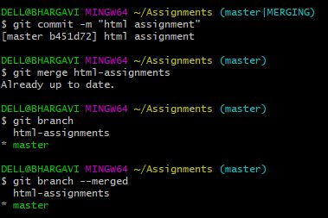

Q38:- Finally delete the ‘html-assignments’ branch.

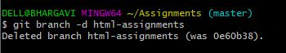

**SECTION 2**:-

Q1:- Create a new branch ‘css-assignments’.



Q2:- Switch to ‘css-assignments’ branch.



Q3:- Copy all CSS assignments inside ‘Assignments’ folder.



Q4:- Commit CSS assignments into ‘css-assignments’ branch.

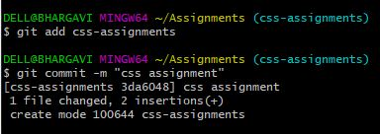

Q5:- Make minor changes into README.txt file on line 1 belonging to ‘css-assignments’ branch.

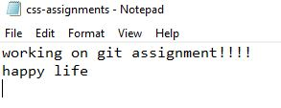

Q6:- Commit those changed files.

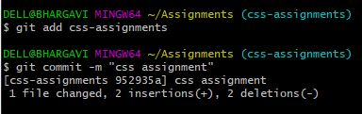

Q7:- Switch to master branch.



Q8:- Make minor changes into README.txt file on line 3 & commit those changes into master.

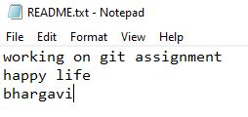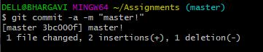

Q9:- Again switch to ‘css-assignments’ branch.



Q10:- Make minor changes into few files belonging to ‘css-assignments’ branch.

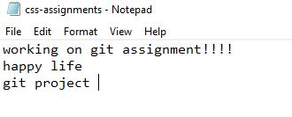

Q11:- Commit those changes.

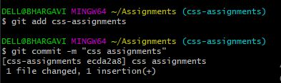

Q12:- Switch to master.

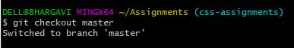

Q13:- Merge ‘css-assignments’ branch into master. Confirm all css assignments are shown in master.

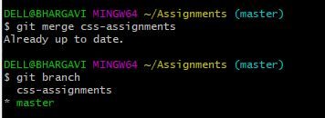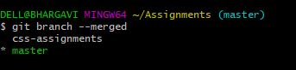

Q14:- Finally delete the ‘css-assignments’ branch

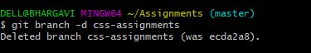

**SECTION 3**:-

Q1:- Create a new branch ‘js-assignments’.



Q2:- Switch to ‘js-assignments’ branch.



Q3:- Copy all JavaScript assignments inside ‘Assignments’ folder.



Q4:- Commit JavaScript assignments into ‘js-assignments’ branch.

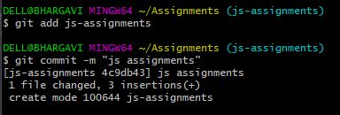

Q5:- Make minor changes into README.txt file on line 1 belonging to ‘js-assignments’ branch.

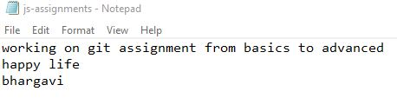

Q6:- Commit those changed files.

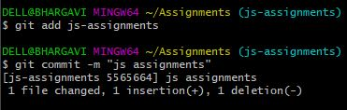

Q7:- Switch to master branch.



Q8:- Make minor changes into README.txt file on line 1 & commit those changes into master.

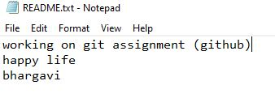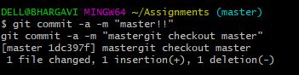

Q9:- Again switch to ‘js-assignments’ branch.



Q10:- Make minor changes into few files belonging to ‘js-assignments’ branch.

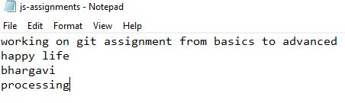

Q11:- Commit those changes.

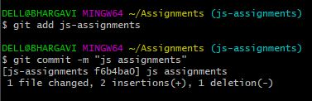

Q12:- Switch to master.



Q13:- Merge ‘js-assignments’ branch into master. Confirm all JavaScript assignments are shown in master.

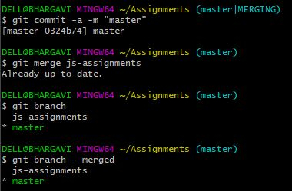

Q14:- Finally delete the ‘js-assignments’ branch.

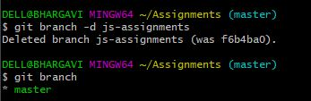

**GIT Remoting**

**SECTION 1:-**

Q39:- Create a github account if you do not have already.

Q40:- Login on into github account.

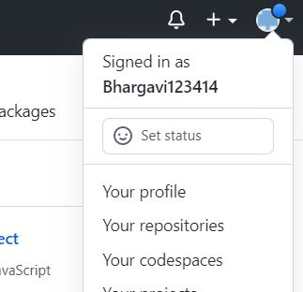

Q41:- Create new public repository ‘freshersbatch-oct16’.

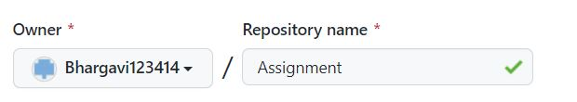

Q42. Commit & push any sample file to this repository under ‘Assignments’ directory.

1. Pushed into Assignments.