Customer Churn Prediction
Data Science Project Report — Telco Customer Churn Dataset

1. Executive Summary
This project builds and evaluates machine learning models that predict which telecom customers are likely to churn, using the IBM Telco Customer Churn dataset (7,043 customers, 21 raw attributes). Four classification models were trained and compared. The best-performing model, Logistic Regression, achieved a ROC AUC of 0.845 and correctly identifies roughly 80% of customers who actually churn (recall), making it well suited to a retention campaign use case where missing a likely churner is more costly than a false alarm.
The analysis also surfaces the key drivers of churn: contract type, tenure, internet service type, payment method, and the presence of support/security add-ons. These findings translate directly into retention recommendations in Section 7.

2. Problem Statement & Objectives
Customer churn — when a subscriber discontinues service — directly impacts recurring revenue. Acquiring a new customer typically costs more than retaining an existing one, so identifying at-risk customers early lets a business intervene with targeted offers before they leave.
Objectives:
- Build a clean, reproducible pipeline from raw data to a deployable churn model.
- Compare multiple algorithms on accuracy, precision, recall, and ROC AUC.
- Identify the strongest behavioral and contractual drivers of churn.
- Package the result as a scorer that can run on new customer batches.

3. Dataset
Source: IBM Telco Customer Churn dataset (7,043 rows, 21 columns), covering demographics, account information, and subscribed services for a telecom provider.
Target variable: Churn (Yes/No). The dataset is moderately imbalanced — about 26.5% of customers churned in the observation window.
Key raw features: tenure, MonthlyCharges, TotalCharges, Contract, InternetService, PaymentMethod, and a set of Yes/No service flags (OnlineSecurity, TechSupport, StreamingTV, etc.).

4. Data Cleaning & Feature Engineering
- TotalCharges was stored as text with blank values for new customers (tenure = 0); coerced to numeric and filled with 0.
- Redundant categories such as “No internet service” and “No phone service” were collapsed into “No” to simplify encoding.
- Engineered AvgMonthlySpend (TotalCharges / tenure) to capture historical spend independent of plan price.
- Engineered NumServices, a count of subscribed add-on services per customer, as a proxy for account depth/engagement.
- Bucketed tenure into 6 ranges (0–6, 7–12, 13–24, 25–48, 49–72 months) to let models capture non-linear lifecycle effects.
The customerID column was dropped (no predictive signal), and the target was encoded as a binary 0/1 flag.

5. Exploratory Data Analysis
The churn rate across the dataset is approximately 26.5%, confirming a moderate class imbalance that was addressed during modeling via class weighting rather than resampling.
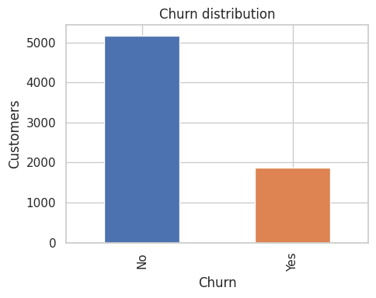
Figure 1. Overall churn distribution (No vs Yes).
Distributions of tenure, MonthlyCharges, and TotalCharges show churners skew toward low tenure and higher monthly charges relative to lifetime spend — a classic early-life risk pattern.
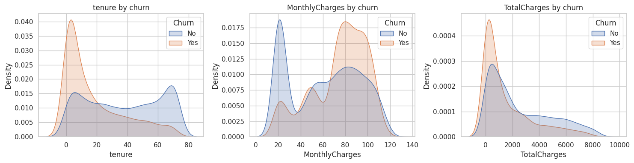
Figure 2. Distribution of tenure, monthly charges, and total charges, split by churn status.
Churn rate breakdowns by category reveal the strongest behavioral and contractual risk factors:
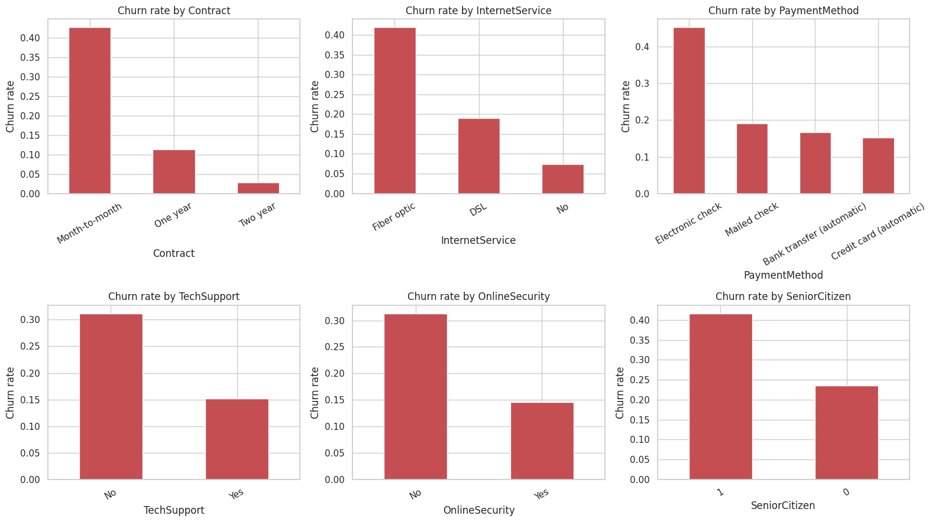
Figure 3. Churn rate by contract type, internet service, payment method, tech support, online security, and senior citizen status.
- Month-to-month contracts churn far more than one- or two-year contracts.
- Fiber optic internet customers churn more than DSL or no-internet customers.
- Electronic check payers churn more than customers using automatic payment methods.
- Customers without TechSupport or OnlineSecurity add-ons churn at higher rates.
- Senior citizens churn more frequently than younger customers.

6. Modeling & Evaluation
Data was split 80/20 (stratified) into training and test sets. A preprocessing pipeline (standard scaling for numeric features, one-hot encoding for categorical features) was combined with each candidate model inside a single scikit-learn Pipeline to avoid data leakage.

6.1 Models Compared
- Logistic Regression (class_weight=balanced) — linear baseline, interpretable coefficients.
- Random Forest (300 trees, max depth 10, class_weight=balanced).
- Gradient Boosting Classifier.
- XGBoost (300 trees, depth 4, learning rate 0.05, scale_pos_weight tuned to class ratio).

6.2 Results
Model | Accuracy | Precision | Recall | ROC AUC
Logistic Regression | 73.9% | 50.5% | 80.2% | 0.845
Random Forest | 76.9% | 55.0% | 72.5% | 0.842
Gradient Boosting | 80.0% | 66.0% | 50.8% | 0.842
XGBoost | 74.9% | 51.8% | 77.5% | 0.837

Logistic Regression was selected as the final model: it achieved the highest ROC AUC (0.845) and the highest recall (80.2%), meaning it catches the largest share of customers who are actually about to churn — the priority for a proactive retention program, where the cost of missing a churner outweighs the cost of a wasted retention offer.

6.3 Confusion Matrix & ROC Curve
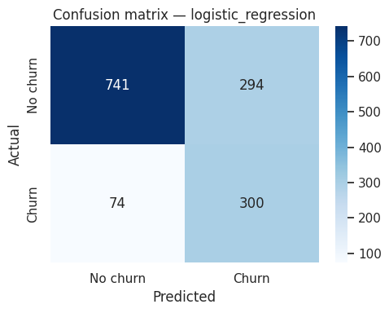
Figure 4. Confusion matrix for the selected model (Logistic Regression) on the held-out test set.
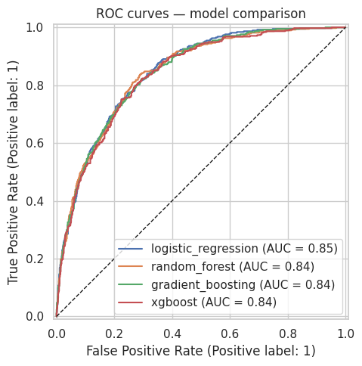
Figure 5. ROC curves for all four models on the test set.

6.4 Feature Importance
Coefficient magnitudes from the logistic regression model highlight which engineered and raw features carry the most predictive weight:
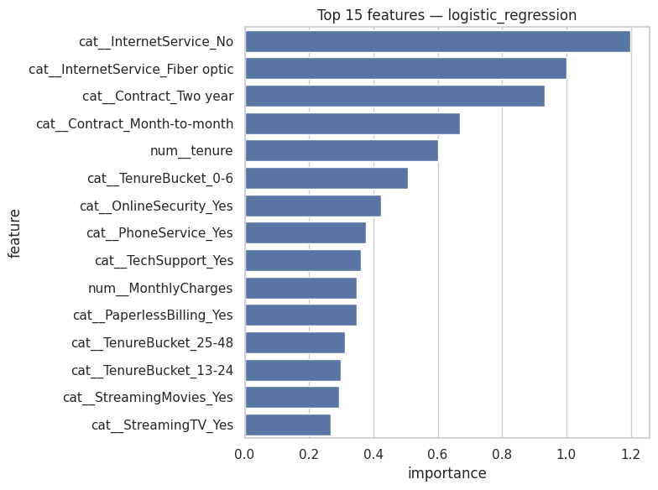
Figure 6. Top 15 features by absolute coefficient magnitude.
Contract type, tenure-related features, internet service type, and payment method dominate the top features, consistent with the EDA findings in Section 5.

7. Business Recommendations
- Prioritize retention outreach for customers in their first 6 months on month-to-month contracts — this segment shows the highest churn concentration.
- Offer incentives to migrate month-to-month customers onto 1- or 2-year contracts, which show substantially lower churn.
- Bundle TechSupport and OnlineSecurity at a discount for fiber-optic customers to reduce churn tied to service gaps.
- Encourage a switch away from electronic check to automatic payment methods, which correlate with materially lower churn.
- Use the model’s churn probability score to rank customers for a monthly retention campaign rather than treating churn as binary.

8. Project Deliverables
- src/preprocessing.py — data cleaning and feature engineering.
- src/train.py — trains and compares all four models, saves the best pipeline and metrics.
- src/predict.py — scores new customer batches with the saved model (CLI: python predict.py --input file.csv).
- notebooks/churn_analysis.ipynb — full EDA and modeling walkthrough with all charts.
- models/best_model.pkl — serialized best pipeline, ready for inference.
- models/metrics.json — metrics for every model evaluated.
- data/Telco-Customer-Churn.csv — source dataset.

9. Limitations & Next Steps
- Single snapshot dataset: no time-series signal (e.g., recent usage trend, support ticket history) was available; adding behavioral trend features would likely improve recall further.
- No hyperparameter tuning beyond reasonable defaults; a grid/Bayesian search on the top 2 models is a natural next step.
- Precision is moderate (~50%) at the chosen model’s default threshold; the probability threshold should be tuned against the actual cost of a retention offer versus a missed churner.
- Consider monitoring for model drift and retraining on a rolling basis as customer behavior and offers change over time.

