First, we have to install docker in your machine to deploy a MySql docker container.

Pulling the image

We need to pull down the correct image. To this, we need to give the MySQL version and we can use below command. By this way, we can pull mysql-server:5.7 image.

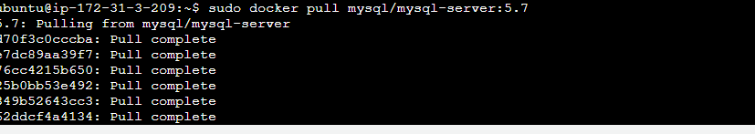

Deploying the container

To deploy the MySQL container we can use the following command. mysqlCon is the container name which is trying to deploy.

sudo docker run --name=mysqlCon -p 3306:3306 -d mysql/mysql-server:5.7

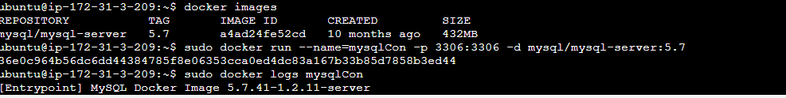

During the deployment, a random password will have been generated. We can see that password using below command.

sudo docker logs mysqlCon

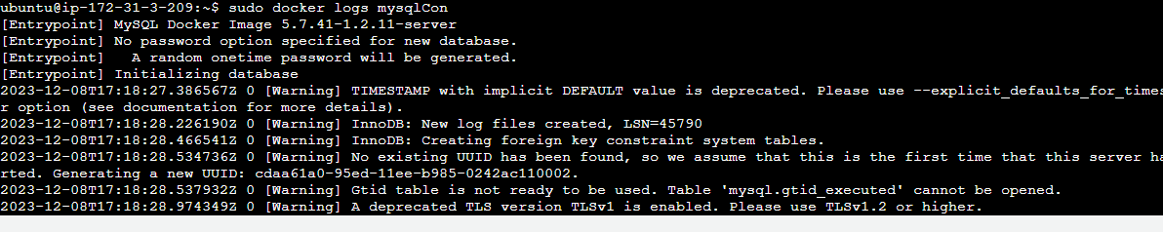

We can login to the containerized MySql server from below command.

sudo docker exec -it mysqlCon mysql -uroot –p

After giving the received password from docker logs mysqlCon command we can login to the MySql server.