**Ideation Phase**

**Brainstorm & Idea Prioritization Template**

|  |  |
| --- | --- |
| Date | 16 June 2025 |
| Team ID | LTVIP2025TMID41917 |
| Project Name | Smart Sorting: Transfer Learning for Identifying Rotten Fruits and Vegetables |
| Maximum Marks | 4 Marks |

**Brainstorm & Idea Prioritization Template:**

User-centered features such as automatic identification of rotten fruits and vegetables, real-time visual feedback, and personalized sorting suggestions should be prioritized. Seamless integration of transfer learning using pre-trained models like MobileNetV2 or EfficientNet enables quick adaptation to new datasets with high accuracy and efficiency. Real-time image classification using edge devices (e.g., Raspberry Pi, Jetson Nano) ensures low-latency decision-making and offline capability in agricultural or market settings. Integration with IoT devices and smart cameras to continuously monitor produce quality and send alerts upon detecting spoilage. Data privacy mechanisms to securely store collected image data and comply with relevant agricultural data protection standards. Multilingual and voice interface support for farmers, market vendors, and warehouse staff to facilitate adoption and improve usability across regions. Emergency escalation protocols to notify supply chain managers in case of large-scale spoilage detection or distribution issues, ensuring quick intervention and reduced wastage.

**Step-1: Team Gathering, Collaboration and Select the Problem Statement**

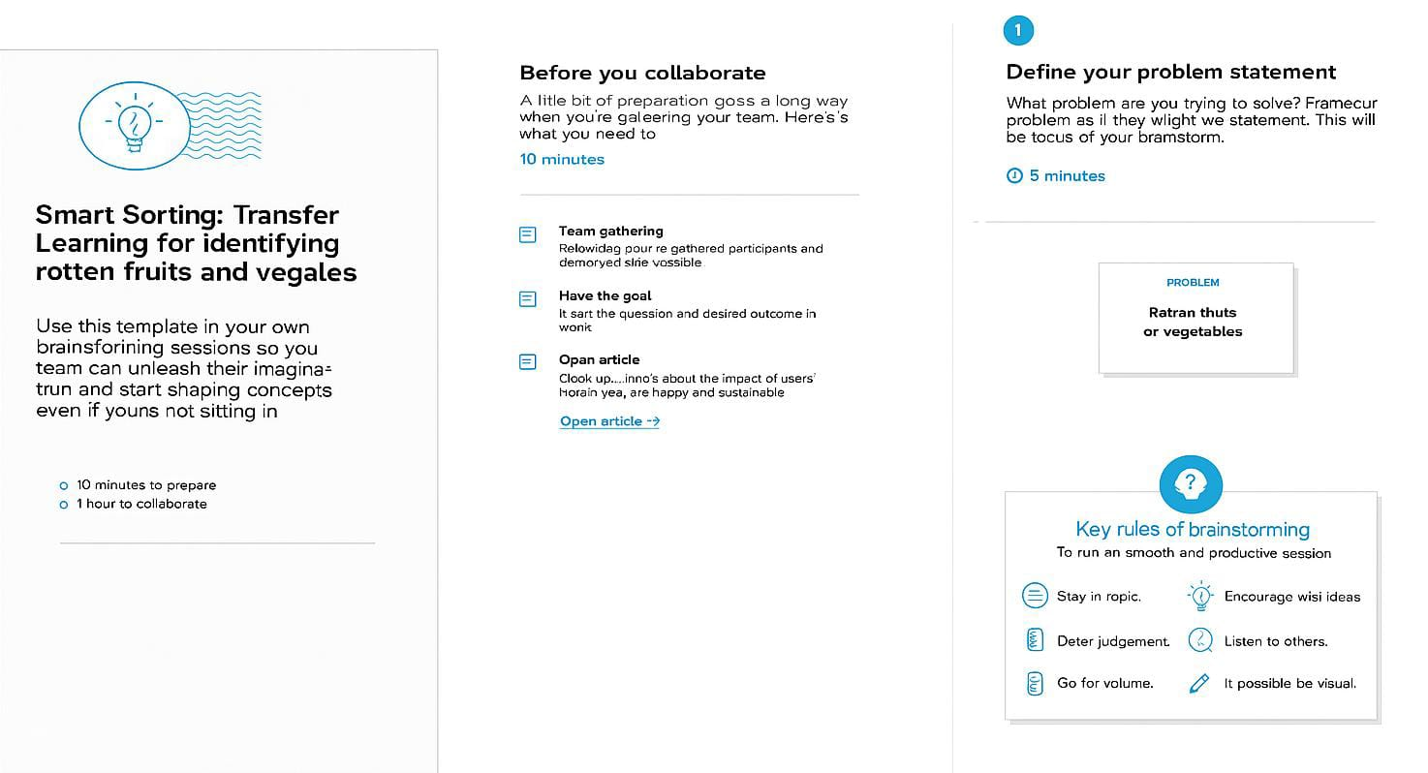

**Step-2: Brainstorm, Idea Listing and Grouping**

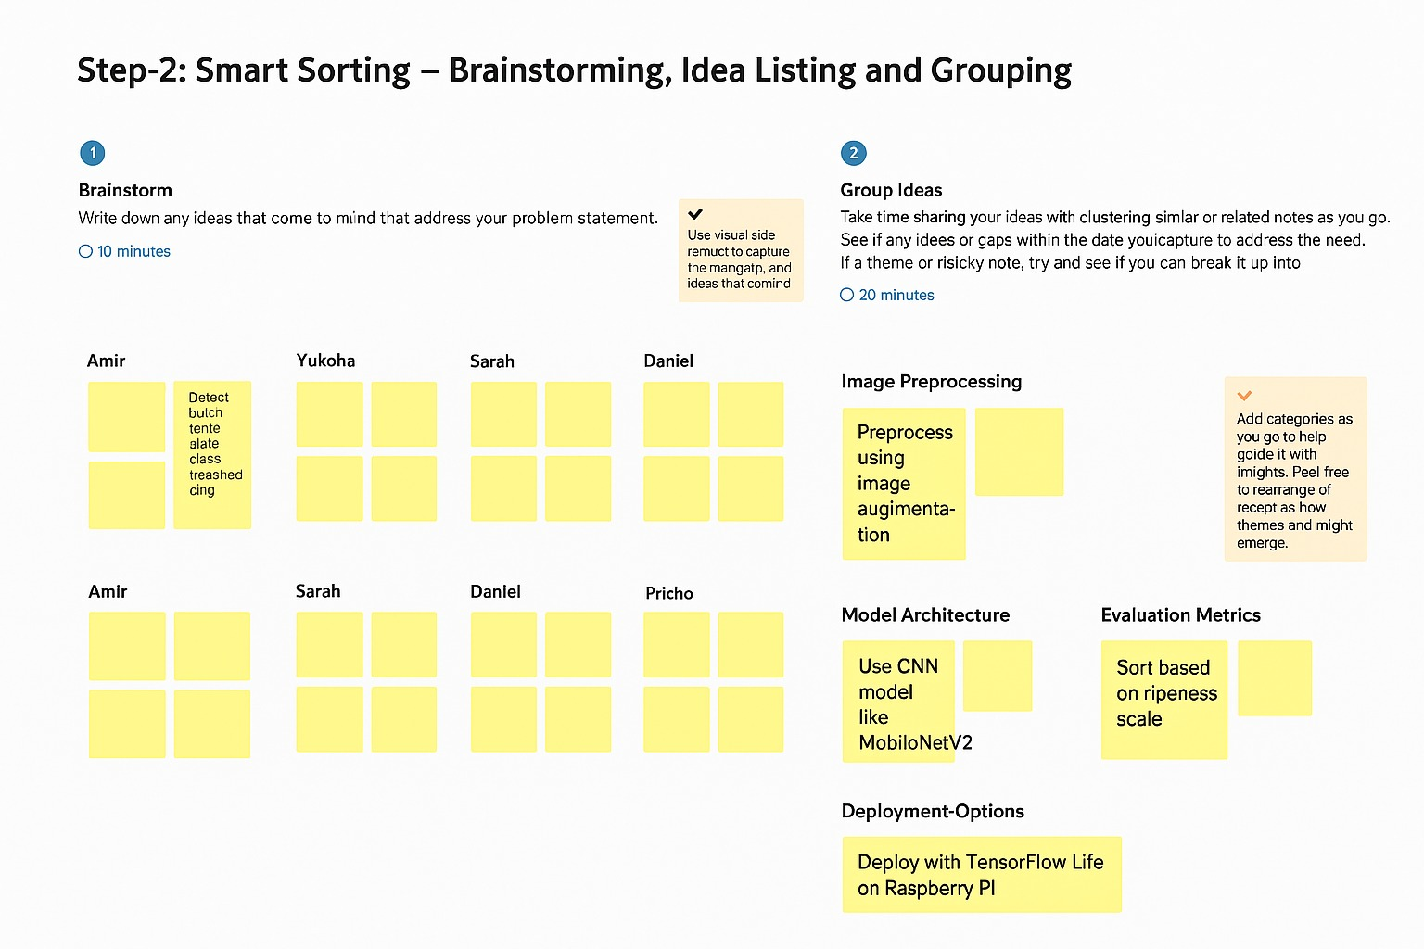

**Step-3: Idea Prioritization**

