**Project Design Phase-II**

**Data Flow Diagram & User Stories**

|  |  |
| --- | --- |
| Date | 16 June 2025 |
| Team ID | LTVIP2025TMID41917 |
| Project Name | Smart Sorting: Transfer Learning for Identifying Rotten Fruits and Vegetables |
| Maximum Marks | 4 Marks |

**Data Flow Diagrams:**

A Data Flow Diagram (DFD) is a traditional visual representation of the information flows within a system. A neat and clear DFD can depict the right amount of the system requirement graphically. It shows how image is classified and predict as fresh or rotten fruit.

Example: DFD on Smart Sorting

**Example:** [**(Simplified)**](https://developer.ibm.com/patterns/visualize-unstructured-text/)

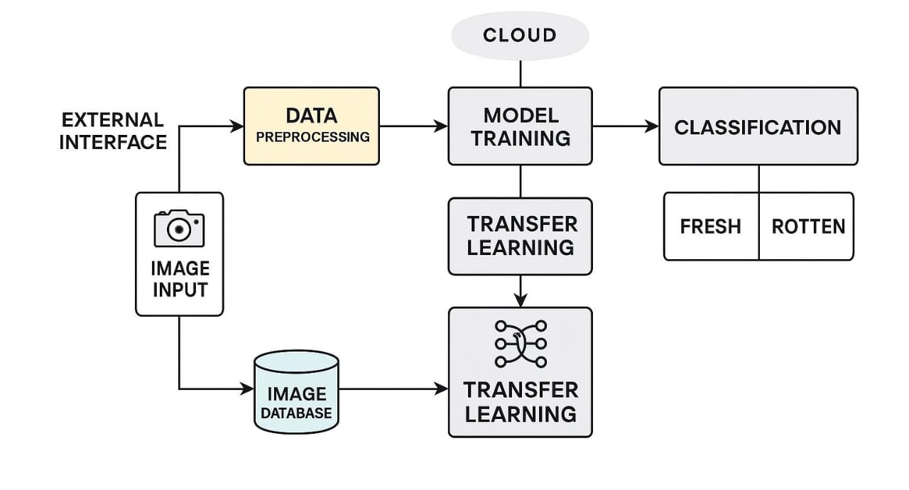

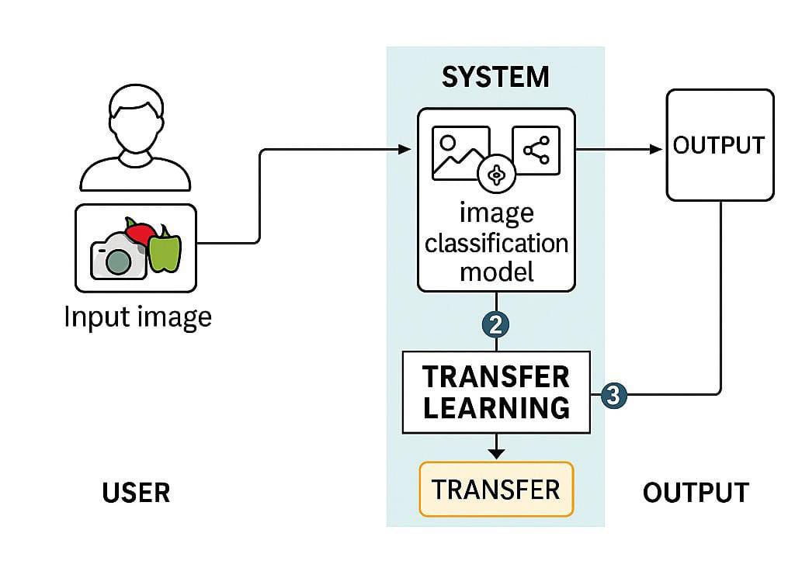

**User Stories**

Use the below template to list all the user stories for the product.

| **User Type** | **Functional Requirement (Epic)** | **User Story Number** | **User Story / Task** | **Acceptance criteria** | **Priority** | **Release** |
| --- | --- | --- | --- | --- | --- | --- |
| Customer (Farmer/Vendor) | Image Capture and Upload | USN-1 | As a user, I can register for the application by entering my email, password, and confirming my password. | I can access my account / dashboard | High | Sprint-1 |
| Customer | View Results | USN-2 | As a user, I will receive confirmation email once I have registered for the application | I can receive confirmation email & click confirm | High | Sprint-1 |
| Operator | Image Upload | USN-3 | As a user, I can register for the application through Facebook | I can register & access the dashboard with Facebook Login | Medium | Sprint-2 |
| Admin | History Tracking | USN-4 | As a user, I can register for the application through Gmail | can register & access dashboard with Gmail login | Medium | Sprint-3 |
| Customer Care Executive | Support Management | USN-5 | As a user, I can log into the application by entering email & password | can successfully login and access the dashboard | Low | Sprint-3 |
| Customer | Login | USN-6 | As a user, I can view a list of scanned fruits/vegetables and their freshness status. | The dashboard displays item names, images, and freshness results | High | Sprint-1 |
| Customer (Web User) | Dashboard | USN-7 | As a web user, I can upload images of fruits/vegetables for quality analysis. | The system uploads image and shows analysis result | High | Sprint-2 |
| Customer Care Executive | Report Management | USN-8 | As a care executive, I can access reports of user scan history and feedback. | I can filter user scans by date or product | Medium | Sprint-3 |
| Administrator | User Management | USN-9 | As an admin, I can manage user roles, block/report accounts if necessary. | I can view, edit or deactivate any user account | High | Sprint-3 |