**Ideation Phase**

**Define the Problem Statements**

|  |  |
| --- | --- |
| Date | 16 June 2025 |
| Team ID | LTVIP2025TMID41917 |
| Project Name | Smart Sorting: Transfer Learning for Identifying Rotten Fruits and Vegetables |
| Maximum Marks | 2 Marks |

**Customer Problem Statement Template:**

The Smart Sorting solution focuses on helping users easily identify spoiled fruits and vegetables using AI and transfer learning, leading to better quality control and reduced waste.

A well-articulated customer problem statement allows your team to understand the real struggles of your users—such as farmers, market vendors, warehouse operators, and supply chain quality controllers. By focusing on their needs and challenges, you can build a solution that enhances their efficiency and decision-making. Throughout this process, empathizing with your users helps you create a system that delivers real value and improves their daily operations. To create a targeted solution for the daily challenges faced in food sorting and quality checks. Through this process, you’ll be able to empathize with users who struggle with manual inspection, allowing you to design a smarter, faster, and more accurate system that meets real-world needs in the agricultural and retail sectors.

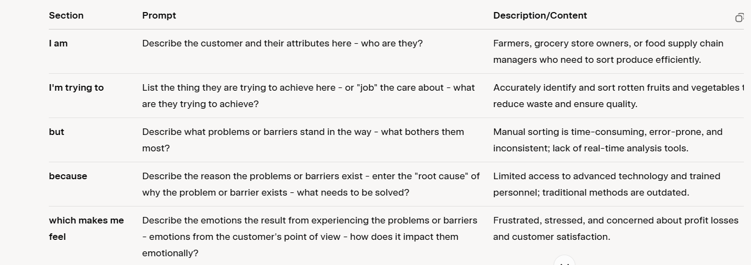

**Example:**

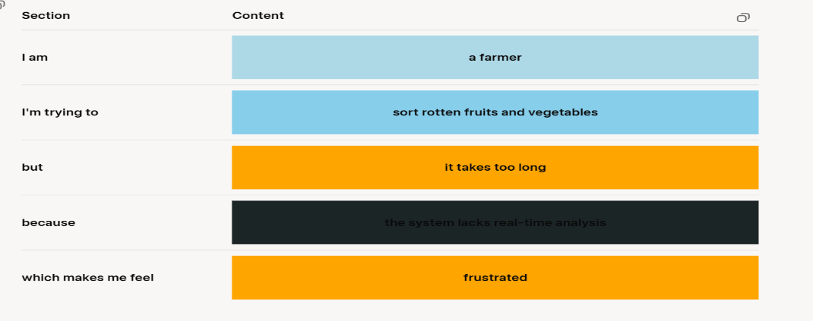

|  |  |  |  |  |  |
| --- | --- | --- | --- | --- | --- |
| **Problem Statement (PS)** | **I am (Customer)** | **I’m trying to** | **But** | **Because** | **Which makes me feel** |
| PS-1 | A fruit / vegetable vendor | quickly and accurately separate rotten items from fresh produce | I have to manually check every item, which is slow and error-prone | there is no efficient system in place for automatic detection | frustrated and overwhelmed |
| PS-2 | A ware-house quality control staff | maintain high product standards for shipment | sometimes rotten items go undetected and get packaged | human inspection is not always reliable or scalable | anxious and dissatisfied |