**Ideation Phase**

**Empathize & Discover**

|  |  |
| --- | --- |
| Date | 16 June 2025 |
| Team ID | LTVIP2025TMID41917 |
| Project Name | Smart Sorting: Transfer Learning for Identifying Rotten Fruits and Vegetables |
| Maximum Marks | 4 Marks |

**Empathy Map Canvas:**

* Think & Feel

-Concerned about food safety

-Wants fast, accurate sorting

-Frustrated with manual methods

* Hear

-Complaints about rotten items

-Talks of AI-based solutions

-Feedback from customers

* See

-Manual sorting in progress

-Spoiled items slipping through

-Other industries using AI

* Say & Do

-Supports automation

-Highlights sorting errors

-Seeks reliable solutions

* Pain

-Financial loss

-Customer complaints

-Time-consuming processes

* Gain

-Accurate AI-based sorting

-Reduced waste Improved quality & customer satisfaction

Example:

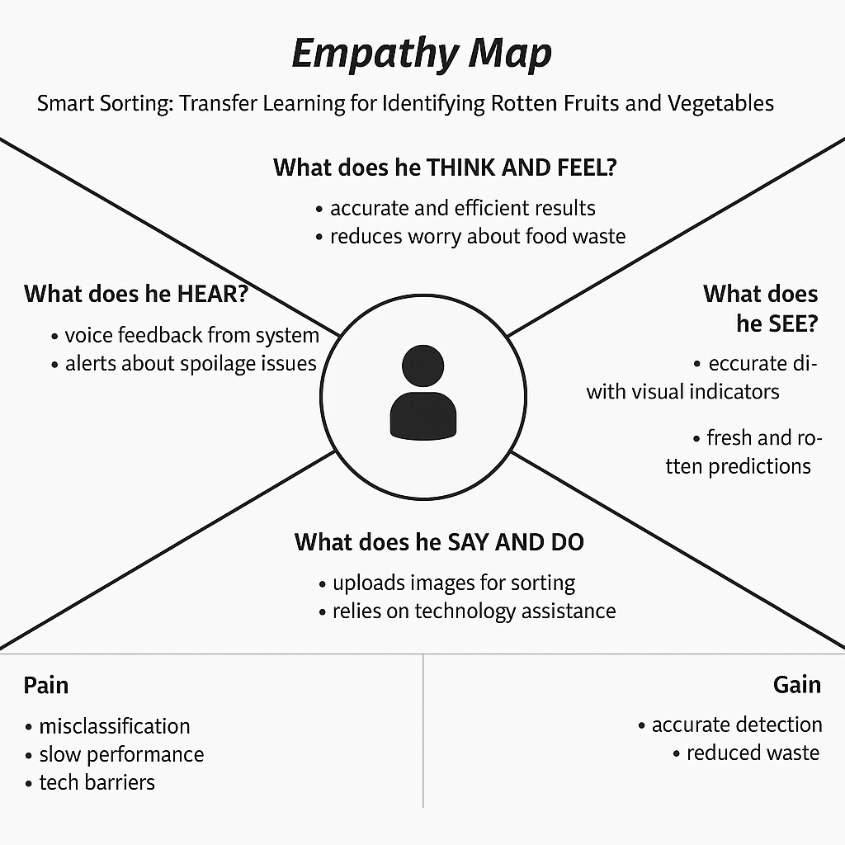

**Example: Food Ordering & Delivery Application**

