**Project Design Phase-II**

**Technology Stack (Architecture & Stack)**

|  |  |
| --- | --- |
| Date | 16 June 2025 |
| Team ID | LTVIP2025TMID41917 |
| Project Name | Smart Sorting: Transfer Learning for Identifying Rotten Fruits and Vegetables |
| Maximum Marks | 4 Marks |

**Technical Architecture:**

The Deliverable shall include the architectural diagram as below and the information as per the table1 & table 2

**Example: AI-Powered Detection of Rotten Fruits and Vegetable**

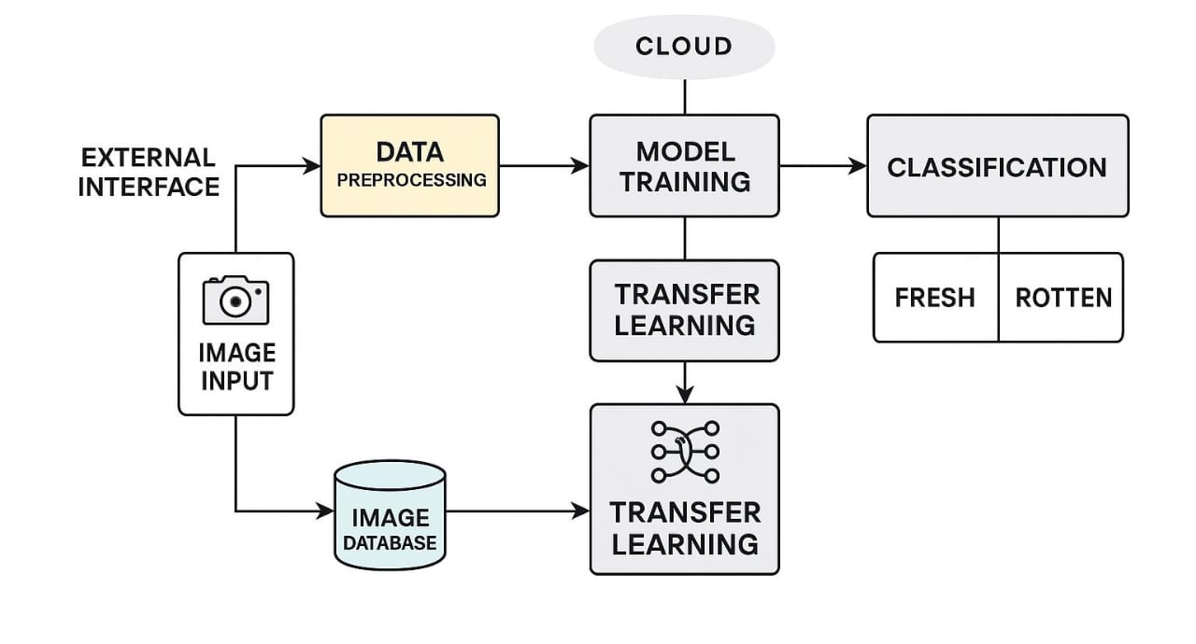

Guidelines:

This system uses pre-trained deep learning models to identify spoiled produce. Transfer learning reduces training time and boosts classification accuracy. Ideal for supply chain quality checks and food safety assurance. Real-time sorting improves efficiency and reduces human effort. Scalable solution for post-harvest automation in agriculture.

**Table-1 : Components & Technologies:**

|  |  |  |  |
| --- | --- | --- | --- |
| **S.No** | **Component** | **Description** | **Technology** |
|  | Image Input | Input of images with fruits and vegetables e.g. Camera, uploaded images | JPG, PNG, etc |
|  | Data Preprocessing | Modify images before training/testing | OpenCV. |
|  | Model Training | Train a model to identify rotten fruits and vegetables | TensorFlow/Py forch |
|  | Transfer Learning | Use pre-trained model for feature extraction. | Proceeding model e.g.. ResNet. Inception etc. |
|  | Classification | Classify images as fresh or rotten. | TensorFlow/Pyforch |
|  | Image Database | Stored images for training and testing | Cloud |
|  | Cloud Interface | Cloud deployment infrastructure | Cloud platform Serverless function |
|  | API | Interface between application and external systems | REST/JSON AΡΙ |
|  | External Dataset | Example images of rotten and fresh fruits and vegetables | Kaggle, ImageNet etc. |

**Table-2: Application Characteristics:**

| **S.No** | **Characteristics** | **Description** | **Technology** |
| --- | --- | --- | --- |
|  | Open-Source Libraries | List the open source libraries used | OpenCV. TensorFlow. etc |
|  | Transfer Learning | Lists purpose of transfer learning implementation | ResNet, VGG, etc. |
|  | Scalability | Ensures the scalability of application | Cloud platform |
|  | Dataset Size | Availability of sufficient amount of image data used for both fresh and rotten truits and vegetables | Large Size of Dataset |
|  | Performance | Optimization consideration for efficiency of deep learning model. | Training Accuracy, Classification Metrics |