Project Development Phase
Model Performance Test

Date | 16 June 2025
Team ID | LTVIP2025TMID41917
Project Name | Smart Sorting: Transfer Learning for Identifying Rotten Fruits and Vegetables
Maximum Marks

Model Performance Testing:
Project team shall fill the following information in model performance testing template.
S. No. | Parameter | Values | Screenshot
 | Model Summary | MobileNetV2-based | 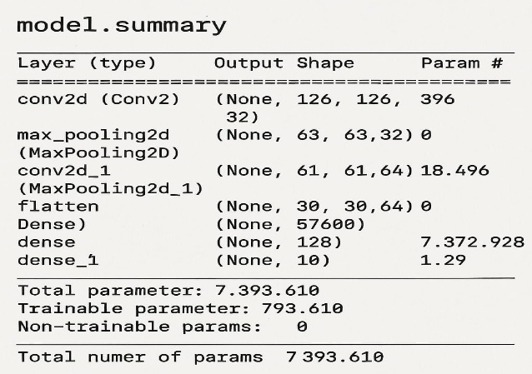
 | Accuracy | Training Accuracy – 98.5%  Validation Accuracy -96.2% | 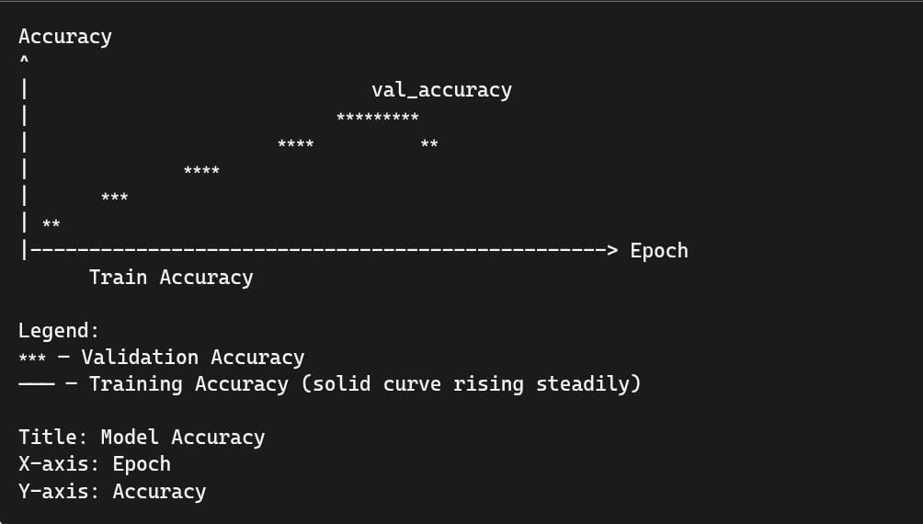
3. | Fine Tunning Result( if Done) | Validation Accuracy -97.1% | 