Project Design Phase-II
Data Flow Diagram & User Stories

Date | 16 June 2025
Team ID | LTVIP2025TMID41917
Project Name | Smart Sorting: Transfer Learning for Identifying Rotten Fruits and Vegetables
Maximum Marks | 4 Marks

Data Flow Diagrams:
A Data Flow Diagram (DFD) is a traditional visual representation of the information flows within a system. A neat and clear DFD can depict the right amount of the system requirement graphically. It shows how image is classified and predict as fresh or rotten fruit.
Example: DFD on Smart Sorting
Example: (Simplified)
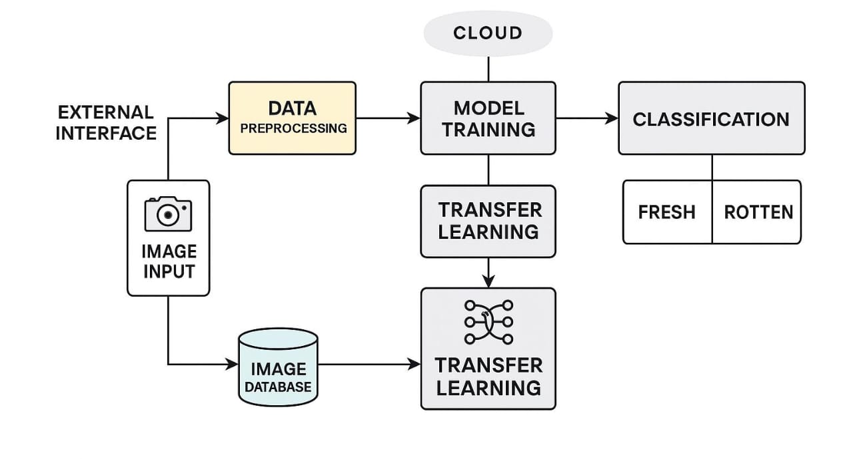
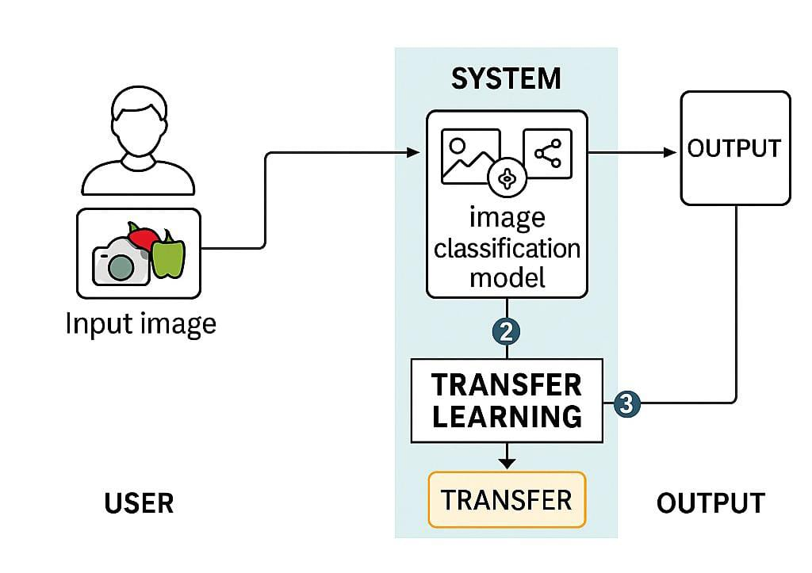

User Stories
Use the below template to list all the user stories for the product.
User Type | Functional Requirement (Epic) | User Story Number | User Story / Task | Acceptance criteria | Priority | Release
Customer (Farmer/Vendor) | Image Capture and Upload | USN-1 | As a user, I can register for the application by entering my email, password, and confirming my password. | I can access my account / dashboard | High | Sprint-1
Customer | View Results | USN-2 | As a user, I will receive confirmation email once I have registered for the application | I can receive confirmation email & click confirm | High | Sprint-1
Operator | Image Upload | USN-3 | As a user, I can register for the application through Facebook | I can register & access the dashboard with Facebook Login | Medium | Sprint-2
Admin | History Tracking | USN-4 | As a user, I can register for the application through Gmail | can register & access dashboard with Gmail login | Medium | Sprint-3
Customer Care Executive | Support Management | USN-5 | As a user, I can log into the application by entering email & password | can successfully login and access the dashboard | Low | Sprint-3
Customer | Login | USN-6 | As a user, I can view a list of scanned fruits/vegetables and their freshness status. | The dashboard displays item names, images, and freshness results | High | Sprint-1
Customer (Web User) | Dashboard | USN-7 | As a web user, I can upload images of fruits/vegetables for quality analysis. | The system uploads image and shows analysis result | High | Sprint-2
Customer Care Executive | Report Management | USN-8 | As a care executive, I can access reports of user scan history and feedback. | I can filter user scans by date or product | Medium | Sprint-3
Administrator | User Management | USN-9 | As an admin, I can manage user roles, block/report accounts if necessary. | I can view, edit or deactivate any user account | High | Sprint-3

