**LAB-1**

Bhargavi Dandekar

1. **Write a Java program to print "Hello, World!" to the console.**

**Code:-**

**public** **class** Hello { **public** **static** **void** main(String args[])

{

System.***out***.print("Hello,World!");

}

}

**Output:-**

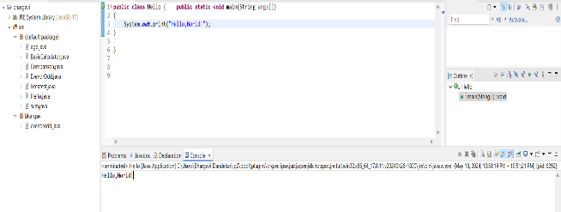

**2. Write a program to find the sum of two numbers entered by the user.**

**Code:-**

**import** java.util.Scanner;

**public** **class** sum {

**public** **static** **void** main(String[] args) {

Scanner scanner = **new** Scanner(System.***in***);

// Prompt the user to enter the first number

System.***out***.print("Enter the first number: ");

**double** num1 = scanner.nextDouble();

// Prompt the user to enter the second number

System.***out***.print("Enter the second number: ");

**double** num2 = scanner.nextDouble();

// Calculate the sum of the two numbers

**double** sum = num1 + num2;

// Print the sum

System.***out***.println("The sum of " + num1 + " and " + num2 + " is: " + sum);

scanner.close();

}

}

**Output:-**

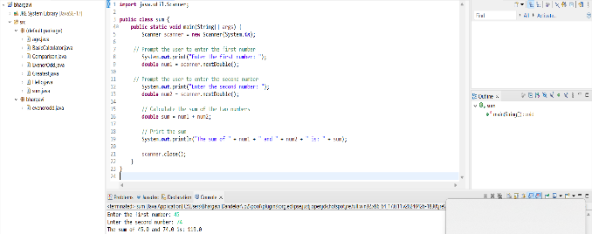

**3. Write a Java program to check whether a given number is even or odd.**

**Code:-**

**import** java.util.Scanner;

**public** **class** EvenorOdd {

**public** **static** **void** main(String[] args) {

Scanner scanner = **new** Scanner(System.***in***);

// Prompt the user to enter a number

System.***out***.print("Enter a number: ");

**int** number = scanner.nextInt();

// Check if the number is even or odd

**if** (number % 2 == 0) {

System.***out***.println(number + " is an even number.");

} **else** {

System.***out***.println(number + " is an odd number.");

}

scanner.close();

}

}

**Output:-**

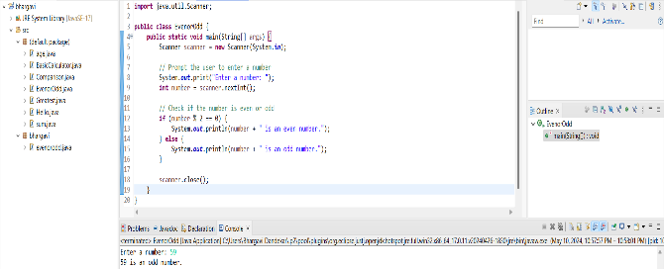

**4. Write a java program to find greatest of 2 numbers.**

**Code:-**

**import** java.util.Scanner;

**public** **class** Greatest {

**public** **static** **void** main(String[] args) {

Scanner scanner = **new** Scanner(System.***in***);

// Prompt the user to enter the first number

System.***out***.print("Enter the first number: ");

**double** num1 = scanner.nextDouble();

// Prompt the user to enter the second number

System.***out***.print("Enter the second number: ");

**double** num2 = scanner.nextDouble();

// Find the greatest of the two numbers

**double** greatestNumber = Math.*max*(num1, num2);

// Print the greatest number

System.***out***.println("The greatest number between " + num1 + " and " + num2 + " is: " + greatestNumber);

scanner.close();

}

}

**Output:-**

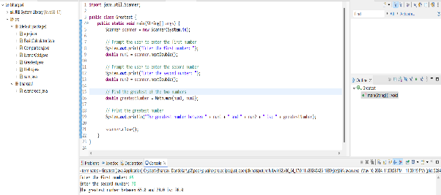

**5. Write a program to implement a basic calculator that takes input as a string expression and evaluates it.**

**Code:-**

**import** java.util.Scanner;

**public** **class** BasicCalculator {

**public** **static** **void** main(String[] args) {

Scanner scanner = **new** Scanner(System.***in***);

// Prompt the user to enter the expression

System.***out***.print("Enter an arithmetic expression: ");

String expression = scanner.nextLine();

// Remove whitespaces from the expression

expression = expression.replaceAll("\\s+", "");

// Evaluate the expression

**double** result = *evaluateExpression*(expression);

// Print the result

System.***out***.println("Result: " + result);

scanner.close();

}

**public** **static** **double** evaluateExpression(String expression) {

// Split the expression into operands and operators

String[] tokens = expression.split("(?<=[-+*/])|(?=[-+*/])");

**double** result = Double.*parseDouble*(tokens[0]);

// Start evaluating from index 1 as index 0 is the first number

**for** (**int** i = 1; i < tokens.length; i += 2) {

String operator = tokens[i];

**double** operand = Double.*parseDouble*(tokens[i + 1]);

**switch** (operator) {

**case** "+":

result += operand;

**break**;

**case** "-":

result -= operand;

**break**;

**case** "*":

result *= operand;

**break**;

**case** "/":

result /= operand;

**break**;

**default**:

**throw** **new** IllegalArgumentException("Invalid operator: " + operator);

}

}

**return** result;

}

}

**Output:-**

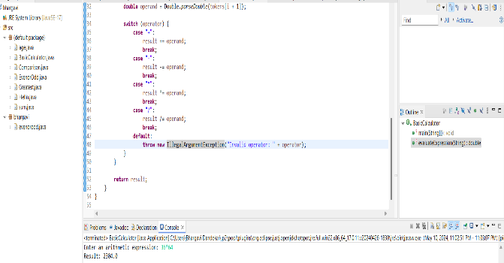

**6. Write a Java program to check if a given number is even or odd.**

**Code:-**

**package** bhargavi;

**import** java.util.Scanner;

**public** **class** evenorodd {

**public** **static** **void** main(String[] args) {

Scanner scanner = **new** Scanner(System.***in***);

// Prompt the user to enter the number

System.***out***.print("Enter a number: ");

**int** number = scanner.nextInt();

// Close the scanner to prevent resource leaks

scanner.close();

// Check whether the number is even or odd

**if** (number % 2 == 0) {

System.***out***.println("The number " + number + " is even.");

} **else** {

System.***out***.println("The number " + number + " is odd.");

}

}

}

**Output:-**

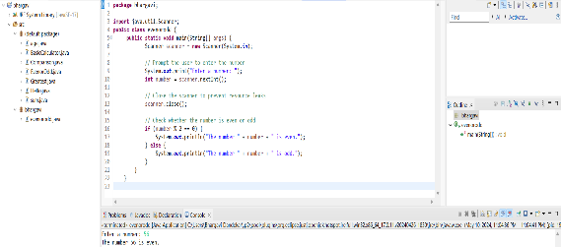

**7. Create a Java program that compares two numbers and prints the larger one.**

**Code:-**

**import** java.util.Scanner;

**public** **class** Comparison {

**public** **static** **void** main(String[] args) {

Scanner scanner = **new** Scanner(System.***in***);

// Prompt the user to enter the first number

System.***out***.print("Enter the first number: ");

**double** num1 = scanner.nextDouble();

// Prompt the user to enter the second number

System.***out***.print("Enter the second number: ");

**double** num2 = scanner.nextDouble();

// Compare the two numbers

**double** largerNumber = num1 > num2 ? num1 : num2;

// Print the larger number

System.***out***.println("The larger number is: " + largerNumber);

scanner.close();

}

}

**Output:-**

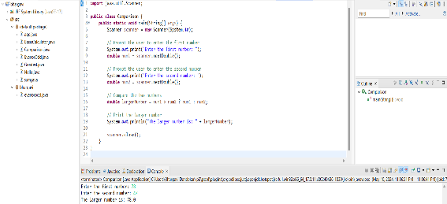

**8. Write a Java program that takes an age input from the user and determines if they are eligible to vote (considering the legal voting age).**

**Code:-**

**import** java.util.Scanner;

**public** **class** age {

**public** **static** **void** main(String[] args) {

Scanner scanner = **new** Scanner(System.***in***);

// Prompt the user to enter their age

System.***out***.print("Enter your age: ");

**int** age = scanner.nextInt();

// Check if the age meets the eligibility criteria for voting

**if** (age >= 18) {

System.***out***.println("You are eligible to vote!");

} **else** {

System.***out***.println("You are not eligible to vote yet.");

}

scanner.close();

}

}

**Output: 