1. Implement the Word Embeddings with a new data set from a text file. Played

around by changing different parameters and came up with screen shots for the best case scenario.

Best solution: AdamOptimizer for learning rate 0.001, step size=10

Tensorflow:

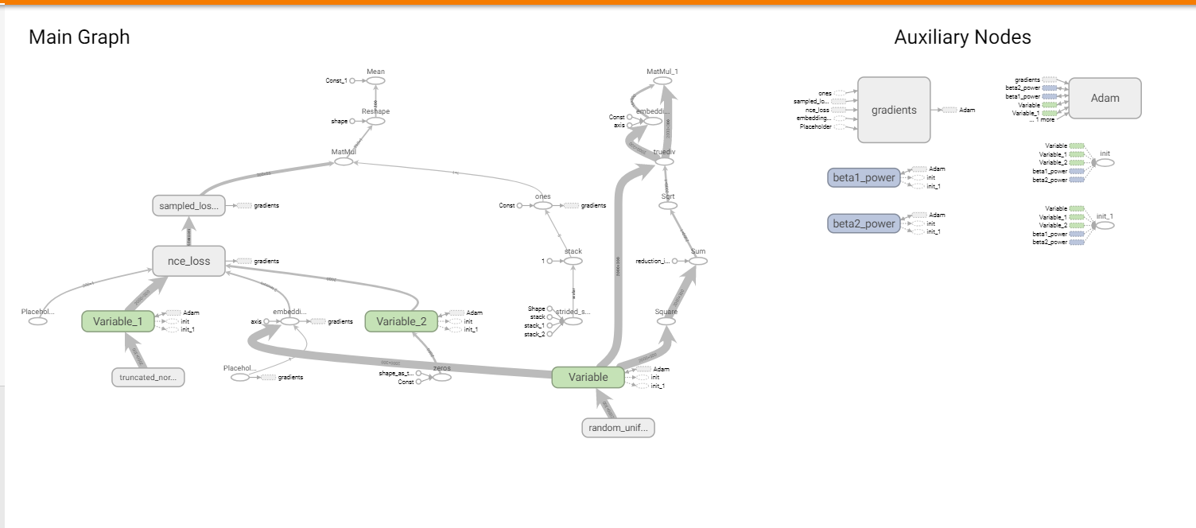

Output:

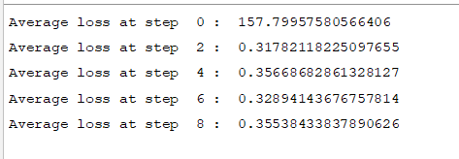

Graph:

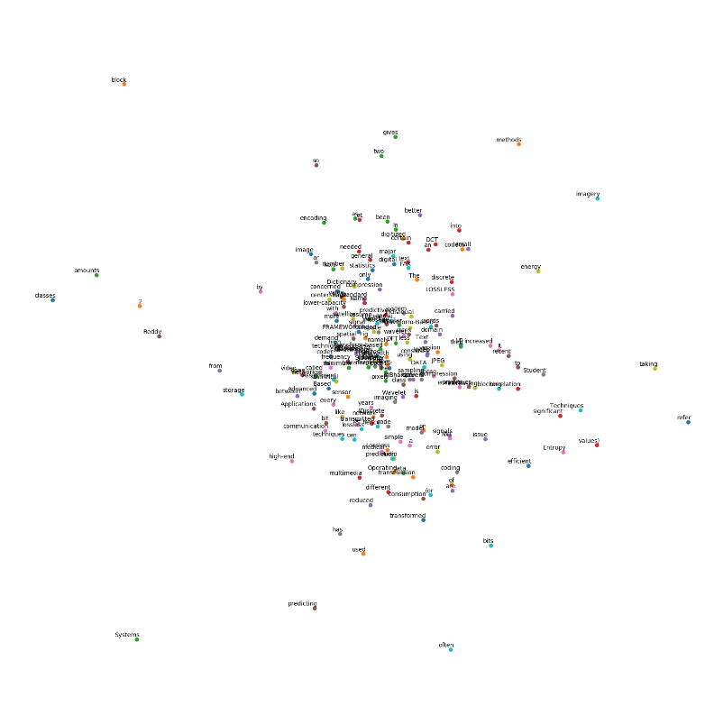

Observations:

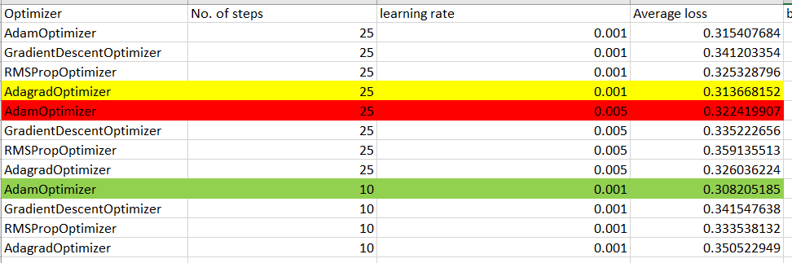

Code snippet:

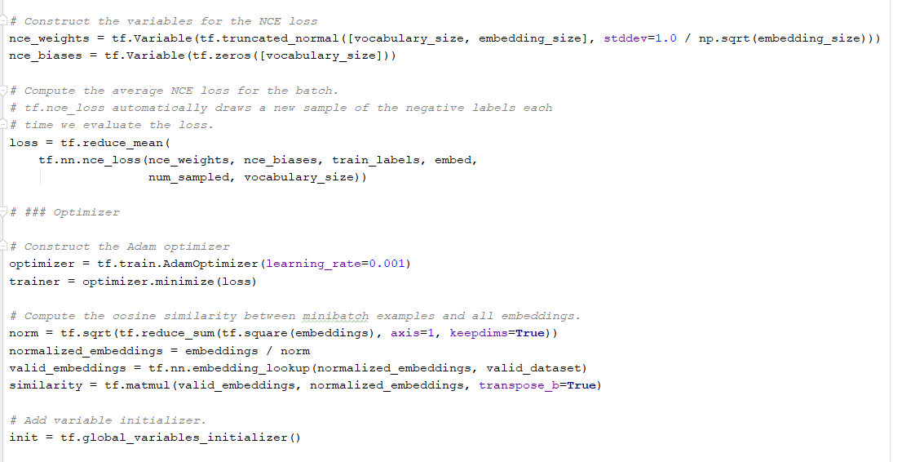

1. Implemented the Logistic Regression on breast cancer data set and came up with few observations by changing certain parameters.

Screenshots for the optimized parameters are:

Best solution: RMPSPropOptimizer, learning rate=0.001,Accuracy=89.9712717507725

Accuracy:

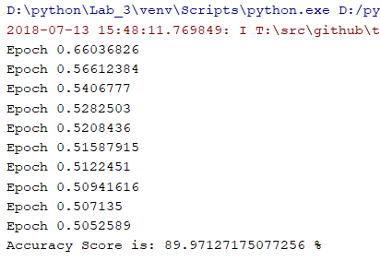

Tensor flow: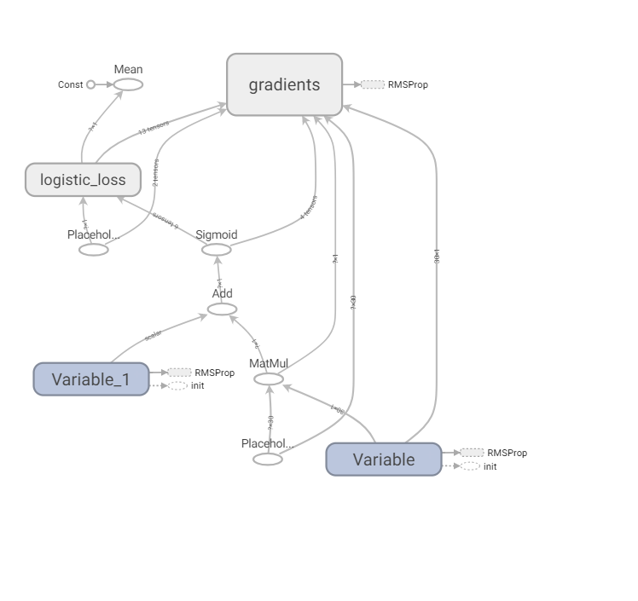

Code snippet:

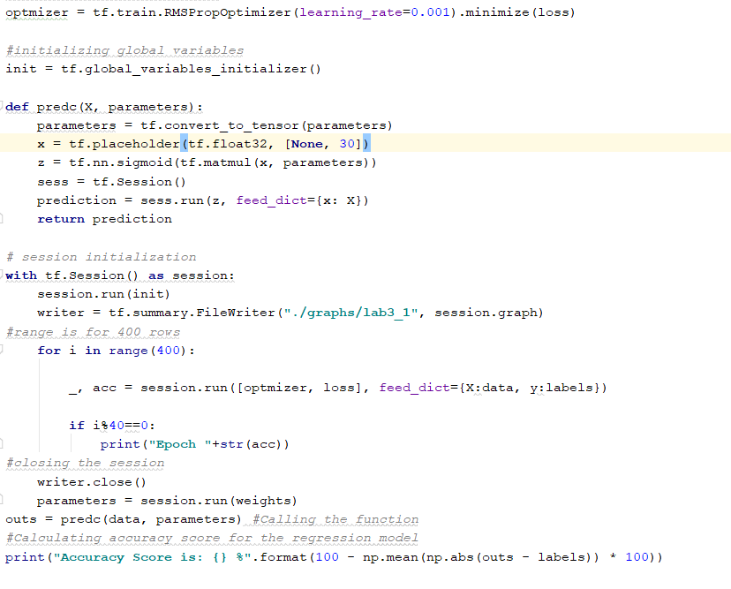

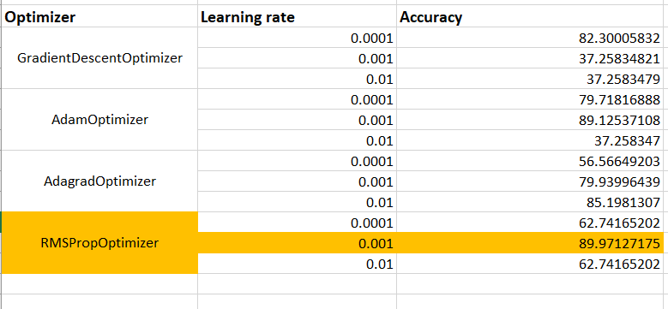

Wiki: https://github.com/BhargaviSiddipeta/Python/wiki/Lab-Assignment

Video url: https://youtu.be/YQfP9Jki_Ps