LAB – 1
Part A – NumPy
Question 1
Create a NumPy array containing the integers from 1 to 20.
Perform the following operations:
- Display the array.
- Find the shape of the array.
- Find the maximum and minimum values.
- Calculate the mean and standard deviation.
- Reshape the array into a 4 X 5 matrix.
- Display the second row of the matrix.
- Display the third column of the matrix.
Code:-
import numpy as np
arr = np.arange(1, 21)
# 1. Display the array
print("Array:\n", arr)
# 2. Find the shape
print("\nShape:", arr.shape)
# 3. Find max and min
print(f"Maximum: {arr.max()} and Minimum: {arr.min()}")
# 4. Calculate mean and standard deviation
print(f"Mean: {arr.mean()} and Standard Deviation: {arr.std()}")
# 5. Reshape into 4x5 matrix
matrix = arr.reshape(4, 5)
print("\n4x5 Matrix:\n", matrix)
# 6. Display second row (Index 1)
print("\nSecond Row:", matrix[1, :])
# 7. Display third column (Index 2)
print("Third Column:", matrix[:, 2])
Output:-
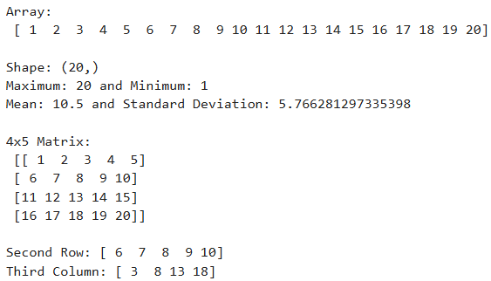
Question 2
Create two NumPy arrays:
A = [10, 20, 30, 40, 50]$
B = [5, 10, 15, 20, 25]$
Perform:
- Addition of A and B.
- Subtraction of B from A.
- Element-wise multiplication.
- Element-wise division.
- Find the sum of all elements in A.
Code:-
import numpy as np
A = np.array([10, 20, 30, 40, 50])
B = np.array([5, 10, 15, 20, 25])
# 1. Addition of A and B
print("Addition (A + B):", A + B)
# 2. Subtraction of B from A
print("Subtraction (A - B):", A - B)
# 3. Element-wise multiplication
print("Multiplication (A * B):", A * B)
# 4. Element-wise division
print("Division (A / B):", A / B)
# 5. Find the sum of all elements in A
print("Sum of elements in A:", A.sum())
Output:-
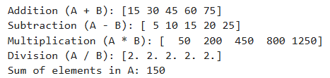
Part B – Pandas
Question 3
Create a DataFrame using the following student data:
Roll No | Name | Marks
101 | Ravi | 85
102 | Priya | 92
103 | Kiran | 78
104 | Anu | 88
105 | Sita | 95
Perform the following operations:
- Display the DataFrame.
- Display the first three records.
- Find the average marks.
- Find the student with the highest marks.
- Find the student with the lowest marks.
- Add a new column called "Grade" using:
  - A for Marks >=90
  - B for Marks between 80 and 89
  - C for Marks < 80
Code:-
import pandas as pd
students_df = pd.DataFrame({
'Roll No': [101, 102, 103, 104, 105],
'Name': ['Ravi', 'Priya', 'Kiran', 'Anu', 'Sita'],
'Marks': [85, 92, 78, 88, 95]
})
# 1. Display full DataFrame
print("Full DataFrame:")
print(students_df)
# 2. Display first three records
print("\nFirst Three Records:")
print(students_df.head(3))
# 3. Find average marks
print(f"\nAverage Marks: {students_df['Marks'].mean()}")
# 4. Find student with highest marks
highest_student = students_df.loc[students_df['Marks'].idxmax()]
print(f"Highest Marks: {highest_student['Name']} ({highest_student['Marks']})")
# 5. Find student with lowest marks
lowest_student = students_df.loc[students_df['Marks'].idxmin()]
print(f"Lowest Marks: {lowest_student['Name']} ({lowest_student['Marks']})")
# 6. Add Grade column using conditional mapping
def assign_grade(mark):
if mark >= 90: return 'A'
elif mark >= 80: return 'B'
else: return 'C'
students_df['Grade'] = students_df['Marks'].apply(assign_grade)
print("\nDataFrame with Grades:")
print(students_df)

Output:-
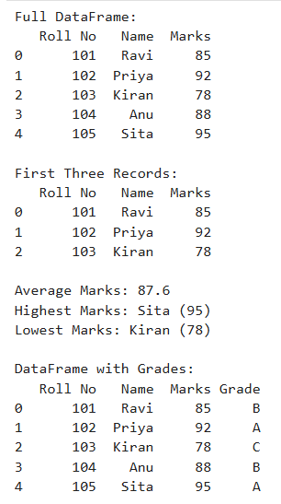
Question 4
Create a DataFrame containing the following information:
Product | Price | Quantity
Laptop | 50000 | 10
Mouse | 500 | 50
Keyboard | 1200 | 30
Monitor | 10000 | 15
Perform:
- Calculate the total value of each product using: Total Value = Price* Quantity
- Add the Total Value column.
- Find the product with the highest total value.
- Calculate the overall inventory value.
Code:-
import pandas as pd
inventory_df = pd.DataFrame({
'Product': ['Laptop', 'Mouse', 'Keyboard', 'Monitor'],
'Price': [50000, 500, 1200, 10000],
'Quantity': [10, 50, 30, 15]
})
# 1 & 2. Calculate and add Total Value column
inventory_df['Total Value'] = inventory_df['Price'] * inventory_df['Quantity']
print("Updated Inventory DataFrame:", inventory_df)
# 3. Find the product with the highest total value
highest_val_prod = inventory_df.loc[inventory_df['Total Value'].idxmax()]['Product']
print(f"\nHighest Total Value Product: {highest_val_prod}")
# 4. Calculate overall inventory value
total_inv_value = inventory_df['Total Value'].sum()
print(f"Overall Inventory Value: {total_inv_value}")
Output:-
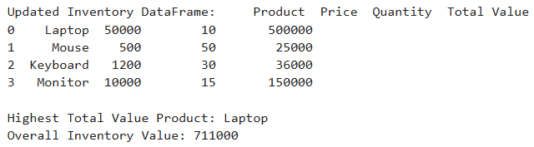
Part C – Dataset Exploration
Question 5
Download the Iris dataset from Scikit-learn and perform the following:
- Load the dataset into a Pandas DataFrame.
- Display the first five records.
- Find the number of rows and columns.
- Display column names.
- Check for missing values.
- Generate summary statistics using describe().
- Find the number of samples belonging to each class.
Code:-
import pandas as pd
from sklearn.datasets import load_iris
# 1. Load dataset into a Pandas DataFrame
iris = load_iris()
iris_df = pd.DataFrame(data=iris.data, columns=iris.feature_names)
iris_df['species'] = iris.target
iris_df['species_name'] = iris_df['species'].map({i: name for i, name in enumerate(iris.target_names)})
# 2. Display the first five records
print("First Five Records:")
print(iris_df.head())
# 3. Find the number of rows and columns
print(f"\Data Dimensions (Rows, Columns): {iris_df.shape}")
# 4. Display column names
print("\nColumn Names:")
print(list(iris_df.columns))
# 5. Check for missing values
print("\nMissing Values Per Column:")
print(iris_df.isnull().sum())
# 6. Generate summary statistics
print("\nSummary Statistics:")
print(iris_df.describe())
# 7. Find number of samples belonging to each class
print("\nClass Sample Distribution Count:")
print(iris_df['species_name'].value_counts())
Output:-
