PIZZA SALES SQL QUERIES REPORT
- KPI’s
- Total Revenue
SELECT SUM(total_price) AS Total_Revenue FROM pizza_sales;
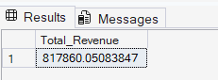
- Avergae Order Value
SELECT SUM(total_price) / COUNT(DISTINCT order_id) AS Avg_Order_Value FROM pizza_sales;
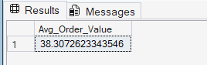
- Total Pizzas Sold
SELECT SUM(quantity) AS Total_Pizzas_Sold FROM pizza_sales;
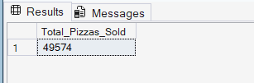
- Total Orders
SELECT COUNT(DISTINCT order_id) AS Total_orders FROM pizza_sales;
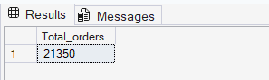
- Average Pizzas Ordered
SELECT CAST((CAST(SUM(quantity) AS DECIMAL(10,2)) /
CAST(COUNT(DISTINCT order_id) AS DECIMAL(10,2))) AS DECIMAL(10,2))
AS Avg_Pizzas_Per_Order
FROM pizza_sales;
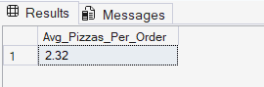

- Daily Trend for Total Orders

SELECT DATENAME(DW, order_date) AS day_of_the_week , COUNT(DISTINCT order_id) AS Total_orders
FROM pizza_sales
GROUP BY DATENAME(DW, order_date);

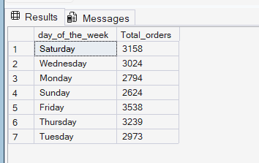

- Hourly Trend for Total Orders

SELECT DATEPART(HOUR, order_time) AS Hour , COUNT(DISTINCT order_id) AS Total_orders
FROM pizza_sales
GROUP BY DATEPART(HOUR, order_time)
ORDER BY DATEPART(HOUR, order_time);
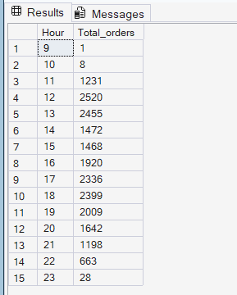

- %Sales By Pizza Category

SELECT pizza_category, CAST(SUM(total_price) AS DECIMAL(10,2)) AS Total_Sales,
CAST(SUM(total_price)*100 / (SELECT SUM(total_price) FROM pizza_sales) AS DECIMAL(10,2)) AS Per_Total_Sales
FROM pizza_sales
GROUP BY pizza_category;

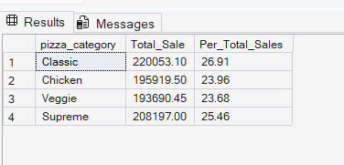

- %Sales By Pizza Size

SELECT pizza_size, CAST(SUM(total_price) AS DECIMAL(10,2)) AS Total_Sale,
CAST(SUM(total_price)*100 / (SELECT SUM(total_price) FROM pizza_sales) AS DECIMAL(10,2)) AS Per_Total_Sales
FROM pizza_sales
GROUP BY pizza_size
ORDER BY pizza_size;
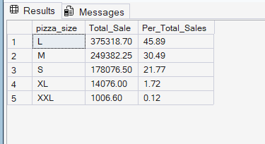

- Total pizzas Sold By Pizza Category

SELECT pizza_category, SUM(quantity) AS Total_Pizza_Sold
FROM pizza_sales
GROUP BY pizza_category
ORDER BY Total_Pizza_Sold DESC;

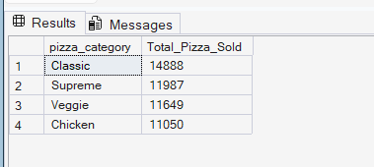

- Top 5 Best sellers by Total Pizzas Sold

SELECT TOP 5 pizza_name, SUM(quantity) AS Total_Pizza_Sold
FROM pizza_sales
GROUP BY pizza_name
ORDER BY Total_Pizza_Sold DESC;

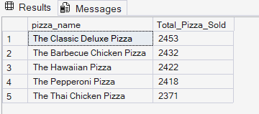

- Top 5 Worst Sellers
SELECT TOP 5 pizza_name, SUM(quantity) AS Total_Pizza_Sold
FROM pizza_sales
GROUP BY pizza_name
ORDER BY Total_Pizza_Sold;

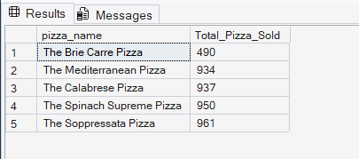

NOTE
If you want to apply the Month, Quarter, Week filters to the above queries you can use WHERE clause. Follow some of below examples
SELECT DATENAME(DW, order_date) AS day_of_the_week, COUNT(DISTINCT order_id) AS total_orders
FROM pizza_sales
WHERE MONTH(order_date) = 1
GROUP BY DATENAME(DW, order_date)

*Here MONTH(order_date) = 1 indicates that the output is for the month of January. MONTH(order_date) = 4 indicates output for Month of April.

SELECT DATENAME(DW, order_date) AS day_of_the_week, COUNT(DISTINCT order_id) AS total_orders
FROM pizza_sales
WHERE DATEPART(QUARTER, order_date) = 1
GROUP BY DATENAME(DW, order_date)

*Here DATEPART(QUARTER, order_date) = 1 indicates that the output is for the Quarter 1. DATEPART(QUARTER, order_date)= 3 indicates output for Quarter 3.

