Students Performance Data Analysis Report

This Data set includes variety of factors that may influence the students performance. It includes various fields/data like age, gender, academic support like scholarship, attendance, weekly study hours, extra circular activities like sports activity and additional work, the learning behaviour of students like reading, listening in class, taking notes etc, the transportation and other factors.
The main objective is to analyse the students performance, identify the top 3 factors that impacting the students performance in positive and negative way and to analyse the performance based on gender.
Note: To analyse this I have created a bucket called Remarks (which is the final grade) as pass (1) for all the grades and fail (0) for fail from grades field.

Top 3 factors influencing students’ performance in a positive way:
- Attendance.
  - Students with "Always" attendance: 67.59% pass rate
  - Failure rate is only 0.69%
- No Extracurricular Involvement
  - Additional Work (No): 64.14% pass rate
  - Sports Activity (No): 57.93% pass rate
- Moderate or No Weekly Study Hours
  - 0 hrs: 61.38% pass rate
  - 2 hrs: 17.93% pass rate

Factors influencing students performance in a negative way:
- Not Reading:
  - Students who are not reading: 4.14% failure
- Bus Transportation:
  - Bus users: 4.14% failure vs. 1.38% for private
- Not Taking Notes:
  - Students not taking notes: 3.45% failure
- Inconsistent Attendance:
  - Sometimes: 3.45% failure
- Involvement in Extracurricular Activities:
  - Additional Work (Yes): 3.45% failure
  - Sports Activity (Yes): 3.45% failure

Gender wise performance of the students:
Male Students:
- 0% failure rate
- Though percentage in top grades (AA, BA, BB) are slightly lower than females but there are no failures.
Female Students:
- Has high scores in top grades but has failures.
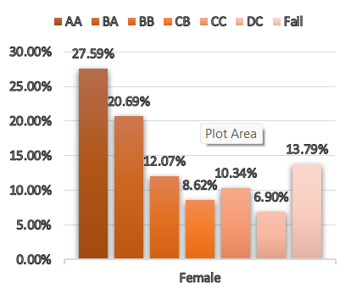
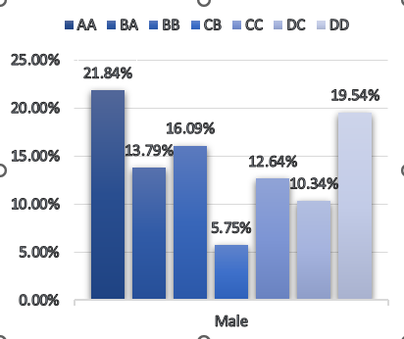

Key Insights:
- Regular Attendance has the strongest positive influence on performance.
- Avoiding extracurricular commitments correlates with higher pass rates.
- Study Time: Moderate weekly study (2–6 hrs) performs better than extreme ends.
- Not Reading/Taking Notes contributes to failure.
- Transportation also has a minor impact.
- Male students performed well than females in this dataset.

Conclusion:
This analysis shows that students perform better when they have a regular routine, attend classes regularly, and stay focused without too many distractions. Studying for a balanced number of hours and paying attention in class also help improve performance.

