# VISVESVARAYA TECHNOLOGICAL UNIVERSITY

**Jnana Sangama, Belagavi- 590018**



A Mini-Project Report on

## **“PNEUMONIA DETECTION USING CNN”**

**BACHELOR OF ENGINEERING**

**in**

**COMPUTER SCIENCE AND ARTIFICIAL INTELLIGENCE ENGINEERING**

**Submitted by**

**1.Ms. Manya B J 4MH22CA023**

**2.Ms. Sanjana M 4MH22CA044**

**3.Mr. Syed Inam 4MH22CA053**

**4.Mr. Ayush H 4MH22CA006**

**Under the Guidance of**

**Dr.Agughasi Victor Ikechukwu**



**MAHARAJA INSTITUTE OF TECHNOLOGY**

**DEPARTMENT OF COMPUTER SCIENCE AND ARTIFICIAL INTELLIGENCE ENGINEERING**

**MYSORE- 573 114**

**2024-2025**



**DEPARTMENT OF COMPUTER SCIENCE AND ARTIFICIAL INTELLIGENCE ENGINEERING**

## **CERTIFICATE**

Certified that the Mini-Project Work entitled **“Pneumonia Detectio Using CNN**” is a bonafide work carried out by **Manya B J (4MH22CA023),Sanjana M (4MH22CA044),Syed Inam (4MH22CA053) and Ayush H (4MH22CA006)** in partial fulfilment for the Mini- Project of Engineering in Computer Science and Artificial Intelligence of Visvesvaraya Technological University, Belagavi during the year 2024-2025. It is certified that all corrections/suggestions indicated for Internal Assessment have been incorporated in the report deposited in the departmental library. The Mini-project report has been approved as it satisfies the academic requirements.

**Guide Name Dr. Hemanth**

**Dr. Agughasi Victor Ikechukwu HOD**

**Mr. Shashanka H P**

**Dr. B.G. Naresh Kumar**

**Principal**

**External Viva**

**Name of the Examiner Signature with date**

1.

2.

**ACKNOWLEDGEMENT**

It is our privilege and primary duty to express our gratitude and respect to all those who guided and inspired us in the successful completion of this Mini-Project.

We express our sincere thanks to **Dr. B.G. Naresh Kumar, Principal, Dr. Hemanth, HOD, Mini-Project Coordinator Dr. Agughasi Victor Ikechukwu, Project Guide Mr. Shashanka H P,** for their cooperation, guidance, and constant support throughout this Mini-Project work.

We extend our heartfelt gratitude to the teaching and non-teaching staff of the Computer Science and Artificial Intelligence Department for their valuable assistance and encouragement during the project.

Lastly, we would like to thank all those who directly or indirectly contributed to the success of this Mini- Project.

Mini-Project Associates:

Manya B J (4MH22CA023)

Sanjana M (4MH22CA044)

Syed Inam (4MH22CA053)

Ayush H (4MH22CA006)

**TABLE CONTENTS**

**1.Introduction**

**Synopsis:**

Introduction

Motivation

Objectives

Literature review

* 1. Aim of the Project
  2. Overview of the Project
  3. Outcome of the Project
  4. Software Requirements
  5. Software Description

##### **2. System Development and Data Analysis**

2.1 Problem Understanding and Objectives

* 1. Data Exploration and Understanding
     1. Choosing the Dataset
     2. EDA
  2. Data Preparation
     1. Data Augmentation
     2. Data Splitting
     3. Training Strategy
     4. Unknown Class Handling

**3.Result Analysis**

3.1 Screenshots

**4. Conclusion**

**SYNOPSIS:**

1. **Introduction**

Pneumonia is a serious lung infection that affects millions of people across the globe every year. It can be mild or severe, and if not managed, it can have negative health consequences, and in certain situations, death. Time is of the essence in diagnosis since young children, the elderly, and individuals with weak immunity are more likely to suffer from various complications. Usually, the diagnosis of pneumonia has to go through a labor-intensive process where chest x-rays have to be examined by trained personnel. This activity is very important in areas that have an abundance of medically trained personnel, but unfortunately, it is not the case for many areas. For instance, rural or low-income areas may not have diagnostic facilities, aggravating the clinical condition of the patients for a very long period.

This project aims to overcome these limitations through the use of a Convolutional Neural Network (CNN) model which detects pneumonia from chest X-ray images automatically. CNNs are deep learning models that have considerable capability in visual and image-related tasks. They achieve this by learning features of the images without supervision which is appropriate for the task of classifying images. Recently, however, CNNs have extended quite a remarkable impact across various fields including facial recognition, self-driving cars, and most notably, medical images. It is quite evident that having a large, adequately-annotated dataset of chest X-ray images, enables a CNN model to detect traces of pneumonia with precision.

This project utilizes the programming language Python and the existing popular technologies characterized by deep learning frameworks like TensorFlow or Pytorch which offer tools for designing, training and testing CNN models. Furthermore, methods like image processing transformations will be employed to enhance the performance and generalization of the model on new data as a way of reducing overfitting consequently enhancing the diagnostic performance of the model. This system for the detection of pneumonia using CNNs can be of significant help to radiologists and health care professionals in improving their diagnosis efficacy especially in areas with a shortage of health care providers. With the creation of an effective automated detection tool, this proposal intends to facilitate faster pneumonia detection. This will enhance healthcare provisions and possibly avert loss of lives

**MOTIVATION:**

Pneumonia is a major respiratory infection, which can be serious and risky for human life as it may affect children, old people and weak immune systems. Timely and correct diagnosis of pneumonia is critical to effective treatment in many cases, and even life-saving. On the other hand, in underserved regions or isolated areas access to radiologist and physicians for immediate diagnosis may be limited. These discrepancies highlight an immediate demand for automated solutions to assist healthcare professionals in accurately diagnosing pneumonia at a quicker pace.

Advanced artificial intelligence and medical imaging techniques can be harnessed to tackle this issue, such as using Convolutional Neural Networks (CNNs) for pneumonia identificat. Convolutional neural networks (CNNs) have shown a positive impact on image classification, which makes them a suitable tool for interpreting chest X-ray . This project intends to contribute the healthcare professionals with a CNN based model in order to diagnose cases of pneumonia as efficiently as possible, thereby saving lives at risk and ease pressure on medical resources.

**OBJECTIVES:**

1. **Developing a CNN Model for High Accuracy**: CNNs are ideal for medical image classification due to their ability to automatically learn important features from chest X-ray images. This capability ensures high accuracy in detecting pneumonia, which is critical for reliable medical diagnosis and timely intervention.
2. **Fast and Efficient Detection Pipeline**: A quick detection pipeline is essential to reduce diagnosis time, enabling rapid decision-making. Optimizing the CNN model for speed through techniques like model quantization or lighter architectures ensures real-time predictions, crucial for emergency scenarios.
3. **Minimizing False Negatives and False Positives**: Reducing errors is vital for reliable diagnosis. Techniques like data augmentation, handling class imbalance, and hyperparameter tuning help minimize false negatives (which could delay treatment) and false positives (which could lead to unnecessary interventions), ensuring consistent, accurate predictions.

**LITERATURE REVIEW:**

|  |  |  |  |  |  |  |
| --- | --- | --- | --- | --- | --- | --- |
| S/N | Author(s),Journal Name, Year of Publication (YOP) | Title | Problem Identified | Dataset used/ Description | Method(ology) Used | Observations (Strengths, Limitations) |
| * 1 | Dr.T.Praveen Blessingtonetal  Journal name:JETIR  YOP:2023 | Pneumonia Detection Using CNN | Traditional methods are time-consuming and prone to human error | Chest X-ray images (pneumonia-positive and pneumonia-negative) | CNN model | High accuracy (96%), but needs real-world validation |
| 2 | Amer Kareem et al  Journal name: Springer  YOP:2022 | Review on Pneumonia Image Detection: A MachineLearning Approach | Need for efficient and accurate pneumonia detection | Various datasets from hospitals and medical institutions | Hybrid model combining CNN with other ML techniques | Comprehensive review, but lacks specific accuracy metrics |
| 3 | Er. Neetu Bala et al  Journal name: SSRN  YOP:2024 | Deep Learning Techniques for Pneumonia Detection: A Review of CNN Applications | Traditional diagnostic methods are time-consuming | Publicly available pneumonia datasets | CNN models with various architectures | Highlights challenges in real-world implementation |
| 4 | Various Authors  Journal name: Springer  YOP:2023 | A Systematic Literature Review on Deep Learning Approaches for Pneumonia Detection | Need for advanced techniques in pneumonia detection | Various datasets | Systematic review of deep learning techniques | Provides a broad overview, but lacks specific findings |

**TABLE 1.1 LITERATURE REVIEW**

**FEASIBILITY STUDY**

It would be possible to implement pneumonia detection using CNNs from large datasets, such as the chests X-ray image repositories, for example NIH Chest X-rays and Kaggle datasets. CNNs have been only recently proved to be potential entities in the arena of medical image analysis with high accuracy in related classification tasks. This project could technologically be realized with existing deep learning tools and libraries, such as TensorFlow and Keras. With the proper computational resource-in this case, GPUs or cloud services, the system design and implementation are feasible within the constraints.

This project is significant because it addresses critical challenges in healthcare, such as diagnostic accuracy, early detection, and accessibility. By implementing a CNN-based solution, healthcare providers can benefit from a reliable diagnostic aid, enabling quicker decision-making and better resource allocation. This system can be particularly impactful in remote or under-resourced areas, where access to expert radiologists is limited. Furthermore, it can contribute to the broader adoption of AI in healthcare, paving the way for advancements in medical diagnostics.

**1.1AIM OF THE PROECT**

The aim of the project Pneumonia Detection Using CNN is to develop an automated, accurate, and efficient system for detecting pneumonia from chest X-ray images. By leveraging deep learning, this project seeks to assist healthcare professionals in early diagnosis, reduce diagnostic errors, and provide a scalable solution for resource-constrained settings.

* 1. **OVERVIEW OF TH PROJECT**

The project involves:

* + - Pre-processing Chest X-ray image datasets for training, validation, and testing.
    - Fine-tuning a model for binary classification (Normal vs. Pneumonia).
    - Incorporating mechanisms to identify unknown classes using techniques like Out Of Distribution technique.

### OUTCOME OF THE PROJECT

* A trained model capable of accurately classifying Chest X-Ray images as Normal or Pneumonia.
* Enhanced detection capabilities for unknown classes, improving model robustness and real-world usability.
* Comprehensive performance analysis, including sensitivity, specificity

### SOFTWARE REQUIREMENTS

* + - **Operating System:** Windows 10 or Linux-based OS.
    - **Programming Language:** Python 3.10+

##### **Frameworks and Libraries:**

* + TensorFlow (for model development and training)
  + Keras (easy model creation)
  + NumPy (numerical computation)
  + PIL (for image processing)
  + OS (for file management)

##### **Tools:**

* + - * Jupyter Notebook (for development and experimentation)
      * Anaconda (for environment management)

### SOFTWARE DESCRIPTION

1. **TensorFlow**: A framework for building, training, and deploying machine learning models, primarily used for deep learning tasks.
2. **Keras**: A high-level neural network API (now part of TensorFlow) for easy model creation and training.
3. **NumPy**: A library for handling arrays and performing numerical computations (linear algebra, statistics, etc.).
4. **PIL (Python Imaging Library, now Pillow)**: A library for opening, manipulating, and saving image files.
5. **OS**: Provides tools for interacting with the operating system (e.g., file and directory management).

**2.SYSTEM DEVELOPMENT AND DATA ANALYSIS**

**2.1 Problem Statement:**

Pneumonia detection using Convolutional Neural Networks (CNNs) and deep learning techniques to classify chest X-ray images into two categories: pneumonia and normal, leveraging advanced image processing and feature extraction methods to improve diagnostic accuracy and efficiency.

**2.2 DATA EXPLOEATION AND UNDERSTANDING**

**2.2.1 Choosing the Dataset:**

There are numerous datasets available on Roboflow for different medical imaging applications. We selected the Chest X-ray Pneumonia dataset, which is widely used for detecting pneumonia in chest X-rays. The dataset consists of 12,811 images, with 8,917 categorized as Pneumonia and 3,894 as Normal. This dataset is divided into training,valid and testing sets, ensuring a balanced evaluation of the model's performance on unseen data.

**2.2.2 EDA:**

Exploratory Data Analysis (EDA) is a crucial step in understanding the characteristics of a dataset and preparing it for model training.

The dataset for pneumonia detection is organized into two main categories: Pneumonia and Normal. Each category in the dataset is systematically organized into separate folders for training and testing, ensuring a clear and structured arrangement. The  **dataset** contains a total of **13,976 images**, with **10,189 labeled as "Pneumonia"** and **3,787 as "Normal"**.

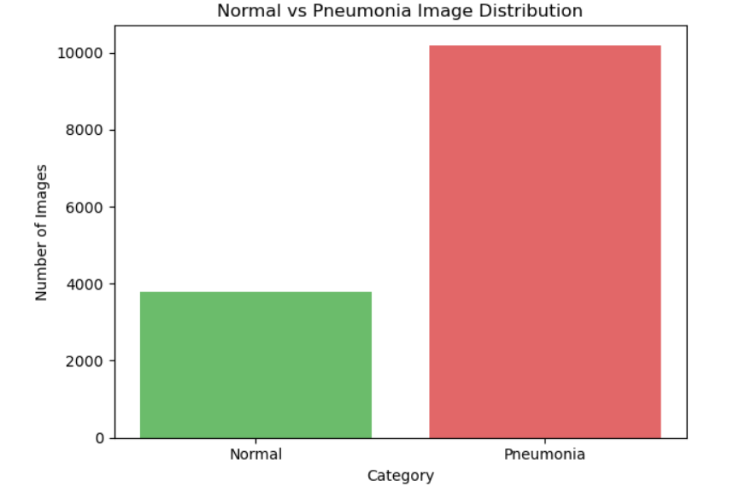

**Fig a) Normal vs Pneumonia Distribution**

While the dataset exhibits class imbalance, with a higher proportion of pneumonia cases, this distribution reflects the real-world prevalence of pneumonia. Addressing this imbalance through data augmentation, weighted loss functions, or oversampling techniques is essential to ensure the model learns features effectively from both classes .The dataset's systematic labeling and organization also support robust evaluation, enabling the computation of metrics like accuracy, precision and recall for each class. These metrics provide a comprehensive assessment of model performance, particularly its ability to detect pneumonia cases reliably.

a scatter plot of file sizes for images in the "Pneumonia" and "Normal" categories, revealing that the file sizes are consistently distributed across both classes. Most images fall within a similar range of approximately **8,000 to 20,000 bytes**, indicating that a uniform preprocessing pipeline has been applied.This uniformity is crucial for training deep learning models, as it ensures consistency in input data representation, minimizing potential biases caused by variations in image preprocessing. The tightly clustered data points within each category, with minimal outliers, further demonstrate the high quality of the dataset.

Such consistency benefits CNN models, which require fixed input dimensions and benefit from standardized data. It allows the model to focus on learning the intrinsic features of pneumonia and normal chest X-rays rather than being influenced by extraneous differences in data representation.

**2.3 Data Preperation**

**2.3.1 Data Augmentaion**

To enhance the diversity of the training data and improve generalization, several augmentation techniques were employed:

* Random Rotation: Images were randomly rotated up to 15 degrees to simulate variations in orientation.
* Horizontal Flipping: Random horizontal flipping was applied to mimic real-world imaging conditions.
* Brightness Adjustment: Random brightness alterations were introduced to handle varying lighting conditions during image acquisition.

These augmentations were applied dynamically during training to create varied input samples, effectively reducing the risk of overfitting.

**2.3.2 Data Splitting**

The dataset was divided into three subsets to facilitate training, validation, and testing:

* Training Set (88%): The largest subset, used for model training.
* Validation Set (8%): Used to monitor the model’s performance during training and adjust hyperparameters.
* Testing Set (4%): Reserved for evaluating the model’s final performance and generalization capability. This split ensures a balanced evaluation of the model’s accuracy and robustness.

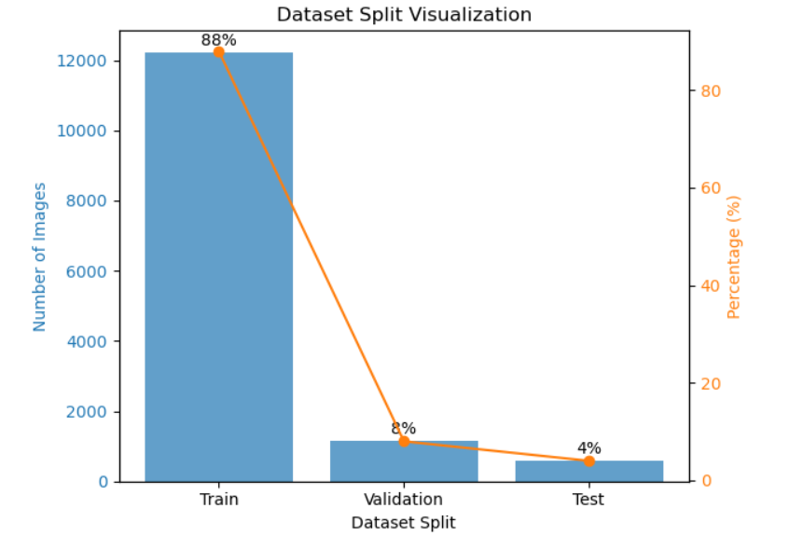

**Fig b) Data Splitting**

**2.3.3 Training Statergy**

* **Loss Function**: Binary Cross-Entropy Loss was selected as the loss function to handle the binary classification task between Pneumonia and Normal effectively. It measures the divergence between the predicted probabilities and the actual class labels, ensuring precise optimization for the model.
* **Optimizer**: The Adam optimizer was employed for its ability to adapt learning rates during training and handle sparse gradients efficiently. An initial learning rate of 0.0001 was chosen to facilitate stable and gradual convergence.
* **Learning Rate Scheduling**: A learning rate scheduler was utilized to reduce the learning rate by half whenever the validation loss plateaued for three consecutive epochs. This approach ensured that the model converged effectively, particularly in later stages of training, without overshooting the optimal solution.
* **Early Stopping**: To prevent overfitting and save computational resources, training was stopped if the validation loss did not improve for three consecutive epochs. This strategy ensured that the model retained its best performance on unseen data without unnecessary overtraining.

**2**.**3.4 Unknown Class Handling**

If the dimensions differ, the function immediately returns Unknown without processing the image further. This ensures that only images of the expected size are considered for model predictions.

**3.RESULT ANALYSIS**

The results of the proposed deep learning model for pneumonia detection using chest X-ray images demonstrate remarkable performance in classifying images into Pneumonia, Normal, and Unknown categories. Achieving an impressive overall accuracy of 98%, the model exhibits high consistency and precision across all categories

**3.1 Screenshots**

Here is a screenshot of our final webpage integrated with Flask and HTML showcasing the user interface for the pneumonia detection system. The webpage allows users to easily upload chest X-ray images for analysis, offering "Choose File" button for added convenience. After the image is uploaded, users can click the "Predict" button to obtain results, which classify the image as either "Pneumonia" or "Normal."

The design features a clean and modern aesthetic, with a professional and welcoming color scheme that ensures clarity and ease of navigation. The title "Pneumonia Detection" is prominently displayed at the top, guiding users toward the primary task of uploading their medical image for diagnosis. The drag-and-drop functionality, along with the intuitive "Choose File" button, enhances the user experience, making the process smooth and accessible.

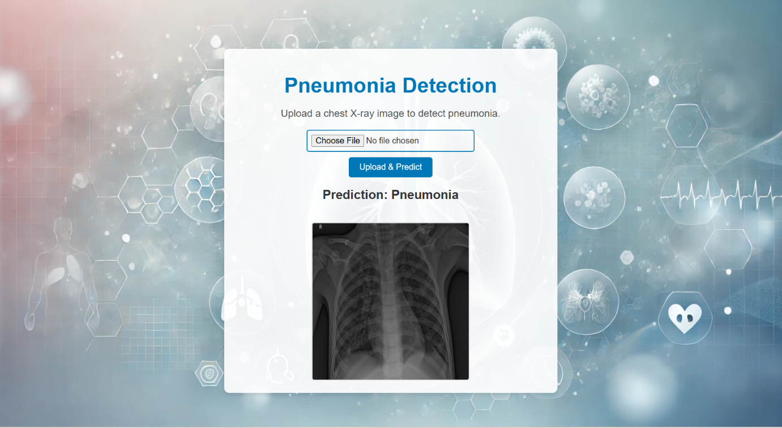

**Figure 3.a**

The screenshot of model predicting Pneumonia class from input image

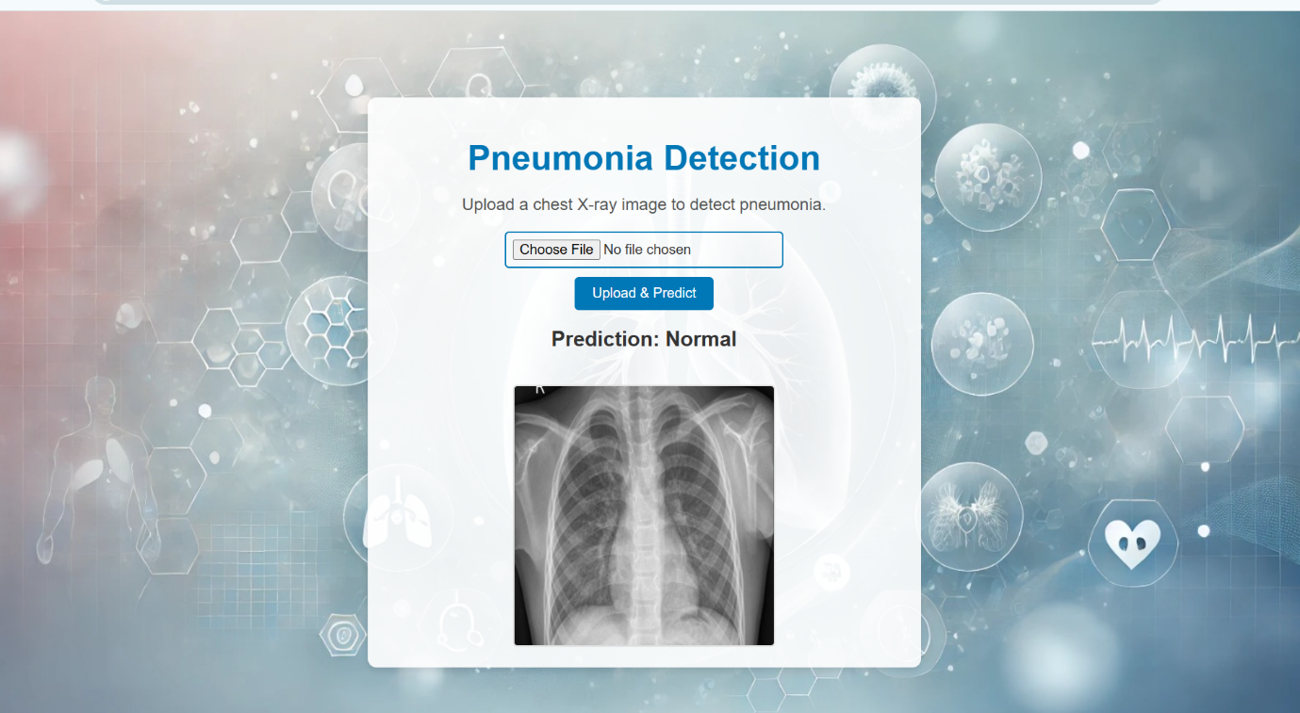

**Figure 3.b**

The screenshot of model predicting Normal class from input image

**4.CONCLUSION**

This project presents a highly effective and user-friendly deep learning model for the detection of pneumonia using chest X-ray images. By leveraging advanced machine learning techniques, the model demonstrates exceptional performance with an accuracy of 98%, showcasing its ability to classify images accurately into "Pneumonia," "Normal," and "Unknown" categories. The precision, recall, F1-score, and Area Under the Curve (AUC) metrics confirm the robustness and reliability of the model in minimizing misclassifications, ensuring both high sensitivity and specificity in diagnosing pneumonia.

In addition to the backend model, the project incorporates a sleek and intuitive user interface developed with Flask and HTML, providing a seamless experience for users. The drag-and-drop functionality, along with the file upload and prediction options, ensures ease of use for healthcare providers. The interface is designed to facilitate quick and accurate pneumonia detection, making it an invaluable tool for early diagnosis and improved patient outcomes.

Overall, this project highlights the potential of AI-driven solutions in transforming healthcare by aiding in the rapid and accurate detection of pneumonia. With its exceptional performance and user-friendly interface, the system can significantly assist healthcare providers in diagnosing pneumonia, ultimately contributing to better patient care and reducing the global burden of respiratory diseases.