Volumes

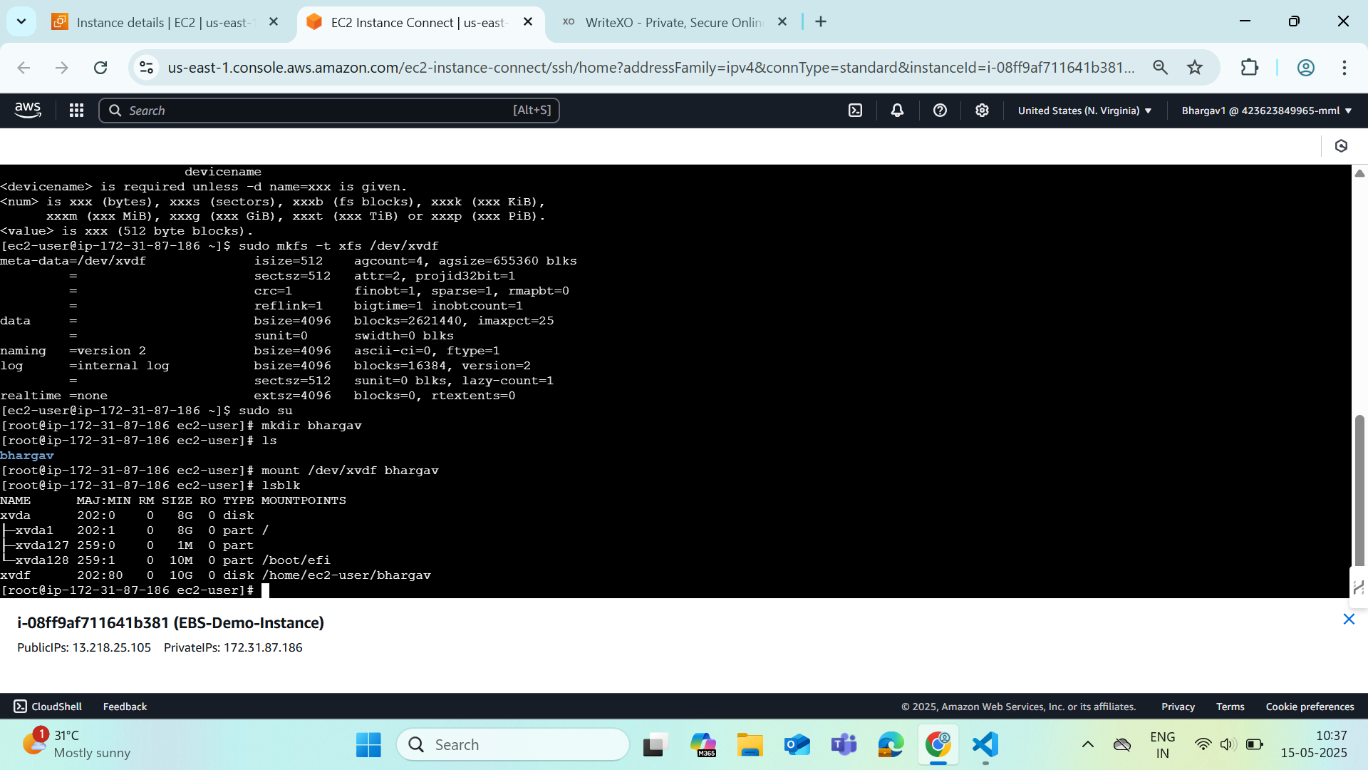

**TASK 1**

**Step 1:** Create Two EC2 Instance in default VPC (or any).

**Step 2:** Add NFS inbound rule to securiy group of the EC2 Instances.

**Step 3:** SSH to the instance and update your machine

**>>** sudo yum update -y

**>>** yum install -y amazon-efs-utils

**Step 4:** create a new directory

**Step 5:** Attach the link of EFS to mount the file to the instance: Using the EFS mount helper Link

**Step 6:** Create a demo file inside the EFS. (eg) nano Demo.txt > This is a Demo File.

Save and Exit

**TASK 2**

Create a new instance and attach the same EFS to the new instance and repeat fromstep 3 to 5

check whether the create Demo.txt file exist.

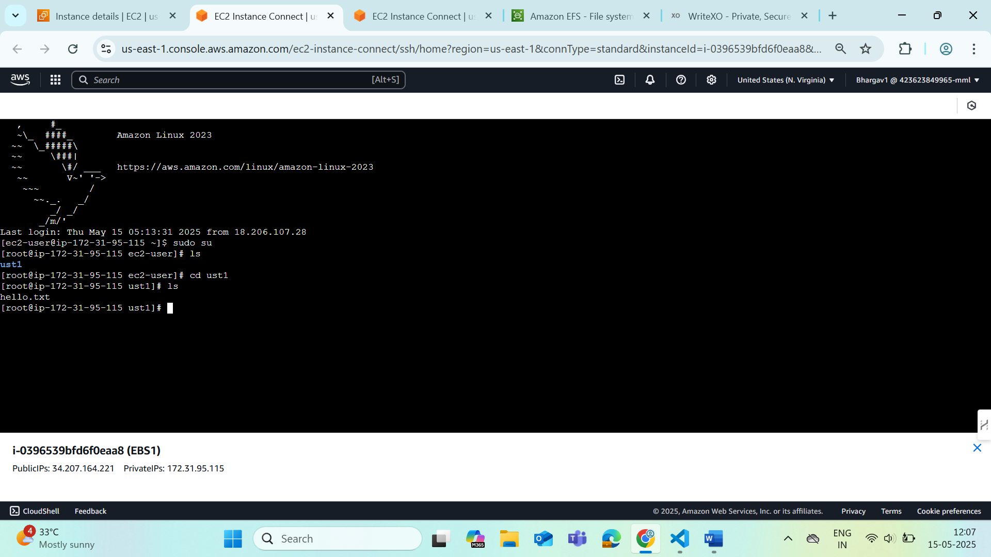

So both the ec2 instances are sharing same file system

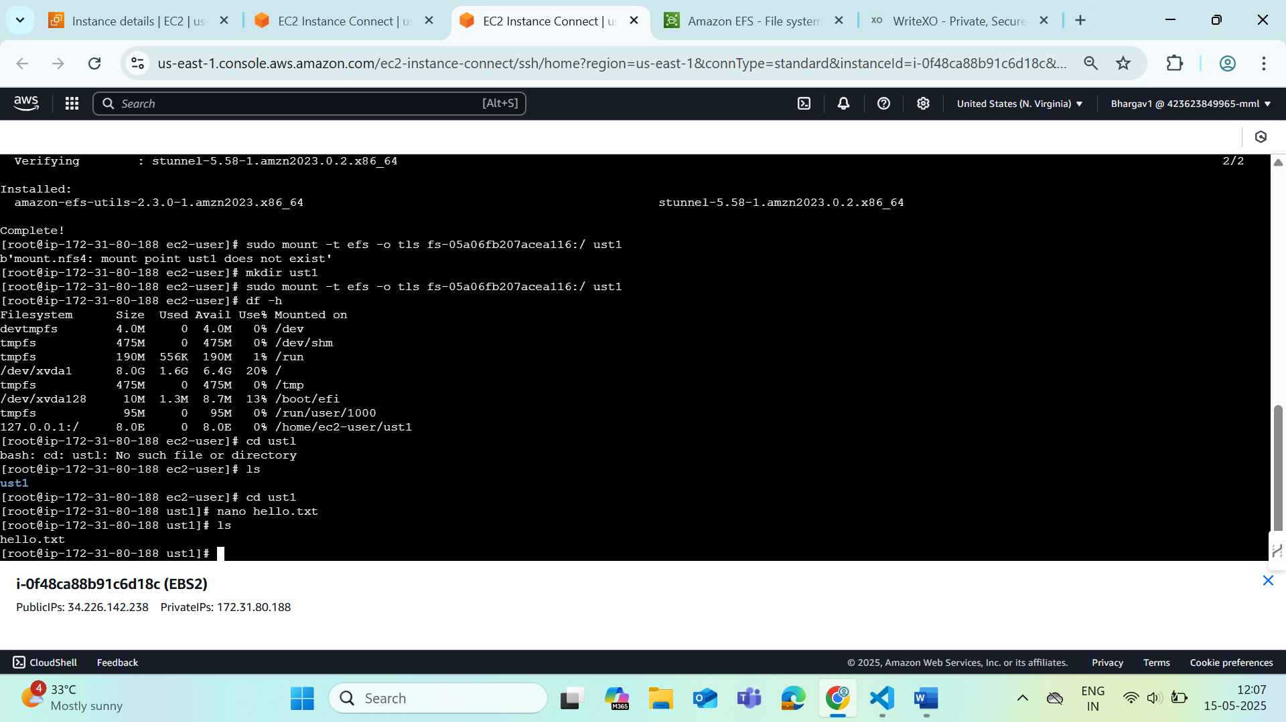

blkid | grep xvdf

nano /etc/fstab

