Aws

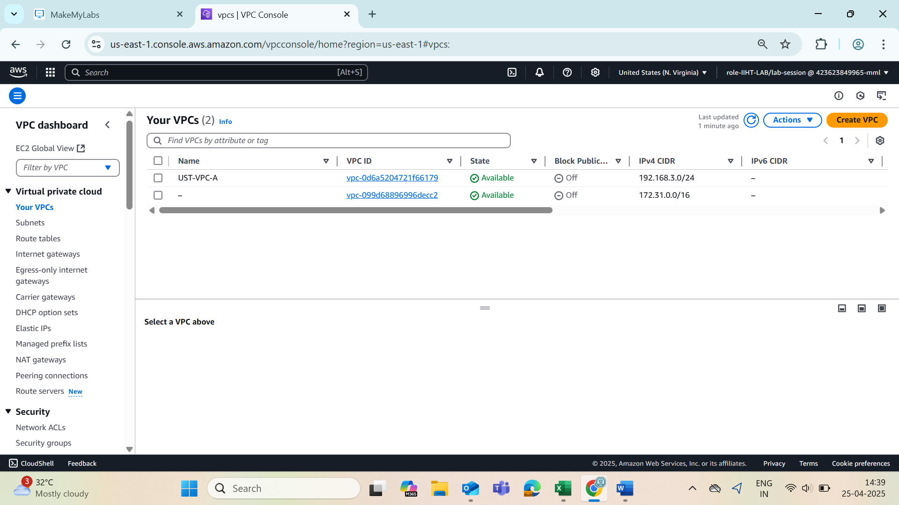

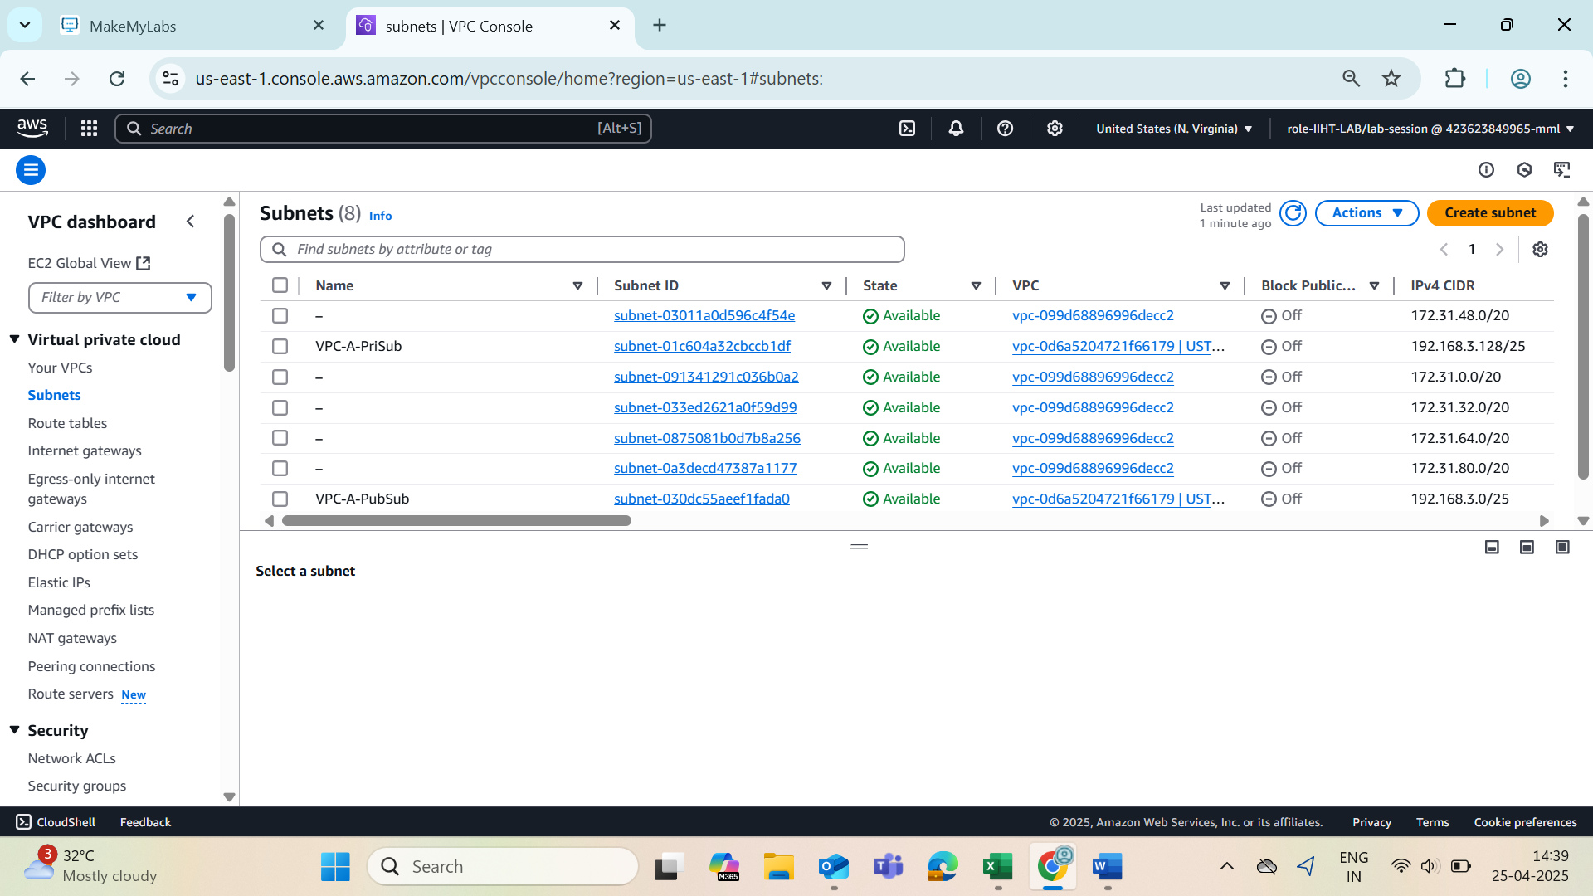

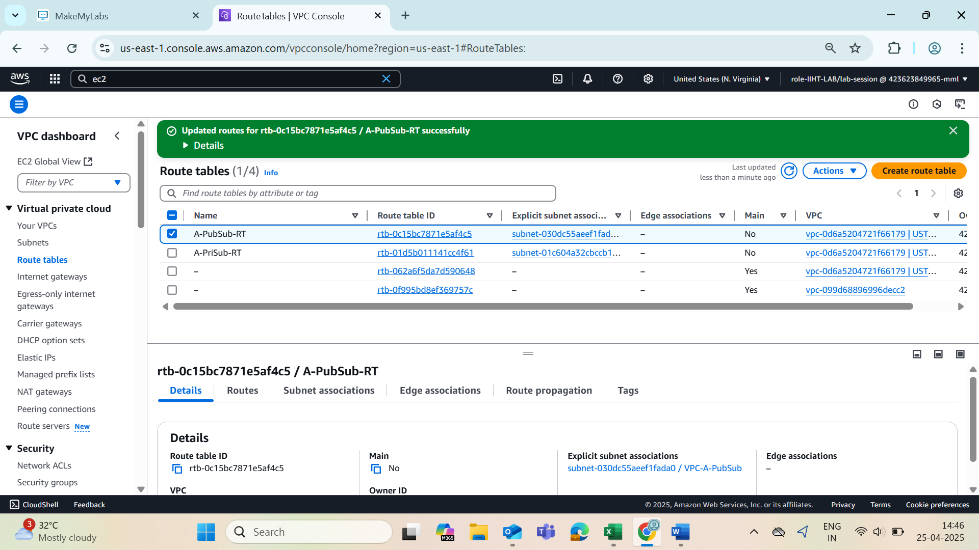

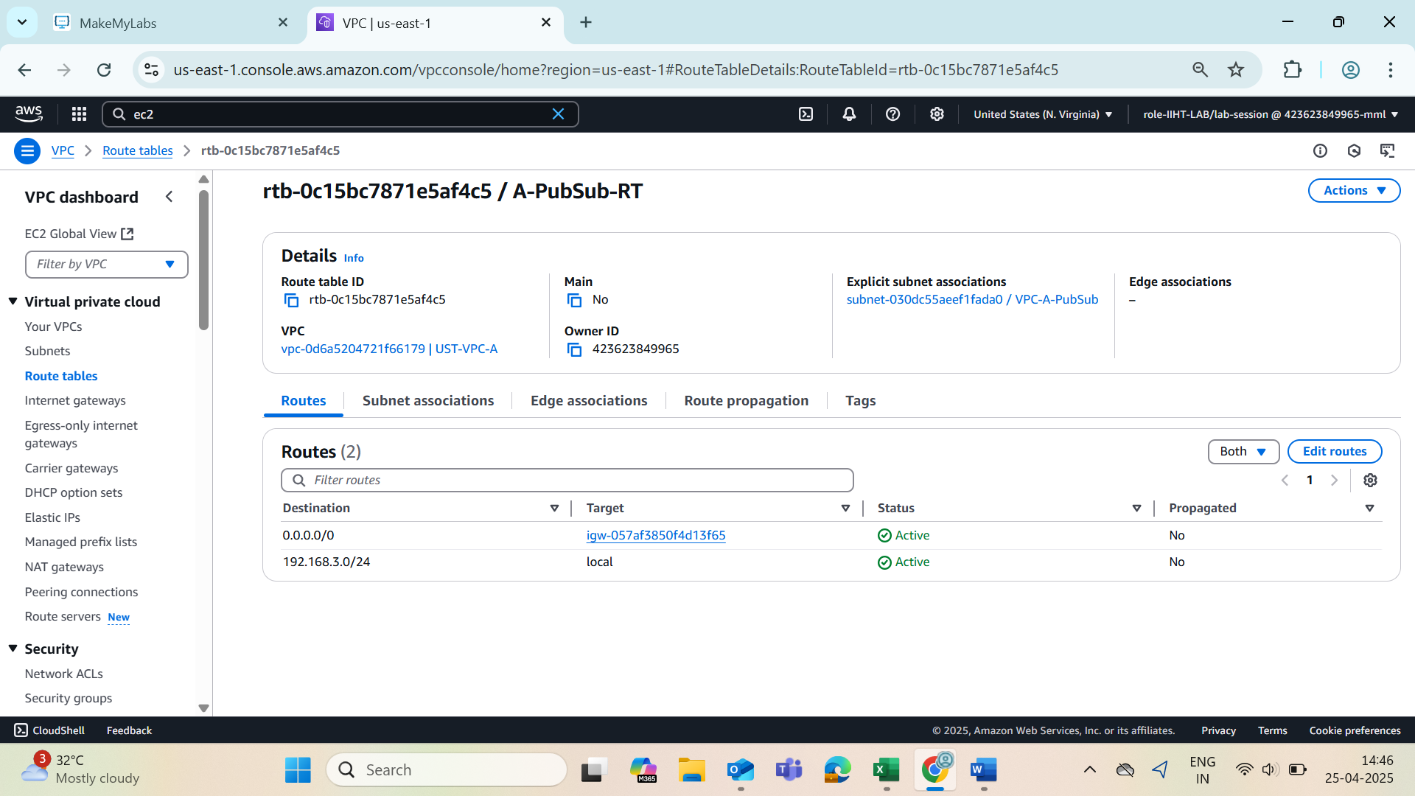

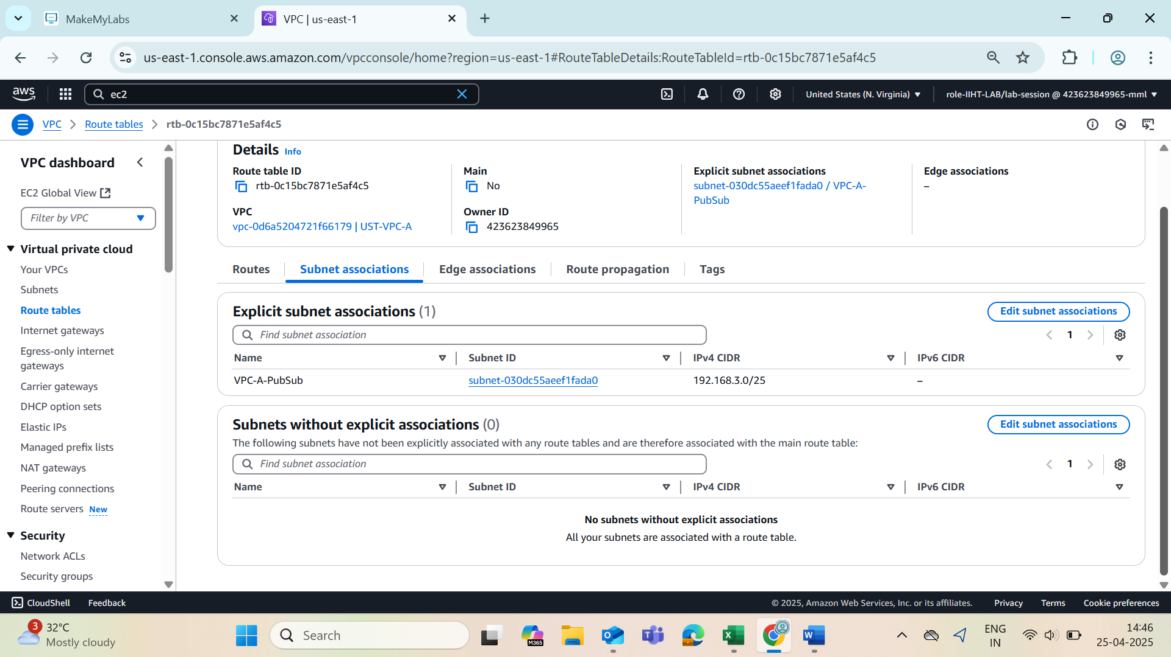

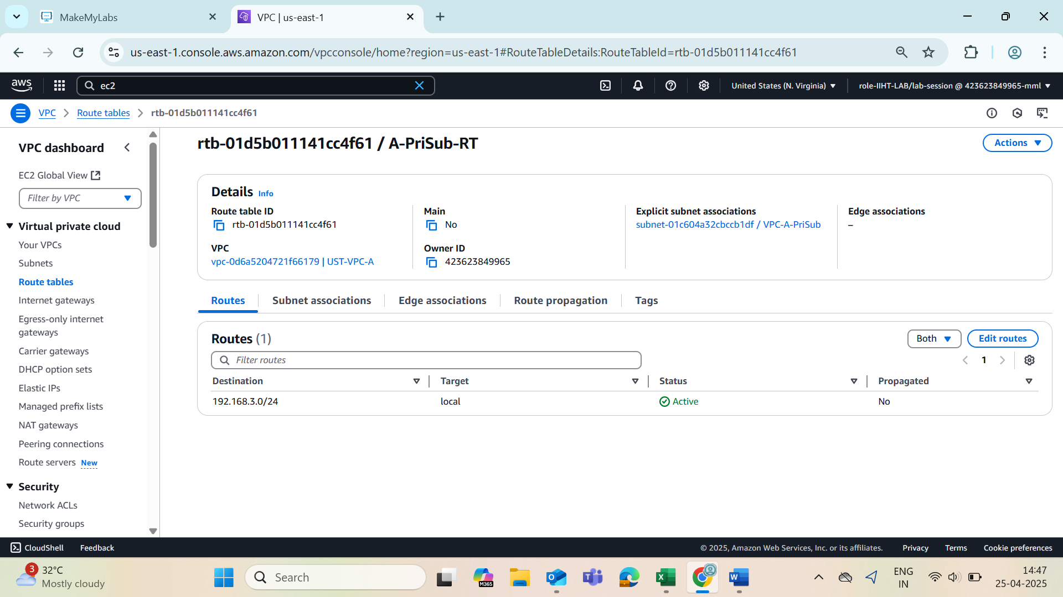

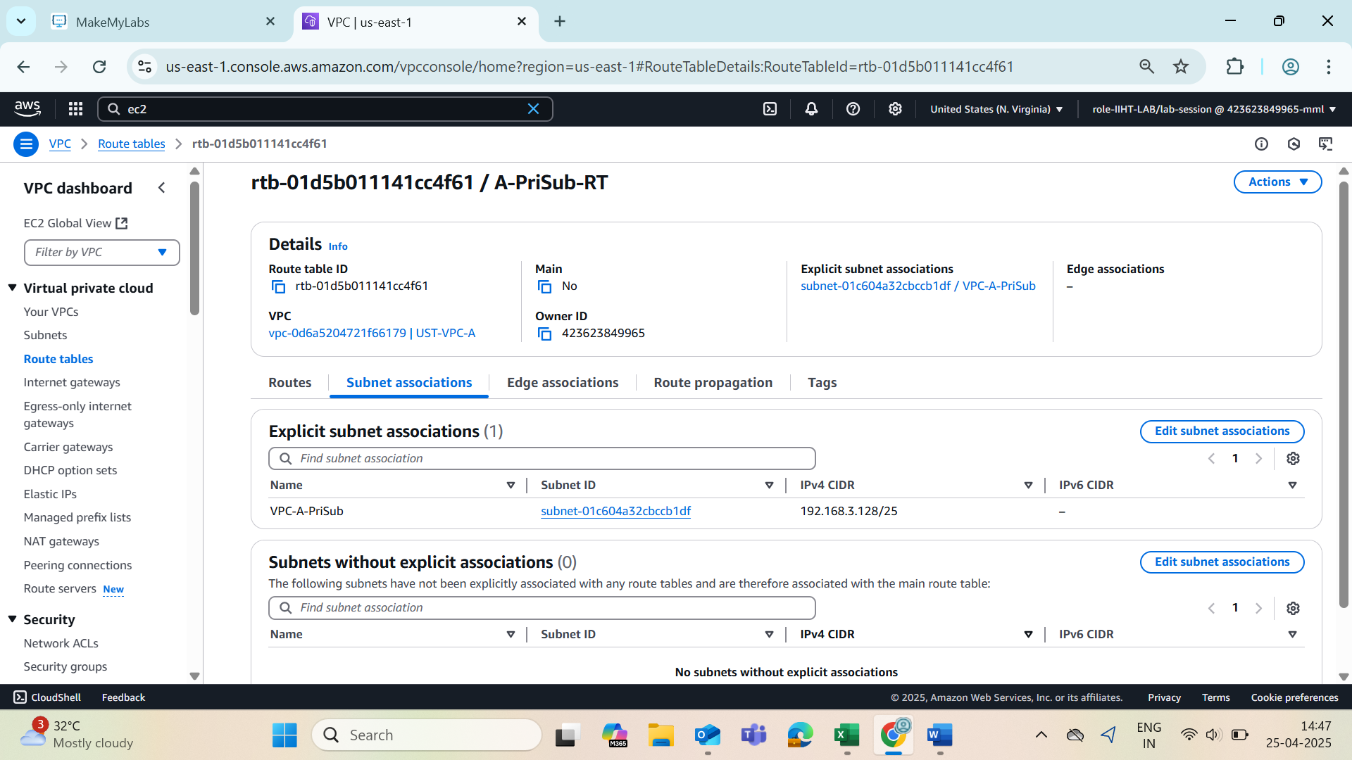

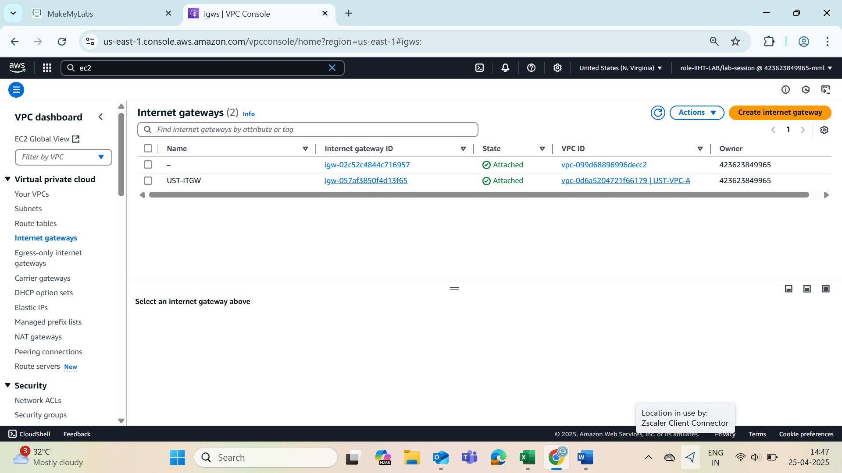

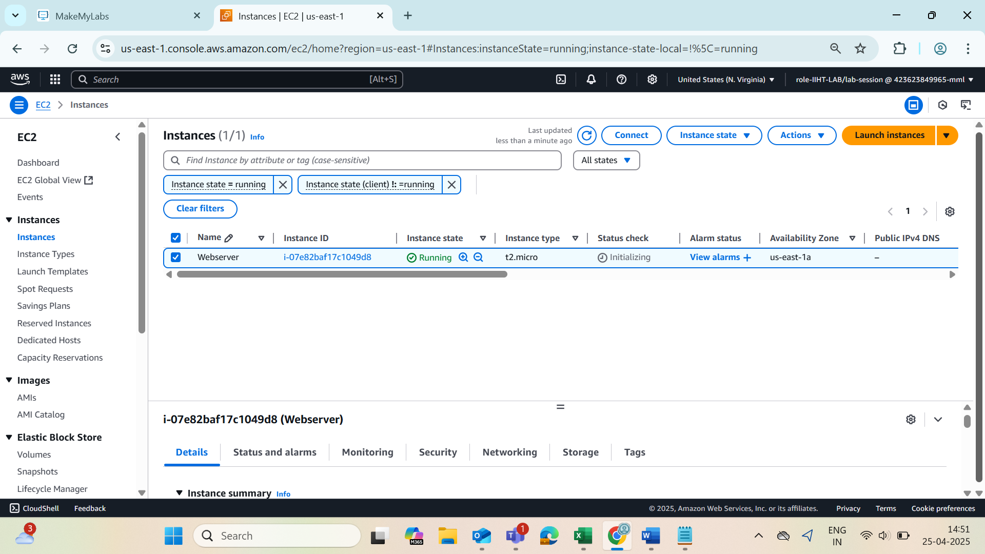

#!/bin/bash

# Wait until internet is available

while ! ping -c 1 -W 5 8.8.8.8 &>/dev/null; do

echo "Waiting for internet connection..."

sleep 5

done

# Update and install httpd

sudo yum update -y

sudo yum install -y httpd

# Start and enable httpd

sudo systemctl start httpd

sudo systemctl enable httpd

# Set proper ownership and permissions

sudo chown -R apache:apache /var/www/html

sudo chmod -R 755 /var/www/html

# Create a basic index.html with the server's hostname

echo "<h1> Welcome to AWS Session $(hostname -f) </h1>" | sudo tee /var/www/html/index.html

