**Established an End-to-End CI/CD Pipeline in AWS**

1) Created an Amazon Elastic Container Registry (ECR) with Repository name as bhargav

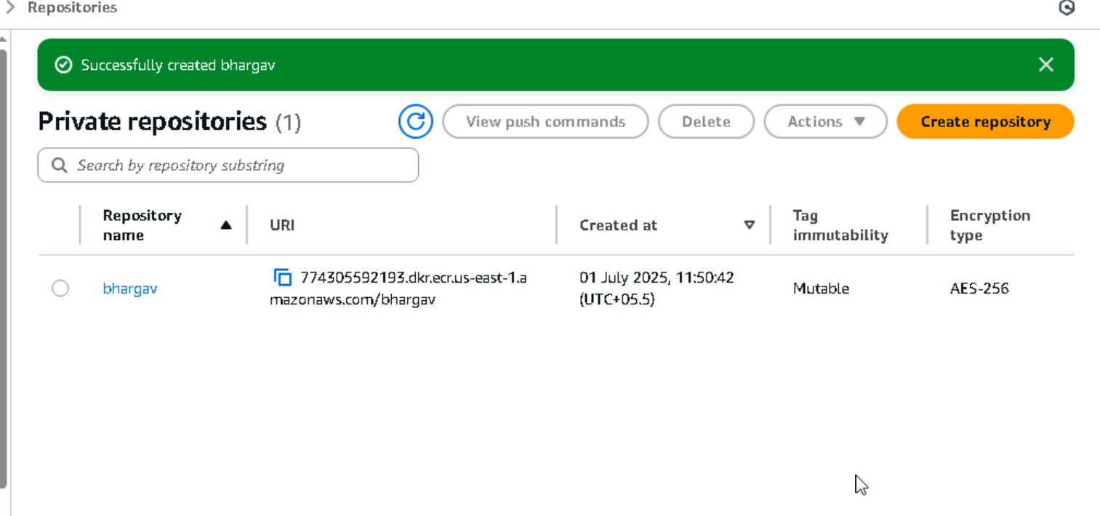

Then created the EKS cluster using command:  
**eksctl create cluster --name cluster1 --region us-east-1 --nodegroup-name eks-nodes1 --node-type t3.medium --nodes 2 --nodes-min 1 --nodes-max 3 --managed**

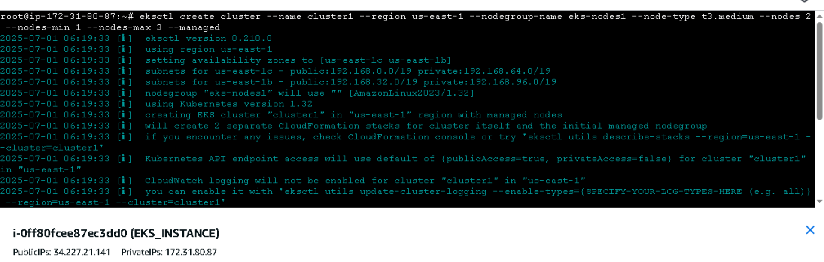

After Cluster is created checked nodes of the cluster by command:

**kubectl get nodes**

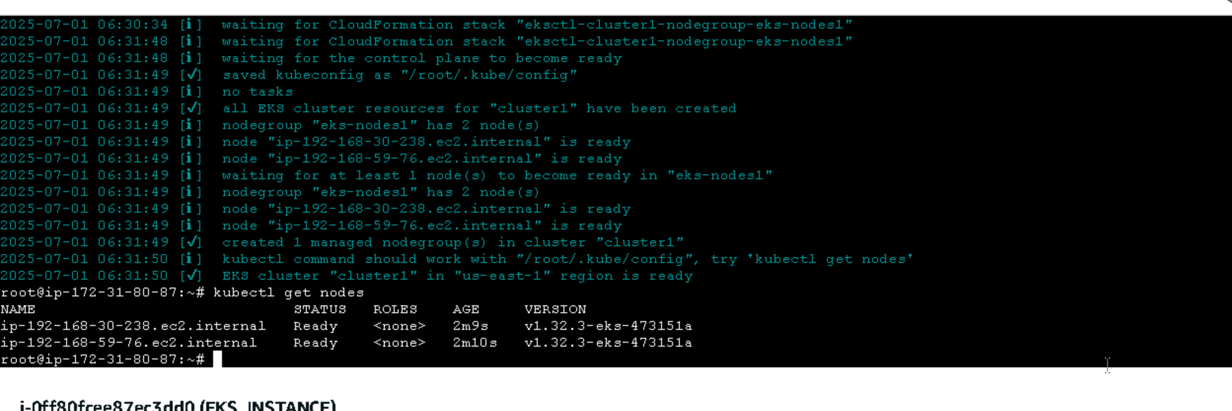

**Cluster screenshot**

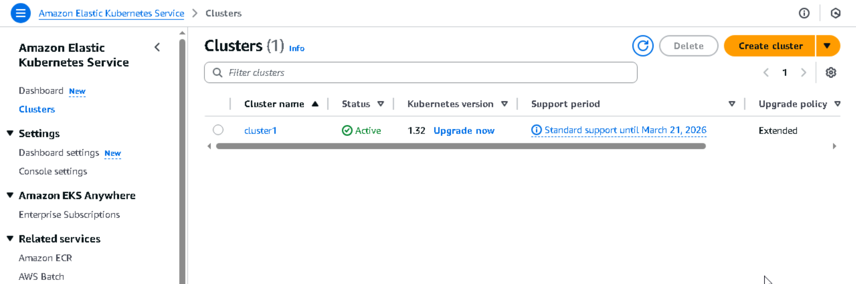

**IAM access entries in cluster**

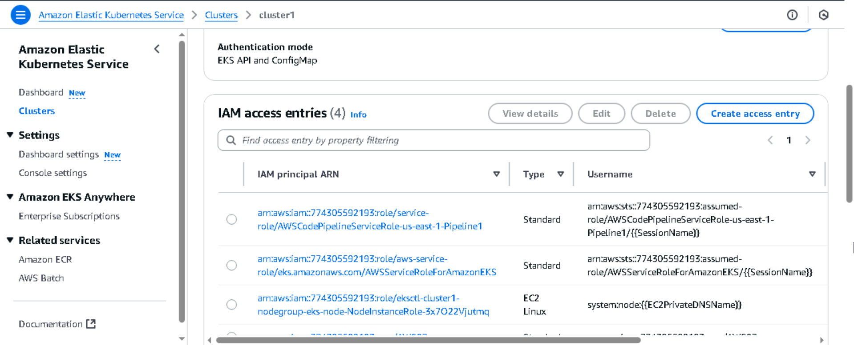

**Nodes and node group in cluster**

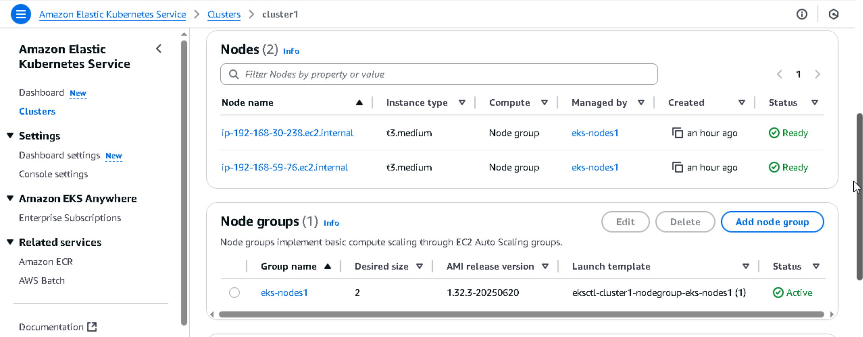

Then I have cloned the given git repo and went into it  
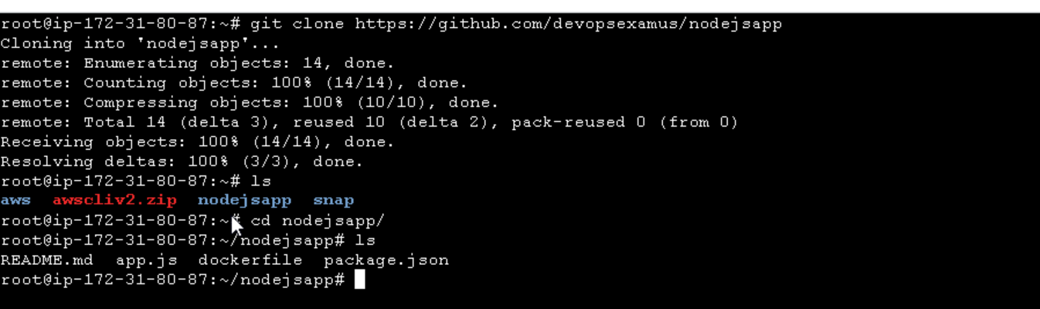

Next I have created the files which are required to build CodeBuild and CodePipeline

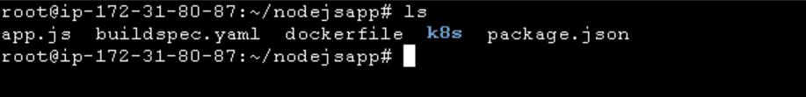

Next I have pushed all these files to CodeCommit   
I have already created a CodeCommit repository bhargavRepo

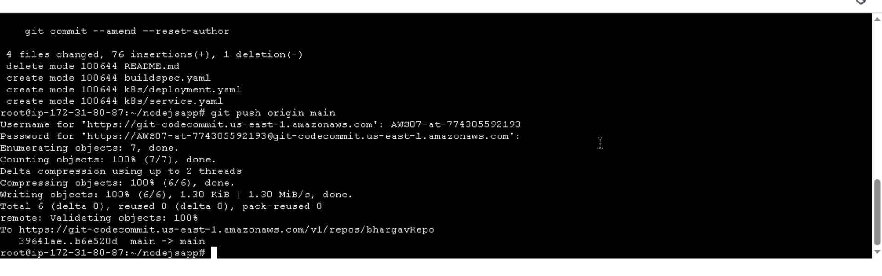

This is the Repository I created

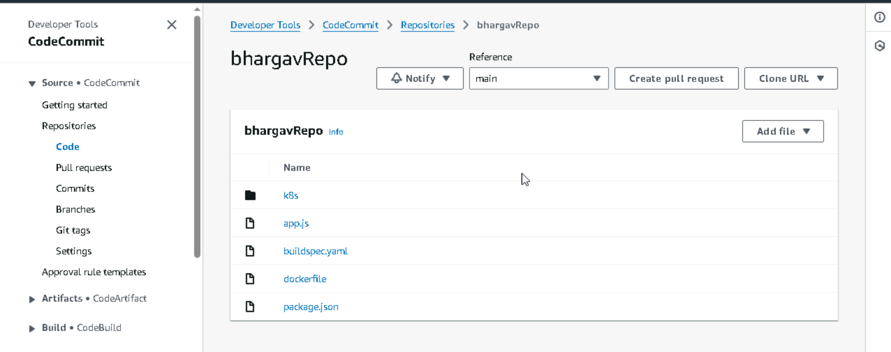

deployment.yaml file

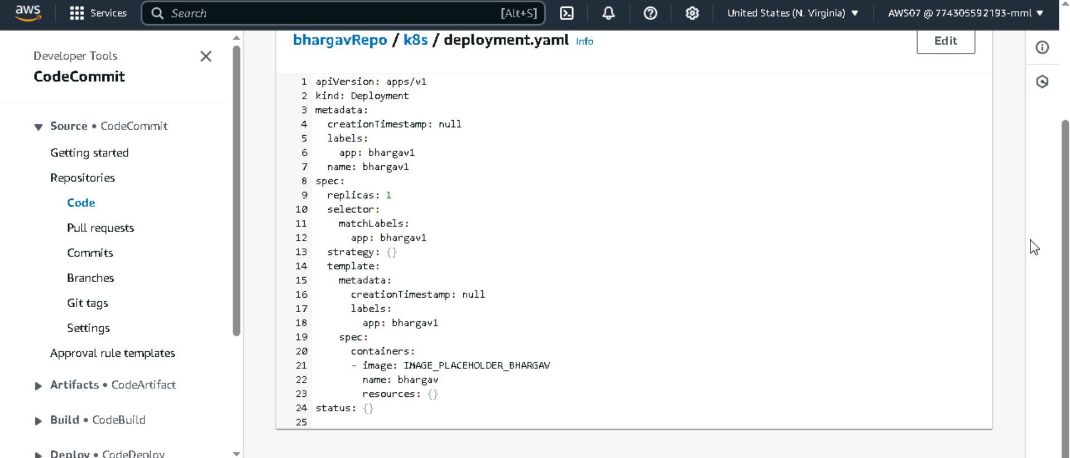

Service.yaml file

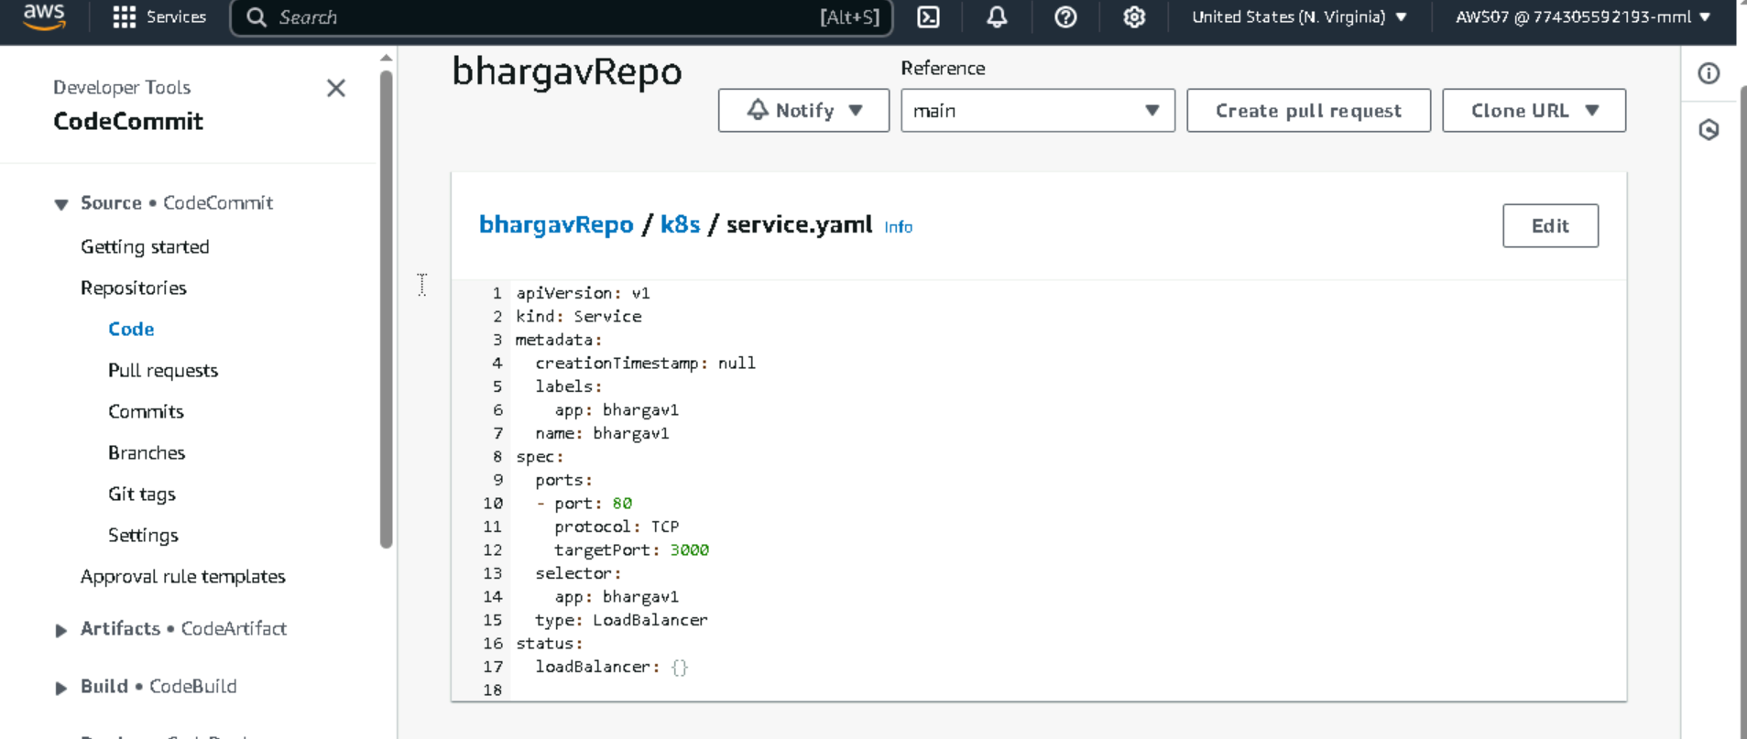

Buildspec.yaml

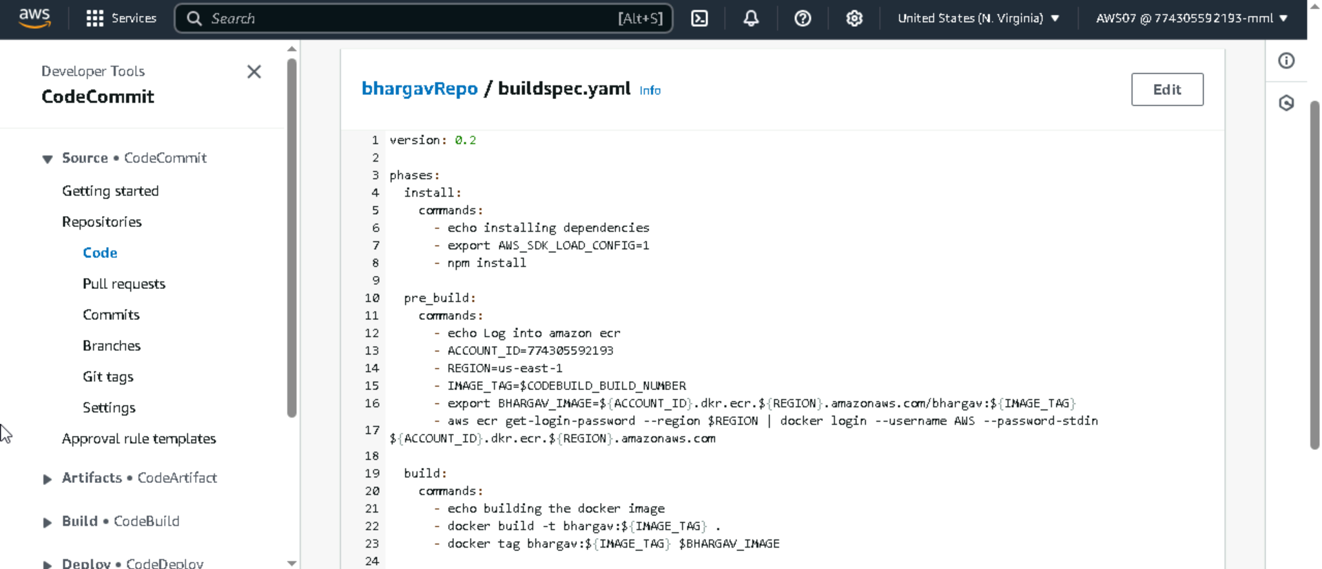

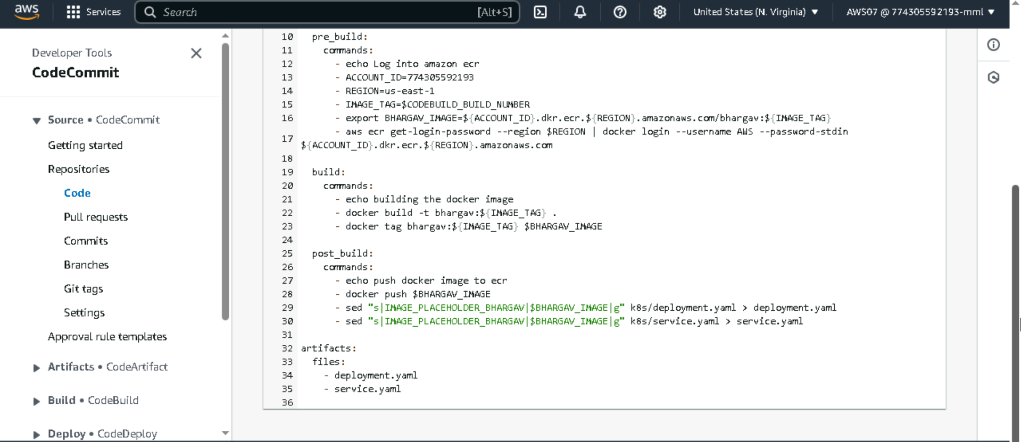

Next Created CodeBuild using buildspec.yaml and source as CodeCommit

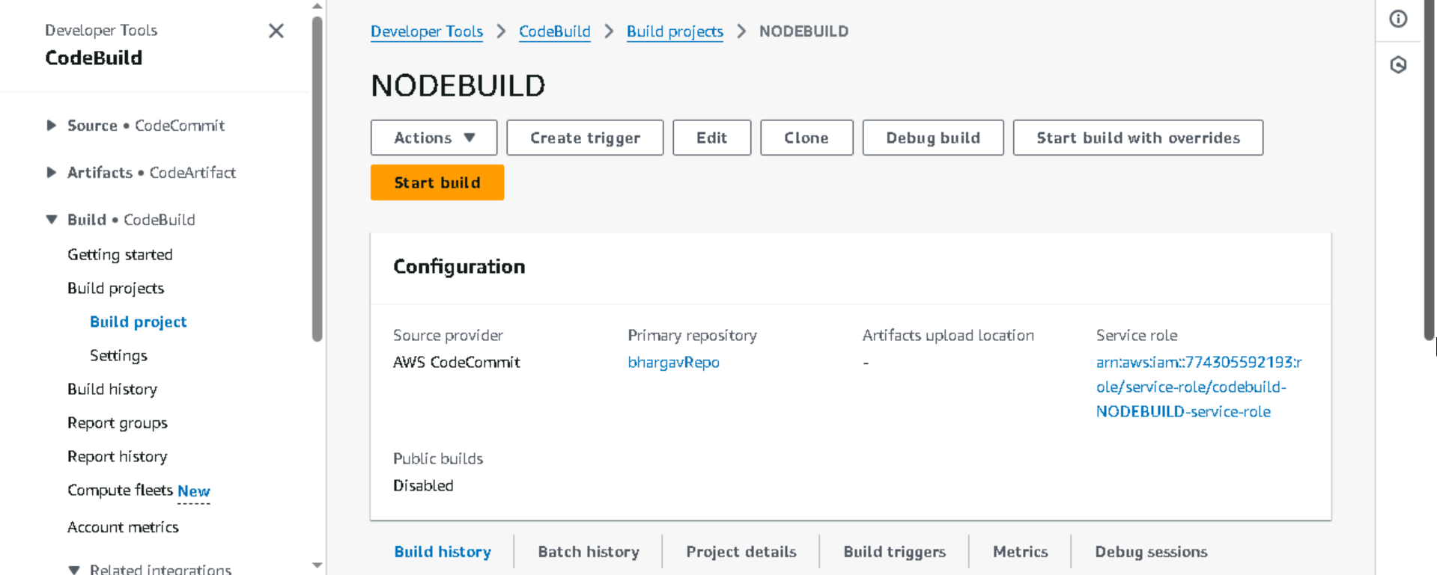

After Creation of CodeBuild   
I went to CodePipeline and started creating pipeline  
source given as CodeCommit and Build given as created CodeBuild

Then in Deploy stage I used EKS and given Kubernetes files like deployment.yaml and service.yaml

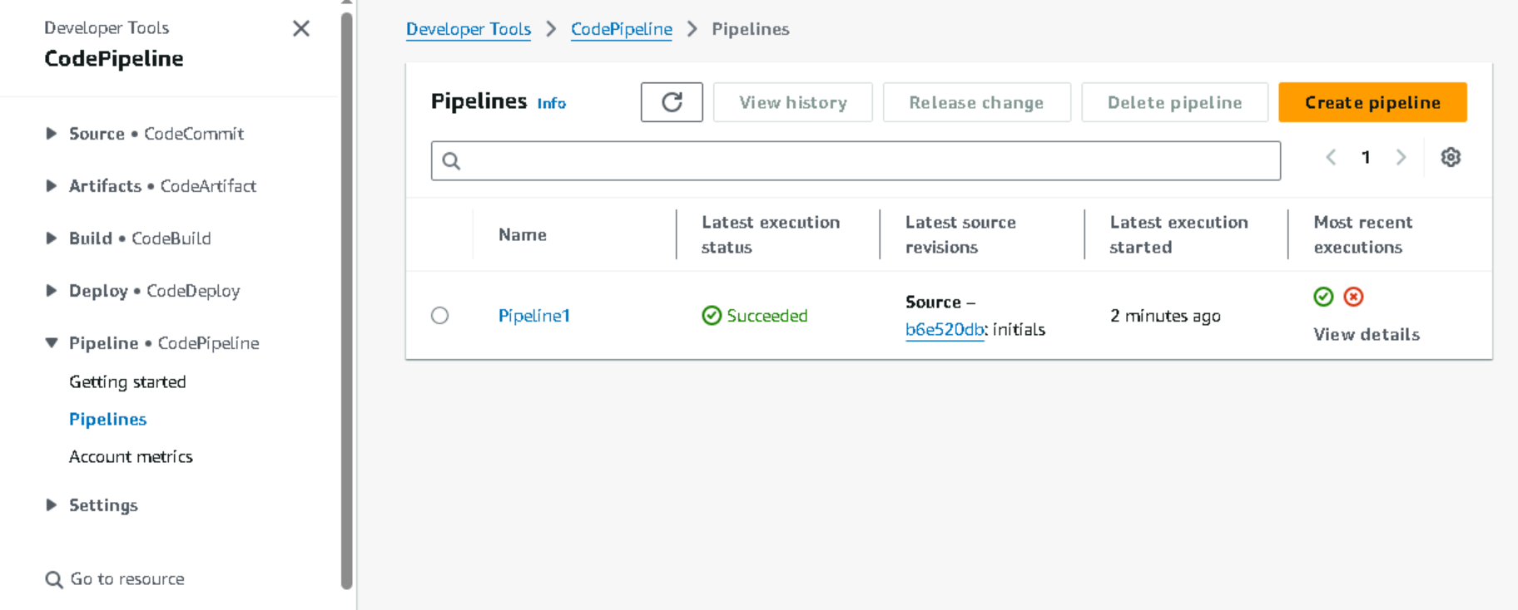

Pipeline Success

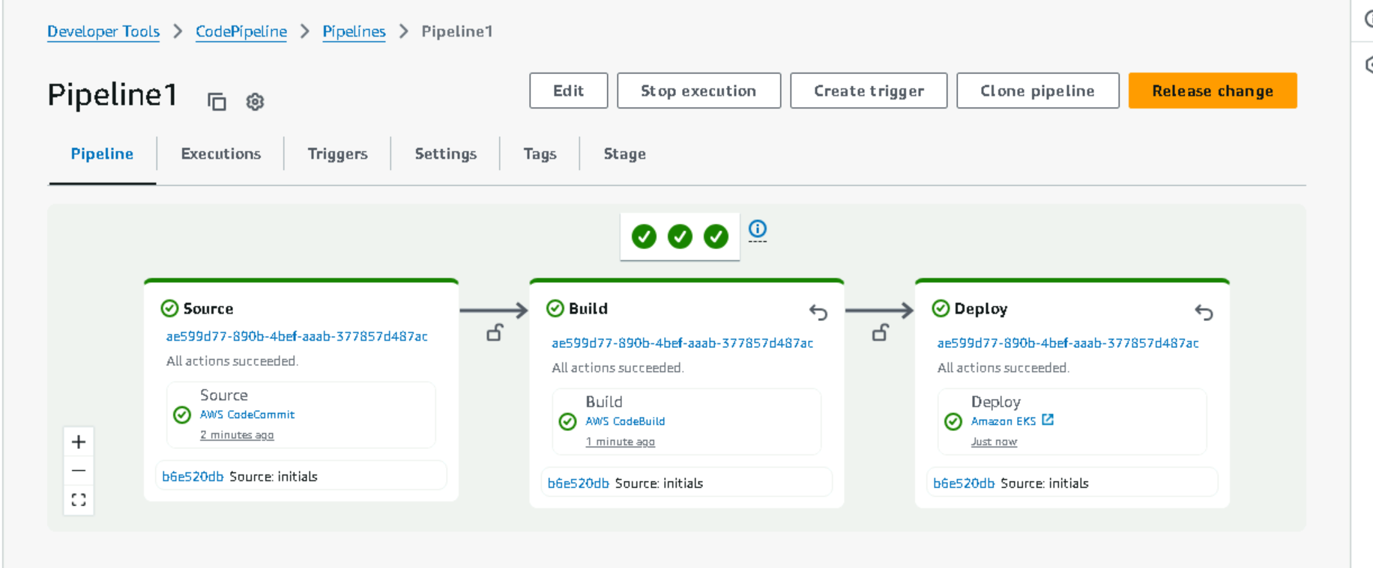

Build logs in CodePipeline

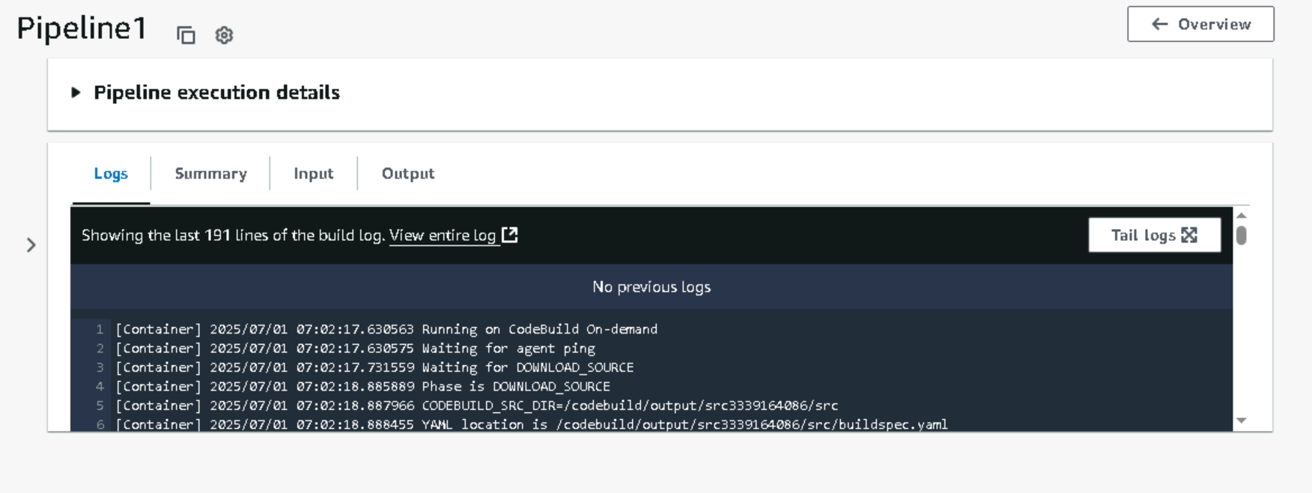

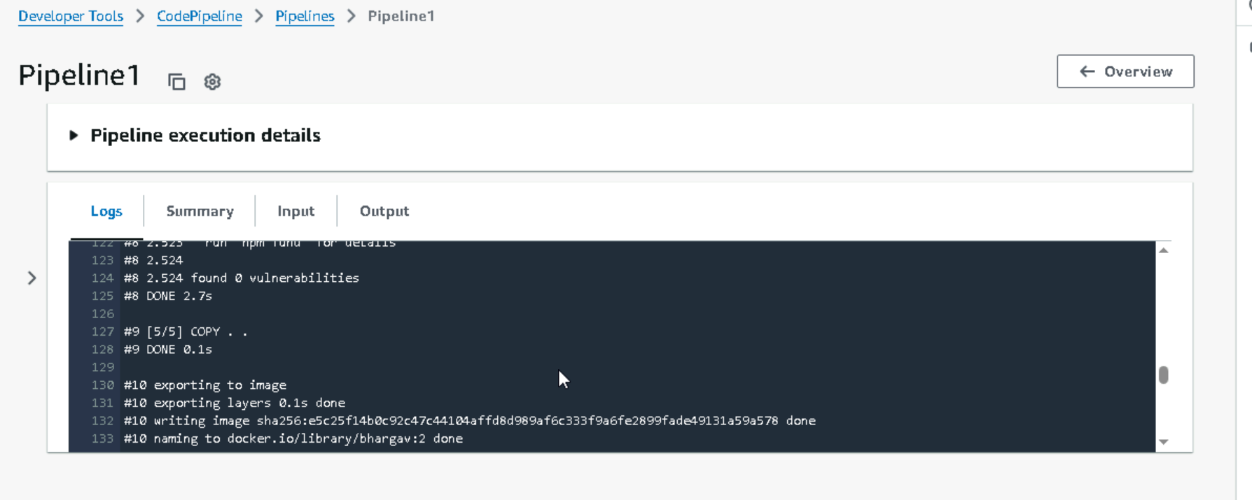

Build Success Message

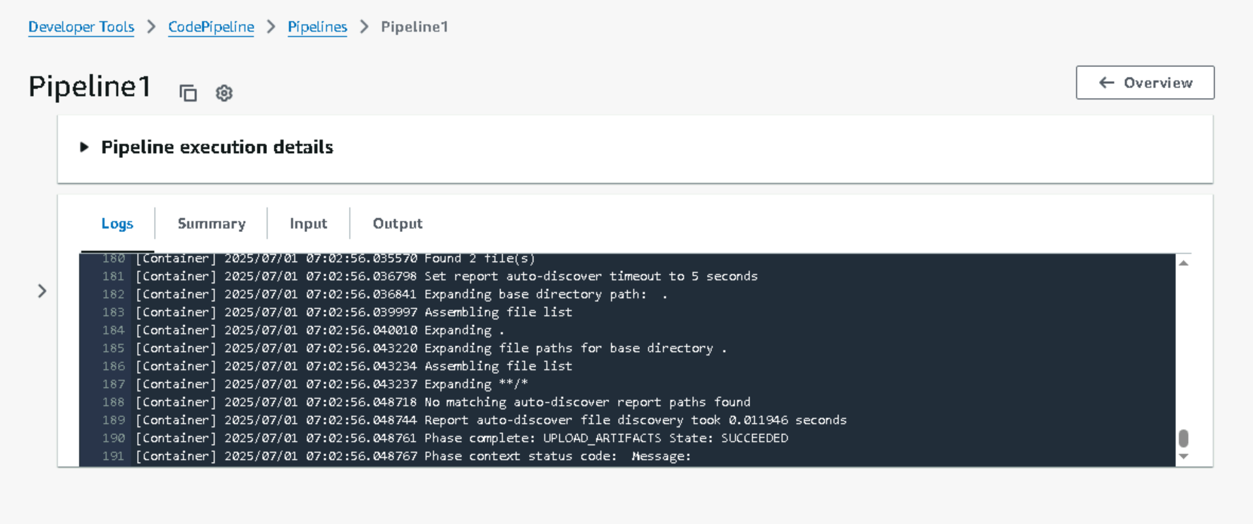

Deploy logs in CodePipeline

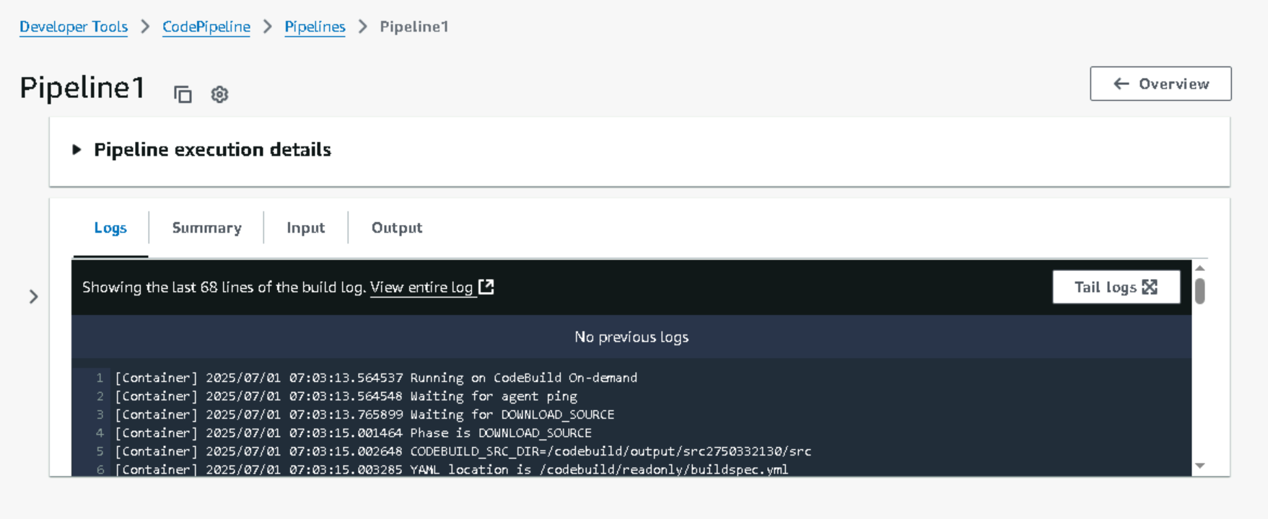

Deploy Success Message

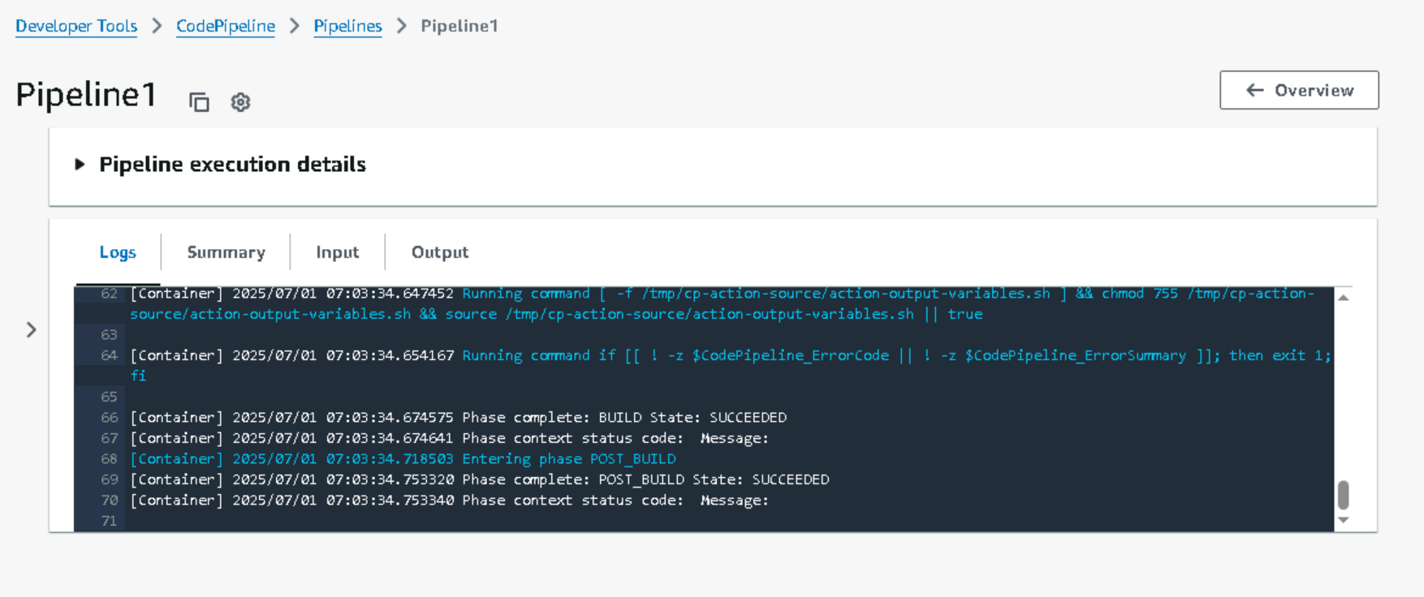

After Pipeline is Success run this command in the terminal where aws cli is installed and cluster is connected  


Next check pods and svc and access load balancer url in browser

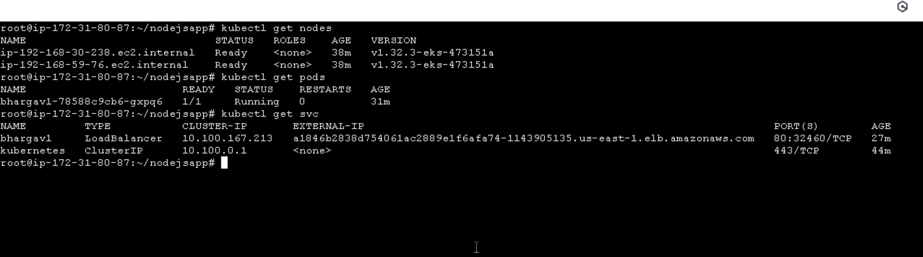

Final Output of website that works well

