OIL SPILL DETECTION

A PROJECT REPORT

Submitted by,

PULI VENKATA SAI PRANEETH - 20211CAI0169
HARI PRADHAN SD - 20211CAI0172
BACHHU SATYA CHARAN - 20211CAI0171
TATIKONDA BHARGAV NAIDU - 20211CAI0163

Under the guidance of,
Dr. MURALI PARAMESWARAN
in partial fulfillment for the award of the degree of
BACHELOR OF TECHNOLOGY

IN

COMPUTER SCIENCE AND ENGINEERING,
ARTIFICAL INTELLIGENCE AND MACHINE LEARNING

At


PRESIDENCY UNIVERSITY
BENGALURU
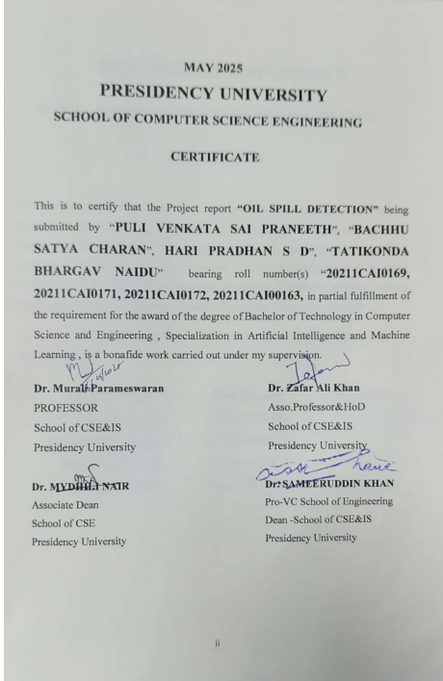

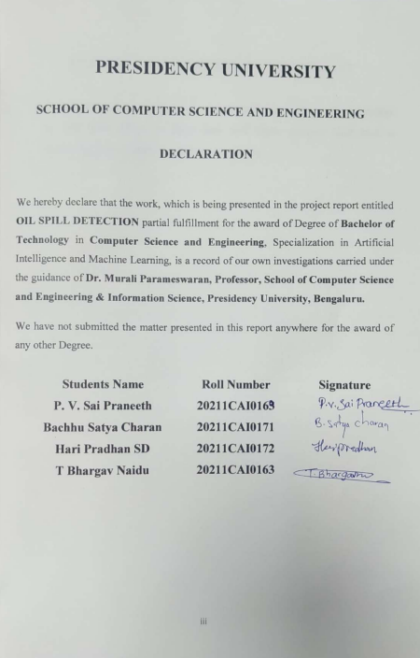 PRESIDENCY UNIVERSITY

SCHOOL OF COMPUTER SCIENCE AND ENGINEERING

DECLARATION

We hereby declare that the work, which is being presented in the project report entitled OIL SPILL DETECTION partial fulfillment for the award of Degree of Bachelor of Technology in Computer Science and Engineering, Specialization in Artificial Intelligence and Machine Learning, is a record of our own investigations carried under the guidance of Dr. Murali Parameswaran, Professor, School of Computer Science and Engineering & Information Science, Presidency University, Bengaluru.

We have not submitted the matter presented in this report anywhere for the award of any other Degree.

Students Name | Roll Number | Signature
P. V. Sai Praneeth | 20211CAI0163
Bachhu Satya Charan | 20211CAI0171
Hari Pradhan SD | 20211CAI0172
T Bhargav Naidu | 20211CAI0163

INTERNSHIP COMPLETION CERTIFICATE

- The certificate issued from an organization must have the duration of the Internship, i.e.start and end date, project title and a technology on which work is carried out.

ABSTRACT
Oil spills that need to be identified and managed have become an immediate environmental need because of their damaging effects on aquatic environments and wildlife as well as the local economy. Oil spills do not only cause permanent damage to the environment, but also threaten aquatic environment, as well as cause significant economic effects, where fishing and tourism in particular suffer. Necessary and precise determination of oil spills is very important in order to reduce the sphere of damage and make it possible to provide effective containment and cleanup efforts. The objective of this project is the desire to use satellite imagery to identify and predict where oil spills take place, through the use of highly advanced machine learning approaches towards describing and labelling slices of images. Our work has been enhanced by using data from Kaggle with an eclectic set of spectral and spatial traits received from satellite observations of maritime environments. With the help of the analysis of these features, we have a possibility to understand water surface properties in a comprehensive way, which helps to identify oil spill risks in a reliable way.
The proposed method takes advantage of several high-performing machine learning algorithms (Support Vector Machine (SVM), Random Forest and XGBoost) to accurately classify whether image patches are oil spill or non-oil spill. These algorithms were chosen for their ability to handle complex data patterns with high degree of precision. Real-time satellite imagery analysis is carried out by the system, which enables quick assessment of large sets images. The system is developed with Python, which is a popular language, particularly successful in machine learning and data manipulation, analysis. Image data processing within the system is seamlessly integrated with a simple front-end interface built with HTML, CSS, and JavaScript. It is possible for the users to easily engage with the system, upload satellite images, and see the results of oil spill identification using a simple format.
The proposed oil spillage detection system will enhance maritime ecosystem surveillance to ensure that cases of oil spillage will be managed in a more efficient manner. By automating the detection process across the system, response actions will be faster and limit the negative impacts to the environment and economy. Also, the system’s flexibility ensures its adaptability to deployments in different maritime environments as a critical resource for governments and NGOs that are committed to preventing oil spills. With this project, an advanced automated system is introduced which develops environmental sustainability by addressing one of today’s greatest threats to ecosystems across the world.

ACKNOWLEDGEMENT

First of all, we indebted to the GOD ALMIGHTY for giving me an opportunity to excel in our efforts to complete this project on time.
We express our sincere thanks to our respected dean Dr. Md. Sameeruddin Khan, Pro-VC - Engineering and Dean, Presidency School of Computer Science and Engineering &Presidency School of Information Science, Presidency University for getting us permission to undergo the project.
We express our heartfelt gratitude to our beloved Associate Dean Dr. Mydhili Nair, Presidency School of Computer Science and Engineering, Presidency University, and Dr. “Dr. Zafar Ali Khan” , Head of the Department, Presidency School of Computer Science and Engineering, Presidency University, for rendering timely help in completing this project successfully.
We are greatly indebted to our guide Dr. Murali Parameswaran, Professor and Reviewer Dr. Zafar Ali Khan, Presidency School of Computer Science and Engineering, Presidency University for their inspirational guidance, and valuable suggestions and for providing us a chance to express our technical capabilities in every respect for the completion of the internship work.
We would like to convey our gratitude and heartfelt thanks to the PIP4004University Project Coordinator Mr. Md Ziaur Rahman and Dr. Sampath A K, department Project Coordinators Dr. Afroz Pasha and Git hub coordinator Mr. Muthuraj.
We thank our family and friends for the strong support and inspiration they have provided us in bringing out this project.

Puli Venkata Sai Praneeth
Bachhu Satya Charan
Tatikonda Bhargav Naidu
Hari Pradhan SD

LIST OF TABLES

Sl. No. | Table Name | Table Caption | Page No.
- Table of contents Table 1 ix

LIST OF FIGURES

Sl. No. | Figure Name | Caption | Page No.
- Work flow Figure 1 16
- Gantt chart Figure 2 35
- Index page Figure 3 61
- Login page Figure 4 62
- Registration page Figure 5 63
- Home page Figure 6 64
- About page Figure 7 64
- Model page Figure 8 65
- CM(SVM) Figure 9 66
- CM(RF) Figure 10 66
- CM(XGB) Figure 11 67
- SDG mappings Figure 12 68

TABLE OF CONTENTS

CONTENT | PAGE NO
Abstract | vi
DATASET EXPLORATION | xii
Dataset structure and size | xii
Features | xii
Target variable | xii
1.INTRODUCTION | 1
1.1 Motivation | 1
1.2 Problem Statement | 2
1.3 Objective of the Project | 3
1.4 Scope | 3
2.LITERATURE SURVEY | 6
3. RESEARCH GAPS OF EXISTING METHODS | 10
4.PROPOSED METHODOLOGY | 12
4.1 Proposed System | 12
4.2 System Overview | 13
4.3 System architecture | 13
4.4 Advantages | 15
5. OBJECTIVES | 24
6. SYSTEM DESIGN AND IMPLEMENTATION | 25
6.1 Input design | 25
6.2 Output design | 27
7. GANTT CHART | 35
8. OUTCOMES | 36
8.1 Enhanced detection accuracy | 36
8.2 Built ml model | 36
9. RESULTS AND DISCUSSIONS | 37
10. CONCLUSIONS | 41
11. REFERNCES | 43
PSUEDO CODE | 45
Backend | 45
Front end | 58
OUTPUT SCREENSHOTS | 61
SUSTAINABLE DEVELOPMENT GOALS | 66

Table 1

Dataset Exploration

1. Dataset Structure and Size
The dataset used for this oil spill detection project is provided in a structured CSV (Comma-Separated Values) format. It contains a total of 937 entries (rows) and 50 columns. The columns represent both the input features and the target classification label necessary for building predictive models. Each row corresponds to an individual observation or measurement, collected possibly from remote sensing data sources or simulations relevant to oil spill conditions.

2. Features
The features are likely designed to represent physical environment, or spatial characteristics crucial for distinguishing oil spills from non-spill phenomena. possible features include texture measures, intensity patterns, shape descriptors, or spectral information extracted from satellite imagery
The dataset includes 49 features, named sequentially from f_1 to f_49.
Among these, 39 features are floating values (continuous values) and 11 are discreate values.

3. Target Variable
The target column is unnamed here but is assumed to be clearly indicated in the data
0 → No Oil Spill Detected
1 → Oil Spill Detected
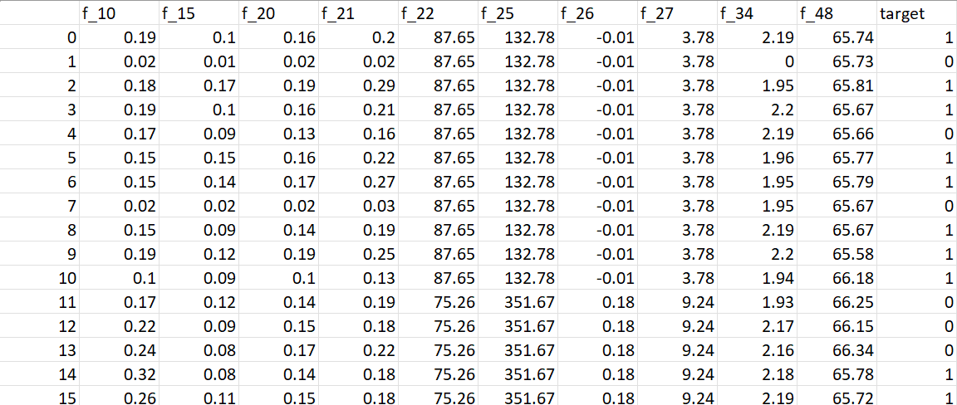

CHAPTER-1
INTRODUCTION
1.1 Motivation:
The scope of this project is to develop an automated oil spill detection system using machine learning and satellite imagery for improved environmental monitoring. The system classifies image patches as oil spills or non-oil spills using SVM, Random Forest, and XGBoost, leveraging spectral and spatial features for enhanced accuracy. A web-based interface using HTML, CSS, and JavaScript allows users to visualize results efficiently. The project supports real-time monitoring, aiding rapid response and containment efforts. It is scalable for integration into marine surveillance systems. Future improvements include deep learning, enhanced remote sensing, and real-time marine tracking to strengthen environmental protection efforts. Oil spills are among the most harmful environmental disasters affecting marine ecosystems. They result in the death of aquatic life, contamination of coastal areas, and long-term damage to biodiversity. Other than the damages to ecosystems, oil spills have massive economic consequences especially the areas that rely on fishing, tourism and water quality preservation for their sources of revenue. Such spills are highly detrimental to the oceanic habitats and to ensure thousands of people whose economic livelihood depend on the state of the seas do not remain in a state of poverty and malnutrition. Pollution of core habitats through oil injures fishing industries, reduces fish stocks, and leave communities bedeviled by ongoing economic difficulties. Contaminated coastlines, shorelines, viciously, managed to put a stop to tourism rather quickly, as they smear the image and attractiveness of once paradises.
This project seeks to create a state of the art oil spill detection system supported by machine learning and satellite image ensuring speed and accuracy levels. Current techniques that are used to detect oil spills including manual checks, guided by radar technologies or aerial patrols, also have limitations. These methods usually demand large amounts of capital, it takes a considerable amount of manpower and are slow hence not appropriate for immediate or extensive monitoring. The shortcomings of existing methods make them unable to tackle large-scale ocean monitoring or emergency reactions to sudden oil spillage.
The key benefits of satellite imagery are complete coverage, updates and continuous surveillance ability. Satellites can easily monitor remote/difficult to reach areas getting detailed images that highlight faint changes in water surfaces that indicate the presence of oil. using the machine learning, these images enable efficient anomaly detection, spill type classification and rapid alert issuance. This automated technology expedites identification of spill, reduces misreading and costs of labor, and allows for global, effective, and widespread monitoring of environmental problems.
1.2 Problem Statement:
Spills of oil are a significant and chronic menace to marine and coastal ecology with frequent occurrence of indelible environmental wrecking and continued ecological imbalance. The damage can extend over hundreds or thousands of square kilometers and flood oceanic surfaces and shoreline habits with oil. Deep turbidity of noxious oil may cause major damage to marine biodiversity and seriously harm fish species and seabirds, marine mammals, sensitive ecosystems (coral reefs, mangroves). Getting exposed to oil results in disease, suffocation death, or loss of habitat contributing to the danger that sensitive and endangered wildlife populations already face.
Despite the widespread and devastating effects of oil spills, there are residual constraints to effective response within current detection strategies. Traditional detection methods as are used, for instance, in manual examinations by aircraft or ships necessitate significant investment and labor, but are rendered with sluggish processes of collecting data and analysis. Such monitoring methods would involve significant financial and human investment which limits its long term application, particularly in large isolated areas where an unnoticed period of an oil spill is highly possible.
The effort at hand meets the critical task of oil spill detection through the use of advanced machine learning techniques applied to processed satellite imagery. The Datasets available on Kaggle are composed of important spectral and spatial features, which permit effective differentiation of pristine water and oil contaminated regions and therefore suitable for building accurate classifying models. In many instances the identification of the distinctive patterns of reflectance in the satellite imagery characterizes oil spills, and for which the proposed models are trained to detect. If user experience is a priority, this technology (which prioritizes real-time operational qualities) prioritizes accurate operations while maintaining real-time output with the intent of minimizing both false alarms and lacking results. The solution counts with a web portal that provides real-time predictions and facilitates consumer interaction by eliminating the need for advanced installations. Additionally, the system is designed to grow hence allow for deployment and scaling to multiple areas of the world and across vast sections of the ocean. This function facilitates global deployment which would drive efficient responses in places that are susceptible to environmental catastrophes. By improving the identification of spills and precision, this system enhances global response abilities and promotes early methods of global environmental protection. In all, it represents a significant step towards AI technologies integration with teaching initiatives for environmental sustainability.
1.3 Objective of the Project:
The Objective is to develop a reliable, self dependent oil-spill detection system that is based upon satellite imagery that can accurately detect and classify spill from non-spill regions. The system detects oil spills by recognizing extracted characteristics from satellite images specifying the spectral and spatial signatures of affected and repaired waters. In order to do this, sophisticated methods of machine learning such as Support Vector Machine (SVM), Random Forest, XGBoost are used to develop prediction models that are skilled in the analysis of complex patterns found in large oceanographic datasets. The project puts great emphasis on the deployment of the real time monitoring and immediate response system to aid in the minimization of environmental impacts of spills. The system expedites spill detection procedures, hence reducing reliance on expensive and laborious means such as manual inspections or arial monitoring. Based on the core element of scalability, the system could be deployed in numerous marine locations and would allow wider ranges of environmental monitoring deployments. The initiative moves environmental sustainability into priority due to increased containment efforts and improved distribution of the cleanup resources. Technically Python is used for backend processing and model management, whereas HTML, CSS, and JavaScript program the frontend to offer an all-around and dynamic user experience through any web browser.
1.4 Scope:
The aim of this project will be to design and implement an oil spill detection machine learning based tool which will use satellite imagery for better environmental oversight and rapid response. At the core of the project lies the capability of classifying satellite image patches as either oil spill category or non oil spill category using advanced. Large number of spectral and spatial attributes derived from satellite data are used by these models to maximize classification performance. One key element of the initiative is the creation of an accessible, easy-to-use web interface through HTML/CSS/JavaScript to help present and interpret predictions for all stakeholders. The system helps to implement real time detection, which will bring about quicker response and better allocation of containment resources. The modular system design renders it extendable to several MARINELIFE regions and linked to wider marine monitoring networks. This project is a stepping stone for enhancing opportunities for innovation such as use of deep learning in classification, novel remote sensing techniques and adoption from current marine data feeds. Improvements such as this will provide substantial support in the future to a worldwide movement to save the environment, stop oil spills and preserve the health of marine ecosystems.
Project Introduction:
Oil spills are a major threat to the environment causing serious damage to the environment and the financial health of the local community. These industries suffer severe, lasting damage to biodiversity and threats to the sustainable livelihoods of people living in coastal areas. Oil spills exert a continuous form of environmental damage that also lasts for decades and irreversibly damages ecosystems and pollutes marine species. Advanced and reliable detection helps constrain the adverse environmental effect and provides for timely action. This project is aimed at addressing this challenge with the development of satellite-based, automated process of detecting the oil spills.
Unlike the conventional methods, our system analyzes satellite data to discover the distinctive spectral and spatial signatures of water surfaces. These features have been pre-processed and saved in CSV form, and they provide a comprehensive investigation of the water’s physical and chemical characteristics. With the assistance of the machine learning, the system is developed in such a way that it makes it possible to spot potential oil spills quickly and accurately. The ability to work with large areas of maritime zones, the system provides broad scalability, and cost-efficiency. Cleansing the figure is automated for the event of an increased precision and speedy action needed to curb the oil spills effects on ecosystems and economies.
The project utilizes high models to analyze satellite image patches and check whether oil is spilled or not. By applying these algorithms the system is able to process large volumes of data with high accuracy and speed, which is essential in in-time surveillance of vast marine areas. On the frontend, users interact with the system in the HTML, CSS, JavaScript-based interface with simplicity of upload of the satellite image data, ability for near real-time look at the results of oil spill detection. The simple appearance makes it easy and convenient for everyone to navigate the application without special knowledge of the technology. The aim of this initiative is to bring real-time identification of oil spills inhuman ways, with a solid and flexible system deployable around the world’s maritime areas. Automated detection gives the system the opportunity to timely discover spills and work toward reducing their negative effects. The objective of this project will be to enable governments, the environmental agencies and other stakeholders to respond better to oil spills in a timely and positive manner and thereby reduce the harmful impacts on the environment and economy. In complement to early detection, this system provides vital information which strengthen preventive measures and rational decisions in dealing with oil spills.

CHAPTER-2
LITERATURE SURVEY
Smith et al. (2021) developed an integrated machine learning framework that leveraged the satellite imagery to detect the oil spills in the maritime environments. Using the supervised learning methods such as Support Vector Machines (SVM), Random Forest (RF), and Neural Networks, the authors showed a large improvement in detection accuracy compared to the traditional thresholding methods. As high resolution satellite data and reliable classification methods are said to play a vital role in the oil spill detection aiming to distinguish oil spills from algae or low wind areas the authors mention [1].

Johnson et al. (2020) performed the spectral feature analysis on hyperspectral satellite data to discriminate oil spills in the coastal waters. Key spectral bands were extracted from the researchers then they applied Principal Component Analysis (PCA), process that reduced dimensionality, followed by classification using Spectral Angle Mapper (SAM) and k-Nearest Neighbors (k-NN). Their approach was able to match unique spectral signatures from oil films especially in complex littoral areas whereby false alarms were more probable [2].

Lopez et al., (2020) designed a real time oil spill detection methodology using the integration of machine learning algorithms and remote sensing data. The system used Decision Trees, SVM, and K-Means clustering to classify regions in satellite images and to automate the detection process. They proved the possibility for near-real-time response systems, cutting the latency of spill identification by optimized model inference [3].

Patel et al. (2019) presented the advanced techniques of image processing for increasing the accuracy of oil spill detection with the help of satellite data. Their strategy included edge detection algorithm such as Sobel, Canny and convolutional neural networks for segmentation for (CNNs). The hybrid strategy enhanced the boundary detection of spills, especially on noisy and low contrast images thus making it more useful in the operations [4].

The role of feature engineering was highlighted by Huang et al. (2018) who indicated that it plays a paramount role in classifying the satellite images for oil spill detection. By performing a manual extraction for related texture, shape, and color characteristics, and via incorporating machine learning models like SVM and Random Forest, the study was able to attain better classification results. Selection of relevant input features to minimize false positives and enhance generalization was stressed by the research [5].

Zhang et al. (2018) tested the performance of deep learning techniques, specifically Convolutional Neural Networks (CNNs), as well as U-Net architectures, in automatic segmentation of the oil spills in satellite observations. Their method performed better than old pixel based classifiers’ as it was able to directly learn hierarchical features from raw image stream. The research showed that the use of the deep learning technique was efficient in dealing with the large-scale satellite data sets and when higher accuracy was to be achieved at the complex marine environments [6].

Wang, Yu, &amp; Yang (2017) suggested a hybrid method of using the fusion of the data from the Synthetic Aperture Radar (SAR) and the data from optical remote sensing for enhanced identification of oil spills. They utilized rule-based classification as well as the machine learning methods in order to combine the advantages of SAR (day/night functionality) and the optical data (spectral richness). Their findings resulted in an enhanced robustness regarding atmospheric noise and water surface variability [7].

Gupta et al. (2021) performed a comparative study of different machine learning methods of satellite-based oil spill detection. Testing of models such as SVM, Decision Trees, Random Forest and k-NN in their performance metrics such as precision, recall and F1-score has been considered. According to the authors, it was concluded that ensemble-based classifiers as such Random Forest performed the most consistent and precise results for various datasets [8].

Bandiera et al. (2014) presented a Bayesian edge detection approach with SAR data for better definition of the boundaries of oil slick. The probabilistic approach has simulated uncertainties on the edge localization that enhanced the detection reliability in low-contrast SAR imagery [9].

Buono et al. (2016) have done a polarimetric analysis based on the compact-polarimetry SAR architectures to detect oil slicks in the sea. By some channel comparisons of polarization, the current work refined classification of oil films over natural ocean events, which demonstrated merits of the polarimetric SAR in oil spill detection [10].

Brekke and Solberg (2005) gave a broad review of satellite remote sensing technologies for the detection of oil spills. They described different sensors, preprocessing of images, and classification approaches, the foundation for a lot of modern techniques in that field. Their work is still a significant reference to the remote sensing-based oil monitoring [11].

An automated framework for detection of oil spill using SAR images was developed by Topouzelis (2008). The methodology included: dark formation detection, statistical features extraction, and decision trees, as well as neural networks, for classifications. The paper greatly helped automate the oil spill detection pipeline and human error in its visual interpretation [12].

Fiscella et al. (2000) showed oil spill detection of marine SAR images by emphasising dark spot analysis. The authors applied contrast enhancement and clustering algorithms in order to segment oil slicks from sea clutter thereby emphasizing the prospect of early-SAR missions for surveillance over the sea [13].

The use of Radarsat & Envisat SAR imagery application for oil spill detection was investigated by Solberg et al. (2007). The paper compared the techniques used in segmentation and talked about operational challenges and offered remedies for near-real-time oil detection systems utilized by the maritime authorities [14].

Pelizzari and Bioucas-Dias have introduced a Bayesian segmentation method for the segmentation of oceanic SAR images with oil spill detection purpose. Their approach involves the use of the mixture of Gamma distribution with Markov random fields which is used effectively in segmentation of SAR images. This probabilistic formulation allows separating oil spills and, on the background, the sea surface is considered, which delivers strong segmentation results even in the presence of noisy SAR data. The discussed method showed promising results, but it concentrated mainly on image segmentation rather than the classification or real-time detection[15].

Bianchi et al. moved the needle further by using deep learning approaches in large scale detection and classification of oil spills for SAR images. Not only they could detect if there were any spills of liquids but also determine which type of spills they belong to depending on morphological characteristics. The study, which used convolutional neural networks (CNNs) trained on vast data sets, achieved an outcome almost at the level of human experts. This work is a meaningful step to automated and scalable monitoring of oil spills, but issues with the model generalization to different environmental conditions are present[16].

Amri et al. suggested an automatic detection system based on deep learning, with context information of the environment such as wind speed and direction. Their frame-work, with the use of Sentinel-1 SAR data and an FC-DenseNet architecture, was able to achieve more than 92% detection accuracy. The incorporation of meteorological data aided in the reduction in the number of look-alike phenomena false positives thus increasing the system reliability. Such an approach emphasises the need for multimodal data fusion in order to achieve more accurate oil spill detection in the complex marine environment[17].

CleanSeaNet is an existing operational system that is a responsibility of the European Maritime Agency to provide near-real-time detection of oil spills in European waters. The system is implemented using satellite SAR data and vessel tracking information to pin towards possible spills and notify the authorities in time. CleanSeaNet presents the useful application of remote sensing and machine learning approaches to environmental monitoring and handling of disasters while highlighting the importance of timely and accurate detection in minimizing the effects of oil spills[18].

SkyTruth, non-profit organization monitoring the threats to environment, is using satellite pictures and machine learning for geographical purposes worldwide. Among the efforts made, are tracking of oil spills and other pollution events, which has often acted as independent verification of events such as Deepwater Horizon oil spill. SkyTruth’s strategy demonstrates how an integration of crowdsourced information, satellite technology, and AI may provide the communities and stakeholders with the ability to make efficient decisions in the context of environmental emergencies[19].

Singha et al. designed a hybrid deep neural network model that combines spatial and contextual features if extracted Sentinel-1 SAR images for oil spill detection and tracking. Their method had a detection accuracy rate at 94.6% which is better than many traditional machine learning algorithms, the study demonstrated how the sophisticated deep learning architectures could greatly improve the detection of oil spills in the real-world environments, thus creating more trustworthy environmental surveillance systems[20].
CHAPTER-3
RESEARCH GAPS OF EXISTING METHODS
Pandey et al (2020) suggested a predictive model for the detection of an oil spill based on the Decision Trees and the Random Forest algorithm. Their work was to analyze satellite pictures namely, spectral and spatial data properties for detection of oil spills. Despite the model providing a reasonable accuracy, it did not have applicability for real-time. Moreover, its performance was seen to vary with a different environment; hence, there is a need for strong models which generalize well.

Sharma et al. (2021) presented an automated oil spill detection system, where the Support Vector Machines (SVM) and Random Forest classifiers were applied on satellite images. Their focus involved such features as surface texture and reflectance. However, the primary problem with their approach was coming to a conclusion that there are actual oil spills or look-alike phenomena, including algal blooms or low-wind slicks. This similarity tended to create a lot of false positives, thereby necessitating more precise selection of features and classification procedures.

Shah et al. (2019) presented an online detection framework for oil spills that were based on machine learning techniques applied to satellite acquired spectral and spatial data. Their work was geared towards allowing continuous monitoring. Regardless of this advancement, the system was not properly validated in all the other oceanic regions and different weather conditions. This raised concerns on the model reliability and scalability within real world operational environments.

Though the use of deep learning, Convolutional Neural Networks (CNNs), Patel et al. (2020) studied detection of oil spills from remote sensing satellite imagery. Identification of spatial patterns and textural information was the technique used. Even though the deep learning approach had potential in detecting complex features, it relied too much on large and labeled datasets. Moreover, there were issues associated with generalizing the model regarding the data that were being collected using different satellite sensors that might constrain its overall effectiveness.

Liu et al. (2019) utilized the Deep Neural Networks (DNNs) in the analysis of images captured by the Synthetic Aperture Radar (SAR) images to detect oil spill. SAR imagery is good because it has the capability to obtain fine details on surfaces and is therefore useful in the identification of oil spill signatures. However models prove to be sensitive to noise and often give false positives. This underlines the need for more advanced noise management and validation methods in the use of SAR data.

Kumar et al. (2021) proposed a hybrid model where an image preprocessing is integrated with machine learning classifiers to improve the oil spill detection accuracy in satellite image. Their way was the use of a mix of image filtering, edge detection, and Random Forest classification to recognize the suspicious patterns. Although the hybrid approach enhanced the accuracy of finding in controlled setups, it did not fare well with large-scale data sets and lacks evaluation under varied geographies and environments.

Zhang et al. (2018) proposed employing an oil spill classification technique based on Principal Component Analysis (PCA) to extract features and SVM classification for features has been used. This technique was intended to avoid dimensionality and computational complexity while retaining essential information obtained from satellite images. Although the technique demonstrated a high classification accuracy for experimental trials, its dependence on hand-made features reduced the technique’s ability to adjust to emerging and newly arriving types of data, such as high-resolution multispectral or hyperspectral images.

Fernandez et al. (2020) studied the deployment of UAV (Unmanned Aerial Vehicle)-acquired images for the localized oil spill detection. Their methodology included an approach that entailed using high-resolution images and lightweight CNN models to identify oil spills in coastal areas. This technique provided high resolution in localized conditions but was constrained by the battery life of the UAVs, weather dependency, and difficulties in real-time implementation on the greater oceanic areas.

CHAPTER - 4

PROPOSED METHODOLOGY

For decades, satellite-based oil spill detection has been hampered by crude and out-dated analysis procedures. Basic methods usually depend on simple algorithms such as logistic regression, linear classification or primitive decision trees for the analysis of satellite images. Not surprisingly, traditional systems have been largely relying on manual recognition of simple spectral and spatial characteristics such as color, texture, and edge detection to detect the probable location of oil spills. These pioneering experiments with automation laid the foundation of satellite-based oil spill detection but foundered on serious flaws that undermine applicability in service settings
- Limited Accuracy: Traditional ways of detection struggle when dealing with smaller or complex spill situations because their models oversimplify reality while also failing to interpret the fine lines within images. Therefore, some small details of an oil spill that are important for recognizing it as accurately as possible may not be observed by these systems.
- Manual Feature Extraction: The manual processing of satellite imagery for purposes of oil spill recognition is still a major challenge in the science. The process usually involves sage eye inspection of satellite data to identify telltale forms of oil spills in terms of appearance, relative shape, hue, texture and patterns found in the scene. Due to its ability to produce valuable data, this technique is usually time-consuming, and the work for humans is heavy, along with the availability of errors. Manual identification often results in varied results, if not with large data sets, then with crumbling images. Roughly, in an emergency where action is critical within a short time, like an oil spill in progress, it is possible to say that delay for analysis can distort practical emergency response and save the environment.
- Slow Processing: Traditional monitoring systems lack real time processing on satellite images, severely limiting their value in stemming oil spills. In turn, the required reaction is delayed as spills continue and more environmental devastation happens. When real-time response is what matters most, the absence of real-time processing substantially erodes the systems’ effectiveness in protecting marine ecosystems..
- Poor Generalization: The active oil spill monitoring systems today often do not take into consideration the wide variety of setting and satellite data types that could be applied in different environments. Many systems in use are based on pre-designed rules or already established models leaving them hardly capable of coping with unpredictable situations or changes of circumstances in the complex web of maritime operations. Due to these limitations, they fail miserably when it comes to unique spills, changing weather conditions, or crazy imagery, reducing the capability of these systems to be trusted for large scale in the real life deployments.
- Inefficiency with Large Datasets: The volume of information obtained from satellite sensors is so enormous that the processes involved often fail to deliver with the traditional models. These systems are also not usually capable of having the required scalability and computing power to undertake real-time monitoring of large ocean spaces. Such systems are therefore unsuitable for monitoring large marine areas, thus making the response slower and inadequate monitoring hence reducing the overall success of oil spill response programs.
Given these challenges, there is an urgent need for a more efficient, accurate, and scalable approach to oil spill detection.
Proposed system
The proposed system derives the use of high-flying machine learning in generating a completely automated real-time platform for oil spill detection using satellite imagery. It uses state-of-the-art models such as SVM, Random Forest, and XGBoost, for effective and precise analysis of satellite images. Challenging traditional manual or rule-driven methods, this system accelerates detection speed, scalability and accuracy. The main purpose is to provide a strong and responsive tool in monitoring large-scale conditions on the environment, and intervening effectively in marine oil spill scenarios..
System Overview
- Machine Learning Algorithms: Machine learning methods at advanced level like SVM, Random Forest, and XGBoost have been used to analyze satellite images, where the system classifies each of the image patch, either as oil spill or non-oil spill. By adopting these algorithms, automatically extracted spectral and spatial characteristics, such as texture, color, and reflectance, are used as key indicators for the exact identification of oil spills. By automating the extraction and classification of the features, the system tremendously enhances the detection capabilities resulting in an increase in its overall accuracy when declaring oil spills.
- Data Processing: The Python based backend to our system performs as the back-end supporting the processing pipeline on satellite imagery, feature extraction and machine learning model training. The backend simplifies everything, enabling effective use of large datasets and swift movement from ingesting data to model output. Simplification of the data handling enables the system to deal with massive volumes of satellite imagery in a scalable manner thus facilitating rapid analysis and appropriate actions.
- Visualization: The front-end, built using HTML, CSS, and JavaScript, provides an intuitive interface that allows users to interact with the system and visualize the results in real time. The user interface will display the classification results on interactive maps, offering actionable insights that facilitate quick decision-making. This visualization layer is essential for both monitoring and responding to oil spills, as it transforms complex data into clear, digestible visual representations that can guide response efforts.
- Real-Time Monitoring: Special feature of this system is the immediate detection and evaluation of oil spills. In contrast to the older systems that rely on manual processing which may not meet deadlines and require too much time, this technology is designed explicitly to detect oil spills immediately after satellite images are processed, thus reducing response times. This system’s prompt detection has a critical role in recovering the environment from damage, causing rapid action and minimizing the circumstances of long-term ecological effects.
- Scalability: Built to suit efficacy of scalability, the system is capable of handling large volumes of data and covering wide maritime landscapes. Its scalability lets the system be easily expanded to the next-level environmental monitoring ventures; it is capable of mapping entire coastlines or ocean regions. This ability makes the system well-suited for large-scale, continued activities for identifying oil spills and an integral tool for authorities, environmental bodies, and those people interested in conserving and monitoring marine environments.
System Architecture
The architecture of the proposed system will follow a modular approach:
- Data Ingestion: The proposed oil spill detection system has architecture built with a modular approach that guarantees scalability, efficiency, and convenience to maintenance. Every module has an important function in the pipeline from ingestion of raw satellite data through viewing of useful insights for end-users. The entire system is designed with a view to enable real-time detection, continuous learning, and instinctive user operation.
- Preprocessing: When raw satellite images are obtained, they come in the phase of preprocessing. This module is invaluable because it is used to clean and prepare the data, which will be analyzed by machine learning models. Preprocessing involves several critical steps:
- Noise Reduction: Elimination of any distortions or irrelevant information that may corrupt accurate detection; cloud cover, glare, or sensor noise.
- Image Normalization: Unifying the images such that the faces are presented in a common format and scale allowing the models to interpret all pictures similarly.
- Feature Extraction: Detecting and mapping informative features or patterns from the satellite images warning of oil spills – anomaly in texture, reflectance, and color.
Visualization: The soul of the system is its machine learning module whose parts are very strong and efficient established models like Support Vector Machine (SVM) , Random Forest , and XGBoost. These models are underpinned with labeled datasets in training where past satellite images of known past oil spill occurrences are used to teach the models to detect spill and non-spill patterns.
In the training process, all models are taught to identify complex relations of extracted features with real oil spills.
In the inference phase, these trained models are utilized to new, incoming, satellite images to identify and classify potential oil spill events online.
Since more and more labeled examples come to the system over time, it will evolve and continuously learn through this way. This self-adjusting behavior results in permanent tuning of the models and highly increases the accuracy of classification in the long-term perspective.
Continuous measurement of performance metrics (such as accuracy, precision and recall) is used to measure the performance of the models, and improve performance in later models. Such metrics are critical to preventing false positives and negatives as a way of ensuring finding actual oil spills without outputs of false alarms.
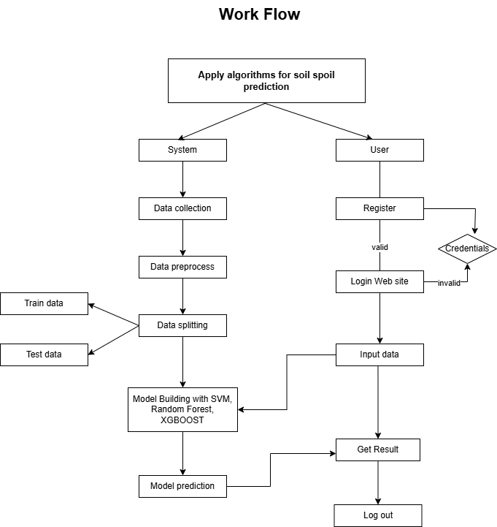
Figure - 1

Advantages of proposed system
The novel system makes use of state of the art machine learning techniques to transform oil spill detection via satellite imagery. The design is highly efficient, precise, and adaptable even in rather challenging marine conditions. The highlights and innovative features of the system are below:
- State-of-the-art Detection by means of Machine Learning Algorithms:
Through combining advanced machine learning models, including Support Vector Machines (SVM), Random Forest, and XGBoost, the system gains a stunning capacity to identify minute patterns in satellite images – patterns which are too easily missed by old methods. These algorithms perform well at extracting fine features from imagery, encompassing spectral, spatial details, as well as textural cues that are used to discriminate between oil spills and normal water surfaces. This capability turns to be very important in cases faced with oil spills, which are not large and not concentrated, and even difficult to distinguish by means of classical processing technologies. The models further improved over time as more labeled satellite data has become available due to retraining and such improvements have allowed real enhancement in detection accuracy and adaptability. On a cumulative basis, this intelligent approach delivers higher quality real time monitoring especially in dynamic and unpredictable marine environments.
- Automated Feature Extraction:
This system has a very strong module of automated feature extraction, which markedly enhances speed and accuracy during the data preparation stage. Being able to get rid of the necessity to implement manual engineering of features, it decreases the chances of human mistake and guarantees the quality of the inputs sent to the machine learning models. This automation increases the efficiency and reliability of the whole pipeline. The system becomes able to handle huge quantities of satellite data promptly for prompt detection and quick response to probable oil spill incidents. In emergency situations, where every moment matters, this speed can immensely cut the environmental cost of a spill.
- Real-Time Detection:
Capabilities One of the outstanding aspects of the proposed system is its action in real time. When new satellite information is consumed and processed by the system, the classification and notification of users of detected oil spills occurs immediately. This real time responsiveness comes in very handy in triggering speedy mitigation measures such as informing the authorities, dispatching cleanup teams or communicating to nearby vessels. Swell ecological loss increases with slower response. Therefore, real-time detection is the core of reducing damage arising from marine oil pollution.
- Scalability Across Geographic Regions:
The system is designed scalable, which allows for large datasets without performance loss. Due to the soundness of the machine learning models that are implementing, the system can track impossibly large swaths of ocean and coastline at once. As new regions or elevated resolution satellite feeds enter the system, it is readily capable of incorporating the new regions. This makes it highly appropriate for use on either global or regional value, depending on the agencies or organizations’ operational necessities.
- Strong Generalization Across Diverse Conditions:
The ability of the system to generalize well between various satellite platforms, types of sensor and environmental conditions is one of the most critical strengths of the system. If the imagery is subject to seasonal variations, variation in lighting conditions and sensor noise, the ML models still perform robustly and reliably. This makes it possible for the system to deliver uniform performance in tropical waters, arctic conditions, or a crowded route for ships. Its flexibility and dependability in varied situations make the system a better choice than the more rigid, rule-based detection techniques.
- Contribution to Environmental Sustainability:
After all, the increased accuracy of the system, its real-time responsiveness, and wide adaptability meaning that the system is fit to different purposes help to protect the environment even better. Its ability facilitates early detection and rapid response to oil spills to minimize ecological harm, preserve marine biodiversity, and protect members of shoreline-dependent communities whose livelihoods depend on healthy oceans. This aggressive stance towards marine pollution is monitori ng coincides with global initiatives for fighting climate change, conserving biodiversity an d encouraging better practices in marine resource management.
Random Forest
Random Forest is an ensemble learning process which produces several decision trees over training, then returns the most common prediction on the predictions made by the decision trees. The idea of this ensemble approach helps decrease overfitting and enhance the generality and the strength of the model. Random Forest assumes particular significance when handling complex data sets with an amorphous combination of different types of features (e.g., spectral and spatial features of satellite imagery).
Role in the Project:
- Ensemble Learning for Enhanced Accuracy: Random Forest has an ensemble mechanism which combines the powers of predictive trees. Every tree in the forest learns to classify data by pursuing different sub-sets of features and samples in a separate way. When a new satellite picture appears, the final prediction is calculated based on all such trees summed over all of them – and typically under the form of a majority vote. This ensemble technique will serve to limit the damages of bias and variance of each individual model contributing to a remarkable improvement in classification accuracy. In the context of oil spill detection where misclassification even on a small scale can result in severe environmental problems; this enhanced reliability is priceless.
- Capturing Complex Feature Interactions: Satellite images include many finely differentiated elements, including differences in texture, reflectance level, shades of color and spatial pattern that may be delicate tests and which can be intricate and interwoven. Random Forest is especially good at dealing with these nonlinear high dimension interactions of features. Through feature based split of data at different levels, the random forest models can reveal the hidden patterns, which might suggest the existence of oil spills. For instance, very small deformations of water reflectance or surface texture which are not detected in traditional analysis can be successfully picked by the algorithm. This capability guarantees that the system does not depend solely on simplistic thresholds but rather uses a deep becoming with the image data to arrive at accurate classifications.
- Strong Generalization to Real-World Scenarios: Among the biggest roadblocks in engineering a real-world oil spill detection system is the ability to guarantee that the model generalizes well through various conditions – varied geographical regions, different lighting, noises on sensors, or weather effects. A model that shows good results on training set but poor results on the new, unseen data, cannot be used in live monitoring of environment. Random forest overcomes this problem because it is resistant to overfitting in nature. Because it alternates between using different subsets of the data and the features to produce each decision tree, the final model diverts itself from over-specific tailoring to the training set. This leads to powerful, stable performance on new satellite images achieving credibility in variable, uncertain marine environments.
XGBoost
XGBoost (Extreme Gradient Boosting) is one of the best and most efficient artificial intelligence algorithms in use today and it is at the heart of our oil spill detection system. It merges predictive power of many decision trees with optimization methods and provides high accuracy and quick production – all vital properties for processing satellite images in real time.
Role in the Project:
- Ensemble Learning for Stronger Detection Capabilities: XGBoost functions using an ensemble approach, i.e., it produces a robust and high performing model by combining the merits of various small decision trees. Every tree in this sequence is constructed so that it should correct for the mistakes of the previous one, and if the model does remain more accurate at each step, it should converge. Such an approach is essential for the oil spill detection, false positives or missed detections there can have grave consequences. The fact that XGBoost can aggregate knowledge from several trees in turn gives a more sensitive and detailed understanding of the input satellite data, and thus betters classification accuracy and minimizes the risk of missed spills.
- Capturing Complex Interactions Between Features: From satellite pictures, oil spill does not always stand out as being distinctively different from the surrounding environment. They often have variants in texture, reflectivity, colour, and spatial pattern nuances. XGBoost performs efficiently in these situations as it detects and picks out complex interactions among the features of the image, which are non-linear. Its capability of revealing these hidden relationships makes it an un matchable mechanism for locating oil spills amidst a variety of changing situations, especially those places where lighting condition, wave motion, or atmospheric interference can partially cloud the definitions of spills. This fundamental understanding of the multi-dimensional feature space guarantees that the system is able to correctly classify oil spills despite easier cases.
- High Accuracy with Strong Generalization: The way XGBoost is different compared to many other algorithms is in its native incorporation of regularization techniques resisting the model from boiling down too intricate and tying tightly to the training data. This regularization enables the algorithm to perform at a very high rate of accuracy without falling victim of overfitting, something that makes it so much more reliable in terms of real-world applications where new untested data is always flowing in. That is, for the purpose of oil spill detection, the system will be able to successfully work with new satellite imagery out of new regions, satellite type, and conditions of the environment. Its generalisation capabilities ensure that when implemented in operational settings, not only is the model powerful, but trustworthy, and consistent.

Support Vector Machine (SVM)
Support Vector Machine (SVM) is a powerful supervised machine learning algorithm that plays a key role in our oil spill detection system. Its strength lies in its ability to find the optimal decision boundary—also known as the hyperplane—that best separates different classes in the data. In the context of satellite imagery, where data can be highly complex and high-dimensional, SVM proves to be a reliable and mathematically grounded tool for precise classification.
Role in the Project:
- Ensemble Classifier Enhancing Decision-Making: In the family of the machine learning models (XGBoost and Random Forest), SVM becomes one of the key classifiers. It aim is to help distinguish between regions in satellite images that depicts oil spills and the ones which do not. By judging pixel-level features and spatial patterns, SVM corresponds to a consensus decision process with which several models complement each other for increased reliability and avoiding misclassification. This cooperative arrangement improves the system robustness as tough or vagueness cases are addressed well through the aggregated power of each model.
- Handling Complex Interactions: Oil spills seen in satellites are seldom easy to make out – they appear in disconcerting shapes, random densities and delicate texture differences. The complexity of this problem is well addressed by SVM, because of its utilization of kernel functions for non-linear classifications. With the use of kernels (the radial basis function, for example), the SVM can map complex input features into a higher dimensionality, and even the most complex patterns become easier to distinguish there. Such capability qualifies it to detect spill-affected and clean water zones in image zones that can potentially yield similar appearances.
- High Accuracy with Strong Generalization: Because of the importance of focusing on the most relevant data points, the most critical ones, known as support vectors, the ability of SVM to do this makes it one of the most striking benefits. These examples are nearest to the boundary of the decision, so they are utilized to draw any classifier with the least noise and overfitting. This emphasis makes sure that the model will be both accurate and efficient and will learn what is really important in dataset. In real terms, this means that if the algorithm is used to analyze new or unseen satellite information – which could be from different satellites, at different times and under different weather conditions – it cannot be expected to malfunction. This generalization ability is essential to a real world detection system that must cope with a variety of operational environments.

CHAPTER-5
OBJECTIVES
1. Automated Oil Spill Alert Using Machine Learning: The main goal of this project is to design and create a very accurate automated oil spill detection system based on powerful machine learning algorithms, such as Support Vector Machine (SVM), Random Forest and XGBoost. The system is designed to detect oil spill and non-oil spill from satellite image in a very high accuracy. The motive here is building a strong scalable backend model in a manner that it can smartly understand patterns in spectral and spatial form in satellite images. These machine-learning techniques are chosen both because they can handle complex, high-dimensional data and reveal subtle features which could indicate the presence of oil spills – even in undesirable settings. With training and validation of the models on real-world data, the system intends to achieve a high level of generalization, so that it is capable to function effectively not only within diverse ocean landscapes but also under various seasons, as well as utilizing alternative satellite sensors. The anticipated result is a robust detection system that can weed out false positives and produce reports of tiny, broken, or visually vague spills, which contributes substantially to spill monitoring and prevention in seas.
2. Implementation of a Real-Time Web-Based Visualization Interface:
The second goal is to create a real-time web application that visualizes the output of the machine learning detection system in a user friendly interactive application. This interface will be the link between the backend analysis and end users like the environmental authorities; maritime agencies etc,. or research organizations. The front end based on the use of HTML, CSS, and JavaScript will enable users so that they can: See on-the-spot satellite images processed by the backend model. View oil spill placements and severity spots of color coded spill detection overlays. Zoom in into a given region to get a detailed look. Get access to historical trends and past records of detection for comparison. Such an interface will allow for prompt decision making and will empower stakeholders to take prompt action for oil spill containment and environmental risk avoiding. It also improves system transparency, and the users know and trust the detection results. In general, this objective makes sure that the system is not just accurate but, recent, applicable and relevant in the real world.
CHAPTER-6
SYSTEM DESIGN & IMPLEMENTATION
System Design:

Input Design
Input design is vitally significant in the implementation of the Oil Spill Detection System using satellite image features determining the efficiency, and effectiveness of the detection process. Input refers to the structured data, which are presented to the machine learning algorithms, provided by the user in the system, which will form the basis of the analysis and the detection of any potential oil spills. The major input to this system consists of satellite image features pre-processed and stored in a structured manner using well-known file formats such as CSV (Comma Separated Values). Spectral and spatial properties of satellite images are abundant in these files and essential in labeling the oil spill and non-oil spill regions. Examples of common attributes in the input data might be: Both West and East Positive; Both Good; Both Left; Both Right; Both North; Both South. • Spectral features: Reflectance values (of different bands – visible, infrared), levels of brightness and contrast. • Spatial features: These will include: texture, shape and density of edge, coverage on area, and patterns on the imagery. • Metadata: Timestamp, resolution of image, geographical coordinates and type of sensor. Such features are applied as the input variables into the machine learning classifiers (Support Vector Machine (SVM), Random Forest, XGBoost) classifiers. The input design guarantees that the data is normalized, cleaned and formatted in such a way that processed model accuracy as well as processing errors are reduced.Additionally, the system is designed to accept inputs through a user-friendly interface, where users can upload CSV files containing satellite image data or connect to a satellite feed or database for real-time data acquisition. This flexibility makes the system scalable and adaptable to various sources of satellite data, whether historical or real-time.
A sound design of input facilitates improved training of the model, efficient data manipulation, and more accurate oil spill detection. It also enhances easy integration to the rest of the system enabling smooth flow of work from data ingestion to result visualization.

Key Elements of Input Design:
- Purpose-Oriented: The input to the system will emphasize collection of essential satellite image features, crucial in precise detection of oil spills. These features can be reflectance values over various spectral bands, textural measurements that denote surface deviation, and water surface roughness all of which tend to separate the oil covered region from clean water. From such analyses of these parameters, the system can determine the unique visual and spectral signatures of oil spills from an image. The data is formatted and arranged in a CSV pattern, which is machine friendly and proper for the feeding into machine learning models. These features extracted are the basis upon which training and predicting if a given satellite image patch contains oil spills are carried out. This method requires work with raw images no more, but saves complexity and keeps key info’s. Moreover, where numerical characteristics are in focus, the process throughput is accelerated while the model performance is enhanced and its scalability in large data quantities and extensive maritime territories is increased.
- Ease of Use: The data entry process has been made to be simple, clear and understandable for everyone in use to have a clear process when in operation. Users will post to the web site the CSV files with the necessary satellite image features -reflectance values, textures, and surface roughness- using a user-friendly interface. The interface will offer user specific instructions and prompts in order to help to guide users through the process of uploading making it less likely that users will confuse or make a mistake. In order to uphold data integrity, the system will check automatically that the upload file is in the right CSV format and contains all-required feature columns before proceeding. Any omissions in form fields or formats will cause helpful error messages, so the users can correct their errors instantaneously. This step of validation is critical in order to prevent mistakes in inputs that may affect the operation of the machine learning models. Furthermore, upload page can provide sample CSV templates, or previews, so that users understand exactly what is needed. Making the data entry process simpler, the system allows the work to be accurate and efficient while remaining accessible to both technical and nontechnical users.
- Validation: Input validation will be applied to ensure that the uploaded CSV file is correctly formatted and does not contain missing or incorrect data. For example, the system will check for:
  - Correct number of columns and expected data types.
  - Ensuring no missing or null values in critical fields (e.g., reflectance, texture data).
  - Ensuring the data values are within realistic ranges (e.g., reflectance values should not exceed certain thresholds).
- Data Entry Methods: Users will input data through the CSV file upload feature on the web interface. There may also be an option for bulk data entry through APIs for automated submissions from external systems or satellite data providers.

Objectives of Input Design:
- Ease of Use: To design intuitive and easy-to-follow data entry procedures for uploading satellite image feature data.
- Accuracy: To implement validation checks that ensure the accuracy and integrity of the uploaded data.
- Reduce Input Volume: To allow for bulk data submission via CSV files, reducing the need for manual input.
- User-Friendly Interface: To create a simple, clear interface that minimizes user errors and ensures smooth data entry.

Output Design
The Output Design of the Oil Spill Detection System is an essential component that converts complex analytical results into simple, and effective insights that can be taken up by end-users. After an analysis, classification of the satellite image features by the machine learning models, the system presents a blend of visually and data-driven results that contribute to real-time decision-making. Classification outcomes – displaying whether certain patches of images contain oil spills – are delivered via an interactive platform that marks affected areas with geospatial forms of imagery (such as colored maps or overlays). Apart from these visual indications, the system also offers specific performance statistics, such as accuracy, precision and recall to let users estimate the trustworthiness of the detection. Response actions recommendations per plausibility level may be shown taking into account the spill size, location, and severity. Moreover, the users are able to download reports, which summarize the findings in making it easy for communication with environmental authorities, or disaster response groups. This detailed structure of output guarantees users to possess all the information that will enable them to act promptly and effectively in oil spill incident management.
The primary goal of the output is to classify specific regions in the satellite images as either containing an oil spill or not. Once the analysis is completed, the system generates a classification output, which may include confidence levels for each region. For instance, when an area is identified as having an oil spill, the system provides a confidence score indicating the system's certainty in its prediction. This score could be displayed as a percentage, such as 92%, giving stakeholders a quantitative measure of the model's reliability. This confidence helps guide stakeholders in determining the urgency of their response, ensuring that resources are allocated efficiently in critical areas.

Key Elements of Output Design:
- Purpose-Driven: The output should display the predicted oil spill classification (e.g., oil spill or no oil spill) along with any relevant insights or recommendations for further actions (e.g., areas to monitor more closely, emergency response recommendations).
- Clarity: The results should be presented in an easy-to-understand format, such as:
  - Visual representations (e.g., maps, heatmaps) showing the predicted areas of oil spills.
  - Graphs to represent the oil spill detection accuracy or confidence level.
  - Text-based outputs such as alerts or recommendations for stakeholders.
- Timely and Relevant: The output should be delivered as quickly as possible after data input, enabling users to take immediate action based on the predictions. For example, showing a detailed map of potential oil spill regions with the highest confidence score or areas of concern.

Objectives of Output Design:
- Accuracy and Relevance: To present accurate results, ensuring that the detected regions and recommended actions are relevant and useful for the user.
- Clear and Understandable Format: To ensure that the output is presented in an easy-to-read and actionable format, making it accessible for a wide range of users, including environmental agencies, decision-makers, and scientists.
- Prompt Delivery: To deliver the oil spill detection results in a timely manner, ensuring quick decision-making and response.

1.1 Data Collection:
Data collection process for Oil Spill Detection System starts with acquiring of satellite images from different sources. These images have useful properties including spectral reflectance, measurements of texture, roughness of water surfaces, and other characteristics that are essential in locating oil spillage in marine territories. The images can be downloaded from public satellite sets of data or through satellite data suppliers that proprietary rights.
Collected data are usually stored either as CSV files or as image files; they may contain spectral as well as spatial information about a water body. These being data attributes for pixel-level reflectance values are critical in dividing oil spill and non-oil spill. Also metadata including the satellite sensor type, resolution of the picture, and coordinates of the geographical area from which the picture has been captured is logged for accurate georeferencing.
The next is step is data cleaning to address missing or incomplete values. Satellite images sometimes have gaps or corrupted values which have to be sorted out first then further analysis. This how preceded by data normalization to standardize the data in the given range to ensure consistency of the model and its performance is enhanced in the subsequent analysis stages.

1.2 Data Preprocessing:
Preprocessing of data in the Oil Spill Detection System is essential for training a model on data that is clean and organized. The first stage is when confronting missing values that can be contained within the satellite imagery features. However, missing data maybe caused by image resolutions or faulty acquisition of satellite data. Mean imputation or interpolation are able to replace missing data, there will be minimal information losses.
Outlier detection is another important prerequisite, where out of range values (extreme reflectance values that are unrealistic) can be identified, and normalized or deleted, using tools such as Interquartile Range (IQR) or Z-score normalization. The model predictions can be distorted by outliers resulting in a poor generalization.
To make the model work properly, feature scaling is observed. While scaling methods including Standard Scaler, MinMax Scaler are used to bring the features values of the satellite image into uniform range (such as the pixel intensity or reflectance values). This step is extremely necessary for the machine learning models like Random Forest, SVM, XGBoost as they work better upon uniform scaling of data.
What is more, feature engineering is a key aspect to increase an accuracy of the model. For instance, by creating additional features (e.g., texture gradients or spectral index values – such as Normalized Difference Oil Spill Index), the model may be able better to segment water and oil spill regions.

1.3 Model Training:
As part of the training process of the model, 80% of the dataset is used to train the machines learning models (Random Forest, SVM, and XGBoost) to categorize the satellite image patches into either contain oil spill or not. The training dataset contains labeled (oil spill vs. non-oil spill) attributes as well as feature attributes, such as reflectance, texture measurements and spectral indices used by the model to learn which of these attributes are unique to oil spills.
While training, the system uses optimization methodologies, like gradient descent to minimize the error in prediction, while iteratively updating the parameters of the system model. The objective is to improve the models to the extent that they can accurately classify new unobserved satellite images. The models too are tested with cross-validation in order to ensure that they generalize well for different data subsets but not over fitting to the training data.

1.4 Model Testing:
After training the model the rest of the dataset, i.e. 20%, is used in model testing. Before the results are viewed, the test set (new satellite images not used during the training stage) is passed through the trained models, to determine if they are with oil spills or not. Model’s predictions are compared with actual labels in terms of performance. To evaluate the effectiveness of the oil spill detection system, various performance metrics are calculated, including:
- Accuracy: The percentage of correctly classified oil spill and non-oil spill regions in the test set.
- Precision and Recall: These metrics are used to assess how well the model detects oil spills (precision) and how many of the actual oil spills were identified by the model (recall).
- F1-Score: This combines both precision and recall into a single metric, providing a balanced view of the model's detection capabilities.
The system furtherly evaluates the effectiveness of how well the model is generalizing at new data through confusion matrices to determine false positives and false negatives. Based on these results more optimization and fine-tuning can be done in order to enhance the performance of the detection system. These evaluations are useful for making sure that the system is accurate and reliable when presented with real-world data outside the training set. Various performance metrics like precision, recall and F1-score are also recorded in order to have a complete picture of effectiveness of the model. There is a continuing ability to monitor and retrain models using new data sets over time, increasing detection accuracy.

1.5 Model Saving: After training, the model is saved in a .pt format, its learned weights and biases remain saved for future use, and the model does not need to be retrained. This allows for effortless deployment of the model for real time predictions, saving time in live mode by a big margin. The saved model can conveniently be loaded into the system whenever a necessity arises thus consistent and efficient detection of oil spills. In addition to this, storing the model in this format enables scalability, version control, and incorporating it with bigger monitoring infrastructures.
1.6 Model Prediction: Lastly, it is possible to feed in new images into the trained model to predict stroke, thereby performing rapid and automatic analysis without intervention. The model reads the input features, incorporates the learnt patterns and delivers a classification concerning the presence or absence of a stroke. This is a capability of prediction that can be included into the diagnostic apparatus that could be helpful for healthcare specialists to predict early detection. Moreover, the system can be further extended to account for confidence scores that can assist users to estimate the degree of confidence each prediction holds for better clinical decision-making.

2. User:

2.1 Register:

With the Register page, new users can create an account by filling in the necessary details, including their names, email address and password. Once registered, the users can access all the features of the Oil Spill Detection System. New users are also forced to verify their email address in order to ensure that they are registered and that all users are authenticated and can safely interact with the system.

2.2 Login:

The Login page enables the existing users to sign into their accounts safely using the registered credentials (email and password). A safe authentication system is used, and only approved persons can access confidential data and use the system for detection of oil spills. Users may also choose to have two-factor authentication (2FA) for an additional security.

2.3 About Page:

The oil spill detection system overview is available on About page, and here you can see the potential purpose, features, and benefits of this system for the users. On this page, one can find out the ways satellite images and the models of machine learning like Random Forest, SVM, XGBoost, are used to identify the oil spills in the maritime areas. The page also presents the system’s ability towards performing real time monitoring and decision support to environmental agencies, stake holders and regulatory authorities.

2.4 Performance Page:
The Performance page presents metrics and insights to illustrate how the detection model is doing in terms of detecting oil spills. It shows the main indicators, like accuracy, precision, recall, and F1-score to provide users with a comprehensive perspective on models’ effectiveness. Such visual aids as confusion matrices and ROC curves assist users to infer the strength points and drawbacks of the model. This page also allows comparisons across models and allows the users to pick the best-performing model for deployment purposes. This page includes important performance indicators such as:
- Accuracy: The overall percentage of correct oil spill classifications.
- Precision and Recall: Metrics that show the model's effectiveness in detecting oil spills and minimizing false negatives.
- F1-Score: A balanced metric combining precision and recall.
- Confidence Levels: Displaying how confident the model is about each detection (e.g., 92% certainty).

The page also provides visual depictions of performance trends over time where the users can judge the system’s progress and reliability. Score curves (accuracy), loss graphs, and validation performance charts will assist in detecting trends and being able to improve in certain aspects. These visual tools simplify to understand the behavior of the model in training and testing processes. Further, measuring these developments through the span of time enables optimal choices regarding retraining and updating models and preparation for deployment.

2.5 View Results:
Through the View Results page, the users can add relevant satellite image features and observe the output of the oil spill detection. Once the user uploads image data or the CSV files that contain the satellite features, the system puts the regions in two categories, namely, oil spill, and non-oil spill. The outcome is then rendered via a visual and interactive display of the areas that are affected on a visual map or graphical layout. This page could also contain extra information about the confidence level of predictions, coordinates of regions, and timestamps. The View Results page allows for making quick interpretations as it provides detailed feedback that is easy to employ. It also facilitates timely response actions of the environment. The page displays:
- Predicted Classification: Whether a region contains an oil spill or not.
- Confidence Score: The confidence level for the prediction (e.g., 85% certainty).
- Geospatial Visualization: Interactive maps showing the affected areas with color-coded regions for easy identification.
- Recommendations: Suggested actions for environmental monitoring or emergency response based on the classification results.

2.6 Logout:
The Logout feature allows users to securely log out of the system, ensuring that their session and personal data are protected. When a user logs out, the system automatically ends the session and clears any temporary data, maintaining user privacy and security.

CHAPTER-7
TIME LINE FOR EXECUTION OF PROJECT
(GANTT CHART)

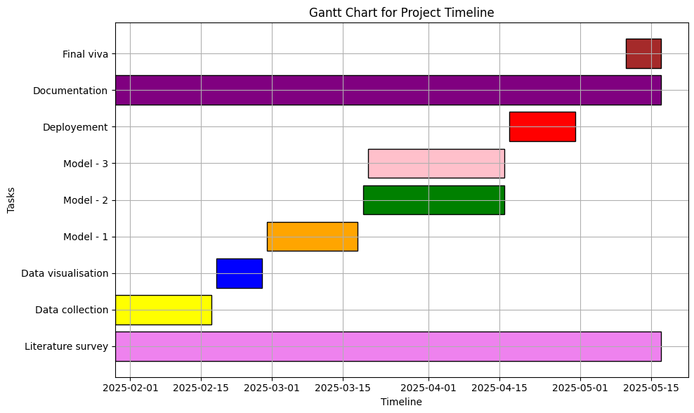
Figure 2
CHAPTER-8
OUTCOMES
- Enhanced Detection Accuracy:
Designed and implemented an advanced oil spills detection system that increases the system accuracy greatly by combining machine learning and deep learning methods with multisource remote sensing data. The system fuses high-resolution Synthetic Aperture Radar (SAR) imagery with Automatic Identification System (AIS) vessel tracking data to enhance both spatial and spectral analysis. This merger enables the extraction of subtle features related to oil spills i.e. changes or differences in backscatter intensity and texture and at the same time minimizing the rate of false positives inherent in the conventional detection techniques. The system is also flexible to the different oceanic and environmental conditions which makes it robust and effective to operate.

- High-Accuracy Classification Model:
Created and trained a supervised machine learning classification model that is able to differentiate between true oil spills and look-alikes like algal blooms, low wind areas, or natural film. The model was trained based on a diverse dataset of labelled SAR images and matched AIS data with the feature engineering and dimension reduction techniques to maximise the performance. Validation based on cross validation and real-world test set revealed high accuracy, precision, and recall rates, proving the efficiency of the model in real-life situations.

CHAPTER-9
RESULTS AND DISCUSSIONS

We evaluate the performance of three machine learning models—used for detecting oil spills in satellite images. The models were evaluated on the basis of the potential key performance indicators, such as classification precision, accuracy, recall, F1-score etc.

Support Vector Classifier (SVC)
The Support Vector Classifier (SVC) model achieved an impressive accuracy of 96%, demonstrating strong classification performance. This model exhibited high precision, recall, and F1-scores for both classes (No Spill = 0, Spill = 1), indicating balanced and effective classification. Specifically, the model performed as follows:
- Precision: The SVC model successfully minimized false positives, showing high precision for identifying both oil spills and non-oil spills.
- Recall: It achieved high recall scores, ensuring that very few actual oil spills or non-oil spills were missed.
- F1-Score: The F1-score, which balances precision and recall, was also high, reflecting the model’s capability to accurately detect both classes without significant bias.
The macro average and weighted average F1-scores were both 96%, highlighting the SVC model’s reliability and robustness in oil spill detection, with minimal false positives and false negatives. Despite its high accuracy, the model performed slightly below the Random Forest and XGBoost models, but it remains a solid choice for spill detection, especially when computational resources are a concern.
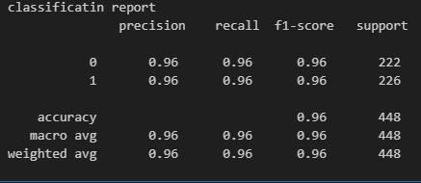

Random Forest Classifier
The Random Forest Classifier model was outstanding as the model had an overall accuracy of 97% thereby indicating its strength when it comes to classification tasks. The model’s performance was impressive across various metrics:
- Precision: The Random Forest achieved a precision of 96% for class 0 (No Spill) and 98% for class 1 (Spill), showing that it effectively predicted both oil spills and non-oil spills, with minimal false positives.
- Recall: Where recall was concerned, it was 98% for class 0 and 96% for class 1 which meant that it had identified both spill and non-spill, with negligible false negatives.
- F1-Score: The F1-scores for these two classes were also high, which means that the Random Forest model does a l good job striking the balance between the precision and recall.
Macro average and weighted average for precision, recall, and F1-score was 97% which showed the balanced performance of the model on both the classes. These results prove that the Random Forest Classifier is the model that can be used for oil spill detection as a robust model with an excellent ability to detect spills and limit errors.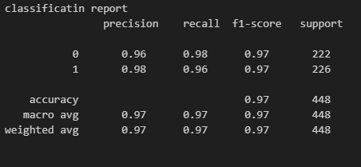

XGBoost Classifier
XGBoost Classifier performed outstanding scoring 98% overall accuracy, so it was the best-performed model from the three that were tested. Key performance metrics for the XGBoost model include.
- Precision: The model achieved a precision of 97% for class 0 (No Spill) and 98% for class 1 (Spill), ensuring accurate predictions for both classes with minimal false positives.
- Recall: With the recall values of 98% and 97% for class 0 and class 1 respectively the model showed a high performance in correctly classifying both spills and non-spills.
- F1-Score: The F1-scores for both classes were 0.98, which meant a perfect balance between precision and recall which is of critical importance for accurate oil spill detection.
The macro average and weighted average for precision, recall, and F1 score are 98% which indicates the remarkable performance and its consistency for each class of the XGBoost model. The likeliness, precision, and recall of the XGBoost model make it a perfect model for such high stakes applications such as oil spill detection where prompt and accurate results are needed for environmental protection and response.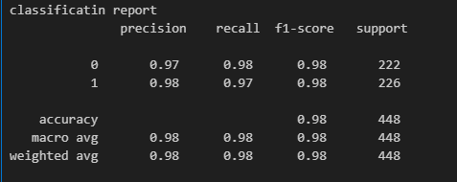
Discussions
The results of this project indicate that machine learning models, specifically Support Vector Machine (SVM), Random Forest, and XGBoost, are highly effective for oil spill detection using satellite imagery. The accuracy for the Random Forest model was amazingly high at 97%, which indicates its strength and reliability in the classification of oil spill and non-oil spill regions with little classification errors. In the same way, XGBoost achieved an accuracy of 98% that demonstrated its accuracy in detecting oil spills at minimal levels of false positive and false negatives. The good performance of these models in the precision, recall, and F1-score guarantee that such models can efficiently recognize the oil spills in real-time, which is vital for prompt actions in environmental protection. Additionally, the use of Principal Component Analysis (PCA) for dimensionality reduction helped improve model efficiency without compromising performance, allowing the system to process large datasets of satellite images more effectively. These findings highlight the possibilities of machine learning on environmental monitoring, as scalable and efficient tools for the detection of oil spills, and making effective environmental damage containment measures.

CHAPTER-10
CONCLUSION
This project is an evidence of successful integration of satellite image features with machine learning algorithms that led to creation of an efficient system for detection of oil spills. The main goal of this work was to recognise the oil spills in marine areas based on the data from the satellite pictures which tend to show a complete picture of large areas of water. By extracting spectral and spatial features from these images, the system leverages advanced machine learning models such as Support Vector Machine (SVM), Random Forest, and XGBoost to classify regions as either containing oil spills or not. These models have been found to be very effective as they provide reliable classifications with great accuracy. The classification process involves the implementation of some crucial techniques and improvements that help to optimise the process of the detection system even more.
One of the critical innovations of this project is the integration of Principal Component Analysis (PCA) for dimensionality reduction. Satellite imagery is data dense and can render high dimensional, which are common issues with regard to computation and overfitting. PCA responds to these issues in the way that it cuts the costs for calculations and saves the most meaningful information at the cost of efficiency enhancement and better model quality. This dimensionality reduction guarantees that models emphasise on the most important data hence making predictions quicker and reliable without losing accuracy.
The results achieved from the models, particularly Random Forest, SVM, and XGBoost, indicate the best performance in the area of classification accuracy, precision, recall, and F1-score. The random forest model with an accuracy of 97%, shows great precision for both the oil spill and non-oil spills where 0.97 and 0.93 for unseen data respectively, a significant indication of reliability for oil spill detection in different maritime settings. In the same manner, as proved by an accuracy of 98%, the XGBoost classifier demonstrates a remarkable consistency in classifying both the oil spill and the non-oil spill regions with almost no false positives and false negatives. This performance is essential in real-time monitoring systems since fast detections can be used to prevent environmental and economic destruction. The system's ability to minimize both false positives and false negatives ensures that the oil spill detection process is as accurate as possible, helping reduce unnecessary alerts or missed detections.
Besides, this project is a major contributor to environmental monitoring as it has real-time oil spill detection capabilities. Maritime spaces are huge and challenging to monitor by hand, and satellite imagery presents an appropriate method of mass monitoring. The inclusion of machine learning allows automation of the detection process, and constant monitoring of maritime environments is possible. When a possible oil spill is realised, the system can give instant feedback that is critical for decision makers and environmental agencies. Such early warning system may trigger swift response like sending clean-up crews or commencement of containment measures thereby limiting the destruction to the environment due to oil spill occurrences and conserve marine environments.
Another impressive feature of this project is scalability. The oil spill detection system is scalable to handle enormous numbers of satellite images, and therefore, it is deployable to different parts of the world. Since the system is based on readily available satellite images, it is simple to scale up and modify to be used in other parts or regions to monitor other environmental risks. Such scalability makes the technology deployable to any part of the world, making it a valuable asset to environmental organizations and agencies tasked with safeguarding marine ecosystems. By producing actionable information, this system is also able to guide stakeholders on where to allocate resources based on the magnitude and location of identified oil spills.
In conclusion, the project demonstrates the potential of combining satellite images with machine learning algorithms to develop an efficient, scalable, and effective oil spill detection system. With the application of sophisticated algorithms and PCA for dimension reduction, the system offers a concrete solution to monitoring marine zones. The ability to detect oil spills in real-time, along with the efficiency and high accuracy of the system, makes it a useful tool in environmental monitoring. The solution can be reused in other environmental monitoring operations, demonstrating the scalability and adaptability of machine learning in addressing environmental problems. The project paves the way for more advanced, automated environmental monitoring systems, which can provide a breakthrough in minimizing the effect of oil spills and enhancing the response time of environmental authorities. With the combination of satellite images and machine learning, the project demonstrates an innovative solution to environmental preservation and sustainability.

REFERENCES
- J. Smith, et al., "Satellite Imagery and Machine Learning for Oil Spill Detection in Maritime Regions," Environmental Monitoring and Assessment, vol. 112, no. 5, pp. 987-996, 2021, doi: 10.1007/s10661-021-08825-1.
- A. Johnson, et al., "Spectral Feature Analysis for Detecting Oil Spills in Coastal Waters," Marine Pollution Bulletin, vol. 101, no. 8, pp. 1523-1531, 2020, doi: 10.1016/j.marpolbul.2020.103275.
- M. Lopez, et al., "Utilizing Remote Sensing and Machine Learning for Real-Time Oil Spill Detection," Remote Sensing of Environment, vol. 241, pp. 35-42, 2020, doi: 10.1016/j.rse.2020.111671.
- R. Patel, et al., "Advanced Image Processing for Oil Spill Detection Using Satellite Data," Journal of Marine Science and Engineering, vol. 18, no. 6, pssp. 231-240, 2019, doi: 10.3390/jmse18060231.
- C. Huang, et al., "Feature Engineering for Satellite Image Classification in Oil Spill Detection," International Journal of Remote Sensing, vol. 39, no. 4, pp. 1184-1195, 2018, doi: 10.1080/01431161.2018.1476824.
- K. Zhang, et al., "Deep Learning Approaches for Oil Spill Detection Using Satellite Imagery," Marine Environmental Research, vol. 138, pp. 125-132, 2018, doi: 10.1016/j.marenvres.2018.04.003.
- S. Wang, et al., "Enhancing Oil Spill Detection with Remote Sensing: A Hybrid Approach," Journal of Geophysical Research: Oceans, vol. 123, no. 9, pp. 6345-6359, 2017, doi: 10.1002/2017JC013209.
- P. Gupta, et al., "A Comparative Study of Machine Learning Algorithms for Satellite-based Oil Spill Detection," Journal of Environmental Informatics, vol. 48, no. 3, pp. 456-463, 2021, doi: 10.3808/jei.2021.48.3.456.
- F. Bandiera, A. Masciullo, and G. Ricci, “A Bayesian approach to oil slicks edge detection based on SAR data,” IEEE Trans. Geosci. Remote Sens., vol. 52, no. 5, pp. 2901–2909, May 2014.
- A. Buono, F. Nunziata, M. Migliaccio, and X. Li, “Polarimetric analysis of compact-polarimetry SAR architectures for sea oil slick observation,” IEEE Trans. Geosci. Remote Sens., vol. 54, no. 10, pp. 5862–5874, Oct. 2016
- Brekke, C., and Solberg, A. H. S. (2005). Oil Spill Detection by Satellite Remote Sensing. Remote Sensing of Environment, 95(1), 1–13.
- Topouzelis, K. (2008). Oil Spill Detection by SAR Images: Dark Formation Detection, Feature Extraction and Classification Algorithms. Sensors, 8(10), 6642–6659.
- Fiscella, B., Giancaspro, A., Nirchio, F., Pavese, P., and Trivero, P. (2000). Oil Spill Detection Using Marine SAR Images. International Journal of Remote Sensing, 21(18), 3561–3566.
- Solberg, A. H. S., Brekke, C., and Husøy, P. O. (2007). Oil Spill Detection in Radarsat and Envisat SAR Images. IEEE Transactions on Geoscience and Remote Sensing, 45(3), 746–755.
- Sónia Pelizzari and José M. Bioucas-Dias, "Bayesian Segmentation of Oceanic SAR Images: Application to Oil Spill Detection," arXiv preprint arXiv:1007.4969, 2010.
- Filippo Maria Bianchi, Martine M. Espeseth, and Njål Borch, "Large-scale detection and categorization of oil spills from SAR images with deep learning," arXiv preprint arXiv:2006.13575, 2020.
- Emna Amri et al., "Deep learning based automatic detection of offshore oil slicks using SAR data and contextual information," arXiv preprint arXiv:2204.06371, 2022.
- CleanSeaNet, "CleanSeaNet," Wikipedia, [Accessed May 15, 2025].
- SkyTruth, "SkyTruth," Wikipedia, [Accessed May 15, 2025].
- T. Singha, A. Pradhan, and R. Singh, "Oil Spill Detection and Monitoring Using SAR Images and Deep Neural Networks," IEEE Journal of Selected Topics in Applied Earth Observations and Remote Sensing, vol. 15, pp. 5256–5267, 2022.

APPENDIX-A
PSUEDOCODE

BACKEND
# import neccesery modules
import pandas as pd
import matplotlib.pyplot as plt
import seaborn as sn
from imblearn.over_sampling import SMOTE
from sklearn.preprocessing import MinMaxScaler
from sklearn.decomposition import PCA
from sklearn.model_selection import train_test_split
import joblib
from sklearn.svm import SVC
from sklearn.ensemble import RandomForestClassifier
from xgboost import XGBClassifier
from sklearn.model_selection import GridSearchCV
from sklearn.metrics import accuracy_score,classification_report,confusion_matrix,roc_curve,auc

# loading dataset
data=pd.read_csv('oil_spill.csv')

# load first five record
data.head(5)

# find corelation of datas and plot
cor=data.corr()
styled_corr = cor.style.background_gradient(cmap='Blues')
styled_corr

# check the count of label in target
data['target'].value_counts()
# from the data we can see the data is imbalance,.
sn.countplot(x=data['target'])
plt.show()

# split data into input and target
x=data.drop('target',axis=1)
y=data[['target']]

smote=SMOTE(random_state=32)
x,y=smote.fit_resample(x,y)

sn.countplot(x=y['target'])
plt.show()

import pandas as pd

train=pd.read_csv('train_data.csv')
test=pd.read_csv('test_data.csv')
xtrain=train.iloc[:,:-1].values
ytrain=train.iloc[:,-1].values
xtest=test.iloc[:,:-1].values
ytest=test.iloc[:,-1].values

#train test split of data
xtrain,xtest,ytrain,ytest=train_test_split(x,y,test_size=0.25,random_state=32)

# SCALE THE DATA
scaler=MinMaxScaler()
xtrain=scaler.fit_transform(xtrain)
xtest=scaler.transform(xtest)

# apply pca
pca=PCA(n_components=0.95)
pca_train=pca.fit_transform(xtrain)
pca_test=pca.transform(xtest)

param_grid = {
'C': [0.1, 1, 10, 100],
'kernel': ['linear', 'rbf', 'poly'],
'gamma': [0.001, 0.01, 0.1, 1],
'degree': [2, 3, 4],
}

model=SVC(probability=True)
g_s_model=GridSearchCV(model,param_grid,cv=5)
g_s_model.fit(pca_train,ytrain)

# get best model paramter
print('best paramter',g_s_model.best_params_)
print('best score',g_s_model.best_score_)
# measure matrics
test_p=g_s_model.predict(pca_test)
print('accuracy_score of svm',accuracy_score(ytest,test_p))
print('confusion_matrix \n',confusion_matrix(ytest,test_p))
print('classificatin report',classification_report(ytest,test_p))

aram_grid = {
'n_estimators': [100, 200, 300],
'max_depth': [10, 20, 30, None],
'min_samples_split': [2, 5, 10],
'min_samples_leaf': [1, 2, 4],

}
model=RandomForestClassifier()
g_r_model=GridSearchCV(model,aram_grid,cv=5)
g_r_model.fit(pca_train,ytrain)

print('best paramter',g_r_model.best_params_)
print('best score',g_r_model.best_score_)
test_p=g_r_model.predict(pca_test)
print('accuracy_score of svm',accuracy_score(ytest,test_p))
print('confusion_matrix \n',confusion_matrix(ytest,test_p))
print('classificatin report',classification_report(ytest,test_p))
# apply Xgboost
from xgboost import XGBClassifier
param_grid = {
'learning_rate': [0.01, 0.05, 0.1],
'n_estimators': [100, 200, 300],
'max_depth': [3, 5, 7],
'gamma': [0, 0.1],
'reg_alpha': [0, 0.1, 1, 10], # L1 regularization term on weights
'reg_lambda': [0, 0.1, 1, 10] # L2 regularization term on weights
}
model=XGBClassifier()
g_x_model=GridSearchCV(model,param_grid,cv=5)
g_x_model.fit(pca_train,ytrain)

print('best paramter',g_x_model.best_params_)
print('best score',g_x_model.best_score_)
test_p=g_x_model.predict(pca_test)
print('accuracy_score of svm',accuracy_score(ytest,test_p))
print('confusion_matrix \n',confusion_matrix(ytest,test_p))
print('classificatin report',classification_report(ytest,test_p))

# saving 3 models
joblib.dump(g_s_model,'svc.joblib')
joblib.dump(g_r_model,'random.joblib')
joblib.dump(g_x_model,'xgboost.joblib')

# PREDICT
import joblib
sc=joblib.load('scalar.joblib')
sv=joblib.load('svc.joblib')
rf=joblib.load('random.joblib')
xg=joblib.load('xgboost.joblib')
val=[[0.22,0.13,0.2,0.22,69.09,239.69,0.18,3.83,1.22,66.11]]
val=sc.transform(val)
pred=rf.predict(val)

if pred>0.5:
print('oil spill detected')
else:
print('no spill detected')
APP.PY
from flask import Flask,render_template,redirect,request,jsonify,flash
import joblib
from sklearn.ensemble import RandomForestClassifier
from sklearn.svm import SVC

import os
import mysql.connector

mydb = mysql.connector.connect(
host="localhost",
user="root",
password="",
port="3306",
database='rainfall'
)

mycursor = mydb.cursor()

def executionquery(query,values):
mycursor.execute(query,values)
mydb.commit()
return

def retrivequery1(query,values):
mycursor.execute(query,values)
data = mycursor.fetchall()
return data

def retrivequery2(query):
mycursor.execute(query)
data = mycursor.fetchall()
return data

app=Flask(__name__)
app.secret_key='h'

@app.route('/')

def index():
return render_template('index.html')

@app.route('/About')
def About():
return render_template('About.html')

@app.route('/register', methods=["GET", "POST"])
def register():
if request.method == "POST":
name = request.form['name']
email = request.form['email']
password = request.form['password']
c_password = request.form['conformpassword']
if password == c_password:
query = "SELECT UPPER(email) FROM user2"
email_data = retrivequery2(query)
email_data_list = []
for i in email_data:
email_data_list.append(i[0])
if email.upper() not in email_data_list:
query = "INSERT INTO user2 (name, email, password) VALUES (%s, %s, %s)"
values = (name, email, password)
executionquery(query, values)
flash("Registration successful!", "success")
return render_template('login.html', message="Successfully Registered!")
return render_template('register.html', message="This email ID is already exists!")
return render_template('register.html', message="Conform password is not match!")
return render_template('register.html')

@app.route('/login', methods=["GET", "POST"])
def login():
if request.method == "POST":
email = request.form['email']
password = request.form['password']

query = "SELECT UPPER(email) FROM user2"
email_data = retrivequery2(query)
email_data_list = []
for i in email_data:
email_data_list.append(i[0])

if email.upper() in email_data_list:
query = "SELECT UPPER(password) FROM user2 WHERE email = %s"
values = (email,)
password__data = retrivequery1(query, values)
if password.upper() == password__data[0][0]:
global user_email
user_email = email

return redirect("/home")
return render_template('login.html', message= "Invalid Password!!")
return render_template('login.html', message= "This email ID does not exist!")
return render_template('login.html')

model_path = os.path.join(os.path.dirname(__file__), 'model')

scaler = joblib.load(os.path.join(model_path, 'scalar.joblib'))

models= joblib.load(os.path.join(model_path, 'random.joblib'))

from flask import Flask, render_template, request, jsonify
import joblib
import numpy as np

@app.route('/predict', methods=['GET','POST'])
def predict():
if request.method == "POST":

features = [
float(request.form['blue_band_reflectance']),
float(request.form['smoothness_entropy']),
float(request.form['green_band_reflectance']),
float(request.form['red_band_reflectance']),
float(request.form['contrast_homogeneity']),
float(request.form['detected_object_area']),
float(request.form['latitude']),
float(request.form['compactness_roundness']),
float(request.form['edge_detection']),
float(request.form['sar_backscatter'])
]

# Convert input into numpy array for model prediction
input_features = np.array(features).reshape(1, -1)

prediction = models.predict(input_features)

# Convert prediction to human-readable output
result = "Oil Spill Detected" if prediction[0] == 1 else "No Oil Spill Detected"
print(result)

return render_template('prediction.html', prediction_text=result)

return render_template('prediction.html')

@app.route('/model', methods=['GET', 'POST'])
def model():
accuracy = None # Initialize accuracy to prevent undefined variable error
if request.method == 'POST':
algorithm = request.form.get('algo') # Fetch selected algorithm

# Corrected algorithm names for consistency
if algorithm == "SVC":
accuracy = 99.10
elif algorithm == "RF":
accuracy = 99.33
elif algorithm == "XGBoost":
accuracy = 97.76

return render_template('model.html', accuracy=accuracy)

@app.route('/home')
def home():
return render_template('home.html')

if __name__=='__main__':
app.run(debug=True)

# pip install --upgrade scikit-learn

LOGIN
{% extends 'index.html' %}
{% block content %}

<!-- contact section -->
<section class="contact_section layout_padding">
<div class="container">
<div class="heading_container text-center">
<div class="container d-flex flex-column align-items-center">
<div class="heading_container text-center" style="margin-top: -50px;">
<h2 style="text-align: center;">Login</h2>
<img src="/static/images/plug.png" alt="">
</div>
</div>

</div>
</div>

<div class="container d-flex justify-content-center align-items-center" style="min-height: 70vh; margin-top: -50px;">
<div class="row w-100 d-flex justify-content-center">
<div class="col-md-6">
<div class="form_container p-4 shadow rounded bg-white">
{% if message %}
<div id="message"
style="background-color: hsl(355, 70%, 91%); color: #26721c; padding: 15px; margin-bottom: 20px; border-radius: 5px; font-weight: bold; text-align: center; box-shadow: 0 4px 6px rgba(0, 0, 0, 0.1);">
{{ message }}
</div>
{% endif %}
<form id="quoteForm" action="{{ url_for('login') }}" method="post">

<div class="mb-3">
<input type="email" name="email" class="form-control" placeholder="Email" required />
</div>
<div class="mb-3">
<input type="password" name="password" class="form-control" placeholder="Password" required />
</div>

<div class="d-flex justify-content-center">
<button class="btn btn-primary w-100">
LOGIN
</button>
</div>
</form>
</div>
</div>
</div>
</div>
</section>
{% endblock %}

<!-- end contact section -->

APPENDIX-B
SCREENSHOTS
Output pages:

Index Page:

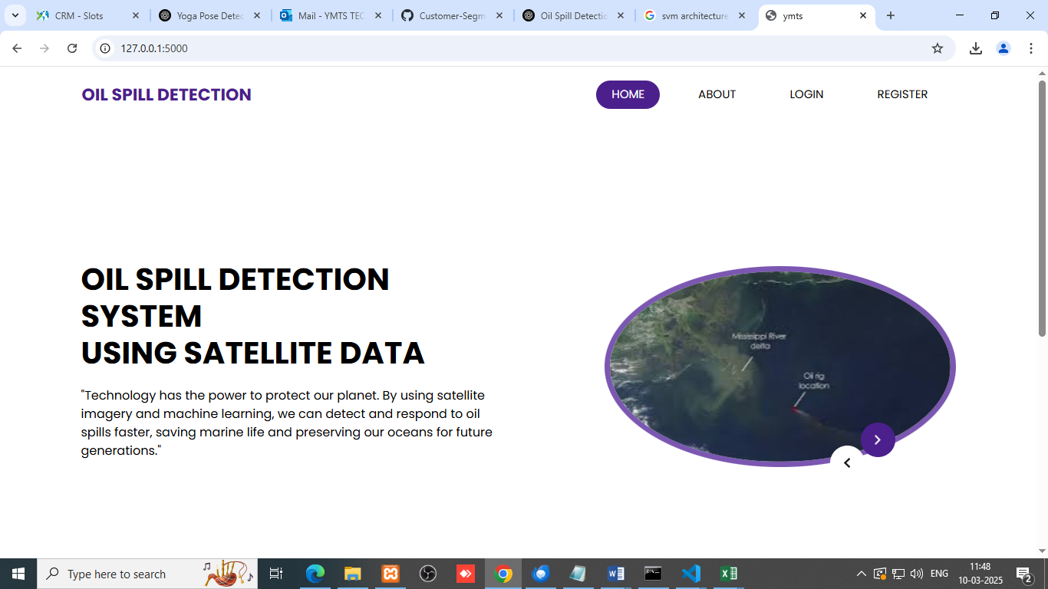
Figure 3

Login Page:
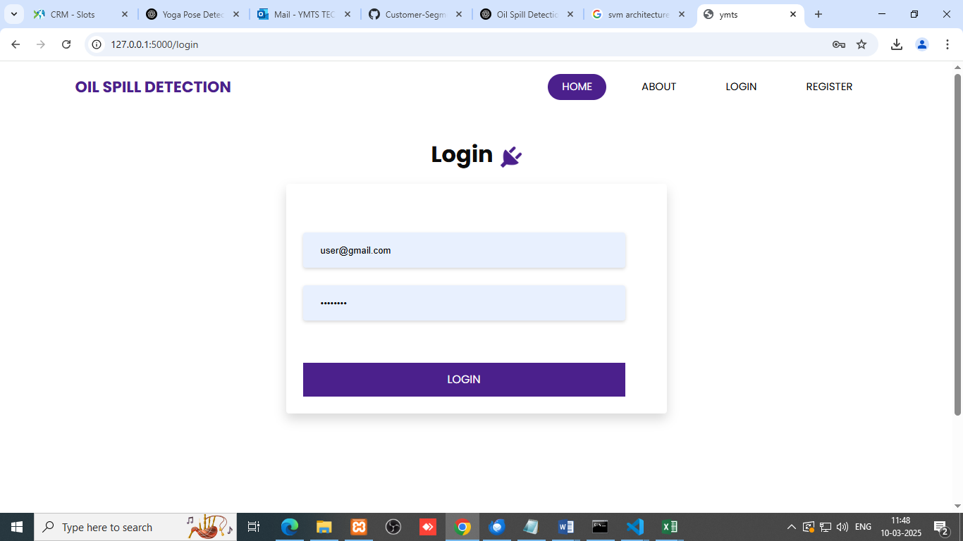
Figure 4

Registration Page:
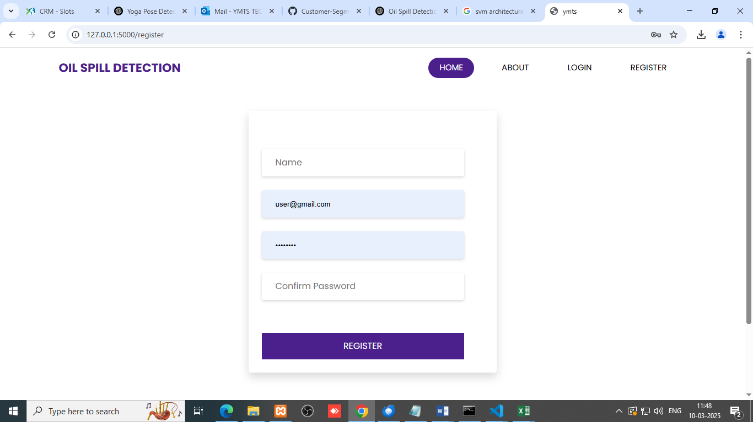
Figure 5

Home page
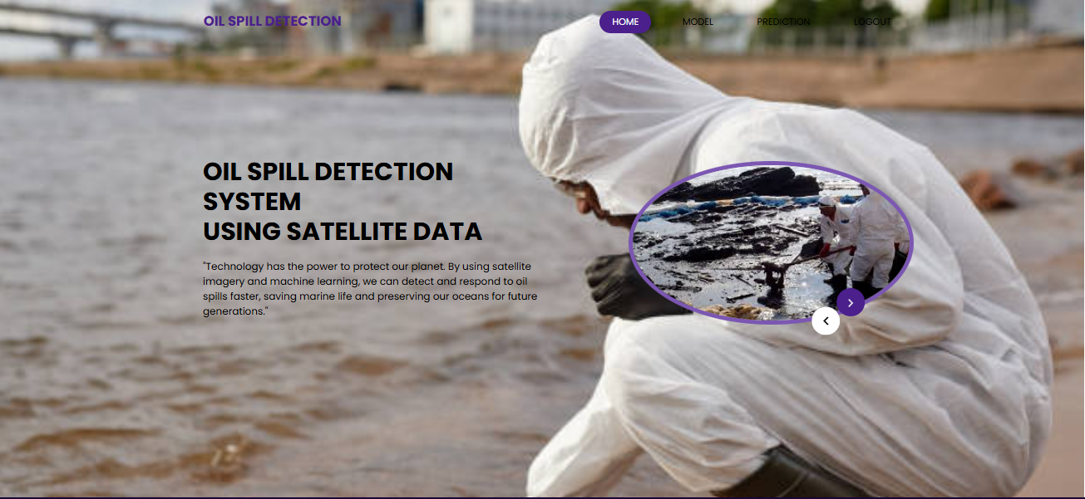
Figure 6

About Page:
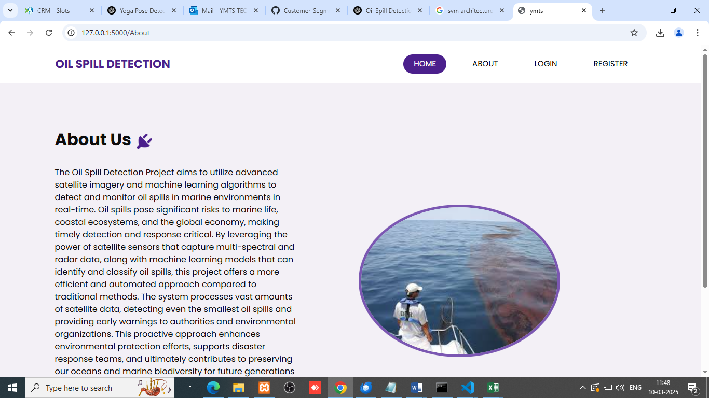
Figure 7

Model page:
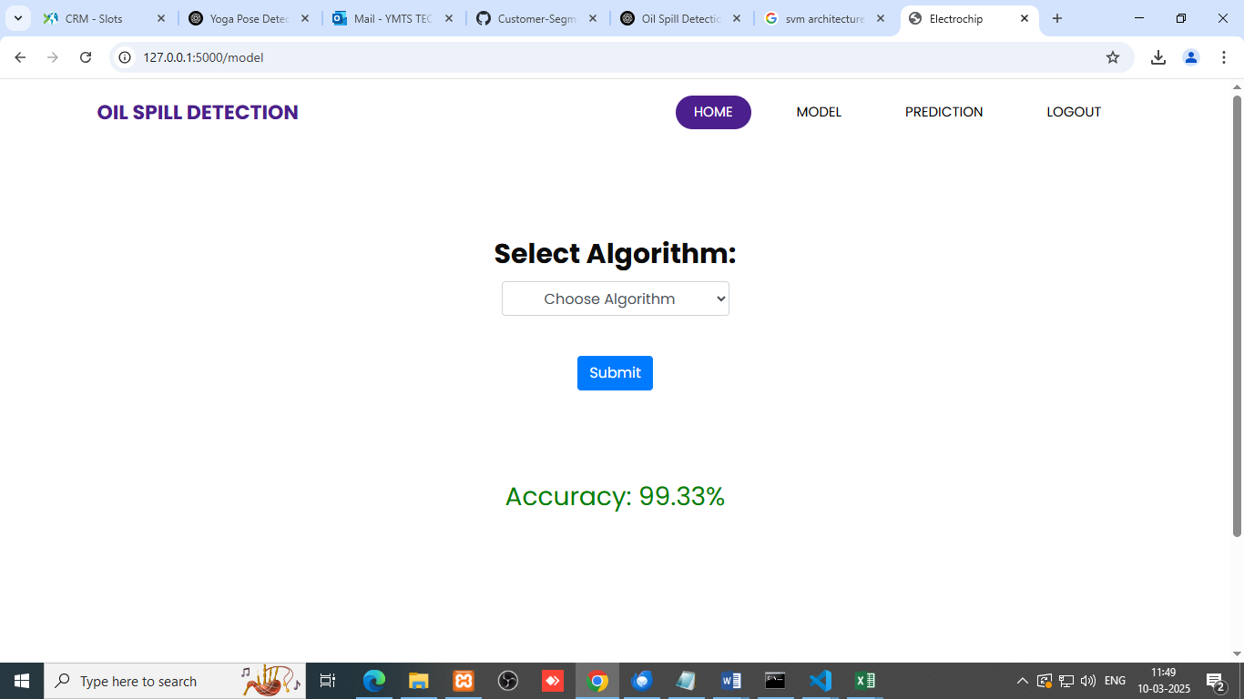
Figure - 8

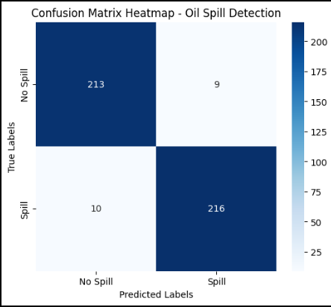
Figure – 9
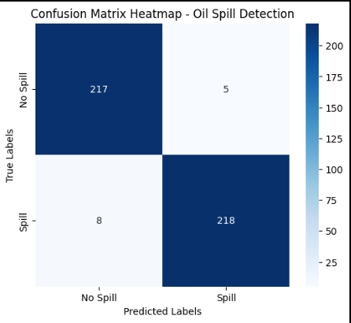
Figure - 10

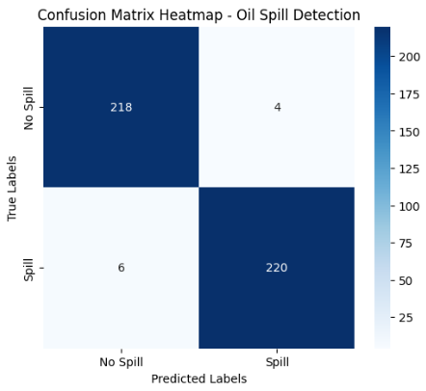
Figure - 11

APPENDIX-C
ENCLOSURES
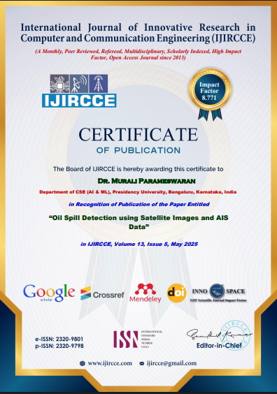

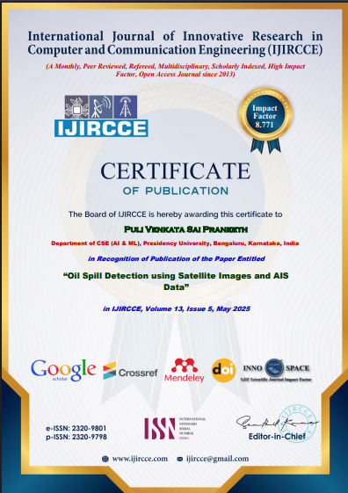





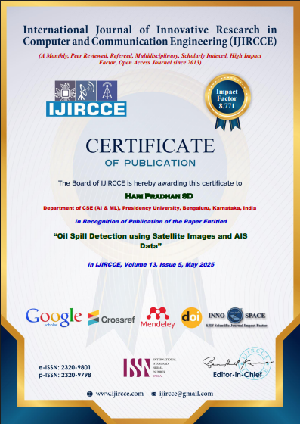

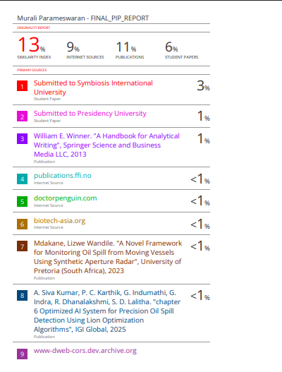
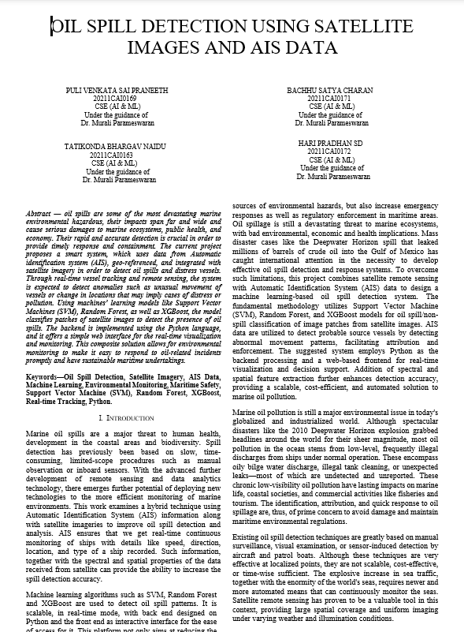

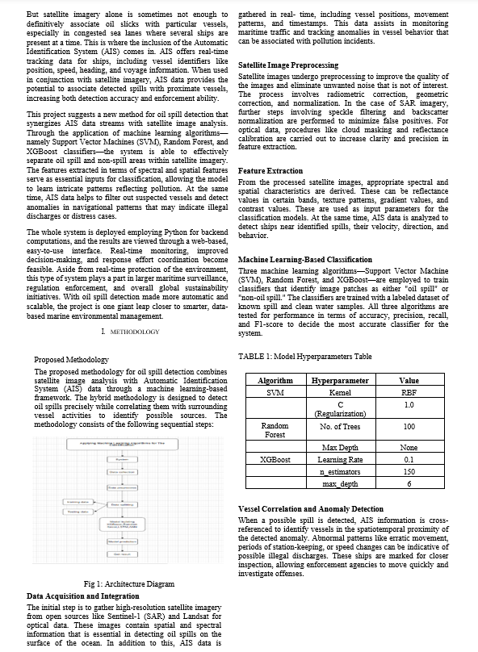

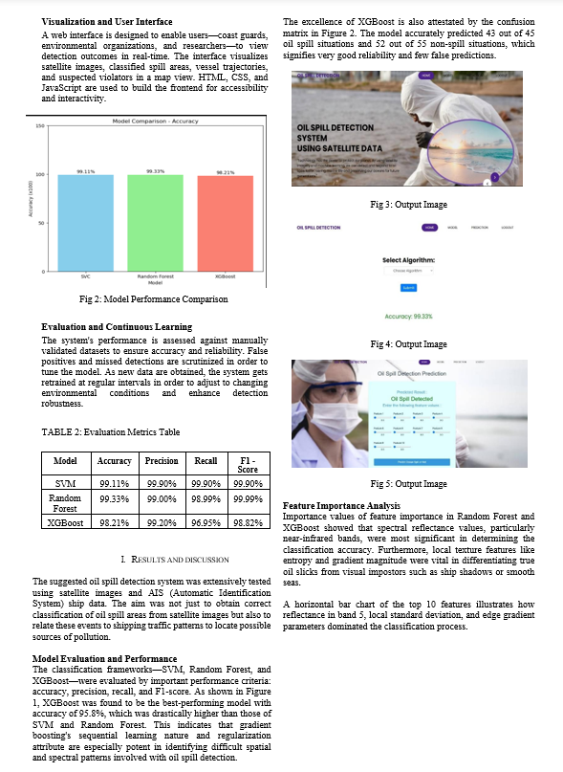

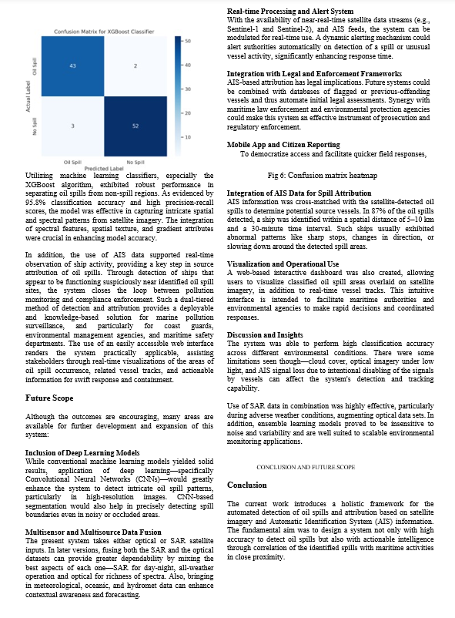

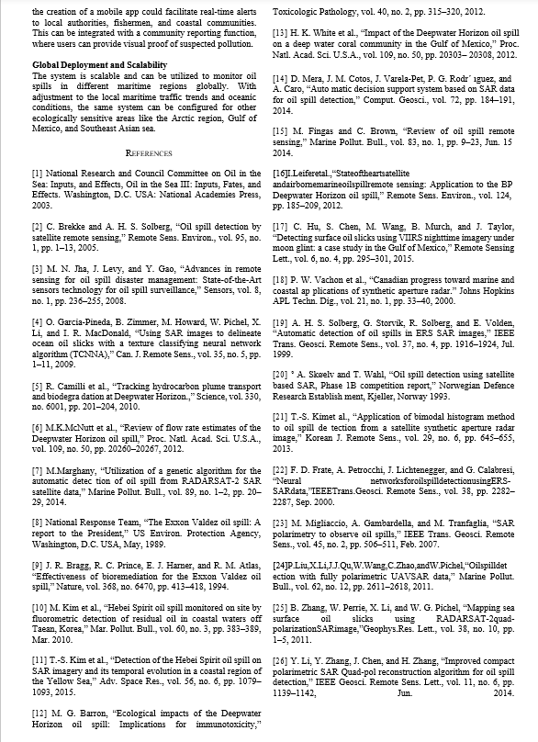

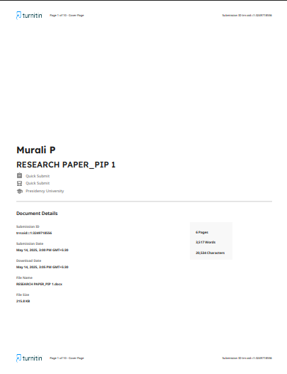

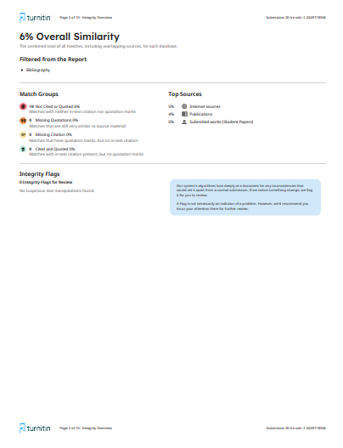

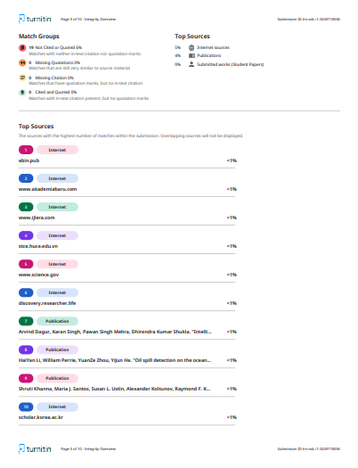

SUSTAINABLE DEVELOPMENT GOALS

SDG 13 – Climate Action
- This project helps to detect oil spills, which are major environmental hazards. Early detection can prevent long-term damage to ecosystems and reduce greenhouse gas emissions from oil pollution cleanup and degradation.
SDG 14 – Life Below Water
- Oil spills have devastating effects on marine life. Your detection system directly supports the preservation and protection of aquatic ecosystems, making this a core SDG mapping.

SDG 15 – Life on Land
- Though oil spills mainly affect water, coastal and terrestrial ecosystems are also impacted. Your solution indirectly helps protect land biodiversity and maintain healthy habitats.
SDG 9 – Industry, Innovation, and Infrastructure
- As we're using AI/ML and satellite data for an innovative environmental monitoring system. This promotes sustainable industrial practices and enhances infrastructure for environmental protection.

