**Topics: Descriptive Statistics and Probability**

1. **Look at the data given below. Plot the data, find the outliers and find out $μ, σ, σ^{2}$**

|  |  |
| --- | --- |
| **Name of company** | **Measure X** |
| **Allied Signal** | **24.23%** |
| **Bankers Trust** | **25.53%** |
| **General Mills** | **25.41%** |
| **ITT Industries** | **24.14%** |
| **J.P.Morgan & Co.** | **29.62%** |
| **Lehman Brothers** | **28.25%** |
| **Marriott** | **25.81%** |
| **MCI** | **24.39%** |
| **Merrill Lynch** | **40.26%** |
| **Microsoft** | **32.95%** |
| **Morgan Stanley** | **91.36%** |
| **Sun Microsystems** | **25.99%** |
| **Travelers** | **39.42%** |
| **US Airways** | **26.71%** |
| **Warner-Lambert** | **35.00%** |

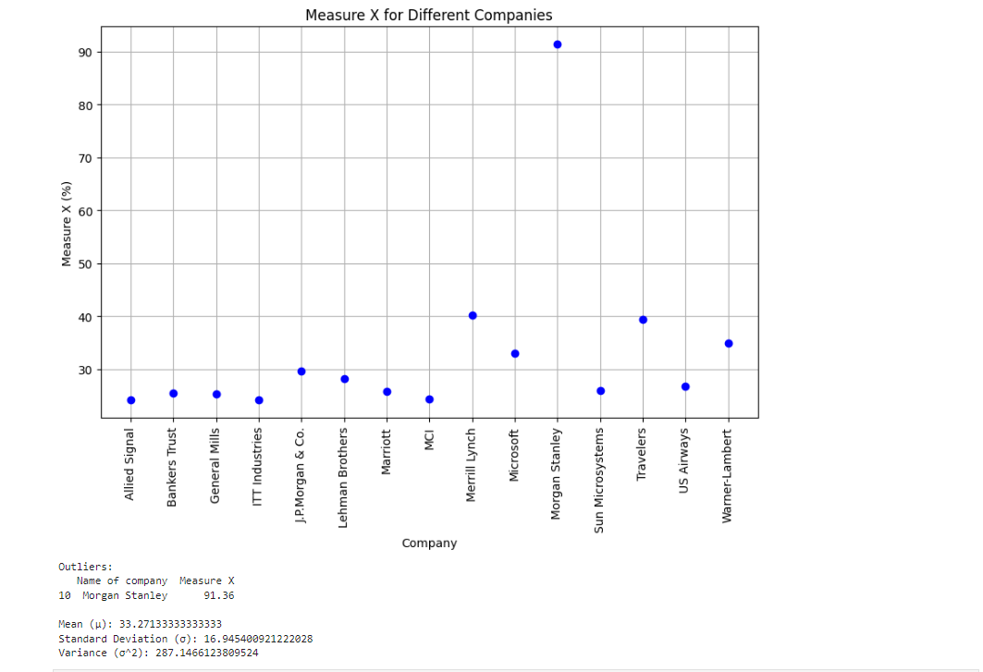



**Answer the following three questions based on the box-plot above.**

1. **What is inter-quartile range of this dataset? (please approximate the numbers) In one line, explain what this value implies.**

Ans: IQR is the range between upper quartile (Q3) and lower quartile (Q1)

IQR= Q3-Q1= 12-5 = 7

50% of the data lies between IQR

1. **What can we say about the skewness of this dataset?**

Ans: Skewness = Positive

1. **If it was found that the data point with the value 25 is actually 2.5, how would the new box-plot be affected?**

Ans: There will be no outlier if the value of 25 was actually 2.5. Subsequently, mean

and median needs to be calculated to see if there is any shift in data



**Answer the following three questions based on the histogram above.**

1. **Where would the mode of this dataset lie?**

**Ans:** The mode can lie between 3 and 10 because majority of the entry in this range. To

pin point the actual Mode we will have analyze the data

1. **Comment on the skewness of the dataset.**

**Ans:** Skewness = Positive

1. **Suppose that the above histogram and the box-plot in question 2 are plotted for the same dataset. Explain how these graphs complement each other in providing information about any dataset.**

**Ans:** There is an outlier of the value 25 and both the plot has positive skewness

1. **AT&T was running commercials in 1990 aimed at luring back customers who had switched to one of the other long-distance phone service providers. One such commercial shows a businessman trying to reach Phoenix and mistakenly getting Fiji, where a half-naked native on a beach responds incomprehensibly in Polynesian. When asked about this advertisement, AT&T admitted that the portrayed incident did not actually take place but added that this was an enactment of something that “could happen.” Suppose that one in 200 long-distance telephone calls is misdirected. What is the probability that at least one in five attempted telephone calls reaches the wrong number? (Assume independence of attempts.)**

**Ans**: X = probability of 1 call misdirected out of 200

Probability of occurring of X = 1/200

P(X)= 1/200

Probability of having at least one successful call will be

1-P(X)= 1-1/200= 199/200= 0.967

As every event is independent of other event the probability will be

1- (0.967)^5

0.02475 = 2% chance.

1. **Returns on a certain business venture, to the nearest $1,000, are known to follow the following probability distribution**

|  |  |
| --- | --- |
| **x** | **P(x)** |
| **-2,000** | **0.1** |
| **-1,000** | **0.1** |
| **0** | **0.2** |
| **1000** | **0.2** |
| **2000** | **0.3** |
| **3000** | **0.1** |

1. **What is the most likely monetary outcome of the business venture?**

$2000 as it has the highest probability of occurrence

1. **Is the venture likely to be successful? Explain**

if Success == positive returns as a measure

Then there is a 60% probability that the venture would be successful (0.3+0.2+0.1=0.6=>0.6*100=>60%).

1. **What is the long-term average earning of business ventures of this kind? Explain**

ANS: (-2000*0.1)+(-1000*0.1)+(0*0.2)+(1000*0.2)+(2000 *0.3)+(3000*0.1)=800

the long-term average earning for these type of ventures would be around $800

1. **What is the good measure of the risk involved in a venture of this kind? Compute this measure**

A good measure to evaluate the risk would be variance and standard deviation

of the

variable x

Var = 3500000

Sd = 1870.83

The large value of standard deviation of $1870 is considered along with the average returns of $800 indicates that this venture is highly risky