Excitation-Coherent Telemetry Analysis for Predictive OBD-II Connector Wear Detection: A Physics-Informed Study on Real In-Vehicle Network Data
P. N. Bhargav Teja, Lanka Sree Chathurya, K. Arun Reddy, and Ragavan K
School of Computer Science and Engineering, Vellore Institute of Technology, Vellore, Tamil Nadu 632014, India
Corresponding author: Ragavan K (e-mail: [ADD E-MAIL])
Abstract—The SAE J1962 diagnostic connector has become the permanent mount and power source of telematics, insurance and fleet devices, yet it was designed for occasional workshop use. Vibration-induced fretting of its contacts causes intermittent data loss and device brown-outs that are routinely blamed on the device or the vehicle. We show that connector wear can be detected, attributed and, within limits, predicted from the telemetry the attached tool already records. The proposed excitation-coherent telemetry analysis (ECTA) combines self-referenced loss and loss-structure features with a Poisson test of whether losses co-vary with the vehicle’s own engine and road excitation, as a fretting contact’s interruptions must. A physics-informed model maps contact wear to the observable behaviour of full-bus loggers, sampling loggers and OBD-II polling testers, with four realistic confounders. All healthy telemetry, excitation and usage are real: five public datasets, nine vehicles analysed in detail and a 381-vehicle fleet. With leave-one-vehicle-out validation on six vehicles from at least three manufacturers, a full-bus tool detects wear with AUROC 0.880 (moderate 0.891, severe 0.995), uniformly across held-out vehicles (0.869–0.921), and confirms moderate wear within two minutes of driving (0.94); deep sequence baselines reach 0.646. A first-principles observability model predicts the detectability of every tool and wear stage without any classifier (Spearman 0.93). For low-rate polling tools, excitation coherence separates wear from bus interference (0.947 vs. 0.737) and lifts fleet-wide detection from 0.704 to 0.775, and a learned health index warns 88% of failing connectors with 1.5% false alarms.
Index Terms—Controller area network, electrical contacts, fault diagnosis, fretting corrosion, intelligent vehicles, on-board diagnostics, predictive maintenance, prognostics and health management, remaining useful life, vehicle telematics.

Introduction
The SAE J1962 data-link connector (DLC) is the standardized physical gateway into a road vehicle’s electronics [1]. Mandated for emissions diagnostics, it is now also the attachment point for a large and growing population of permanently installed devices: usage-based insurance dongles, fleet telematics units, aftermarket data loggers, driver coaching devices and remote-diagnostics gateways. These devices remain mated to the DLC for months or years and draw their supply current through it. The J1962 receptacle, however, was designed for occasional workshop use: it is unsealed, mounted in the cabin under the dashboard, and its terminals are typically tin-plated. A permanently mated tool cantilevers from the receptacle and is shaken by every engine-order and road-induced vibration, which is precisely the regime in which fretting corrosion turns a milliohm contact into an intermittent, ohmic one [2], [3], [4], [5].
A degraded DLC does not announce itself. To the vehicle it is invisible: the in-vehicle network keeps operating because the connector is a stub that no electronic control unit (ECU) depends on. To the attached tool it appears as unexplained data loss, as communication timeouts, and as brown-out resets when the supply pins open for longer than the tool’s hold-up time. Field symptoms are therefore misattributed to tool firmware, to cellular coverage, to the vehicle’s ECUs, or to the user, and the usual remedy—replacing the tool—leaves the worn receptacle in service. In fleet operations, where a single provider manages large numbers of installed units, this is a recurring and costly diagnostic blind spot.
This paper asks a simple question: can the wear of the diagnostic connector itself be detected, attributed and predicted from the telemetry that the attached tool already records, without any added sensor? We answer it with a physics-informed method and an evaluation on real in-vehicle data at a scale not previously attempted for this problem.
The key observation is physical. A fretted contact interrupts more often when it is shaken harder. Its interruption rate is therefore modulated by the vehicle’s own mechanical excitation—engine speed and road speed—and these excitation signals are themselves available in the same telemetry stream (as OBD-II parameters, or as broadcast signals on the bus). Most competing causes of data loss (logger buffer overflow, ECU busy states, software scheduling) are not excitation-coherent, and those that can be (e.g., ignition-coupled interference) leave a different footprint: they corrupt frames for every node on the bus, which then retransmits, whereas a DLC interruption destroys frames for the tool alone. We call the resulting approach excitation-coherent telemetry analysis (ECTA).
Validating such a method is difficult because no public dataset contains naturally worn diagnostic connectors, and growing worn specimens takes weeks to months on a vibration rig. We therefore adopt a transparent real-data-plus-physics protocol: every healthy observation in this study is real telemetry recorded on real vehicles, and every fault observation is the same real telemetry passed through a physical model of the degraded link whose structure is taken from the electrical-contact literature and whose unmeasured constants are stress-tested by deliberate mis-specification. The detector never sees the physical model’s latent variables; it only sees what a tool would record.
The contributions of this work are:
- A physics-informed generative model of DLC degradation that links fretting wear to its observable effects on three classes of diagnostic tool—full-bus passive loggers, low-cost sampling loggers, and OBD-II polling testers—including brown-out resets, timeout dynamics and four realistic confounders (Section III).
- ECTA, a detection and fault-origin attribution method built on self-referenced loss features, loss-structure features and a Poisson excitation-coherence statistic, with a health index and a Bayesian, censoring-aware remaining-useful-life (RUL) estimator that operates in the vehicle’s exposure domain (Section IV).
- A first-principles observability law that predicts, without any classifier, which wear stages each class of tool can detect, and that rank-orders the measured detection performance of all tools and stages (Spearman $ρ=0.93$).
- To our knowledge, the first evaluation of diagnostic-connector health monitoring on real in-vehicle data, and a broad one: five public real-vehicle datasets (can-train-and-test, HCRL Car-Hacking, CAN-MIRGU, CANmodes and the Vehicle Energy Dataset) covering nine vehicles in detail—six of them with complete bus captures from at least three manufacturers—and a fleet of 381 vehicles, with strictly vehicle-disjoint splits, eleven baseline and ablation models including deep sequence models, and a test against a structurally different fault process (Section VI).
- Practical results: on unseen vehicles a full-bus tool detects moderate wear (1.5–6 $Ω$) and confirms it within two minutes of driving; for low-rate polling tools, excitation coherence is what separates wear from its look-alikes, and a fleet-scale study in which each VED vehicle’s connector wears with its own recorded year of usage yields early warnings with a 1.5% false-alarm rate.
- An honest account of where telemetry-only monitoring cannot reach—incipient wear, moderate wear for low-rate tools, months-ahead RUL, and DLC-versus-ECU attribution without multi-ECU visibility—with code and data-preparation scripts that reproduce every number in this paper.
The remainder of the paper is organized as follows. Section II reviews related work. Section III presents the system and degradation model, and Section IV the ECTA method and the observability analysis. Section V describes the data and protocol, Section VI the results, and Section VII discusses implications and limitations before Section VIII concludes.

Related Work

Fretting Corrosion and Connector Reliability
The physics of electrical contacts is mature [5], [6]. Under small-amplitude relative motion, the oxide-free metallic spots of a tin-plated contact are progressively replaced by an insulating debris layer; contact resistance stays near its initial milliohm level for an incubation period and then rises steeply, often by several orders of magnitude, within a comparatively small number of additional cycles [2], [3], [4]. Fretting in automotive connectors has been reviewed by Park et al. [7], and Flowers et al. [8] showed that its onset exhibits a vibration threshold at each excitation frequency. Shen et al. measured the dynamic contact resistance of connectors under vibration and characterized the resulting intermittent faults [9], and showed that contact-resistance degradation impairs high-speed signal transmission, which permits on-line diagnosis by monitoring the signal that passes through the connector [10]. Industry qualification tests (e.g., USCAR-2 [11]) define an electrical discontinuity as a resistance excursion above 7 Ω lasting at least 1 µs during vibration. These works either characterize the connector on a test bench or diagnose it by instrumenting the link (e.g., measuring resistance or signal integrity). None addresses how a degraded connector manifests in the application-level data that an attached device already records—without added measurement hardware—which is the question here.

Timing and Physical-Layer Analysis of In-Vehicle Networks
A large literature exploits the timing and electrical characteristics of Controller Area Network (CAN) traffic [12], [13], mostly for intrusion detection. Inter-arrival-time analysis of periodic messages [14], clock-skew fingerprinting of ECUs [15] and voltage fingerprinting [16], [17], [18], [19], [20] identify senders or detect injected frames; deep learning detectors operate on frame sequences [21], [22], [23]. Public datasets such as HCRL Car-Hacking [24], ROAD [25], can-train-and-test [26] and CAN-MIRGU [27] serve this community. We borrow the timing view, but our target is the opposite of an attack: frames that should arrive but do not, and only at one observation point. To our knowledge no prior work uses in-vehicle network telemetry to assess the health of the diagnostic connector itself.

Diagnostics, Anomaly Detection and Prognostics
Model-based fault detection by analytical redundancy [28] and data-driven anomaly detection for automotive systems [29] are established, as are general prognostics and health management (PHM) methods for estimating RUL [30], [31] and their evaluation metrics [32]. Unsupervised detectors such as Isolation Forest [33], one-class SVM [34] and LSTM encoder–decoders [35] are standard baselines and are used as such here. What distinguishes the present problem is that (i) the degrading component has no sensor of its own, (ii) its symptoms are shared with several benign or unrelated causes, and (iii) the stimulus that drives the degradation is itself measurable in the same data stream. ECTA is designed around these three properties.

System Model
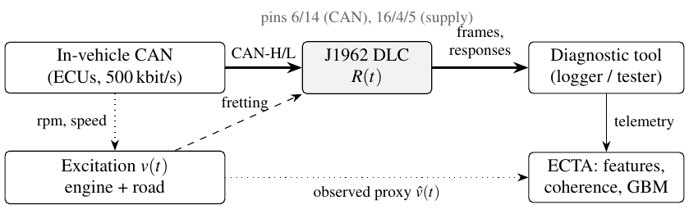
Fig. 1. Problem setting. Vibration excitation $v\left(t\right)$ drives fretting of the DLC contacts and modulates their interruption rate. The tool observes only its own telemetry, from which ECTA also recovers an excitation proxy $\hat{v}\left(t\right)$.
Fig. 1 summarizes the setting. A diagnostic tool is attached to the DLC. Through pins 6 and 14 it observes the vehicle’s diagnostic CAN; through pin 16 (battery) and pins 4/5 (ground) it is powered. We distinguish three tool classes, which differ in what they record and therefore in what a degraded contact can do to their data:
- Full-bus passive logger: records every frame on the bus with microsecond timestamps (e.g., a SocketCAN interface in listen-only mode).
- Sampling passive logger: a low-cost device that records only the frames it can service (about 65 frames/s in the CANmodes hardware, against several hundred to a few thousand on the bus).
- OBD-II polling tester: requests SAE J1979 Mode-01 parameters over ISO 15765-4 [36], [37] and records the responses, as ELM327-class dongles and fleet telematics units do.

Wear State
Let $N\left(t\right)$ denote accumulated fretting exposure. Following the incubation-then-rise behaviour of tin-plated contacts [2], [3], [4], we model the contact resistance as a logistic law in log-resistance,
$$lnR\left(N\right)=lnR_{0}+\left(lnR_{max}−lnR_{0}\right) S​\left(\frac{N−N_{50}}{w}\right) \left(1\right)$$
where $S\left(x\right)=1/\left(1+e^{−x}\right)$ is the logistic function, $R_{0}$ the as-new resistance, $R_{max}$ the saturated resistance, $N_{50}$ the unit-specific mid-life exposure and $w$ the knee width. Exposure accumulates from vibration and thermal cycling,
$$N\left(t\right)=\int_{0}^{t}{\overset{‾}{v}}\left(τ\right) dτ+c_{th} n_{trip}\left(t\right) \left(2\right)$$
with $\overset{‾}{v}$ the deterministic part of the excitation defined below and $n_{trip}$ the number of ignition (thermal) cycles. For the detection experiments we sample $R$ directly from four stages: healthy ($2$–$50$ m$Ω$), incipient ($0.3$–$1.5 Ω$), moderate ($1.5$–$6 Ω$) and severe ($6$–$30 Ω$), log-uniformly within each stage.

Excitation
The vibration intensity at the DLC is modelled as an engine-order term and a road term, modulated by an unobservable road-input factor:
$$v\left(t\right)=\underset{\overset{‾}{v}\left(t\right)}{\underset{⏟}{\left(w_{e}{n\left(t\right)}/{2000}+w_{r}{s\left(t\right)}/{60}\right)}}exp​\left(σ_{u}z\left(t\right)−{σ_{u}^{2}}/2\right) \left(3\right)$$
where $n$ is engine speed (rpm), $s$ is vehicle speed (km/h), and $z\left(t\right)$ is a unit Ornstein–Uhlenbeck process with correlation time $τ_{u}$. Crucially, $n\left(t\right)$ and $s\left(t\right)$ are the real signals recorded in each capture, so every simulated interruption is driven by that vehicle’s own measured operating history, while $z\left(t\right)$ ensures that the detector’s excitation proxy is only an imperfect measurement of the true stimulus.

Intermittency
Under vibration, the instantaneous resistance of a fretted contact fluctuates about $R$, producing the vibration-induced intermittent faults measured by Shen et al. [9], whose onset shows the threshold behaviour reported by Flowers et al. [8]. Modelling the fluctuation as log-normal with spread $σ$, the probability that a micro-motion cycle produces an excursion above the discontinuity threshold $R_{th}$ [11] is $Φ\left(\left(lnR−lnR_{th}\right)/σ\right)$. Interruptions therefore form an inhomogeneous Poisson process with intensity
$$λ\left(t\right)=ν_{0} v\left(t\right) Φ​\left(\frac{lnR−lnR_{th}}{σ}\right) \left(4\right)$$
where $ν_{0}$ is the rate of micro-motion opportunities at unit excitation. Interruption durations are log-normal with median $d_{0}{\left(R/R_{th}\right)}^{γ}$ and spread $σ_{d}$, capped at $d_{max}$; a fraction $p_{pwr}$ occurs on the supply pins. Since (4) is proportional to $v\left(t\right)$, the loss process inherits the excitation’s temporal structure: this is the signature ECTA exploits.

Telemetry Effects
Passive tool. An interruption on CAN-H/L destroys, for the tool only, every frame whose on-wire interval $\left[t_{i}−T_{f}\left(i\right), t_{i}\right]$ intersects it, with $T_{f}=1.1\left(47+8 DLC\right)/\text{bitrate}$. Because the rest of the network received the frame, nothing is retransmitted: the frame is simply missing from the log. We assume a listen-only tool, as passive loggers are; an active tool would also emit error flags that make the fault visible to the ECUs (e.g., as network trouble codes), an additional observable that we deliberately do not exploit. A supply interruption longer than the tool’s hold-up time $T_{h}$ causes a brown-out and silences the tool for $T_{r}∼U\left(0.3,1.5\right)$ s.
Polling tester. We replay each real polling session through the degraded link, preserving the capture’s own inter-transaction gaps. A transaction whose request or response is on the wire during a CAN-line interruption is lost and costs the tester a timeout $T_{o}$; a brown-out halts polling until re-initialisation completes ($T_{r}∼U\left(1,3\right)$ s), after which the loop resumes. All later responses shift accordingly, so the simulated session has exactly the real session’s structure except where the fault acts.

Confounders
A useful detector must not confuse DLC wear with other causes of missing or late data. We model four, each from its own physics:
- ECU-side intermittent: the same contact physics at one ECU’s connector. Its corrupted frames are error-signalled and retransmitted after reconnection (late, not lost); interruptions longer than 10 ms drive the ECU bus-off and silence its frames during recovery. Only that ECU’s identifiers are affected. In polling mode, a supply interruption reboots the engine ECU ($0.2$–$0.8$ s), and the tester accumulates consecutive timeouts.
- Bus-wide EMI: bursts of errors seen by every node, including the tool; affected frames are retransmitted back-to-back after the burst. Half of the instances are made ignition-coupled (rate proportional to engine speed), so that excitation coherence alone cannot separate them from wear.
- Logger overflow (passive): frames beyond the tool’s service capacity within a 10 ms interval are dropped—a load-driven, vibration-independent loss.
- Vibration-independent loss (polling): transactions lost at random (ECU busy, tester scheduling), at rates spanning those of moderate wear.
TABLE 1. Nominal Parameters of the Degradation Model and Their Stress-Test Ranges
Symbol | Meaning | Nominal | Stress test (Sec. VI-H)
$R_{th}$ | discontinuity threshold | 7 Ω [11] | 3, 15 Ω
$σ$ | resistance fluctuation spread | 0.8 | 0.5, 1.2
$ν_{0}$ | opportunities at $v=1$ | 20 s⁻¹ | $×0.5$, $×2$
$d_{0},γ,σ_{d}$ | interruption duration | 0.2 ms, 1, 1 | $d_{0}×\frac{1}{4}$, $×4$
$p_{pwr}$ | share on supply pins | 0.3 | 0.1, 0.6
$T_{h}$ | tool hold-up time | 2 ms | 0.5, 10 ms
$T_{o}$ | tester timeout | 0.2 s | —
$w_{e},w_{r}$ | engine / road weights | 0.5, 0.5 | (1,0), (0,1)
$σ_{u},τ_{u}$ | unobserved road input | 0.5, 2 s | $σ_{u}=0$, 1.0
Table 1 lists the nominal parameters. Those not fixed by a standard are unmeasured for J1962 receptacles; rather than claim values for them, Section VI-H trains on the nominal model and tests against each perturbed model.

Excitation-Coherent Telemetry Analysis
ECTA processes the tool’s telemetry in windows (30 s for full-bus captures, 60 s for sampling loggers, 120 s or one trip for polling) and computes three feature families. All features are self-referenced: none requires a healthy recording of the same vehicle or tool.

Loss Features
For a passive capture, each identifier $k$ whose inter-arrival times are predominantly within $\left[0.5,1.5\right]$ of their median $P_{k}$ is treated as periodic. A gap $Δ$ implies $round\left(Δ/P_{k}\right)−1$ missing frames. We aggregate the missing-frame ratio, missing frames and gap events per minute, all-identifier silences, the longest silence and the frame rate. For a polling tester the corresponding quantities are derived from the inter-response gaps relative to the loop period: the share and rate of timeout-like gaps, the excess time fraction, long gaps ($>0.8$ s, the re-initialisation signature), the longest gap and the per-PID cycle completeness.

Structure Features
These describe how losses are distributed, which is what separates the origins of Section III: selectivity—a $χ^{2}$ statistic and a Gini coefficient of per-identifier losses against the airtime-proportional pattern that a DLC fault produces (an ECU-side fault concentrates losses on few identifiers); lateness and bunching—the share of intervals slightly above the period without a missing frame, and below half the period (retransmission and backlog release); jitter; and load coupling—the local frame density at the moment of loss relative to the window mean, and the rank correlation between per-second losses and per-second load (logger overflow). For polling, the median and dispersion of timeout-gap durations distinguish a tester re-initialisation from a run of ECU timeouts.

Excitation-Coherence Features
The tool decodes engine and vehicle speed from the frames or responses it did receive (for passive captures, from broadcast signals; for polling, from PIDs 0x0C and 0x0D), forming the observed proxy $\hat{v}\left(t\right)=w_{e}n\left(t\right)/2000+w_{r}s\left(t\right)/60$ on a 1–2 s grid. Let $y_{j}$ be the count of loss events in bin $j$. ECTA fits the Poisson generalized linear model [38]
$$y_{j}∼Poisson\left(exp\left(α+β x_{j}\right)\right), x_{j}=std\left(ln\left({\hat{v}}_{j}+0.05\right)\right) \left(5\right)$$
by iteratively reweighted least squares and records the slope $\hat{β}$, its Wald statistic $z_{β}=\hat{β}/\hat{se}\left(\hat{β}\right)$, the Spearman correlation between $y$ and $\hat{v}$, and the log ratio of loss rates above and below the median excitation. Under (4), DLC losses have $β>0$; overflow and random loss have $β≈0$. The statistics are computed twice: for all loss events, and for strong events only (silences or gaps exceeding three loop periods), which isolates brown-outs from the tool’s own background irregularity.
On its own, $z_{β}$ is a training-free test: it needs no labels and no healthy data from the target vehicle. We report it as a separate method.
Algorithm 1: ECTA for One Telemetry Window
Input: received frames or responses $\{\left(t_{i},{id}_{i},{payload}_{i}\right)\}$ in window $[t_{0},t_{0}+W)$; trained classifiers $g_{det}$, $g_{attr}$
Output: wear score $\hat{p}$, fault origin $\hat{c}$, health index contribution $h$
- Loss features: for every periodic identifier (or the polling loop) estimate the period $P$ by the median gap; count missing units $round\left(Δ/P\right)−1$ in every gap $Δ≥1.5P$; record silences and the longest gap
- Structure features: $χ^{2}$ and Gini selectivity of losses across identifiers; lateness, bunching and jitter; load at loss instants; timeout-gap duration statistics
- Excitation proxy: decode engine speed $n$ and vehicle speed $s$ from the received data; $\hat{v}←w_{e}n/2000+w_{r}s/60$ on a 1–2-s grid
- Coherence: bin loss events $y_{j}$; fit $y_{j}∼Poisson\left(e^{α+βx_{j}}\right)$, $x_{j}=std\left(ln\left({\hat{v}}_{j}+0.05\right)\right)$ by IRLS; keep $\hat{β}$, $z_{β}$, Spearman $ρ\left(y,\hat{v}\right)$, high/low-excitation rate ratio; repeat for strong events only
- $f←$ [loss, structure, coherence features]
- $\hat{p}←g_{det}\left(f\right)$;$\hat{c}←argmaxg_{attr}\left(f\right)$
- pool $log\frac{\hat{p}}{1−\hat{p}}$ across windows or trips of the same vehicle; alarm when the pooled evidence exceeds the operating threshold

Detection and Attribution
The feature vector (25 passive, 20 polling features) is classified by gradient-boosted decision trees (LightGBM [39]; 400 trees, learning rate 0.05, 31 leaves, class-balanced weights). The same features feed a binary detector (wear versus everything else, including confounders) and a five-way attribution classifier (healthy, DLC wear, ECU-side, bus EMI, overflow/random loss); Algorithm 1 summarizes the procedure. The model is deliberately small (a 1.3-MB tree ensemble) and the feature extraction is a single pass over the window, so ECTA can run on the tool or at the fleet back end.

Observability Analysis
To separate what the physics allows from what a detector achieves, we derive the expected number of fault-induced events a tool can observe. A telemetry unit occupying the wire for $T$ (one frame for a passive tool; a request and a response for a tester) is destroyed when an interruption starts within $\left[t−T−d, t\right]$. With unit rate $r$ and the intensity (4) evaluated at the mean excitation $\overset{‾}{v}$, the expected event rates are
$$a_{sig}=r λ \left(1−p_{pwr}\right) \left(T+E\left[d\right]\right) \left(6\right)$$
$$a_{pwr}=λ p_{pwr} Pr\left(d>T_{h}\right) κ \left(7\right)$$
where $κ=E\left[T_{r}\right] r$ for a full-bus tool (frames lost while it reboots) and $κ=1$ for a tester or sampling logger (one gap per reboot). For a sampling logger $a_{sig}=0$: a frame lost on the wire is silently replaced by the next frame it samples, so only brown-outs are visible. Over a window of length $W$ the predicted signal is $A=\left(a_{sig}+a_{pwr}\right)W$, and the noise is the standard deviation $σ_{B}$ of the same event count measured on the tool’s real healthy windows. The observability SNR is $A/σ_{B}$. It involves no classifier and no labelled data.

Health Index and Remaining Useful Life
Because the fault is persistent, evidence accumulates across trips. For prognosis, a gradient-boosted regressor maps per-trip features to an estimate $h_{k}$ of $\log_{10}R$ (the health index, HI). Two uses of the HI are evaluated.
Trend alarm. A least-squares line through the last 30 trips’ HI values is extrapolated in calendar time to the failure level; an alarm is raised when the projected crossing is less than 30 days away.
Bayesian exposure-domain RUL. Here the wear law (1) is fitted in the exposure domain, where degradation is physically stationary; each trip’s exposure $N_{k}$ is computed from its own telemetry via (2). With $R_{0}$, $R_{max}$ and $w/N_{50}$ fixed, the unit-specific $lnN_{50}$ receives a Gaussian prior estimated from the failure exposures of other vehicles. HI readings above a detection floor $h_{0}$ are Gaussian observations of $\log_{10}R\left(N_{i}\right)$ with noise $τ$; readings at or below $h_{0}$ are treated as left-censored, contributing $Φ\left(\left(h_{0}−\log_{10}R\left(N_{i}\right)\right)/τ\right)$ to the likelihood, because a low-rate tool cannot distinguish a fresh contact from a moderately worn one. Survival to the current exposure truncates the posterior. The RUL in days is the posterior median of $\left(N_{f}−N_{k}\right)/{\dot{N}}_{k}$, where $N_{f}$ solves $R\left(N_{f}\right)=R_{fail}$ and ${\dot{N}}_{k}$ is the vehicle’s mean exposure per day so far, so heavily used vehicles are predicted to fail sooner. The floor $h_{0}$ (99th percentile of the HI on contacts below 1 $Ω$), $τ$ and the prior are calibrated on one half of the vehicles and applied to the other.

Experimental Setup

Real-Vehicle Data
Table 2 summarizes the five public datasets. All are recordings made on real vehicles in real operation; none was produced for this study, so the healthy behaviour against which ECTA is scored is independent of our assumptions. The datasets are used as released by their authors for research (VED under Apache-2.0, CANmodes under GPL-3.0; the others as published with their papers); none is redistributed here, and our scripts obtain each from its original source.
TABLE 2. Real-Vehicle Telemetry Used in This Study (After Cleaning)
Corpus | Source | Vehicle(s) | Sessions | Hours | Frames / records | Windows | Excitation signals
Full-bus passive | can-train-and-test [26] | Chevrolet Impala 2011 | 4 | 1.03 | 5 362 001 | 6 468 | 0x0C9/0x3E9
 | can-train-and-test [26] | Chevrolet Traverse 2011 | 4 | 0.33 | 2 407 121 |  | 0x0C9/0x3E9
 | can-train-and-test [26] | Chevrolet Silverado 2016 | 4 | 0.49 | 4 568 357 |  | 0x0C9/0x3E9
 | can-train-and-test [26] | Subaru Forester 2017 | 4 | 0.50 | 2 873 382 |  | 0x140/0x0D1
 | HCRL Car-Hacking [24] | KIA Soul | 2 | 0.27 | 1 879 939 |  | 0x316 (EMS11)
 | CAN-MIRGU [27] | undisclosed | 1 | 0.05 | 368 296 |  | none decodable
Sampling passive | CANmodes RAW [40] | GM Cruze, Ford Fiesta, VW Gol | 63 | 10.65 | 2 486 941 | 12 684 | 0x0C9/0x3E9, 0x201, 0x280/0x1A0
OBD-II polling | CANmodes OBD [40] | GM Cruze, Ford Fiesta, VW Gol | 62 | 9.03 | 154 185 | 8 631 | PIDs 0x0C, 0x0D
Fleet polling | VED [41] | 381 vehicles (ICE, HEV, PHEV, EV) | 11 277 trips | 1 283 | 8.24 M | 236 817 | engine and vehicle speed
Windows include the real (healthy) window and one copy per fault condition and confounder, for three independent injection seeds.
Cleaning. The CANmodes logger writes timestamps as <seconds>.<milliseconds> with an unpadded millisecond field and a seconds field that lags the millisecond counter for up to one second after each wrap; one file also uses locale thousands separators. We reconstruct monotone time by resolving each stamp to the candidate in $\{t,t+1,t−1\}$ s that continues the sequence, drop rows with corrupted identifiers, and split files into sessions at gaps above 5 s (files concatenate recordings made on different days). The four HCRL attack captures embed an identical 482 s benign block, which we keep once; their attack segments are excluded entirely. From can-train-and-test we use only the sixteen attack-free drives (four per vehicle); its engine- and vehicle-speed layouts are taken from the opendbc mapping distributed with the dataset. All gaps shorter than 5 s are retained: they are the real background irregularity of healthy installations and constitute the false-alarm floor.
Excitation decoding. For passive captures, engine and vehicle speed are taken from public opendbc definitions where available (all GM vehicles: 0x0C9/0x3E9; Subaru Forester: 0x140/0x0D1, from the mapping shipped with can-train-and-test; KIA Soul: EMS11, 0x316). For the Ford Fiesta and VW Gol they were located by searching every 16-bit field for smooth, wide-range signals and checking scaled values against physical ranges; the VW result agrees with the PQ-platform Motor_1/Bremse_1 layouts. The CAN-MIRGU vehicle is undisclosed; ECTA then runs without coherence features, which tests its graceful degradation.

Labelled Windows
Each real window is kept unmodified (healthy) and is also replayed through the physical model of Section III once per condition: DLC wear at the incipient, moderate and severe stages, and each confounder. This paired design means that every fault window has a real healthy twin, so a detector cannot exploit differences in driving between classes. The whole procedure is repeated with three independent random seeds.

Protocol
Splits are disjoint in the real data. The full-bus corpus uses leave-one-vehicle-out cross-validation over its six vehicles (six folds), the sampling-passive and polling corpora leave-one-vehicle-out over three vehicles; VED uses five-fold cross-validation grouped by vehicle (76–77 test vehicles per fold). All seeds of a real window stay in the same fold. Metrics are computed on pooled out-of-fold scores. We report the area under the ROC curve (AUROC) for wear versus all other windows (healthy and confounders), the area under the precision–recall curve (AUPRC), the true-positive rate at 1% false-positive rate (TPR@1%), the per-stage AUROC, and macro-F1 for five-way attribution. Confidence intervals are 95% percentile intervals from 500 bootstrap resamples of vehicles [42], which respects the dependence between windows of the same vehicle.

Baselines
- U-code timeout rule: the longest silence (passive) or response gap (polling) in the window, i.e., the quantity behind lost-communication diagnostic trouble codes.
- Loss-rate threshold: missing frames per minute (full-bus), silences per minute (sampling) or excess time fraction (polling).
- Isolation Forest [33] and one-class SVM [34] on the full ECTA feature vector, trained on healthy windows only.
- LSTM autoencoder [35] on the binned telemetry sequence (frames per bin, distinct identifiers per bin, longest silence per bin), trained on healthy windows; score = reconstruction error.
- 1D-CNN: a three-block convolutional classifier trained end-to-end on the same sequences (five classes).
- Transformer: a two-layer, four-head encoder ($d=32$) on the same sequences, temporally pooled to at most 60 tokens (Supplement S10).
- Ablations of ECTA: loss features only; loss and structure (no coherence); loss and coherence.
- Coherence test: the training-free $z_{β}$ statistic.
Deep models are trained with Adam (learning rate ${10}^{−3}$, 15 epochs) on at most 40 000 training windows per fold.
Implementation. All methods are implemented in Python with LightGBM 4.7.0, scikit-learn 1.9.1 [43] and PyTorch 2.14.1, and run on a four-core CPU; no GPU is required. Hyperparameters were fixed before the held-out evaluations and are identical across corpora.

Results
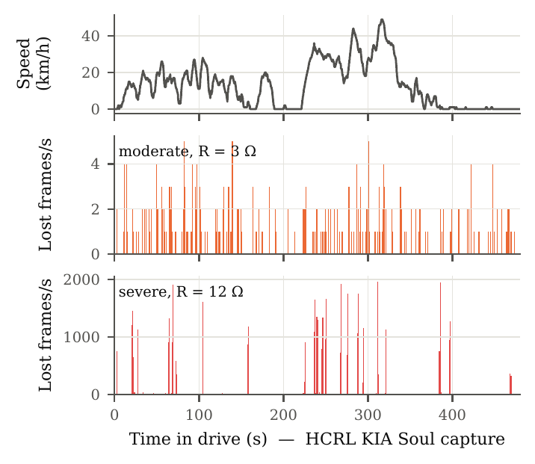
Fig. 2. A real 8-minute drive of the HCRL KIA Soul (top: decoded vehicle speed) replayed through a moderately (middle) and severely (bottom) worn DLC. Losses cluster where the vehicle is moving and vanish at standstill: the excitation coherence that ECTA measures. Severe wear adds brown-out silences (tall bars).
Fig. 2 illustrates the phenomenon on real data before any statistics: in the same drive, losses from a worn DLC follow the vehicle’s motion, while the tool sees nothing at standstill.

Detection
TABLE 3. Detection Performance (AUROC) on Real-Vehicle Telemetry. “All”: DLC Wear (Any Stage) vs. Healthy and Confounder Windows. “Mod.”/“Sev.”: Moderate/Severe Wear vs. Real Healthy Windows Only. Vehicle-Disjoint Splits; Best per Column in Bold.
 | Full-bus passive |  |  | Sampling passive |  |  | OBD-II polling |  |  | VED fleet (381 vehicles)
Method | All | Mod. | Sev. | All | Mod. | Sev. | All | Mod. | Sev. | All | Mod. | Sev.
ECTA (proposed) | 0.880 | 0.891 | 0.995 | 0.675 | 0.556 | 0.957 | 0.723 | 0.528 | 0.891 | 0.775 | 0.493 | 0.851
ECTA w/o coherence | 0.878 | 0.881 | 0.996 | 0.674 | 0.554 | 0.955 | 0.686 | 0.524 | 0.898 | 0.704 | 0.497 | 0.845
ECTA loss features only | 0.768 | 0.761 | 0.955 | 0.673 | 0.551 | 0.952 | 0.670 | 0.527 | 0.845 | 0.672 | 0.501 | 0.806
1D-CNN (supervised) | 0.646 | 0.522 | 0.895 | 0.677 | 0.569 | 0.964 | 0.673 | 0.512 | 0.882 | 0.701 | 0.539 | 0.911
Transformer (supervised) | 0.641 | 0.528 | 0.907 | 0.665 | 0.555 | 0.942 | 0.665 | 0.514 | 0.862 | 0.590 | 0.499 | 0.757
LSTM autoencoder | 0.631 | 0.524 | 0.907 | 0.651 | 0.534 | 0.920 | 0.548 | 0.551 | 0.795 | 0.554 | 0.502 | 0.703
Isolation Forest | 0.622 | 0.939 | 0.992 | 0.637 | 0.530 | 0.883 | 0.599 | 0.523 | 0.821 | 0.551 | 0.494 | 0.739
One-class SVM | 0.596 | 0.830 | 0.958 | 0.658 | 0.542 | 0.931 | 0.603 | 0.511 | 0.864 | 0.541 | 0.488 | 0.682
Loss-rate threshold | 0.653 | 0.963 | 0.996 | 0.667 | 0.551 | 0.948 | 0.579 | 0.520 | 0.893 | 0.567 | 0.508 | 0.813
U-code timeout rule | 0.587 | 0.539 | 0.922 | 0.668 | 0.587 | 0.952 | 0.609 | 0.575 | 0.962 | 0.557 | 0.535 | 0.796
Coherence test $z_{β}$ (no training) | 0.594 | 0.684 | 0.692 | 0.510 | 0.499 | 0.532 | 0.485 | 0.498 | 0.413 | 0.509 | 0.496 | 0.440
Table 3 reports detection on all four corpora. Four findings stand out.
(i) On full-bus captures ECTA generalizes to unseen vehicles. Trained on five vehicles and tested on the sixth, in turn, ECTA reaches an AUROC of 0.880 (95% CI 0.871–0.906) for wear against all other windows and a true-positive rate of 55% at a 1% false-positive rate; no non-ECTA method exceeds 0.653 AUROC or 29% TPR@1%. The end-to-end 1D-CNN and the LSTM autoencoder, trained on the same windows, reach only 0.646 and 0.631: with six vehicles whose buses differ in rate (1 446–2 570 frames/s), identifier sets (27–98) and timing, we attribute this gap to raw sequence models learning vehicle-specific patterns that the self-referenced ECTA features normalize away.
(ii) ECTA is the only method that is strong on both questions. Single-statistic rules and novelty detectors are good at telling wear from healthy data—on full-bus captures the loss-rate threshold reaches 0.963 (moderate) and 0.996 (severe), above ECTA’s 0.891 and 0.995—but they collapse once confounders are present (0.56–0.67 overall for the two rules, 0.54–0.66 for the three novelty detectors, across corpora), because every confounder also produces losses, timeouts or anomalies. ECTA trades a few points of the easier question for a large gain on the realistic one; it has the highest overall AUROC on the full-bus, polling (0.723) and fleet (0.775, 95% CI 0.772–0.778) corpora and ties the 1D-CNN on the sampling corpus (0.675 vs. 0.677, overlapping CIs).
(iii) Detectability is governed by the wear stage and by the tool. Severe wear (6–30 $Ω$, where brown-outs begin) is detected against healthy telemetry at every fidelity: 0.995 (full-bus), 0.957 (sampling), 0.891 (polling) and 0.851 (VED). Moderate wear (1.5–6 $Ω$) is detected only by the full-bus logger (0.891, CI 0.878–0.964): its interruptions last tens to hundreds of microseconds and destroy individual frames, which only a tool that sees every frame can count. To a sampling logger or a polling tester they are almost invisible (0.49–0.56), and incipient wear is indistinguishable from healthy telemetry in any single window for every method. Section VI-C shows that this pattern is predicted by first principles.
(iv) Excitation coherence is what makes polling-mode detection work. Removing the coherence features costs 0.037 AUROC on the polling corpus and 0.071 on VED; on VED even ECTA’s margin over its strongest ablation (loss and coherence features only) has a 95% CI of $+0.017$ to $+0.019$. On full-bus captures it changes nothing (0.880 vs. 0.878): when every frame is visible, the loss-structure features already separate wear from its look-alikes. The training-free $z_{β}$ test alone is not a detector: coherence is a discriminating feature, informative in combination with evidence that losses exist.

Generalization Across Vehicles and Manufacturers
TABLE 4. Full-Bus Detection per Held-Out Vehicle (ECTA Trained on the Other Five). AUROC: Wear vs. All; Moderate and Severe vs. Healthy
Held-out vehicle | Windows | All | Moderate | Severe
CAN-MIRGU vehicle | 126 | 0.904 | 0.898 | 1.000
Chevrolet Impala (2011) | 2541 | 0.882 | 0.900 | 0.999
Chevrolet Silverado (2016) | 1176 | 0.886 | 0.863 | 0.995
Chevrolet Traverse (2011) | 798 | 0.921 | 0.951 | 0.982
KIA Soul | 651 | 0.869 | 0.946 | 0.978
Subaru Forester (2017) | 1176 | 0.910 | 0.982 | 0.994
Table 4 breaks the full-bus result down by held-out vehicle. Performance is uniform across three named manufacturers (model years 2011–2017 where known) and an undisclosed vehicle: 0.869–0.921 overall, 0.863–0.982 for moderate and 0.978–1.000 for severe wear. No vehicle is an outlier, which is the behaviour expected of features that measure the physics of the link rather than the idiosyncrasies of a bus.

An Observability Law
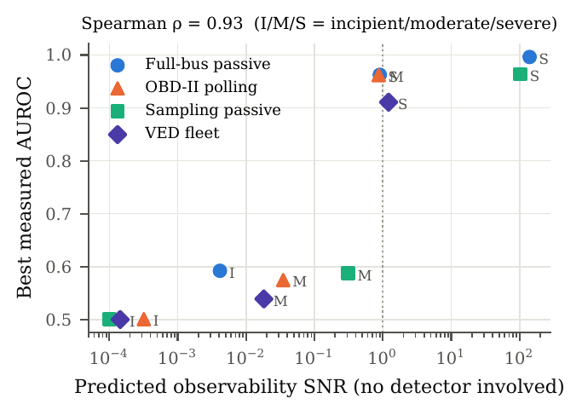
Fig. 3. Predicted observability SNR (Section IV-E), computed from the physics and each tool’s measured healthy background without any detector, against the best AUROC measured for that tool and stage (I, M, S: incipient, moderate, severe wear).
Fig. 3 plots, for every tool and wear stage, the observability SNR of Section IV-E—the number of fault-induced events the physics predicts per window, divided by the spread of the same event count in the tool’s real healthy telemetry—against the best AUROC any method achieved. The two are rank-correlated with Spearman $ρ=0.93$ across the twelve tool–stage combinations. Every combination with a predicted SNR above 0.8 is detected with AUROC $≥0.91$; every combination below 0.4 stays at or below 0.59. The law explains the fidelity results without reference to any classifier: a full-bus tool observes $∼$1 600 frames/s and so turns moderate wear’s sub-millisecond interruptions into $∼$45 lost frames per 30 s, whereas a polling tester observing a few transactions per second expects about one fault-induced event per two-minute window against a background spread of 34 such events in healthy driving, until brown-outs begin. It also tells a tool designer what to change: the observation rate, not the algorithm.

Time to Detect With a Full-Bus Tool
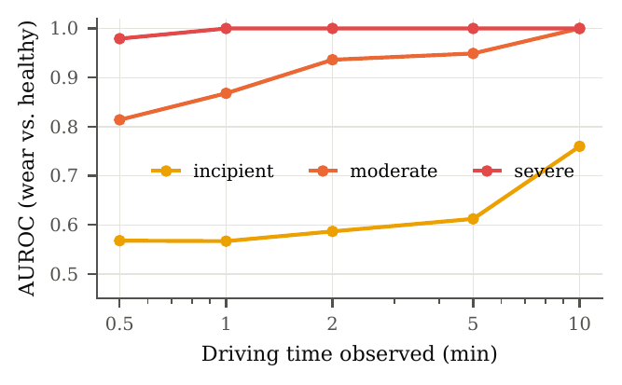
Fig. 4. Full-bus detection when one persistent fault is applied to an entire real drive and the evidence of consecutive 30-s windows is accumulated (vehicle-disjoint models). Points are shown while at least 50 drive trajectories are long enough (399 at 0.5–2 min, 252 at 5 min, 105 at 10 min).
A worn contact keeps its resistance for days, so a tool can accumulate evidence. Fig. 4 applies one fault per drive and stage to whole real drives and averages the per-window log-odds. Severe wear is detected against healthy drives with AUROC 0.98 after 30 s and 1.00 after one minute; moderate wear reaches 0.94 after two minutes and 0.95 after five. Even incipient wear begins to emerge (0.61 after five minutes, 0.76 after ten on the 105 longest drives). In practice, a full-bus tool would flag a moderately worn connector within the first few minutes of the first drive after the wear develops.
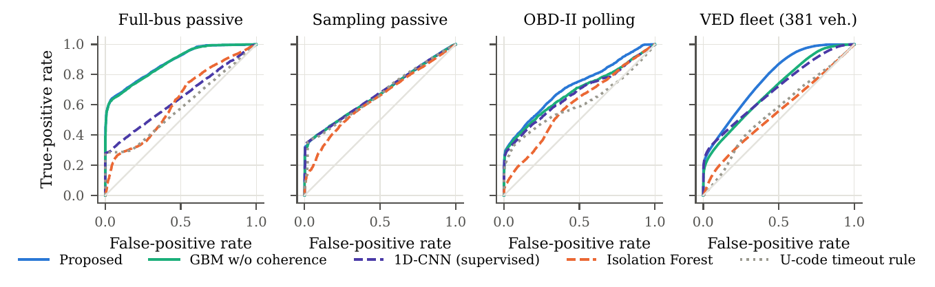
Fig. 5. ROC curves (wear vs. healthy and confounders) on the four corpora, pooled out-of-fold scores.

Telling Wear from Its Look-Alikes
TABLE 5. Discrimination of Moderate/Severe DLC Wear From Each Confounder (AUROC)
Corpus | Method | ECU-side | Bus EMI | Overfl./rand.
Full-bus passive | ECTA (proposed) | 0.949 | 0.979 | 0.977
 | ECTA w/o coherence | 0.945 | 0.978 | 0.977
 | 1D-CNN (supervised) | 0.733 | 0.712 | 0.704
 | U-code timeout rule | 0.728 | 0.529 | 0.718
Sampling passive | ECTA (proposed) | 0.759 | 0.766 | 0.756
 | ECTA w/o coherence | 0.758 | 0.764 | 0.755
 | 1D-CNN (supervised) | 0.764 | 0.766 | 0.767
 | U-code timeout rule | 0.763 | 0.741 | 0.770
OBD-II polling | ECTA (proposed) | 0.753 | 0.878 | 0.762
 | ECTA w/o coherence | 0.761 | 0.741 | 0.772
 | 1D-CNN (supervised) | 0.732 | 0.736 | 0.750
 | U-code timeout rule | 0.690 | 0.701 | 0.699
VED fleet (381 veh.) | ECTA (proposed) | 0.750 | 0.947 | 0.856
 | ECTA w/o coherence | 0.749 | 0.737 | 0.825
 | 1D-CNN (supervised) | 0.756 | 0.734 | 0.841
 | U-code timeout rule | 0.615 | 0.654 | 0.533
Table 5 isolates the attribution question. Against bus-wide EMI, coherence features raise the AUROC from 0.741 to 0.878 on the polling corpus and from 0.737 to 0.947 on VED, even though half of the simulated EMI was deliberately made ignition-coupled. The separation comes from the joint footprint: DLC interruptions remove transactions and correlate with both engine and road excitation, whereas EMI delays transactions and correlates, at most, with engine speed. Against vibration-independent loss, coherence adds 0.031 on VED. Against an ECU-side intermittent no telemetry feature helps in polling mode (0.73–0.76 for all methods): an intermittent engine-ECU connector and an intermittent DLC both make Mode-01 responses disappear, both are vibration-driven, and a tester that talks only to that ECU cannot tell them apart. On the full-bus corpus, where the selectivity of losses across identifiers is observable, the same distinction reaches 0.949 (and 0.979 against EMI, 0.977 against overflow, versus 0.70–0.73 for the 1D-CNN). This is a structural limit worth stating plainly: attributing a fault to the DLC rather than to an ECU connector requires visibility of traffic from more than one ECU.
TABLE 6. Five-Way Fault-Origin Attribution: Macro-F1 (All Windows; Excluding Incipient Windows), Per-Class F1 (Excluding Incipient), and the 1D-CNN Macro-F1
 | ECTA macro-F1 |  | ECTA per-class F1 |  |  |  |  | CNN
Corpus | all | excl. | Hlth. | DLC | ECU | EMI | Ovf. | all
Full-bus passive | 0.554 | 0.616 | 0.33 | 0.90 | 0.38 | 0.58 | 0.90 | 0.273
Sampling passive | 0.231 | 0.235 | 0.16 | 0.55 | 0.07 | 0.24 | 0.15 | 0.256
OBD-II polling | 0.368 | 0.403 | 0.04 | 0.60 | 0.34 | 0.69 | 0.35 | 0.307
VED fleet (381 veh.) | 0.501 | 0.557 | 0.49 | 0.55 | 0.32 | 0.83 | 0.59 | 0.348
Table 6 summarizes the full five-way attribution. ECTA outperforms the end-to-end 1D-CNN by 0.06–0.28 macro-F1 on three corpora and is comparable on the sampling corpus, where all methods are limited by the logger. Fig. 6 shows the VED confusion matrix: bus EMI and overflow/random loss are recognized reliably; the dominant confusions are healthy $↔$ early wear (physically indistinguishable in a single trip) and DLC $↔$ ECU-side (the structural limit above).
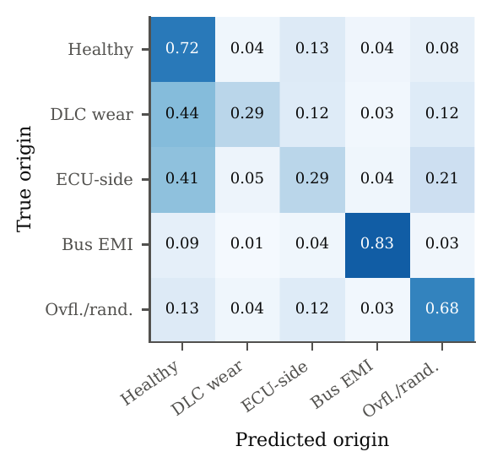
Fig. 6. Row-normalized attribution confusion matrix, VED fleet (381 vehicles, vehicle-disjoint folds).

Pooling Evidence Across Trips
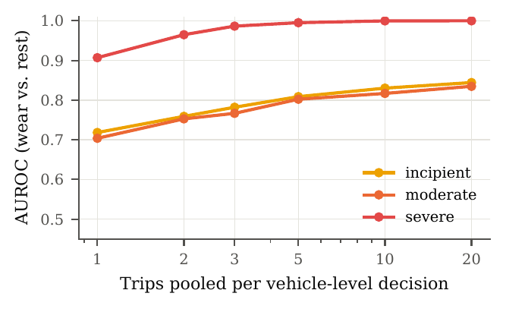
Fig. 7. Vehicle-level detection on VED when the per-trip log-odds of $K$ trips of the same vehicle are averaged. Negatives include healthy and all confounder trips.
A worn DLC stays worn, whereas the background irregularity of healthy telemetry is trip-local. Fig. 7 exploits this. Averaging the per-trip evidence of $K$ trips of the same vehicle raises severe-wear detection on VED from 0.907 ($K=1$) to 0.987 ($K=3$) and 0.9998 ($K=10$) against all negatives, and from 0.850 to 0.999 against healthy vehicles alone. Pooling does not, however, create evidence that is not there: moderate and incipient wear remain at chance against healthy vehicles for every $K$ (0.46–0.50), confirming that for a $∼$1.3 Hz polling logger their footprint lies below the logger’s own background irregularity (the healthy VED trips contain, on median, 31 gaps longer than 0.8 s per minute).

Fleet Prognosis
TABLE 7. Fleet Prognosis on VED (166 Vehicles, 21 824 Real Trips). MAE of RUL (Days) for Failing Vehicles; Alarm When Predicted RUL $<30$ Days: Timely ($≤60$ Days Before Failure), Premature, Missed (% of Failing Vehicles), Median Lead (Days), False Alarms (% of Non-Failing Vehicles)
Method | MAE | Timely | Prem. | Missed | Lead | FA
Failure at 6 $Ω$ (pre-specified), 110 of 166 vehicles fail
Bayesian wear law + HI (proposed) | 71 | 13 | 29 | 58 | 0.0 | 16.1
Conditional reliability (no HI) | 64 | 7 | 7 | 85 | 0.0 | 0.0
HI trend extrapolation | – | 8 | 10 | 82 | 0.0 | 3.6
Fleet reliability (exposure) | 66 | 36 | 28 | 35 | 18.7 | 60.7
Failure at 20 $Ω$ (functional failure; added post hoc), 100 of 166 vehicles fail
Bayesian wear law + HI (proposed) | 71 | 45 | 28 | 27 | 4.0 | 12.1
Conditional reliability (no HI) | 67 | 5 | 10 | 85 | 0.0 | 0.0
HI trend extrapolation | – | 88 | 5 | 7 | 6.4 | 1.5
Fleet reliability (exposure) | 69 | 36 | 34 | 30 | 25.1 | 60.6
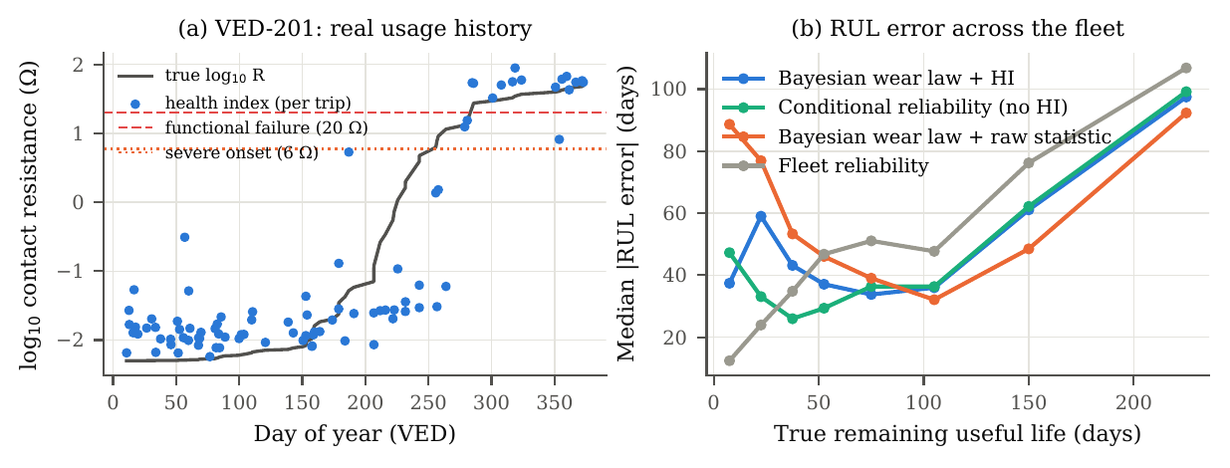
Fig. 8. Fleet prognosis on VED. (a) One vehicle’s connector, wearing with its own recorded usage: true resistance and the per-trip health index learned from telemetry by a vehicle-disjoint model. (b) Median absolute RUL error versus true RUL across all failing vehicles (20-$Ω$ failure definition; the trend alarm is not a point estimator and is omitted).
The 166 VED vehicles with at least 60 trips over at least 200 days were each given a connector that wears with that vehicle’s own recorded usage (21 824 real trips). The learned health index tracks the true contact resistance with $R^{2}=0.86$ (Spearman 0.77) on held-out vehicles (Fig. 8a), but its information is concentrated above $≈$2–4 $Ω$; below that it is left-censored, as the detection results predict.
Table 7 reports the consequences honestly. With failure pre-specified at the onset of the severe stage (6 $Ω$), the detectability floor and the failure threshold nearly coincide, and no telemetry-based method beats the population reliability prior: the RUL error is 64–71 days for all of them. We then evaluated the threshold that matters operationally—functional failure of the tool link at 20 $Ω$, where brown-outs dominate—noting that this second threshold was chosen after seeing the first result. There, a simple alarm on the trend of the learned health index warns 88% of failing vehicles in time (median lead 6.4 days) with a 1.5% false-alarm rate on vehicles that do not fail, whereas the fleet-reliability schedule, which uses the same exposure information but no telemetry, is timely for only 36% and false-alarms on 61%. Point estimates of RUL months ahead, by contrast, are not improved by telemetry at this tool fidelity (Fig. 8b): the Bayesian exposure-domain estimator, which correctly treats sub-floor readings as censored, matches the conditional reliability model but does not beat it. Long-horizon RUL from telemetry therefore requires a tool that sees moderate wear, i.e., full-bus capture. Applying the detection thresholds established above to the same real usage histories gives a projected warning window (from first reliable detection to functional failure) of median 25.5 days (interquartile range 14.3–40.2) for a full-bus tool, which detects from about 1.5 $Ω$, against 14.1 days (7.3–21.2) for a polling tool, which detects from about 6 $Ω$. This projection depends on the knee width of the wear law and is therefore indicative, but the ordering does not.

Robustness to Mis-Specified Physics
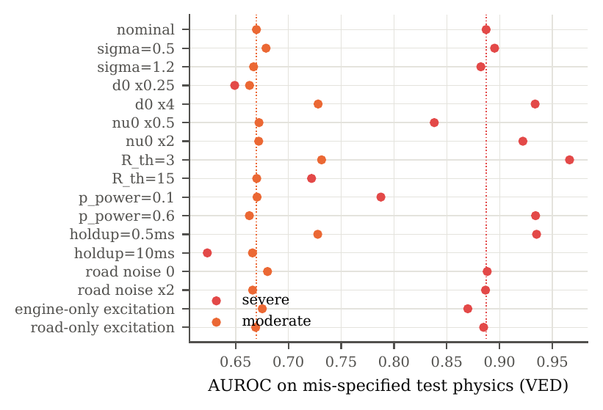
Fig. 9. Robustness of VED detection when the test data are generated with mis-specified physics (training always uses the nominal model of Table 1). Dotted lines: nominal test physics. AUROC against healthy and confounder trips; held-out half of the vehicles.
The constants of Table 1 that are not fixed by standards are unmeasured for J1962 receptacles. We therefore trained ECTA once on the nominal model and tested it on held-out real data generated with each constant perturbed (Fig. 9; for the full-bus corpus, training on three vehicles and testing on the other three). On the full-bus corpus ECTA is robust to every perturbation: the overall AUROC stays between 0.84 and 0.95 (nominal 0.901) and severe-stage AUROC never falls below 0.97, because a tool that counts individual lost frames does not depend on brown-outs. For the polling fleet two regimes emerge. Detection is insensitive—within $±0.02$ AUROC of nominal on VED (0.748)—to the resistance fluctuation spread $σ$, the opportunity rate $ν_{0}$, the magnitude of the unobserved road input, and the composition of the excitation (engine-only or road-only), i.e., to the constants that shape where and how often interruptions occur. It is sensitive to the constants that decide whether interruptions cause brown-outs: shorter interruptions ($d_{0}×\frac{1}{4}$), a longer tool hold-up time (10 ms), a higher discontinuity threshold (15 Ω) or fewer supply-pin interruptions ($p_{pwr}=0.1$) lower severe-stage AUROC on VED from 0.887 to 0.62–0.79, while the opposite perturbations raise it to 0.93–0.97. The practical reading is that a polling tool sees wear chiefly through brown-outs, so the two quantities most worth measuring first on a bench are the interruption-duration distribution of worn receptacles and the hold-up time of the tool itself—the latter a design parameter that, somewhat counter-intuitively, makes a tool a better wear sensor when it is short.

Additional Validation
Four further checks, detailed in the Supplementary Material, address the most likely objections to a physics-informed evaluation.
A structurally different fault model. To test whether ECTA learns the physics or merely the simulator, we generated test faults with a different process: a two-state (Gilbert–Elliott) contact that alternates between quiet periods and chatter episodes, with exponential rather than log-normal interruption durations and a brown-out criterion based on the cumulative open time of an episode instead of a single long interruption. Its mean interruption rate and duration equal those of the nominal model; its temporal structure does not. Trained only on the nominal model, ECTA reaches an AUROC of 0.856 on full-bus captures (moderate 0.848, severe 0.999), against 0.880 on matched physics, and higher values than on matched physics for the polling corpus (0.779) and VED (0.813), where the energy-based brown-out rule makes severe wear more visible.
Window length. Full-bus detection rises monotonically with the window: 0.824 (10 s), 0.879 (30 s) and 0.911 (60 s), with moderate wear at 0.843, 0.895 and 0.930. The 30-s window used throughout is therefore not the most favourable choice; it trades a little accuracy for latency.
Hyperparameters. Hyperparameters were fixed once and never tuned. Across seven gradient-boosting configurations (200–1 000 trees, 15–63 leaves, learning rates 0.02–0.1) the overall AUROC varies by at most 0.004 on full-bus captures, 0.007 on the polling corpus and 0.015 on VED.
Operating points. With the threshold set to detect 90% of severely worn connectors, a full-bus tool raised no false alarm on the real healthy windows of held-out vehicles (0.39 per hour at 95% detection). For low-rate polling tools a single window cannot reach such a point, which is why vehicle-level pooling (Fig. 7) is required before acting.
A Transformer baseline. A supervised Transformer encoder trained end-to-end on the same binned sequences and folds does not close the gap: it reaches an overall AUROC of 0.641 on full-bus captures, 0.665 on the sampling and polling corpora and 0.590 on VED (ECTA: 0.880, 0.675, 0.723 and 0.775). On unseen vehicles, three different sequence architectures (1D-CNN, LSTM autoencoder, Transformer) all fall well short of the physics-derived features. Paired vehicle-bootstrap tests (Supplement S11) confirm that ECTA’s advantage over every non-ECTA baseline on the full-bus corpus (six vehicles) and on VED (381 vehicles) is significant at $p≤0.001$, the resolution of 1 000 resamples; the polling corpus shows the same direction but, with three vehicles, supports no formal test.

Feature Importance and Cost
On VED the five most important features by split gain are the dispersion of timeout-gap durations, the strong-event high/low excitation ratio, the longest gap, long gaps per minute and the all-event excitation ratio (Fig. 10); coherence features account for 48 % of the total gain. Feature extraction takes 23 ms for a 30-s full-bus window containing 58 583 frames and 4.8 ms for a 120-s polling window in unoptimized Python, and the trained detector is a 1.3-MB tree ensemble; ECTA is therefore deployable on the tool or at the fleet back end at negligible cost.
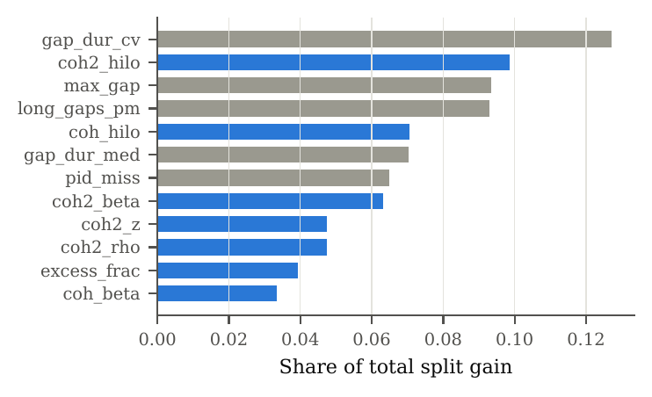
Fig. 10. Twelve most important ECTA features on VED (share of split gain). Blue: excitation-coherence features.

Discussion

What the Evidence Supports
Across five public datasets, nine vehicles analysed in detail and a 381-vehicle fleet, the results support five claims. First, a full-bus tool detects moderate and severe DLC wear on vehicles it has never seen, with uniform performance across six vehicles from at least three manufacturers, and confirms moderate wear within minutes of driving. Second, severe wear is detectable at every tool fidelity, and with near-certainty at the vehicle level once a handful of trips are pooled. Third, which stage a tool can see is predicted by a first-principles observability law, so the choice of tool—its observation rate—rather than the choice of algorithm sets the earliest point at which wear can be detected. Fourth, excitation coherence is the feature family that makes polling-mode detection specific: it separates wear from bus-wide interference and from vibration-independent loss, which loss-counting rules and generic anomaly detectors cannot. Fifth, a health index learned from telemetry supports a short-horizon early warning with a low false-alarm rate, but not months-ahead RUL estimation for polling tools.

Practical Implications
For telematics and fleet operators the findings translate into concrete guidance: (i) log full-bus traffic, or at least CAN error counters and brown-out events, if early warning matters; (ii) never attribute data loss to a DLC from loss counts alone—check excitation coherence and, where possible, whether losses are spread across ECUs; (iii) pool evidence per vehicle across trips before acting; and (iv) treat the J1962 receptacle, not only the device, as a field-replaceable item when the pooled evidence is positive. These require no hardware change to existing devices.

Limitations and Threats to Validity
Fault realism. The healthy telemetry, the excitation and the usage histories are real, but the connector faults are modelled. No public dataset of naturally worn J1962 connectors exists, and we do not claim measured values for the unmeasured constants of Table 1. We mitigated this in four ways: the model’s structure follows the contact literature and CAN/ISO 15765 behaviour; the detector never accesses model internals; Section VI-H quantifies how performance changes when the test physics differs from the training physics; and Section VI-I shows that a detector trained on one fault process retains its performance on a structurally different one. Validation on connectors worn on a vibration rig and on field returns is the necessary next step; a pre-registered bench protocol for it has been prepared by the authors.
Data coverage. The full-bus corpus covers six vehicles and 2.68 h of driving (17.5 million frames); three of the six are General Motors products, and broader manufacturer coverage would strengthen the generalization claim. The sampling and polling corpora each cover three vehicles. VED provides breadth (381 vehicles) but only through one, low-rate logger type.
Post-hoc choices. The 20-$Ω$ failure threshold in the prognosis study was chosen after the pre-specified 6-$Ω$ analysis; we report both. In the observability model, the sampling-logger term ($a_{sig}=0$) was corrected after a first comparison revealed that a frame lost on the wire is replaced by the next sampled frame; the correction is physical and is stated in Section IV-E. All detector design choices (features, model, hyperparameters, windows, splits) were fixed before the held-out evaluations were run.
Confounder coverage. Four confounders were modelled; others exist (e.g., ignition-key cycling, deliberate tool sleep modes, cellular back-haul outages that drop already-logged data). The ECU-side confounder in polling mode is, as shown, not separable without multi-ECU visibility.
Protocol coverage. All data are classical CAN at 500 kbit/s. The physics carries over to CAN-FD, whose faster data phase shortens frames and therefore lowers the per-frame hit probability, and to legacy OBD-II transports (ISO 9141, J1850), but these were not evaluated.

Conclusion
This paper introduced excitation-coherent telemetry analysis for detecting, attributing and predicting the wear of the OBD-II diagnostic connector from the telemetry of the attached tool. A physics-informed model links fretting wear to the observable behaviour of three classes of diagnostic tool, and an evaluation on real data from five public datasets, nine vehicles and a 381-vehicle fleet, with strictly vehicle-disjoint splits, shows that (i) a full-bus tool detects wear on unseen vehicles with AUROC 0.880 (moderate 0.891, severe 0.995), uniformly across six vehicles from at least three manufacturers, and confirms moderate wear within two minutes of driving; (ii) a first-principles observability law predicts which wear stages each tool can detect (Spearman 0.93 with measured performance); (iii) for low-rate polling tools, excitation coherence is what separates wear from its look-alikes (0.947 vs. 0.737 against bus interference) and severe wear is confirmed per vehicle with AUROC 0.999 after ten trips; and (iv) telemetry supports early warnings with 88% timely detection and 1.5% false alarms, but not months-ahead RUL, for low-rate tools. Future work will validate the method on naturally worn connectors, extend it to CAN error-counter telemetry and CAN-FD, and investigate multi-ECU attribution.

Data and Code Availability
All datasets used are public [24], [26], [27], [40], [41]. The complete code for data cleaning, fault modelling, feature extraction, experiments, figures and tables, together with scripts that reproduce every number reported here, is available at https://github.com/Bhargavteja-9779/FOAE-Fault-Origin-Attribution-Engine (directory ocwd).

Acknowledgment
The authors thank the creators of the can-train-and-test, HCRL Car-Hacking, CAN-MIRGU, CANmodes and Vehicle Energy datasets for making their recordings public. The method described here is related to Indian Patent Application 202641074361 [44].

References

Author Biographies
P. N. Bhargav Teja is with the School of Computer Science and Engineering, Vellore Institute of Technology, Vellore, India. [ADD BIOGRAPHY]
Lanka Sree Chathurya is with the School of Computer Science and Engineering, Vellore Institute of Technology, Vellore, India. [ADD BIOGRAPHY]
K. Arun Reddy is with the School of Computer Science and Engineering, Vellore Institute of Technology, Vellore, India. [ADD BIOGRAPHY]
Ragavan K is with the School of Computer Science and Engineering, Vellore Institute of Technology, Vellore, India. [ADD BIOGRAPHY]

References
[1] SAE International, “SAE J1962: Diagnostic connector.” Surface Vehicle Standard, 2016.
[2] M. Antler, “Survey of contact fretting in electrical contacts,” IEEE Trans. Compon., Hybrids, Manuf. Technol., vol. 8, no. 1, pp. 87–104, 1985.
[3] M. D. Bryant, “Resistance buildup in electrical connectors due to fretting corrosion of rough surfaces,” IEEE Trans. Compon., Packag., Manuf. Technol. A, vol. 17, no. 1, pp. 86–95, 1994.
[4] Y. W. Park, T. S. N. S. Narayanan, and K. Y. Lee, “Fretting corrosion of tin-plated contacts,” Tribol. Int., vol. 41, no. 7, pp. 616–628, 2008, doi: 10.1016/j.triboint.2007.02.002.
[5] M. Braunović, V. V. Konchits, and N. K. Myshkin, Electrical contacts: Fundamentals, applications and technology. Boca Raton, FL, USA: CRC Press, 2007.
[6] R. Holm, Electric contacts: Theory and application, 4th ed. Berlin, Germany: Springer, 1967.
[7] Y. W. Park, J. P. Jung, and K. Y. Lee, “Overview of fretting corrosion in electrical connectors,” Int. J. Automot. Technol., vol. 7, no. 1, pp. 75–82, 2006.
[8] G. T. Flowers, F. Xie, M. J. Bozack, and R. D. Malucci, “Vibration thresholds for fretting corrosion in electrical connectors,” IEEE Trans. Compon. Packag. Technol., vol. 27, no. 1, pp. 65–71, 2004.
[9] Q. Shen, K. Lv, G. Liu, and J. Qiu, “Dynamic performance of electrical connector contact resistance and intermittent fault under vibration,” IEEE Trans. Compon., Packag., Manuf. Technol., vol. 8, no. 2, pp. 216–225, 2018.
[10] Q. Shen, K. Lv, G. Liu, and J. Qiu, “Impact of electrical contact resistance on the high-speed transmission and on-line diagnosis of electrical connector intermittent faults,” IEEE Access, vol. 5, pp. 4221–4232, 2017, doi: 10.1109/ACCESS.2017.2679223.
[11] USCAR, “SAE/USCAR-2: Performance specification for automotive electrical connector systems.” SAE International / United States Council for Automotive Research, 2020.
[12] Robert Bosch GmbH, “CAN specification version 2.0,” Robert Bosch GmbH, Stuttgart, Germany, 1991.
[13] ISO, “ISO 11898-1: Road vehicles—controller area network (CAN)—part 1: Data link layer and physical signalling.” International Organization for Standardization, 2015.
[14] H. M. Song, H. R. Kim, and H. K. Kim, “Intrusion detection system based on the analysis of time intervals of CAN messages for in-vehicle network,” in Proc. Int. Conf. Inf. Netw. (ICOIN), 2016, pp. 63–68. doi: 10.1109/ICOIN.2016.7427089.
[15] K.-T. Cho and K. G. Shin, “Fingerprinting electronic control units for vehicle intrusion detection,” in Proc. 25th USENIX secur. symp., 2016, pp. 911–927.
[16] P.-S. Murvay and B. Groza, “Source identification using signal characteristics in controller area networks,” IEEE Signal Process. Lett., vol. 21, no. 4, pp. 395–399, 2014.
[17] K.-T. Cho and K. G. Shin, “Viden: Attacker identification on in-vehicle networks,” in Proc. ACM SIGSAC conf. Comput. Commun. Secur. (CCS), 2017, pp. 1109–1123. doi: 10.1145/3133956.3134001.
[18] W. Choi, K. Joo, H. J. Jo, M. C. Park, and D. H. Lee, “VoltageIDS: Low-level communication characteristics for automotive intrusion detection system,” IEEE Trans. Inf. Forensics Security, vol. 13, no. 8, pp. 2114–2129, 2018, doi: 10.1109/TIFS.2018.2812149.
[19] M. Kneib and C. Huth, “Scission: Signal characteristic-based sender identification and intrusion detection in automotive networks,” in Proc. ACM SIGSAC conf. Comput. Commun. Secur. (CCS), 2018, pp. 787–800. doi: 10.1145/3243734.3243751.
[20] L. Popa, B. Groza, C. Jichici, and P.-S. Murvay, “ECUPrint—physical fingerprinting electronic control units on CAN buses inside cars and SAE J1939 compliant vehicles,” IEEE Trans. Inf. Forensics Security, vol. 17, pp. 1185–1200, 2022.
[21] M.-J. Kang and J.-W. Kang, “Intrusion detection system using deep neural network for in-vehicle network security,” PLoS ONE, vol. 11, no. 6, p. e0155781, 2016.
[22] A. Taylor, S. Leblanc, and N. Japkowicz, “Anomaly detection in automobile control network data with long short-term memory networks,” in Proc. IEEE int. Conf. Data sci. Adv. Analytics (DSAA), 2016, pp. 130–139.
[23] M. Hanselmann, T. Strauss, K. Dormann, and H. Ulmer, “CANet: An unsupervised intrusion detection system for high dimensional CAN bus data,” IEEE Access, vol. 8, pp. 58194–58205, 2020, doi: 10.1109/ACCESS.2020.2982544.
[24] E. Seo, H. M. Song, and H. K. Kim, “GIDS: GAN based intrusion detection system for in-vehicle network,” in Proc. 16th annu. Conf. Privacy, secur. Trust (PST), 2018, pp. 1–6. doi: 10.1109/PST.2018.8514157.
[25] M. E. Verma et al., “A comprehensive guide to CAN IDS data and introduction of the ROAD dataset,” PLoS ONE, vol. 19, no. 1, p. e0296879, 2024, doi: 10.1371/journal.pone.0296879.
[26] B. Lampe and W. Meng, “Can-train-and-test: A curated CAN dataset for automotive intrusion detection,” Comput. Secur., vol. 140, p. 103777, 2024, doi: 10.1016/j.cose.2024.103777.
[27] S. Rajapaksha, G. Madzudzo, H. Kalutarage, A. Petrovski, and M. O. Al-Kadri, “CAN-MIRGU: A comprehensive CAN bus attack dataset from moving vehicles for intrusion detection system evaluation,” in Proc. Symp. Vehicles secur. Privacy (VehicleSec), 2024.
[28] E. Y. Chow and A. S. Willsky, “Analytical redundancy and the design of robust failure detection systems,” IEEE Trans. Autom. Control, vol. 29, no. 7, pp. 603–614, 1984.
[29] A. Theissler, “Detecting known and unknown faults in automotive systems using ensemble-based anomaly detection,” Knowl.-Based Syst., vol. 123, pp. 163–173, 2017, doi: 10.1016/j.knosys.2017.02.023.
[30] X.-S. Si, W. Wang, C.-H. Hu, and D.-H. Zhou, “Remaining useful life estimation—a review on the statistical data driven approaches,” Eur. J. Oper. Res., vol. 213, no. 1, pp. 1–14, 2011.
[31] Y. Lei, N. Li, L. Guo, N. Li, T. Yan, and J. Lin, “Machinery health prognostics: A systematic review from data acquisition to RUL prediction,” Mech. Syst. Signal Process., vol. 104, pp. 799–834, 2018.
[32] A. Saxena, J. Celaya, B. Saha, S. Saha, and K. Goebel, “Metrics for offline evaluation of prognostic performance,” Int. J. Prognostics Health Manage., vol. 1, no. 1, pp. 4–23, 2010.
[33] F. T. Liu, K. M. Ting, and Z.-H. Zhou, “Isolation forest,” in Proc. 8th IEEE int. Conf. Data mining (ICDM), 2008, pp. 413–422.
[34] B. Schölkopf, J. C. Platt, J. Shawe-Taylor, A. J. Smola, and R. C. Williamson, “Estimating the support of a high-dimensional distribution,” Neural Comput., vol. 13, no. 7, pp. 1443–1471, 2001.
[35] P. Malhotra, A. Ramakrishnan, G. Anand, L. Vig, P. Agarwal, and G. Shroff, “LSTM-based encoder-decoder for multi-sensor anomaly detection.” arXiv:1607.00148, 2016.
[36] SAE International, “SAE J1979: E/e diagnostic test modes.” Surface Vehicle Standard, 2017.
[37] ISO, “ISO 15765-4: Road vehicles—diagnostic communication over controller area network (DoCAN)—part 4: Requirements for emissions-related systems.” International Organization for Standardization, 2021.
[38] P. McCullagh and J. A. Nelder, Generalized linear models, 2nd ed. London, U.K.: Chapman & Hall, 1989.
[39] G. Ke et al., “LightGBM: A highly efficient gradient boosting decision tree,” in Proc. Adv. Neural inf. Process. Syst. (NeurIPS), 2017, pp. 3146–3154.
[40] A. S. Roque, L. M. S. Alves, and E. P. Freitas, “CAN-Modes: In-vehicle datasets generation and analysis in different driving situations,” in Proc. IEEE 9th workshop commun. Netw. Power syst. (WCNPS), Brasília, Brazil, 2024.
[41] G. Oh, D. J. LeBlanc, and H. Peng, “Vehicle energy dataset (VED), a large-scale dataset for vehicle energy consumption research,” IEEE Trans. Intell. Transp. Syst., vol. 23, no. 4, pp. 3302–3312, 2022, doi: 10.1109/TITS.2020.3035596.
[42] B. Efron and R. J. Tibshirani, An introduction to the bootstrap. New York, NY, USA: Chapman & Hall, 1993.
[43] F. Pedregosa et al., “Scikit-learn: Machine learning in Python,” J. Mach. Learn. Res., vol. 12, pp. 2825–2830, 2011.
[44] P. N. B. Teja, L. S. Chathurya, K. A. Reddy, and R. K, “Predictive OBD-II connector wear detection using CAN telemetry analysis.” Indian Patent Application 202641074361, 2026.

