Group-conformal calibration of near-infrared prediction intervals for new seasons, instruments and regions using PLS diagnostics
P N Bhargav Tejaª, Divya Meena S^{a,*}
ª School of Computer Science and Engineering, Vellore Institute of Technology, Vellore, Tamil Nadu, India
* Corresponding author: Divya Meena S, divyameena.s@vit.ac.in

Abstract
Prediction intervals for multivariate calibration are usually calibrated on samples that resemble the calibration set, but near-infrared (NIR) models are deployed on new harvest seasons, instruments and regions. Using 146,873 public spectra (mango dry matter, soil organic carbon, corn, tablets) in 12 deployment-shift scenarios with sample-disjoint group splits, we show that classical partial least squares (PLS) intervals and random-split conformal prediction under-cover new groups: for new mango seasons and instruments, random-split conformal prediction covered 0.78–0.83 of spectra at a nominal 0.90. We propose group-conformal calibration (GC-D), which computes conformity scores out-of-group with group-balanced weights and scales them by Hotelling T² and Q residuals. GC-D covered 0.88–0.90 for new seasons, 0.88 for new instruments and 0.90 for new soil regions, with interval scores close to an oracle calibrated on the new group, and lowered false acceptances in specification-limit decisions. Out-of-group calibration supplied most of the gain — a classical interval based on the group-wise root-mean-square error of cross-validation reached similar coverage with higher interval scores — whereas diagnostic scaling kept the coverage of atypical spectra and under spectral drift. Interval-score gains over random-split conformal prediction were consistent in direction but mostly not significant at the group level. Finite-sample group-level guarantees required at least 1/α − 1 calibration groups (ten at 90 %), and no interval method rescued uncorrected instrument transfer, for which a few labelled samples of the new group and a Q-based rejection rule are needed.
Keywords: Near-infrared spectroscopy; Multivariate calibration; Conformal prediction; Prediction interval; Calibration transfer; Measurement uncertainty

1. Introduction
Near-infrared (NIR) spectroscopy combined with multivariate calibration is used routinely to predict composition in agriculture, food, soil and pharmaceutical analysis because it is rapid, non-destructive and inexpensive per sample [1,2]. A predicted concentration is, however, only useful for a decision when it is accompanied by an honest statement of its uncertainty [3]. Standard practice derives sample-specific prediction intervals from the calibration error and the leverage of the new spectrum [4–6], or from linearisation and resampling approximations [7–9]. These intervals rest on distributional assumptions and, more importantly, on the assumption that future samples resemble the calibration samples.
Conformal prediction offers prediction intervals with a finite-sample, distribution-free coverage guarantee under a single assumption: exchangeability of calibration and test data [10–12]. It has begun to enter chemometrics and analytical chemistry: jackknife+ intervals for PLS regression [13], normalised inductive conformal predictors for mid-infrared food adulteration [14], conformalised uncertainty models for soil organic carbon from Raman spectra [15], aggregated inductive conformal prediction for NIR spectra [16] and multiview conformal identification of microplastics [17]; it has also been used for applicability-domain assessment in QSAR [18]. In the regression studies, calibration and test samples are obtained by random partitioning of one data pool, which is exactly the setting in which the exchangeability assumption holds by construction.
The setting in which NIR calibrations are actually used is different. A fruit-quality model is calibrated on past harvest seasons and applied to the next one; a model developed on one spectrometer is used on another unit; a soil model is applied to a region that did not contribute calibration samples. Such season, instrument and region effects are a central problem of NIR practice [19–22] and motivate calibration transfer and domain-adaptation methods [23,24]. Under these deployment shifts calibration and test samples are no longer exchangeable, so the coverage guarantee of randomly calibrated conformal intervals no longer applies. Statistical work has proposed weighted conformal prediction for covariate shift [25,26], adaptive procedures for sequential shift [27] and, most relevant here, conformal methods for hierarchical (grouped) data [28–30], which guarantee coverage for an observation from a new group when the groups themselves are exchangeable. To our knowledge these group-level ideas have not been examined for multivariate calibration, and it is not known how large the coverage loss of current practice is in real NIR deployments, nor whether the remedy is practical with the limited number of seasons or instruments typically available.
What distinguishes this work from the statistical literature on hierarchical conformal prediction is not the coverage theory, which we borrow, but its adaptation to multivariate calibration, where three features of NIR practice matter. First, groups and physical samples are crossed: the same fruit or corn sample is scanned on several instruments, so the calibration must be unit-disjoint as well as group-disjoint. Second, the PLS model's own diagnostics, Hotelling T² and the Q residual [31], describe how far a new spectrum lies from the calibration space and can drive the interval width without an additional difficulty model. Third, out-of-group residuals are a by-product of the group-wise cross-validation that chemometricians already run, but the number of groups is small (often fewer than ten seasons or instruments) — exactly where finite-sample guarantees break down.
We state at the outset what is borrowed. Group-wise validation is established practice for estimating the error under shift [21,32]; conformal prediction for new groups and its theory are due to Dunn et al. and Lee et al. [28,29]; normalised conformity scores date back to Papadopoulos et al. [33], who scaled residuals by the mean error of the k nearest training points, recently applied to mid-infrared spectra [14]. Our scale σ(x) differs in being a three-parameter function of T² and Q, which extrapolates to spectra unlike any training spectrum, and in being fitted to out-of-group residuals, so that it learns how the error grows for a group the model has not seen; a k-nearest-neighbour normalised predictor is included as a baseline.
This work makes four contributions. (i) We quantify, on four public data sets comprising 146,873 spectra and 12 deployment-shift scenarios, how much classical PLS intervals, random-split conformal methods and model-based uncertainty estimates miscover when a calibration meets a new season, instrument, population or region. (ii) We propose a group-conformal calibration for PLS models (GC-D) with unit-disjoint out-of-group conformity scores, group-balanced weights and a T²/Q scale. (iii) We identify in a factorial ablation where each component is needed, when distribution-free group-level guarantees are attainable and how reliable a single deployment is, and evaluate specification-limit decisions. (iv) We derive rules for the cases in which no interval method can help. The protocol, hypotheses and primary end-points were fixed before the held-out evaluation; later analyses are identified as such.

2. Theory

2.1. Problem setting
Let the calibration data consist of spectra xᵢ ∈ ℝᵖ with reference values yᵢ, i = 1, …, n, each belonging to one of K groups gᵢ ∈ {1, …, K} (harvest seasons, instruments, populations or regions) and to a physical unit uᵢ (fruit, soil sample, tablet). Several spectra may share a unit. A model is deployed on spectra of a new group K + 1. For a miscoverage level α we seek an interval C(x) with
P{ Y_{new} ∈ C(X_{new}) } ≥ 1 − α, (X_{new}, Y_{new}) drawn from the new group (1)
Random-split conformal prediction attains (1) when calibration and test points are exchangeable [11]. Here we instead assume hierarchical exchangeability [29]: the groups are exchangeable with one another (a new season is a priori like past seasons) and spectra are exchangeable within a group, while spectra of the same group may share a common effect (for example a seasonal bias).

2.2. PLS model and spectral diagnostics
The point predictor is PLS1 regression [2] with A latent variables, ŷ(x) = ȳ + (x − x̄)ᵀ R_{A} q_{A}, where R_{A} = W_{A} (P_{A}ᵀ W_{A})⁻¹ maps a mean-centred spectrum to its scores t = R_{A}ᵀ(x − x̄). Two diagnostics describe how a spectrum relates to the calibration space [31]:
T²(x) = Σₐ tₐ² / sₐ², Q(x) = ‖(x − x̄) − P_{A} t‖² (2)
where sₐ² is the variance of the a-th training score. T² measures extrapolation within the model subspace and Q measures spectral variation the model has not seen. The leverage used in classical intervals is h(x) = 1/n + Σₐ tₐ²/(𝐭ₐᵀ𝐭ₐ), where 𝐭ₐ is the vector of training scores of component a, i.e. a rescaled version of T².

2.3. Group-conformal calibration with diagnostic scaling (GC-D)
Step 1 (out-of-group residuals). The calibration groups are partitioned into folds (one group per fold when K is small). For each fold k, a PLS model μ̂_{−k} is fitted on the remaining groups after removing every unit that also occurs in fold k, so that no physical sample contributes to the model that predicts it. The out-of-group residual of spectrum i in fold k(i) is rᵢ = yᵢ − μ̂_{−k(i)}(xᵢ), with diagnostics T²ᵢ and Qᵢ computed by the same model. The number of latent variables A is chosen by minimising the group-balanced root mean squared error of these residuals, so the step costs nothing beyond the group-wise cross-validation that is usual practice.
Step 2 (diagnostic scale). The expected absolute residual is modelled as
log σ(x) = β₀ + β₁ log(1 + T²(x)) + β₂ log(Q(x)/Q̃) (3)
with Q̃ the median training Q of the final model. β is estimated by a log-link generalised linear model with Poisson quasi-likelihood on (|rᵢ|, T²ᵢ, Qᵢ); σ is bounded below by 10 % of its median to avoid division by near-zero scales. Under a log link the quasi-likelihood estimates the mean of |r| consistently whatever the distribution of the absolute residuals [34], and, unlike least squares on log|r|, it is not dominated by residuals close to zero. The constant 1 keeps log(1 + T²) finite for spectra at the centre of the score space, and dividing Q by Q̃ only shifts β₀. Eq. (3) generalises the √(1 + h) factor of classical intervals by letting the data decide how strongly extrapolation (T²) and unmodelled spectral variation (Q) inflate the error; σ only ranks spectra by expected difficulty, and q̂ below is calibrated on the out-of-group scores whatever its form (alternative families, transforms and an interaction are compared in Section 4.5).
Step 3 (group-balanced quantile). With conformity scores sᵢ = |rᵢ|/σ(xᵢ) and weights wᵢ = 1/(K·N_{gᵢ}), where N_{g} is the number of spectra in group g, every group contributes the same total mass regardless of its size. The calibrated multiplier is
q̂ = inf{ t : Σᵢ wᵢ 1(sᵢ ≤ t) ≥ 1 − α } (4)
Step 4 (interval). The final PLS model, fitted on all calibration spectra, provides ŷ(x), T²(x) and Q(x) for a new spectrum, and
C(x) = [ ŷ(x) − q̂ σ(x), ŷ(x) + q̂ σ(x) ] (5)
The procedure is summarised in Fig. 1.
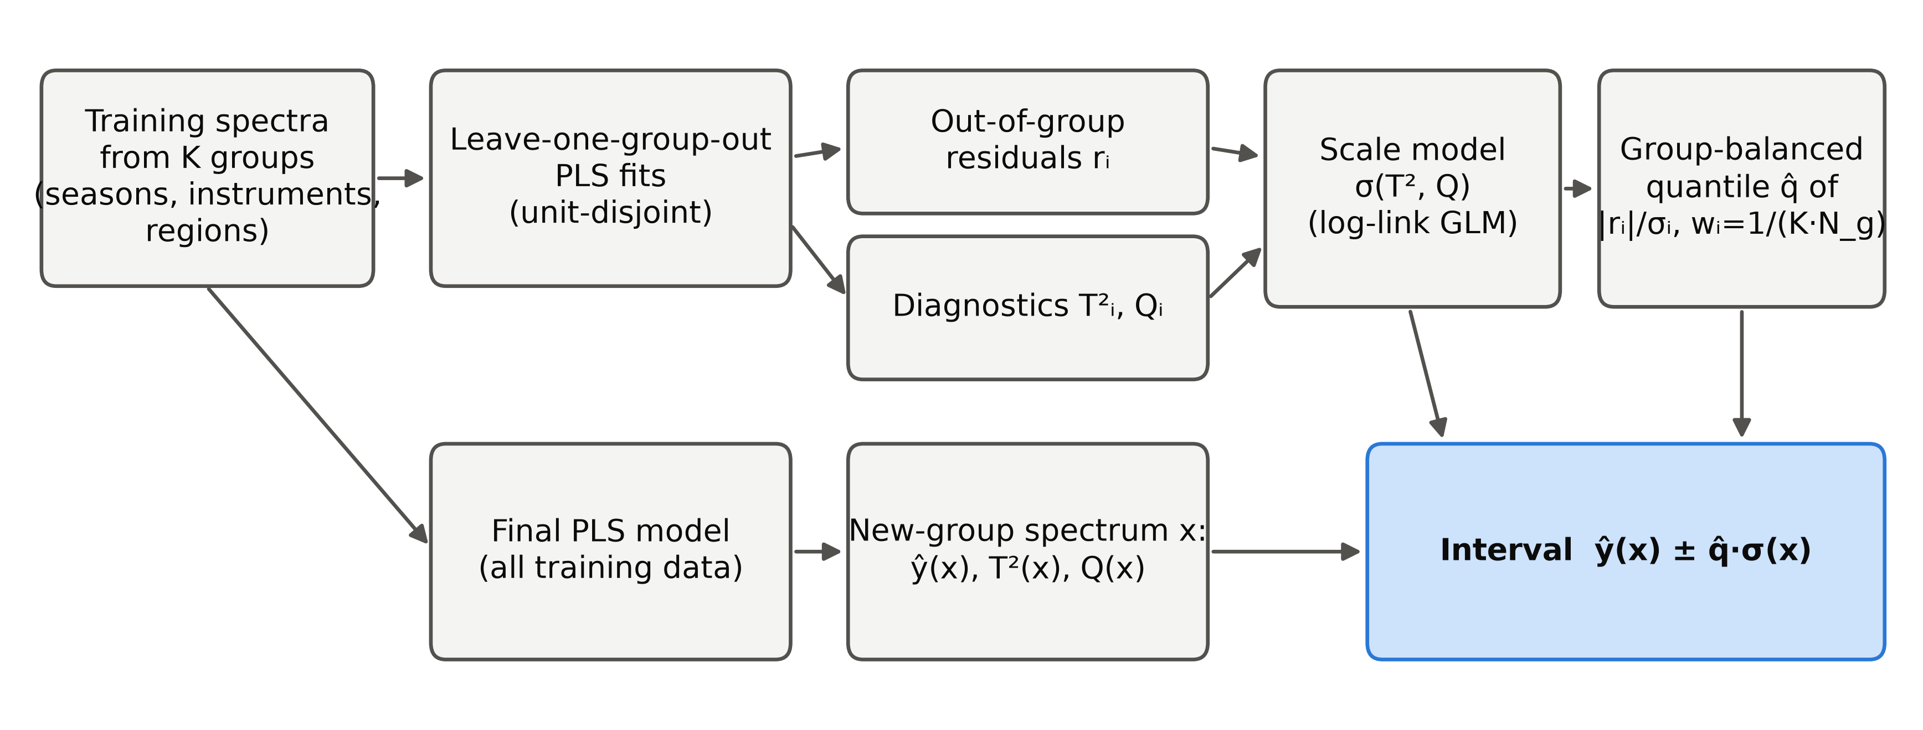
Fig. 1. Group-conformal calibration with diagnostic scaling (GC-D). Out-of-group residuals and the PLS diagnostics T² and Q of the training spectra are obtained from the group-wise cross-validation; a scale model σ(T², Q) and a group-balanced quantile q̂ of the normalised residuals turn the final model's prediction into an interval.

2.4. Coverage guarantees and their limits
Because q̂ in (4) equalises group contributions, it estimates the quantile of the score distribution of a randomly chosen new group (pooled empirical distribution functions), which is asymptotically valid as K grows [28]. Finite-sample guarantees under hierarchical exchangeability are available for two variants that we also evaluate [29]: hierarchical split conformal prediction (HCP), in which half of the groups fit the model and σ and the other K₁ groups calibrate with weights 1/((K₁ + 1)N_{g}) and a point mass 1/(K₁ + 1) at +∞, has coverage ≥ 1 − α; the hierarchical jackknife+ (HJ+), the leave-one-group-out analogue of the jackknife+ [35], has coverage ≥ 1 − 2α. The point mass at +∞ implies that a finite interval at level 1 − α requires K₁ + 1 > 1/α, i.e. at least 10 calibration groups at α = 0.10, but 20 at α = 0.05 and 5 at α = 0.20; the threshold depends on the nominal level, not on the data. With six past harvest seasons a distribution-free season-level guarantee is therefore impossible at 90 % coverage; the cross-fitted GC-D trades this guarantee for usability, and its coverage must be assessed empirically, which is what Section 4 does. All these statements concern coverage averaged over new groups: even an exact method covers some new groups less and others more than 1 − α, because each group carries its own effect. How widely single deployments scatter around the nominal level is examined in Section 4.4.

3. Experimental

3.1. Data sets
Mango. The public Mango DMC and NIR spectra data set (version 5, file v4) [36] contains 85,401 short-wave NIR absorbance spectra (285–1200 nm, 3 nm steps) of 10,560 intact mango fruit with dry-matter content (DM, % w/w) reference values, collected over seven harvest seasons (2015–2021; Fig. 2a) with 31 individual spectrometer units (instrument identifiers in the data set), 199 populations (orchard and harvest-date lots) and ten cultivars [21,37]. Many fruit were scanned several times and on several instruments (on average 8.1 spectra per fruit).
Soil. The Open Soil Spectral Library v1.2 [38] provides visible-NIR reflectance spectra (400–2500 nm) and organic carbon (OC) for the LUCAS topsoil survey [39] (40,175 samples from the 2009 and 2015 campaigns) and the USDA KSSL library (19,747 samples with OC and spectra after quality filtering).
Corn and tablets. The corn data set [40] contains 80 ground-corn samples measured on three NIR spectrometers (m5, mp5, mp6; 1100–2498 nm) with moisture, oil, protein and starch values. The IDRC 2002 pharmaceutical tablet shoot-out data [41] contain 655 tablets measured on two spectrometers (600–1898 nm) with their official calibration (155), validation (40) and test (460) sets; the active-ingredient assay was modelled.
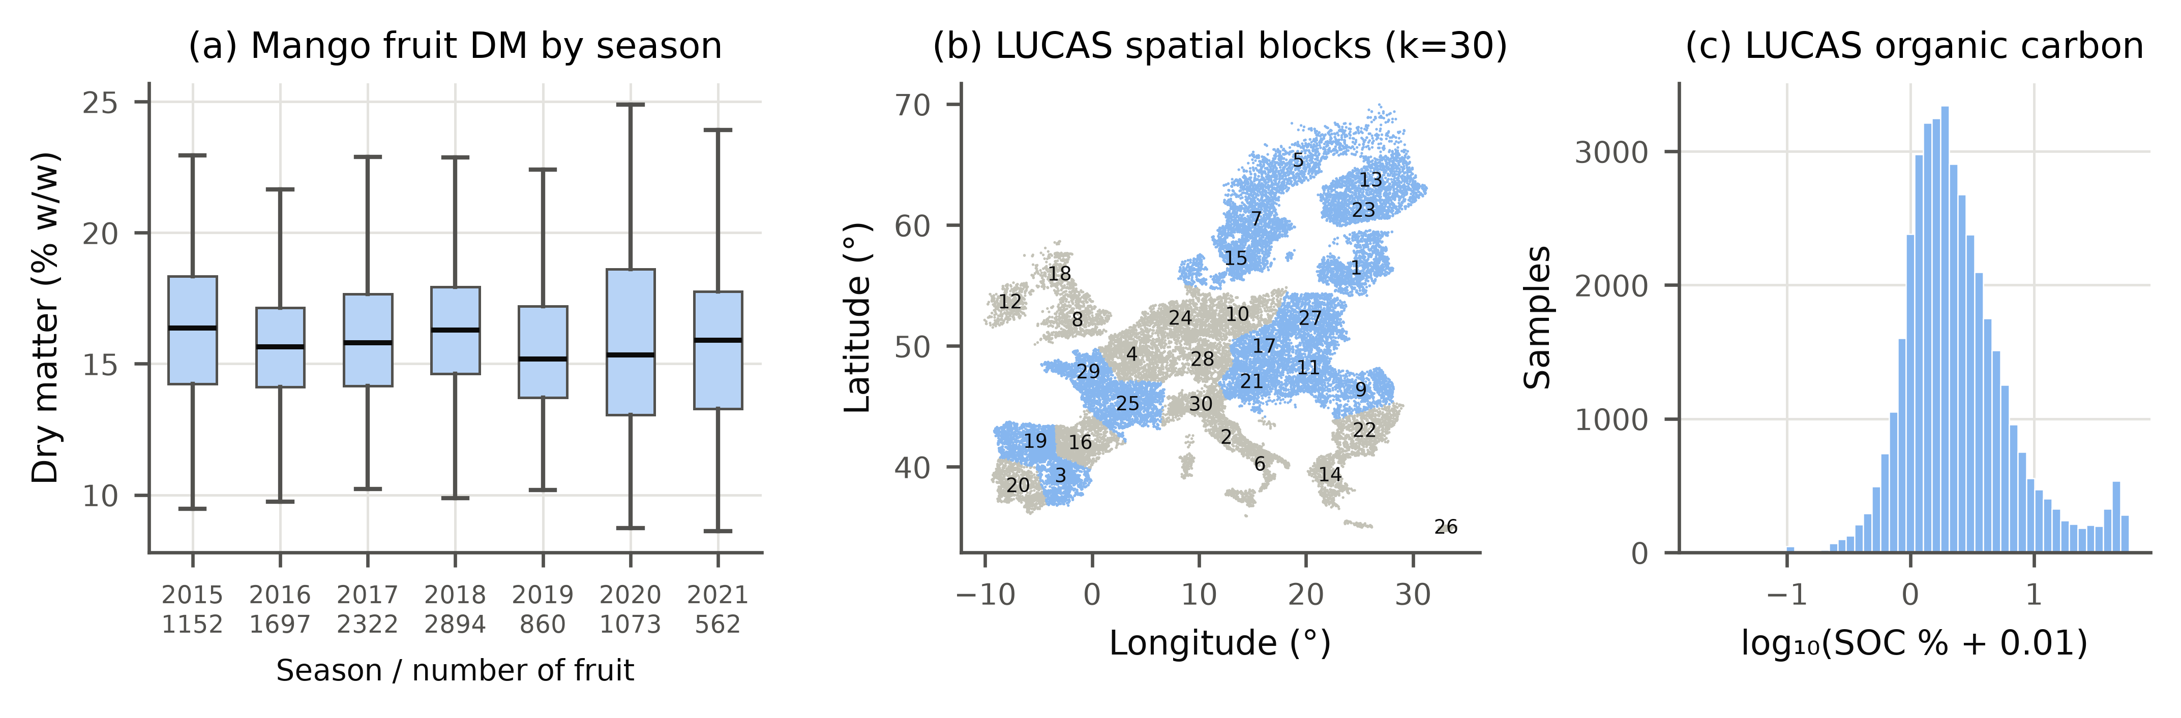
Fig. 2. Data overview. (a) Dry matter of mango fruit by harvest season (boxes: quartiles; whiskers: 1.5 IQR; tick labels give the number of fruit); (b) the 30 spatial blocks of the LUCAS soil samples used as held-out regions; (c) distribution of LUCAS organic carbon (log scale).

3.2. Deployment-shift scenarios and leakage control
Each scenario holds out complete groups (Table 1). Mango: leave-one-season-out (LOSO, 7 folds), forward prediction of each season from all earlier seasons (2017–2021), leave-one-instrument-out for the 24 instruments with ≥ 300 fruit, and grouped 10-fold splitting of populations. Soil: leave-one-region-out over 30 spatial blocks obtained by k-means clustering of LUCAS coordinates (Fig. 2b) (spatial blocking [32]), and two stress tests, LUCAS 2009 ↔ 2015 campaigns and KSSL → LUCAS across libraries, instruments and continents. Corn: leave-one-instrument-out, repeated ten times with 20 randomly chosen test samples. Tablets: instrument 1 calibration applied to the instrument-1 test set (exchangeable control) and to the instrument-2 test set (instrument shift without group information).
Leakage control was enforced in code by an assertion in every outer and inner split: a physical unit (fruit, soil sample, corn sample, tablet) never appears in both a training set and the set it predicts. This matters in practice: 7100 mango fruit were scanned on more than one instrument, and the corn and tablet samples were measured on every instrument, so instrument-wise splitting without unit exclusion would leak the reference value of the test sample into training. All preprocessing is row-wise (no parameters estimated across samples) and fixed a priori per data set: Savitzky–Golay second derivative (window 13, 684–990 nm) for mango [42]; absorbance log₁₀(1/R) at 10 nm steps and first derivative (window 11) for soil; SNV [43] followed by first derivative (window 15) for corn and tablets. Soil OC was modelled as log(1 + OC) and interval end-points were back-transformed, which preserves coverage exactly.
Units are shared between groups only where groups are instruments (of the 10,508 fruit measured on the 24 held-out instruments, 6,992 were measured on more than one of them; every corn and tablet sample was measured on every instrument); seasons, populations and soil regions share none (Supplementary Table S16 lists groups, units per group and shared units for every scenario).

3.3. Interval methods compared
All PLS-based methods share the same preprocessing, the same number of latent variables (selected by group-wise cross-validation in the training data) and the same final model, so differences arise from the uncertainty calibration only. Prediction errors are summarised by the root mean squared error of prediction (RMSEP) on held-out spectra and of cross-validation (RMSECV) within the training data. Baselines: (a) the classical interval ŷ ± t·RMSECV·√(1 + h) [4] with random cross-validation (ASTM-R) or with group-wise cross-validation (ASTM-G); (b) bagged PLS [44] (25 unit-level bootstrap models) with bootstrap variance plus out-of-bag residual variance (BAG); (c) Gaussian-process regression on PLS scores [45] (GPR, 1000-sample subset); (d) quantile gradient boosting [46] (300 trees, learning rate 0.05, 31 leaves) on PLS scores, log(1 + T²) and log Q (QGB) and its conformalised version CQR [47]; (e) split conformal prediction with a random 75/25 unit-wise split (SCP) [11]; (f) normalised split CP with k-nearest-neighbour difficulty (NCP-kNN) [33]; (g) CV+ with random unit-grouped folds [13,35]; and (h) weighted split CP under covariate shift [25], with the density ratio estimated by logistic regression between calibration spectra and the unlabelled spectra of the deployment group (WCP; this method uses test spectra transductively). WCP places the weight w(x)/(Σᵢ wᵢ + w(x)) of the test spectrum at +∞, so its interval is unbounded when this share exceeds α, as happens when calibration and deployment spectra are well separated; a variant with ratios normalised to mean 1 and capped at 20 (WCP-clip) is also reported. The proposed GC-D was compared with the guaranteed variants HCP and HJ+ (Section 2.4), with GC-D plus the finite-sample point mass at +∞ (GC-D+), and with an oracle that calibrates split CP on labelled spectra of the test group itself (2-fold within the group; not available in practice, reported as a reference for the attainable width).
The factorial ablation crosses three components of GC-D: calibration folds that are random (R) or out-of-group (G); uniform (U) or group-balanced (W) weights; and absolute (A) or diagnostic-normalised (D) scores. GC-D corresponds to G-W-D; R-U-A is ordinary cross-conformal calibration.

3.4. Evaluation and statistics
Primary end-points (fixed in advance) at α = 0.10 were the group-averaged empirical coverage on held-out groups and the mean interval (Winkler) score [48]
IS_{α}(l, u; y) = (u − l) + (2/α)(l − y)·1(y < l) + (2/α)(y − u)·1(y > u) (6)
a proper score that rewards narrow intervals and penalises misses in proportion to their size. Secondary end-points were mean width, worst-group coverage, the share of groups with coverage below 0.85, and results at α = 0.05 and 0.20. Three hypotheses were pre-specified: H1, random-split SCP covers less than 0.85 on at least one shift task; H2, GC-D covers between 0.87 and 0.95 on every task with ≥ 10 training groups; H3, diagnostic normalisation lowers the interval score relative to absolute scores (GC-D vs G-W-A). H3, unlike H1 and H2, was stated without a decision rule; we call it supported when GC-D has the lower interval score in most main scenarios with Holm-significant differences in most, partly supported when only the first condition holds (rule formulated during revision). The unit of analysis for method comparisons is the held-out group or, where an outer fold holds out several groups that share one model (populations, campaigns), the outer fold; per-group values were averaged over five pre-specified seeds (0–4) and compared with two-sided Wilcoxon signed-rank tests [49] with Holm correction across comparators within each task [50]. Effect sizes are matched-pairs rank-biserial correlations [51]; 95 % confidence intervals of group-averaged coverage are percentile bootstraps over groups, and within-task pooled coverage intervals use a cluster bootstrap over physical units. Because Wilcoxon tests on five to seven seasons cannot reach significance after correction, interval-score differences are also given as mean differences with 95 % bootstrap intervals and as posterior probabilities under the Bayesian bootstrap [52].

3.5. Analyses added during revision
In response to peer review, and after the main results were known, we added analyses of the form of the scale model, of strongly unequal group sizes, of bias correction with k labelled units of the new group (GC-D-BC, in which the correction is mimicked in every calibration group before σ and q̂ are fitted), of a Q-based rejection rule and an 'uninformative interval' flag, of decisions over a grid of specification limits, of density-ratio variants of WCP, and a synthetic simulation of single-deployment coverage. They did not change the methods or settings of the main study; protocols are given in Supplementary Sections S16–S28.

3.6. Software and reproducibility
All code is in Python (NumPy, SciPy, scikit-learn [53], LightGBM [46], PyTorch [54]). PLS1 was implemented with NIPALS and checked against scikit-learn to 10⁻¹⁴. A single command (python run_all.py --mode full) downloads the data, runs every experiment and regenerates all tables, figures and the statistics files from which every number in this paper is read; all computations ran on a 4-core CPU without a GPU.

4. Results and discussion

4.1. Current practice miscovers under deployment shift
Table 1. Deployment-shift scenarios. K is the number of distinct calibration groups available in the training data of an outer fold; PLS LVs is the range of latent variables selected by group-wise cross-validation.
Scenario | Outer folds | Held-out groups | Training spectra | Test spectra (total) | Calibration groups K | PLS LVs
M-season | 7 | 7 | 58089–84011 | 85401 | 6 | 12–19
M-forward | 5 | 5 | 30510–84011 | 54891 | 2–6 | 13–19
M-instr. | 24 | 24 | 26279–80757 | 82383 | 27–30 | 12–19
M-pop. | 10 | 199 | 74737–79204 | 85401 | 179–180 | 18–20
S-region | 30 | 30 | 37525–40099 | 40175 | 29 | 23–25
C-moist | 30 | 30 | 120 | 600 | 2 | 1–4
C-oil | 30 | 30 | 120 | 600 | 2 | 1–7
C-prot | 30 | 30 | 120 | 600 | 2 | 1–7
C-starch | 30 | 30 | 120 | 600 | 2 | 1–6
S-campaign | 2 | 58 | 18393–21782 | 40175 | 28–30 | 25
S-KSSL→LUCAS | 1 | 30 | 19747 | 40175 | 84 | 21
Tablets | 2 | 2 | 195 | 920 | 195 | 7

Fig. 3 and Tables 2–3 summarise coverage and interval score at the nominal level 0.90. When the held-out group was a new harvest season or a new instrument, the classical PLS interval covered 0.788–0.833 and random-split conformal prediction (SCP) 0.783–0.826 of the test spectra on average across groups, and SCP covered less than 0.85 in 7 of the 9 main scenarios, so pre-registered hypothesis H1 is supported. CV+ and bagged PLS behaved like SCP (e.g. new instrument: 0.796 and 0.805), and GPR, quantile boosting and CQR covered even less on the mango shift scenarios (0.750–0.797, 0.660–0.735 and 0.726–0.789). The under-coverage is not a consequence of poor point predictions alone: the oracle, which calibrates on labelled spectra of the test group, attains nominal coverage with widths of 4.47 (new season) and 4.59 % DM (new instrument), against 3.65 and 3.66 % DM for SCP. Random calibration simply under-estimates the error that a new group brings, because the calibration spectra come from seasons, instruments and populations that the model has already seen.
Weighted conformal prediction (WCP), which reweights the calibration residuals with the unlabelled spectra of the new group, reached high coverage (e.g. 0.905 for new instruments) only by returning unbounded intervals for part of the test spectra in almost every scenario. Calibration and deployment spectra were so well separated (classifier AUC 0.82–0.99) that the effective sample size of the weights fell to 0.2–9 % of the calibration set and many deployment spectra carried more than α of the total weight. This is a property of the shift, not of the estimator (Supplementary Table S20): a classifier restricted to three PLS scores avoided extreme weights but no longer corrected for the mango shifts (coverage 0.766–0.817), and stronger regularisation did not remove the unbounded intervals. Capping the normalised density ratios at 20 (WCP-clip; Tables 2–3) bounded almost all intervals but covered only 0.822–0.855 on the mango season and instrument shifts, and with the ~30 calibration spectra of the corn scenarios even a capped weight exceeded α of the total. An interval that is unbounded for a share of samples cannot support a decision, so WCP is not a practical remedy here; on the milder soil-region shift the capped variant reached nominal coverage.
For new mango populations all methods were close to nominal (SCP 0.889, classical 0.894). A new population brought little error that random calibration had not seen: its RMSEP was only 4 % above the random unit-wise cross-validation error, against 17 % for a new season and 24 % for a new instrument (Supplementary Table S27). Populations nevertheless differ spectrally — season and instrument composition explained 40 % of the between-population variance of the PLS scores — so the model generalises across lots rather than population effects being a re-labelling of season and instrument effects. On the exchangeable control (tablets measured on the calibration instrument) every method reached at least nominal coverage (Supplementary Table S2).
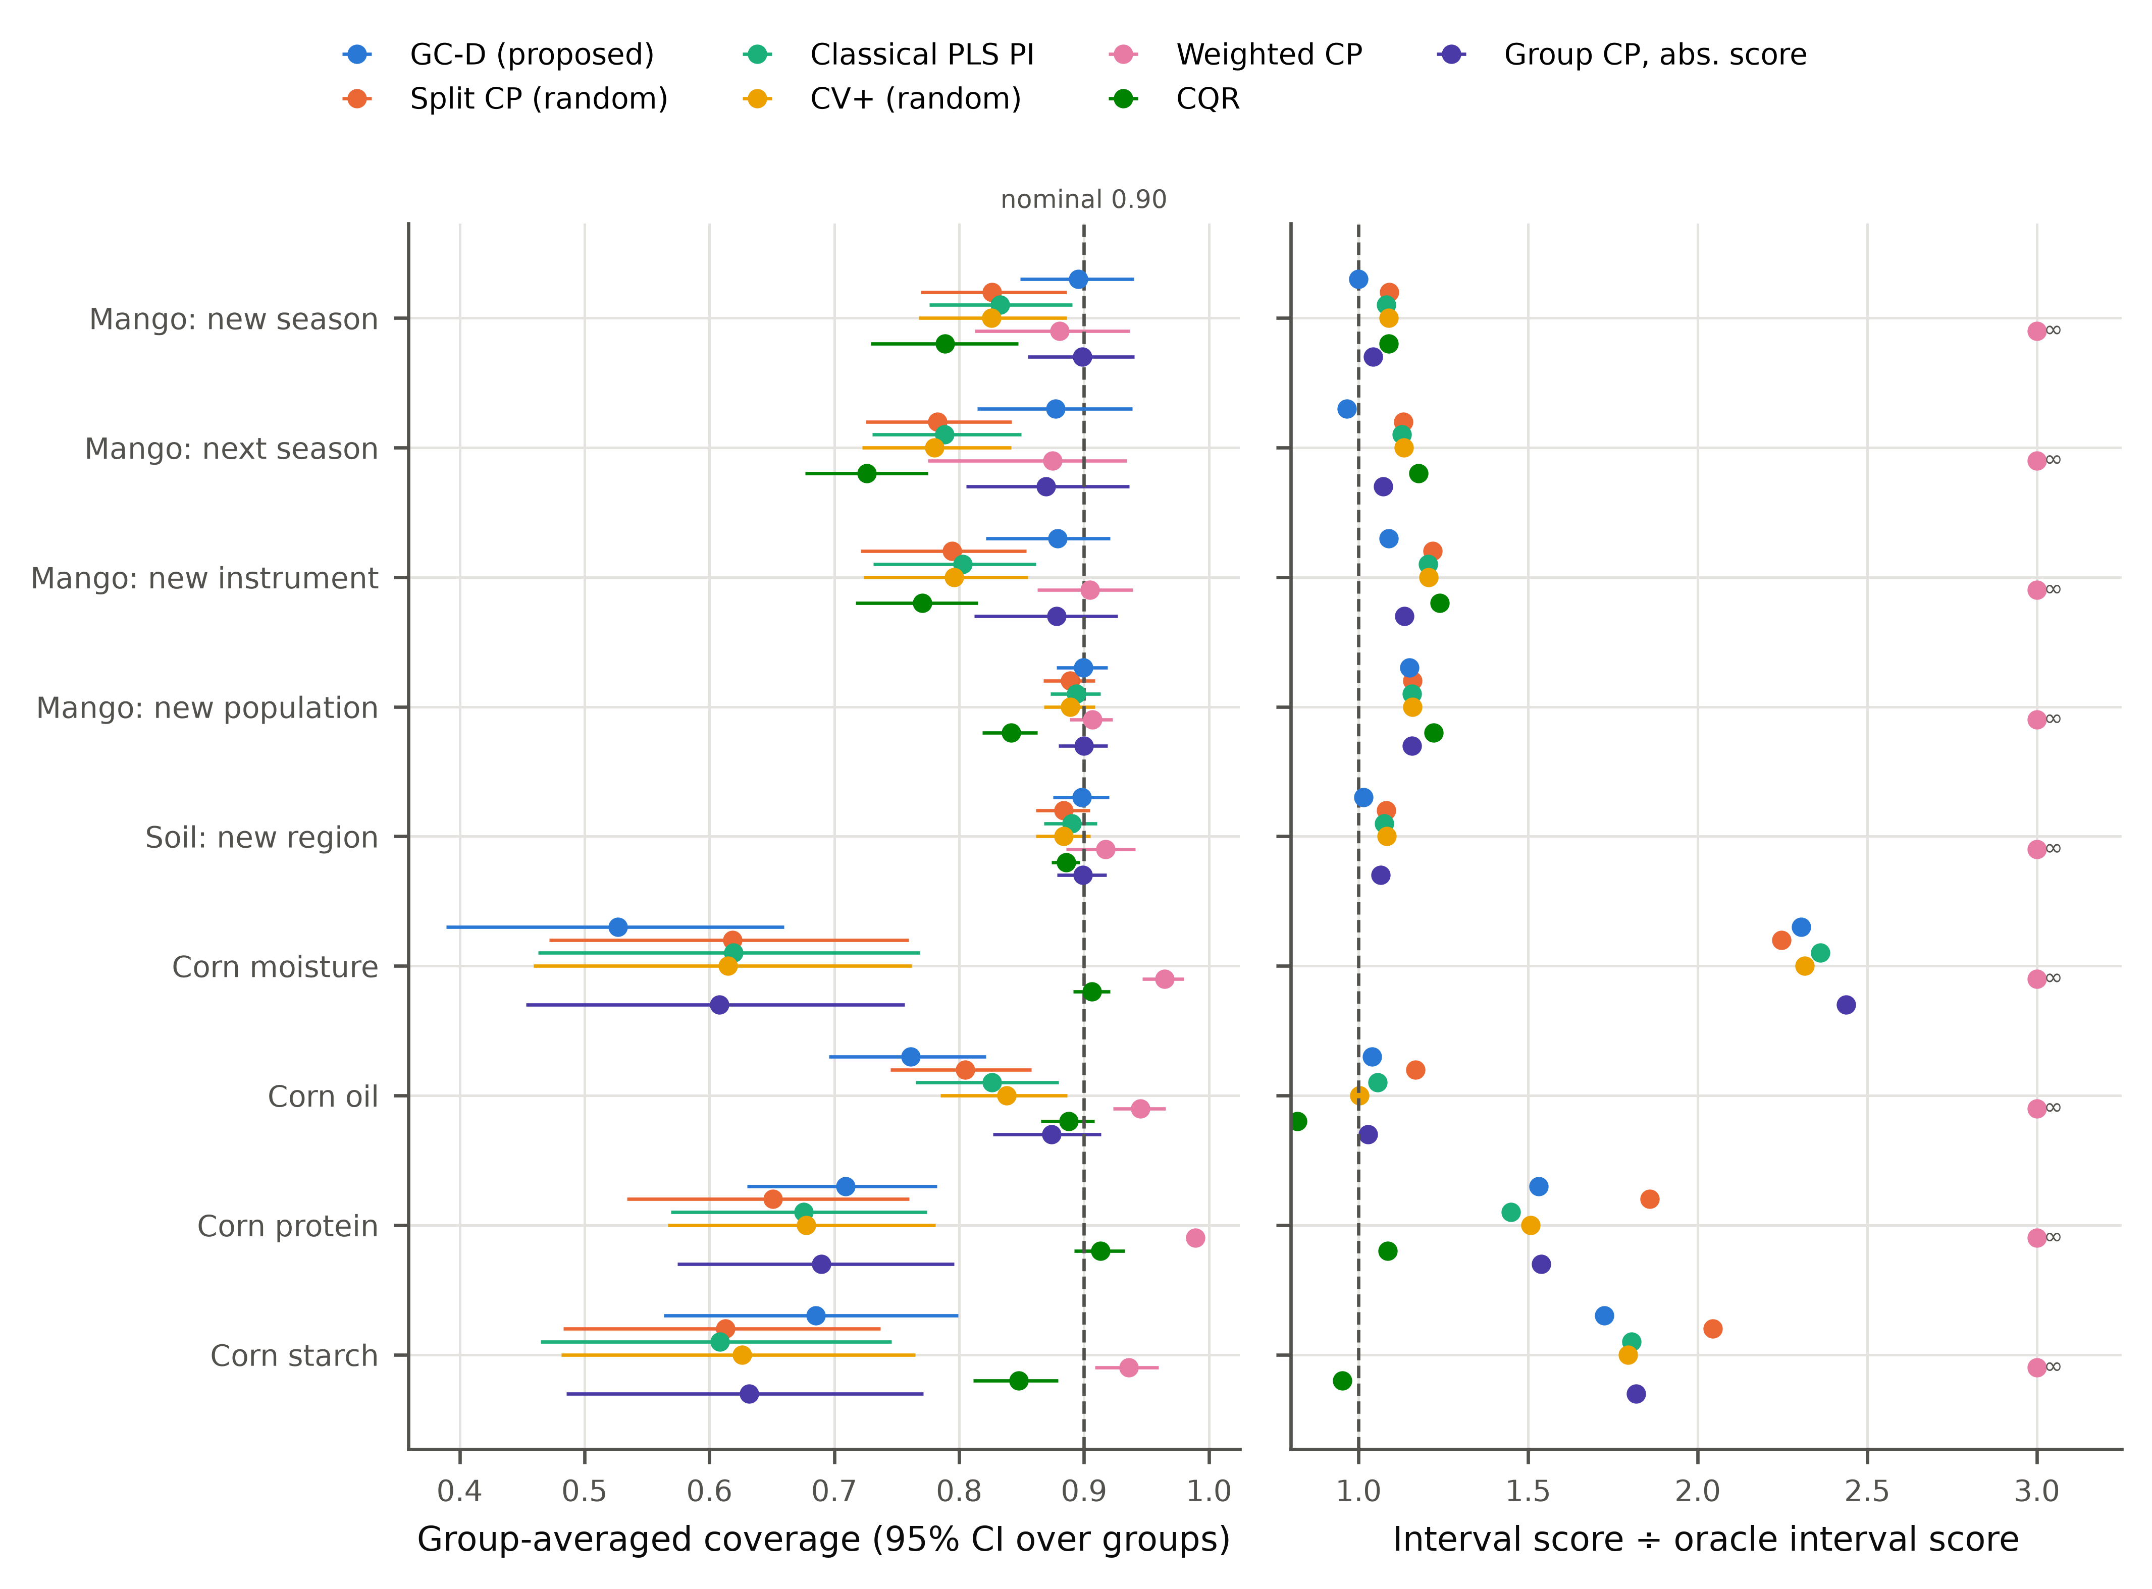
Fig. 3. Group-averaged coverage (left; bars are 95 % bootstrap intervals over held-out groups) and interval score relative to the oracle (right; lower is better; ratios above 3 and infinite scores are plotted at 3 and labelled) at nominal coverage 0.90, means over five seeds. GC-D: proposed group-conformal calibration with diagnostic scaling.
Table 2. Group-averaged empirical coverage at nominal coverage 0.90 (means over five seeds). M = mango (instr. = instrument, pop. = population), S = soil (LUCAS), C = corn.
Method | M-season | M-forward | M-instr. | M-pop. | S-region | C-moist | C-oil | C-prot | C-starch
ASTM-R | 0.833 | 0.788 | 0.803 | 0.894 | 0.890 | 0.619 | 0.826 | 0.675 | 0.608
ASTM-G | 0.906 | 0.884 | 0.884 | 0.906 | 0.905 | 0.623 | 0.884 | 0.737 | 0.645
BAG | 0.833 | 0.790 | 0.805 | 0.895 | 0.891 | 0.625 | 0.867 | 0.708 | 0.665
GPR | 0.797 | 0.750 | 0.753 | 0.875 | 0.884 | 0.682 | 0.831 | 0.732 | 0.627
CQR | 0.789 | 0.726 | 0.771 | 0.841 | 0.886 | 0.906 | 0.888 | 0.913 | 0.848
SCP | 0.826 | 0.783 | 0.794 | 0.889 | 0.884 | 0.618 | 0.805 | 0.651 | 0.613
CV+ | 0.826 | 0.780 | 0.796 | 0.889 | 0.884 | 0.615 | 0.838 | 0.678 | 0.626
WCP | 0.880 | 0.875 | 0.905 | 0.907 | 0.917 | 0.964 | 0.945 | 0.989 | 0.936
WCP-clip | 0.855 | 0.822 | 0.851 | 0.899 | 0.921 | 0.964 | 0.945 | 0.989 | 0.936
HJ+ | 1.000 | 1.000 | 0.925 | 0.906 | 0.931 | 1.000 | 1.000 | 1.000 | 1.000
HCP-D | 1.000 | 1.000 | 0.932 | 0.911 | 0.964 | 1.000 | 1.000 | 1.000 | 1.000
GC-D+ | 1.000 | 1.000 | 0.912 | 0.904 | 0.929 | 1.000 | 1.000 | 1.000 | 1.000
GC-D | 0.895 | 0.877 | 0.879 | 0.899 | 0.898 | 0.527 | 0.761 | 0.709 | 0.685
ORACLE | 0.899 | 0.899 | 0.900 | 0.898 | 0.901 | 0.917 | 0.905 | 0.903 | 0.913
HJ+, HCP-D and GC-D+ are unbounded (coverage 1) whenever the number of calibration groups is too small for their finite-sample correction (Section 2.4); WCP returns unbounded intervals when the estimated density ratio places more than α of the weight on the test point; WCP-clip caps the normalised density ratios at 20 (Section 4.1).
Table 3. Mean interval score (Eq. (6); lower is better; units of the analyte) at nominal coverage 0.90. ∞: at least one group received an unbounded interval.
Method | M-season | M-forward | M-instr. | M-pop. | S-region | C-moist | C-oil | C-prot | C-starch
ASTM-R | 6.38 | 7.18 | 6.88 | 4.95 | 12.63 | 4.85 | 0.82 | 2.02 | 6.41
ASTM-G | 6.18 | 6.73 | 6.48 | 4.95 | 12.39 | 4.74 | 0.77 | 1.94 | 5.97
BAG | 6.35 | 7.10 | 6.76 | 4.95 | 12.50 | 4.42 | 0.73 | 1.91 | 5.73
GPR | 6.32 | 7.14 | 7.70 | 4.76 | 9.25 | 3.30 | 0.72 | 1.73 | 6.06
CQR | 6.42 | 7.49 | 7.08 | 5.23 | 8.06 | 1.53 | 0.64 | 1.52 | 3.39
SCP | 6.43 | 7.21 | 6.95 | 4.96 | 12.70 | 4.62 | 0.91 | 2.60 | 7.26
CV+ | 6.42 | 7.21 | 6.89 | 4.96 | 12.71 | 4.75 | 0.78 | 2.10 | 6.37
WCP | ∞ | ∞ | ∞ | ∞ | ∞ | ∞ | ∞ | ∞ | ∞
WCP-clip | 6.26 | 7.31 | ∞ | ∞ | ∞ | ∞ | ∞ | ∞ | ∞
HJ+ | ∞ | ∞ | 6.30 | 4.95 | 12.05 | ∞ | ∞ | ∞ | ∞
HCP-D | ∞ | ∞ | 14.80 | 5.04 | 14.14 | ∞ | ∞ | ∞ | ∞
GC-D+ | ∞ | ∞ | 6.21 | 4.92 | 11.77 | ∞ | ∞ | ∞ | ∞
GC-D | 5.90 | 6.14 | 6.21 | 4.92 | 11.90 | 4.73 | 0.81 | 2.14 | 6.13
ORACLE | 5.90 | 6.36 | 5.71 | 4.28 | 11.74 | 2.05 | 0.78 | 1.40 | 3.55

4.2. Group-conformal calibration restores near-nominal coverage
GC-D achieved group-averaged coverage between 0.877 and 0.899 on the mango season, instrument and population scenarios and on new soil regions (Table 2). Relative to SCP, coverage on new seasons rose from 0.826 to 0.895 (LOSO) and from 0.783 to 0.877 (forward prediction), and on new instruments from 0.794 to 0.879. The intervals were wider (4.54 vs 3.66 % DM for new instruments), but the width was close to that of the oracle (4.59), and the interval score, which weighs width against misses, was lower: 5.90 vs 6.43 (new season), 6.14 vs 7.21 (next season) and 6.21 vs 6.95 (new instrument). For new seasons GC-D's interval score differed from the oracle's by less than 1 %, and for the next season it was lower than the oracle's, because the oracle uses a constant width within a group.
Pre-registered hypothesis H2 required coverage between 0.87 and 0.95 on every task with at least ten training groups (mango, new instrument; mango, new population; soil, new region); it is supported. Paired over held-out groups (outer folds for the population task, whose ten folds each hold out about 20 populations that share one model), GC-D had a lower interval score than SCP in 7 of 9 main scenarios, significantly after Holm correction only for soil, new region (Supplementary Table S14); with five to seven seasons the smallest attainable two-sided Wilcoxon p-value (0.0625 or 0.0156) cannot reach significance after correction for 19 comparators. Estimates make the size and certainty of the differences explicit (Supplementary Table S19): in the mango and soil scenarios GC-D lowered the mean interval score relative to SCP by 1–9 %, the 95 % bootstrap interval excluded zero for new instruments, new populations and new soil regions, and the Bayesian-bootstrap probability that GC-D has the lower mean score was 0.96–1.00 (corn: 0.26–1.00). With few groups, such estimates and the attained coverage are a better basis for choosing a method than a test on five to seven groups. The advantage was the same at other nominal levels: on the mango season and instrument scenarios GC-D covered 5–11 percentage points more than SCP at 0.80, 0.90 and 0.95, and deviated from the nominal level by at most 0.030 (Supplementary Table S3).
A simple alternative captured much of the same benefit: the classical interval with the root mean squared error of group-wise rather than random cross-validation (ASTM-G) covered 0.906 (new season), 0.884 (next season), 0.884 (new instrument) and 0.905 (new region). GC-D had a lower interval score than ASTM-G in all four of these scenarios (5.90 vs 6.18, 6.14 vs 6.73, 6.21 vs 6.48 and 11.90 vs 12.39), but these differences were not significant after correction. The central practical message is thus that intervals must be calibrated on out-of-group errors; the conformal formulation adds a distribution-free quantile instead of a Gaussian t-multiplier, a sample-specific width driven by T² and Q, and, with enough groups, access to the finite-sample guarantees of Section 2.4.
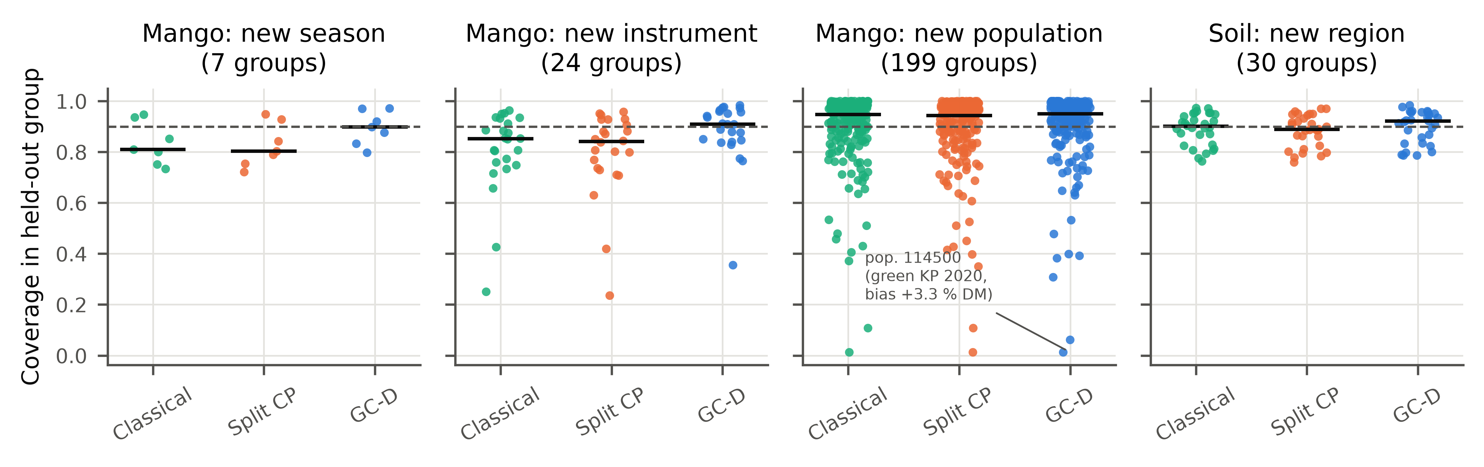
Fig. 4. Coverage in each held-out group (points; seed-averaged) for the classical PLS interval, random-split conformal prediction and GC-D; horizontal bars are medians and the dashed line is the nominal 0.90.

4.3. Which components matter
The factorial ablation (Fig. 5) separates the three ingredients. Because every cell uses the same final PLS model as GC-D, differences between cells reflect the calibration alone; in particular, ordinary cross-conformal calibration with random folds (R-U-A) under-covered as much as SCP (new instruments 0.795 vs 0.794), so the shortfall of SCP is not caused by its smaller training set. Replacing random calibration folds by out-of-group folds (R-U-A → G-U-A) carried most of the coverage gain on the mango shift scenarios, e.g. 0.795 → 0.861 for new instruments and 0.779 → 0.855 for the next season. Group-balanced weights (G-U-A → G-W-A) changed coverage little with the moderately unequal group sizes of the real data (new instruments: 0.861 → 0.878). When the training groups were subsampled to Zipf-like sizes (largest group 42–59 % of the spectra; Supplementary Table S18), balancing raised coverage (mango, new instrument 0.843 → 0.866; mango, new season (LOSO) 0.854 → 0.876; soil, new region 0.888 → 0.897), because with uniform weights the calibration reflects mainly the error of the largest group. Diagnostic normalisation (G-W-A → GC-D) lowered the interval score in 5 of 9 main scenarios (significantly after Holm correction in 1), so H3 is partly supported under the rule of Section 3.4. The average interval score is, however, not where the scaling matters: it redistributes width from typical to atypical spectra, so its benefit appears in the coverage of the most atypical spectra and under spectral drift, where group calibration with absolute scores (and therefore ASTM-G) fails (Sections 4.5 and 4.8).
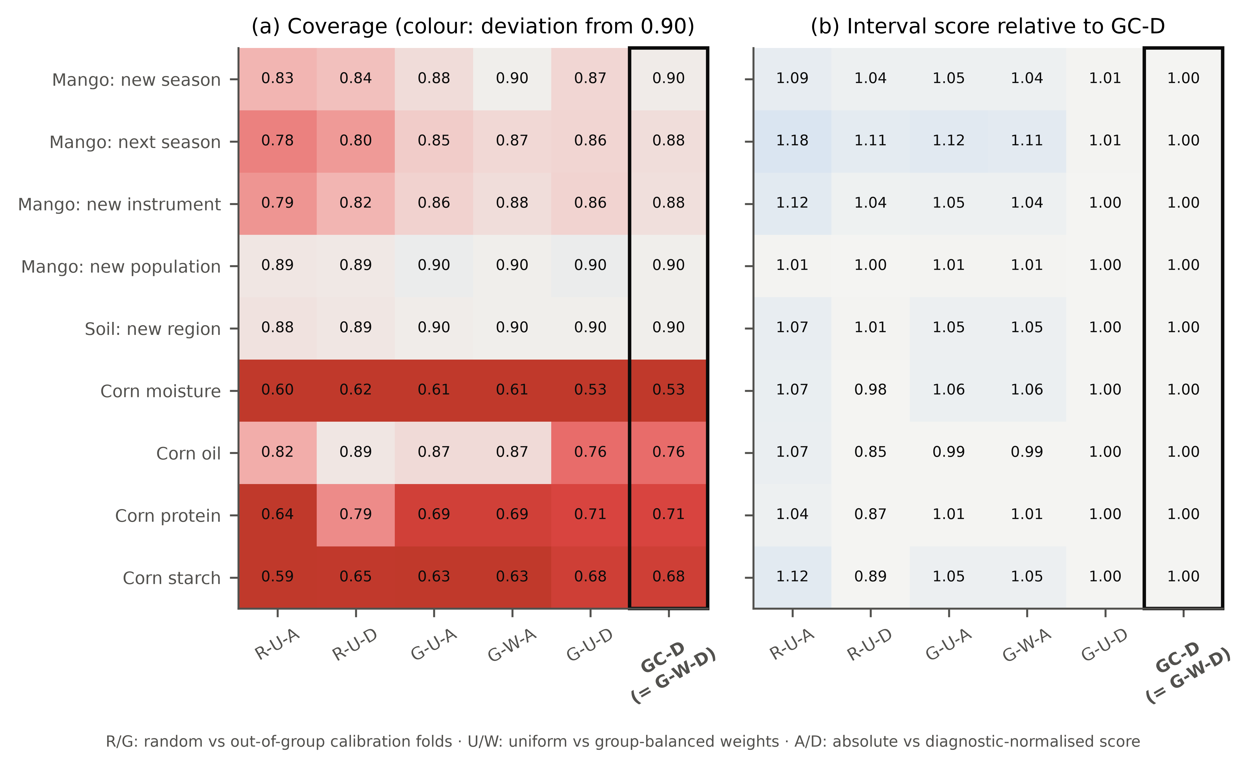
Fig. 5. Factorial ablation of GC-D at nominal coverage 0.90: (a) coverage (colour: deviation from 0.90, red = under-coverage) and (b) interval score relative to GC-D (values > 1: worse than GC-D).

4.4. Distribution-free guarantees need many groups
The variants with finite-sample guarantees behaved as theory predicts. With at most six training seasons or two corn instruments, HJ+, HCP and GC-D+ returned unbounded intervals (Tables 2–3), because the point mass 1/(K + 1) at +∞ exceeds α. With 27–30 instruments or 29 soil regions they were finite and covered 0.925 (HJ+) and 0.932 (HCP-D) for new instruments and 0.931 and 0.964 for new regions, above the nominal level as their guarantees require, but at a higher interval score than GC-D (6.30 and 14.80 vs 6.21 for instruments). HCP-D pays for its exactness by fitting the model on half of the groups. Being unbounded with few groups, the guaranteed variants are no alternative in exactly the settings — few seasons or instruments — in which GC-D is most needed.
Subsampling the training groups (Fig. 6a) shows how many are needed. With K = 3 training instruments, GC-D covered 0.757 of new-instrument spectra and SCP 0.627; with K = 10 the values were 0.861 and 0.725, and with K = 20 0.865 and 0.754. For soil regions GC-D covered 0.864 (K = 3) to 0.898 (K = 20). HJ+ became finite in all repetitions only from K = 10 (fraction of finite intervals 0.00 at K = 5 and 1.00 at K = 10 for instruments). In practice, GC-D improves on random calibration already with a handful of groups, while formal group-level guarantees at 90 % require about ten or more.
Group-averaged coverage is not the whole story for a single deployment. In the real data, the coverage of GC-D in individual held-out groups had a standard deviation of 0.06–0.15, 93–99 % of which was genuine between-group variation rather than sampling noise (Supplementary Table S28). A synthetic hierarchical model (Supplementary Section S26, Fig. S3) shows how this depends on K, α and group-size balance: out-of-group calibration was close to nominal on average for every K from 3 to 50 (α = 0.10: 0.885–0.902; random split 0.846 at K = 3), but the standard deviation of single-deployment coverage fell only from 0.11 (K = 3) to 0.07 (K = 50), because it is caused by the new group's own effect, which only information about that group can remove (Section 4.8). The finite-sample correction became finite at K = 20 (α = 0.05), 10 (α = 0.10), 5 (α = 0.20), i.e. at K ≥ 1/α − 1 for balanced and unbalanced groups alike, so the 'ten groups' above are specific to α = 0.10. With fewer groups, GC-D still removes the systematic under-coverage of random calibration, but the coverage of one deployment is uncertain by several percentage points, which should be stated when the intervals are reported.
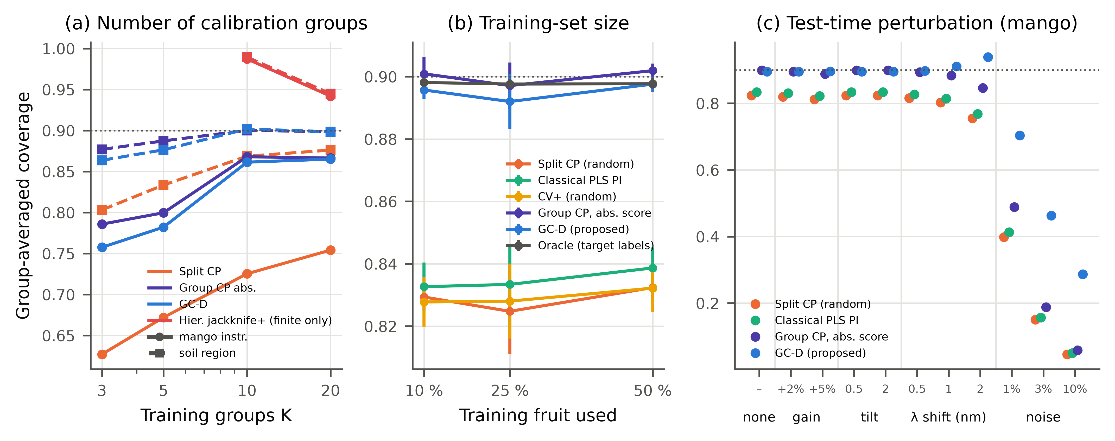
Fig. 6. Robustness. (a) Coverage on new mango instruments (circles) and new soil regions (squares) when only K randomly chosen training groups are available (three repetitions; HJ+ shown only where all intervals were finite). (b) Coverage for new seasons when 10–50 % of training fruit are used (mean ± SD over three repetitions). (c) Coverage for new seasons when the test spectra are perturbed (gain, linear baseline tilt, wavelength shift, white noise relative to the median absorbance SD); training spectra are unperturbed.

4.5. Robustness, sensitivity and choice of point predictor
Coverage of GC-D did not depend on the amount of training data: with 10, 25 and 50 % of the training fruit it covered 0.896, 0.892 and 0.898 of new-season spectra, against 0.829, 0.825 and 0.832 for SCP (Fig. 6b). The coverage gap of random calibration is therefore a consequence of the shift, not of a small sample. Under simulated instrument drift of the test spectra (Fig. 6c), the second-derivative preprocessing removed linear baseline tilts entirely. A 2-nm wavelength shift lowered SCP coverage to 0.755 and that of group calibration with absolute scores (G-W-A) to 0.846, whereas GC-D widened its intervals for the affected spectra (larger Q) and covered 0.938. White noise of 1 % of the median absorbance SD raised the RMSEP from 1.38 to 3.50 % DM; coverage fell to 0.398 for SCP and to 0.703 for GC-D. The diagnostic scale thus detects and partly compensates for spectral anomalies, but it cannot restore coverage when the predictions themselves degrade this strongly; such spectra should be rejected rather than reported with an interval. Withholding the interval when Q/Q̃ exceeds the 99 % quantile of the out-of-group calibration values rejected 2.7 % of unperturbed new-season spectra (false rejections), 71 % of those with 1 % noise and 100 % with 3 % noise (Supplementary Table S23). Its misses were perturbations that hardly changed Q (0.3 % noise, gain, tilt, shifts ≤ 1 nm), which GC-D covered at least 0.894 anyway; the retained 1 %-noise spectra, however, were covered only 0.741, so the rule mitigates but does not remove the problem.
Sensitivity analyses (Supplementary Table S5: number of latent variables ± 4, T² or Q alone, floor of σ, preprocessing, number of population folds) kept the new-season coverage of GC-D between 0.884 and 0.898. Replacing the Poisson quasi-likelihood by a Gamma or Gaussian log-link GLM or least squares on log|r|, using log T², omitting Q̃, adding a T² × Q interaction or weighting the fit by group changed the coverage of GC-D by at most 0.006 and its interval score by −1.5 to +2.0 % (Supplementary Table S17).
With a one-dimensional convolutional network [55,56] as point predictor (mango, new season, 3 seeds; σ from PLS diagnostics; Supplementary Table S6), random-split conformal covered 0.651, out-of-group calibration with absolute scores 0.881 and GC-D 0.886, so the calibration principle did not depend on PLS for this network.

4.6. When group calibration cannot help — or is not needed
Three settings mark the limits of the approach. First, corn: with only two training instruments, no interval method based on the PLS model reached nominal coverage, because the uncorrected instrument shift left the model weakly informative (RMSEP 0.61–2.45 times the standard deviation of the reference values; instrument-level bias up to 1.26 units). CQR covered 0.913 (protein) only because its intervals (0.53–2.62) matched the central 90 % range of the reference values (0.57–2.56), i.e. they ignored the spectra. Second, the KSSL → LUCAS transfer across libraries, instruments and continents gave an RMSEP of 23.7 % OC; SCP covered 0.046, GC-D 0.604 and the exact HCP-D 0.712, the latter with intervals (91 % OC wide) of no analytical use. Third, the tablet calibration contained no group structure, so GC-D degenerated to cross-conformal calibration (coverage 0.912 over the control and the shifted instrument; Supplementary Table S2). In the first two settings the failure is that of the point predictor, not of the calibration principle: an interval can only quantify the error of a model that is still valid for the new group, and model transfer or bias correction [19,20] must precede uncertainty quantification.
The useful output of an interval method in this regime is a signal not to report the prediction. Two checks computed from the calibration data provide it (Supplementary Table S24): the interval is at least as wide as the central 90 % range of the training reference values, or Q/Q̃ exceeds the 99 % quantile of the out-of-group calibration values. At least one check fired for 38–65 % of the corn test spectra and 50 % of the KSSL → LUCAS spectra, against 2.0–5.6 % in the mango season and instrument and soil-region scenarios; for the tablets, calibrated on one instrument, the Q check flagged 100 % of the second-instrument spectra and 0.2 % of the calibration-instrument spectra, i.e. it recognised an instrument change that no interval method could anticipate. When a check fires, we recommend reporting 'no reliable interval — model not valid for this sample', and transferring or re-calibrating the model when it fires for a large share of a new group's spectra.
Conversely, group calibration is unnecessary when the held-out factor adds little group-level error. In a leave-one-cultivar-out test (ten cultivars, 3 seeds; Supplementary Table S15), SCP covered 0.900 and GC-D 0.902 with nearly identical interval scores (4.71 and 4.68), because every cultivar was measured in seasons and on instruments that remained in training. GC-D therefore cost no sharpness when the shift was small and helped when the held-out factor carried an unrepresented group effect (season, instrument).

4.7. Computational cost
Almost all of the computation of GC-D is the group-wise cross-validation that chemometric practice performs anyway to choose the number of latent variables (K + 1 PLS fits; 5.0 s per held-out season for ~70 000 training spectra on one CPU core). The additional cost of GC-D — a three-parameter scale model and one weighted quantile — was 0.12 s and 83 MiB per season, i.e. effectively zero; random-split CP, bagging, GPR and CQR needed 0.7, 15, 16 and 5 s because they fit additional models (Supplementary Table S9 and Fig. S1, which also explain the memory differences). A deployed GC-D model needs only the PLS model, three scale coefficients and q̂; no training data are stored.

4.8. Where the diagnostic scale matters, bias correction and consequences for decisions
Diagnostic scaling is not needed for coverage averaged over all spectra — out-of-group calibration with absolute scores (G-W-A), like ASTM-G, achieves that — but for the atypical spectra. Giving every spectrum the same width, G-W-A covered 0.953–0.982 of the spectra in the lowest Q/Q̃ decile but only 0.614–0.819 in the highest decile of the new-season, next-season, new-instrument and soil-region scenarios, against 0.837–0.923 for GC-D; ASTM-G, whose width varies only through the leverage, covered 0.626–0.827 (Fig. 7a,b; Supplementary Table S21). The same held under spectral drift (Section 4.5) and in the KSSL → LUCAS transfer (highest decile: G-W-A 0.090, GC-D 0.772). The scaling is therefore irreplaceable whenever decisions are taken on individual samples, some of which differ from the calibration population.
The largest remaining failures were group-level biases. Per-instrument coverage of GC-D fell with the absolute mean prediction bias of the instrument (r = −0.73; Fig. 7c); the worst instrument (bias −2.45 % DM) was covered 0.356. Every method failed on the same few populations; the worst (population 114500, annotated in Fig. 4) consisted of green 'Kensington Pride' fruit of 2020, harvested before maturity, which the model over-predicted by 3.33 % DM, so that GC-D covered 0.013 of its spectra. No calibration of interval width can repair such a bias. A few labelled reference samples of the new group do help (Fig. 7c,d; Supplementary Table S22). Shifting the interval centre by the mean residual of three labelled fruit raised the worst-instrument coverage from 0.356 to 0.755, but a single fruit gave too noisy a bias estimate (group-averaged coverage 0.847) and larger k over-covered (0.936 at k = 10). Mimicking the correction in every calibration group before fitting σ and q̂ (GC-D-BC) kept the average coverage at 0.877–0.886 for every k while narrowing the intervals (interval score 5.90 vs 6.21 at k = 3). For population 114500, one labelled fruit raised the coverage from 0.012 to 0.938 (GC-D-BC). For new seasons, whose biases were small relative to the fruit-to-fruit variation, a few fruit were not enough (shifted: 0.866 at k = 3; GC-D-BC: interval score 6.51 vs 5.90). Bias correction pays when the group bias is large — a new instrument or an atypical lot — and should then be calibrated for the noise of the bias estimate, as in GC-D-BC.
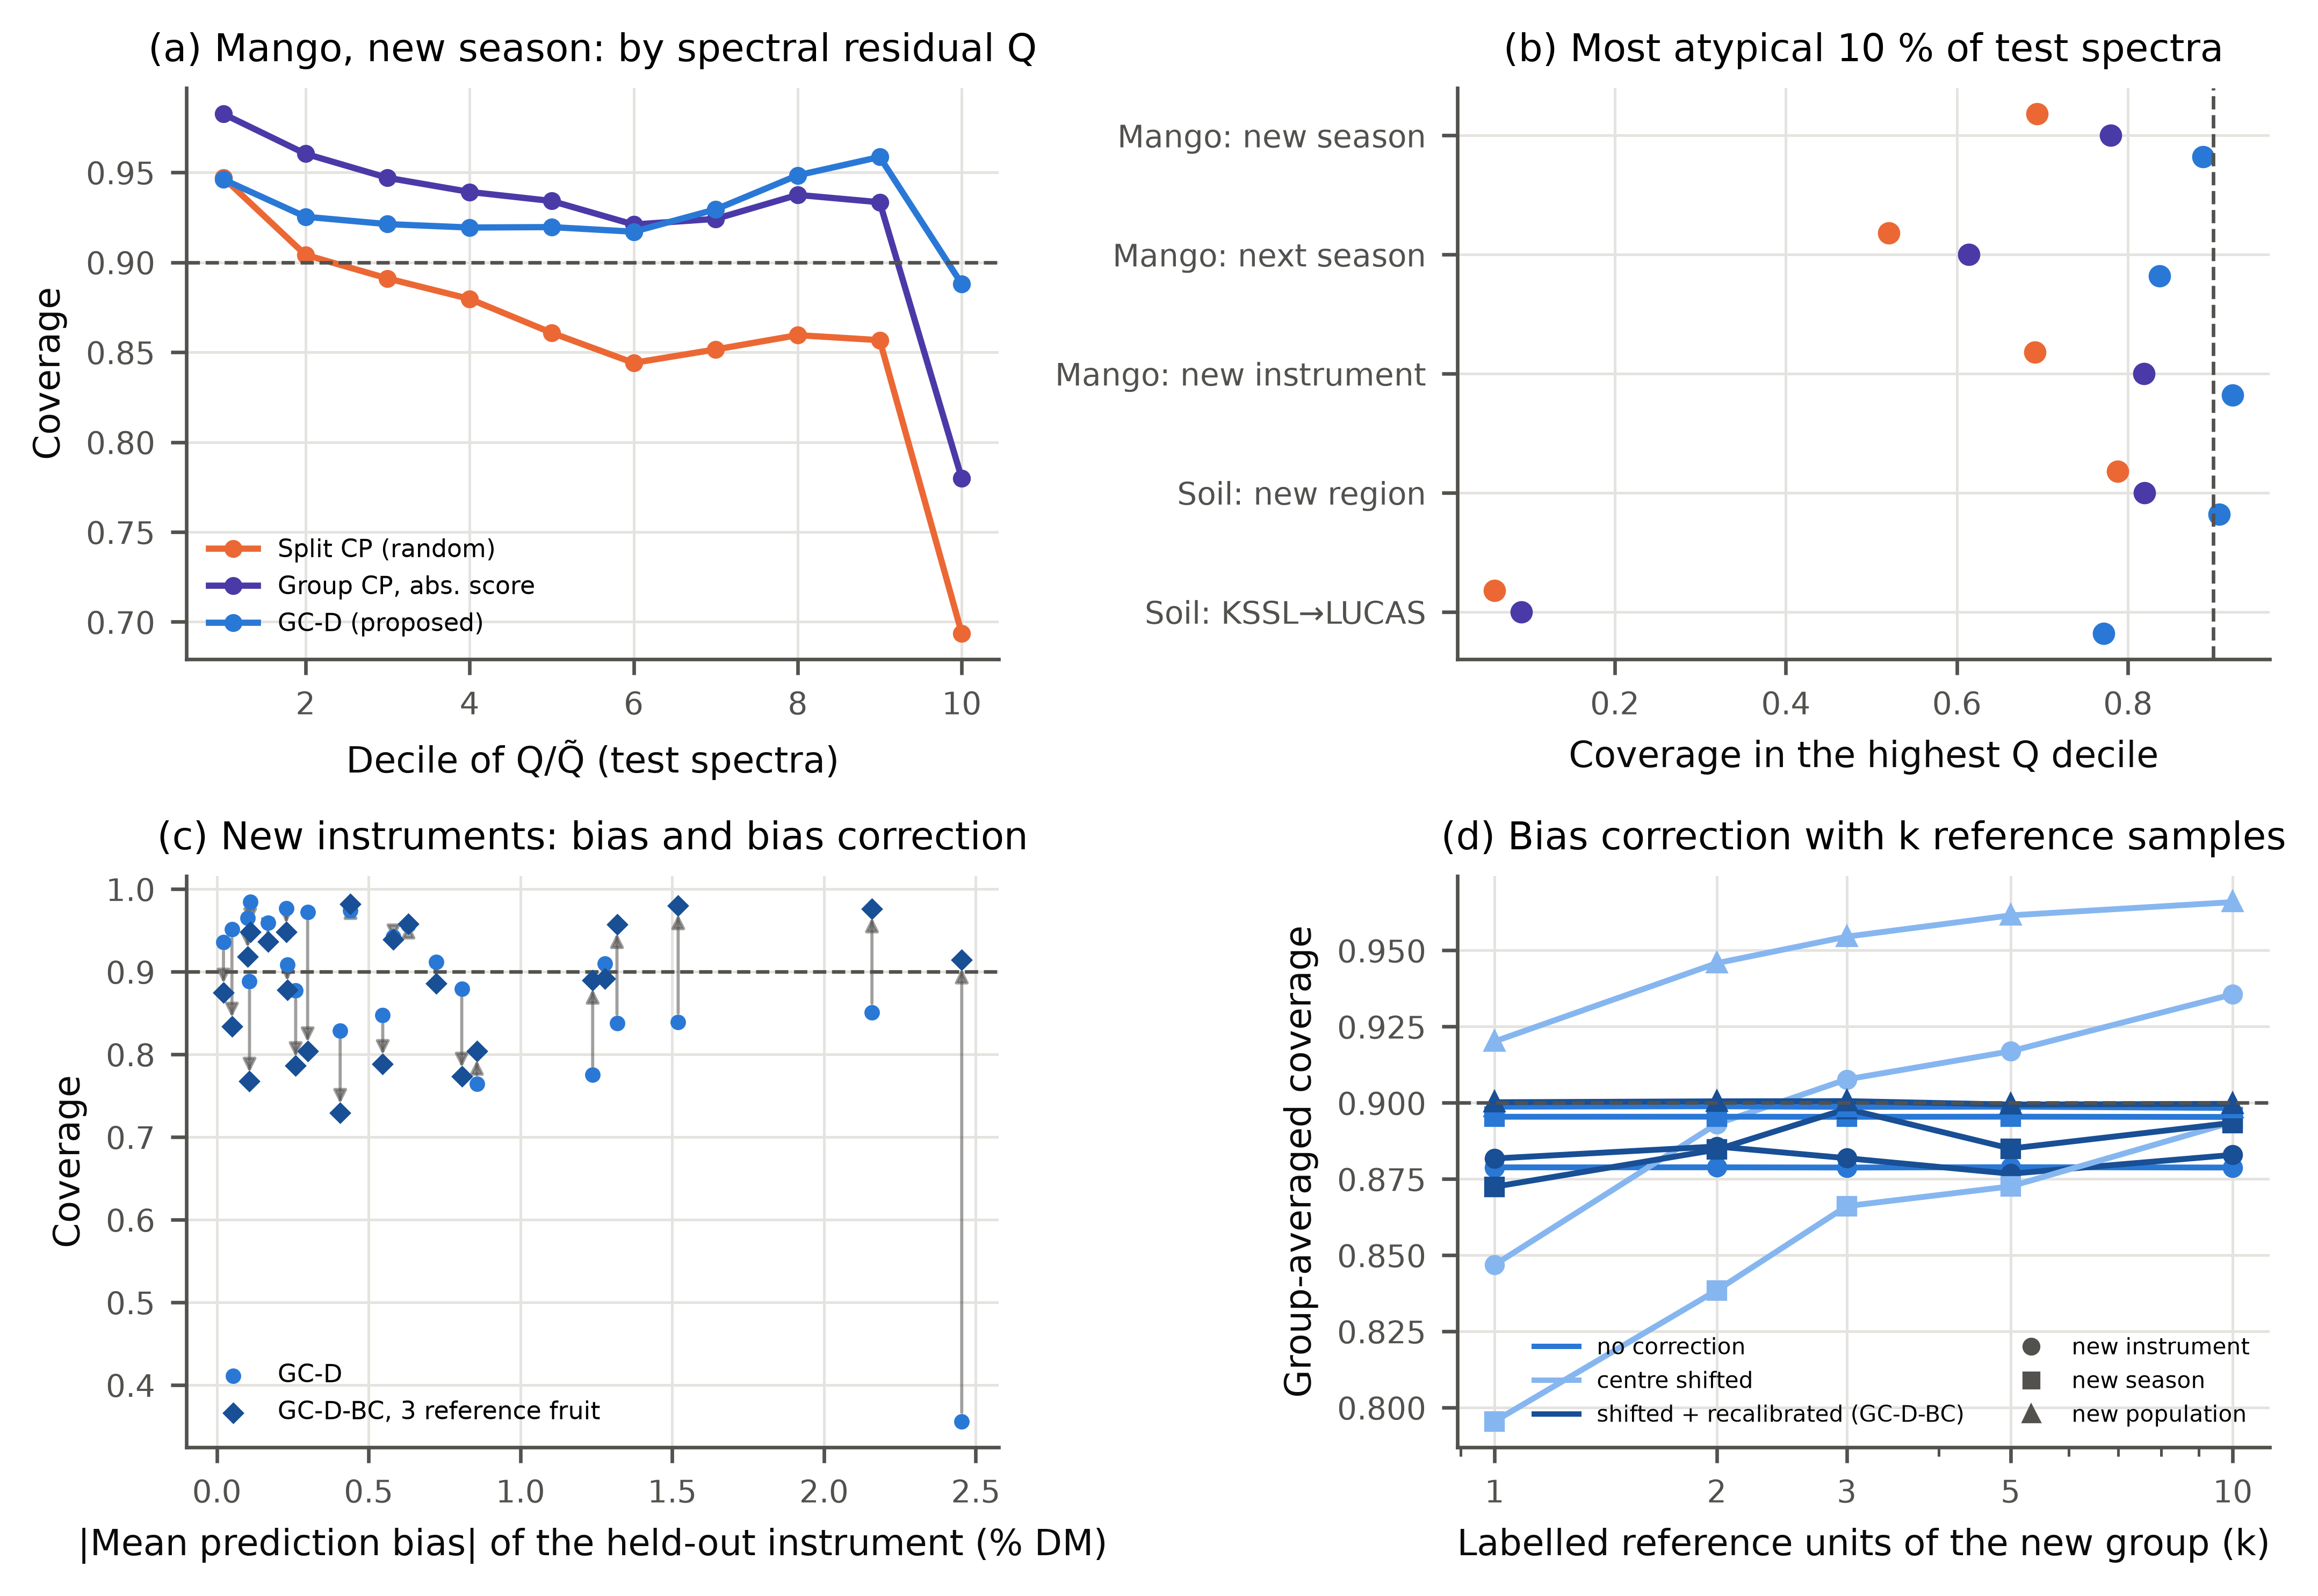
Fig. 7. Error analysis. (a) Coverage for new mango seasons by decile of the Q residual ratio Q/Q̃ of the test spectra; (b) coverage of the 10 % most atypical test spectra (highest Q/Q̃ decile) in five scenarios; (c) coverage of each held-out instrument against its absolute mean prediction bias, without correction and after bias correction with three labelled reference fruit (GC-D-BC; arrows); (d) group-averaged coverage as a function of the number k of labelled reference units of the new group (20 random draws per group; per-group results in Supplementary Table S22). Colours in (b) as in (a). Panels (b)–(d) were added during revision.
Accepting a fruit for 'DM ≥ L' only when the lower interval limit exceeds L is a one-sided 95 % statement. Over limits from 12 to 19 % DM (Fig. 8a,b; Supplementary Table S25), GC-D had a false-acceptance rate no higher than SCP at every limit (L = 16 %: 0.021 vs 0.041), whereas SCP exceeded the nominal 5 % from L = 16.5 % upwards; against ASTM-G it had both no more false acceptances and a higher yield at 12 of the 15 limits. The price is yield: at L = 16 % GC-D accepted 0.342 of the compliant fruit, SCP 0.434 and the oracle 0.375, so most of the yield loss is the cost of any honest uncertainty statement; accepting on the point prediction alone kept 0.831 of the compliant fruit, but 0.145 of the accepted fruit were non-compliant. Which rule is preferable depends on c, the cost of accepting a non-compliant fruit relative to rejecting a compliant one: GC-D has the lower expected cost than SCP for c above 8.2 at L = 16 % (3.2–37.7 over the grid). Contractual penalties for out-of-specification lots, minimum-maturity rules or safety-related attributes (c ≫ 10) favour GC-D; bulk processing in which a rejected fruit is merely downgraded (c ≈ 1) favours the point prediction. For soil organic carbon (Fig. 8c,d) GC-D, SCP and the classical intervals differed little (false acceptance at L = 2 % OC: 0.030 vs 0.031); CQR, with asymmetric intervals, had the fewest false acceptances (0.010) at a lower yield, consistent with the level-dependent errors discussed in Section 4.9.
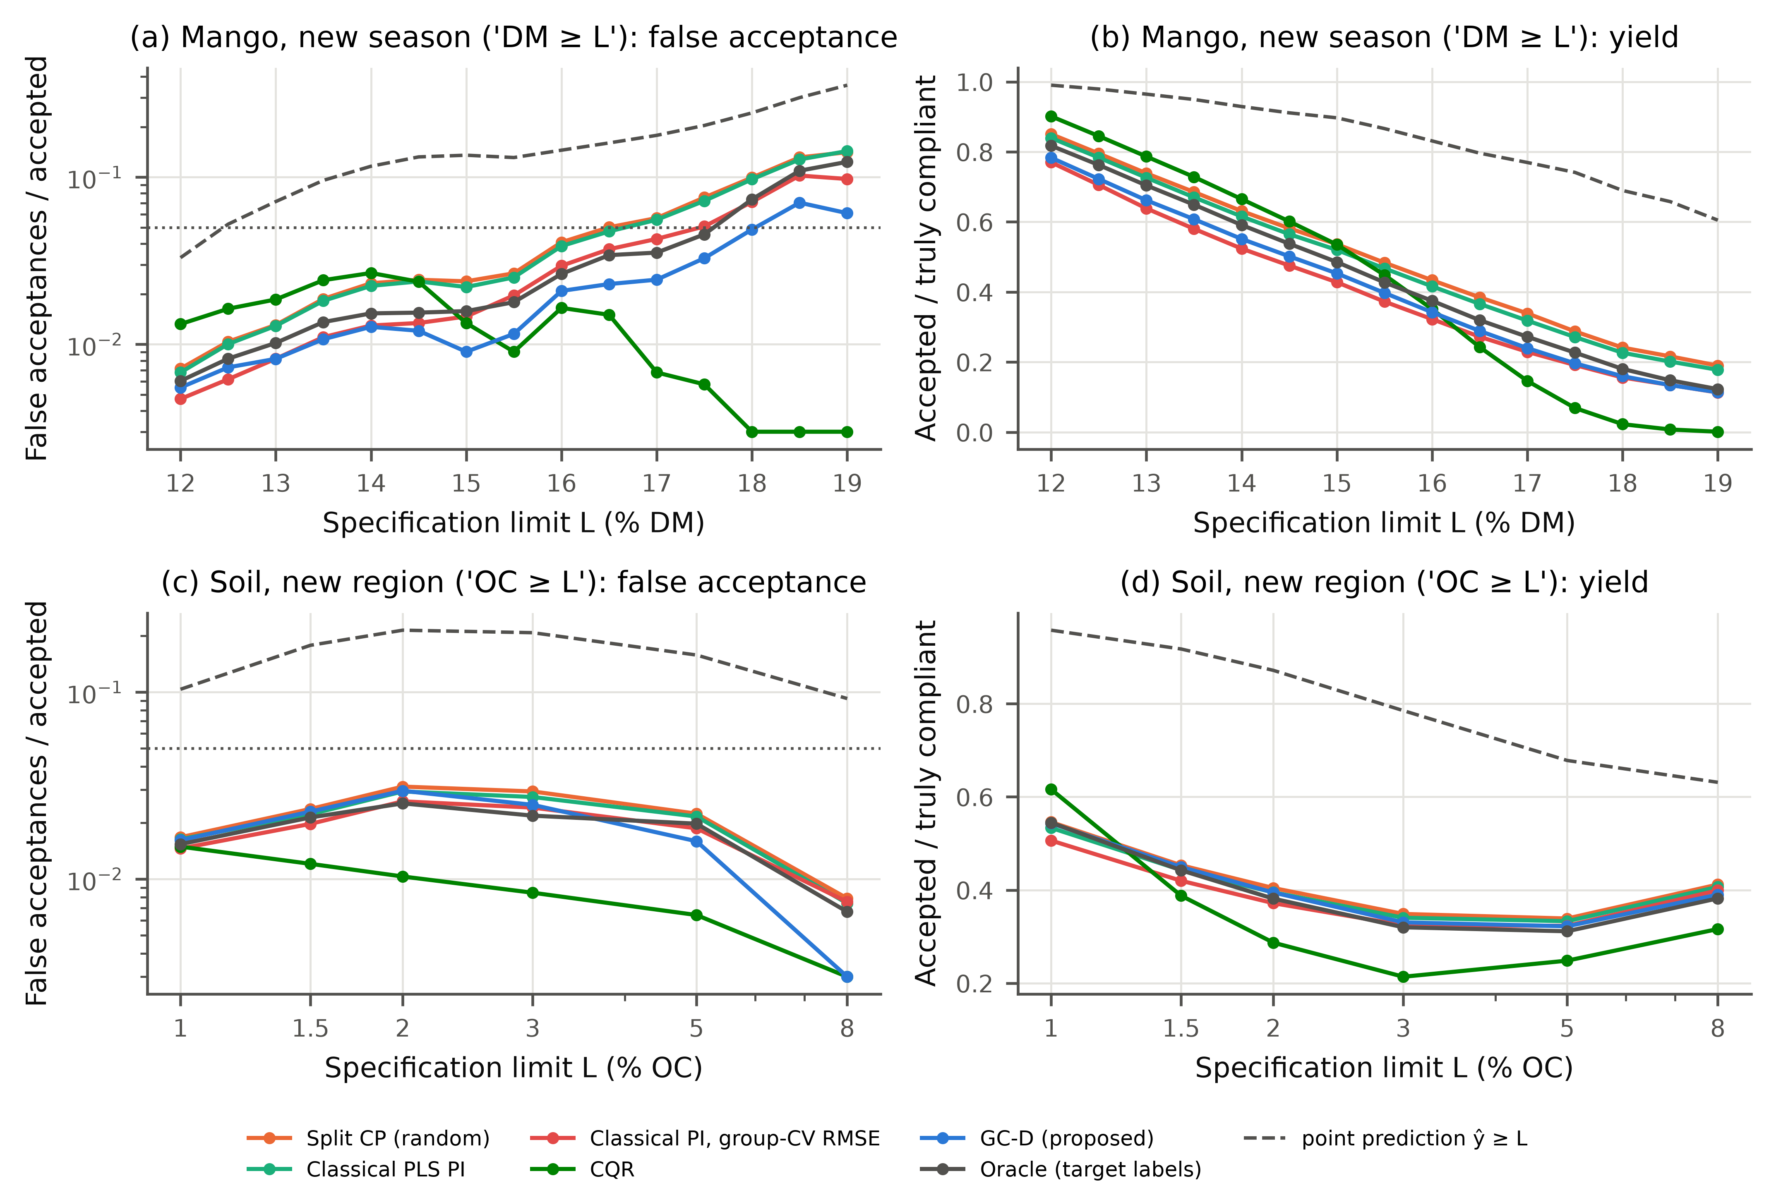
Fig. 8. Specification-limit decisions ('accept if the lower interval limit ≥ L') over a grid of limits: (a, b) dry matter of new mango seasons, (c, d) organic carbon of new soil regions. (a, c) Share of accepted spectra whose reference value is below L (log scale; zero values plotted at 0.003; dotted line: nominal one-sided 5 %); (b, d) share of truly compliant spectra accepted. Dashed grey: accepting on the point prediction alone (ŷ ≥ L).

4.9. Post-hoc extension: level-dependent errors
The soil results revealed a weakness of GC-D not anticipated in the protocol: on new soil regions CQR and GPR had clearly lower interval scores (8.06 and 9.25) than GC-D (11.90) and even the oracle, because OC errors grow with the OC level and are asymmetric. We therefore tested two post-hoc variants (seeds 0–2): GC-D2 adds the predicted value to the scale model, and GC-CQR computes CQR conformity scores out-of-group with group-balanced weights (Supplementary Table S7). GC-D2 did not improve on GC-D (lower median interval score in 6 of 9 scenarios, none significant; soil 13.53 vs 11.90). GC-CQR scored 7.77 on new soil regions and restored the coverage of CQR under group shift (new instruments 0.770 → 0.900, next season 0.727 → 0.858); its median interval score was lower than CQR's in 8 of 9 scenarios (4 significant), but on new mango instruments it remained less sharp than GC-D (6.36 vs 6.21) and on corn it covered less than CQR (0.814–0.898). Out-of-group calibration thus transfers to other conformity scores, and which score is best depends on whether the error is dominated by spectral novelty (mango) or by level-dependent heteroscedasticity (soil).

4.10. Practical recommendations
- Record the deployment-level group (season, instrument, site) and the physical sample of every calibration spectrum, and validate group-wise and unit-disjoint; random cross-validation over-states the coverage attained on a new group.
- With several groups, calibrate intervals on out-of-group residuals: ASTM-G suffices when only average coverage matters; GC-D keeps coverage for atypical spectra and under drift, which matters for decisions on individual samples.
- With fewer than 1/α − 1 groups, state that coverage was verified empirically and may deviate for a single new group by several percentage points (the group-to-group spread of the group-wise validation estimates by how much); with more groups, HCP or HJ+ give formal guarantees at the price of wider intervals.
- With a single calibration instrument or season, or a large bias in a new group, measure a few reference samples of the new group for bias correction (GC-D-BC) or calibration transfer before reporting intervals.
- Withhold the interval ('model not valid for this sample') when Q/Q̃ exceeds the 99 % calibration limit or the interval is as wide as the calibration range; choose interval- or point-based acceptance from the relative cost of the two errors.

4.11. Limitations
- GC-D's coverage was verified empirically, not guaranteed; formal guarantees need K ≥ 1/α − 1 groups, and even then the coverage of a single new group scatters around the nominal level (Section 4.4).
- All methods assume exchangeable groups. A trend beyond the variation among past seasons, or a cultivar or instrument type unlike any in the calibration population, is not covered.
- Group-level biases are absorbed into wider intervals; their correction needs labelled samples of the new group and pays only for large biases (Section 4.8).
- The exponential scale model can produce very wide intervals for a few extrapolating spectra, which back-transformation of a log-scaled analyte amplifies; in a strongly subsampled soil experiment this inflated the mean, though not the median, interval score of every method, most for the diagnostic-scaled ones (Supplementary Table S18). An upper bound on σ would prevent this; we did not add one, to keep the method as pre-specified.
- Other analytes, techniques (Raman, MIR) and deep models were tested only partially (one CNN), and decisions for two analytes only. The post-hoc variants (Section 4.9) and the analyses added during revision were designed after seeing the results and need independent confirmation.

5. Conclusions
Prediction intervals for NIR calibrations should be calibrated against the kind of variation the model will meet. Computing conformity scores out-of-group, weighting groups equally and scaling by the PLS diagnostics T² and Q kept intervals close to nominal coverage for new seasons, instruments and regions in our scenarios with several groups, at no cost beyond the group-wise cross-validation that chemometricians already run. Most of the gain in average coverage comes from out-of-group calibration itself, which a classical interval with group-wise RMSECV also provides; the diagnostic scale adds what matters for decisions on individual samples, coverage of atypical spectra and robustness to drift. In a post-hoc analysis the out-of-group principle also restored the coverage of quantile-regression intervals and gave the sharpest intervals where errors depended on the analyte level; calibration on out-of-group errors, whatever the conformity score, is therefore the main transferable message, and the T²/Q-scaled version a cheap default for PLS models.
Calibration campaigns should span as many seasons or instruments as possible — at least 1/α − 1 for formal guarantees — and report coverage under group-wise validation; with fewer groups, out-of-group calibration still removes the systematic under-coverage of random calibration, but the coverage of one deployment remains uncertain. When a model is calibrated on a single instrument or season, or a new group lies far outside the calibration population, no interval method can compensate: a few reference samples of the new group are needed for bias correction or transfer, and spectra that fail the Q check should be reported without an interval.

CRediT authorship contribution statement
P N Bhargav Teja: Conceptualization, Methodology, Software, Formal analysis, Investigation, Data curation, Visualization, Writing – original draft. Divya Meena S: Conceptualization, Supervision, Validation, Project administration, Writing – review & editing.

Declaration of competing interest
The authors declare that they have no known competing financial interests or personal relationships that could have appeared to influence the work reported in this paper.

Data availability
All data are public: Mango DMC and NIR spectra [36], Open Soil Spectral Library [38], corn [40] and tablet shoot-out data [41]. Code, configuration, per-group results and the scripts that regenerate every number, table and figure are provided as supplementary material and will be archived with a persistent identifier (Zenodo DOI) upon acceptance.

Declaration of generative AI and AI-assisted technologies in the manuscript preparation process
During the preparation of this work the authors used Claude (Anthropic) to assist with literature search, code development, data analysis and the drafting and editing of the text. After using this tool, the authors reviewed and edited the content as needed and take full responsibility for the content of the published article.

References
[1] K.B. Walsh, J. Blasco, M. Zude-Sasse, X. Sun, Visible-NIR ‘point’ spectroscopy in postharvest fruit and vegetable assessment: the science behind three decades of commercial use, Postharvest Biol. Technol. 168 (2020) 111246. https://doi.org/10.1016/j.postharvbio.2020.111246
[2] S. Wold, M. Sjöström, L. Eriksson, PLS-regression: a basic tool of chemometrics, Chemom. Intell. Lab. Syst. 58 (2001) 109–130. https://doi.org/10.1016/S0169-7439(01)00155-1
[3] JCGM 100:2008, Evaluation of measurement data — Guide to the expression of uncertainty in measurement, Joint Committee for Guides in Metrology (BIPM, IEC, IFCC, ILAC, ISO, IUPAC, IUPAP, OIML), 2008. https://doi.org/10.59161/JCGM100-2008E
[4] ASTM International, ASTM E1655-17, Standard Practices for Infrared Multivariate Quantitative Analysis, West Conshohocken, PA. https://doi.org/10.1520/E1655-17
[5] K. Faber, B.R. Kowalski, Propagation of measurement errors for the validation of predictions obtained by principal component regression and partial least squares, J. Chemom. 11 (1997) 181–238. https://doi.org/10.1002/(SICI)1099-128X(199705)11:3<181::AID-CEM459>3.0.CO;2-7
[6] M.C. Denham, Prediction intervals in partial least squares, J. Chemom. 11 (1997) 39–52. https://doi.org/10.1002/(SICI)1099-128X(199701)11:1<39::AID-CEM433>3.0.CO;2-S
[7] J.A. Fernández Pierna, L. Jin, F. Wahl, N.M. Faber, D.L. Massart, Estimation of partial least squares regression prediction uncertainty when the reference values carry a sizeable measurement error, Chemom. Intell. Lab. Syst. 65 (2003) 281–291. https://doi.org/10.1016/S0169-7439(02)00139-9
[8] L. Zhang, S. Garcia-Munoz, A comparison of different methods to estimate prediction uncertainty using partial least squares (PLS): a practitioner's perspective, Chemom. Intell. Lab. Syst. 97 (2009) 152–158. https://doi.org/10.1016/j.chemolab.2009.03.007
[9] R. Romera, Prediction intervals in partial least squares regression via a new local linearization approach, Chemom. Intell. Lab. Syst. 103 (2010) 122–128. https://doi.org/10.1016/j.chemolab.2010.06.007
[10] V. Vovk, A. Gammerman, G. Shafer, Algorithmic Learning in a Random World, Springer, New York, 2005. https://doi.org/10.1007/b106715
[11] J. Lei, M. G’Sell, A. Rinaldo, R.J. Tibshirani, L. Wasserman, Distribution-free predictive inference for regression, J. Am. Stat. Assoc. 113 (2018) 1094–1111. https://doi.org/10.1080/01621459.2017.1307116
[12] A.N. Angelopoulos, S. Bates, Conformal prediction: a gentle introduction, Found. Trends Mach. Learn. 16 (2023) 494–591. https://doi.org/10.1561/2200000101
[13] Y. Lin, C. Xu, Z. Zhou, L. Shen, S. Huang, Distribution-free predictive inference for partial least squares regression with applications to molecular descriptors datasets, J. Chemom. 36 (2022) e3457. https://doi.org/10.1002/cem.3457
[14] O. Jovic, Conformal predictors in chemometric study of mid-infrared food adulteration: quantification of prediction uncertainty, Food Chem. 492 (2025) 145387. https://doi.org/10.1016/j.foodchem.2025.145387
[15] J.K. Wiens, N. Solomatova, S. Shokatian, Calibrated uncertainty estimation for soil organic carbon from Raman spectra, Anal. Chem. 98 (2026) 309–316. https://doi.org/10.1021/acs.analchem.5c04616
[16] H. Cui, Y. Qiao, C. Sun, Aggregated inductive conformal prediction for distribution-free uncertainty quantification in near-infrared spectroscopy, SSRN preprint (2026). https://doi.org/10.2139/ssrn.7528488
[17] R.L. Parham, E. Ochoa Rivera, A.M. Ayala, M.E. Clough, Y. Patel, A.J. McNeil, A. Tewari, A.P. Ault, Improved microplastic identification from simultaneously collected photothermal infrared and Raman spectra using multiview conformal prediction, ACS Meas. Sci. Au 6 (2026) 690–702. https://doi.org/10.1021/acsmeasuresciau.6c00002
[18] U. Norinder, L. Carlsson, S. Boyer, M. Eklund, Introducing conformal prediction in predictive modeling. A transparent and flexible alternative to applicability domain determination, J. Chem. Inf. Model. 54 (2014) 1596–1603. https://doi.org/10.1021/ci5001168
[19] R.N. Feudale, N.A. Woody, H. Tan, A.J. Myles, S.D. Brown, J. Ferré, Transfer of multivariate calibration models: a review, Chemom. Intell. Lab. Syst. 64 (2002) 181–192. https://doi.org/10.1016/S0169-7439(02)00085-0
[20] J.J. Workman, A review of calibration transfer practices and instrument differences in spectroscopy, Appl. Spectrosc. 72 (2018) 340–365. https://doi.org/10.1177/0003702817736064
[21] N.T. Anderson, K.B. Walsh, P.P. Subedi, C.H. Hayes, Achieving robustness across season, location and cultivar for a NIRS model for intact mango fruit dry matter content, Postharvest Biol. Technol. 168 (2020) 111202. https://doi.org/10.1016/j.postharvbio.2020.111202
[22] X. Sun, P. Subedi, K.B. Walsh, Achieving robustness to temperature change of a NIRS-PLSR model for intact mango fruit dry matter content, Postharvest Biol. Technol. 162 (2020) 111117. https://doi.org/10.1016/j.postharvbio.2019.111117
[23] R. Nikzad-Langerodi, W. Zellinger, E. Lughofer, S. Saminger-Platz, Domain-invariant partial-least-squares regression, Anal. Chem. 90 (2018) 6693–6701. https://doi.org/10.1021/acs.analchem.8b00498
[24] B. Mikulasek, V. Fonseca Diaz, D. Gabauer, C. Herwig, R. Nikzad-Langerodi, Partial least squares regression with multiple domains, J. Chemom. 37 (2023) e3477. https://doi.org/10.1002/cem.3477
[25] R.J. Tibshirani, R. Foygel Barber, E. Candès, A. Ramdas, Conformal prediction under covariate shift, in: Adv. Neural Inf. Process. Syst. 32 (NeurIPS 2019). arXiv:1904.06019
[26] R.F. Barber, E.J. Candès, A. Ramdas, R.J. Tibshirani, Conformal prediction beyond exchangeability, Ann. Stat. 51 (2023) 816–845. https://doi.org/10.1214/23-AOS2276
[27] I. Gibbs, E. Candès, Adaptive conformal inference under distribution shift, in: Adv. Neural Inf. Process. Syst. 34 (NeurIPS 2021). arXiv:2106.00170
[28] R. Dunn, L. Wasserman, A. Ramdas, Distribution-free prediction sets for two-layer hierarchical models, J. Am. Stat. Assoc. 118 (2023) 2491–2502. https://doi.org/10.1080/01621459.2022.2060112
[29] Y. Lee, R.F. Barber, R. Willett, Distribution-free inference with hierarchical data, ACM J. Data Sci. (2026) 3786352. https://doi.org/10.1145/3786352 (preprint arXiv:2306.06342)
[30] S. Mallick, E. Tchetgen Tchetgen, E. Dobriban, Y. Lee, Generalized hierarchical conformal prediction, arXiv:2608.15500 (2026)
[31] J.E. Jackson, G.S. Mudholkar, Control procedures for residuals associated with principal component analysis, Technometrics 21 (1979) 341–349. https://doi.org/10.1080/00401706.1979.10489779
[32] D.R. Roberts, V. Bahn, S. Ciuti, M.S. Boyce, J. Elith, G. Guillera-Arroita, et al., Cross-validation strategies for data with temporal, spatial, hierarchical, or phylogenetic structure, Ecography 40 (2017) 913–929. https://doi.org/10.1111/ecog.02881
[33] H. Papadopoulos, V. Vovk, A. Gammerman, Regression conformal prediction with nearest neighbours, J. Artif. Intell. Res. 40 (2011) 815–840. https://doi.org/10.1613/jair.3198
[34] C. Gourieroux, A. Monfort, A. Trognon, Pseudo maximum likelihood methods: theory, Econometrica 52 (1984) 681–700. https://doi.org/10.2307/1913471
[35] R.F. Barber, E.J. Candès, A. Ramdas, R.J. Tibshirani, Predictive inference with the jackknife+, Ann. Stat. 49 (2021) 486–507. https://doi.org/10.1214/20-AOS1965
[36] N. Anderson, Mango DMC and NIR spectra (Version 5), Mendeley Data (2024). https://doi.org/10.17632/46htwnp833.5
[37] N.T. Anderson, K.B. Walsh, J.R. Flynn, J.P. Walsh, Achieving robustness across season, location and cultivar for a NIRS model for intact mango fruit dry matter content. II. Local PLSR and ANN modelling, Postharvest Biol. Technol. 171 (2021) 111358. https://doi.org/10.1016/j.postharvbio.2020.111358
[38] J.L. Safanelli, T. Hengl, L.L. Parente, R. Minarik, D.E. Bloom, K. Todd-Brown, et al., Open Soil Spectral Library (OSSL): building reproducible soil calibration models through open development and community engagement, PLoS One 20 (2025) e0296545. https://doi.org/10.1371/journal.pone.0296545
[39] A. Orgiazzi, C. Ballabio, P. Panagos, A. Jones, O. Fernández-Ugalde, LUCAS Soil, the largest expandable soil dataset for Europe: a review, Eur. J. Soil Sci. 69 (2018) 140–153. https://doi.org/10.1111/ejss.12499
[40] Eigenvector Research, Inc., Corn data set (80 samples measured on three NIR spectrometers; data from Cargill). https://eigenvector.com/resources/data-sets/ (accessed 3 October 2026)
[41] Eigenvector Research, Inc., NIR pharmaceutical tablets ‘Shootout 2002’ data set. https://eigenvector.com/resources/data-sets/ (accessed 3 October 2026)
[42] A. Savitzky, M.J.E. Golay, Smoothing and differentiation of data by simplified least squares procedures, Anal. Chem. 36 (1964) 1627–1639. https://doi.org/10.1021/ac60214a047
[43] R.J. Barnes, M.S. Dhanoa, S.J. Lister, Standard normal variate transformation and de-trending of near-infrared diffuse reflectance spectra, Appl. Spectrosc. 43 (1989) 772–777. https://doi.org/10.1366/0003702894202201
[44] L. Breiman, Bagging predictors, Mach. Learn. 24 (1996) 123–140. https://doi.org/10.1007/BF00058655
[45] C.E. Rasmussen, C.K.I. Williams, Gaussian Processes for Machine Learning, MIT Press, Cambridge, MA, 2006. https://doi.org/10.7551/mitpress/3206.001.0001
[46] G. Ke, Q. Meng, T. Finley, T. Wang, W. Chen, W. Ma, et al., LightGBM: a highly efficient gradient boosting decision tree, in: Adv. Neural Inf. Process. Syst. 30 (NIPS 2017).
[47] Y. Romano, E. Patterson, E. Candès, Conformalized quantile regression, in: Adv. Neural Inf. Process. Syst. 32 (NeurIPS 2019). arXiv:1905.03222
[48] T. Gneiting, A.E. Raftery, Strictly proper scoring rules, prediction, and estimation, J. Am. Stat. Assoc. 102 (2007) 359–378. https://doi.org/10.1198/016214506000001437
[49] F. Wilcoxon, Individual comparisons by ranking methods, Biom. Bull. 1 (1945) 80–83. https://doi.org/10.2307/3001968
[50] S. Holm, A simple sequentially rejective multiple test procedure, Scand. J. Stat. 6 (1979) 65–70.
[51] D.S. Kerby, The simple difference formula: an approach to teaching nonparametric correlation, Compr. Psychol. 3 (2014) 11.IT.3.1. https://doi.org/10.2466/11.IT.3.1
[52] D.B. Rubin, The Bayesian bootstrap, Ann. Stat. 9 (1981) 130–134. https://doi.org/10.1214/aos/1176345338
[53] F. Pedregosa, G. Varoquaux, A. Gramfort, V. Michel, B. Thirion, O. Grisel, et al., Scikit-learn: machine learning in Python, J. Mach. Learn. Res. 12 (2011) 2825–2830.
[54] A. Paszke, S. Gross, F. Massa, A. Lerer, J. Bradbury, G. Chanan, et al., PyTorch: an imperative style, high-performance deep learning library, in: Adv. Neural Inf. Process. Syst. 32 (NeurIPS 2019).
[55] C. Cui, T. Fearn, Modern practical convolutional neural networks for multivariate regression: applications to NIR calibration, Chemom. Intell. Lab. Syst. 182 (2018) 9–20. https://doi.org/10.1016/j.chemolab.2018.07.008
[56] P. Mishra, D. Passos, A synergistic use of chemometrics and deep learning improved the predictive performance of near-infrared spectroscopy models for dry matter prediction in mango fruit, Chemom. Intell. Lab. Syst. 212 (2021) 104287. https://doi.org/10.1016/j.chemolab.2021.104287

