Supplementary material for: Temporal quantification of atrial fibrillation burden with distribution-free uncertainty intervals: development and multinational external validation
[Author names to be inserted]

Supplementary material

S1. Pre-registration and design decisions
The full analysis plan (candidate topics considered, stress test, novelty map, hypotheses, research questions, splits, seeds, fixed hyper-parameters, endpoints and statistical tests) was committed to version control before any model was trained and is provided as the file S1_research_design_preregistration.md. One amendment (A1) was recorded after a one-seed pipeline check and before the full analysis: the emission model of PA-HMMQ would be selected on development patients only (calibration-B and development test patients, LightGBM, mean per-patient absolute error). The rule selected the probability-emission variant (development error 2.858 vs 3.186 pp). The one-seed check also displayed errors for 40-patient subsets of two external cohorts (disclosed in S1). Deviations from the plan: (i) reduced-training-data and window-length analyses omitted Icentia11k for computational reasons; (ii) post-hoc analyses: fair-comparator tests (same emissions, fixed dynamics), per-detector emission selection (R1; selection on calibration-A patients, on which the source dynamics are also fitted, so the selection may be optimistic), exclusion of flutter patients, newly missed patients and tests at 0.1-pp resolution; (iii) one SHDB-AF recording was excluded after the leakage audit (below).

S2. Data processing and leakage audit
Only beat and rhythm annotation files were downloaded and verified against PhysioNet SHA-256 checksums. CPSC2021 records of patient 51 (11 records) were not retrievable from the repository (HTTP 404) and are absent. In Icentia11k, beats outside labelled rhythm regions were treated as unlabelled and excluded. The automated audit hashed every 60-beat window (RR rounded to 8 ms) and fingerprinted every recording. SHDB-AF Data_ID 020 was an exact RR-level duplicate of Data_ID 005 (same Subject_ID; metadata Holter dates 2021 and 2024) and was removed; after removal no recording-level duplicates remained, and 2 individual windows (of 928477) were shared between different patients, consistent with chance identity of very regular rhythms. Patient-level splits were verified disjoint for every seed, and no development patient occurred in an external cohort. The SHDB-AF metadata columns are Data_ID/Subject_ID (not the names given in the database README); patients with two recordings were aggregated. MITDB paced records were retained as non-AF recordings. Windows separated by an invalid RR interval within a recording were treated as adjacent in the hidden Markov model (valid intervals constituted ≥99.8% of intervals in every database).

S3. Detector details
Features (16). Mean RR; SDNN; coefficient of variation; RMSSD/mean RR; pNN50; pNN20; median |ΔRR|/mean RR; interquartile range/median RR; turning-point ratio; normalised Shannon entropy of the 16-bin RR histogram; Poincaré SD1/mean RR, SD2/mean RR and SD1/SD2; a coefficient-of-sample-entropy-type irregularity measure, computed as SampEn(m = 2, r = 0.2·SD) + ln(0.06) − ln(mean RR) (a hybrid of sample entropy and the COSEn normalisation, not the original fixed-tolerance COSEn); fraction of sign changes of ΔRR; min/max RR ratio. Classical-LR used normalised RMSSD, Shannon entropy and turning-point ratio with standardisation fitted on training patients. LightGBM: up to 400 trees, learning rate 0.05, 31 leaves, row and column subsampling 0.8, early stopping (50 rounds) on inner-validation patients. RRNet: input two channels (log RR minus window mean; ΔRR), three 1-D convolutional blocks (32 channels, kernel 5, batch normalisation, ReLU, residual connections), bidirectional GRU (32 units per direction), mean and max pooling, two-layer head with dropout 0.2; AdamW (learning rate 10⁻³, weight decay 10⁻⁴), cosine schedule, batch 512, ≤12 epochs, early stopping (patience 3) on inner-validation binary cross-entropy; 27,681 parameters. RRNet is a re-implementation inspired by ArNet/ArNet2, not the original code or weights. PyTorch was run with deterministic algorithms; LightGBM used four threads without its deterministic flag, so re-runs may differ negligibly.

S4. PA-HMMQ and interval details
Hidden states z_{t} ∈ {0 (non-AF), 1 (AF)} for consecutive windows of a recording; emissions e_{k}(x_{t}) are fixed: in the final variant e₁ = p_{t}, e₀ = 1 − p_{t} (p clipped to [10⁻⁶, 1 − 10⁻⁶]); in the pre-registered variant e_{k} is a Laplace-smoothed 50-bin histogram density of logit(p) among calibration-A windows of class k. The source transition matrix and initial distribution are add-one-smoothed frequencies of reference window labels in calibration-A sequences. For each patient i, expectation–maximisation alternates forward–backward smoothing (all recordings of the patient share A_{i}, π_{i}) with the MAP updates A_{i}(k,l) ∝ Σξ(k,l) + κA_{src}(k,l) and π_{i}(k) ∝ Σγ₁(k) + κπ_{src}(k), until the relative log-likelihood change is <10⁻⁶ (≤50 iterations). Burden is Σd_{t}γ_{t}(1)/Σd_{t}. Convergence is assessed on the summed log-likelihood over all patients of a cohort. EMQ is applied to isotonic-recalibrated posteriors (calibration A) with the duration-weighted source prior. Posterior samples of the whole state path are drawn by forward-filtering backward-sampling at the converged parameters; σ̂_{i} is the standard deviation of the duration-weighted sampled burden. EMQ is recovered by removing temporal dependence and HMM-src by fixing A_{i} = A_{src}. Complexity: one forward–backward pass is O(T·S²) with S = 2 states and T windows (≈1,500–3,000 per 24 h), repeated for each EM iteration; FFBS adds O(K·T) for K = 200 samples. The implementation vectorises across sequences by padding to the longest sequence, so memory is O(N_{seq}·T_{max}·K) during sampling; the measured peak Python memory for a 24-h recording was 1.4 MB. The Monte-Carlo error of σ̂ (200 samples) was not varied; σ̂ only scales the nonconformity score, whose quantile is calibrated empirically. Timings are CPU wall-clock medians on 4 threads; energy was not measured.

S5. Supplementary tables and figures
Supplementary Tables S1–S14 and Figures S1–S8 follow. All values are generated automatically from the result files in the code repository.

Table S1 Databases: sources, versions, licences and window counts
Database | Role | Country | Source/version | Licence | Recordings | Patients | Hours analysed | Windows (60 beats) | Patients with AF | Patients with AFL | AF windows (%)
Long-Term AF Database | development | USA | PhysioNet ltafdb 1.0.0 | ODC-By 1.0 | 84 | 84 | 1897 | 149760 | 83 | 0 | 58.1
MIT-BIH AF Database | development | USA | PhysioNet afdb 1.0.0 | ODC-By 1.0 | 25 | 25 | 248 | 20312 | 25 | 8 | 42.5
MIT-BIH Arrhythmia Database | development | USA | PhysioNet mitdb 1.0.0 | ODC-By 1.0 | 48 | 47 | 23 | 1787 | 7 | 3 | 10.6
MIT-BIH Normal Sinus Rhythm Database | development | USA | PhysioNet nsrdb 1.0.0 | ODC-By 1.0 | 18 | 18 | 378 | 28454 | 0 | 0 | 0.0
Normal Sinus Rhythm RR Interval Database | development | USA | PhysioNet nsr2db 1.0.0 | ODC-By 1.0 | 54 | 54 | 1200 | 92190 | 0 | 0 | 0.0
BIDMC Congestive Heart Failure Database | development | USA | PhysioNet chfdb 1.0.0 | ODC-By 1.0 | 15 | 15 | 298 | 27000 | 4 | 0 | 5.9
SHDB-AF Japanese Holter AF database | external validation | Japan | PhysioNet shdb-af 1.0.1 | ODC-By 1.0 | 97 | 93 | 2297 | 170001 | 72 | 12 | 23.8
4th China Physiological Signal Challenge 2021 | external validation | China | PhysioNet cpsc2021 1.0.0 | CC BY 4.0 | 1405 | 105 | 471 | 34706 | 53 | 2 | 35.9
Icentia11k continuous ECG (random subset) | external validation | Canada | PhysioNet icentia11k-continuous-ecg 1.0 | CC BY-NC-SA 4.0 | 790 | 790 | 5808 | 404267 | 50 | 25 | 5.9
All databases from PhysioNet; counts after exclusions (see Supplementary S2). ODC-By, Open Data Commons Attribution License; CC BY, Creative Commons Attribution; CC BY-NC-SA, Creative Commons Attribution-NonCommercial-ShareAlike.

Table S2 Window-level detector performance (mean ± SD over seeds)
Detector | Cohort | auroc | auprc | sensitivity | specificity | f1 | ece | brier
Classical-LR | Development test | 0.959 ± 0.012 | 0.875 ± 0.036 | 0.851 ± 0.039 | 0.951 ± 0.009 | 0.873 ± 0.022 | 0.058 ± 0.027 | 0.067 ± 0.008
Classical-LR | SHDB-AF | 0.884 ± 0.001 | 0.628 ± 0.010 | 0.837 ± 0.023 | 0.889 ± 0.009 | 0.763 ± 0.005 | 0.068 ± 0.010 | 0.104 ± 0.003
Classical-LR | CPSC2021 | 0.884 ± 0.004 | 0.663 ± 0.010 | 0.926 ± 0.025 | 0.798 ± 0.018 | 0.810 ± 0.005 | 0.100 ± 0.019 | 0.129 ± 0.005
Classical-LR | Icentia11k | 0.961 ± 0.000 | 0.457 ± 0.011 | 0.931 ± 0.028 | 0.933 ± 0.007 | 0.622 ± 0.009 | 0.099 ± 0.009 | 0.057 ± 0.005
LightGBM | Development test | 0.992 ± 0.005 | 0.986 ± 0.009 | 0.909 ± 0.046 | 0.983 ± 0.012 | 0.936 ± 0.023 | 0.032 ± 0.013 | 0.035 ± 0.011
LightGBM | SHDB-AF | 0.969 ± 0.003 | 0.902 ± 0.007 | 0.881 ± 0.011 | 0.960 ± 0.004 | 0.878 ± 0.003 | 0.035 ± 0.012 | 0.051 ± 0.001
LightGBM | CPSC2021 | 0.992 ± 0.001 | 0.980 ± 0.004 | 0.976 ± 0.009 | 0.954 ± 0.013 | 0.949 ± 0.010 | 0.025 ± 0.007 | 0.029 ± 0.005
LightGBM | Icentia11k | 0.990 ± 0.001 | 0.776 ± 0.021 | 0.974 ± 0.006 | 0.972 ± 0.004 | 0.804 ± 0.016 | 0.030 ± 0.002 | 0.024 ± 0.003
RRNet | Development test | 0.992 ± 0.007 | 0.987 ± 0.012 | 0.917 ± 0.060 | 0.983 ± 0.011 | 0.940 ± 0.029 | 0.032 ± 0.017 | 0.033 ± 0.014
RRNet | SHDB-AF | 0.973 ± 0.001 | 0.910 ± 0.005 | 0.908 ± 0.012 | 0.952 ± 0.008 | 0.881 ± 0.006 | 0.045 ± 0.003 | 0.051 ± 0.002
RRNet | CPSC2021 | 0.990 ± 0.002 | 0.967 ± 0.008 | 0.989 ± 0.012 | 0.939 ± 0.023 | 0.943 ± 0.015 | 0.036 ± 0.017 | 0.035 ± 0.009
RRNet | Icentia11k | 0.986 ± 0.001 | 0.686 ± 0.029 | 0.981 ± 0.012 | 0.963 ± 0.009 | 0.762 ± 0.037 | 0.036 ± 0.010 | 0.032 ± 0.006
Threshold 0.5. ECE, expected calibration error (15 bins).

Table S3 Per-patient AF-burden MAE (pp) by estimator, Classical-LR detector
Estimator | Development test | SHDB-AF | CPSC2021 | Icentia11k | Pooled external
CC | 7.71 ± 0.48 | 9.94 ± 0.54 | 17.34 ± 0.81 | 7.20 ± 0.57 | 8.54 ± 0.56
CC-MF | 7.28 ± 0.52 | 9.69 ± 0.50 | 16.95 ± 0.98 | 6.79 ± 0.57 | 8.14 ± 0.58
PCC | 13.40 ± 1.13 | 12.31 ± 0.54 | 22.10 ± 0.95 | 12.99 ± 0.68 | 13.90 ± 0.65
PCC-iso | 10.87 ± 1.66 | 11.13 ± 0.35 | 20.82 ± 0.75 | 10.55 ± 0.85 | 11.70 ± 0.74
ACC | 7.28 ± 0.91 | 11.01 ± 0.51 | 17.75 ± 1.20 | 6.84 ± 0.34 | 8.40 ± 0.41
PACC | 8.95 ± 1.66 | 12.16 ± 0.69 | 20.05 ± 1.37 | 8.87 ± 0.61 | 10.37 ± 0.65
EMQ | 7.36 ± 2.15 | 11.42 ± 0.48 | 18.32 ± 1.30 | 8.66 ± 0.79 | 9.95 ± 0.79
HMM-src | 7.45 ± 2.16 | 10.38 ± 0.70 | 16.94 ± 1.21 | 9.33 ± 0.91 | 10.23 ± 0.91
HMM-src[rawE] | 6.79 ± 0.83 | 9.20 ± 0.40 | 15.76 ± 1.58 | 6.06 ± 0.66 | 7.39 ± 0.71
HMM-src[sel] (post hoc R1) | 7.54 ± 2.10 | 10.13 ± 1.02 | 16.77 ± 1.30 | 8.63 ± 1.85 | 9.64 ± 1.68
PA-HMMQ (pre-registered) | 7.40 ± 1.78 | 10.59 ± 0.64 | 17.50 ± 1.06 | 9.53 ± 0.94 | 10.47 ± 0.91
PA-HMMQ (final) | 6.86 ± 0.62 | 9.26 ± 0.39 | 15.87 ± 1.41 | 6.10 ± 0.65 | 7.44 ± 0.69
PA-HMMQ[sel] (post hoc R1) | 7.43 ± 1.76 | 10.29 ± 1.07 | 16.94 ± 1.55 | 8.79 ± 1.94 | 9.79 ± 1.81
Mean ± SD over seeds.

Table S4 Per-patient AF-burden MAE (pp) by estimator, RRNet detector
Estimator | Development test | SHDB-AF | CPSC2021 | Icentia11k | Pooled external
CC | 3.55 ± 1.29 | 4.78 ± 0.46 | 5.01 ± 1.15 | 3.72 ± 0.88 | 3.96 ± 0.83
CC-MF | 3.34 ± 1.20 | 4.52 ± 0.40 | 4.73 ± 1.21 | 3.50 ± 0.84 | 3.72 ± 0.80
PCC | 4.02 ± 1.16 | 5.06 ± 0.50 | 5.86 ± 1.35 | 4.10 ± 0.99 | 4.37 ± 0.93
PCC-iso | 3.67 ± 0.82 | 5.00 ± 0.33 | 5.50 ± 0.99 | 3.96 ± 0.67 | 4.22 ± 0.63
ACC | 3.54 ± 1.21 | 4.97 ± 0.44 | 4.81 ± 1.26 | 3.59 ± 0.84 | 3.85 ± 0.81
PACC | 3.71 ± 1.09 | 5.18 ± 0.51 | 5.27 ± 1.39 | 3.82 ± 0.92 | 4.10 ± 0.89
EMQ | 3.03 ± 0.97 | 4.85 ± 0.44 | 4.51 ± 1.15 | 3.37 ± 0.64 | 3.63 ± 0.61
HMM-src | 2.64 ± 1.06 | 4.55 ± 0.41 | 4.49 ± 1.01 | 3.53 ± 0.68 | 3.73 ± 0.64
HMM-src[rawE] | 3.00 ± 1.12 | 4.29 ± 0.26 | 4.21 ± 1.14 | 3.22 ± 0.75 | 3.43 ± 0.70
HMM-src[sel] (post hoc R1) | 3.06 ± 1.04 | 4.37 ± 0.26 | 4.68 ± 1.20 | 3.23 ± 0.82 | 3.49 ± 0.67
PA-HMMQ (pre-registered) | 2.68 ± 1.06 | 4.60 ± 0.44 | 4.59 ± 0.95 | 3.57 ± 0.70 | 3.78 ± 0.65
PA-HMMQ (final) | 3.18 ± 1.08 | 4.31 ± 0.28 | 4.20 ± 1.06 | 3.25 ± 0.76 | 3.45 ± 0.70
PA-HMMQ[sel] (post hoc R1) | 3.06 ± 0.94 | 4.43 ± 0.33 | 4.39 ± 1.14 | 3.27 ± 0.86 | 3.50 ± 0.78
Mean ± SD over seeds.

Table S5 Ablation of PA-HMMQ components (LightGBM, MAE in pp)
Variant | Calibration B | Development test | SHDB-AF | CPSC2021 | Icentia11k | Pooled external
PA-HMMQ | 3.40 ± 1.79 | 2.97 ± 1.03 | 4.54 ± 0.36 | 3.50 ± 1.06 | 2.84 ± 0.34 | 3.07 ± 0.30
PA-HMMQ[k=0] | 3.35 ± 1.84 | 2.97 ± 1.03 | 4.54 ± 0.36 | 3.54 ± 1.09 | 2.84 ± 0.34 | 3.08 ± 0.31
PA-HMMQ[k=100] | 3.49 ± 1.76 | 2.98 ± 1.03 | 4.54 ± 0.36 | 3.47 ± 1.03 | 2.83 ± 0.33 | 3.06 ± 0.29
PA-HMMQ[k=1] | 3.37 ± 1.81 | 2.97 ± 1.03 | 4.54 ± 0.36 | 3.54 ± 1.08 | 2.84 ± 0.34 | 3.08 ± 0.31
PA-HMMQ[k=30] | 3.46 ± 1.75 | 2.97 ± 1.03 | 4.54 ± 0.36 | 3.48 ± 1.05 | 2.84 ± 0.34 | 3.07 ± 0.30
PA-HMMQ[k=3] | 3.38 ± 1.80 | 2.97 ± 1.03 | 4.54 ± 0.36 | 3.52 ± 1.07 | 2.84 ± 0.34 | 3.08 ± 0.31
PA-HMMQ[rawE,k=0] | 2.68 ± 1.56 | 3.04 ± 1.26 | 4.23 ± 0.11 | 2.77 ± 0.38 | 2.27 ± 0.33 | 2.51 ± 0.25
PA-HMMQ[rawE,k=100] | 2.76 ± 1.53 | 3.03 ± 1.28 | 4.24 ± 0.11 | 2.98 ± 0.45 | 2.26 ± 0.33 | 2.52 ± 0.23
PA-HMMQ[rawE,k=1] | 2.66 ± 1.55 | 3.04 ± 1.25 | 4.23 ± 0.11 | 2.80 ± 0.38 | 2.27 ± 0.33 | 2.51 ± 0.25
PA-HMMQ[rawE,k=30] | 2.71 ± 1.54 | 3.03 ± 1.26 | 4.24 ± 0.11 | 2.94 ± 0.42 | 2.26 ± 0.33 | 2.52 ± 0.24
PA-HMMQ[rawE,k=3] | 2.66 ± 1.57 | 3.04 ± 1.25 | 4.23 ± 0.11 | 2.84 ± 0.38 | 2.27 ± 0.33 | 2.51 ± 0.25
PA-HMMQ[rawE] | 2.67 ± 1.57 | 3.04 ± 1.26 | 4.23 ± 0.11 | 2.88 ± 0.39 | 2.27 ± 0.33 | 2.52 ± 0.24
PA-HMMQ[sel] | 2.93 ± 1.82 | 3.16 ± 1.28 | 4.29 ± 0.12 | 3.05 ± 0.47 | 2.29 ± 0.35 | 2.56 ± 0.27
CC | 2.86 ± 1.25 | 3.55 ± 1.05 | 4.51 ± 0.12 | 3.85 ± 0.76 | 2.69 ± 0.35 | 2.99 ± 0.26
EMQ | 3.48 ± 1.74 | 3.10 ± 0.93 | 4.92 ± 0.52 | 3.78 ± 1.12 | 2.72 ± 0.29 | 3.04 ± 0.21
HMM-src | 3.56 ± 1.84 | 3.00 ± 1.02 | 4.53 ± 0.37 | 3.48 ± 1.02 | 2.82 ± 0.33 | 3.05 ± 0.29
HMM-src[rawE] | 2.84 ± 1.54 | 3.04 ± 1.32 | 4.24 ± 0.10 | 3.02 ± 0.43 | 2.25 ± 0.31 | 2.52 ± 0.22
HMM-src[sel] | 2.75 ± 1.64 | 3.13 ± 1.38 | 4.27 ± 0.14 | 3.42 ± 0.66 | 2.26 ± 0.32 | 2.57 ± 0.21
k, prior strength κ in pseudo-transitions (κ=10 pre-specified); rawE, detector probability used as emission likelihood (final variant); HMM-src, no per-patient adaptation (κ→∞); EMQ, per-patient prior adaptation without temporal model; CC, no quantification.

Table S6 MAE (pp) by reference burden stratum, pooled external cohorts (LightGBM)
Estimator | 0 (AF-free) (n=813) | (0,1%] (n=16) | (1,10%] (n=30) | (10,50%] (n=35) | >50% (n=94)
CC | 2.66 | 5.81 | 1.84 | 4.72 | 5.02
CC-MF | 2.45 | 5.65 | 1.60 | 4.58 | 4.37
PCC-iso | 3.47 | 6.89 | 3.31 | 5.66 | 6.08
ACC | 2.59 | 5.88 | 2.06 | 5.10 | 4.45
EMQ | 2.77 | 6.01 | 2.32 | 7.56 | 3.46
HMM-src | 2.89 | 5.88 | 2.78 | 6.14 | 2.93
HMM-src[rawE] | 2.22 | 5.62 | 1.53 | 4.54 | 4.16
PA-HMMQ (pre-registered) | 2.91 | 5.95 | 2.77 | 6.18 | 2.90
PA-HMMQ (final) | 2.24 | 5.62 | 1.56 | 4.44 | 4.00
PA-HMMQ[sel] | 2.26 | 5.66 | 1.63 | 4.44 | 4.25
Mean over seeds.

Table S7 Classification of patients by burden thresholds, pooled external cohorts (LightGBM)
Estimator | present_30s sens | present_30s spec | ge1pct sens | ge1pct spec | ge10pct sens | ge10pct spec
CC | 0.992 ± 0.003 | 0.744 ± 0.034 | 0.992 ± 0.005 | 0.850 ± 0.026 | 0.974 ± 0.004 | 0.946 ± 0.011
CC-MF | 0.982 ± 0.005 | 0.826 ± 0.027 | 0.989 ± 0.007 | 0.882 ± 0.022 | 0.974 ± 0.004 | 0.954 ± 0.010
PCC-iso | 0.997 ± 0.003 | 0.487 ± 0.251 | 1.000 ± 0.000 | 0.712 ± 0.136 | 0.977 ± 0.000 | 0.923 ± 0.011
ACC | 0.949 ± 0.028 | 0.846 ± 0.027 | 0.979 ± 0.008 | 0.879 ± 0.016 | 0.972 ± 0.004 | 0.948 ± 0.009
EMQ | 0.961 ± 0.018 | 0.895 ± 0.025 | 0.976 ± 0.010 | 0.911 ± 0.020 | 0.975 ± 0.003 | 0.949 ± 0.006
HMM-src | 0.971 ± 0.004 | 0.869 ± 0.018 | 0.987 ± 0.004 | 0.891 ± 0.019 | 0.978 ± 0.003 | 0.943 ± 0.009
HMM-src[rawE] | 0.947 ± 0.014 | 0.910 ± 0.025 | 0.967 ± 0.011 | 0.925 ± 0.020 | 0.971 ± 0.003 | 0.961 ± 0.008
PA-HMMQ (pre-registered) | 0.965 ± 0.008 | 0.877 ± 0.022 | 0.985 ± 0.006 | 0.889 ± 0.017 | 0.978 ± 0.003 | 0.940 ± 0.009
PA-HMMQ (final) | 0.941 ± 0.014 | 0.914 ± 0.025 | 0.971 ± 0.012 | 0.923 ± 0.021 | 0.974 ± 0.004 | 0.960 ± 0.009
PA-HMMQ[sel] | 0.941 ± 0.030 | 0.907 ± 0.046 | 0.967 ± 0.024 | 0.923 ± 0.038 | 0.974 ± 0.004 | 0.959 ± 0.011
present_30s: ≥30 s of AF in the analysed recording; ge1pct/ge10pct: burden ≥1%/≥10%. Mean ± SD over seeds.

Table S8 Influence of atrial flutter (LightGBM, pooled external)
Estimator | MAE vs AF reference (pp) | MAE vs AF+AFL reference (pp) | MAE excluding patients with any AFL, n=949 (post hoc)
CC | 2.99 ± 0.26 | 2.11 ± 0.22 | 1.67 ± 0.25
CC-MF | 2.73 ± 0.23 | 1.85 ± 0.20 | 1.41 ± 0.23
PCC | 3.94 ± 0.57 | 3.10 ± 0.67 | 2.67 ± 0.63
PCC-iso | 3.85 ± 0.51 | 2.95 ± 0.57 | 2.55 ± 0.55
ACC | 2.89 ± 0.22 | 1.98 ± 0.19 | 1.55 ± 0.21
PACC | 3.21 ± 0.15 | 2.29 ± 0.17 | 1.87 ± 0.16
EMQ | 3.04 ± 0.21 | 2.03 ± 0.20 | 1.66 ± 0.21
HMM-src | 3.05 ± 0.29 | 2.02 ± 0.26 | 1.67 ± 0.28
HMM-src[rawE] | 2.52 ± 0.22 | 1.65 ± 0.19 | 1.19 ± 0.22
PA-HMMQ (pre-registered) | 3.07 ± 0.30 | 2.03 ± 0.27 | 1.69 ± 0.29
PA-HMMQ (final) | 2.52 ± 0.24 | 1.64 ± 0.21 | 1.19 ± 0.23
PA-HMMQ[sel] | 2.56 ± 0.27 | 1.69 ± 0.24 | 1.24 ± 0.27
The AF+AFL reference counts flutter time as arrhythmia time. The analysis excluding patients with any flutter is post hoc.

Table S9 Robustness to simulated R-peak and rhythm perturbations, SHDB-AF (MAE in pp, mean ± SD over seeds)
Detector | Condition | CC | CC-MF | PCC-iso | ACC | EMQ | HMM-src | PA-HMMQ (pre-registered) | PA-HMMQ (final)
LightGBM | none_0.0 | 4.51 ± 0.12 | 4.31 ± 0.11 | 5.13 ± 0.42 | 4.73 ± 0.31 | 4.92 ± 0.52 | 4.53 ± 0.37 | 4.54 ± 0.36 | 4.23 ± 0.11
LightGBM | missed_0.02 | 4.60 ± 0.13 | 4.39 ± 0.11 | 5.49 ± 0.64 | 4.80 ± 0.31 | 5.33 ± 0.70 | 4.69 ± 0.35 | 4.71 ± 0.34 | 4.30 ± 0.09
LightGBM | missed_0.05 | 4.75 ± 0.13 | 4.55 ± 0.12 | 5.87 ± 0.72 | 4.96 ± 0.33 | 5.76 ± 0.85 | 4.94 ± 0.45 | 4.96 ± 0.44 | 4.47 ± 0.12
LightGBM | false_0.02 | 4.60 ± 0.16 | 4.33 ± 0.18 | 5.62 ± 0.59 | 4.80 ± 0.34 | 5.50 ± 0.81 | 4.82 ± 0.55 | 4.81 ± 0.58 | 4.18 ± 0.17
LightGBM | false_0.05 | 4.95 ± 0.29 | 4.53 ± 0.32 | 6.71 ± 0.77 | 5.10 ± 0.42 | 6.54 ± 1.15 | 5.44 ± 1.00 | 5.47 ± 1.10 | 4.27 ± 0.30
LightGBM | jitter_0.01 | 4.82 ± 0.15 | 4.53 ± 0.19 | 5.76 ± 0.55 | 5.03 ± 0.33 | 5.65 ± 0.72 | 5.07 ± 0.54 | 5.08 ± 0.55 | 4.40 ± 0.17
LightGBM | jitter_0.025 | 8.46 ± 1.12 | 7.53 ± 0.99 | 10.48 ± 1.06 | 8.62 ± 0.97 | 10.68 ± 0.88 | 9.61 ± 0.74 | 9.73 ± 0.81 | 6.79 ± 0.92
LightGBM | ectopy_0.05 | 4.68 ± 0.14 | 4.38 ± 0.12 | 5.63 ± 0.75 | 4.90 ± 0.31 | 5.49 ± 0.89 | 4.76 ± 0.57 | 4.78 ± 0.58 | 4.25 ± 0.13
LightGBM | ectopy_0.1 | 4.99 ± 0.22 | 4.56 ± 0.17 | 6.18 ± 0.84 | 5.17 ± 0.36 | 6.07 ± 1.17 | 5.13 ± 0.86 | 5.16 ± 0.88 | 4.34 ± 0.19
RRNet | none_0.0 | 4.78 ± 0.46 | 4.52 ± 0.40 | 5.00 ± 0.33 | 4.97 ± 0.44 | 4.85 ± 0.44 | 4.55 ± 0.41 | 4.60 ± 0.44 | 4.31 ± 0.28
RRNet | missed_0.02 | 6.13 ± 1.31 | 5.77 ± 1.24 | 6.58 ± 0.83 | 6.25 ± 1.25 | 6.74 ± 1.16 | 5.95 ± 0.92 | 6.03 ± 0.93 | 5.42 ± 1.07
RRNet | missed_0.05 | 7.49 ± 1.90 | 7.07 ± 1.91 | 8.17 ± 1.11 | 7.60 ± 1.85 | 8.82 ± 1.82 | 7.68 ± 1.39 | 7.72 ± 1.37 | 6.65 ± 1.74
RRNet | false_0.02 | 4.68 ± 0.44 | 4.40 ± 0.38 | 5.01 ± 0.29 | 4.86 ± 0.42 | 4.81 ± 0.46 | 4.47 ± 0.47 | 4.52 ± 0.47 | 4.17 ± 0.25
RRNet | false_0.05 | 4.62 ± 0.42 | 4.27 ± 0.35 | 5.16 ± 0.37 | 4.76 ± 0.39 | 4.85 ± 0.61 | 4.46 ± 0.66 | 4.53 ± 0.71 | 4.00 ± 0.25
RRNet | jitter_0.01 | 5.04 ± 0.52 | 4.76 ± 0.44 | 5.31 ± 0.39 | 5.20 ± 0.46 | 5.17 ± 0.51 | 4.82 ± 0.49 | 4.87 ± 0.51 | 4.55 ± 0.33
RRNet | jitter_0.025 | 7.91 ± 1.92 | 7.22 ± 1.62 | 8.65 ± 1.56 | 7.83 ± 1.72 | 8.24 ± 1.57 | 7.73 ± 1.92 | 7.81 ± 2.01 | 6.58 ± 1.38
RRNet | ectopy_0.05 | 5.49 ± 0.99 | 5.07 ± 0.91 | 5.81 ± 0.72 | 5.60 ± 0.98 | 5.75 ± 0.94 | 5.12 ± 0.81 | 5.19 ± 0.82 | 4.80 ± 0.71
RRNet | ectopy_0.1 | 6.47 ± 1.60 | 5.84 ± 1.45 | 6.87 ± 1.09 | 6.45 ± 1.59 | 6.93 ± 1.49 | 5.89 ± 1.13 | 6.00 ± 1.17 | 5.41 ± 1.24
missed/false: probability of deleting/inserting an R peak per beat; jitter: SD of Gaussian R-peak timing noise (s); ectopy: probability of a premature beat with compensatory pause.

Table S10 Coverage of normalised conformal intervals under perturbation, SHDB-AF
Detector | Method | Condition | Coverage | Mean width (pp)
LightGBM | PA-HMMQ+conformal(norm) | none_0.0 | 0.845 ± 0.006 | 6.30 ± 0.70
LightGBM | PA-HMMQ[rawE]+conformal(norm) | none_0.0 | 0.843 ± 0.026 | 5.07 ± 1.22
LightGBM | PA-HMMQ[sel]+conformal(norm) | none_0.0 | 0.834 ± 0.037 | 4.85 ± 1.97
LightGBM | PA-HMMQ+conformal(norm) | missed_0.02 | 0.845 ± 0.006 | 6.55 ± 0.84
LightGBM | PA-HMMQ[rawE]+conformal(norm) | missed_0.02 | 0.847 ± 0.014 | 5.09 ± 1.26
LightGBM | PA-HMMQ[sel]+conformal(norm) | missed_0.02 | 0.837 ± 0.028 | 4.93 ± 2.07
LightGBM | PA-HMMQ+conformal(norm) | missed_0.05 | 0.854 ± 0.010 | 6.79 ± 0.88
LightGBM | PA-HMMQ[rawE]+conformal(norm) | missed_0.05 | 0.849 ± 0.008 | 5.32 ± 1.44
LightGBM | PA-HMMQ[sel]+conformal(norm) | missed_0.05 | 0.832 ± 0.035 | 5.19 ± 2.22
LightGBM | PA-HMMQ+conformal(norm) | false_0.02 | 0.856 ± 0.006 | 6.85 ± 0.95
LightGBM | PA-HMMQ[rawE]+conformal(norm) | false_0.02 | 0.849 ± 0.020 | 5.07 ± 1.19
LightGBM | PA-HMMQ[sel]+conformal(norm) | false_0.02 | 0.828 ± 0.041 | 5.18 ± 2.18
LightGBM | PA-HMMQ+conformal(norm) | false_0.05 | 0.834 ± 0.029 | 7.77 ± 1.29
LightGBM | PA-HMMQ[rawE]+conformal(norm) | false_0.05 | 0.865 ± 0.027 | 5.61 ± 1.41
LightGBM | PA-HMMQ[sel]+conformal(norm) | false_0.05 | 0.847 ± 0.046 | 5.43 ± 2.31
LightGBM | PA-HMMQ+conformal(norm) | jitter_0.01 | 0.849 ± 0.008 | 7.04 ± 0.86
LightGBM | PA-HMMQ[rawE]+conformal(norm) | jitter_0.01 | 0.839 ± 0.025 | 5.33 ± 1.20
LightGBM | PA-HMMQ[sel]+conformal(norm) | jitter_0.01 | 0.817 ± 0.054 | 5.21 ± 2.19
LightGBM | PA-HMMQ+conformal(norm) | jitter_0.025 | 0.682 ± 0.016 | 10.69 ± 1.14
LightGBM | PA-HMMQ[rawE]+conformal(norm) | jitter_0.025 | 0.746 ± 0.092 | 7.68 ± 1.48
LightGBM | PA-HMMQ[sel]+conformal(norm) | jitter_0.025 | 0.723 ± 0.124 | 7.29 ± 3.32
LightGBM | PA-HMMQ+conformal(norm) | ectopy_0.05 | 0.849 ± 0.008 | 6.67 ± 0.90
LightGBM | PA-HMMQ[rawE]+conformal(norm) | ectopy_0.05 | 0.852 ± 0.016 | 5.16 ± 1.20
LightGBM | PA-HMMQ[sel]+conformal(norm) | ectopy_0.05 | 0.830 ± 0.032 | 5.04 ± 2.08
LightGBM | PA-HMMQ+conformal(norm) | ectopy_0.1 | 0.841 ± 0.019 | 7.23 ± 1.03
LightGBM | PA-HMMQ[rawE]+conformal(norm) | ectopy_0.1 | 0.849 ± 0.027 | 5.37 ± 1.27
LightGBM | PA-HMMQ[sel]+conformal(norm) | ectopy_0.1 | 0.826 ± 0.044 | 5.31 ± 2.21
RRNet | PA-HMMQ+conformal(norm) | none_0.0 | 0.841 ± 0.009 | 6.83 ± 2.26
RRNet | PA-HMMQ[rawE]+conformal(norm) | none_0.0 | 0.841 ± 0.019 | 4.90 ± 1.38
RRNet | PA-HMMQ[sel]+conformal(norm) | none_0.0 | 0.826 ± 0.046 | 6.01 ± 4.36
RRNet | PA-HMMQ+conformal(norm) | missed_0.02 | 0.811 ± 0.050 | 8.01 ± 2.44
RRNet | PA-HMMQ[rawE]+conformal(norm) | missed_0.02 | 0.800 ± 0.055 | 5.58 ± 1.48
RRNet | PA-HMMQ[sel]+conformal(norm) | missed_0.02 | 0.785 ± 0.082 | 6.70 ± 4.61
RRNet | PA-HMMQ+conformal(norm) | missed_0.05 | 0.774 ± 0.058 | 9.07 ± 2.84
RRNet | PA-HMMQ[rawE]+conformal(norm) | missed_0.05 | 0.757 ± 0.077 | 6.19 ± 1.70
RRNet | PA-HMMQ[sel]+conformal(norm) | missed_0.05 | 0.744 ± 0.117 | 7.75 ± 5.82
RRNet | PA-HMMQ+conformal(norm) | false_0.02 | 0.847 ± 0.019 | 6.92 ± 2.24
RRNet | PA-HMMQ[rawE]+conformal(norm) | false_0.02 | 0.839 ± 0.020 | 4.90 ± 1.43
RRNet | PA-HMMQ[sel]+conformal(norm) | false_0.02 | 0.828 ± 0.049 | 6.07 ± 4.50
RRNet | PA-HMMQ+conformal(norm) | false_0.05 | 0.845 ± 0.028 | 7.10 ± 2.20
RRNet | PA-HMMQ[rawE]+conformal(norm) | false_0.05 | 0.834 ± 0.036 | 4.95 ± 1.33
RRNet | PA-HMMQ[sel]+conformal(norm) | false_0.05 | 0.822 ± 0.060 | 6.25 ± 4.68
RRNet | PA-HMMQ+conformal(norm) | jitter_0.01 | 0.843 ± 0.024 | 6.99 ± 2.24
RRNet | PA-HMMQ[rawE]+conformal(norm) | jitter_0.01 | 0.837 ± 0.028 | 5.00 ± 1.44
RRNet | PA-HMMQ[sel]+conformal(norm) | jitter_0.01 | 0.813 ± 0.058 | 6.24 ± 4.72
RRNet | PA-HMMQ+conformal(norm) | jitter_0.025 | 0.731 ± 0.064 | 9.76 ± 3.27
RRNet | PA-HMMQ[rawE]+conformal(norm) | jitter_0.025 | 0.731 ± 0.087 | 6.70 ± 1.85
RRNet | PA-HMMQ[sel]+conformal(norm) | jitter_0.025 | 0.735 ± 0.122 | 8.22 ± 5.90
RRNet | PA-HMMQ+conformal(norm) | ectopy_0.05 | 0.828 ± 0.040 | 7.57 ± 2.50
RRNet | PA-HMMQ[rawE]+conformal(norm) | ectopy_0.05 | 0.811 ± 0.048 | 5.32 ± 1.39
RRNet | PA-HMMQ[sel]+conformal(norm) | ectopy_0.05 | 0.796 ± 0.074 | 6.43 ± 4.59
RRNet | PA-HMMQ+conformal(norm) | ectopy_0.1 | 0.800 ± 0.054 | 8.25 ± 2.55
RRNet | PA-HMMQ[rawE]+conformal(norm) | ectopy_0.1 | 0.798 ± 0.066 | 5.75 ± 1.42
RRNet | PA-HMMQ[sel]+conformal(norm) | ectopy_0.1 | 0.787 ± 0.087 | 7.05 ± 4.96
Target 0.90.

Table S11 Sensitivity to training-set size and window length (LightGBM, MAE in pp)
Setting | Estimator | Development test | SHDB-AF | CPSC2021
100% training data, W=60 (main) | CC | 3.55 ± 1.05 | 4.51 ± 0.12 | 3.85 ± 0.76
100% training data, W=60 (main) | CC-MF | 3.24 ± 1.22 | 4.31 ± 0.11 | 3.38 ± 0.67
100% training data, W=60 (main) | PCC-iso | 4.16 ± 0.92 | 5.13 ± 0.42 | 5.50 ± 1.38
100% training data, W=60 (main) | ACC | 3.49 ± 1.03 | 4.73 ± 0.31 | 3.53 ± 0.71
100% training data, W=60 (main) | EMQ | 3.10 ± 0.93 | 4.92 ± 0.52 | 3.78 ± 1.12
100% training data, W=60 (main) | HMM-src | 3.00 ± 1.02 | 4.53 ± 0.37 | 3.48 ± 1.02
100% training data, W=60 (main) | PA-HMMQ (pre-registered) | 2.97 ± 1.03 | 4.54 ± 0.36 | 3.50 ± 1.06
100% training data, W=60 (main) | PA-HMMQ (final) | 3.04 ± 1.26 | 4.23 ± 0.11 | 2.88 ± 0.39
25% training data | CC | 3.45 ± 0.49 | 4.89 ± 0.16 | 4.02 ± 0.36
25% training data | CC-MF | 2.99 ± 0.53 | 4.67 ± 0.16 | 3.46 ± 0.31
25% training data | PCC-iso | 4.20 ± 0.82 | 5.36 ± 0.51 | 5.17 ± 0.91
25% training data | ACC | 3.32 ± 0.45 | 5.12 ± 0.26 | 3.69 ± 0.41
25% training data | EMQ | 2.88 ± 0.74 | 5.03 ± 0.38 | 3.23 ± 0.47
25% training data | HMM-src | 2.48 ± 0.82 | 4.65 ± 0.10 | 3.17 ± 0.41
25% training data | PA-HMMQ (pre-registered) | 2.56 ± 0.80 | 4.67 ± 0.09 | 3.24 ± 0.50
25% training data | PA-HMMQ (final) | 2.71 ± 0.73 | 4.54 ± 0.15 | 2.92 ± 0.24
50% training data | CC | 3.80 ± 1.40 | 4.89 ± 0.28 | 3.78 ± 0.43
50% training data | CC-MF | 3.42 ± 1.53 | 4.66 ± 0.20 | 3.23 ± 0.37
50% training data | PCC-iso | 4.44 ± 1.11 | 5.48 ± 0.53 | 5.52 ± 1.33
50% training data | ACC | 3.66 ± 1.34 | 5.13 ± 0.38 | 3.37 ± 0.43
50% training data | EMQ | 3.02 ± 0.84 | 5.18 ± 0.50 | 3.38 ± 0.45
50% training data | HMM-src | 2.91 ± 0.96 | 4.71 ± 0.09 | 3.24 ± 0.39
50% training data | PA-HMMQ (pre-registered) | 2.96 ± 1.03 | 4.73 ± 0.09 | 3.30 ± 0.48
50% training data | PA-HMMQ (final) | 3.18 ± 1.62 | 4.56 ± 0.16 | 2.70 ± 0.25
window = 30 beats | CC | 3.69 ± 1.49 | 5.13 ± 0.23 | 5.51 ± 0.80
window = 30 beats | CC-MF | 3.19 ± 1.66 | 4.76 ± 0.24 | 4.39 ± 0.75
window = 30 beats | PCC-iso | 5.15 ± 1.57 | 6.04 ± 0.65 | 7.80 ± 1.57
window = 30 beats | ACC | 3.52 ± 1.49 | 5.33 ± 0.31 | 4.90 ± 0.80
window = 30 beats | EMQ | 3.39 ± 0.92 | 5.55 ± 0.50 | 5.14 ± 1.26
window = 30 beats | HMM-src | 3.07 ± 0.97 | 4.99 ± 0.37 | 4.68 ± 0.94
window = 30 beats | PA-HMMQ (pre-registered) | 3.01 ± 0.99 | 5.01 ± 0.35 | 4.87 ± 0.91
window = 30 beats | PA-HMMQ (final) | 2.86 ± 1.93 | 4.49 ± 0.19 | 3.25 ± 0.55
window = 120 beats | CC | 3.46 ± 0.92 | 4.44 ± 0.18 | 3.64 ± 0.85
window = 120 beats | CC-MF | 3.36 ± 0.93 | 4.37 ± 0.19 | 3.38 ± 0.80
window = 120 beats | PCC-iso | 4.26 ± 0.51 | 5.11 ± 0.59 | 5.00 ± 1.25
window = 120 beats | ACC | 3.50 ± 0.98 | 4.99 ± 0.25 | 3.32 ± 1.00
window = 120 beats | EMQ | 3.34 ± 0.93 | 4.78 ± 0.57 | 3.02 ± 1.23
window = 120 beats | HMM-src | 3.41 ± 0.95 | 4.38 ± 0.20 | 3.12 ± 0.95
window = 120 beats | PA-HMMQ (pre-registered) | 3.42 ± 0.95 | 4.39 ± 0.20 | 3.10 ± 1.02
window = 120 beats | PA-HMMQ (final) | 3.25 ± 0.85 | 4.33 ± 0.19 | 2.89 ± 0.82
Reduced-data and window-length runs used SHDB-AF and CPSC2021 as external cohorts (Icentia11k omitted for computational reasons).

Table S12 Subgroup MAE (pp) in SHDB-AF by sex and age (LightGBM)
Estimator | Subgroup | n | MAE (pp)
CC | female | 42 | 3.78
CC | male | 51 | 5.12
CC | age < 69 | 45 | 1.91
CC | age ≥ 69 | 48 | 6.96
PA-HMMQ (pre-registered) | female | 42 | 3.30
PA-HMMQ (pre-registered) | male | 51 | 5.57
PA-HMMQ (pre-registered) | age < 69 | 45 | 1.68
PA-HMMQ (pre-registered) | age ≥ 69 | 48 | 7.23
PA-HMMQ (final) | female | 42 | 3.63
PA-HMMQ (final) | male | 51 | 4.73
PA-HMMQ (final) | age < 69 | 45 | 1.73
PA-HMMQ (final) | age ≥ 69 | 48 | 6.58
Age split at the cohort median.

Table S13 The 15 external patients with the largest absolute error of the final PA-HMMQ (LightGBM, seed-averaged)
patient | ae | err | true_burden | ectopy_sv | ectopy_v | afl | hours | db
icentia_p05828 | 100.000 | 100.000 | 0.000 | 0.000 | 0.000 | 1.000 | 5.274 | icentia11k
icentia_p01292 | 100.000 | 100.000 | 0.000 | 0.000 | 0.017 | 1.000 | 6.351 | icentia11k
icentia_p01304 | 100.000 | 100.000 | 0.000 | 0.000 | 0.031 | 1.000 | 1.236 | icentia11k
icentia_p05149 | 100.000 | 100.000 | 0.000 | 0.000 | 0.023 | 1.000 | 8.921 | icentia11k
icentia_p07973 | 99.991 | 99.991 | 0.000 | 0.000 | 0.000 | 1.000 | 5.662 | icentia11k
icentia_p00921 | 97.229 | 97.229 | 0.000 | 0.000 | 0.162 | 1.000 | 2.271 | icentia11k
icentia_p09800 | 91.539 | 91.539 | 0.000 | 0.000 | 0.000 | 1.000 | 10.668 | icentia11k
icentia_p06999 | 87.350 | 87.350 | 0.000 | 0.417 | 0.006 | 0.000 | 7.884 | icentia11k
cpsc_II_54 | 87.160 | -87.160 | 1.000 | 0.000 | 0.001 | 0.000 | 0.708 | cpsc2021
icentia_p08389 | 85.769 | 85.769 | 0.000 | 0.000 | 0.001 | 0.858 | 6.546 | icentia11k
icentia_p10993 | 80.605 | 80.605 | 0.000 | 0.000 | 0.000 | 0.806 | 7.194 | icentia11k
icentia_p03332 | 78.338 | 78.338 | 0.000 | 0.000 | 0.000 | 1.000 | 7.721 | icentia11k
icentia_p06217 | 70.810 | 70.810 | 0.000 | 0.016 | 0.003 | 0.708 | 7.050 | icentia11k
shdb_2148042 | 70.431 | -70.431 | 1.000 | 0.000 | 0.000 | 0.000 | 23.816 | shdb-af
shdb_5210865 | 69.129 | 69.129 | 0.000 | 0.000 | 0.000 | 0.723 | 23.996 | shdb-af
ae, absolute error (pp); err, signed error (pp); true_burden, fraction; ectopy and AFL as fractions of beats/time.

Table S14 Paired comparisons in the pooled external cohorts for all detectors and PA-HMMQ variants
Detector | Proposed | Cohort | Comparator | n patients | Mean AE proposed (pp) | Mean AE comparator (pp) | Mean paired diff (pp) [95% CI] | p (Holm)
Classical-LR | PA-HMMQ (final) | Pooled external | CC | 988 | 7.44 | 8.54 | -1.10 [-1.31, -0.92] | 7.6e-36
Classical-LR | PA-HMMQ (final) | Pooled external | CC-MF | 988 | 7.44 | 8.14 | -0.71 [-0.85, -0.57] | 8.8e-06
Classical-LR | PA-HMMQ (final) | Pooled external | PCC | 988 | 7.44 | 13.90 | -6.46 [-6.88, -6.03] | 7.7e-119
Classical-LR | PA-HMMQ (final) | Pooled external | PCC-iso | 988 | 7.44 | 11.70 | -4.26 [-4.70, -3.85] | 5e-103
Classical-LR | PA-HMMQ (final) | Pooled external | ACC | 988 | 7.44 | 8.40 | -0.96 [-1.15, -0.77] | 0.0002
Classical-LR | PA-HMMQ (final) | Pooled external | PACC | 988 | 7.44 | 10.37 | -2.93 [-3.27, -2.59] | 4.8e-54
Classical-LR | PA-HMMQ (final) | Pooled external | EMQ | 988 | 7.44 | 9.95 | -2.51 [-3.08, -1.99] | 0.086
Classical-LR | PA-HMMQ (final) | Pooled external | HMM-src | 988 | 7.44 | 10.23 | -2.80 [-3.37, -2.23] | 1.9e-86
Classical-LR | PA-HMMQ (final) | Pooled external | HMM-src[rawE] (post hoc, same emissions) | 988 | 7.44 | 7.39 | 0.05 [0.00, 0.10] | 1.2e-30
Classical-LR | PA-HMMQ (pre-registered) | Pooled external | CC | 988 | 10.47 | 8.54 | 1.93 [1.43, 2.44] | 5.8e-13
Classical-LR | PA-HMMQ (pre-registered) | Pooled external | CC-MF | 988 | 10.47 | 8.14 | 2.33 [1.82, 2.85] | 9.5e-55
Classical-LR | PA-HMMQ (pre-registered) | Pooled external | PCC | 988 | 10.47 | 13.90 | -3.42 [-3.99, -2.82] | 1.8e-50
Classical-LR | PA-HMMQ (pre-registered) | Pooled external | PCC-iso | 988 | 10.47 | 11.70 | -1.23 [-1.67, -0.77] | 7e-35
Classical-LR | PA-HMMQ (pre-registered) | Pooled external | ACC | 988 | 10.47 | 8.40 | 2.08 [1.59, 2.57] | 1.3e-68
Classical-LR | PA-HMMQ (pre-registered) | Pooled external | PACC | 988 | 10.47 | 10.37 | 0.11 [-0.31, 0.51] | 0.91
Classical-LR | PA-HMMQ (pre-registered) | Pooled external | EMQ | 988 | 10.47 | 9.95 | 0.52 [0.27, 0.75] | 4.1e-50
Classical-LR | PA-HMMQ (pre-registered) | Pooled external | HMM-src | 988 | 10.47 | 10.23 | 0.24 [0.18, 0.31] | 0.04
Classical-LR | PA-HMMQ (pre-registered) | Pooled external | HMM-src (post hoc, same emissions) | 988 | 10.47 | 10.23 | 0.24 [0.18, 0.31] | 0.02
Classical-LR | PA-HMMQ[sel] | Pooled external | CC | 988 | 9.79 | 8.54 | 1.26 [0.87, 1.66] | 8.4e-09
Classical-LR | PA-HMMQ[sel] | Pooled external | CC-MF | 988 | 9.79 | 8.14 | 1.65 [1.25, 2.06] | 6.3e-51
Classical-LR | PA-HMMQ[sel] | Pooled external | PCC | 988 | 9.79 | 13.90 | -4.10 [-4.61, -3.57] | 5e-67
Classical-LR | PA-HMMQ[sel] | Pooled external | PCC-iso | 988 | 9.79 | 11.70 | -1.90 [-2.27, -1.51] | 6.8e-56
Classical-LR | PA-HMMQ[sel] | Pooled external | ACC | 988 | 9.79 | 8.40 | 1.40 [1.02, 1.78] | 2.2e-61
Classical-LR | PA-HMMQ[sel] | Pooled external | PACC | 988 | 9.79 | 10.37 | -0.57 [-0.91, -0.24] | 0.0018
Classical-LR | PA-HMMQ[sel] | Pooled external | EMQ | 988 | 9.79 | 9.95 | -0.16 [-0.40, 0.06] | 2.8e-25
Classical-LR | PA-HMMQ[sel] | Pooled external | HMM-src | 988 | 9.79 | 10.23 | -0.44 [-0.57, -0.31] | 3.4e-25
Classical-LR | PA-HMMQ[sel] | Pooled external | HMM-src[sel] (post hoc, same emissions) | 988 | 9.79 | 9.64 | 0.16 [0.11, 0.22] | 0.054
LightGBM | PA-HMMQ (final) | Pooled external | CC | 988 | 2.52 | 2.99 | -0.47 [-0.56, -0.38] | 1e-08
LightGBM | PA-HMMQ (final) | Pooled external | CC-MF | 988 | 2.52 | 2.73 | -0.21 [-0.27, -0.17] | 0.23
LightGBM | PA-HMMQ (final) | Pooled external | PCC | 988 | 2.52 | 3.94 | -1.42 [-1.57, -1.28] | 2.4e-128
LightGBM | PA-HMMQ (final) | Pooled external | PCC-iso | 988 | 2.52 | 3.85 | -1.33 [-1.50, -1.16] | 2.2e-125
LightGBM | PA-HMMQ (final) | Pooled external | ACC | 988 | 2.52 | 2.89 | -0.37 [-0.46, -0.30] | 0.23
LightGBM | PA-HMMQ (final) | Pooled external | PACC | 988 | 2.52 | 3.21 | -0.69 [-0.83, -0.57] | 0.2
LightGBM | PA-HMMQ (final) | Pooled external | EMQ | 988 | 2.52 | 3.04 | -0.53 [-0.74, -0.33] | 3.6e-21
LightGBM | PA-HMMQ (final) | Pooled external | HMM-src | 988 | 2.52 | 3.05 | -0.53 [-0.73, -0.35] | 8.2e-94
LightGBM | PA-HMMQ (final) | Pooled external | HMM-src[rawE] (post hoc, same emissions) | 988 | 2.52 | 2.52 | 0.00 [-0.02, 0.02] | 6.4e-56
LightGBM | PA-HMMQ (pre-registered) | Pooled external | CC | 988 | 3.07 | 2.99 | 0.09 [-0.07, 0.26] | 0.54
LightGBM | PA-HMMQ (pre-registered) | Pooled external | CC-MF | 988 | 3.07 | 2.73 | 0.34 [0.17, 0.53] | 1.1e-27
LightGBM | PA-HMMQ (pre-registered) | Pooled external | PCC | 988 | 3.07 | 3.94 | -0.87 [-1.04, -0.69] | 6.2e-105
LightGBM | PA-HMMQ (pre-registered) | Pooled external | PCC-iso | 988 | 3.07 | 3.85 | -0.78 [-0.92, -0.62] | 4e-107
LightGBM | PA-HMMQ (pre-registered) | Pooled external | ACC | 988 | 3.07 | 2.89 | 0.18 [0.03, 0.34] | 7.5e-20
LightGBM | PA-HMMQ (pre-registered) | Pooled external | PACC | 988 | 3.07 | 3.21 | -0.14 [-0.27, -0.00] | 0.019
LightGBM | PA-HMMQ (pre-registered) | Pooled external | EMQ | 988 | 3.07 | 3.04 | 0.03 [-0.07, 0.13] | 3.4e-58
LightGBM | PA-HMMQ (pre-registered) | Pooled external | HMM-src | 988 | 3.07 | 3.05 | 0.02 [0.00, 0.04] | 2.9e-43
LightGBM | PA-HMMQ (pre-registered) | Pooled external | HMM-src (post hoc, same emissions) | 988 | 3.07 | 3.05 | 0.02 [0.00, 0.04] | 5.8e-44
LightGBM | PA-HMMQ[sel] | Pooled external | CC | 988 | 2.56 | 2.99 | -0.43 [-0.52, -0.34] | 2.6e-07
LightGBM | PA-HMMQ[sel] | Pooled external | CC-MF | 988 | 2.56 | 2.73 | -0.17 [-0.22, -0.12] | 0.0096
LightGBM | PA-HMMQ[sel] | Pooled external | PCC | 988 | 2.56 | 3.94 | -1.38 [-1.52, -1.24] | 7.2e-127
LightGBM | PA-HMMQ[sel] | Pooled external | PCC-iso | 988 | 2.56 | 3.85 | -1.29 [-1.45, -1.12] | 4e-123
LightGBM | PA-HMMQ[sel] | Pooled external | ACC | 988 | 2.56 | 2.89 | -0.33 [-0.41, -0.25] | 0.0041
LightGBM | PA-HMMQ[sel] | Pooled external | PACC | 988 | 2.56 | 3.21 | -0.65 [-0.79, -0.53] | 0.66
LightGBM | PA-HMMQ[sel] | Pooled external | EMQ | 988 | 2.56 | 3.04 | -0.48 [-0.71, -0.28] | 3.4e-32
LightGBM | PA-HMMQ[sel] | Pooled external | HMM-src | 988 | 2.56 | 3.05 | -0.49 [-0.70, -0.30] | 5.8e-10
LightGBM | PA-HMMQ[sel] | Pooled external | HMM-src[sel] (post hoc, same emissions) | 988 | 2.56 | 2.57 | -0.01 [-0.04, 0.01] | 7.8e-39
RRNet | PA-HMMQ (final) | Pooled external | CC | 988 | 3.45 | 3.96 | -0.51 [-0.59, -0.43] | 1.5e-18
RRNet | PA-HMMQ (final) | Pooled external | CC-MF | 988 | 3.45 | 3.72 | -0.27 [-0.32, -0.23] | 0.014
RRNet | PA-HMMQ (final) | Pooled external | PCC | 988 | 3.45 | 4.37 | -0.92 [-1.05, -0.81] | 4.5e-120
RRNet | PA-HMMQ (final) | Pooled external | PCC-iso | 988 | 3.45 | 4.22 | -0.77 [-0.88, -0.67] | 1.8e-114
RRNet | PA-HMMQ (final) | Pooled external | ACC | 988 | 3.45 | 3.85 | -0.40 [-0.48, -0.33] | 0.82
RRNet | PA-HMMQ (final) | Pooled external | PACC | 988 | 3.45 | 4.10 | -0.65 [-0.76, -0.55] | 0.014
RRNet | PA-HMMQ (final) | Pooled external | EMQ | 988 | 3.45 | 3.63 | -0.18 [-0.31, -0.08] | 3.9e-29
RRNet | PA-HMMQ (final) | Pooled external | HMM-src | 988 | 3.45 | 3.73 | -0.28 [-0.38, -0.19] | 4.1e-78
RRNet | PA-HMMQ (final) | Pooled external | HMM-src[rawE] (post hoc, same emissions) | 988 | 3.45 | 3.43 | 0.02 [-0.00, 0.04] | 9.2e-33
RRNet | PA-HMMQ (pre-registered) | Pooled external | CC | 988 | 3.78 | 3.96 | -0.18 [-0.28, -0.09] | 5.3e-08
RRNet | PA-HMMQ (pre-registered) | Pooled external | CC-MF | 988 | 3.78 | 3.72 | 0.05 [-0.03, 0.14] | 8e-06
RRNet | PA-HMMQ (pre-registered) | Pooled external | PCC | 988 | 3.78 | 4.37 | -0.60 [-0.73, -0.48] | 1.7e-103
RRNet | PA-HMMQ (pre-registered) | Pooled external | PCC-iso | 988 | 3.78 | 4.22 | -0.45 [-0.57, -0.33] | 9.2e-91
RRNet | PA-HMMQ (pre-registered) | Pooled external | ACC | 988 | 3.78 | 3.85 | -0.08 [-0.16, 0.01] | 1.2e-09
RRNet | PA-HMMQ (pre-registered) | Pooled external | PACC | 988 | 3.78 | 4.10 | -0.32 [-0.43, -0.22] | 0.37
RRNet | PA-HMMQ (pre-registered) | Pooled external | EMQ | 988 | 3.78 | 3.63 | 0.14 [0.06, 0.22] | 1.3e-64
RRNet | PA-HMMQ (pre-registered) | Pooled external | HMM-src | 988 | 3.78 | 3.73 | 0.04 [0.02, 0.07] | 3.4e-21
RRNet | PA-HMMQ (pre-registered) | Pooled external | HMM-src (post hoc, same emissions) | 988 | 3.78 | 3.73 | 0.04 [0.02, 0.07] | 6.8e-22
RRNet | PA-HMMQ[sel] | Pooled external | CC | 988 | 3.50 | 3.96 | -0.46 [-0.54, -0.38] | 1.2e-15
RRNet | PA-HMMQ[sel] | Pooled external | CC-MF | 988 | 3.50 | 3.72 | -0.23 [-0.28, -0.17] | 0.63
RRNet | PA-HMMQ[sel] | Pooled external | PCC | 988 | 3.50 | 4.37 | -0.88 [-1.00, -0.76] | 7.6e-117
RRNet | PA-HMMQ[sel] | Pooled external | PCC-iso | 988 | 3.50 | 4.22 | -0.73 [-0.83, -0.63] | 7.7e-111
RRNet | PA-HMMQ[sel] | Pooled external | ACC | 988 | 3.50 | 3.85 | -0.35 [-0.43, -0.28] | 0.63
RRNet | PA-HMMQ[sel] | Pooled external | PACC | 988 | 3.50 | 4.10 | -0.60 [-0.70, -0.50] | 0.16
RRNet | PA-HMMQ[sel] | Pooled external | EMQ | 988 | 3.50 | 3.63 | -0.14 [-0.27, -0.02] | 3.4e-36
RRNet | PA-HMMQ[sel] | Pooled external | HMM-src | 988 | 3.50 | 3.73 | -0.23 [-0.34, -0.14] | 2.6e-06
RRNet | PA-HMMQ[sel] | Pooled external | HMM-src[sel] (post hoc, same emissions) | 988 | 3.50 | 3.49 | 0.01 [-0.02, 0.04] | 4.3e-25
As Table 4. Comparisons for each individual cohort and the development test set are provided in the code repository (tables/tableS_all_tests.csv).

Table S15 Revision R1 (post hoc): emission model selected on calibration-A patients per seed and detector
Seed | Detector | Selected emission | calA MAE hist (pp) | calA MAE T=0.5 (pp) | calA MAE T=1 (pp) | calA MAE T=2 (pp) | calA MAE T=4 (pp) | calA MAE T=8 (pp)
11 | Classical-LR | hist | 7.92 | 9.53 | 9.60 | 9.73 | 9.49 | 9.31
11 | LightGBM | T=0.5 | 7.49 | 6.50 | 6.71 | 7.26 | 7.69 | 7.62
11 | RRNet | T=0.5 | 6.34 | 5.78 | 6.66 | 6.96 | 7.07 | 7.05
22 | Classical-LR | T=4 | 7.37 | 7.50 | 7.29 | 7.34 | 6.96 | 7.06
22 | LightGBM | T=8 | 5.77 | 6.14 | 6.11 | 5.91 | 5.75 | 5.72
22 | RRNet | T=4 | 3.15 | 3.03 | 3.15 | 3.12 | 2.95 | 3.09
33 | Classical-LR | hist | 7.55 | 8.01 | 8.14 | 8.21 | 7.94 | 7.93
33 | LightGBM | T=0.5 | 0.88 | 0.65 | 0.76 | 0.92 | 1.09 | 1.12
33 | RRNet | T=1 | 0.66 | 0.54 | 0.47 | 0.69 | 0.89 | 0.98
44 | Classical-LR | hist | 3.42 | 6.50 | 6.32 | 6.03 | 5.55 | 5.26
44 | LightGBM | T=0.5 | 0.86 | 0.48 | 0.53 | 0.68 | 1.14 | 1.03
44 | RRNet | T=0.5 | 1.26 | 1.09 | 1.26 | 1.31 | 1.36 | 1.36
55 | Classical-LR | hist | 7.34 | 9.42 | 9.52 | 9.83 | 9.77 | 9.60
55 | LightGBM | T=4 | 2.45 | 1.45 | 1.39 | 1.20 | 1.01 | 1.05
55 | RRNet | T=8 | 2.34 | 1.98 | 2.14 | 2.19 | 1.63 | 1.20
Mean per-patient burden error of the fixed-dynamics HMM on calibration-A patients for each candidate emission (hist: calibration-set histogram; T: likelihood ratio (p/(1−p))^(1/T)).

Table S16 External patients with ≥30 s of reference AF classified as AF-present by classify-and-count but AF-free by the final PA-HMMQ (LightGBM, seed-majority; post hoc)
patient | db | true_burden | af_minutes | hours
shdb_4878813 | shdb-af | 0.0061 | 8.7389 | 23.9871
shdb_5113281 | shdb-af | 0.0008 | 1.1737 | 23.9804
shdb_5218251 | shdb-af | 0.002 | 2.8342 | 23.8223
shdb_5494269 | shdb-af | 0.0008 | 1.109 | 22.8142
shdb_5577891 | shdb-af | 0.0006 | 0.8888 | 23.9025
cpsc_II_64 | cpsc2021 | 0.0233 | 1.5813 | 1.1315
cpsc_II_66 | cpsc2021 | 0.0361 | 4.7462 | 2.1907
cpsc_II_92 | cpsc2021 | 0.0346 | 4.1198 | 1.9867
cpsc__I_31 | cpsc2021 | 0.0072 | 2.4503 | 5.7086
true_burden as a fraction of analysed time; af_minutes, reference AF time; hours, analysed time.

Table S17 Post-hoc paired comparisons with burden estimates reported at 0.1-percentage-point resolution (LightGBM, pooled external cohorts)
Proposed | Comparator | Mean AE proposed (pp) | Mean paired diff (pp) [95% CI] | Non-zero pairs | Rank-biserial r | p (Holm)
PA-HMMQ (final) | CC | 2.52 | -0.47 [-0.56, -0.38] | 444 | -0.733 | 4.1e-40
PA-HMMQ (final) | CC-MF | 2.52 | -0.22 [-0.27, -0.17] | 326 | -0.699 | 2.3e-27
PA-HMMQ (final) | PCC | 2.52 | -1.42 [-1.57, -1.28] | 988 | -0.888 | 1.7e-129
PA-HMMQ (final) | PCC-iso | 2.52 | -1.33 [-1.50, -1.16] | 984 | -0.878 | 6.8e-125
PA-HMMQ (final) | ACC | 2.52 | -0.37 [-0.46, -0.30] | 321 | -0.737 | 9.6e-30
PA-HMMQ (final) | PACC | 2.52 | -0.70 [-0.83, -0.57] | 355 | -0.790 | 2.3e-37
PA-HMMQ (final) | EMQ | 2.52 | -0.53 [-0.74, -0.33] | 252 | -0.495 | 1e-11
PA-HMMQ (final) | HMM-src | 2.52 | -0.53 [-0.73, -0.35] | 266 | -0.660 | 2.2e-20
PA-HMMQ (final) | HMM-src[rawE] | 2.52 | 0.00 [-0.02, 0.02] | 192 | 0.111 | 0.18
PA-HMMQ[sel] | CC | 2.56 | -0.43 [-0.52, -0.34] | 473 | -0.670 | 9.4e-36
PA-HMMQ[sel] | CC-MF | 2.56 | -0.17 [-0.23, -0.13] | 371 | -0.544 | 3.1e-19
PA-HMMQ[sel] | PCC | 2.56 | -1.38 [-1.52, -1.24] | 988 | -0.883 | 5.9e-128
PA-HMMQ[sel] | PCC-iso | 2.56 | -1.29 [-1.45, -1.12] | 985 | -0.869 | 1.1e-122
PA-HMMQ[sel] | ACC | 2.56 | -0.33 [-0.42, -0.26] | 367 | -0.594 | 2.6e-22
PA-HMMQ[sel] | PACC | 2.56 | -0.65 [-0.79, -0.53] | 391 | -0.706 | 5.7e-33
PA-HMMQ[sel] | EMQ | 2.56 | -0.48 [-0.71, -0.28] | 318 | -0.212 | 0.0011
PA-HMMQ[sel] | HMM-src | 2.56 | -0.49 [-0.70, -0.30] | 320 | -0.353 | 9.1e-08
PA-HMMQ[sel] | HMM-src[sel] | 2.56 | -0.01 [-0.04, 0.01] | 337 | 0.003 | 0.96
Same procedure as Table 4 after rounding each estimate to 0.001 (0.1 pp); fair comparator (same emissions, fixed dynamics) not included in the Holm family.

Table S18 Post-hoc local recalibration of the normalised conformal quantile in each external cohort (final PA-HMMQ, LightGBM)
Cohort | Local calibration patients | Coverage, mean | Coverage, 5th–95th percentile | Coverage in AF patients | Mean width (pp)
CPSC2021 | 10 | 0.910 | 0.747–1.000 | 0.886 | 10.54
CPSC2021 | 20 | 0.903 | 0.765–0.988 | 0.876 | 7.45
CPSC2021 | 40 | 0.901 | 0.785–0.985 | 0.873 | 6.73
Icentia11k | 10 | 0.913 | 0.758–0.996 | 0.816 | 14.75
Icentia11k | 20 | 0.908 | 0.790–0.983 | 0.814 | 3.65
Icentia11k | 40 | 0.903 | 0.817–0.967 | 0.803 | 0.91
SHDB-AF | 10 | 0.907 | 0.723–1.000 | 0.881 | 22.28
SHDB-AF | 20 | 0.907 | 0.781–0.986 | 0.881 | 17.02
SHDB-AF | 40 | 0.904 | 0.792–0.981 | 0.876 | 13.97
For each seed, n locally labelled patients were drawn at random (200 repeats) to compute the conformal quantile; coverage and width evaluated on the remaining patients of the cohort. Target coverage 0.90.

Table S19 Post-hoc comparison of median-filter lengths for classify-and-count (LightGBM, mean over seeds)
Median-filter length (windows) | Development MAE (pp) | Pooled external MAE (pp)
3 | 3.00 | 2.73
5 | 2.96 | 2.66
7 | 2.91 | 2.63
9 | 2.94 | 2.60
15 | 3.00 | 2.56
Filter length selected on development patients (calibration B and development test) before inspecting the external results of this analysis.

Figure legends
Figure S1 Distribution of reference AF burden (A) and analysed monitoring time per patient (B) in the development test set (seed 11) and the external cohorts.
Alt text: Two cumulative distribution plots, one per panel, with four lines for the cohorts.
Figure S2 Window-level ROC (top; x-axis truncated at 0.3) and precision–recall (bottom) curves of the three detectors in each cohort (seed 11).
Alt text: Grid of eight small line charts showing ROC and precision-recall curves for three detectors in four cohorts.
Figure S3 Row-normalised window-level confusion matrices of the LightGBM detector (all seeds pooled).
Alt text: Four two-by-two heat maps with proportions of correctly and incorrectly classified AF and non-AF windows.
Figure S4 RRNet training and inner-validation binary cross-entropy per epoch for the five seeds.
Alt text: Line chart of loss against epoch, ten lines for five seeds.
Figure S5 Mean absolute burden error as a function of the prior strength κ for calibrated-histogram and probability emissions, in the development test set and pooled external cohorts (LightGBM; mean ± SD over seeds).
Alt text: Line chart with six κ values on the horizontal axis and error on the vertical axis for four combinations of emission model and cohort.
Figure S6 Mean paired difference in per-patient absolute burden error between the final PA-HMMQ and each comparator in the pooled external cohorts (LightGBM), with bootstrap 95% CI and Holm-adjusted P values.
Alt text: Forest plot with eight comparators, all point estimates left of zero.
Figure S7 Per-patient absolute error of the final PA-HMMQ versus the proportion of ectopic beats (A) and atrial flutter burden (B), pooled external cohorts (log–log axes).
Alt text: Two scatter plots on logarithmic axes; large errors cluster at high flutter burden.
Figure S8 Median CPU time per 24-h recording of each pipeline component.
Alt text: Horizontal bar chart of milliseconds per 24-hour recording for feature extraction, detector inference and burden estimators on a logarithmic axis.

Figure S1
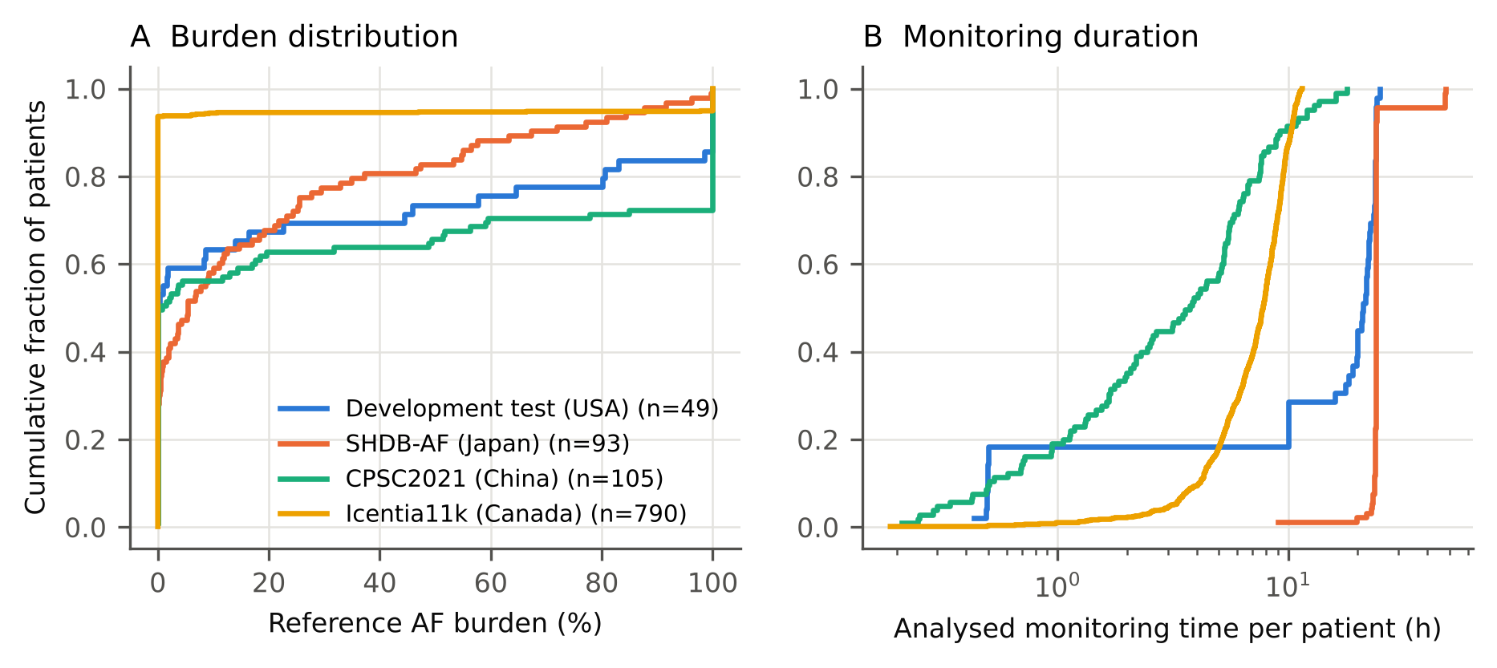

Figure S2
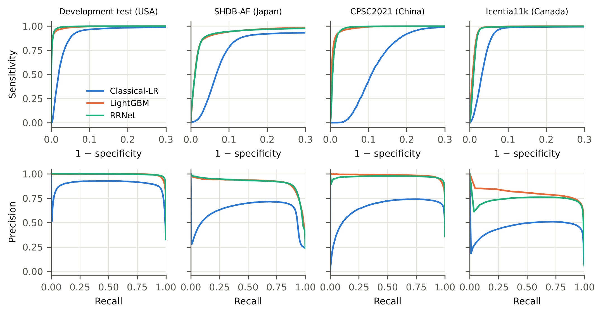

Figure S3
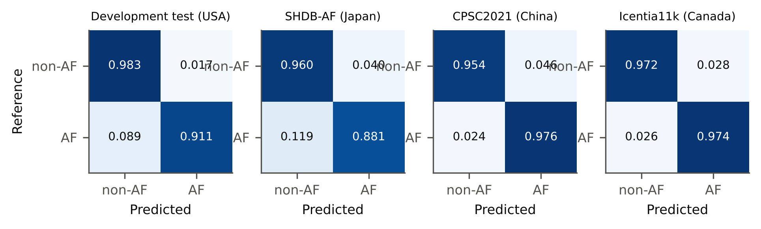

Figure S4
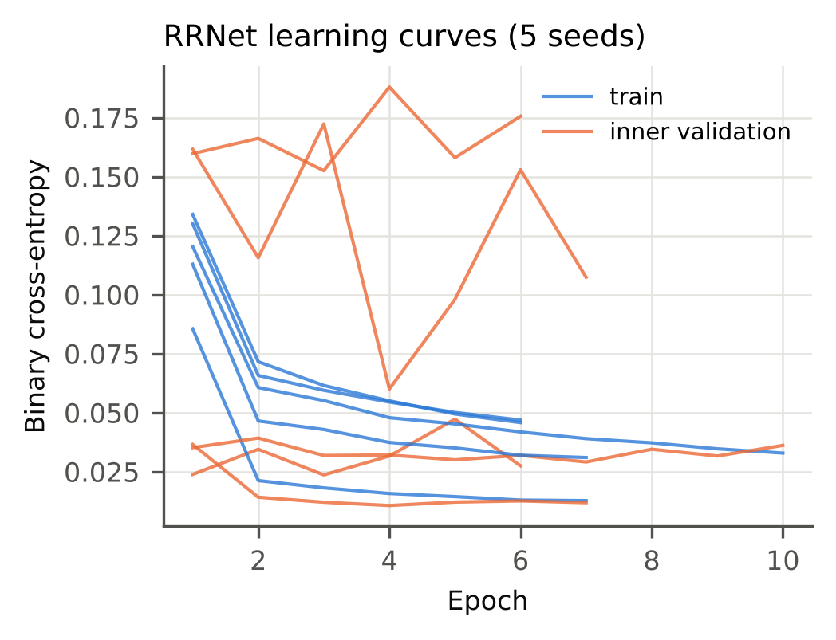

Figure S5
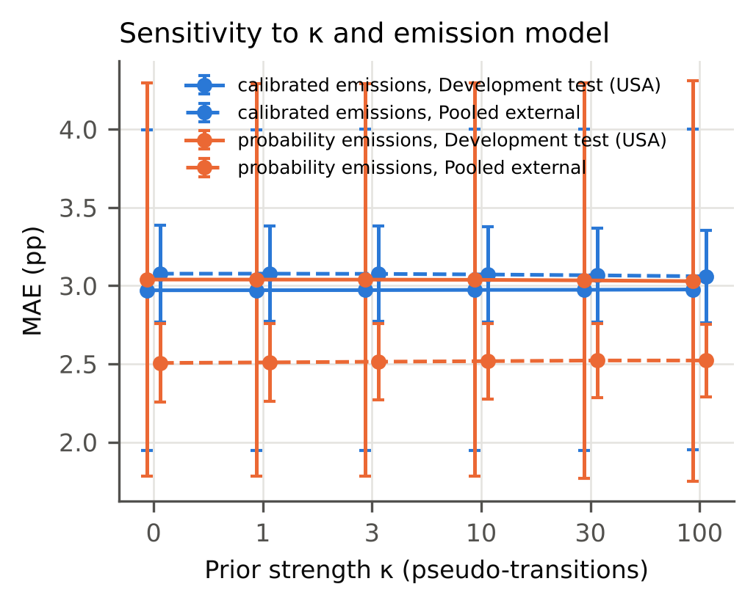

Figure S6
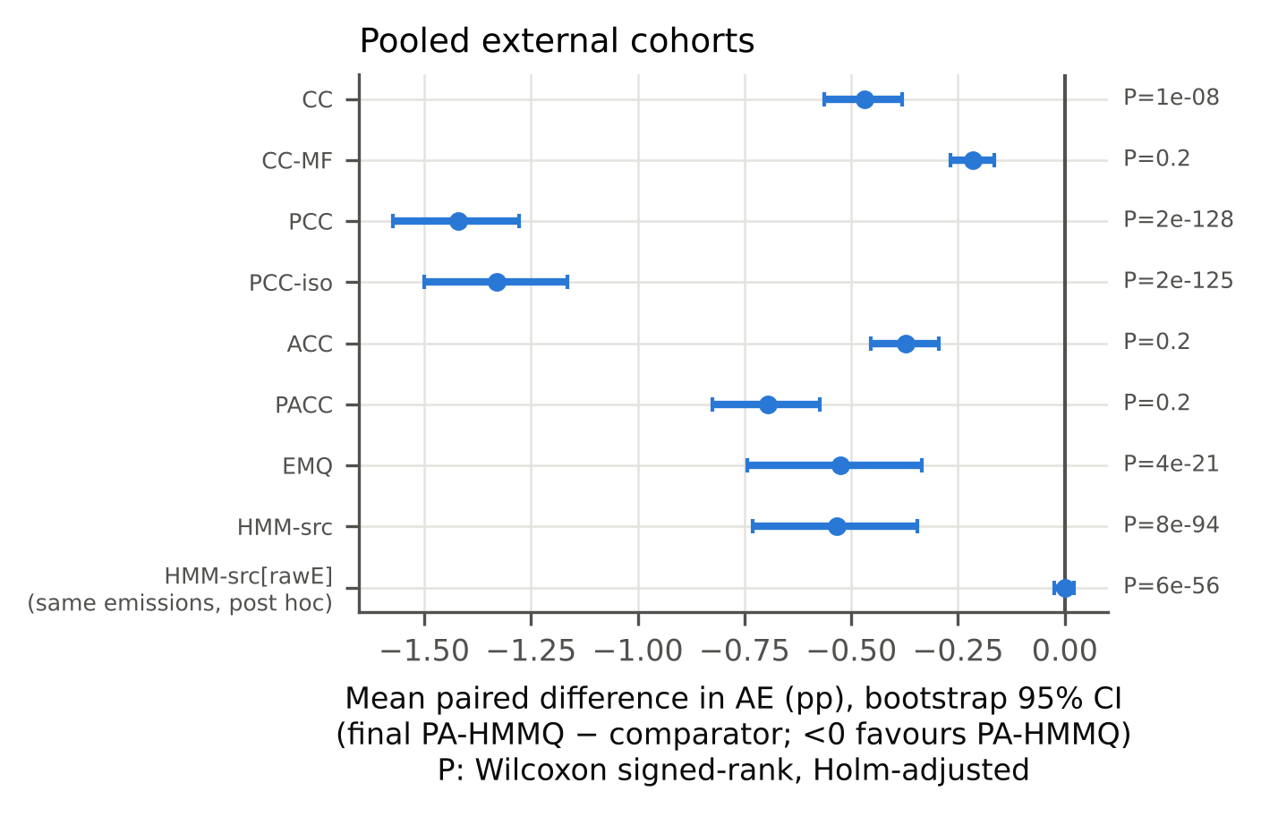

Figure S7
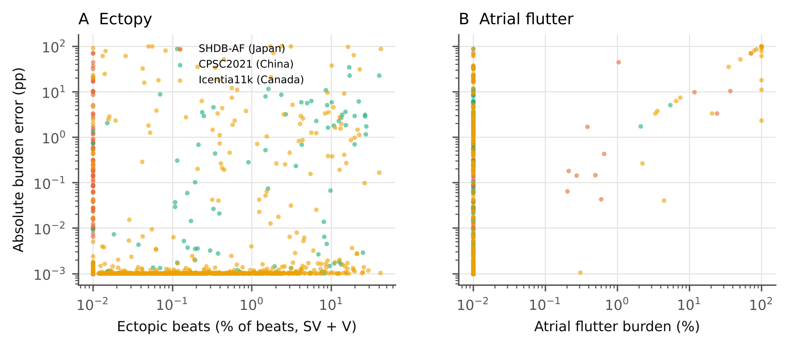

Figure S8


