Knowing when to ask a human: fault-aware confidence for fast time series classifiers

Introduction
Consider a wearable heart monitor that labels each short ECG recording as normal or abnormal, a factory system that classifies the signal of a production sensor, or a watch that recognises gestures from an accelerometer. Such systems make many decisions per day and nobody can check each one. A common safeguard is to let the classifier decide alone when it is sure and to pass the other cases to a person. This works only if the confidence of the classifier means something: high when the prediction is likely to be right and low when it is not (Abdar et al. 2021; Gawlikowski et al. 2023).
Real sensor data make this hard. Electrodes come loose, cables pick up interference, a patient moves, a sensor drifts or drops samples. A recording damaged in this way can look unlike any training example, yet most classifiers still return a confident answer. For a triage system, a confident wrong answer is the worst case, because it never reaches the reviewer.
We study this problem for random convolutional kernel classifiers. ROCKET (Dempster et al. 2020) and its successors MiniRocket (Dempster et al. 2021), MultiRocket (Tan et al. 2022) and Hydra (Dempster et al. 2023) map each series to thousands of features from random convolutions and fit a ridge regression on top. They are about as accurate as much larger ensembles and deep networks on the UCR archive (Ismail Fawaz et al. 2019; Dau et al. 2019; Middlehurst et al. 2024b) and a model trains in a median of 0.31 s on one CPU core in our experiments (Sect. 6.11), which makes them attractive for monitoring on modest hardware. Their ridge readout, however, gives scores rather than probabilities. Platt scaling, isotonic regression and temperature scaling (Platt 2000; Zadrozny and Elkan 2002; Guo et al. 2017) need held-out data; the Arsenal (Middlehurst et al. 2021) needs an ensemble; and prevalidated ridge regression (PreVal) (Dempster et al. 2025) rescales all scores by one factor fitted on exact leave-one-out (LOO) predictions. All of them treat a damaged recording like a clean one.
Ridge regression already measures how far a new input lies from its training data: the leverage, a classical diagnostic of extrapolation (Hoaglin and Welsch 1978) and the predictive variance factor of the equivalent Bayesian linear model (MacKay 1992). We show that the algebra behind the LOO shortcut also gives the held-out leverage of every training example, so that a leverage-aware calibration can be fitted on exact out-of-sample pairs without any held-out data. The resulting readout, LOOM (leave-one-out fitted, leverage-moderated), divides each ridge score by the square root of its relative leverage.

Motivation and contributions
The gap we address is that no readout for fast random-kernel classifiers lowers its confidence specifically for recordings that lie far from the training data, and none has been tested for fault-aware triage. Our contributions are:
- LOOM, a closed-form probabilistic readout whose confidence drops for recordings far from the training data, fitted on exact LOO scores and held-out leverages from one singular value decomposition (SVD) (Sect. 4).
- Exact jackknife+ prediction sets for ridge readouts, computed without refitting (Sect. 4.5).
- A pre-registered evaluation with explicit hypotheses: 114 datasets and 18 simulated sensor faults, real recorded ECG noise, readouts on non-convolutional features, ablations, sanity checks, and frequentist and Bayesian statistics (Sects. 5 and 6).
- A triage case study with an exploratory phase on 12 datasets and a pre-registered confirmatory replication on 38 further datasets (Sect. 6.5).
- An open-source command-line tool that turns labelled recordings into a triage system with a review queue (Sect. 6.12).
The ingredients—LOO identities, leverage and moderated outputs—are classical; our contribution is to combine them into a readout that needs no held-out data and to test it for triage under sensor faults. We also report where LOOM does not help (Sect. 6.13).

Organization
Section 2 reviews related work, Sect. 3 introduces notation and assumptions, Sect. 4 describes LOOM, Sect. 5 the experimental framework and Sect. 6 the results. Section 7 concludes. Proofs, the deviations log and further results are in the Supplementary Material (Sects. S1–S6).

Literature review

Random convolutional kernel classifiers
ROCKET (Dempster et al. 2020) applies 10,000 random dilated kernels and keeps the maximum and the proportion of positive values of each output. MiniRocket (Dempster et al. 2021) makes the transform almost deterministic and much faster, MultiRocket (Tan et al. 2022) adds pooling operators and the first-difference series, and Hydra (Dempster et al. 2023) lets groups of kernels compete. All use a linear readout. The bake-off of Middlehurst et al. (2024b) confirms their accuracy–cost trade-off and reports log-loss, but not calibration under shift. Probabilistic alternatives include the Arsenal (Middlehurst et al. 2021), QUANT (Dempster et al. 2024) and deep networks such as InceptionTime (Ismail Fawaz et al. 2020).

Calibration and prevalidation
Platt scaling (Platt 2000), isotonic regression (Zadrozny and Elkan 2002; Niculescu-Mizil and Caruana 2005), temperature scaling (Guo et al. 2017) and Dirichlet calibration (Kull et al. 2019) map scores to probabilities with held-out or cross-validated scores (Silva Filho et al. 2023). Fitting a second model to cross-validated predictions is known as pre-validation (Tibshirani and Efron 2002). For least squares, LOO predictions have a closed form (Allen 1974; Golub et al. 1979; Cawley and Talbot 2004). PreVal (Dempster et al. 2025) uses them to fit a global scale factor for ridge regression; it is the work closest to ours.

Uncertainty when the data change
Globally calibrated models become overconfident under dataset shift, while ensembles hold up better (Lakshminarayanan et al. 2017; Ovadia et al. 2019). Distance-aware networks such as SNGP (Liu et al. 2020, 2023) and DUQ (van Amersfoort et al. 2020) and last-layer Laplace approximations (Kristiadi et al. 2020) become uncertain away from the data, following the moderated outputs of MacKay (1992), but require changes to a network’s training. Corruption benchmarks (Hendrycks and Dietterich 2019) and confidence-based detection of unusual inputs (Hendrycks and Gimpel 2017) are standard for images; for time series, perturbations are mostly used for augmentation (Um et al. 2017; Iwana and Uchida 2021) and domain adaptation assumes unlabelled target data (Ragab et al. 2023). Selective classification studies the trade-off between coverage and risk (Geifman and El-Yaniv 2017).

Conformal prediction
Conformal prediction gives prediction sets with a coverage guarantee under exchangeability (Vovk et al. 2022; Angelopoulos and Bates 2023). Split conformal prediction sets data aside (Lei et al. 2018); jackknife+ uses all LOO models (Barber et al. 2021). APS (Romano et al. 2020; Angelopoulos et al. 2021) and LAC (Sadinle et al. 2018) are common scores. For ridge regression, conformal prediction has a closed form (Nouretdinov et al. 2001; Burnaev and Vovk 2014); time series work has focused on forecasting (Xu and Xie 2023).

Motivations
Table 1 summarises the properties of the closest methods. Five motivations follow: (i) the fast random-kernel classifiers lack a probabilistic readout that responds to unusual inputs; (ii) held-out calibration data are scarce in small monitoring datasets; (iii) ensembles and distance-aware networks are costly for embedded use; (iv) the closed-form statistics needed for an input-dependent readout already exist but have not been combined for this purpose; and (v) no study has evaluated readouts for fault-aware triage with real sensor noise.
Table 1 Properties of the closest methods. : yes; (): partly; –: no. “Fault-aware” means that confidence decreases for inputs far from the training data; “tested on faults” means an evaluation under sensor faults or corruptions of time series.
Method | Proba- bilities | No held- out data | No refit/ ensemble | Fault- aware | Prediction sets | Tested on faults
Ridge readout (Dempster et al. 2021) | – |  |  | – | – | –
Platt / isotonic / temperature (Platt 2000; Zadrozny and Elkan 2002; Guo et al. 2017) |  | – | ($✓$) | – | – | –
PreVal (Dempster et al. 2025) |  |  |  | – | – | –
Arsenal (Middlehurst et al. 2021) |  |  | – | ($✓$) | – | –
QUANT (Dempster et al. 2024) |  |  | – | – | – | –
Deep ensembles (Lakshminarayanan et al. 2017) |  |  | – | ($✓$) | – | ($✓$)
SNGP / DUQ / Laplace (Kristiadi et al. 2020; Liu et al. 2020; van Amersfoort et al. 2020) |  |  | – |  | – | –
Jackknife+ (Barber et al. 2021) | – |  | – | – |  | –
LOOM (ours)

Preliminary concepts
We observe $n$ training series $x_{i}∈R^{L}$ with labels $y_{i}∈\{1,…,K\}$. A random-kernel transform $φ:R^{L}→R^{p}$ ($p≈{10}^{4}$) is fitted on the training series. Features are standardised with the training mean and standard deviation; $ψ\left(x\right)$ denotes the centred standardised features, $\tilde{x}\left(x\right)=\left(1,ψ\left(x\right)\right)$ the augmented vector, $\tilde{X}$ the matrix of training vectors, $Φ_{c}$ the centred training matrix and $Y∈\{−1,+1\}^{n×K}$ the one-vs-rest targets. Ridge regression (Hoerl and Kennard 1970) with an unpenalised intercept and penalty $λ$ gives
$$A={\tilde{X}}^{⊤}\tilde{X}+diag\left(0,λI_{p}\right), B=A^{−1}{\tilde{X}}^{⊤}Y, \hat{Y}=\tilde{X}B=HY.$$
With the thin SVD $Φ_{c}=USV^{⊤}$ (rank $r≤min\left(n−1,p\right)$) and $D_{λ}=diag\left(1/\left(s_{j}^{2}+λ\right)\right)$, the hat diagonal $d_{i}$, the scores $z\left(x\right)=B^{⊤}\tilde{x}\left(x\right)$ and the leverage $h\left(x\right)=\tilde{x}{\left(x\right)}^{⊤}A^{−1}\tilde{x}\left(x\right)$ are
$$d_{i}=\frac{1}{n}+\sum_{j=1}^{r}{u_{ij}^{2}}\frac{s_{j}^{2}}{s_{j}^{2}+λ}, h\left(x\right)=\frac{1}{n}+∥D_{λ}^{1/2}V^{⊤}ψ∥^{2}+\frac{∥ψ∥^{2}−∥V^{⊤}ψ∥^{2}}{λ}.$$
The last term measures the part of $ψ\left(x\right)$ outside the span of the training data; it dominates when $p≫n$.
We make the following assumptions.
Assumption 1. Clean training and clean test recordings are exchangeable.
Assumption 2. Under Assumption A1, the held-out leverages $h_{−i}$ of the training examples are distributed like the leverages $h\left(x\right)$ of clean test recordings. (Checked empirically in Sect. 6.10.)
Assumption 3. Sensor faults move the features of a recording away from the span of the training features, so that its leverage grows. (Holds for some fault types but not all; Sects. 6.3 and 6.10.)
Assumption 4. The standardisation and the kernel biases are treated as fixed when LOO quantities are computed. (They are estimated on all $n$ series, so the LOO identities are exact only conditionally on them.)

Proposed methodology

Overview
Figure 1 shows the pipeline and Algorithm 1 the procedure. One thin SVD gives, for every candidate penalty, the exact LOO scores and held-out leverages of all training series; the penalty and a temperature are fitted on these pairs; and at test time each score is divided by the square root of the relative leverage. The resulting confidence decides whether a recording is handled automatically or sent to review.
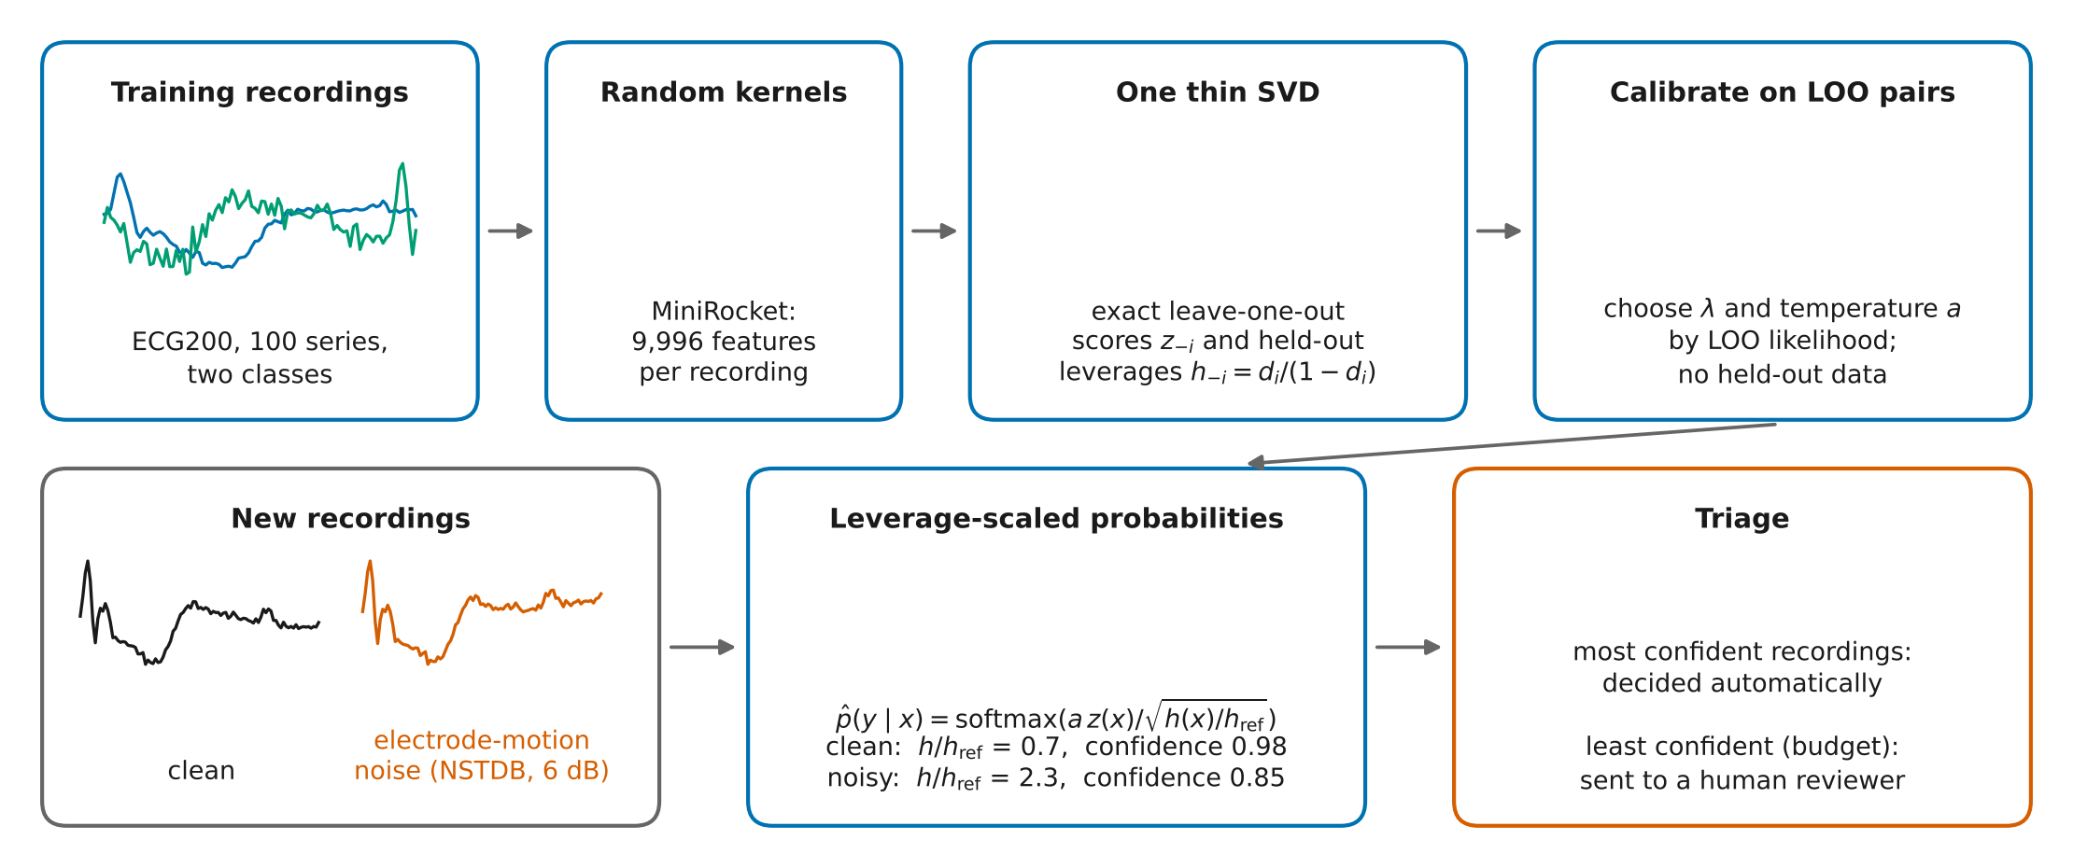
Fig. 1 LOOM turns the ridge readout of a random-kernel classifier into probabilities whose confidence drops for unusual recordings. Examples are real: the first training series of each class of ECG200 and the first test series in file order, shown clean and with real electrode-motion noise from the MIT-BIH Noise Stress Test Database at 6 dB; the printed leverage ratios and confidences are computed by the fitted model.

Algorithm 1. LOOM: fitting and triage
- training series $\{\left(x_{i},y_{i}\right)\}_{i=1}^{n}$, penalty grid $Λ$, review budget $b$
- Fit the random-kernel transform; compute standardised features $ψ\left(x_{i}\right)$
- Thin SVD $Φ_{c}=USV^{⊤}$ one decomposition for all $λ$
- $λ∈Λ$
- $d_{i}$ by Eq. (2); $z_{−i}$ and $h_{−i}$ by Eq. (3); $h_{ref}←median\left(h_{−i}\right)$
- $a_{λ}←arg\min_{a}L\left(a,λ\right)$ by Eq. (5) with smoothed targets
- $\left(λ^{⋆},a^{⋆}\right)←arg\min_{λ}L\left(a_{λ},λ\right)$
- each new recording $x$
- $\hat{p}\left(⋅∣x\right)$ by Eq. (4) with $λ^{⋆},a^{⋆}$; optional jackknife+ set by Eq. (6)
- Send the $b$ share of recordings with the lowest $\max_{k}\hat{p}\left(k∣x\right)$ to review; decide the rest automatically

Exact leave-one-out scores and held-out leverages
Let $B_{−i}$ denote the fit without example $i$ (same $λ$ and standardisation).
Proposition 1 (LOO scores and held-out leverages). $$z_{−i}:=B_{−i}^{⊤}{\tilde{x}}_{i}=Y_{i}−\frac{Y_{i}−{\hat{Y}}_{i}}{1−d_{i}}, h_{−i}:={\tilde{x}}_{i}^{⊤}A_{−i}^{−1}{\tilde{x}}_{i}=\frac{d_{i}}{1−d_{i}}.$$
The first identity is the classical PRESS shortcut (Allen 1974) used by RidgeClassifierCV and PreVal; the second follows from the same Sherman–Morrison update and is the quantity LOOM adds. Proofs are in Supplementary Sect. S1. The pair $\left(z_{−i},h_{−i}\right)$ is an exact out-of-sample observation of a score and its uncertainty, available for all $n$ examples at $O\left(nr\right)$ cost.

Leverage-scaled probabilities
Under the Bayesian linear model with prior $β∼N\left(0,σ^{2}λ^{−1}I\right)$, the predictive standard deviation of each score is $σ\sqrt{h\left(x\right)}$. LOOM divides the scores by this quantity relative to $h_{ref}=median\left(h_{−i}\right)$:
$$\hat{p}\left(y=k∣x\right)={softmax}_{k}​\left(\frac{a z_{k}\left(x\right)}{\sqrt{h\left(x\right)/h_{ref}}}\right).$$
The leverage is a ridge-regularised Mahalanobis distance of $ψ\left(x\right)$ from the training mean, plus $1/n$, computed in the geometry the classifier itself uses. For recordings like the training data $h\left(x\right)≈h_{ref}$ and Eq. (4) is a temperature-scaled ridge; when a fault moves a recording away from the training span, $h\left(x\right)$ grows and the probabilities move towards uniform. Eq. (4) is the limit $c→∞$ of the moderation $softmax\left(az/\sqrt{1+ch/h_{ref}}\right)$ (MacKay 1992; Kristiadi et al. 2020); the limit was fixed on eight development datasets before the benchmark, and finite $c$ is an ablation.

Fitting on exact LOO pairs
For each $λ$ the temperature minimises the LOO negative log-likelihood
$$L\left(a,λ\right)=−\frac{1}{n}\sum_{i=1}^{n}{\sum_{k=1}^{K}{t_{ik}}}log{softmax}_{k}​\left(\frac{a z_{−i,k}}{\sqrt{h_{−i}/h_{ref}}}\right),$$
and the pair $\left(λ,a\right)$ with the smallest value is kept. When the LOO predictions separate the classes, the optimal temperature is infinite; we therefore smooth the targets following Platt (2000): the true class receives $\left(n_{k}+1\right)/\left(n_{k}+2\right)$, where $n_{k}$ is its training count, and the rest is spread evenly. The one-dimensional problem in $loga$ is solved with L-BFGS from three starting values.

Closed-form jackknife+ prediction sets
With a non-conformity score $s\left(x,y;f\right)$ (LAC, $1−\hat{p}\left(y∣x\right)$ (Sadinle et al. 2018), or deterministic APS (Romano et al. 2020)), jackknife+ returns $C\left(x\right)=\{y:\#\{i:s_{i}<s\left(x,y;f_{−i}\right)\}<\left(1−α\right)\left(n+1\right)\}$ with $s_{i}=s\left(x_{i},y_{i};f_{−i}\right)$ (Barber et al. 2021). It needs every LOO model at every test point.
Proposition 2 (LOO predictions at a new point). With $k\left(x,i\right)=\tilde{x}{\left(x\right)}^{⊤}A^{−1}{\tilde{x}}_{i}=1/n+{\left(V^{⊤}ψ\right)}^{⊤}D_{λ}Su_{i}$ and residuals $E=Y−\hat{Y}$, $$z_{−i}\left(x\right)=z\left(x\right)−\frac{k\left(x,i\right)E_{i}}{1−d_{i}}, h_{−i}\left(x\right)=h\left(x\right)+\frac{k{\left(x,i\right)}^{2}}{1−d_{i}}.$$
This parallels closed-form conformal ridge regression (Nouretdinov et al. 2001). Because $λ$, $a$ and the standardisation use all $n$ examples (Assumption A4), the coverage guarantee holds only approximately; we check it empirically (Sect. 6.8).

Complexity
The SVD costs $O\left(npmin\left(n,p\right)\right)$, as for RidgeClassifierCV; ten penalties and the temperature fits add $O\left(10 nrK\right)$; prediction costs $O\left(p\left(r+K\right)\right)$ per series instead of $O\left(pK\right)$; memory is $O\left(\left(n+p\right)r\right)$. Cross-validated calibration needs $k$ further fits and an $M$-member ensemble $M$ transforms and fits.

Experimental framework

Setup
Code is in Python (NumPy, SciPy, scikit-learn (Pedregosa et al. 2011), aeon 1.6.0 (Middlehurst et al. 2024a)). Every job ran on one core of a 4-core cloud CPU without a GPU (14.3 GB memory limit); times are single-core wall-clock times. One script regenerates all results, tables, figures and the number macros of this paper; unit tests compare Eqs. (2), (3) and (6) with explicit refits. The method was developed on eight datasets and the pipeline tested on six more; results without them are reported. The protocol was registered before the benchmark, and every later change is logged (Supplementary Sect. S2). An AI assistant (Claude, Anthropic) was used for the literature search, for writing and running code and for drafting text; all numbers come from the released result files, and the authors take responsibility for the content.

Datasets
Table 2 lists the data. The benchmark uses the 114 univariate equal-length UCR datasets (Dau et al. 2019) with the official split and four stratified resamples (three for the four largest datasets), following the bake-off protocol (Bagnall et al. 2016). A leakage audit found exact train/test duplicates in 16 datasets and exact or near duplicates in 24; a planted-leak test confirmed that the audit detects such cases (Supplementary Sect. S3).
Table 2 Data used in each experiment. All datasets are from the UCR archive; real noise is from the MIT-BIH Noise Stress Test Database.
Experiment | Datasets | Splits | Purpose
Benchmark (E1–E9) | 114 univariate, equal length | official + 4 resamples | calibration, faults, ablation, prediction sets
Real ECG noise (E12) | 7 ECG datasets | official + 4 resamples | real recorded noise, 9 conditions
Triage, exploratory (E11) | 12 sensor datasets, 3 domains | official + 4 resamples | review-queue study
Triage, confirmatory (E13) | 38 further sensor datasets | official + 4 resamples | pre-registered replication
QUANT features (E14) | 110 datasets ($≤$ 3,000 training series) | official split | non-convolutional features
Natural change (E10) | UWaveGestureLibrary X/Y/Z | official + 4 resamples | cross-axis sensor change

Faults and the triage protocol
Simulated faults are applied to test series only, with amplitudes relative to each series’ standard deviation: noise, baseline wander or drift, dropout (a segment replaced by interpolation), spikes, speed variation (smooth time warp) and misalignment (circular shift), each at three severities (Supplementary Sect. S4). Real noise: baseline wander, electrode motion and muscle artefact recordings of the MIT-BIH Noise Stress Test Database (Moody et al. 1984; Goldberger et al. 2000) are added at 12, 6 and 0 dB SNR to the seven ECG datasets. Triage: each test recording is faulty with probability 0.3, with a domain-specific fault at a random severity; the share $b$ of recordings with the lowest confidence goes to review.

Metrics
With predicted probabilities ${\hat{p}}_{ik}$ and true labels $y_{i}$ on $m$ test recordings, we report the negative log-likelihood, the expected calibration error over 15 equal-width bins $B_{1},…,B_{15}$ of the top-label confidence, and the Brier score:
NLL=−1mi​logpiyi, Brier=1mi,k​(pik−1yi=k)2,ECE=j​Bjm|accBj−confBj|.
Fault detection is measured by the AUROC of $1−\max_{k}{\hat{p}}_{ik}$ for separating faulty from clean recordings. For prediction sets we report coverage 1mi​1yi∈Cxi and mean set size. For triage with review set $R$ ($\left|R\right|=bm$) and faulty set $F$:
$$\text{faults caught}=\frac{\left|R∩F\right|}{\left|F\right|}, \text{automatic error}=\frac{\left|\{i∉R:{\hat{y}}_{i}≠y_{i}\}\right|}{m−\left|R\right|}.$$

Baselines
All readouts use identical MiniRocket features: ridge one-hot output, softmax of the ridge scores, PreVal (Dempster et al. 2025) (reimplemented without smoothing, as published), hold-out temperature scaling (80/20), five-fold Platt and isotonic calibration (Pedregosa et al. 2011), cross-validated logistic regression, and five-seed ensembles of PreVal and LOOM. QUANT (Dempster et al. 2024) and the Arsenal (Middlehurst et al. 2021) work on the raw series. Eight ablations remove or replace one component of LOOM at a time (Sect. 6.7). All methods receive the same data, seeds and fixed hyperparameter grids.

Hypotheses and tests
Table 3 lists the hypotheses with their metrics and outcomes. Datasets are the unit of analysis, with each metric averaged over resamples. We use two-sided Wilcoxon signed-rank tests (Wilcoxon 1945) with Holm’s correction (Holm 1979), as recommended for comparisons across datasets (Demšar 2006; Benavoli et al. 2016), report how many datasets a result holds in, means with 95 % bootstrap confidence intervals (1,000 resamples), and Bayesian signed-rank tests (Benavoli et al. 2017) with a region of practical equivalence of $±0.01$ nats for NLL and $±1$ percentage point for rates. Only the hypotheses in Table 3 are confirmatory; all other comparisons are descriptive, with Holm’s correction applied within each table. Numeric pass criteria for H1–H3 were written down after the results (deviation D18).

Results and analysis

Hypothesis tests
Table 3 summarises the outcomes and Fig. 2 the main comparison. Of the 10 pre-specified hypotheses, nine passed and H1b failed.
Table 3 Hypotheses, tests and outcomes. H1–H3 were registered on 13 October 2026 before the benchmark, H4–H7 on 2 November 2026 before the corresponding experiments (Supplementary Sect. S2). Counts give the datasets (or dataset–noise combinations) in favour of LOOM; $p$ is Holm-adjusted.
ID | Hypothesis | Metric | Result | Outcome
H1a | Clean NLL not worse than PreVal, hold-out TS, Platt, LogReg | NLL | vs PreVal: not significantly different, with 49 wins and 65 losses of 114 datasets, $p=1.000$ | pass
H1b | Clean ECE and Brier not worse than PreVal | ECE, Brier | ECE: LOOM worse on 86 of 114 datasets, $p<0.001$ | fail
H1c | Accuracy unchanged vs PreVal | accuracy | not significantly different, with 28 wins and 29 losses of 114 datasets, $p=0.572$ | pass
H2a | Faults: NLL lower than every closed-form / CV readout | NLL, 18 conditions | vs PreVal: LOOM better on 108/114, $p<0.001$; all 7 readouts | pass
H2b | Faults: better detection of faulty inputs than PreVal | AUROC | LOOM better on 114/114, $p<0.001$ | pass
H3 | Jackknife+: coverage 0.88–0.92, smaller sets than split | coverage, size | coverage 0.898; smaller on 103/114, $p<0.001$ | pass
H4 | Real ECG noise: NLL lower than PreVal | NLL, 63 cells | LOOM better on 50/63, $p<0.001$ | pass
H5 | Triage: more faulty recordings caught than PreVal | 20 % budget | LOOM better on 38/38, $p<0.001$ | pass
H6 | Triage: fewer automatic errors than PreVal | 20 % budget | LOOM better on 35/38, $p<0.001$ | pass
H7 | QUANT features: NLL under faults lower than PreVal | NLL, severity 3 | LOOM better on 110/110, $p<0.001$ | pass
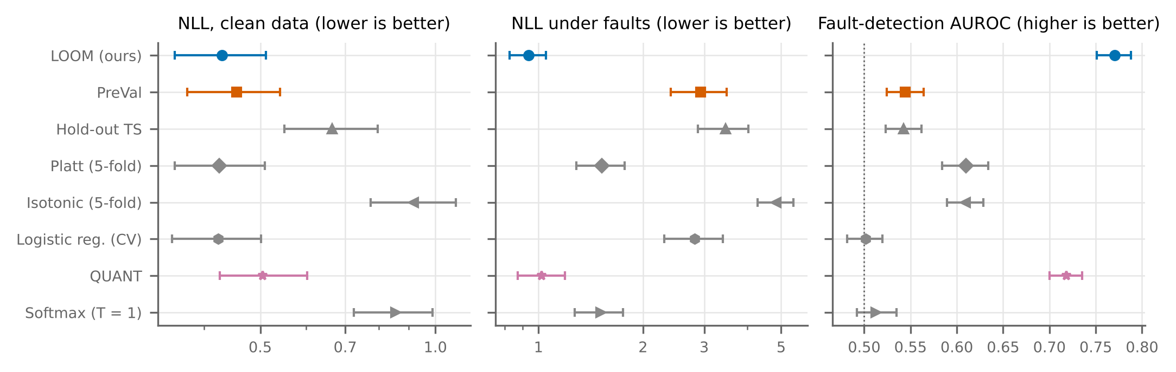
Fig. 2 LOOM is on a par with the best readouts on clean data and clearly better than the other readouts under simulated faults, where QUANT is close to it. Means over the 114 UCR datasets of the per-dataset mean over resamples, with 95 % bootstrap confidence intervals: NLL on clean data, NLL averaged over 18 simulated fault conditions (log scale), and AUROC for detecting faulty recordings. Ridge one-hot is omitted because its NLL is off scale.

Calibration on clean data (H1)
On clean data LOOM is roughly on a par with the best readouts but not better (Table 4). Its median NLL is 0.295; compared with PreVal it is not significantly different, with 49 wins and 65 losses of 114 datasets, $p=1.000$, and it is also not significantly different from five-fold Platt scaling and logistic regression. A non-significant test does not mean equivalence: the Bayesian analysis gives probability 0.38 that LOOM is better, 0.00 that the two are practically equivalent and 0.62 that PreVal is better, and the per-dataset differences exceed resampling noise in favour of PreVal on 38 % of the datasets and in favour of LOOM on 13 % (Sect. 6.10). LOOM’s calibration error is higher than PreVal’s (median ECE 0.075 vs 0.040; LOOM worse on 86 of 114 datasets, $p<0.001$), and so is its Brier score; H1b therefore fails. The cause is the target smoothing (Sect. 6.7). Accuracy is the same as PreVal’s (median 0.914 vs 0.914).
Table 4 Clean test data, 114 datasets: median over datasets of the mean over resamples. W/D/L counts datasets on which LOOM is better/equal/worse in NLL; $p$ is the Holm-adjusted Wilcoxon $p$-value for NLL.
Method | NLL | ECE | Brier | Acc. | W/D/L | $p$
LOOM (ours) | 0.295 | 0.075 | 0.144 | 0.914 | – | –
PreVal | 0.360 | 0.040 | 0.134 | 0.914 | 49/0/65 | $p=1.000$
Hold-out TS | 0.524 | 0.052 | 0.177 | 0.896 | 85/0/29 | $p<0.001$
Ridge + Platt (5-fold) | 0.294 | 0.080 | 0.148 | 0.912 | 53/0/57 | $p=1.000$
Ridge + isotonic (5-fold) | 0.670 | 0.044 | 0.157 | 0.904 | 96/0/14 | $p<0.001$
Logistic regression (CV) | 0.314 | 0.049 | 0.151 | 0.901 | 53/0/56 | $p=1.000$
QUANT | 0.386 | 0.116 | 0.210 | 0.895 | 77/0/37 | $p<0.001$
Ridge softmax ($T=1$) | 0.588 | 0.249 | 0.284 | 0.914 | 110/0/4 | $p<0.001$
Ridge one-hot | 2.959 | 0.086 | 0.171 | 0.914 | 103/0/11 | $p<0.001$

Simulated sensor faults (H2)
The leverage reacts to faults (Fig. 3). For clean test series the median ratio $h\left(x\right)/h_{ref}$ is 1.01; at the highest severity it reaches 30.3 for noise, 29.5 for spikes, 8.6 for dropout, 6.2 for baseline wander and 3.5 for misalignment, but only 1.26 for speed variation. Averaged over the 18 conditions (Table 5), LOOM’s median NLL is 0.738 against 1.728 for PreVal; LOOM is better on 108 of 114 datasets, $p<0.001$ (Bayesian probability 1.00 that LOOM is better; mean NLL with 95 % CI 0.936 [0.825, 1.051] vs 2.932 [2.406, 3.480]), and it is also better than hold-out, Platt and isotonic calibration and logistic regression. Accuracy is unchanged (median 0.695 vs 0.692): the gain comes from lower confidence on the damaged recordings that are misclassified. The median AUROC for detecting faulty recordings is 0.765 for LOOM and 0.563 for PreVal. Figure 4 shows that the gap grows with severity for every fault type except speed variation.
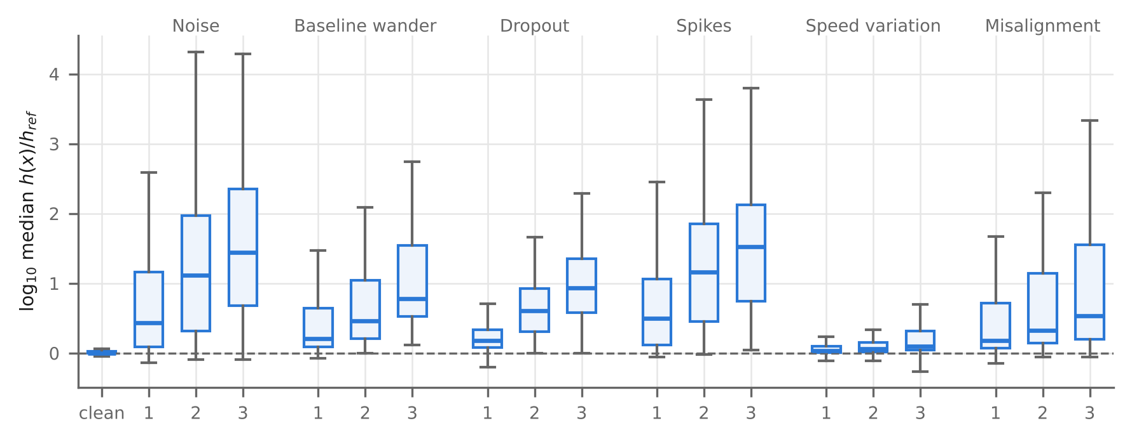
Fig. 3 Faults push recordings away from the training data, except speed variation. Distribution over datasets of the median leverage ratio $h\left(x\right)/h_{ref}$ ($\log_{10}$) for clean data and each simulated fault at severities 1–3.
Table 5 Simulated faults, 114 datasets: per-dataset mean over 18 conditions, then median over datasets. Statistics as in Table 4.
Method | NLL | ECE | Acc. | AUROC | W/D/L | $p$
LOOM (ours) | 0.738 | 0.151 | 0.695 | 0.765 | – | –
PreVal | 1.728 | 0.185 | 0.692 | 0.563 | 108/0/6 | $p<0.001$
Hold-out TS | 2.221 | 0.197 | 0.676 | 0.558 | 110/0/4 | $p<0.001$
Ridge + Platt (5-fold) | 1.125 | 0.144 | 0.697 | 0.610 | 86/0/24 | $p<0.001$
Ridge + isotonic (5-fold) | 4.358 | 0.153 | 0.682 | 0.592 | 108/0/2 | $p<0.001$
Logistic regression (CV) | 1.878 | 0.219 | 0.660 | 0.516 | 104/0/5 | $p<0.001$
QUANT | 0.732 | 0.170 | 0.694 | 0.709 | 44/0/70 | $p=0.291$
Ridge softmax ($T=1$) | 1.086 | 0.256 | 0.696 | 0.531 | 105/0/9 | $p<0.001$
Ridge one-hot | 10.495 | 0.304 | 0.696 | 0.500 | 114/0/0 | $p<0.001$
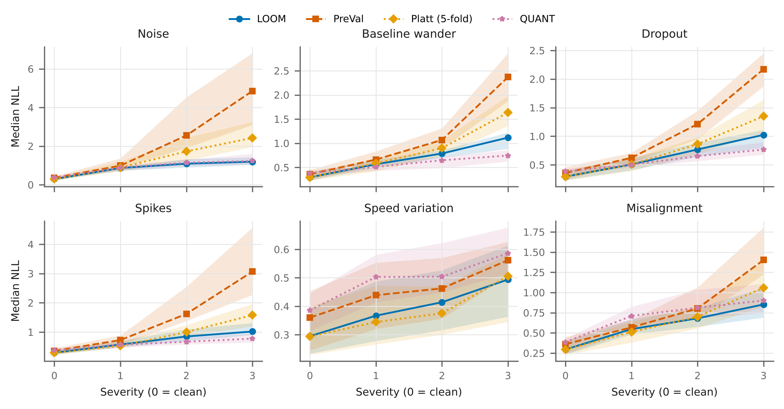
Fig. 4 LOOM’s advantage over PreVal grows with fault severity, but QUANT is better for baseline wander, dropout and spikes at the highest severity. Median NLL over the 114 datasets against severity for each simulated fault, with 95 % bootstrap bands of the median.

Real-world validation: recorded ECG noise (H4)
Figure 5 and Table 6 show the results with real noise. All methods have a similar NLL on the clean ECG recordings (median 0.196 for LOOM, 0.175 for PreVal). With real noise added, PreVal’s median NLL rises to 3.346 and LOOM’s to 0.678. Over the 63 combinations of dataset, noise type and level, LOOM compared with PreVal is better on 50 of 63 dataset–noise combinations, $p<0.001$, which confirms H4 (Bayesian probability 1.00 that LOOM is better); compared with QUANT it is not significantly different, with 28 wins and 35 losses of 63 dataset–noise combinations, $p=0.748$. LOOM recognises noisy recordings best: its median detection AUROC is 0.973, against 0.899 for QUANT (LOOM better on 54 of 63 dataset–noise combinations, $p<0.001$) and 0.591 for PreVal. In a stream with 30 % noisy recordings and a 20 % review budget, LOOM’s queue contains 63 % of the noisy recordings, against 34 % for PreVal and 49 % for QUANT, while QUANT has the lowest automatic error rate (4.8 % vs 7.5 % for LOOM). With seven datasets, dataset-level tests have little power; the conclusions rest on the 63 combinations.
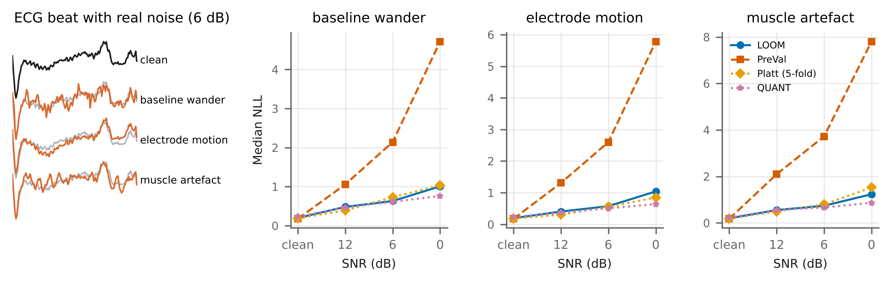
Fig. 5 Under real recorded ECG noise, PreVal’s NLL explodes while LOOM’s stays close to QUANT’s. Left: an ECG5000 beat (grey) with each MIT-BIH NSTDB noise type at 6 dB (orange). Right: median NLL over the seven ECG datasets against signal-to-noise ratio for each noise type.
Table 6 Real recorded ECG noise on seven ECG datasets: median over datasets. Noisy NLL, detection AUROC and accuracy average nine combinations of noise type and SNR; “Caught” and “Auto err.” refer to a stream with 30 % noisy recordings and a 20 % review budget.
Method | Clean NLL | Noisy NLL | AUROC | Acc. | Caught | Auto err.
LOOM (ours) | 0.196 | 0.678 | 0.973 | 0.684 | 63 % | 7.5 %
PreVal | 0.175 | 3.346 | 0.591 | 0.673 | 34 % | 9.2 %
Hold-out TS | 0.194 | 6.097 | 0.623 | 0.675 | 37 % | 10.2 %
Ridge + Platt (5-fold) | 0.186 | 0.686 | 0.737 | 0.686 | 44 % | 9.0 %
QUANT | 0.231 | 0.585 | 0.899 | 0.700 | 49 % | 4.8 %

Case study: triage of faulty recordings (H5, H6)
In the exploratory study (12 datasets, 20 % review budget), LOOM’s review queue contained a median of 45 % of the faulty recordings, against 25 % for PreVal and 38 % for QUANT, and caught more than PreVal on all twelve datasets ($p=0.002$). Its automatic error rate was lower in the median (4.2 % vs 9.5 %) but not significantly ($p=0.056$), and QUANT made the fewest automatic errors (1.6 %).
The pre-registered confirmatory replication on 38 further datasets (Fig. 6, Table 7) confirmed both hypotheses under Holm’s correction over all eight primary tests. LOOM’s queue caught a median of 41 % of the faulty recordings, against 24 % for PreVal (LOOM better on 38 of 38 datasets, $p<0.001$; H5) and 34 % for QUANT (LOOM better on 34 of 38 datasets, $p<0.001$). Its automatic error rate was 10.1 %, against 14.6 % for PreVal (LOOM better on 35 of 38 datasets, $p<0.001$; H6) and 13.2 % for QUANT (LOOM not significantly different, with 17 wins and 20 losses of 38 datasets, $p=0.635$). Means with 95 % CIs are 43.4 % [39.4, 47.5] (LOOM) and 26.0 % [23.2, 29.2] (PreVal) for faults caught. The advantage over PreVal remains after merging datasets from the same source (LOOM better on 27 of 27 source-level units, $p<0.001$). On fault-free streams the methods behave alike (automatic error 4.4 % vs 4.8 %), so LOOM does not change how a system behaves on good data. A post hoc check (deviation D22) reduced the share of faulty recordings by subsampling the stored outputs: at 10 % prevalence LOOM’s queue caught 55 % against 27 % for PreVal (LOOM better on 38 of 38 datasets, $p<0.001$) and its automatic error was 5.1 % against 6.2 % (LOOM better on 33 of 38 datasets, $p<0.001$). For an operator, this means that with one recording in five sent to review, about 41 % instead of 24 % of the damaged recordings reach a person.
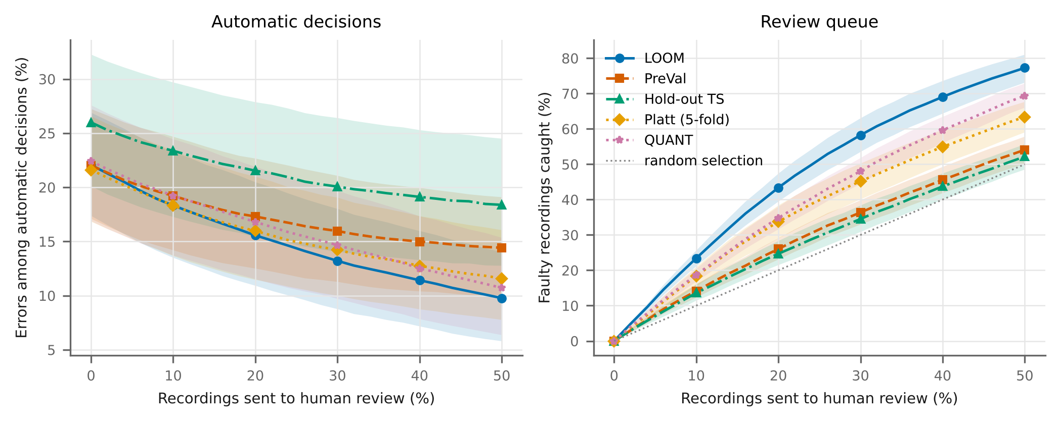
Fig. 6 In the pre-registered triage study, LOOM’s review queue catches the most faulty recordings at every budget. 38 sensor datasets with 30 % faulty recordings: error rate of automatic decisions (left) and share of faulty recordings caught (right) against the review budget; means over datasets of the mean over resamples with 95 % bootstrap bands over datasets (bands include the differences in difficulty between datasets; paired comparisons are in the text).
Table 7 Triage with a 20 % review budget: median over datasets of the share of faulty recordings caught and of the error rate of automatic decisions, in the exploratory (12 datasets) and confirmatory (38 datasets) studies, and the automatic error on fault-free streams (confirmatory).
 | Exploratory (12) |  | Confirmatory (38)
2-3(lr)4-6 Method | Caught | Auto err. | Caught | Auto err. | No faults
LOOM (ours) | 45 % | 4.2 % | 41 % | 10.1 % | 4.4 %
PreVal | 25 % | 9.5 % | 24 % | 14.6 % | 4.8 %
Hold-out TS | 26 % | 9.9 % | 23 % | 19.8 % | 9.8 %
Ridge + Platt (5-fold) | 27 % | 8.7 % | 28 % | 15.0 % | 4.6 %
QUANT | 38 % | 1.6 % | 34 % | 13.2 % | 8.9 %

Comparative analysis: ensembles, raw-series classifiers and QUANT features (H7)
On the official split (Table 8) the comparison under faults uses the six severity-3 conditions for every method, because the Arsenal was only run there; this restriction was introduced after the results were first inspected and works against LOOM (deviation D10). On clean data a five-seed PreVal ensemble is slightly better than a single LOOM model (LOOM worse on 83 of 114 datasets, $p<0.001$), while LOOM beats QUANT (LOOM better on 70 of 114 datasets, $p=0.004$). Under the strongest faults LOOM beats the PreVal ensemble and the Arsenal, but QUANT is better (LOOM worse on 78 of 114 datasets, $p=0.042$); averaged over all 18 conditions the two do not differ significantly (Table 5), but the Bayesian probability that QUANT is better is 0.86. At the highest severity QUANT has the lower median NLL for baseline wander, dropouts and spikes, and LOOM for noise, speed variation and misalignment. The Arsenal’s high NLL comes mainly from vote-based probabilities that give exactly zero to the true class; in the bounded Brier score the clean gap is small (0.173 vs 0.163).
To see whether QUANT’s robustness comes from its features or its trees, we fitted the readouts on QUANT’s features (median 2,957 features, 110 datasets). LOOM again rescued the ridge readout under faults: PreVal’s median NLL was 17.7 and LOOM’s 1.242 (LOOM better on 110 of 110 datasets, $p<0.001$), confirming H7. LOOM on QUANT features also detected faults far better than the QUANT classifier (AUROC 0.950 vs 0.767; LOOM better on 93 of 110 datasets, $p<0.001$). But the linear readout lost much more accuracy than QUANT’s trees (0.354 vs 0.621), so QUANT kept the lower NLL (LOOM worse on 97 of 110 datasets, $p<0.001$). QUANT’s robustness therefore comes mainly from its trees, whose outputs stay within the range seen in training, while LOOM’s strength is recognising unusual inputs; the two are complementary.
Table 8 Official split, strongest (severity-3) simulated faults: median over datasets. Statistics as in Table 4. The Arsenal has no result on Fungi (undefined probabilities with one training series per class).
Method | NLL | Brier | Acc. | AUROC | W/D/L | $p$
LOOM (ours) | 1.020 | 0.526 | 0.604 | 0.845 | – | –
LOOM, 5-seed ens. | 1.003 | 0.519 | 0.614 | 0.847 | 38/0/76 | $p<0.001$
PreVal | 2.260 | 0.673 | 0.613 | 0.531 | 105/0/9 | $p<0.001$
PreVal, 5-seed ens. | 2.040 | 0.636 | 0.616 | 0.584 | 104/0/10 | $p<0.001$
QUANT | 0.931 | 0.489 | 0.621 | 0.760 | 36/0/78 | $p=0.042$
Arsenal | 7.024 | 0.672 | 0.600 | 0.676 | 110/0/3 | $p<0.001$

Ablation study
Figure 7 compares LOOM with eight variants. Removing the leverage scaling while keeping smoothing (PreVal-smooth) is much worse under faults (median NLL 1.172 vs 0.738; LOOM better on 94 of 114 datasets, $p<0.001$), while on clean data LOOM is worse on 75 of 114 datasets, $p=0.038$, so the scaling has a small cost on clean data. Calibrating on in-sample instead of LOO pairs gives a median clean NLL of 0.978, and an 80/20 split 0.441, so the exact LOO pairs matter. A finite moderation strength ($c=1$) gives a slightly lower clean NLL (LOOM worse on 89 of 114 datasets, $p<0.001$) but detects faults worse (AUROC 0.729 vs 0.765; LOOM higher on 111 of 114 datasets). Removing the smoothing brings the clean ECE to PreVal’s level (0.041 vs 0.040) but is worse under faults (LOOM better on 71 of 114 datasets, $p=0.003$). A nearest-neighbour distance in place of leverage gives similar NLL but worse detection (AUROC 0.725).
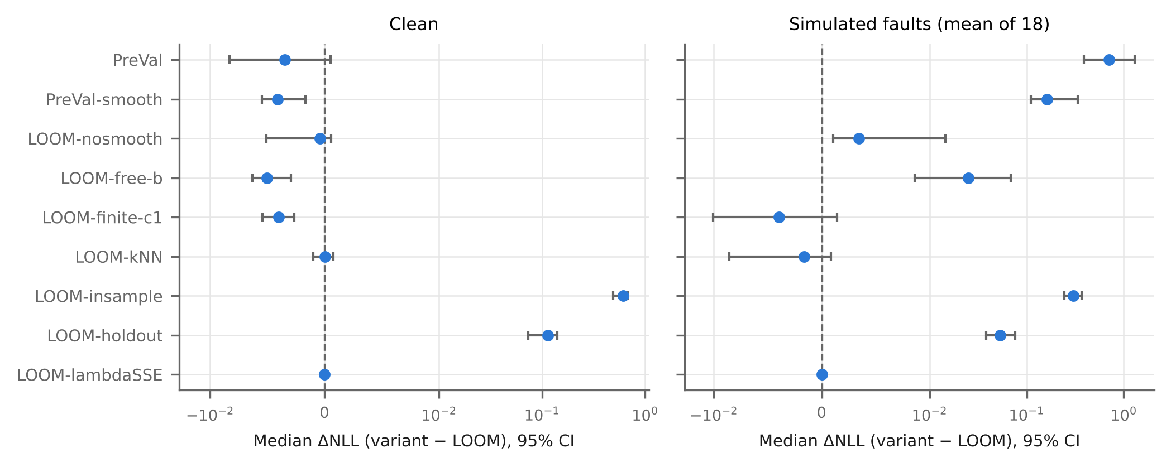
Fig. 7 The leverage scaling and the exact LOO pairs are what make LOOM work under faults. Median paired NLL difference (variant $−$ LOOM) over the 114 datasets with bootstrap 95 % confidence intervals, clean data (left) and simulated faults (right); positive values mean that the variant is worse.

Prediction sets and validity (H3)
On clean data LOOM’s closed-form jackknife+ sets with the LAC score cover 89.8 % of test series at target 0.9 with 1.55 labels per set, against 92.8 % and 2.49 for split conformal prediction (set size smaller on 103 of 114 datasets, $p<0.001$), so H3 passes (Fig. 8a, Table S3). Coverage at targets 0.95 and 0.8 is 95.1 % and 79.6 %. Under faults coverage drops because damaged recordings are not exchangeable with training data (Fig. 8b); with LAC, LOOM’s flat probabilities produce empty sets for 25.0 % of damaged recordings, whereas APS keeps coverage at 90.5 %. The reliability diagrams (Fig. 8c) show that LOOM stays close to the diagonal under strong faults while PreVal becomes overconfident.
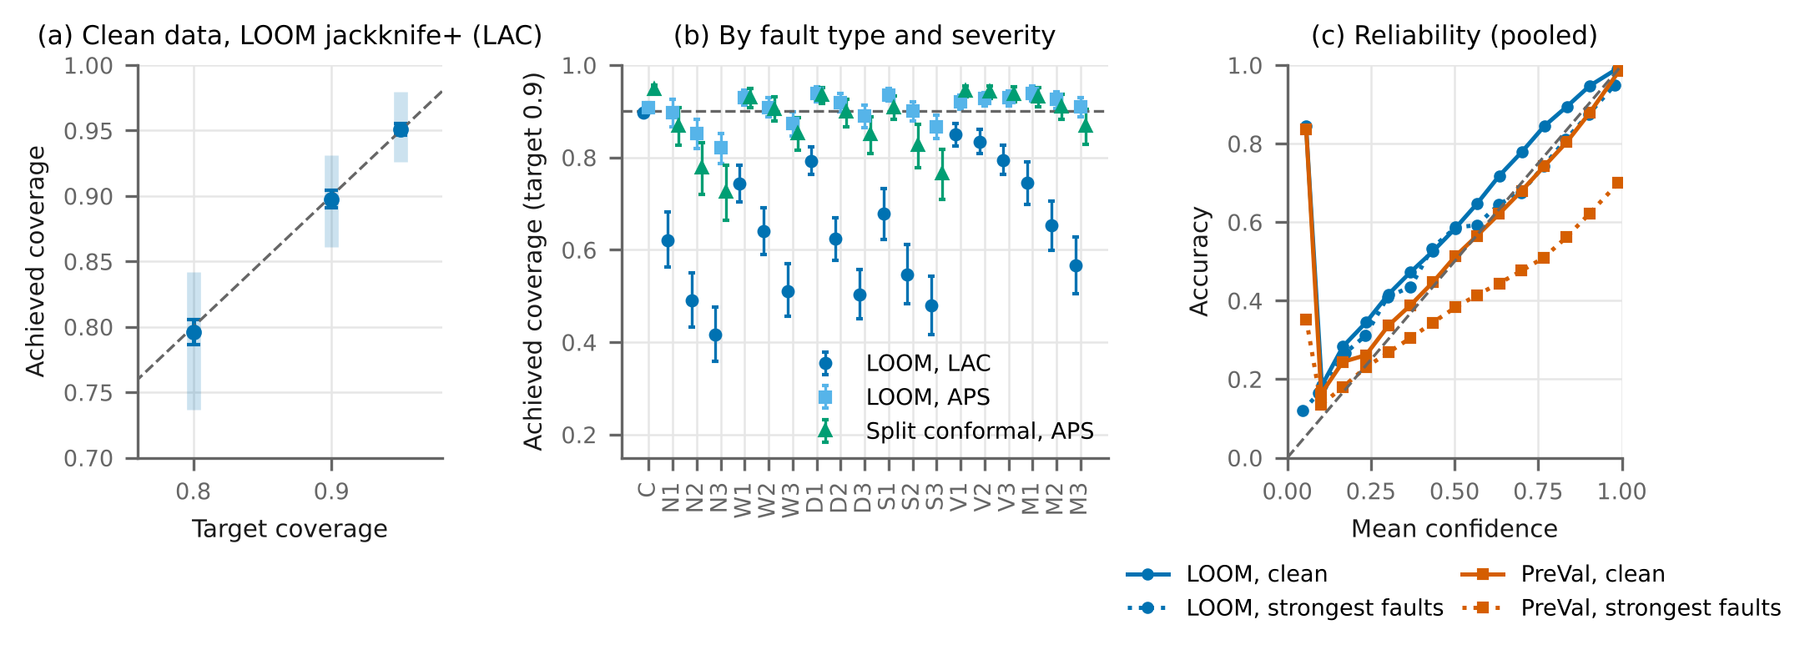
Fig. 8 Jackknife+ coverage matches its target on average on clean data; under faults only APS sets keep coverage. (a) Target vs achieved coverage of LOOM’s jackknife+ sets (LAC), mean over datasets with 95 % bootstrap CI and 10th–90th percentile of datasets (band). (b) Achieved coverage at target 0.9 by condition (C clean; N noise, W baseline wander, D dropout, S spikes, V speed variation, M misalignment; 1–3 severity). (c) Reliability pooled over all datasets and resamples; bins with fewer than 200 predictions are not drawn.

Qualitative analysis and failure cases
Figure 9 shows four recordings of the ECG5000 real-noise stream, chosen by a fixed rule. Two show the intended behaviour; two are failures. A recording with muscle artefact at 12 dB is misclassified with high confidence (panel c), and a clean but unusual beat is sent to review (panel d). Across datasets, LOOM’s gain under faults grows with the leverage increase the faults cause (Spearman $ρ=0.61$, $p<0.001$), and the share of datasets on which LOOM beats PreVal grows with severity for every fault type except speed variation. At the highest severity it is 95 % for noise but only 53 % for speed variation. LOOM loses most where faulty recordings remain correctly classified (PigCVP, ECG5000 and InsectEPGRegularTrain; $ρ=−0.24$ with accuracy under faults, $p=0.010$), and on clean data where there are few training series per class (largest losses on PigArtPressure, Symbols, ShapesAll and PigAirwayPressure, with two to 10 series per class), because smoothing then makes the model underconfident.
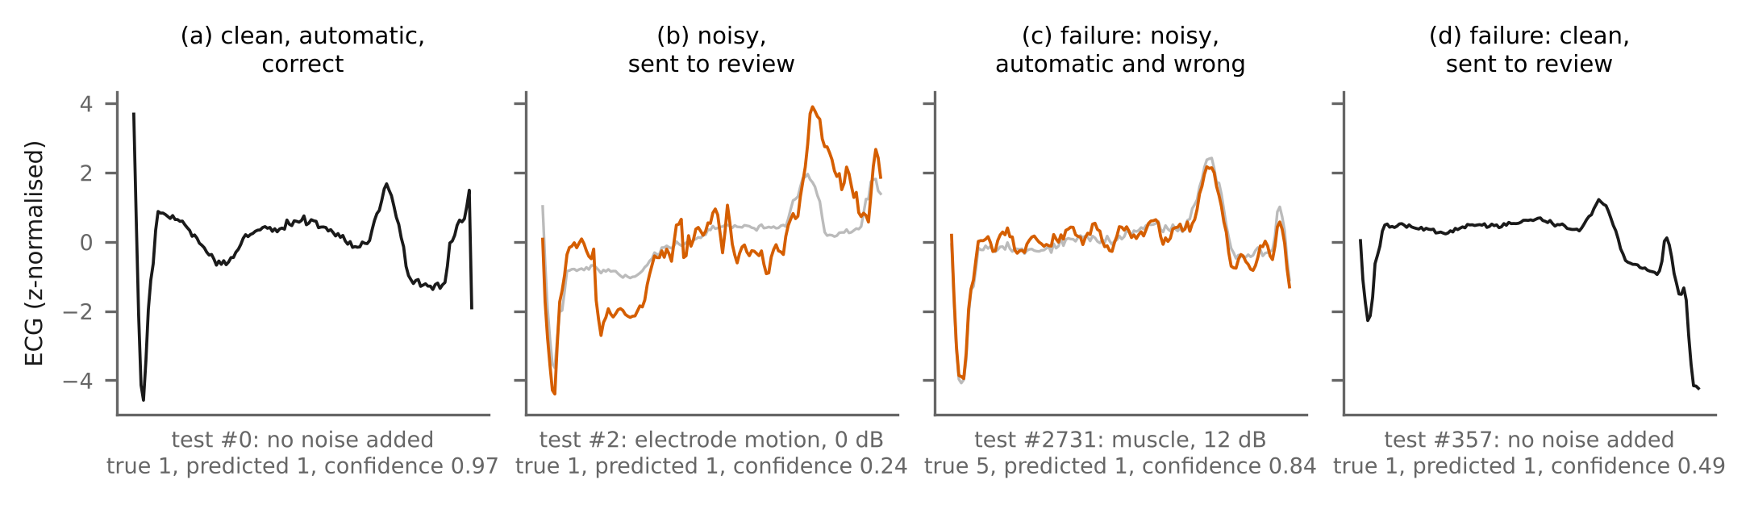
Fig. 9 LOOM flags most noisy recordings but misses some and sends some clean ones to review. Real-noise stream of ECG5000 (official split, LOOM, 20 % review budget). Rule: for each outcome, the first test recording in file order with that outcome. Grey: clean recording; orange: with NSTDB noise.

Generality, sensitivity and sanity checks
With MultiRocket features, LOOM compared with PreVal is better on 105 of 110 datasets, $p<0.001$ under faults and worse on 72 of 110 datasets, $p=0.008$ on clean data; with Hydra features it is better on 106 of 110 datasets, $p<0.001$ under faults and not significantly different, with 43 wins and 67 losses of 110 datasets, $p=0.147$ on clean data. On the 100 datasets never used during development LOOM is better on 94 of 100 datasets, $p<0.001$ under faults; without datasets with exact duplicates better on 92 of 98 datasets, $p<0.001$; without exact or near duplicates (90 datasets) better on 84 of 90 datasets, $p<0.001$; and after merging datasets from the same source (70 units) better on 68 of 70 source-level units, $p<0.001$. With 25 % and 50 % of the training data, LOOM’s median NLL under severity-3 faults is 1.058 and 1.049, against 2.155 and 2.543 for PreVal (111 datasets); LOOM keeps its advantage under faults with smaller training sets. Under a real change of sensor (training on one accelerometer axis of UWaveGestureLibrary and testing on another), accuracy drops from 0.810 to 0.323 but leverage barely moves (median ratio 1.13–1.29), and LOOM’s advantage is small (mean NLL 2.469 vs 2.550, lower on six of six axis pairs).
Sanity checks. (1) Assumption A2: held-out and clean test leverages have the same median scale, but a Kolmogorov–Smirnov test rejects equal distributions on 19 of 110 datasets (Holm-adjusted), so the assumption holds only approximately. (2) The spread of per-dataset jackknife+ coverage (standard deviation 0.035) is larger than binomial sampling alone would give (0.010, 97.5 % quantile 0.013); 42 % of datasets lie outside the binomial 95 % range, so coverage holds on average but not for every dataset. (3) Differences between LOOM and PreVal exceed two resampling standard errors on 51 % of the datasets on clean data and on 78 % under faults, in favour of LOOM on 76 % of the datasets.

Computational complexity and cost
LOOM costs the same to fit as PreVal (median 0.14 s vs 0.14 s on top of the shared MiniRocket transform of 0.17 s; Supplementary Table S4). From raw data to a fitted model, LOOM takes about 0.31 s, against 1.30 s for QUANT, 2.25 s for a five-seed ensemble and 4.47 s for the Arsenal.

Software tool
We release LOOM as a Python package with a command-line tool, loom-triage: fit trains a model on a CSV of labelled recordings, run writes a review queue with prediction, confidence, unusualness ($h/h_{ref}$), decision and optional prediction set, plus an HTML report, and evaluate scores labelled data. The tool has its own unit tests and was validated end to end on plain CSV files outside the experimental pipeline (Supplementary Sect. S5).

Discussions
LOOM uses a second quantity that the LOO algebra provides for free, the held-out leverage, to put each prediction on the scale of its own uncertainty. For an operator, this means that a LOOM model that is unsure about a recording is more likely to be looking at a damaged one, and that a fixed review budget catches about 41 % rather than 24 % of the damaged recordings in our confirmatory study. QUANT classifies damaged recordings more accurately; it made the fewest automatic errors in the exploratory study and with real ECG noise, while in the confirmatory study LOOM’s median automatic error was lower but not significantly. A tree ensemble for the label combined with LOOM’s leverage for the review decision is a promising design. We would use LOOM when training sets are small, recordings may be damaged, and a single fast model is preferred; where test data are known to be clean, PreVal gives a lower clean calibration error.
The main limitations are:
- Apart from the real ECG noise, all faults are simulated, and real noise was tested on ECG only; the noise was added at its native 360 Hz sampling because the UCR files do not record their sampling rates. The only real change of sensor we studied barely moves leverage, and LOOM gains little there.
- Leverage does not respond to changes that keep the features within the training range (speed variation, another sensor axis, label noise, changing class frequencies).
- On clean data LOOM is not better than PreVal, and target smoothing raises its calibration error on datasets with few training series per class.
- QUANT has a lower likelihood loss than LOOM under the strongest faults.
- The jackknife+ guarantee holds only approximately (Assumption A4), and per-dataset coverage varies more than sampling noise allows.
- For compute reasons, ensembles, other extractors and the Arsenal were evaluated on the official split only, logistic regression was skipped for four large datasets, and deep networks were not run.
- The exploratory triage study and several analyses were designed after the main results were known; they are labelled as post hoc (Supplementary Sect. S2).

Conclusion and future scope
We showed that a closed-form change to the readout of fast random-kernel classifiers makes their confidence drop for recordings far from the training data, without held-out data, refitting or ensembles. LOOM lowered the likelihood loss under simulated faults and real ECG noise compared with the strongest previous readout, and in a pre-registered triage study its review queue caught 41 % instead of 24 % of the faulty recordings. We did not show an advantage on clean data or over the tree-based QUANT classifier under the strongest faults, and leverage does not detect changes that keep the features in range. Next steps are a study with expert-labelled real faulty recordings, multivariate signals, combining QUANT’s trees with LOOM’s leverage, and adaptive target smoothing for problems with many classes and few examples.
Supplementary Material: proofs, deviations log, leakage audit, fault definitions, software validation and additional tables and figures.
An AI assistant (Claude, Anthropic) was used for the literature search, code, experiments and drafting, as described in Sect. 5. [Further acknowledgements to be completed by the authors.]

Declarations
- Funding: [to be completed by the authors]
- Competing interests: [to be completed by the authors]
- Ethics approval and consent to participate: not applicable (public, de-identified benchmark data).
- Data availability: UCR archive (https://www.timeseriesclassification.com; free for research use with citation of Dau et al. (2019)) and MIT-BIH Noise Stress Test Database (https://physionet.org/content/nstdb/1.0.0/; Open Data Commons Attribution License v1.0).
- Code availability: [public repository link to be inserted by the authors]; all results, tables, figures and the number macros of this paper are regenerated by one script.
- Author contribution: [to be completed by the authors]
Abdar M, Pourpanah F, Hussain S, et al (2021) A review of uncertainty quantification in deep learning: Techniques, applications and challenges. Information Fusion 76:243–297
Allen DM (1974) The Relationship Between Variable Selection and Data Agumentation and a Method for Prediction. Technometrics 16:125–127
Angelopoulos AN, Bates S (2023) Conformal Prediction: A Gentle Introduction. Foundations and Trends® in Machine Learning 16:494–591
Angelopoulos AN, Bates S, Malik J, Jordan MI (2021) Uncertainty sets for image classifiers using conformal prediction. In: International Conference on Learning Representations
Bagnall A, Lines J, Bostrom A, et al (2016) The great time series classification bake off: a review and experimental evaluation of recent algorithmic advances. Data Mining and Knowledge Discovery 31:606–660
Barber RF, Candès EJ, Ramdas A, Tibshirani RJ (2021) Predictive inference with the jackknife+. The Annals of Statistics 49:486–507
Benavoli A, Corani G, Demšar J, Zaffalon M (2017) Time for a change: a tutorial for comparing multiple classifiers through Bayesian analysis. Journal of Machine Learning Research 18:1–36
Benavoli A, Corani G, Mangili F (2016) Should we really use post-hoc tests based on mean-ranks? Journal of Machine Learning Research 17:1–10
Burnaev E, Vovk V (2014) Efficiency of conformalized ridge regression. In: Proceedings of the 27th Conference on Learning Theory. pp 605–622
Cawley GC, Talbot NLC (2004) Fast exact leave-one-out cross-validation of sparse least-squares support vector machines. Neural Networks 17:1467–1475
Dau HA, Bagnall A, Kamgar K, et al (2019) The UCR time series archive. IEEE/CAA Journal of Automatica Sinica 6:1293–1305
Dempster A, Petitjean F, Webb GI (2020) ROCKET: exceptionally fast and accurate time series classification using random convolutional kernels. Data Mining and Knowledge Discovery 34:1454–1495
Dempster A, Schmidt DF, Webb GI (2021) MiniRocket: a very fast (almost) deterministic transform for time series classification. Proceedings of the 27th ACM SIGKDD Conference on Knowledge Discovery & Data Mining 248–257
Dempster A, Schmidt DF, Webb GI (2023) Hydra: competing convolutional kernels for fast and accurate time series classification. Data Mining and Knowledge Discovery 37:1779–1805
Dempster A, Schmidt DF, Webb GI (2024) quant: a minimalist interval method for time series classification. Data Mining and Knowledge Discovery 38:2377–2402
Dempster A, Webb GI, Schmidt DF (2025) Prevalidated ridge regression is a highly-efficient drop-in replacement for logistic regression for high-dimensional data. arXiv preprint arXiv:2401.15610 (version 2)
Demšar J (2006) Statistical comparisons of classifiers over multiple data sets. Journal of Machine Learning Research 7:1–30
Gawlikowski J, Tassi CRN, Ali M, et al (2023) A survey of uncertainty in deep neural networks. Artificial Intelligence Review 56:1513–1589
Geifman Y, El-Yaniv R (2017) Selective classification for deep neural networks. In: Advances in Neural Information Processing Systems
Goldberger AL, Amaral LAN, Glass L, et al (2000) PhysioBank, PhysioToolkit, and PhysioNet: components of a new research resource for complex physiologic signals. Circulation 101:e215–e220. https://doi.org/10.1161/01.CIR.101.23.e215
Golub GH, Heath M, Wahba G (1979) Generalized Cross-Validation as a Method for Choosing a Good Ridge Parameter. Technometrics 21:215–223
Guo C, Pleiss G, Sun Y, Weinberger KQ (2017) On calibration of modern neural networks. In: Proceedings of the 34th International Conference on Machine Learning. pp 1321–1330
Hendrycks D, Dietterich T (2019) Benchmarking neural network robustness to common corruptions and perturbations. In: International Conference on Learning Representations
Hendrycks D, Gimpel K (2017) A baseline for detecting misclassified and out-of-distribution examples in neural networks. In: International Conference on Learning Representations
Hoaglin DC, Welsch RE (1978) The Hat Matrix in Regression and ANOVA. The American Statistician 32:17–22
Hoerl AE, Kennard RW (1970) Ridge Regression: Biased Estimation for Nonorthogonal Problems. Technometrics 12:55–67
Holm S (1979) A simple sequentially rejective multiple test procedure. Scandinavian Journal of Statistics 6:65–70
Ismail Fawaz H, Forestier G, Weber J, et al (2019) Deep learning for time series classification: a review. Data Mining and Knowledge Discovery 33:917–963
Ismail Fawaz H, Lucas B, Forestier G, et al (2020) InceptionTime: Finding AlexNet for time series classification. Data Mining and Knowledge Discovery 34:1936–1962
Iwana BK, Uchida S (2021) An empirical survey of data augmentation for time series classification with neural networks. PLOS ONE 16:e0254841
Kristiadi A, Hein M, Hennig P (2020) Being Bayesian, even just a bit, fixes overconfidence in ReLU networks. In: Proceedings of the 37th International Conference on Machine Learning. pp 5436–5446
Kull M, Perello-Nieto M, Kängsepp M, et al (2019) Beyond temperature scaling: obtaining well-calibrated multi-class probabilities with Dirichlet calibration. In: Advances in Neural Information Processing Systems
Lakshminarayanan B, Pritzel A, Blundell C (2017) Simple and scalable predictive uncertainty estimation using deep ensembles. In: Advances in Neural Information Processing Systems
Lei J, G’Sell M, Rinaldo A, et al (2018) Distribution-Free Predictive Inference for Regression. Journal of the American Statistical Association 113:1094–1111
Liu JZ, Lin Z, Padhy S, et al (2020) Simple and principled uncertainty estimation with deterministic deep learning via distance awareness. In: Advances in Neural Information Processing Systems
Liu JZ, Padhy S, Ren J, et al (2023) A simple approach to improve single-model deep uncertainty via distance-awareness. Journal of Machine Learning Research 24:1–63
MacKay DJC (1992) The Evidence Framework Applied to Classification Networks. Neural Computation 4:720–736
Middlehurst M, Ismail-Fawaz A, Guillaume A, et al (2024a) aeon: a Python toolkit for learning from time series. Journal of Machine Learning Research 25:1–10
Middlehurst M, Large J, Flynn M, et al (2021) HIVE-COTE 2.0: a new meta ensemble for time series classification. Machine Learning 110:3211–3243
Middlehurst M, Schäfer P, Bagnall A (2024b) Bake off redux: a review and experimental evaluation of recent time series classification algorithms. Data Mining and Knowledge Discovery 38:1958–2031
Moody GB, Muldrow WK, Mark RG (1984) A noise stress test for arrhythmia detectors. In: Computers in Cardiology. pp 381–384
Niculescu-Mizil A, Caruana R (2005) Predicting good probabilities with supervised learning. Proceedings of the 22nd international conference on Machine learning - ICML ’05 625–632
Nouretdinov I, Melluish T, Vovk V (2001) Ridge regression confidence machine. In: Proceedings of the 18th International Conference on Machine Learning. Morgan Kaufmann, San Francisco, pp 385–392
Ovadia Y, Fertig E, Ren J, et al (2019) Can you trust your model’s uncertainty? Evaluating predictive uncertainty under dataset shift. In: Advances in Neural Information Processing Systems
Pedregosa F, Varoquaux G, Gramfort A, et al (2011) Scikit-learn: machine learning in Python. Journal of Machine Learning Research 12:2825–2830
Platt JC (2000) Probabilistic outputs for support vector machines and comparisons to regularized likelihood methods. In: Smola AJ, Bartlett P, Schölkopf B, Schuurmans D (eds) Advances in Large Margin Classifiers. MIT Press, Cambridge, MA, pp 61–74
Ragab M, Eldele E, Tan WL, et al (2023) ADATIME: A Benchmarking Suite for Domain Adaptation on Time Series Data. ACM Transactions on Knowledge Discovery from Data 17:1–18
Romano Y, Sesia M, Candès EJ (2020) Classification with valid and adaptive coverage. In: Advances in Neural Information Processing Systems
Sadinle M, Lei J, Wasserman L (2018) Least Ambiguous Set-Valued Classifiers With Bounded Error Levels. Journal of the American Statistical Association 114:223–234
Silva Filho T, Song H, Perello-Nieto M, et al (2023) Classifier calibration: a survey on how to assess and improve predicted class probabilities. Machine Learning 112:3211–3260
Tan CW, Dempster A, Bergmeir C, Webb GI (2022) MultiRocket: multiple pooling operators and transformations for fast and effective time series classification. Data Mining and Knowledge Discovery 36:1623–1646
Tibshirani RJ, Efron B (2002) Pre-validation and inference in microarrays. Statistical Applications in Genetics and Molecular Biology 1
Um TT, Pfister FMJ, Pichler D, et al (2017) Data augmentation of wearable sensor data for parkinson’s disease monitoring using convolutional neural networks. Proceedings of the 19th ACM International Conference on Multimodal Interaction 216–220
van Amersfoort J, Smith L, Teh YW, Gal Y (2020) Uncertainty estimation using a single deep deterministic neural network. In: Proceedings of the 37th International Conference on Machine Learning. pp 9690–9700
Vovk V, Gammerman A, Shafer G (2022) Algorithmic Learning in a Random World. Springer International Publishing
Wilcoxon F (1945) Individual Comparisons by Ranking Methods. Biometrics Bulletin 1:80
Xu C, Xie Y (2023) Conformal Prediction for Time Series. IEEE Transactions on Pattern Analysis and Machine Intelligence 45:11575–11587
Zadrozny B, Elkan C (2002) Transforming classifier scores into accurate multiclass probability estimates. Proceedings of the eighth ACM SIGKDD international conference on Knowledge discovery and data mining 694–699

