Trustworthy prediction intervals after moving an NIR calibration to a new instrument or season: how many reference samples, and from how many batches?
Authors: [Author 1]ª, [Author 2]^{a,*}
ª [Affiliation, address, country]
* Corresponding author: [e-mail address]

Abstract
Background: When a near-infrared (NIR) calibration is moved to a new instrument or harvest season, a few reference samples are measured to adapt it. Results are then reported, and products accepted or rejected, with an uncertainty range. Whether that range still holds after the move, and how the reference samples should be chosen, is rarely checked.
Results: On three public data sets (corn, tablets, mango), 90% ranges taken from the original calibration contained as few as 0.03 of the reference values after transfer. Re-fitting the transfer with each reference sample left out in turn (a jackknife+) gave intervals that were never detectably below their nominal coverage in 40 planned scenarios with randomly chosen samples, without extra reference analyses; simple Gaussian and regression intervals did almost as well at 90% but fell slightly short at 95%. How the samples were collected mattered more. With 20 reference fruit from two consignments, intervals were too narrow for fruit from other consignments in 6 of 8 instrument and season combinations (coverage 0.67–0.91). Taking one fruit from each of 15–20 consignments, or leaving out whole consignments when re-fitting, restored coverage. In a mango harvest-maturity check at 14% dry matter, passing fruit on the predicted value alone accepted 36–41% of immature fruit; 90% intervals cut this to 3.2% with reference fruit from ten consignments and 9.8% with fruit from two.
Significance: Reliable uncertainty for a transferred NIR method can be obtained from the reference samples the transfer already needs, provided they come from many batches.
Keywords: calibration transfer; prediction interval; near-infrared spectroscopy; measurement uncertainty; conformal prediction; fruit dry matter

1. Introduction
NIR spectroscopy is used every day to measure moisture in grain, active ingredient in tablets and dry matter in fruit [1]. Each of these measurements relies on a calibration model built on one instrument, for one population of samples. Sooner or later the model has to be moved. A packhouse replaces a handheld unit, a pharmaceutical site adds a second spectrometer, a new harvest season brings fruit grown under different conditions. Calibration transfer handles the move. A small set of reference samples is measured on the new instrument, or in the new season, and used to correct either the spectra or the predictions: direct and piecewise direct standardisation (DS, PDS), or slope/bias correction (SBC) [2–5]. Newer approaches adapt the model with few or no reference values [6–11].
Transfer methods are almost always judged by their prediction error (RMSEP or bias). In practice, though, a laboratory does not report a bare number. It reports a value with an uncertainty range and takes decisions with it: a tablet batch is released if its assay lies within specification, and a mango block is harvested if the fruit reach a minimum dry matter. For mango, a minimum of 14% dry matter at harvest has long been recommended in Australia [12]. The usual uncertainty statements for multivariate calibrations are error-propagation formulas and ASTM E1655-type intervals [13–16]. They are built from the error of the original calibration. After a move to a new instrument or season, that error no longer describes the model in use. A recent review of calibration transfer for portable optical instruments names the lack of uncertainty-aware validation as one of the open problems of the field [17].
This paper asks a practical question. After a calibration has been transferred with m reference samples, can those same samples be used to give each new prediction an uncertainty range that can be trusted? And if so, which samples are needed?
Trusted here has a precise meaning. A 90% prediction interval should contain the reference value of about 90% of future samples. In method-validation language, this is a β-expectation tolerance interval, the quantity behind accuracy profiles [18,19]. Conformal prediction gives intervals with this property under one assumption: the calibration samples and the future samples must be exchangeable, for example drawn at random from the same population [20–22]. Conformal intervals have recently been used for NIR and MIR regression on a single instrument [23–25], and for spectral classification under laboratory-to-field shift [26]. Corrections for a change in the spectral distribution exist [27,28], but they assume that the relation between spectrum and property stays the same, which an instrument change violates. Transfer creates two difficulties. First, the reference samples are needed to fit the transfer itself, and setting half of them aside to calibrate an interval leaves too few for either job. Second, the samples are rarely a random draw from future production. They usually come from one or two lots, collected on the day the instrument was set up.
The first difficulty has a clean solution. The jackknife+ [29] re-fits a model with each calibration sample left out in turn and uses the left-out errors to build the interval, so no sample is wasted. We apply it to the transfer step only: the original calibration stays as it is, and only the standardisation or bias correction is re-fitted. We call the result the transfer jackknife+ (TJ+). The coverage guarantee then follows from the existing theory; we do not claim new statistics. The second difficulty is the one that decides whether the method is useful in practice. When samples come in batches (harvest consignments, production lots), the theory says that the batch, not the individual sample, has to be the random unit [30,31]. Whether this matters after calibration transfer, and how much, has to be measured. The mango data used here record which consignment every fruit came from, which allowed us to measure it.
We therefore organised the study around four questions a laboratory would ask:
- Can the uncertainty statement of the original calibration be kept after transfer?
- If not, can valid intervals be obtained from the reference samples alone, and how do they compare with the simpler options a laboratory might use (Gaussian intervals, the regression prediction interval of slope/bias correction, bootstrap)?
- Does it matter whether the reference samples come from a few batches or from many?
- What does this mean for a real accept/reject decision, here harvest-maturity screening of mango?
The study uses public data only. The main experiments were specified in advance; the batch study and the harvest case study were added in a second round, and every change is recorded in a dated deviation log that accompanies the code, which reproduces every number in the paper.

2. Theory

2.1. Setting
Let $f$ be the original calibration (PLS unless stated otherwise), built on source data: the master instrument, or earlier seasons. After the move, $m$ reference samples (transfer standards) $Z_{i}=\left(x_{i}^{T},x_{i}^{S},y_{i}\right)$ are available. $x_{i}^{T}$ is the spectrum on the new instrument or in the new season, $x_{i}^{S}$ the spectrum of the same sample on the master instrument (needed only for spectral standardisation), and $y_{i}$ the reference value. The transfer method $T$ turns a set of standards $D$ into the predictor that is actually used,
$$μ_{D}\left(x\right)=a_{D}+b_{D} f​\left(g_{D}\left(x\right)\right), \left(1\right)$$
where $g_{D}$ is a spectral standardisation and $\left(a_{D},b_{D}\right)$ an output correction. For PDS and DS, $g$ is fitted on the spectrum pairs and $\left(a,b\right)=\left(0,1\right)$. For SBC, $g$ is the identity and $\left(a,b\right)$ come from regressing $y_{i}$ on $f\left(x_{i}^{T}\right)$. Without transfer, $μ=f$. For a new routine sample we want an interval $\hat{C}\left(x\right)$ that contains its reference value with probability at least $1−α$ and is as narrow as possible.

2.2. Re-fitting the transfer with one standard left out (TJ+)
For each $i$ the transfer is re-fitted without standard $i$, giving $μ_{−i}$. The left-out error of standard $i$ is scaled by a difficulty value $σ_{−i}\left(x_{i}^{T}\right)$ (Section 2.3):
$$R_{i}=\frac{\left|y_{i}−μ_{−i}\left(x_{i}^{T}\right)\right|}{σ_{−i}\left(x_{i}^{T}\right)}, i=1,…,m. \left(2\right)$$
The interval for a new spectrum $x$ collects the $m$ left-out predictions, each widened by its own scaled error:
$$\hat{C}\left(x\right)=[{\hat{q}}_{α}^{−}\{μ_{−i}\left(x\right)−σ_{−i}\left(x\right)R_{i}\}, {\hat{q}}_{α}^{\text{+}}\{μ_{−i}\left(x\right)+σ_{−i}\left(x\right)R_{i}\}]. \left(3\right)$$
Here ${\hat{q}}_{α}^{\text{+}}$ is the $⌈\left(1−α\right)\left(m+1\right)⌉$-th smallest value ($+∞$ if this rank exceeds $m$), and ${\hat{q}}_{α}^{−}$ is the $⌊α\left(m+1\right)⌋$-th smallest ($−∞$ if the rank is below 1). The original calibration $f$ is never re-fitted; often it could not be, because its data belong to another instrument or season. We write TJ+N for the scaled version used throughout, and TJ+ when $σ≡1$. For PDS each re-fit takes milliseconds, and the whole interval takes seconds at most. Fig. 1 summarises the procedure.
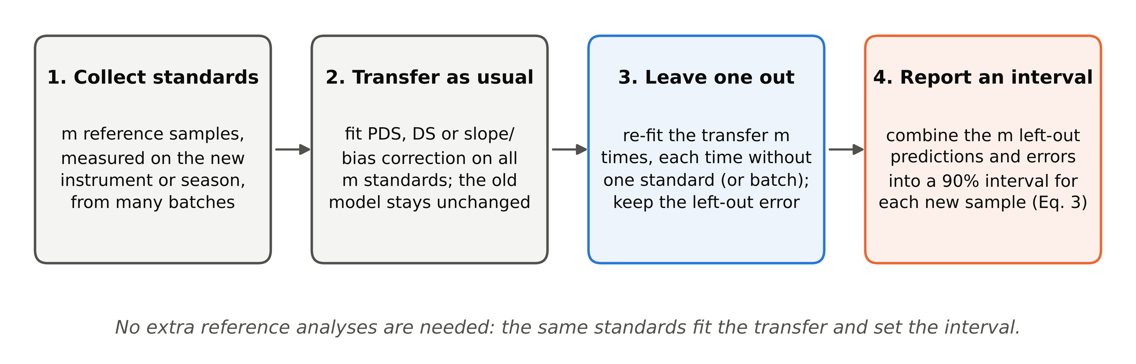
Fig. 1. The procedure in four steps. Only the transfer step is re-fitted; the original calibration and the difficulty scaling are fixed beforehand from source data.
Proposition 1 [29]. If the $m$ standards and the future sample are exchangeable (for instance, all drawn at random from the routine population), and $f$ and $σ$ do not use the standards, then $Pr\{y∈\hat{C}\left(x\right)\}≥1−2α$.
This is the jackknife+ theorem applied to the transfer step, which is a symmetric fitting algorithm; Appendix A writes out the argument for this setting. In practice the coverage is usually close to $1−α$ [29]. A bounded interval needs $m≥9$ standards at $α=0.10$ and $m≥19$ at $α=0.05$. With fewer standards the method returns an unbounded interval rather than an over-confident one.

2.3. Making the width follow the sample
PLS calibrations come with two standard warning signals: Hotelling $T^{2}$, for samples far from the calibration set, and the residual $Q$, for spectral features the model cannot explain. We use them to let the interval widen for difficult samples. The difficulty is
$$σ\left(x\right)=max\left\{ε, c_{0}+c_{1}\sqrt{T^{2}\left(x\right)}+c_{2}\sqrt{Q\left(x\right)}\right\}, \left(4\right)$$
with $c_{j}≥0$ fitted on the source cross-validation residuals only. Such normalised scores are standard in conformal regression [23,32]. Inside TJ+N it is evaluated on the spectrum after each fold’s transfer, so a spectrum that the transfer maps poorly gets a large $Q$ and a wider interval. This scaling is a refinement, not the core of the method. Its effect on efficiency was modest (Supplementary Table S3), and the guarantee holds without it.

2.4. When the standards come in batches
Fruit arrive in consignments, tablets in production lots, grain in deliveries. Errors of a transferred calibration are often shared within a batch: a consignment of slightly riper fruit is predicted slightly too low, all together. If the $m$ standards come from only $K$ batches, their left-out errors reflect those $K$ batches. A sample from a new batch can then fall outside the interval more often than the nominal rate. Proposition 1 does not cover this case, because a sample from a new batch is not exchangeable with standards from the old ones.
The remedy is to treat the batch as the unit. In the batch-level version (TJ+B), all standards of batch $k$ are left out together, the transfer is re-fitted on the other batches, and each left-out error is given the weight $1/\left(\left(K+1\right)n_{k}\right)$, so that every batch counts equally. This is the hierarchical jackknife+ of Lee, Barber and Willett [30]. It guarantees coverage $≥1−2α$ for a sample from a new batch, provided the batches behind the standards are a random draw of batches. Two consequences are useful in practice (Appendix B).
First, a bounded interval needs at least nine batches at $α=0.10$, however many samples are taken from each.
Second, if every standard comes from a different, randomly chosen batch, the ordinary TJ+ already is the batch-level method, so nothing else is needed.
We use this construction with the σ(x) scaling and call it TJ+B. Appendix B also gives a variant that keeps only the largest error per batch (TJ+G), with a short self-contained proof. At 90% and 95% both gave identical intervals in the designs studied here, because both then reduce to the largest left-out error; at 80% TJ+B was slightly less conservative. The guarantee of TJ+B rests on the theorem of Lee et al. [30], that of TJ+G on Appendix B.

2.5. Methods compared
All methods use the same transferred predictor and differ only in the interval. They fall into four groups.
Intervals carried over from the original calibration:
- ASTM-PI: the ASTM E1655-type interval $μ\left(x\right)±t SEC\sqrt{1+h\left(x\right)}$, with the source standard error of calibration [16];
- SCP-S: split conformal prediction with source residuals [21];
- WCP-S: a version reweighted for covariate shift [27];
- Transport: a regression version of transported conformal calibration [33].
Intervals built from the standards with simple formulas:
- Gauss-LOO: $μ\left(x\right)±t_{m−1}RMSE_{LOO}$, from the same left-out errors as TJ+;
- Gauss-LOO-N: the same, scaled by $σ\left(x\right)$;
- ASTM-T: the ASTM formula with the standard error re-estimated from the left-out errors;
- OLS-PI: for SBC only, the textbook prediction interval of the regression of $y$ on $f$;
- Boot-T: a bootstrap prediction interval with 200 resamples of the standards [34], in the resampling tradition of chemometric uncertainty estimation [35].
Valid alternatives that cost standards:
- SCP-T-split: half the standards fit the transfer and half calibrate a split-conformal interval.
Batch-aware alternatives:
- Gauss-LGO: a Gaussian interval from leave-one-batch-out errors, with $K−1$ degrees of freedom;
- ANOVA-PI: the random-effects (one-way ANOVA) prediction interval for a new batch [19], computed from the same signed leave-one-batch-out errors, with moment estimates of the between- and within-batch variances (the former truncated at zero), Satterthwaite degrees of freedom, and a centre shifted by the mean left-out error;
- LGO-CV+N: CV+ with batches as folds but with every sample counted as a separate unit, a natural shortcut without a guarantee for new batches.
An exploratory label-free variant and the ablations of TJ+N (no leave-one-out, no “+”, five-fold CV+, single-diagnostic scaling) are reported in the Supplementary Material.

3. Experimental

3.1. Data
Three public NIR data sets with documented shifts were used (Table 1, Fig. 2).
Corn [36]. 80 samples measured on three spectrometers (m5 as master, mp5 and mp6) at 1100–2498 nm, with moisture, oil, protein and starch.
Pharmaceutical tablets (IDRC Shootout 2002) [36]. 655 tablets on two spectrometers (600–1898 nm), with weight, hardness and assay. The organisers’ calibrate, validate and test sets were kept.
Mango dry matter [37,38]. Spectra of intact fruit (684–990 nm) from four seasons. Replicate scans were averaged per fruit, giving 4,677 fruit. Seasons 1–3 were the source and season 4 the target. Season 4 contains 18 consignments of 33–54 fruit each; the data providers call them populations, and each is one cultivar from one orchard, at one maturity stage and harvest date. For an instrument shift, the providers’ extended data set [39] was used: fruit measured on handheld unit 15006 and on one of three other units (15016, 15014, 15029). These pairs share 49, 38 and 29 consignments, respectively.
Table 1. Data sets and splitting protocol.
Data set | Size | Shift | Range (channels) | Responses | Source train / source cal. / target pool | m
Corn | 80 samples | m5 → mp5, mp6 (and mp5 → m5) | 1100–2498 nm (700) | moisture, oil, protein, starch (%) | 40 / 10 / 30 (random each repetition) | 10, 15, 20
Tablets | 655 tablets | 1 → 2 | 600–1898 nm (650) | assay (mg), weight (mg), hardness | 155 / 40 / 460 (fixed) | 10, 20, 30, 50
Mango | 4,677 fruit (3,952 source, 725 target) | seasons 1–3 → 4 | 684–990 nm (103) | dry matter (%) | 3,162 / 790 / 725 | 10, 20, 30, 50
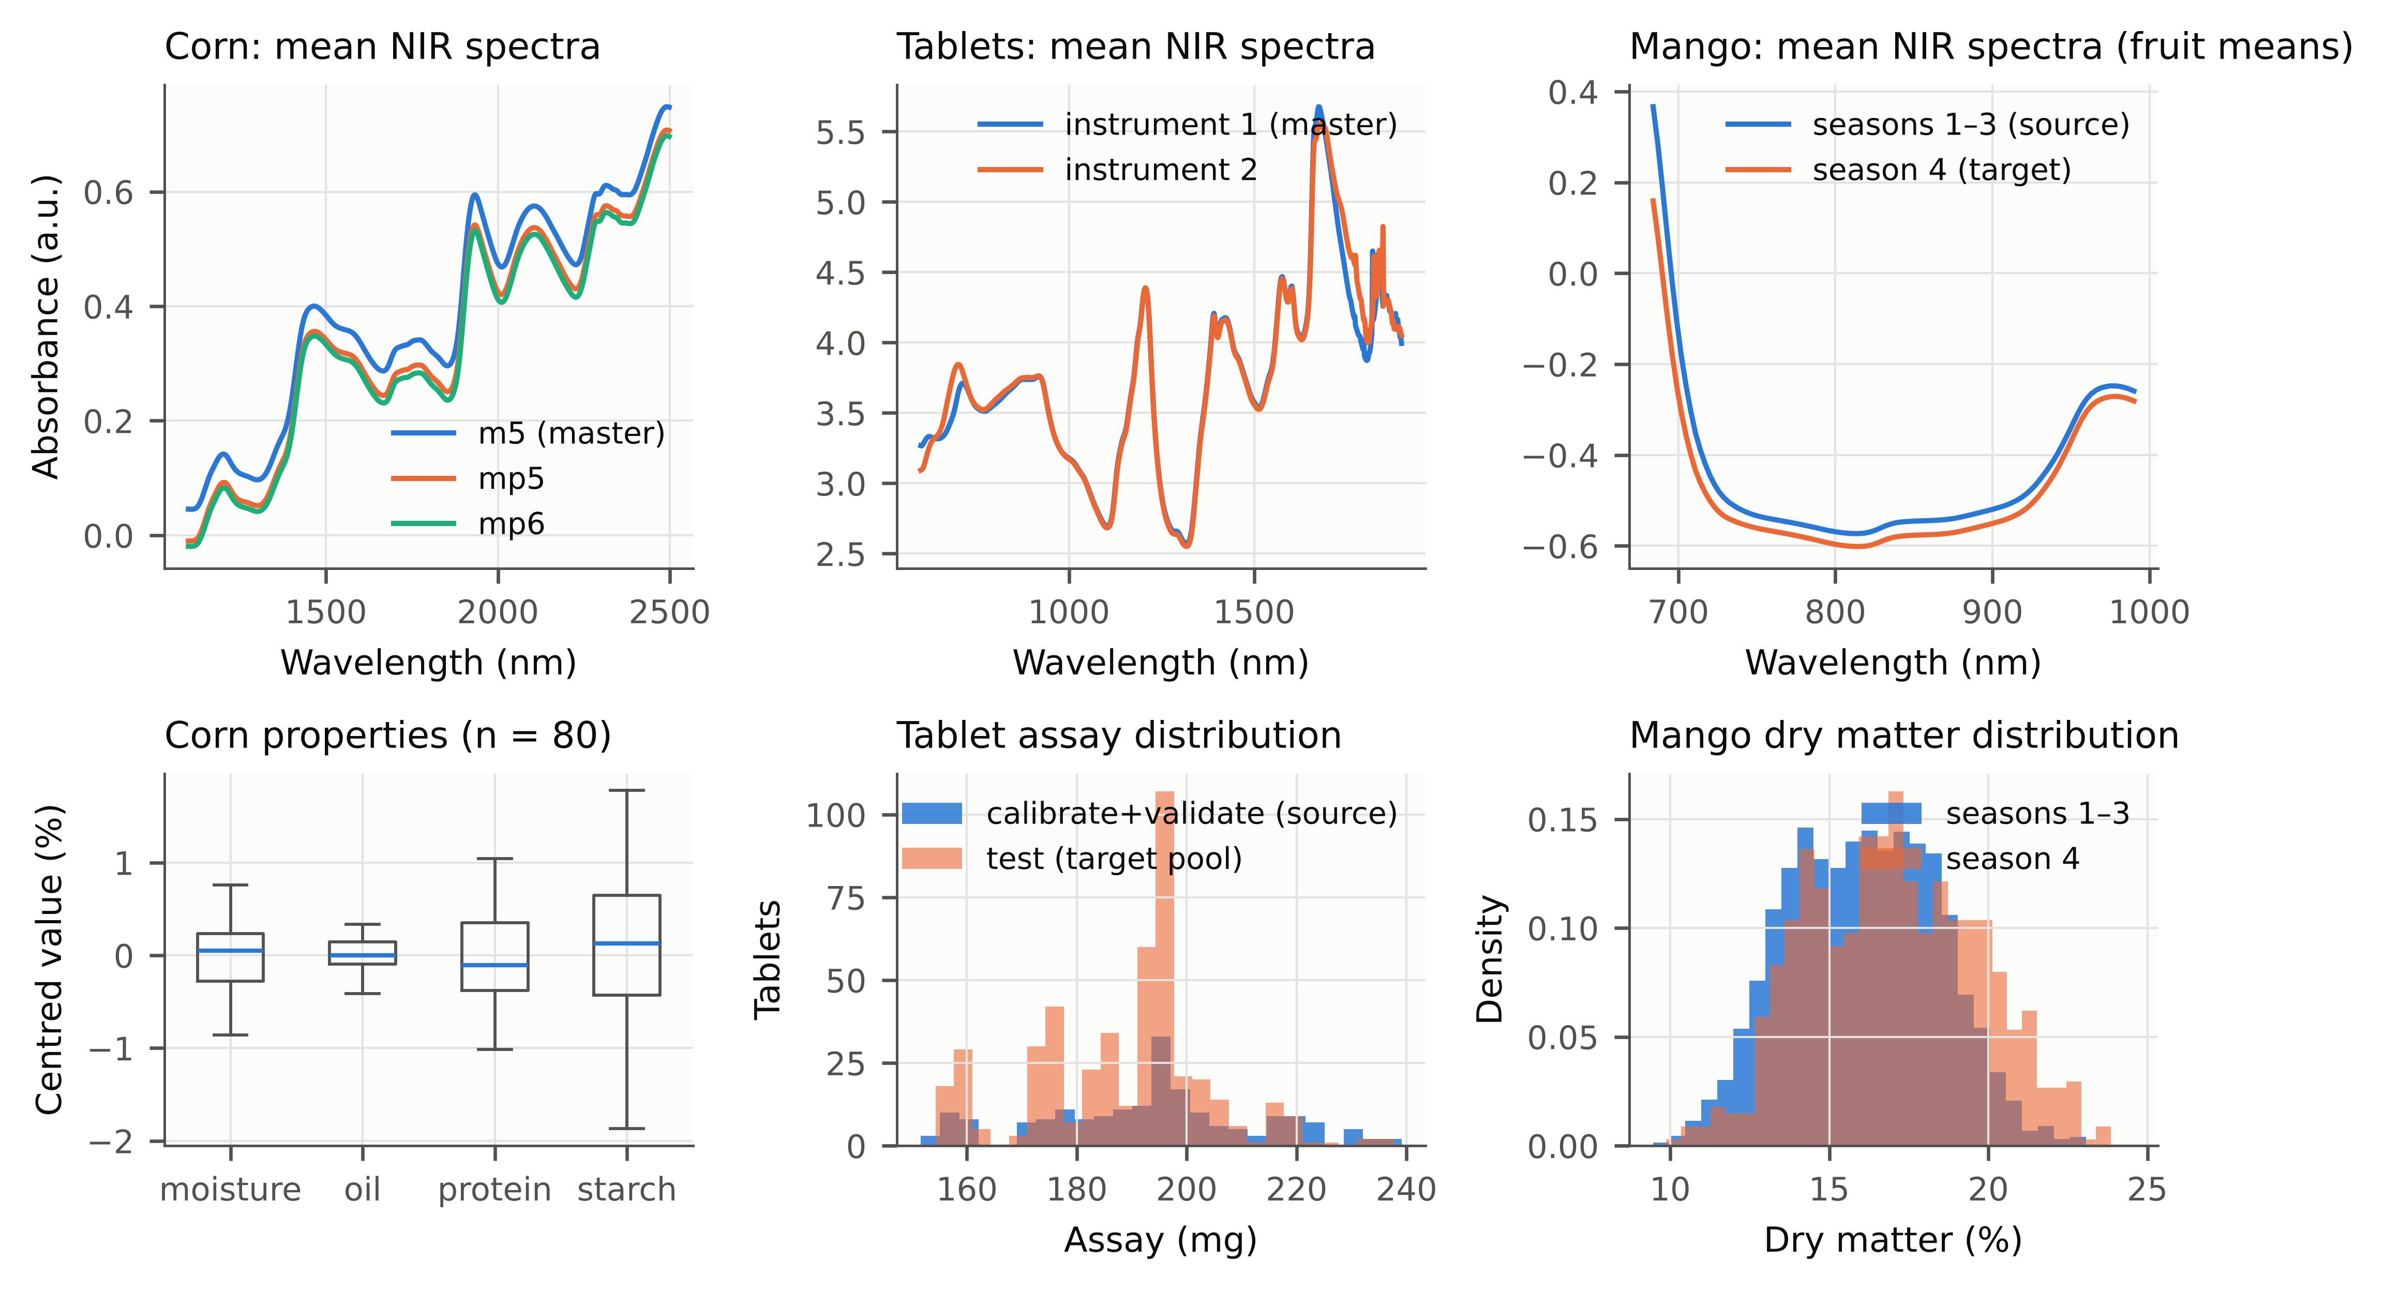
Fig. 2. The three data sets. Top: mean spectra per instrument (corn, tablets) or per season group (mango). Bottom: distributions of the reference values.

3.2. How the study was run
For the main experiments with random standards, all settings, seeds and criteria were fixed before target results were computed. The batch study and the harvest case study were specified later, before their own results were computed, and one baseline was corrected after an internal review; all changes are recorded in a dated deviation log in the repository.
Original calibrations. Preprocessing (none, SNV, first or second Savitzky–Golay derivative) and the number of PLS components were chosen by 10-fold cross-validation on source data only [40–42]. Ridge regression and a small 1D-CNN were used as alternative model types.
Transfer. PDS (window 5) [2], DS, SBC and no transfer. The planned main pipelines were PDS for corn and tablets and SBC for mango.
Random standards. In each repetition, $m$ standards were drawn at random from the target pool, and the remaining target samples served as test samples:
- corn: $m$ = 10, 15, 20;
- tablets and mango: $m$ = 10, 20, 30, 50.
This gives 40 main scenarios, with 500 repetitions for corn and tablets and 300 for mango. A further 200 repetitions per scenario compared the simpler interval formulas (Gauss-LOO-N, ASTM-T, OLS-PI, Boot-T) on identical standards.
Standards from batches. For the four mango settings, giving eight setting-pipeline combinations (season shift with SBC and without transfer; three instrument shifts with PDS and SBC), $K$ consignments were drawn at random and $n_{g}$ fruit taken from each, always with 20 standards or fewer:
- 2 × 10;
- 5 × 4;
- 10 × 2;
- 15 × 1;
- 20 × 1, for the instrument data only.
A chronological design took 4 fruit from each of the five earliest-harvested consignments. Coverage was measured on the fruit of the consignments that supplied no standards, averaging first within and then across consignments. Each design was repeated 300 times. This part of the study was specified after the first manuscript draft and before any of its results were computed. One baseline (ANOVA-PI) was corrected after an internal review and the experiment re-run (deviation R3).
Application. For the harvest-maturity case study, each test fruit was classified with its 90% interval:
- pass (mature) if the lower limit was at least 14% dry matter [12];
- fail if the upper limit was below 14%;
- refer for a re-measurement otherwise.
The usual point rule (pass if the prediction is at least 14%) served as reference. We recorded how many immature fruit were passed, and how many fruit had to be referred (200 repetitions). This case study was added after the batch results were known.
Robustness and sensitivity. These checks covered:
- Kennard–Stone selection of the standards [43];
- added spectral noise;
- a wavelength shift of the routine spectra after standardisation (±1 and ±0.25 channel);
- half the source data;
- the PDS window and the number of PLS components;
- other model types (ridge, 1D-CNN);
- the reverse transfer direction.
Evaluation. For each repetition we recorded the share of test samples inside their interval (coverage), the interval width, and the interval score, which rewards narrow intervals and penalises misses [44]. Mean coverage over repetitions is given with a 95% bootstrap confidence interval. A method was flagged as too narrow in a scenario when the upper end of this interval was below the nominal level. As a positive check, we also report how often the lower end stayed within 0.02 of nominal. Interval scores were compared within scenarios with paired Wilcoxon tests and Holm correction [45]. Because realised coverage varies from one set of standards to the next, we also report the share of standard sets whose coverage on their test samples reached at least 0.85. For small test sets (corn: 10–20 samples) this share also reflects the randomness of the test set itself. Bootstrap intervals resample repetitions and are therefore conditional on the data sets and, for the batch study, on the available consignments. Computations used Python (NumPy, SciPy, scikit-learn, PyTorch) on 4 CPU cores.

4. Results and discussion

4.1. The old uncertainty statement does not survive the move
Transfer was clearly needed. Applied directly to the mp5 and mp6 spectra, the corn master models had prediction errors 2.6–5.2 times larger than after PDS with 20 standards (Supplementary Table S1). The uncertainty statements of the original calibrations fared worse than their predictions. On corn, nominal 90% intervals from the ASTM formula, from source split conformal prediction and from the covariate-shift-weighted version contained far fewer reference values than intended (coverage 0.03–0.74). All 72 of 72 scenario-method combinations were too narrow. On mango the coverage was 0.71–0.76 (12 of 12 too narrow). On tablets the picture was mixed (0.81–0.95; 11 of 36 too narrow): the assay suffered with ten standards, while hardness, which hardly changed between instruments, was unaffected (Table 2, Fig. 3).
The original calibration error does not include the error added by the transfer itself, which is estimated from only a few standards. Out-of-fold source residuals did not help (SCP-S under-covered almost as badly as ASTM-PI). Neither did reweighting them for the change in spectral distribution: WCP-S returned unbounded intervals in 59% of corn repetitions and was too narrow elsewhere, because an instrument change alters the relation between spectrum and property, not only the spectra. Mapping source samples into the new instrument’s space (Transport) recovered part of the coverage (mean coverage 0.75, range 0.29–0.92) but remained too narrow in 14 of 24 corn scenarios. The independent instrument shift on mango told the same story: after PDS, the ASTM, SCP-S and WCP-S intervals covered only 0.15–0.51 of the fruit. The exception was Transport, which covered 0.95–0.99, but with intervals more than twice as wide as those of TJ+N (median width 24.6 vs 11.1% dry matter; Supplementary Table S6).
An uncertainty range validated on the original instrument therefore says little about the transferred method, and has to be re-established on the new one.
Table 2. Coverage of nominal 90% intervals (α = 0.10) for the primary transfer pipelines (corn and tablets: PDS; mango: SBC). Coverage: mean over scenarios of the mean per-repetition coverage, with the range over scenarios in parentheses. Under: scenarios flagged as under-covering (upper limit of the 95% bootstrap CI < 0.90) / number of scenarios. Friedman rank: mean rank of the scenario median interval score over the 40 scenarios (1 = best; only methods available in all scenarios).
Method | Corn coverage | Corn under | Tablets coverage | Tablets under | Mango coverage | Mango under | Unbounded (% reps) | Friedman rank (IS)
TJ+N | 0.931 (0.91–0.96) | 0/24 | 0.910 (0.90–0.95) | 0/12 | 0.904 (0.90–0.91) | 0/4 | 0 | 2.52
TJ+ | 0.933 (0.91–0.96) | 0/24 | 0.911 (0.90–0.95) | 0/12 | 0.904 (0.90–0.91) | 0/4 | 0 | 3.12
SCP-T-split-N | 0.970 (0.90–1.00) | 0/24 | 0.942 (0.91–1.00) | 0/12 | 0.942 (0.90–1.00) | 0/4 | 50 | 6.03
SCP-T-split | 0.969 (0.89–1.00) | 0/24 | 0.943 (0.91–1.00) | 0/12 | 0.941 (0.91–1.00) | 0/4 | 50 | 6.60
Gauss-LOO | 0.904 (0.89–0.91) | 0/24 | 0.908 (0.89–0.93) | 0/12 | 0.904 (0.90–0.91) | 0/4 | 0 | 2.17
ASTM-PI | 0.233 (0.03–0.43) | 24/24 | 0.925 (0.85–0.95) | 1/12 | 0.748 (0.73–0.76) | 4/4 | 0 | 5.03
SCP-S | 0.453 (0.05–0.68) | 24/24 | 0.910 (0.81–0.94) | 5/12 | 0.729 (0.71–0.74) | 4/4 | 0 | 4.26
WCP-S | 0.567 (0.19–0.74) | 24/24 | 0.917 (0.85–0.95) | 5/12 | 0.736 (0.72–0.75) | 4/4 | 49 | 6.26
Transport | 0.753 (0.29–0.92) | 14/24 | 0.926 (0.88–0.97) | 4/12 | – | – | 0 | –
LF-conv | 0.883 (0.85–0.91) | 16/24 | 0.920 (0.88–0.96) | 4/12 | – | – | 0 | –
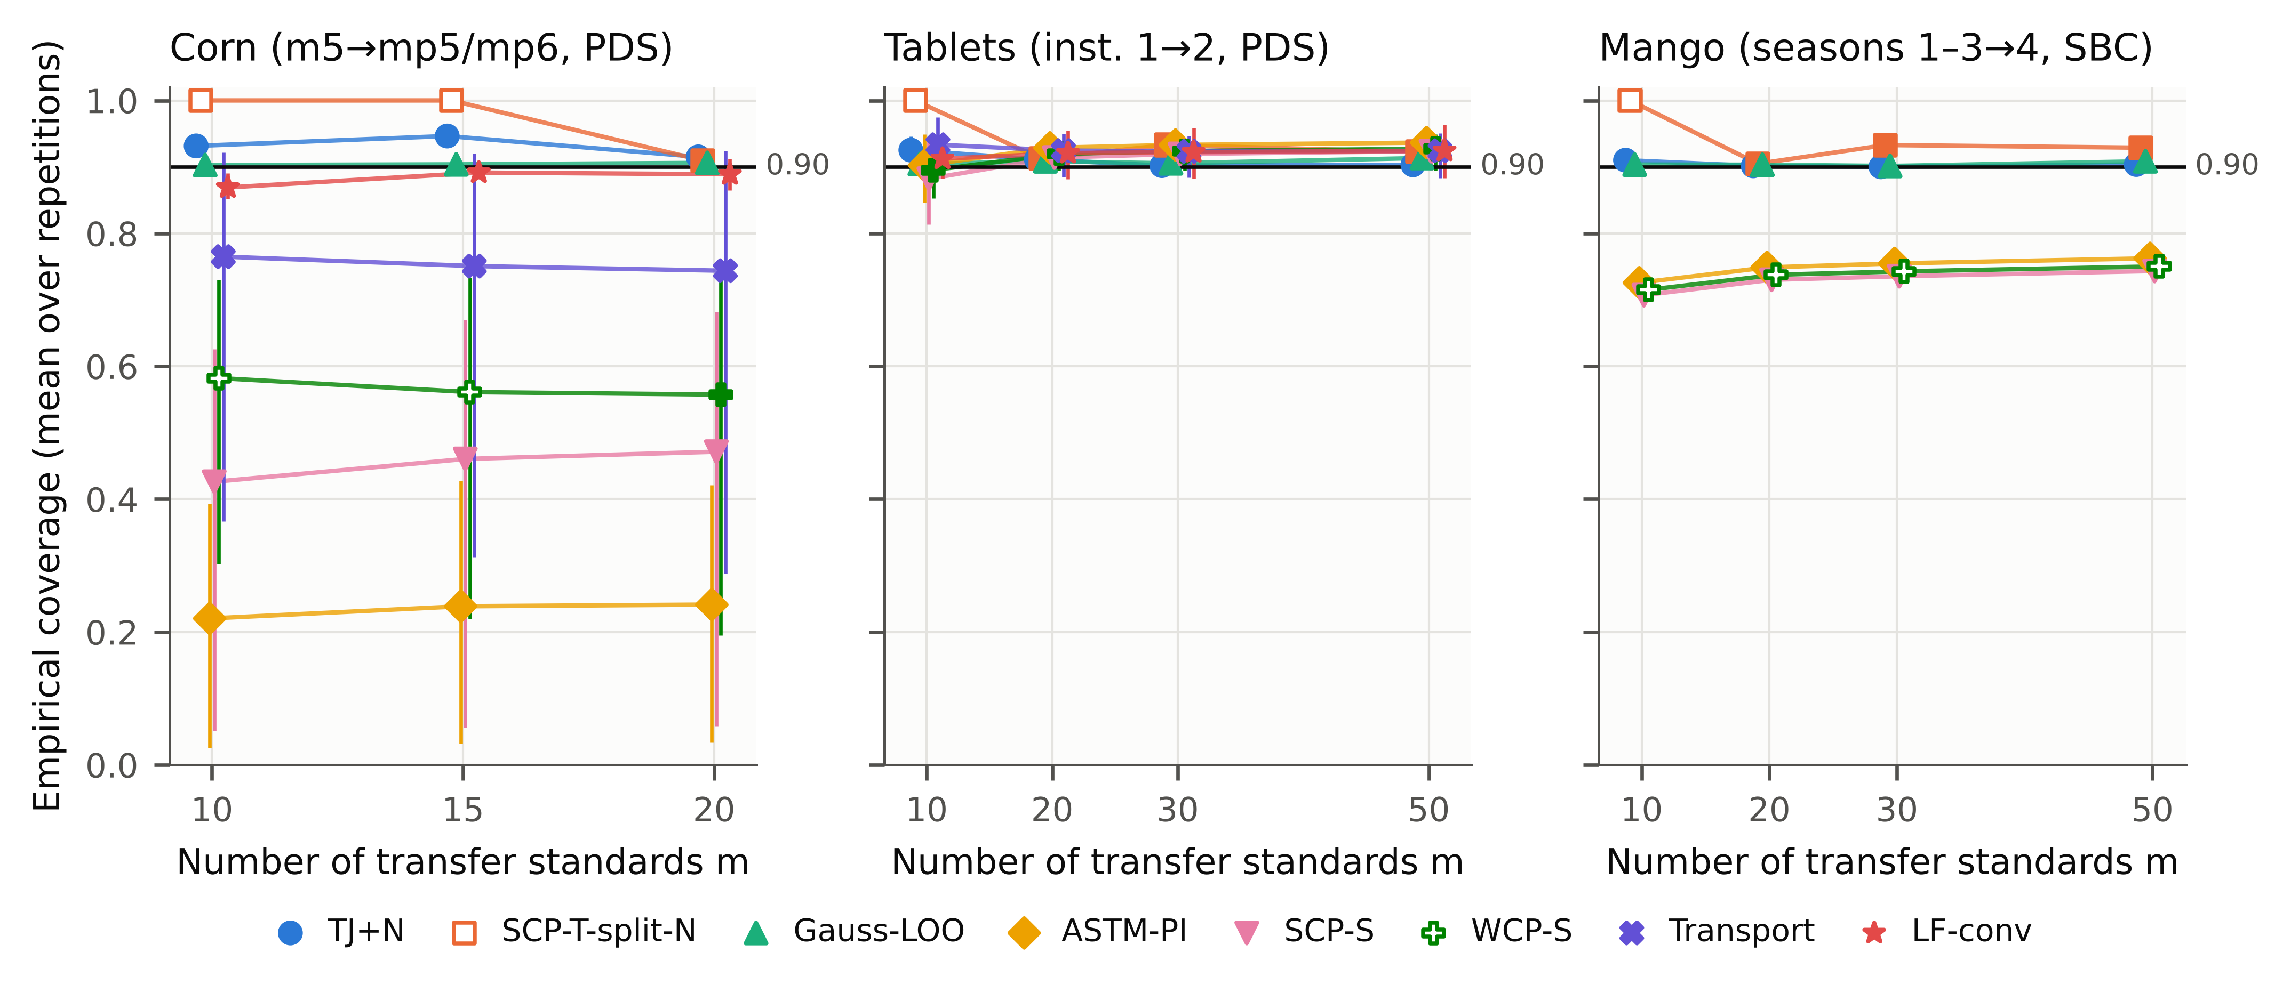
Fig. 3. Coverage of nominal 90% intervals versus the number of standards m when the standards are drawn at random (main pipelines; 500 repetitions for corn and tablets, 300 for mango). Markers: mean over scenarios; lines: range over scenarios; hollow markers: unbounded in more than half of the repetitions. Dashed line: nominal level.

4.2. With randomly chosen standards, the standards are enough
When the standards were a random sample of the target samples, TJ+N held its level everywhere we looked. It was never too narrow in the 40 main scenarios at 90% (Table 2) or 80%. At 95% it was never too narrow either, but in 20 of 40 scenarios it returned an unbounded interval because fewer than 19 standards were available (Supplementary Table S2). Its mean coverage was 0.922 at 90%. The same held across all four transfer pipelines (0 of 152 combinations too narrow), for ridge and 1D-CNN models and the reverse transfer direction (0 of 22 scenarios; Supplementary Table S4), and for the independent transfer between handheld fruit spectrometers (0/72 scenario-level combinations too narrow).
This is what Proposition 1 predicts, and it should be read as a confirmation that the transfer step is the right thing to re-fit rather than as a discovery. It is still worth seeing how close the coverage stays to nominal. The lower end of the 95% confidence interval of coverage was within 0.02 of the nominal level in 192 of 192 scenario-level cases (unbounded intervals counted as covering), so where TJ+N gave an interval it was demonstrably close to target, not merely “not detectably too narrow”. Leaving the standard out matters. Computing the errors from a transfer that had seen all standards (the obvious shortcut) produced intervals that were too narrow in 199 of 528 cases, because a slope and bias fitted on the same standards absorb part of their own errors (Supplementary Table S3).
The alternative that is equally valid, splitting the standards in half, wastes them. With 15 or fewer standards, the half left for calibration was too small for a bounded 90% interval in any repetition (20 of 40 scenarios, all with m ≤ 15). Where both methods gave bounded intervals, TJ+N was narrower in 20 of 20 scenarios.
A laboratory that already has the left-out errors of its standards will naturally try a simpler formula first. We therefore compared TJ+N on identical standards with five such formulas (Table 3; 100 scenario-pipeline combinations, 200 repetitions each): a t-interval from the leave-one-out RMSE (Gauss-LOO), with and without σ(x) scaling; the ASTM formula with the standard error re-estimated on the standards (ASTM-T); for slope/bias correction, the textbook prediction interval of that regression (OLS-PI); and a bootstrap interval (Boot-T).
At 90% most of them did well. Gauss-LOO was too narrow in 2 of 100 combinations, ASTM-T in 1 of 100, and OLS-PI in 2 of 52 slope/bias cases. They were also often narrower. Where both were valid, OLS-PI had the lower interval score in 33 of 50 slope/bias scenarios and TJ+N in 7. The scaled Gaussian interval had the lower score in 81 of 97 (see also Supplementary Table S7). For 90% statements with randomly chosen standards, a Gaussian interval from the left-out errors is therefore a reasonable shortcut, and for slope/bias correction the textbook regression interval is usually the better choice.
At 95% the comparison needs care. TJ+N cannot give a bounded 95% interval with fewer than 19 standards; it was unbounded in 45 of 100 combinations here (and in 20 of 40 of the main scenarios), so “never too narrow” is partly automatic. Restricted to $m≥20$, where TJ+N was bounded, it was too narrow in 0 of 55 combinations, against 16 of 55 for Gauss-LOO, 12 of 55 for ASTM-T and 11 of 29 for OLS-PI. The shortfalls of the formulas were small, though: with $m≥20$, flagged intervals still covered at least 0.92 of the samples (nominal 0.95). Using the same 0.02 margin as for TJ+N, and again $m≥20$, Gauss-LOO was within 0.02 of nominal in 48 of 55 combinations, ASTM-T in 52 of 55 and OLS-PI in 24 of 29. The practical difference at 95% is therefore a few percentage points of coverage at most, not a failure of the simpler methods.
The bootstrap behaved differently. As implemented here (pairs resampling of the standards plus resampled in-sample residuals), it was too narrow in 52 of 100 combinations at 90%, including 19 of 29 scenarios with ten standards. With 10–20 standards, the in-sample residuals understate the error of a new sample. A bootstrap based on leverage-corrected or out-of-sample residuals may do better; we did not test one.
The coverage shortfall of the Gaussian formulas was associated with the shape of the errors. For Gauss-LOO it grew with the skewness of the prediction errors (Spearman ρ = 0.35, p < 0.001) and with the ratio of the actual error to the leave-one-out RMSE (ρ = 0.35, p < 0.001). For OLS-PI it grew with skewness (ρ = 0.54, p < 0.001) and with excess kurtosis (ρ = 0.41, p = 0.002). A t-interval sets its 95% limits from the standard deviation and a normal tail shape, so skewed or heavy-tailed errors are under-covered in the longer tail. TJ+N takes its limits from the empirical distribution of the absolute left-out errors, so it does not rely on a normal tail shape. With 20–50 standards it is also conservative by construction, because the 95% limit is then set by the largest or second-largest left-out error.
Table 3. Simpler interval formulas on identical, randomly chosen standards (200 repetitions per scenario). Each cell: scenarios too narrow at 95%, counted only for m ≥ 20 where TJ+N gives bounded 95% intervals · scenarios too narrow at 90%, all m (number of scenarios in parentheses after the pipeline). OLS-PI applies to slope/bias correction only; Split: half of the standards fit the transfer, half calibrate the interval. Results at 80% and interval scores: Supplementary Table S12.
Data set | Pipeline | TJ+N | Gauss-LOO | Gauss-LOO-N | ASTM-T | OLS-PI | Boot-T | Split
Corn | PDS (24) | 0/8 · 0/24 | 1/8 · 0/24 | 0/8 · 0/24 | 0/8 · 0/24 | – | 2/8 · 3/24 | 0/8 · 0/24
Corn | SBC (24) | 0/8 · 0/24 | 2/8 · 1/24 | 2/8 · 1/24 | 0/8 · 0/24 | 2/8 · 1/24 | 8/8 · 19/24 | 0/8 · 0/24
Tablets | PDS (12) | 0/9 · 0/12 | 4/9 · 0/12 | 1/9 · 1/12 | 3/9 · 0/12 | – | 6/9 · 7/12 | 0/9 · 0/12
Tablets | SBC (12) | 0/9 · 0/12 | 6/9 · 1/12 | 6/9 · 1/12 | 6/9 · 1/12 | 6/9 · 1/12 | 7/9 · 8/12 | 0/9 · 0/12
Mango, season | SBC (4) | 0/3 · 0/4 | 0/3 · 0/4 | 0/3 · 0/4 | 0/3 · 0/4 | 0/3 · 0/4 | 3/3 · 4/4 | 0/3 · 0/4
Mango, instruments | PDS (12) | 0/9 · 0/12 | 0/9 · 0/12 | 0/9 · 0/12 | 0/9 · 0/12 | – | 0/9 · 0/12 | 0/9 · 0/12
Mango, instruments | SBC (12) | 0/9 · 0/12 | 3/9 · 0/12 | 4/9 · 0/12 | 3/9 · 0/12 | 3/9 · 0/12 | 9/9 · 11/12 | 0/9 · 0/12

4.3. Where the standards come from matters more than how many there are
The results so far assume that the standards are a random sample of everything the instrument will measure later. In a packhouse this is rarely true. The fruit used to adapt a new handheld unit are typically picked from one or two consignments on the day of installation, and the unit is then used on consignments that arrive weeks later. We reproduced this on the mango data, which record each fruit’s consignment, in eight setting-pipeline combinations: the season shift with SBC and without transfer, and the three handheld-instrument pairs with PDS and SBC. These eight combinations are not independent. They come from one product, the instrument pairs share the master unit and some consignments, and the two pipelines of a pair share their standards. The errors of the transferred predictors were clearly correlated within consignments: the intra-consignment correlation averaged 0.46–0.60 over the combinations.
Table 4, Fig. 4 and Supplementary Table S11 show the coverage for fruit from consignments that supplied no standards. With 20 standards taken from only two consignments, TJ+N was too narrow in 6 of 8 combinations, with coverage between 0.67–0.91 for a nominal 0.90. Several alternatives failed as well. Gaussian intervals from the same left-out errors were too narrow in 8 of 8 combinations, the split-standards interval in 8 of 8, CV+ with consignments as folds but every fruit counted as a separate unit in 4 of 8, and the intervals carried over from the source calibration in all of them.
The shortfall was largest for slope/bias correction (Supplementary Table S11). A plausible reason is that a slope and offset fitted on two consignments absorb part of those consignments’ own bias, so their left-out errors underestimate how different the next consignment will be. For the remaining fruit of the two sampled consignments, the same TJ+N intervals were accurate (coverage 0.91–0.93).
Spreading the 20 standards over more consignments reduced the problem. TJ+N was too narrow in 4 of 8 combinations with 5 × 4 standards, and in 3 of 8 with 10 × 2. With one fruit from each of 20 consignments, available for the instrument pairs only, it was too narrow in none (0 of 6), as Appendix B predicts. The 15 × 1 design, the only one-per-consignment design possible for the season shift, uses 15 standards. It also showed no under-coverage (0 of 8), but its coverage of 0.93–0.98 is inflated by the rank rule, because with 15 standards the 90% limit is the largest left-out error. We had expected the intra-consignment correlation to explain which combinations failed. It did not (Spearman ρ = 0.52, p = 0.18 across the eight combinations with two consignments; Supplementary Fig. S6): the correlation was high everywhere, and the number of consignments decided the outcome.
The methods that treat the consignment as the unit held their level. TJ+B was never too narrow where it gave a bounded interval (0 of 22 combinations at 90%, 0 of 30 at 80%, 0 of 6 at 95%; coverage 0.90–0.98 at 90%). With fewer than nine consignments it gives no finite 90% interval. With 10 × 2 standards its intervals were wider than those of TJ+N (median width ratio 1.38). With one fruit per consignment the two methods are identical. At 90% and 95%, the max-score variant TJ+G gave exactly the same intervals as TJ+B in these designs; at 80% its coverage was up to 0.04 higher.
The simplest batch-aware option worked as well. A t-interval built from leave-one-consignment-out errors, with K − 1 degrees of freedom (Gauss-LGO), was too narrow in 0 of 38 of the random-design combinations at 90%. It has no distribution-free guarantee, and with two consignments its t factor made it 5.3 times wider than TJ+N. From five consignments onwards its width was reasonable (width ratio to TJ+N 1.27–1.65 with 5 × 4, 1.02–1.33 with 10 × 2). The classical random-effects interval for a new batch (ANOVA-PI), computed from the same leave-one-consignment-out errors, did similarly. It was too narrow in 2 of 8 combinations with 2 × 10 standards and in none with five or more consignments (0 of 8 with 5 × 4, 0 of 8 with 10 × 2), with widths 1.22–1.58 times those of TJ+N with 5 × 4 standards. In these data, the classical batch-aware formulas therefore did as well as TJ+B, and they gave bounded intervals from fewer consignments. What TJ+B adds is a coverage guarantee that does not depend on normal errors, at the price of needing at least nine consignments. The common message of these results is that the standards must be left out consignment by consignment when the errors are estimated. Which formula is then applied to those errors matters less, as long as it accounts for the small number of consignments.
The chronological design is the least favourable case. Its standards came from the five earliest consignments, and it was tested on everything harvested later: weeks later in the season setting, and in later seasons for the instrument pairs, partly from other regions and cultivars. TJ+N was too narrow in 3 of 8 combinations, Gauss-LOO in 7 of 8, ANOVA-PI in 4 of 8, Gauss-LGO in 1 of 8 and the source-based ASTM interval in 8 of 8. TJ+B could not give a bounded 90% interval from five consignments. At the 80% level, where five consignments are enough, it covered 0.89–1.00 of the later fruit. This design uses a single, fixed set of consignments per setting, so it is one case study rather than a general result. No guarantee covers standards taken only from the start of a season.
For a laboratory the conclusion is cheap to act on. The cost of a transfer lies in the reference analyses, and those cost the same whether 20 fruit come from 2 consignments or from 20. In these data, taking one or two samples from each of many consignments gave intervals that remained valid for new consignments, while taking many samples from a few did not. We expect the same for other products that arrive in lots, but we could not test this.
Table 4. Coverage of nominal 90% intervals for fruit from consignments that supplied no standards, by how the standards were spread over consignments (mean over the setting-pipeline combinations, 300 repetitions each; in parentheses: combinations flagged as too narrow / combinations). The instrument settings alone have the 20 × 1 design. TJ+B: leave-one-consignment-out (hierarchical) jackknife+; Split: half the standards for transfer, half for calibration; LGO-CV+N: CV+ with consignments as folds but fruit as units; Gauss-LGO and ANOVA-PI: Gaussian and random-effects intervals from leave-one-consignment-out errors. The first four methods treat samples as the unit, the last four consignments.
Consignments × fruit | TJ+N | Gauss-LOO | Split | ASTM-PI | TJ+B | LGO-CV+N | Gauss-LGO | ANOVA-PI
2 × 10 | 0.80 (6/8) | 0.74 (8/8) | 0.80 (8/8) | 0.55 (8/8) | unbounded | 0.90 (4/8) | 0.99 (0/8) | 0.90 (2/8)
5 × 4 | 0.87 (4/8) | 0.85 (7/8) | 0.87 (4/8) | 0.58 (8/8) | unbounded | 0.92 (2/8) | 0.94 (0/8) | 0.92 (0/8)
10 × 2 | 0.90 (3/8) | 0.89 (5/8) | 0.90 (1/8) | 0.59 (8/8) | 0.96 (0/8) | 0.92 (0/8) | 0.92 (0/8) | 0.92 (0/8)
15 × 1 | 0.95 (0/8) | 0.91 (0/8) | unbounded | 0.59 (8/8) | 0.95 (0/8) | 0.95 (0/8) | 0.91 (0/8) | 0.92 (0/8)
20 × 1 | 0.92 (0/6) | 0.91 (0/6) | 0.91 (0/6) | 0.57 (6/6) | 0.92 (0/6) | 0.92 (0/6) | 0.91 (0/6) | 0.92 (0/6)
chronological 5 × 4 | 0.87 (3/8) | 0.81 (7/8) | 0.87 (3/8) | 0.55 (8/8) | unbounded | 0.91 (2/8) | 0.92 (1/8) | 0.88 (4/8)
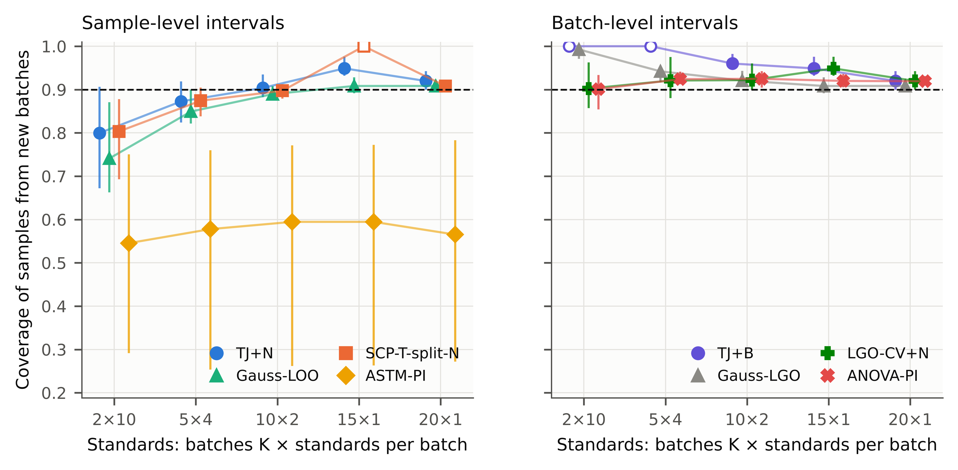
Fig. 4. Coverage of nominal 90% intervals for mango fruit from consignments that supplied no standards, as a function of how 20 (or 15) standards were spread over consignments. Markers: mean over the setting-pipeline combinations; lines: range. Hollow markers: unbounded intervals. Left: methods that treat samples as the unit; right: methods that treat consignments as the unit. Dashed line: nominal level.

4.4. What this means for a harvest decision
To see what interval validity means in practice, we used the mango data for the task the handheld instruments are bought for: deciding whether fruit have reached the 14% dry matter recommended at harvest [12]. This case study was added after the batch results were known (deviation R2 in the protocol). It translates those results into decision terms and is not an independent test.
Each test fruit came from a consignment that had supplied no standards. A fruit was passed as mature if the lower limit of its 90% interval was at least 14%, and referred for re-measurement if the interval contained 14%. The reference was the simplest rule, passing every fruit whose predicted value is at least 14%. We report slope/bias correction, which predicted these fruit with an RMSEP of 1.1–1.2% dry matter (Table 5, Fig. 5). PDS between the handheld units was not usable for this purpose (RMSEP 3.0–5.4%), and its results are in Supplementary Table S14. About 22% of the test fruit were below 14%.
Deciding on the predicted value alone passed 36% of the immature fruit (range over settings 31%–42%). Intervals taken over from the original calibration reduced this to 7.0%. Intervals rebuilt from the reference fruit reduced it further, and here the sampling of the reference fruit mattered more than the formula. With reference fruit from two consignments, TJ+N passed 9.8% of the immature fruit and the Gaussian interval 10%. With the same number spread over ten consignments, the rates were 3.2% and 3.2%. The two interval formulas behaved almost identically at this level, so the case study does not favour TJ+N over a Gaussian interval. What it shows is the cost of drawing the reference fruit from too few consignments: 3.1 times as many immature fruit passed with TJ+N. The leave-one-consignment-out TJ+B passed 1.4% with ten consignments. With two consignments it referred every fruit, because a bounded 90% interval requires at least nine consignments.
The price of these decisions is the share of fruit that needs a second look: 49% with TJ+N and 58% with TJ+B, for ten consignments. A cruder alternative would be to add a fixed guard band to the threshold, for example passing fruit only if the prediction exceeds 14% by one RMSE. That would also reduce the share of immature fruit passed, but its error rate cannot be set in advance. A valid interval provides the same kind of margin, with a width chosen to give the stated coverage for each fruit. Neither can make a single NIR reading more precise; for fruit close to the threshold a second measurement is the only remedy.
Table 5. Harvest-maturity screening of mango at 14% dry matter with 90% intervals, slope/bias correction, for fruit from consignments that supplied no standards. Immature passed: percentage of truly immature fruit (DM < 14%) declared mature, mean (range) over the season shift and the three handheld-instrument pairs; referred: percentage of all fruit whose interval contains 14%. Designs: consignments × fruit per consignment (20 × 1: instrument pairs only). 200 repetitions. PDS results: Supplementary Table S14.
Rule | 2 × 10: immature passed | 2 × 10: referred | 10 × 2: immature passed | 10 × 2: referred | 20 × 1: immature passed | 20 × 1: referred
Point rule (ŷ ≥ 14%) | 40.5 (31.5–44.5) | 0 | 36.3 (31.2–41.5) | 0 | 35.0 (27.6–39.7) | 0
ASTM-PI (original calibration) | 10.9 (8.2–12.4) | 34 | 7.0 (4.3–9.9) | 36 | 7.8 (5.0–9.9) | 39
Gauss-LOO | 10.1 (7.8–12.8) | 37 | 3.2 (0.9–5.8) | 47 | 3.4 (1.8–4.6) | 52
TJ+N | 9.8 (7.8–11.5) | 38 | 3.2 (1.1–5.0) | 49 | 3.5 (1.9–4.5) | 55
TJ+B (leave one consignment out) | 0.0 (0.0–0.0) | 100 | 1.4 (0.3–2.4) | 58 | 3.5 (1.9–4.5) | 55
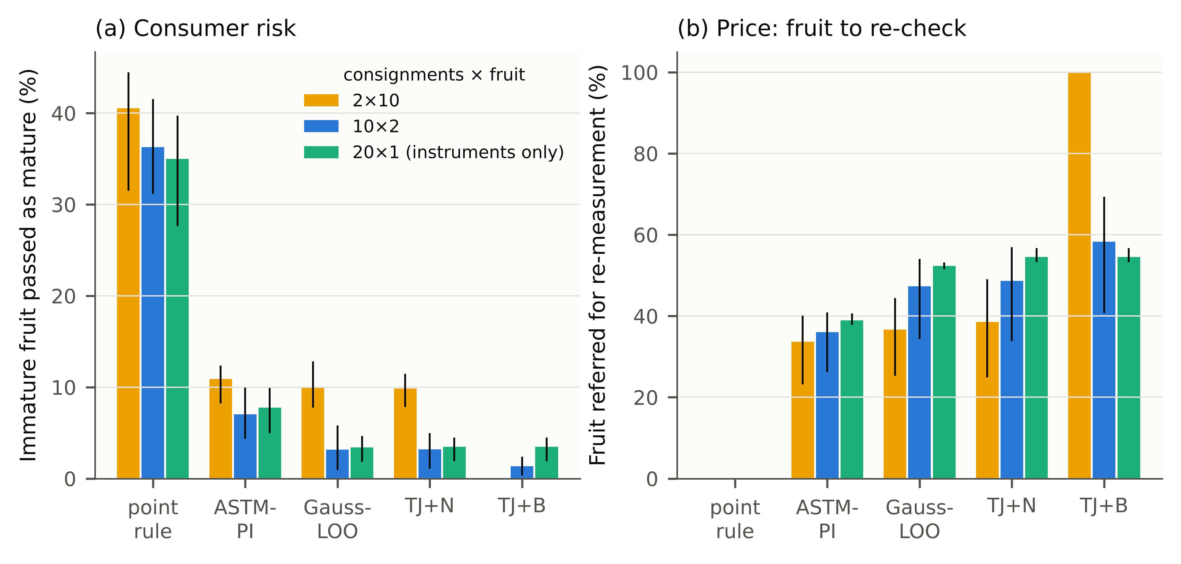
Fig. 5. Harvest-maturity screening at 14% dry matter with slope/bias correction, for fruit from consignments without standards. (a) Share of immature fruit passed as mature; (b) share of fruit referred for re-measurement because the 90% interval contains 14%. Bars: mean over the season shift and the three handheld-instrument pairs; lines: range. Colours: how 20 reference fruit were spread over consignments.

4.5. What the intervals cannot do
Two further situations break the exchangeability on which every method here relies, and they are worth knowing before the intervals are used.
Selecting standards by design. Kennard–Stone selection picks standards that span the target population, so they are not a random sample. In our tests it made TJ+N conservative (coverage 0.93–0.96), because extreme standards produce larger left-out errors than typical samples. This is reassuring for a common practice, but it is an observation, not a guarantee.
Drift after standardisation. A shift of the routine spectra by one wavelength channel after the transfer had been fitted simulates an instrument that drifts between set-up and use. Under this shift no interval method remained valid (Fig. 6; Supplementary Table S5). On tablets, TJ+N covered only 0.04–0.07 of the samples. On corn and mango the $Q$ residual in the difficulty scaling caught much of the damage (TJ+N 0.60–0.94 and 0.73–0.97, against 0.02–0.29 and 0.07–0.21 for Gaussian intervals). Even a quarter-channel shift left TJ+N too narrow in 4/12 combinations (Supplementary Table S8). Spectral drift must therefore be monitored, for example through the $Q$ residual or periodic check samples, and the transfer repeated when it appears; an interval computed at set-up time cannot absorb it.
Added spectral noise and halving the source data did not cause under-coverage (0 of 30 robustness scenarios without drift). Neither did changing the PDS window or the number of PLS components (0 of 27; Supplementary Table S9), although these settings changed the prediction error considerably. Poorer transfer settings simply produced wider intervals.
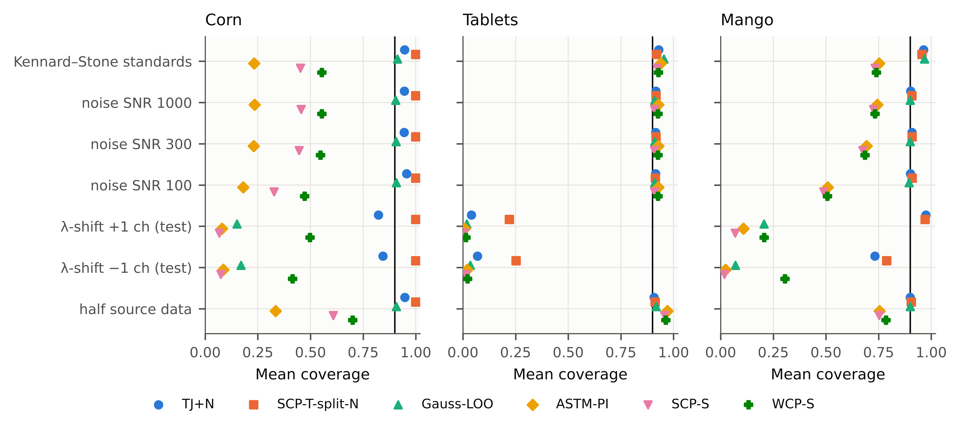
Fig. 6. Coverage of nominal 90% intervals under Kennard–Stone selection of the standards, added spectral noise, a ±1-channel wavelength shift of the routine spectra after standardisation, and halved source data. Results for a ±0.25-channel shift are in Supplementary Table S8.

4.6. Cost and use in routine work
TJ+N needs m extra fits of the transfer step, carried out once, when the instrument is set up. A PDS fit with prediction took 4.6 ms for corn and 24.3 ms for tablets on one CPU core. The complete interval computation took 0.15 s, 2.79 s and 0.06 s for corn, tablets and mango (Supplementary Table S10). In routine use, each new spectrum is passed through the m stored transfers, which is negligible for any laboratory computer. The leave-one-batch-out version needs only K fits and is cheaper still.

4.7. A procedure for the laboratory
For someone who transfers an NIR calibration and must report results with an uncertainty range, the results suggest the following procedure:
- Do not reuse the uncertainty formula of the original calibration after a change of instrument or season. Re-establish it on the new instrument.
- Collect the reference samples for the transfer from as many different batches as practical, ideally one or two per batch. A distribution-free 90% statement for future batches (TJ+B) needs at least nine batches; the Gaussian and random-effects batch formulas worked from five batches in our data. In our data, twenty samples from twenty consignments served far better than twenty from two, at the same cost in reference analyses.
- Fit the transfer as usual. Then re-fit it with each standard left out, or each batch left out if several standards share a batch, and build the interval of Eq. (3) from the left-out errors. A t-interval or a random-effects interval from the leave-one-batch-out errors are simpler alternatives that worked as well in our data, although without a distribution-free guarantee.
- For 90% statements with standards from many batches, a Gaussian interval from the leave-one-out RMSE (or, for slope/bias correction, the regression prediction interval) is a reasonable shortcut. For 95% statements these formulas fell one or two points short in some scenarios, and TJ+N needs at least 19 standards.
- Monitor the instrument after set-up, as described in Section 4.5.

4.8. Relation to measurement uncertainty
The intervals studied here are prediction intervals for the reference value of an individual routine sample. In method-validation terms they are β-expectation tolerance intervals [18,19]. Their width therefore contains everything that separates the NIR result from the reference method: reference-method error, spectral noise, model error and the error added by the transfer. They are not a GUM-type uncertainty budget, in which components are estimated separately and propagated. Instead, they provide an empirical check that the transferred method meets a stated coverage. Error-propagation methods for multivariate calibration [13–15] give sample-specific uncertainties, but they rest on the original calibration’s error model, which Section 4.1 shows no longer applies after transfer.
The guarantee is an average over possible sets of standards. For a single transfer, the realised coverage on the following samples varies. Across the main scenarios (m = 10–50 random standards; test sets of 10–700 samples), a median of 0.88 of the standard sets gave a realised coverage of at least 0.85 on their test samples. In the least favourable scenario the share was 0.74 (Supplementary Table S13). The Gaussian intervals reached 0.82. Statements about one particular set of standards (β-content intervals in validation terms) cannot be guaranteed by the jackknife+ in general [46], unless the fitting procedure is stable in a quantifiable sense [47]. A laboratory that needs them should use more standards, or a lower α, and re-check coverage on fresh samples.

4.9. Limitations
The evidence comes from three public data sets. The batch results, which carry the main practical finding, come from one product (mango), in one season shift and on three handheld-instrument pairs. These eight combinations share a product, a master instrument, consignments and standards, and are closer to two independent settings than to eight. We found no other public NIR transfer data set that records lots. Whether the findings carry over to pharmaceutical production lots or grain deliveries is therefore a conjecture to be tested.
The batches used as standards were drawn at random from the available consignments, which is more favourable than many real set-ups, and the bootstrap intervals are conditional on those consignments. The chronological design is a single configuration per setting. The 15 × 1 design used 15 rather than 20 standards, because the season shift has only 18 consignments.
The noise, wavelength-drift and Kennard–Stone experiments are simulations on real spectra. Only PLS, ridge and a small CNN were tested as models, and PDS, DS and SBC as transfer methods. The bootstrap competitor used in-sample residuals; other bootstrap schemes were not tested. Domain-adaptation methods that use no reference values cannot be covered by this approach, because it needs reference values for the standards. An exploratory label-free variant under-covered in 20 of 36 scenarios (Table 2). The harvest case study was designed after the batch results were known. Finally, every guarantee here is marginal and assumes a stable instrument between set-up and use.

5. Conclusions
Moving an NIR calibration to a new instrument or season breaks its old uncertainty statement. In our data, nominal 90% intervals carried over from the original calibration covered as few as 0.03 of the reference values. The reference samples used for the transfer are enough to restore a valid statement, without measuring anything extra, if the transfer is re-fitted with each of them left out in turn and the left-out errors are used to set the interval. This takes seconds. With randomly chosen standards, simple Gaussian and regression intervals built from the same left-out errors were nearly as good at 90%, so the main benefit of the jackknife+ is its guarantee and its behaviour at 95%.
How the reference samples are collected turned out to matter more than the formula. Intervals built from samples of a few consignments were accurate for those consignments but too narrow for new ones, whichever sample-level formula was used. Spreading the same number of reference samples over many consignments, or leaving out whole consignments when estimating the errors, gave intervals that held for new consignments. In a harvest-maturity check of mango, intervals from well-spread reference fruit reduced the share of immature fruit passed as mature from 36% (predicted value alone) to 3.2%, at the cost of referring about half of the fruit for a second measurement.
For laboratories this leads to a rule that costs nothing: collect transfer standards from as many batches as possible, and estimate the interval from errors obtained by leaving them out one at a time, or one batch at a time.

Declarations
CRediT authorship contribution statement. [Author 1]: Conceptualization, Methodology, Software, Formal analysis, Writing – original draft. [Author 2]: Supervision, Validation, Writing – review & editing. (To be completed by the authors.)
Declaration of competing interest. The authors declare that they have no known competing financial interests or personal relationships that could have appeared to influence the work reported in this paper.
Declaration of generative AI and AI-assisted technologies in the writing process. During the preparation of this work the authors used an AI assistant (Claude, Anthropic) for literature search support, code development, data analysis and drafting of the manuscript. After using this tool, the authors reviewed and edited the content as needed and take full responsibility for the content of the publication.
Funding. [To be completed by the authors.]
Data availability. All data sets are public: corn and IDRC Shootout 2002 tablets from Eigenvector Research [36], and mango dry matter from Mendeley Data (record version 1, doi:10.17632/46htwnp833.1 [38]; record version 6, doi:10.17632/46htwnp833.6 [39]). All code, configuration files, raw per-repetition results and the scripts that regenerate every table and figure are available at [repository URL / archived DOI to be inserted].
Acknowledgements. We thank the providers of the public data sets: Cargill and Eigenvector Research (corn), the International Diffuse Reflectance Conference (Shootout 2002), and N. Anderson, K. Walsh, P. Subedi and J. Walsh (mango).

Appendix A. Proof of Proposition 1
Setting. Let $Z_{1},…,Z_{m}$ be the transfer standards and $Z_{m+1}=\left(x_{m+1}^{T},x_{m+1}^{S},y_{m+1}\right)$ the future sample. Its master spectrum $x_{m+1}^{S}$ is never used by the procedure; it enters only the argument, as the spectrum the sample would give on the master instrument. For any index set $S⊆\{1,…,m+1\}$, let $μ_{S}$ and $σ_{S}$ be the deployed predictor (Eq. (1)) and the difficulty function obtained by applying the transfer algorithm $T$ to $\{Z_{k}:k∈S\}$. The source model $f$ and the function $σ$ of Eq. (4) are fixed beforehand from source data. $T$ is symmetric, i.e. invariant to the order of its inputs; this holds for PDS, DS and SBC, which are least-squares fits on the set of standards. Because $σ≥ε>0$, all normalised scores are well defined.
Step 1 (scores). For $i≠j$, write $−ij$ for the set $\{1,…,m+1\}∖\{i,j\}$ and define
$$R_{ij}=\frac{\left|y_{i}−μ_{−ij}\left(x_{i}^{T}\right)\right|}{σ_{−ij}\left(x_{i}^{T}\right)}.$$
The fit that excludes $i$ and $m+1$ is exactly the leave-one-out fit $μ_{−i}$ of Eq. (2), computed from the $m$ standards without standard $i$. Hence $R_{i}=R_{i,m+1}$, and for the future sample $\left|y_{m+1}−μ_{−i}\left(x_{m+1}^{T}\right)\right|/σ_{−i}\left(x_{m+1}^{T}\right)=R_{m+1,i}$.
Step 2 (miscoverage implies many lost comparisons). Let $U_{i}=μ_{−i}\left(x\right)+σ_{−i}\left(x\right)R_{i}$ and $L_{i}=μ_{−i}\left(x\right)−σ_{−i}\left(x\right)R_{i}$ with $x=x_{m+1}^{T}$.
- Upper tail. If $y_{m+1}$ exceeds the upper bound in Eq. (3), the $⌈\left(1−α\right)\left(m+1\right)⌉$-th smallest $U_{i}$, then $y_{m+1}>U_{i}$ for at least $\left(1−α\right)\left(m+1\right)$ indices $i$.
- Lower tail. If $y_{m+1}$ is below the lower bound, the $k$-th smallest $L_{i}$ with $k=⌊α\left(m+1\right)⌋$, then $y_{m+1}<L_{i}$ for at least $m−k+1≥\left(1−α\right)\left(m+1\right)$ indices.
In both cases $\left|y_{m+1}−μ_{−i}\left(x\right)\right|/σ_{−i}\left(x\right)>R_{i}$, i.e. $R_{m+1,i}>R_{i,m+1}$, for at least $\left(1−α\right)\left(m+1\right)$ indices. Therefore
{ym+1∉Cxm+1T}⊆i≤m​1[Rm+1,i>Ri,m+1]≥1−αm+1.
Step 3 (tournament bound). Call a point $j∈\{1,…,m+1\}$ strange if i≠j​1[Rji>Rij]≥1−αm+1. By the counting lemma in the proof of Theorem 1 of Barber et al. [29], at most $2α\left(m+1\right)$ points can be strange, for any realisation of the scores.
Step 4 (exchangeability). The $Z_{k}$ are exchangeable and $T$ is symmetric. Hence the joint law of the matrix $\left(R_{ij}\right)$ is invariant under a simultaneous permutation of rows and columns, and every point is equally likely to be strange. Thus $Pr\{Z_{m+1}\text{ strange}\}=E[N_{\text{strange}}]/\left(m+1\right)≤2α$. Combining with Step 2 gives $Pr\{y_{m+1}∉\hat{C}\}≤2α$. $▫$
Remarks.
- The normalisation enters only through the definition of the scores. Steps 2–4 hold for any score of the form $\left|y_{i}−μ_{−ij}\left(x_{i}\right)\right|/σ_{−ij}\left(x_{i}\right)$ with $σ>0$, provided the pair $\left(μ,σ\right)$ is produced by a symmetric algorithm.
- Fitting the transfer on all $m$ standards and reusing it to compute residuals (TJ-insample) breaks Step 1: the residual of standard $i$ is then computed with a fit that has seen $i$, and the exchangeability with the future sample’s residual is lost. The resulting under-coverage is observed in Section 4.2.
- Ties between scores have probability zero for continuous data; with ties, the strict inequalities in Step 2 make the interval only more conservative.
- If the standards are chosen by a data-dependent design such as Kennard–Stone, they are no longer exchangeable with a random future sample, and Step 4 does not apply.

Appendix B. Batch-level validity (Proposition 2)
Setting. The target population consists of batches (production lots, harvest consignments). Let $B_{1},…,B_{K+1}$ be batches drawn so that they are exchangeable, for example at random from the population of batches. Within batch $k$, let $Z_{k1},…,Z_{kn_{g}}$ be drawn so that, conditionally on the batch, they are exchangeable, for example at random from the batch. The standards are the $Kn_{g}$ samples of batches $1,…,K$. The future routine sample is $Z_{K+1,1}$. The other members of batch $K+1$ are hypothetical and are used only in the argument.
The transfer algorithm $T$ is symmetric in its input samples. For index sets of batches $S$, write $μ_{S},σ_{S}$ for the deployed predictor and difficulty function fitted on the standards of the batches in $S$. For $k≠l$, let $−kl$ denote all batches except $k$ and $l$.
Proposition 2 (TJ+G). Define the batch scores
$$S_{kl}=\max_{j≤n_{g}}\frac{\left|y_{kj}−μ_{−kl}\left(x_{kj}^{T}\right)\right|}{σ_{−kl}\left(x_{kj}^{T}\right)}, S_{k}=S_{k,K+1},$$
and the interval
$${\hat{C}}_{G}\left(x\right)=[{\hat{q}}_{α}^{−}\{μ_{−k}\left(x\right)−σ_{−k}\left(x\right)S_{k}\}, {\hat{q}}_{α}^{\text{+}}\{μ_{−k}\left(x\right)+σ_{−k}\left(x\right)S_{k}\}],$$
where the quantiles are taken over the $K$ batches with the ranks of Eq. (3) ($m$ replaced by $K$). Then $Pr\{y_{K+1,1}∈{\hat{C}}_{G}\left(x_{K+1,1}^{T}\right)\}≥1−2α$.
Proof. Let $x=x_{K+1,1}^{T}$.
- Step 1 (miscoverage implies lost comparisons). If $y_{K+1,1}∉{\hat{C}}_{G}\left(x\right)$, the argument of Appendix A, Step 2 gives
$$\left|y_{K+1,1}−μ_{−k}\left(x\right)\right|/σ_{−k}\left(x\right)>S_{k,K+1}$$
- for at least $\left(1−α\right)\left(K+1\right)$ batches $k$.
- Step 2 (bound by the batch score). Since $μ_{−k}=μ_{−\left(K+1\right),k}$ is fitted without batches $k$ and $K+1$, the left-hand side is one of the terms of the maximum defining $S_{K+1,k}$. Hence $S_{K+1,k}>S_{k,K+1}$ for at least $\left(1−α\right)\left(K+1\right)$ indices, i.e. batch $K+1$ is strange in the sense of Appendix A, Step 3.
- Step 3 (exchangeability). $S_{kl}$ is a symmetric function of the members of batch $k$. The batches are exchangeable and $T$ is symmetric, so the law of the matrix $\left(S_{kl}\right)$ is invariant under simultaneous permutations of the batch indices.
- Step 4 (counting). The tournament lemma of Barber et al. [29] bounds the expected number of strange batches by $2α\left(K+1\right)$. Therefore $Pr\{\text{batch }K+1\text{ strange}\}≤2α$. $▫$
Remarks.
- One standard per batch. With $n_{g}=1$, TJ+G coincides with TJ+. Ordinary TJ+ is therefore valid for samples from new batches when every standard comes from a different, randomly drawn batch.
- The hierarchical jackknife+. The hierarchical jackknife+ of Lee, Barber & Willett [30] uses the same leave-one-batch-out fits. It weights each member score by $1/\left(\left(K+1\right)n_{k}\right)$ and places a mass $1/\left(K+1\right)$ at $±∞$, with the same $1−2α$ guarantee. TJ+B (Section 2.4) is its instantiation for the transfer step. It can be less conservative than the maximum score of TJ+G when $n_{g}>1$; in our designs this happened only at $α=0.20$. We use TJ+B as the primary batch-level construction and claim no new conformal methodology.
- Number of batches. Both constructions give finite bounds only if $⌈\left(1−α\right)\left(K+1\right)⌉≤K$, i.e. $K≥9$ batches at $α=0.10$, $K≥19$ at $α=0.05$ and $K≥4$ at $α=0.20$, whatever the number of standards per batch. The number of distinct batches, not the number of standards, determines whether a distribution-free statement for new batches can be made.
- Samples from batches that supplied standards. For routine samples from such batches, neither construction is tailored. Prediction sets for a new observation from an already observed group have been studied for hierarchical models [31] and are not pursued here.

References
[1] C. Pasquini, Near infrared spectroscopy: A mature analytical technique with new perspectives – A review, Analytica Chimica Acta 1026 (2018) 8–36. https://doi.org/10.1016/j.aca.2018.04.004.
[2] Yongdong. Wang, D.J. Veltkamp, B.R. Kowalski, Multivariate instrument standardization, Analytical Chemistry 63 (1991) 2750–2756. https://doi.org/10.1021/ac00023a016.
[3] E. Bouveresse, D.L. Massart, Improvement of the piecewise direct standardisation procedure for the transfer of NIR spectra for multivariate calibration, Chemometrics and Intelligent Laboratory Systems 32 (1996) 201–213. https://doi.org/10.1016/0169-7439(95)00074-7.
[4] R.N. Feudale, N.A. Woody, H. Tan, A.J. Myles, S.D. Brown, J. Ferré, Transfer of multivariate calibration models: a review, Chemometrics and Intelligent Laboratory Systems 64 (2002) 181–192. https://doi.org/10.1016/S0169-7439(02)00085-0.
[5] J.J. Workman, A Review of Calibration Transfer Practices and Instrument Differences in Spectroscopy, Applied Spectroscopy 72 (2018) 340–365. https://doi.org/10.1177/0003702817736064.
[6] R. Nikzad-Langerodi, W. Zellinger, E. Lughofer, S. Saminger-Platz, Domain-Invariant Partial-Least-Squares Regression, Analytical Chemistry 90 (2018) 6693–6701. https://doi.org/10.1021/acs.analchem.8b00498.
[7] P. Mishra, R. Nikzad-Langerodi, Partial least square regression versus domain invariant partial least square regression with application to near-infrared spectroscopy of fresh fruit, Infrared Physics & Technology 111 (2020) 103547. https://doi.org/10.1016/j.infrared.2020.103547.
[8] V. Fonseca Diaz, J.-M. Roger, W. Saeys, Unsupervised dynamic orthogonal projection. An efficient approach to calibration transfer without standard samples, Analytica Chimica Acta 1225 (2022) 340154. https://doi.org/10.1016/j.aca.2022.340154.
[9] Z. Xie, X. Chen, J.-M. Roger, S. Ali, G. Huang, W. Shi, Calibration transfer via filter learning, Analytica Chimica Acta 1298 (2024) 342404. https://doi.org/10.1016/j.aca.2024.342404.
[10] X. Fan, L. Gao, J. Lv, B. Li, K. Xu, X. Li, Y. Shao, T. Yang, X. Chen, H. Ji, A systematic calibration transfer and quantification method based on principal components extreme learning machine for near-infrared spectroscopy, Analytica Chimica Acta 1361 (2025) 344151. https://doi.org/10.1016/j.aca.2025.344151.
[11] X. Huang, X. Chen, G. Huang, Z. Xie, W. Shi, X. Chen, L. Yuan, P. Liang, J. Zhu, Y. He, UCT-LMIR: A standard-free unsupervised calibration transfer method without model recalibration, Analytica Chimica Acta 1423 (2026) 346104. https://doi.org/10.1016/j.aca.2026.346104.
[12] N. Ainsworth, Quality standards, refinement and testing, Horticulture Innovation Australia Limited, Sydney, 2016. https://era.dpi.qld.gov.au/id/eprint/6544/.
[13] K. Faber, B.R. Kowalski, Propagation of measurement errors for the validation of predictions obtained by principal component regression and partial least squares, Journal of Chemometrics 11 (1997) 181–238. https://doi.org/10.1002/(SICI)1099-128X(199705)11:3<181::AID-CEM459>3.0.CO;2-7.
[14] A.C. Olivieri, N.M. Faber, J. Ferré, R. Boqué, J.H. Kalivas, H. Mark, Uncertainty estimation and figures of merit for multivariate calibration (IUPAC Technical Report), Pure and Applied Chemistry 78 (2006) 633–661. https://doi.org/10.1351/pac200678030633.
[15] F. Allegrini, P.D. Wentzell, A.C. Olivieri, Generalized error-dependent prediction uncertainty in multivariate calibration, Analytica Chimica Acta 903 (2016) 51–60. https://doi.org/10.1016/j.aca.2015.11.028.
[16] ASTM International, ASTM E1655-17, Standard Practices for Infrared Multivariate Quantitative Analysis, ASTM International, West Conshohocken, PA, 2017. https://doi.org/10.1520/E1655-17.
[17] R.A. Haggam, R. Jayabal, K. Mehar, S.K. Jangid, J. Nanda, S.H. M, B. Nagappan, D.R. Vaghela, M. Ismoilov, Chemometric and machine-learning strategies for calibration transfer and uncertainty quantification in portable optical analytical systems, Chemometrics and Intelligent Laboratory Systems 278 (2026) 105848. https://doi.org/10.1016/j.chemolab.2026.105848.
[18] Ph. Hubert, J.-J. Nguyen-Huu, B. Boulanger, E. Chapuzet, P. Chiap, N. Cohen, P.-A. Compagnon, W. Dewé, M. Feinberg, M. Lallier, M. Laurentie, N. Mercier, G. Muzard, C. Nivet, L. Valat, Harmonization of strategies for the validation of quantitative analytical procedures, Journal of Pharmaceutical and Biomedical Analysis 36 (2004) 579–586. https://doi.org/10.1016/j.jpba.2004.07.027.
[19] R.W. Mee, β-Expectation and β-Content Tolerance Limits for Balanced One-Way ANOVA Random Model, Technometrics 26 (1984) 251–254. https://doi.org/10.1080/00401706.1984.10487962.
[20] V. Vovk, A. Gammerman, G. Shafer, Algorithmic Learning in a Random World, Springer, 2005. https://doi.org/10.1007/b106715.
[21] J. Lei, M. G’Sell, A. Rinaldo, R.J. Tibshirani, L. Wasserman, Distribution-Free Predictive Inference for Regression, Journal of the American Statistical Association 113 (2018) 1094–1111. https://doi.org/10.1080/01621459.2017.1307116.
[22] A.N. Angelopoulos, S. Bates, Conformal Prediction: A Gentle Introduction, Foundations and Trends® in Machine Learning 16 (2023) 494–591. https://doi.org/10.1561/2200000101.
[23] O. Jovic, Conformal predictors in chemometric study of mid-infrared food adulteration: quantification of prediction uncertainty, Food Chemistry 492 (2025) 145387. https://doi.org/10.1016/j.foodchem.2025.145387.
[24] Z.-S. Duma, O. Lamminpää, J. Susiluoto, H. Haario, T. Zheng, T. Sihvonen, A. Braverman, P.A. Townsend, S.-P. Reinikainen, Uncertainty calibration for latent-variable regression models, Chemometrics and Intelligent Laboratory Systems 273 (2026) 105711. https://doi.org/10.1016/j.chemolab.2026.105711.
[25] C. Sun, H. Cui, Y. Qiao, Aggregated Inductive Conformal Prediction for Distribution-Free Uncertainty Quantification in Near-Infrared Spectroscopy: A Chemometric Framework with Application to Botanical Adulteration Quantification, (2026). https://doi.org/10.2139/ssrn.7611591.
[26] A.A. Khairbek, Distribution-Shift-Aware Conformal Prediction for Meteorite and Asteroid Reflectance Spectroscopy: Finite-Sample Class Guarantees from the Laboratory to the Telescope, ACS Earth and Space Chemistry (2026). https://doi.org/10.1021/acsearthspacechem.6c00266.
[27] R.J. Tibshirani, R.F. Barber, E. Candès, A. Ramdas, Conformal prediction under covariate shift, in: Advances in Neural Information Processing Systems 32 (NeurIPS 2019), 2019.
[28] D. Prinster, A. Liu, S. Saria, JAWS: auditing predictive uncertainty under covariate shift, in: Advances in Neural Information Processing Systems 35 (NeurIPS 2022), 2022.
[29] R.F. Barber, E.J. Candès, A. Ramdas, R.J. Tibshirani, Predictive inference with the jackknife+, The Annals of Statistics 49 (2021) 486–507. https://doi.org/10.1214/20-aos1965.
[30] Y. Lee, R. Barber, R. Willett, Distribution-free inference with hierarchical data, ACM Journal of Data Science (2026). https://doi.org/10.1145/3786352.
[31] R. Dunn, L. Wasserman, A. Ramdas, Distribution-Free Prediction Sets for Two-Layer Hierarchical Models, Journal of the American Statistical Association 118 (2023) 2491–2502. https://doi.org/10.1080/01621459.2022.2060112.
[32] H. Papadopoulos, V. Vovk, A. Gammerman, Regression Conformal Prediction with Nearest Neighbours, Journal of Artificial Intelligence Research 40 (2011) 815–840. https://doi.org/10.1613/jair.3198.
[33] A. Doula, Conformal calibration transfer, arXiv Preprint arXiv:2609.10737 (Accepted at ICML 2026) (2026). https://arxiv.org/abs/2609.10737.
[34] A.C. Davison, D.V. Hinkley, Bootstrap Methods and their Application, Cambridge University Press, 1997. https://doi.org/10.1017/cbo9780511802843.
[35] F.A. Chiappini, M.R. Alcaraz, L. Forzani, A bootstrap-assisted methodology for the estimation of prediction uncertainty in multilayer perceptron-based calibration, Analytica Chimica Acta 1353 (2025) 343954. https://doi.org/10.1016/j.aca.2025.343954.
[36] Eigenvector Research, Inc., Data sets: Corn and NIR Shootout 2002 (IDRC), (n.d.). https://eigenvector.com/resources/data-sets/ (accessed October 13, 2026).
[37] N.T. Anderson, K.B. Walsh, P.P. Subedi, C.H. Hayes, Achieving robustness across season, location and cultivar for a NIRS model for intact mango fruit dry matter content, Postharvest Biology and Technology 168 (2020) 111202. https://doi.org/10.1016/j.postharvbio.2020.111202.
[38] N. Anderson, Mango DMC and spectra Anderson et al. 2020 (Version 1), (2020). https://doi.org/10.17632/46htwnp833.1.
[39] N. Anderson, K. Walsh, P. Subedi, J. Walsh, Mango DMC and NIR spectra (Version 6), (2026). https://doi.org/10.17632/46htwnp833.6.
[40] R.J. Barnes, M.S. Dhanoa, S.J. Lister, Standard Normal Variate Transformation and De-Trending of Near-Infrared Diffuse Reflectance Spectra, Applied Spectroscopy 43 (1989) 772–777. https://doi.org/10.1366/0003702894202201.
[41] Abraham. Savitzky, M.J.E. Golay, Smoothing and Differentiation of Data by Simplified Least Squares Procedures., Analytical Chemistry 36 (1964) 1627–1639. https://doi.org/10.1021/ac60214a047.
[42] S. Wold, M. Sjöström, L. Eriksson, PLS-regression: a basic tool of chemometrics, Chemometrics and Intelligent Laboratory Systems 58 (2001) 109–130. https://doi.org/10.1016/S0169-7439(01)00155-1.
[43] R.W. Kennard, L.A. Stone, Computer Aided Design of Experiments, Technometrics 11 (1969) 137–148. https://doi.org/10.1080/00401706.1969.10490666.
[44] T. Gneiting, A.E. Raftery, Strictly Proper Scoring Rules, Prediction, and Estimation, Journal of the American Statistical Association 102 (2007) 359–378. https://doi.org/10.1198/016214506000001437.
[45] S. Holm, A simple sequentially rejective multiple test procedure, Scandinavian Journal of Statistics 6 (1979) 65–70. https://doi.org/10.2307/4615733.
[46] M. Bian, R.F. Barber, Training-conditional coverage for distribution-free predictive inference, Electronic Journal of Statistics 17 (2023) 2044–2066. https://doi.org/10.1214/23-ejs2145.
[47] R. Liang, R.F. Barber, Algorithmic stability implies training-conditional coverage for distribution-free prediction methods, The Annals of Statistics 53 (2025) 1457–1482. https://doi.org/10.1214/25-aos2510.

