Supplementary Material
Trustworthy prediction intervals after moving an NIR calibration to a new instrument or season
Every table and figure in this document was generated automatically from the result files of the study. Method names: TJ+N, transfer jackknife+ with T²/Q scaling; TJ+, without scaling; TJ+B, leave-one-batch-out version; Split, half of the standards for transfer and half for calibration (SCP-T-split); Gauss-LOO, t-interval from leave-one-out errors.

Table S1. Prediction error after transfer
Table S1. Mean RMSEP of the transferred predictor for each pipeline and number of standards m (corn averaged over mp5 and mp6). NONE: original calibration applied without transfer.
Data set | Response | DS (m=10) | DS (m=20) | NONE (m=10) | NONE (m=20) | PDS (m=10) | PDS (m=20) | SBC (m=10) | SBC (m=20)
Corn | moisture | 0.308 | 0.238 | 1.598 | 1.592 | 0.349 | 0.304 | 0.251 | 0.229
Corn | oil | 0.187 | 0.145 | 0.287 | 0.286 | 0.142 | 0.109 | 0.091 | 0.084
Corn | protein | 0.439 | 0.316 | 0.794 | 0.794 | 0.233 | 0.194 | 0.168 | 0.158
Corn | starch | 0.885 | 0.669 | 1.901 | 1.897 | 0.568 | 0.466 | 0.406 | 0.377
Mango | dry matter | – | – | 1.052 | 1.052 | – | – | 1.155 | 1.095
Tablets | assay | 9.216 | 5.998 | 7.351 | 7.347 | 6.434 | 5.101 | 7.797 | 7.298
Tablets | hardness | 1.011 | 1.014 | 1.055 | 1.054 | 1.021 | 1.022 | 1.074 | 0.998
Tablets | weight | 4.138 | 4.165 | 4.456 | 4.456 | 4.194 | 4.201 | 4.212 | 3.926

Table S2. Three confidence levels
Table S2. Number of scenarios flagged as too narrow / scenarios, with the mean percentage of repetitions that returned unbounded intervals in parentheses (main pipelines, random standards).
Method | α = 0.05 (nominal 0.95) | α = 0.1 (nominal 0.90) | α = 0.2 (nominal 0.80)
TJ+N | 0/40 (50%) | 0/40 (0%) | 0/40 (0%)
TJ+ | 0/40 (50%) | 0/40 (0%) | 0/40 (0%)
SCP-T-split-N | 0/40 (90%) | 0/40 (50%) | 0/40 (0%)
Gauss-LOO | 14/40 (0%) | 0/40 (0%) | 2/40 (0%)
ASTM-PI | 29/40 (0%) | 29/40 (0%) | 29/40 (0%)
SCP-S | 29/40 (0%) | 33/40 (0%) | 34/40 (0%)
WCP-S | 29/40 (69%) | 33/40 (49%) | 33/40 (30%)
LF-conv | 25/36 (0%) | 20/36 (0%) | 13/36 (0%)

Table S3. Components of TJ+N
Table S3. Ablation of TJ+N (α = 0.10, main pipelines). TCV+N: five-fold CV+; TJ-naive-N: full-fit centre with leave-one-out quantile; TJ-insample-N: residuals of the transfer fitted on all standards; TJ+N[T2], TJ+N[Q]: scaling with one diagnostic. Rel. IS: median interval score relative to TJ+N. Last column: coverage in the lowest/highest third of σ(x).
Variant | Corn cov. | Corn under | Corn rel. IS | Tablets cov. | Tablets under | Tablets rel. IS | Mango cov. | Mango under | Mango rel. IS | Cov. low/high σ tertile
TJ+N | 0.931 | 0/24 | 1.000 | 0.910 | 0/12 | 1.000 | 0.904 | 0/4 | 1.000 | 0.904 / 0.933
TJ+ | 0.933 | 0/24 | 1.019 | 0.911 | 0/12 | 1.062 | 0.904 | 0/4 | 1.016 | 0.957 / 0.878
TCV+N | 0.942 | 0/24 | 1.066 | 0.917 | 0/12 | 1.000 | 0.908 | 0/4 | 1.009 | 0.916 / 0.941
TJ-naive-N | 0.919 | 0/24 | 0.961 | 0.905 | 0/12 | 0.999 | 0.903 | 0/4 | 0.996 | 0.894 / 0.924
TJ-insample-N | 0.897 | 10/24 | 0.935 | 0.912 | 0/12 | 1.000 | 0.863 | 4/4 | 0.992 | 0.878 / 0.909
TJ+N[T2] | 0.931 | 0/24 | 0.976 | 0.911 | 0/12 | 0.999 | 0.904 | 0/4 | 1.005 | 0.922 / 0.916
TJ+N[Q] | 0.931 | 0/24 | 1.020 | 0.911 | 0/12 | 1.011 | 0.904 | 0/4 | 1.006 | 0.914 / 0.924

Table S4. Pipelines, directions and model types
Table S4. Reverse direction, ridge regression and a 1D-CNN (α = 0.10). Each cell: mean coverage (scenarios too narrow / scenarios); median interval score.
Setting | TJ+N | TJ+ | Gauss-LOO | SCP-T-split-N | ASTM-PI | SCP-S | WCP-S | MC-dropout
Corn mp5→m5, PLS, PDS | 0.931 (0/12); 1.11 | 0.932 (0/12); 1.21 | 0.905 (0/12); 1.17 | 0.971 (0/12); inf | 0.657 (12/12); 1.34 | 0.757 (12/12); 1.25 | 0.800 (12/12); 1.53 | –
Corn m5→mp5, ridge, PDS | 0.943 (0/4); 1.21 | 0.953 (0/4); 1.17 | 0.904 (0/4); 1.06 | 1.000 (0/4); inf | 0.057 (4/4); 3.6 | 0.416 (4/4); 1.98 | 0.518 (4/4); inf | –
Tablets assay, ridge, PDS | 0.916 (0/1); 21.8 | 0.915 (0/1); 21.9 | 0.914 (0/1); 22 | 0.918 (0/1); 26.4 | 0.905 (0/1); 20.7 | 0.874 (1/1); 20.9 | 0.888 (1/1); 21.8 | –
Mango, ridge, SBC | 0.898 (0/1); 4.5 | 0.899 (0/1); 4.57 | 0.899 (0/1); 4.52 | 0.902 (0/1); 4.97 | 0.729 (1/1); 5.1 | 0.716 (1/1); 5.2 | 0.742 (1/1); inf | –
Mango, 1D-CNN, SBC | 0.910 (0/4); 5.24 | 0.909 (0/4); 5.51 | 0.894 (2/4); 5.42 | 0.945 (0/4); 5.59 | 0.714 (4/4); 6.48 | 0.693 (4/4); 6.71 | 0.780 (4/4); inf | 0.807 (4/4); 5.66

Table S5. Robustness
Table S5. Robustness (α = 0.10; corn m = 15, tablets assay and mango m = 20; 200 repetitions): mean and minimum coverage over scenarios, median interval score and scenarios flagged as too narrow.
dataset | variant | method | coverage | coverage_min | IS_median | n_under | n_scen
corn | half_source | ASTM-PI | 0.335 | 0.071 | 2.841 | 4 | 4
corn | half_source | Gauss-LOO | 0.908 | 0.898 | 1.092 | 0 | 4
corn | half_source | SCP-S | 0.608 | 0.157 | 1.627 | 4 | 4
corn | half_source | SCP-T-split-N | 1.0 | 1.0 | inf | 0 | 4
corn | half_source | TJ+ | 0.947 | 0.941 | 1.183 | 0 | 4
corn | half_source | TJ+N | 0.948 | 0.932 | 1.2 | 0 | 4
corn | half_source | WCP-S | 0.7 | 0.355 | inf | 4 | 4
corn | ks | ASTM-PI | 0.232 | 0.033 | 2.929 | 4 | 4
corn | ks | Gauss-LOO | 0.913 | 0.9 | 1.048 | 0 | 4
corn | ks | SCP-S | 0.452 | 0.067 | 1.813 | 4 | 4
corn | ks | SCP-T-split-N | 1.0 | 1.0 | inf | 0 | 4
corn | ks | TJ+ | 0.955 | 0.946 | 1.191 | 0 | 4
corn | ks | TJ+N | 0.947 | 0.934 | 1.185 | 0 | 4
corn | ks | WCP-S | 0.554 | 0.221 | inf | 4 | 4
corn | noise_100 | ASTM-PI | 0.181 | 0.033 | 3.558 | 4 | 4
corn | noise_100 | Gauss-LOO | 0.908 | 0.893 | 1.167 | 0 | 4
corn | noise_100 | SCP-S | 0.327 | 0.058 | 3.197 | 4 | 4
corn | noise_100 | SCP-T-split-N | 1.0 | 1.0 | inf | 0 | 4
corn | noise_100 | TJ+ | 0.956 | 0.946 | 1.306 | 0 | 4
corn | noise_100 | TJ+N | 0.956 | 0.939 | 1.261 | 0 | 4
corn | noise_100 | WCP-S | 0.473 | 0.238 | inf | 4 | 4
corn | noise_1000 | ASTM-PI | 0.234 | 0.037 | 2.983 | 4 | 4
corn | noise_1000 | Gauss-LOO | 0.905 | 0.892 | 1.044 | 0 | 4
corn | noise_1000 | SCP-S | 0.456 | 0.066 | 1.794 | 4 | 4
corn | noise_1000 | SCP-T-split-N | 1.0 | 1.0 | inf | 0 | 4
corn | noise_1000 | TJ+ | 0.951 | 0.943 | 1.17 | 0 | 4
corn | noise_1000 | TJ+N | 0.946 | 0.934 | 1.175 | 0 | 4
corn | noise_1000 | WCP-S | 0.554 | 0.221 | inf | 4 | 4
corn | noise_300 | ASTM-PI | 0.23 | 0.036 | 3.006 | 4 | 4
corn | noise_300 | Gauss-LOO | 0.906 | 0.895 | 1.054 | 0 | 4
corn | noise_300 | SCP-S | 0.446 | 0.065 | 1.97 | 4 | 4
corn | noise_300 | SCP-T-split-N | 1.0 | 1.0 | inf | 0 | 4
corn | noise_300 | TJ+ | 0.952 | 0.944 | 1.175 | 0 | 4
corn | noise_300 | TJ+N | 0.945 | 0.931 | 1.168 | 0 | 4
corn | noise_300 | WCP-S | 0.548 | 0.22 | inf | 4 | 4
corn | shift_-1 | ASTM-PI | 0.086 | 0.0 | 18.75 | 4 | 4
corn | shift_-1 | Gauss-LOO | 0.17 | 0.025 | 13.629 | 4 | 4
corn | shift_-1 | SCP-S | 0.074 | 0.0 | 19.4 | 4 | 4
corn | shift_-1 | SCP-T-split-N | 1.0 | 1.0 | inf | 0 | 4
corn | shift_-1 | TJ+ | 0.286 | 0.058 | 9.399 | 4 | 4
corn | shift_-1 | TJ+N | 0.843 | 0.679 | 5.656 | 2 | 4
corn | shift_-1 | WCP-S | 0.416 | 0.361 | 30.404 | 4 | 4
corn | shift_1 | ASTM-PI | 0.079 | 0.0 | 19.718 | 4 | 4
corn | shift_1 | Gauss-LOO | 0.151 | 0.02 | 14.643 | 4 | 4
corn | shift_1 | SCP-S | 0.067 | 0.0 | 20.582 | 4 | 4
corn | shift_1 | SCP-T-split-N | 1.0 | 1.0 | inf | 0 | 4
corn | shift_1 | TJ+ | 0.262 | 0.05 | 10.341 | 4 | 4
corn | shift_1 | TJ+N | 0.823 | 0.605 | 5.795 | 2 | 4
corn | shift_1 | WCP-S | 0.497 | 0.416 | inf | 4 | 4
mango | half_source | ASTM-PI | 0.755 | 0.755 | 4.864 | 1 | 1
mango | half_source | Gauss-LOO | 0.899 | 0.899 | 4.46 | 0 | 1
mango | half_source | SCP-S | 0.752 | 0.752 | 4.887 | 1 | 1
mango | half_source | SCP-T-split-N | 0.905 | 0.905 | 4.857 | 0 | 1
mango | half_source | TJ+ | 0.9 | 0.9 | 4.51 | 0 | 1
mango | half_source | TJ+N | 0.899 | 0.899 | 4.479 | 0 | 1
mango | half_source | WCP-S | 0.785 | 0.785 | inf | 1 | 1
mango | ks | ASTM-PI | 0.752 | 0.752 | 4.888 | 1 | 1
mango | ks | Gauss-LOO | 0.968 | 0.968 | 4.994 | 0 | 1
mango | ks | SCP-S | 0.733 | 0.733 | 5.028 | 1 | 1
mango | ks | SCP-T-split-N | 0.956 | 0.956 | 5.337 | 0 | 1
mango | ks | TJ+ | 0.968 | 0.968 | 5.005 | 0 | 1
mango | ks | TJ+N | 0.964 | 0.964 | 4.958 | 0 | 1
mango | ks | WCP-S | 0.739 | 0.739 | inf | 1 | 1
mango | noise_100 | ASTM-PI | 0.508 | 0.508 | 13.075 | 1 | 1
mango | noise_100 | Gauss-LOO | 0.895 | 0.895 | 7.863 | 0 | 1
mango | noise_100 | SCP-S | 0.49 | 0.49 | 13.545 | 1 | 1
mango | noise_100 | SCP-T-split-N | 0.91 | 0.91 | 8.261 | 0 | 1
mango | noise_100 | TJ+ | 0.9 | 0.9 | 7.968 | 0 | 1
mango | noise_100 | TJ+N | 0.901 | 0.901 | 7.627 | 0 | 1
mango | noise_100 | WCP-S | 0.507 | 0.507 | inf | 1 | 1
mango | noise_1000 | ASTM-PI | 0.744 | 0.744 | 5.038 | 1 | 1
mango | noise_1000 | Gauss-LOO | 0.9 | 0.9 | 4.554 | 0 | 1
mango | noise_1000 | SCP-S | 0.726 | 0.726 | 5.186 | 1 | 1
mango | noise_1000 | SCP-T-split-N | 0.908 | 0.908 | 4.957 | 0 | 1
mango | noise_1000 | TJ+ | 0.902 | 0.902 | 4.63 | 0 | 1
mango | noise_1000 | TJ+N | 0.902 | 0.902 | 4.54 | 0 | 1
mango | noise_1000 | WCP-S | 0.733 | 0.733 | inf | 1 | 1
mango | noise_300 | ASTM-PI | 0.693 | 0.693 | 6.271 | 1 | 1
mango | noise_300 | Gauss-LOO | 0.9 | 0.9 | 5.235 | 0 | 1
mango | noise_300 | SCP-S | 0.675 | 0.675 | 6.478 | 1 | 1
mango | noise_300 | SCP-T-split-N | 0.91 | 0.91 | 5.722 | 0 | 1
mango | noise_300 | TJ+ | 0.907 | 0.907 | 5.328 | 0 | 1
mango | noise_300 | TJ+N | 0.908 | 0.908 | 5.149 | 0 | 1
mango | noise_300 | WCP-S | 0.685 | 0.685 | inf | 1 | 1
mango | shift_-1 | ASTM-PI | 0.023 | 0.023 | 50.584 | 1 | 1
mango | shift_-1 | Gauss-LOO | 0.07 | 0.07 | 42.187 | 1 | 1
mango | shift_-1 | SCP-S | 0.018 | 0.018 | 52.878 | 1 | 1
mango | shift_-1 | SCP-T-split-N | 0.789 | 0.789 | 13.758 | 1 | 1
mango | shift_-1 | TJ+ | 0.081 | 0.081 | 41.036 | 1 | 1
mango | shift_-1 | TJ+N | 0.732 | 0.732 | 13.493 | 1 | 1
mango | shift_-1 | WCP-S | 0.305 | 0.305 | inf | 1 | 1
mango | shift_1 | ASTM-PI | 0.109 | 0.109 | 30.41 | 1 | 1
mango | shift_1 | Gauss-LOO | 0.206 | 0.206 | 25.282 | 1 | 1
mango | shift_1 | SCP-S | 0.069 | 0.069 | 34.439 | 1 | 1
mango | shift_1 | SCP-T-split-N | 0.97 | 0.97 | 15.736 | 0 | 1
mango | shift_1 | TJ+ | 0.216 | 0.216 | 24.705 | 1 | 1
mango | shift_1 | TJ+N | 0.974 | 0.974 | 14.14 | 0 | 1
mango | shift_1 | WCP-S | 0.207 | 0.207 | inf | 1 | 1
tablets | half_source | ASTM-PI | 0.971 | 0.971 | 21.998 | 0 | 1
tablets | half_source | Gauss-LOO | 0.916 | 0.916 | 20.21 | 0 | 1
tablets | half_source | SCP-S | 0.957 | 0.957 | 20.65 | 0 | 1
tablets | half_source | SCP-T-split-N | 0.913 | 0.913 | 22.635 | 0 | 1
tablets | half_source | TJ+ | 0.908 | 0.908 | 20.01 | 0 | 1
tablets | half_source | TJ+N | 0.907 | 0.907 | 19.729 | 0 | 1
tablets | half_source | WCP-S | 0.964 | 0.964 | 21.402 | 0 | 1
tablets | ks | ASTM-PI | 0.94 | 0.94 | 21.237 | 0 | 1
tablets | ks | Gauss-LOO | 0.954 | 0.954 | 23.123 | 0 | 1
tablets | ks | SCP-S | 0.922 | 0.922 | 21.252 | 0 | 1
tablets | ks | SCP-T-split-N | 0.92 | 0.92 | 25.461 | 0 | 1
tablets | ks | TJ+ | 0.956 | 0.956 | 23.808 | 0 | 1
tablets | ks | TJ+N | 0.93 | 0.93 | 20.831 | 0 | 1
tablets | ks | WCP-S | 0.928 | 0.928 | 21.95 | 0 | 1
tablets | noise_100 | ASTM-PI | 0.927 | 0.927 | 21.563 | 0 | 1
tablets | noise_100 | Gauss-LOO | 0.91 | 0.91 | 23.167 | 0 | 1
tablets | noise_100 | SCP-S | 0.91 | 0.91 | 21.729 | 0 | 1
tablets | noise_100 | SCP-T-split-N | 0.913 | 0.913 | 28.094 | 0 | 1
tablets | noise_100 | TJ+ | 0.913 | 0.913 | 23.109 | 0 | 1
tablets | noise_100 | TJ+N | 0.914 | 0.914 | 22.03 | 0 | 1
tablets | noise_100 | WCP-S | 0.926 | 0.926 | 23.533 | 0 | 1
tablets | noise_1000 | ASTM-PI | 0.928 | 0.928 | 21.591 | 0 | 1
tablets | noise_1000 | Gauss-LOO | 0.91 | 0.91 | 23.064 | 0 | 1
tablets | noise_1000 | SCP-S | 0.91 | 0.91 | 21.695 | 0 | 1
tablets | noise_1000 | SCP-T-split-N | 0.916 | 0.916 | 27.687 | 0 | 1
tablets | noise_1000 | TJ+ | 0.913 | 0.913 | 23.01 | 0 | 1
tablets | noise_1000 | TJ+N | 0.916 | 0.916 | 22.036 | 0 | 1
tablets | noise_1000 | WCP-S | 0.927 | 0.927 | 23.478 | 0 | 1
tablets | noise_300 | ASTM-PI | 0.927 | 0.927 | 21.568 | 0 | 1
tablets | noise_300 | Gauss-LOO | 0.91 | 0.91 | 23.077 | 0 | 1
tablets | noise_300 | SCP-S | 0.91 | 0.91 | 21.718 | 0 | 1
tablets | noise_300 | SCP-T-split-N | 0.916 | 0.916 | 27.932 | 0 | 1
tablets | noise_300 | TJ+ | 0.912 | 0.912 | 23.032 | 0 | 1
tablets | noise_300 | TJ+N | 0.915 | 0.915 | 22.011 | 0 | 1
tablets | noise_300 | WCP-S | 0.926 | 0.926 | 23.397 | 0 | 1
tablets | shift_-1 | ASTM-PI | 0.02 | 0.02 | 304.33 | 1 | 1
tablets | shift_-1 | Gauss-LOO | 0.035 | 0.035 | 300.236 | 1 | 1
tablets | shift_-1 | SCP-S | 0.015 | 0.015 | 314.736 | 1 | 1
tablets | shift_-1 | SCP-T-split-N | 0.253 | 0.253 | 226.108 | 1 | 1
tablets | shift_-1 | TJ+ | 0.034 | 0.034 | 286.928 | 1 | 1
tablets | shift_-1 | TJ+N | 0.069 | 0.069 | 259.707 | 1 | 1
tablets | shift_-1 | WCP-S | 0.022 | 0.022 | 340.682 | 1 | 1
tablets | shift_1 | ASTM-PI | 0.008 | 0.008 | 350.126 | 1 | 1
tablets | shift_1 | Gauss-LOO | 0.018 | 0.018 | 347.84 | 1 | 1
tablets | shift_1 | SCP-S | 0.007 | 0.007 | 360.886 | 1 | 1
tablets | shift_1 | SCP-T-split-N | 0.22 | 0.22 | 245.495 | 1 | 1
tablets | shift_1 | TJ+ | 0.014 | 0.014 | 341.348 | 1 | 1
tablets | shift_1 | TJ+N | 0.04 | 0.04 | 299.11 | 1 | 1
tablets | shift_1 | WCP-S | 0.015 | 0.015 | 444.978 | 1 | 1

Table S6. Transfer between handheld fruit spectrometers
Table S6. Mango instrument transfer, source unit 15006 to three target units, four values of m (12 scenarios per pipeline; α = 0.10; 200 repetitions; standards drawn at random).
Pipeline | Method | Coverage (range) | Under | Unbounded (% reps) | Median width (% DM) | RMSEP (% DM)
PDS | TJ+N | 0.931 (0.91–0.97) | 0/12 | 0 | 11.05 | 4.03
PDS | TJ+ | 0.929 (0.90–0.97) | 0/12 | 0 | 12.79 | 4.03
PDS | SCP-T-split-N | 0.943 (0.91–1.00) | 0/12 | 25 | 11.15 | 4.03
PDS | Gauss-LOO | 0.916 (0.90–0.93) | 0/12 | 0 | 12.13 | 4.03
PDS | ASTM-PI | 0.355 (0.22–0.51) | 12/12 | 0 | 2.71 | 4.03
PDS | SCP-S | 0.342 (0.20–0.50) | 12/12 | 0 | 2.60 | 4.03
PDS | WCP-S | 0.292 (0.15–0.47) | 12/12 | 25 | 2.24 | 4.03
PDS | Transport | 0.978 (0.95–0.99) | 0/12 | 0 | 24.63 | 4.03
PDS | LF-conv | 0.887 (0.86–0.91) | 6/12 | 0 | 11.83 | 4.03
SBC | TJ+N | 0.906 (0.90–0.92) | 0/12 | 0 | 4.00 | 1.14
SBC | TJ+ | 0.906 (0.90–0.92) | 0/12 | 0 | 3.87 | 1.14
SBC | SCP-T-split-N | 0.941 (0.90–1.00) | 0/12 | 25 | 4.56 | 1.14
SBC | Gauss-LOO | 0.900 (0.89–0.91) | 0/12 | 0 | 3.85 | 1.14
SBC | ASTM-PI | 0.781 (0.74–0.81) | 12/12 | 0 | 2.66 | 1.14
SBC | SCP-S | 0.762 (0.73–0.80) | 12/12 | 0 | 2.60 | 1.14
SBC | WCP-S | 1.000 (1.00–1.00) | 0/12 | 100 | 4.54 | 1.14

Table S7. Gaussian intervals with difficulty scaling
Table S7. TJ+N compared with Gaussian leave-one-out intervals without (Gauss-LOO) and with (Gauss-LOO-N) σ(x) scaling (200 repetitions).
Data/pipeline set | Method | α = 0.05 | α = 0.10 | α = 0.20
corn | TJ+N | 0.986 (0/24) | 0.932 (0/24) | 0.835 (0/24)
corn | Gauss-LOO | 0.945 (6/24) | 0.903 (0/24) | 0.818 (0/24)
corn | Gauss-LOO-N | 0.951 (0/24) | 0.905 (0/24) | 0.811 (0/24)
mango | TJ+N | 0.968 (0/4) | 0.902 (0/4) | 0.803 (0/4)
mango | Gauss-LOO | 0.955 (0/4) | 0.902 (0/4) | 0.792 (1/4)
mango | Gauss-LOO-N | 0.956 (0/4) | 0.902 (0/4) | 0.790 (2/4)
mango_inst | TJ+N | 0.974 (0/24) | 0.919 (0/24) | 0.827 (0/24)
mango_inst | Gauss-LOO | 0.950 (4/24) | 0.908 (0/24) | 0.820 (0/24)
mango_inst | Gauss-LOO-N | 0.958 (6/24) | 0.915 (0/24) | 0.810 (3/24)
tablets | TJ+N | 0.971 (0/12) | 0.912 (0/12) | 0.820 (0/12)
tablets | Gauss-LOO | 0.949 (6/12) | 0.910 (0/12) | 0.825 (1/12)
tablets | Gauss-LOO-N | 0.948 (2/12) | 0.907 (1/12) | 0.819 (0/12)

Table S8. Quarter-channel drift
Table S8. Coverage under a ±0.25-channel wavelength shift of the routine spectra after standardisation (α = 0.10; 200 repetitions).
dataset | shift | method | coverage | coverage_min | too_narrow | n
corn | shift_-0.25 | ASTM-PI | 0.152 | 0.017 | 4 | 4
corn | shift_-0.25 | Gauss-LOO | 0.692 | 0.672 | 4 | 4
corn | shift_-0.25 | SCP-S | 0.259 | 0.025 | 4 | 4
corn | shift_-0.25 | SCP-T-split-N | 1.0 | 1.0 | 0 | 4
corn | shift_-0.25 | TJ+ | 0.807 | 0.781 | 4 | 4
corn | shift_-0.25 | TJ+N | 0.928 | 0.879 | 0 | 4
corn | shift_-0.25 | WCP-S | 0.459 | 0.281 | 4 | 4
corn | shift_0.25 | ASTM-PI | 0.152 | 0.021 | 4 | 4
corn | shift_0.25 | Gauss-LOO | 0.665 | 0.616 | 4 | 4
corn | shift_0.25 | SCP-S | 0.251 | 0.03 | 4 | 4
corn | shift_0.25 | SCP-T-split-N | 1.0 | 1.0 | 0 | 4
corn | shift_0.25 | TJ+ | 0.781 | 0.746 | 4 | 4
corn | shift_0.25 | TJ+N | 0.919 | 0.839 | 1 | 4
corn | shift_0.25 | WCP-S | 0.501 | 0.392 | 4 | 4
mango | shift_-0.25 | ASTM-PI | 0.624 | 0.624 | 1 | 1
mango | shift_-0.25 | Gauss-LOO | 0.781 | 0.781 | 1 | 1
mango | shift_-0.25 | SCP-S | 0.605 | 0.605 | 1 | 1
mango | shift_-0.25 | SCP-T-split-N | 0.885 | 0.885 | 0 | 1
mango | shift_-0.25 | TJ+ | 0.786 | 0.786 | 1 | 1
mango | shift_-0.25 | TJ+N | 0.861 | 0.861 | 1 | 1
mango | shift_-0.25 | WCP-S | 0.619 | 0.619 | 1 | 1
mango | shift_0.25 | ASTM-PI | 0.682 | 0.682 | 1 | 1
mango | shift_0.25 | Gauss-LOO | 0.833 | 0.833 | 1 | 1
mango | shift_0.25 | SCP-S | 0.659 | 0.659 | 1 | 1
mango | shift_0.25 | SCP-T-split-N | 0.958 | 0.958 | 0 | 1
mango | shift_0.25 | TJ+ | 0.832 | 0.832 | 1 | 1
mango | shift_0.25 | TJ+N | 0.961 | 0.961 | 0 | 1
mango | shift_0.25 | WCP-S | 0.682 | 0.682 | 1 | 1
tablets | shift_-0.25 | ASTM-PI | 0.663 | 0.663 | 1 | 1
tablets | shift_-0.25 | Gauss-LOO | 0.659 | 0.659 | 1 | 1
tablets | shift_-0.25 | SCP-S | 0.613 | 0.613 | 1 | 1
tablets | shift_-0.25 | SCP-T-split-N | 0.697 | 0.697 | 1 | 1
tablets | shift_-0.25 | TJ+ | 0.668 | 0.668 | 1 | 1
tablets | shift_-0.25 | TJ+N | 0.591 | 0.591 | 1 | 1
tablets | shift_-0.25 | WCP-S | 0.67 | 0.67 | 1 | 1
tablets | shift_0.25 | ASTM-PI | 0.661 | 0.661 | 1 | 1
tablets | shift_0.25 | Gauss-LOO | 0.658 | 0.658 | 1 | 1
tablets | shift_0.25 | SCP-S | 0.613 | 0.613 | 1 | 1
tablets | shift_0.25 | SCP-T-split-N | 0.726 | 0.726 | 1 | 1
tablets | shift_0.25 | TJ+ | 0.675 | 0.675 | 1 | 1
tablets | shift_0.25 | TJ+N | 0.615 | 0.615 | 1 | 1
tablets | shift_0.25 | WCP-S | 0.671 | 0.671 | 1 | 1

Table S9. Transfer and model settings
Table S9. Sensitivity to the PDS window (hw1 = 3 channels, hw3 = 7, hw5 = 11; main analysis 5) and to the number of PLS components (±2).
dataset | setting | method | coverage | coverage_min | IS_median | rmsep | n_under | n_scen
corn | hw1 | ASTM-PI | 0.25 | 0.033 | 2.655 | 0.237 | 4 | 4
corn | hw1 | Gauss-LOO | 0.903 | 0.89 | 0.932 | 0.237 | 0 | 4
corn | hw1 | SCP-S | 0.496 | 0.064 | 1.566 | 0.237 | 4 | 4
corn | hw1 | SCP-T-split-N | 1.0 | 1.0 | inf | 0.237 | 0 | 4
corn | hw1 | TJ+ | 0.941 | 0.93 | 1.057 | 0.237 | 0 | 4
corn | hw1 | TJ+N | 0.941 | 0.927 | 1.083 | 0.237 | 0 | 4
corn | hw1 | WCP-S | 0.588 | 0.217 | inf | 0.237 | 4 | 4
corn | hw3 | ASTM-PI | 0.213 | 0.028 | 3.314 | 0.348 | 4 | 4
corn | hw3 | Gauss-LOO | 0.909 | 0.896 | 1.21 | 0.348 | 0 | 4
corn | hw3 | SCP-S | 0.404 | 0.056 | 2.363 | 0.348 | 4 | 4
corn | hw3 | SCP-T-split-N | 1.0 | 1.0 | inf | 0.348 | 0 | 4
corn | hw3 | TJ+ | 0.962 | 0.951 | 1.313 | 0.348 | 0 | 4
corn | hw3 | TJ+N | 0.954 | 0.938 | 1.272 | 0.348 | 0 | 4
corn | hw3 | WCP-S | 0.509 | 0.217 | inf | 0.348 | 4 | 4
corn | hw5 | ASTM-PI | 0.17 | 0.032 | 4.362 | 0.503 | 4 | 4
corn | hw5 | Gauss-LOO | 0.903 | 0.896 | 1.549 | 0.503 | 0 | 4
corn | hw5 | SCP-S | 0.314 | 0.053 | 4.002 | 0.503 | 4 | 4
corn | hw5 | SCP-T-split-N | 1.0 | 1.0 | inf | 0.503 | 0 | 4
corn | hw5 | TJ+ | 0.967 | 0.955 | 1.735 | 0.503 | 0 | 4
corn | hw5 | TJ+N | 0.962 | 0.95 | 1.512 | 0.503 | 0 | 4
corn | hw5 | WCP-S | 0.44 | 0.233 | inf | 0.503 | 4 | 4
corn | lv+2 | ASTM-PI | 0.189 | 0.033 | 3.136 | 0.283 | 4 | 4
corn | lv+2 | Gauss-LOO | 0.905 | 0.893 | 1.047 | 0.283 | 0 | 4
corn | lv+2 | SCP-S | 0.436 | 0.059 | 1.872 | 0.283 | 4 | 4
corn | lv+2 | SCP-T-split-N | 1.0 | 1.0 | inf | 0.283 | 0 | 4
corn | lv+2 | TJ+ | 0.952 | 0.943 | 1.18 | 0.283 | 0 | 4
corn | lv+2 | TJ+N | 0.949 | 0.939 | 1.2 | 0.283 | 0 | 4
corn | lv+2 | WCP-S | 0.552 | 0.237 | inf | 0.283 | 4 | 4
corn | lv-2 | ASTM-PI | 0.313 | 0.051 | 2.488 | 0.275 | 4 | 4
corn | lv-2 | Gauss-LOO | 0.904 | 0.894 | 1.06 | 0.275 | 0 | 4
corn | lv-2 | SCP-S | 0.516 | 0.083 | 1.616 | 0.275 | 4 | 4
corn | lv-2 | SCP-T-split-N | 1.0 | 1.0 | inf | 0.275 | 0 | 4
corn | lv-2 | TJ+ | 0.951 | 0.943 | 1.161 | 0.275 | 0 | 4
corn | lv-2 | TJ+N | 0.944 | 0.933 | 1.191 | 0.275 | 0 | 4
corn | lv-2 | WCP-S | 0.589 | 0.203 | 2.741 | 0.275 | 4 | 4
mango | lv+2 | ASTM-PI | 0.737 | 0.737 | 5.054 | 1.108 | 1 | 1
mango | lv+2 | Gauss-LOO | 0.898 | 0.898 | 4.538 | 1.108 | 0 | 1
mango | lv+2 | SCP-S | 0.721 | 0.721 | 5.186 | 1.108 | 1 | 1
mango | lv+2 | SCP-T-split-N | 0.902 | 0.902 | 4.989 | 1.108 | 0 | 1
mango | lv+2 | TJ+ | 0.899 | 0.899 | 4.612 | 1.108 | 0 | 1
mango | lv+2 | TJ+N | 0.898 | 0.898 | 4.535 | 1.108 | 0 | 1
mango | lv+2 | WCP-S | 0.734 | 0.734 | inf | 1.108 | 1 | 1
mango | lv-2 | ASTM-PI | 0.757 | 0.757 | 5.016 | 1.106 | 1 | 1
mango | lv-2 | Gauss-LOO | 0.896 | 0.896 | 4.587 | 1.106 | 0 | 1
mango | lv-2 | SCP-S | 0.745 | 0.745 | 5.117 | 1.106 | 1 | 1
mango | lv-2 | SCP-T-split-N | 0.906 | 0.906 | 4.968 | 1.106 | 0 | 1
mango | lv-2 | TJ+ | 0.9 | 0.9 | 4.642 | 1.106 | 0 | 1
mango | lv-2 | TJ+N | 0.899 | 0.899 | 4.544 | 1.106 | 0 | 1
mango | lv-2 | WCP-S | 0.793 | 0.793 | inf | 1.106 | 1 | 1
tablets | hw1 | ASTM-PI | 0.943 | 0.943 | 20.805 | 4.767 | 0 | 1
tablets | hw1 | Gauss-LOO | 0.911 | 0.911 | 21.754 | 4.767 | 0 | 1
tablets | hw1 | SCP-S | 0.928 | 0.928 | 20.589 | 4.767 | 0 | 1
tablets | hw1 | SCP-T-split-N | 0.912 | 0.912 | 23.102 | 4.767 | 0 | 1
tablets | hw1 | TJ+ | 0.913 | 0.913 | 21.903 | 4.767 | 0 | 1
tablets | hw1 | TJ+N | 0.916 | 0.916 | 20.449 | 4.767 | 0 | 1
tablets | hw1 | WCP-S | 0.939 | 0.939 | 22.007 | 4.767 | 0 | 1
tablets | hw3 | ASTM-PI | 0.906 | 0.906 | 22.434 | 5.39 | 0 | 1
tablets | hw3 | Gauss-LOO | 0.91 | 0.91 | 24.192 | 5.39 | 0 | 1
tablets | hw3 | SCP-S | 0.884 | 0.884 | 22.73 | 5.39 | 1 | 1
tablets | hw3 | SCP-T-split-N | 0.92 | 0.92 | 33.539 | 5.39 | 0 | 1
tablets | hw3 | TJ+ | 0.916 | 0.916 | 24.22 | 5.39 | 0 | 1
tablets | hw3 | TJ+N | 0.916 | 0.916 | 23.243 | 5.39 | 0 | 1
tablets | hw3 | WCP-S | 0.909 | 0.909 | 24.208 | 5.39 | 0 | 1
tablets | hw5 | ASTM-PI | 0.867 | 0.867 | 25.273 | 5.98 | 1 | 1
tablets | hw5 | Gauss-LOO | 0.912 | 0.912 | 27.218 | 5.98 | 0 | 1
tablets | hw5 | SCP-S | 0.837 | 0.837 | 26.267 | 5.98 | 1 | 1
tablets | hw5 | SCP-T-split-N | 0.915 | 0.915 | 37.461 | 5.98 | 0 | 1
tablets | hw5 | TJ+ | 0.925 | 0.925 | 27.284 | 5.98 | 0 | 1
tablets | hw5 | TJ+N | 0.924 | 0.924 | 26.505 | 5.98 | 0 | 1
tablets | hw5 | WCP-S | 0.87 | 0.87 | 29.995 | 5.98 | 1 | 1
tablets | lv+2 | ASTM-PI | 0.898 | 0.898 | 22.363 | 5.326 | 0 | 1
tablets | lv+2 | Gauss-LOO | 0.908 | 0.908 | 24.135 | 5.326 | 0 | 1
tablets | lv+2 | SCP-S | 0.876 | 0.876 | 23.175 | 5.326 | 1 | 1
tablets | lv+2 | SCP-T-split-N | 0.918 | 0.918 | 26.722 | 5.326 | 0 | 1
tablets | lv+2 | TJ+ | 0.91 | 0.91 | 24.74 | 5.326 | 0 | 1
tablets | lv+2 | TJ+N | 0.918 | 0.918 | 21.987 | 5.326 | 0 | 1
tablets | lv+2 | WCP-S | 0.907 | 0.907 | inf | 5.326 | 0 | 1
tablets | lv-2 | ASTM-PI | 0.903 | 0.903 | 29.591 | 6.999 | 0 | 1
tablets | lv-2 | Gauss-LOO | 0.909 | 0.909 | 31.299 | 6.999 | 0 | 1
tablets | lv-2 | SCP-S | 0.912 | 0.912 | 29.915 | 6.999 | 0 | 1
tablets | lv-2 | SCP-T-split-N | 0.908 | 0.908 | 37.834 | 6.999 | 0 | 1
tablets | lv-2 | TJ+ | 0.912 | 0.912 | 32.295 | 6.999 | 0 | 1
tablets | lv-2 | TJ+N | 0.916 | 0.916 | 28.684 | 6.999 | 0 | 1
tablets | lv-2 | WCP-S | 0.92 | 0.92 | 30.799 | 6.999 | 0 | 1

Table S10. Computing time
Table S10. Wall-clock time and peak memory (one CPU core, median of 20 runs).
dataset | kind | m | n_test | n_channels | step | median_s | p90_s | peak_mem_MB | source_model_fit_s
corn | pds | 20 | 10 | 700 | point prediction only (1 transfer fit) | 0.0046 | 0.0061 | 0.8785 | 0.1027
corn | pds | 20 | 10 | 700 | SCP-T-split (1 fit) | 0.0047 | 0.0065 | 0.7389 | 0.1027
corn | pds | 20 | 10 | 700 | TJ+N incl. m LOO + 5 CV fits | 0.1469 | 0.1572 | 1.2104 | 0.1027
tablets | pds | 50 | 410 | 650 | point prediction only (1 transfer fit) | 0.0243 | 0.0298 | 14.3825 | 0.2743
tablets | pds | 50 | 410 | 650 | SCP-T-split (1 fit) | 0.0259 | 0.0265 | 14.3831 | 0.2743
tablets | pds | 50 | 410 | 650 | TJ+N incl. m LOO + 5 CV fits | 2.7857 | 2.9018 | 15.2063 | 0.2743
mango | sbc | 50 | 675 | 103 | point prediction only (1 transfer fit) | 0.0004 | 0.0005 | 1.1246 | 1.4279
mango | sbc | 50 | 675 | 103 | SCP-T-split (1 fit) | 0.0004 | 0.0004 | 1.1246 | 1.4279
mango | sbc | 50 | 675 | 103 | TJ+N incl. m LOO + 5 CV fits | 0.0635 | 0.0742 | 3.1352 | 1.4279

Table S11. Batch designs, every combination
Table S11. Standards from K consignments × n_g fruit (α = 0.10; 300 repetitions). Coverage for fruit from consignments without standards (consignment-weighted); * flagged as too narrow (upper 95% bootstrap limit < 0.90); unb.: unbounded in more than half of the repetitions. Last two columns: TJ+N coverage for the remaining fruit of the sampled consignments, and the intra-consignment correlation (ICC) of the errors of the transferred predictor. Confidence intervals for every cell are in results/summary/E10_summary.csv.
Setting | Pipeline | Design | TJ+N | TJ+B | Gauss-LOO | Split | ANOVA-PI | Gauss-LGO | ASTM-PI | TJ+N, same batches | ICC
inst_15014 | PDS | chrono 5×4 | 0.927 | unb. | 0.804* | 0.903 | 0.870* | 0.905 | 0.424* | 0.933 | 0.62
inst_15014 | PDS | 2×10 | 0.897 | unb. | 0.733* | 0.872* | 0.891 | 0.984 | 0.335* | 0.926 | 0.59
inst_15014 | PDS | 5×4 | 0.916 | unb. | 0.846* | 0.894 | 0.916 | 0.945 | 0.364* | 0.926 | 0.58
inst_15014 | PDS | 10×2 | 0.925 | 0.981 | 0.889* | 0.901 | 0.925 | 0.926 | 0.363* | 0.932 | 0.56
inst_15014 | PDS | 15×1 | 0.976 | 0.976 | 0.928 | unb. | 0.936 | 0.928 | 0.351* | 0.977 | 0.55
inst_15014 | PDS | 20×1 | 0.943 | 0.943 | 0.921 | 0.914 | 0.928 | 0.921 | 0.382* | 0.943 | 0.54
inst_15014 | SBC | chrono 5×4 | 0.763* | unb. | 0.755* | 0.800* | 0.848* | 0.868* | 0.757* | 0.919 | 0.69
inst_15014 | SBC | 2×10 | 0.672* | unb. | 0.662* | 0.700* | 0.910 | 0.997 | 0.643* | 0.907 | 0.63
inst_15014 | SBC | 5×4 | 0.824* | unb. | 0.822* | 0.845* | 0.925 | 0.927 | 0.719* | 0.916 | 0.61
inst_15014 | SBC | 10×2 | 0.882* | 0.947 | 0.876* | 0.889 | 0.922 | 0.910 | 0.744* | 0.921 | 0.60
inst_15014 | SBC | 15×1 | 0.940 | 0.940 | 0.903 | unb. | 0.920 | 0.903 | 0.748* | 0.959 | 0.60
inst_15014 | SBC | 20×1 | 0.906 | 0.906 | 0.899 | 0.910 | 0.912 | 0.899 | 0.758* | 0.926 | 0.59
inst_15016 | PDS | chrono 5×4 | 0.932 | unb. | 0.775* | 0.911 | 0.859* | 0.889 | 0.394* | 0.938 | 0.57
inst_15016 | PDS | 2×10 | 0.907 | unb. | 0.762* | 0.875* | 0.854* | 0.971 | 0.291* | 0.927 | 0.56
inst_15016 | PDS | 5×4 | 0.918 | unb. | 0.855* | 0.904 | 0.923 | 0.951 | 0.254* | 0.932 | 0.55
inst_15016 | PDS | 10×2 | 0.935 | 0.982 | 0.901 | 0.904 | 0.935 | 0.933 | 0.262* | 0.940 | 0.55
inst_15016 | PDS | 15×1 | 0.968 | 0.968 | 0.920 | unb. | 0.929 | 0.920 | 0.263* | 0.972 | 0.54
inst_15016 | PDS | 20×1 | 0.930 | 0.930 | 0.910 | 0.908 | 0.919 | 0.910 | 0.272* | 0.933 | 0.55
inst_15016 | SBC | chrono 5×4 | 0.919 | unb. | 0.877* | 0.923 | 0.923 | 0.943 | 0.807* | 0.908 | 0.43
inst_15016 | SBC | 2×10 | 0.774* | unb. | 0.753* | 0.799* | 0.934 | 0.999 | 0.705* | 0.906 | 0.47
inst_15016 | SBC | 5×4 | 0.871* | unb. | 0.859* | 0.874* | 0.938 | 0.945 | 0.760* | 0.915 | 0.46
inst_15016 | SBC | 10×2 | 0.891 | 0.950 | 0.886* | 0.900 | 0.922 | 0.913 | 0.770* | 0.917 | 0.46
inst_15016 | SBC | 15×1 | 0.936 | 0.936 | 0.898 | unb. | 0.916 | 0.898 | 0.771* | 0.948 | 0.46
inst_15016 | SBC | 20×1 | 0.900 | 0.900 | 0.899 | 0.906 | 0.913 | 0.899 | 0.783* | 0.911 | 0.46
inst_15029 | PDS | chrono 5×4 | 0.937 | unb. | 0.799* | 0.909 | 0.792* | 0.908 | 0.212* | 0.923 | 0.53
inst_15029 | PDS | 2×10 | 0.877* | unb. | 0.761* | 0.868* | 0.890 | 0.994 | 0.298* | 0.925 | 0.56
inst_15029 | PDS | 5×4 | 0.904 | unb. | 0.861* | 0.896 | 0.924 | 0.952 | 0.335* | 0.921 | 0.54
inst_15029 | PDS | 10×2 | 0.924 | 0.974 | 0.908 | 0.907 | 0.942 | 0.943 | 0.386* | 0.928 | 0.55
inst_15029 | PDS | 15×1 | 0.959 | 0.959 | 0.917 | unb. | 0.926 | 0.917 | 0.368* | 0.964 | 0.54
inst_15029 | PDS | 20×1 | 0.932 | 0.932 | 0.923 | 0.911 | 0.931 | 0.923 | 0.415* | 0.933 | 0.53
inst_15029 | SBC | chrono 5×4 | 0.735* | unb. | 0.681* | 0.767* | 0.908 | 0.896 | 0.320* | 0.913 | 0.36
inst_15029 | SBC | 2×10 | 0.723* | unb. | 0.709* | 0.742* | 0.923 | 0.997 | 0.707* | 0.908 | 0.61
inst_15029 | SBC | 5×4 | 0.827* | unb. | 0.823* | 0.839* | 0.913 | 0.917 | 0.748* | 0.915 | 0.61
inst_15029 | SBC | 10×2 | 0.888* | 0.945 | 0.879* | 0.897 | 0.919 | 0.908 | 0.771* | 0.923 | 0.61
inst_15029 | SBC | 15×1 | 0.932 | 0.932 | 0.892 | unb. | 0.907 | 0.892 | 0.772* | 0.956 | 0.60
inst_15029 | SBC | 20×1 | 0.908 | 0.908 | 0.899 | 0.900 | 0.911 | 0.899 | 0.781* | 0.924 | 0.59
season | NONE | chrono 5×4 | 0.914 | unb. | 0.923 | 0.915 | 0.916 | 0.973 | 0.746* | 0.906 | 0.64
season | NONE | 2×10 | 0.870* | unb. | 0.871* | 0.878* | 0.882* | 1.000 | 0.750* | 0.908 | 0.56
season | NONE | 5×4 | 0.897 | unb. | 0.900 | 0.903 | 0.912 | 0.956 | 0.754* | 0.910 | 0.55
season | NONE | 10×2 | 0.900 | 0.950 | 0.898 | 0.901 | 0.904 | 0.918 | 0.747* | 0.911 | 0.55
season | NONE | 15×1 | 0.946 | 0.946 | 0.910 | unb. | 0.905 | 0.910 | 0.762* | 0.945 | 0.47
season | SBC | chrono 5×4 | 0.853* | unb. | 0.860* | 0.863* | 0.936 | 0.951 | 0.725* | 0.907 | 0.63
season | SBC | 2×10 | 0.676* | unb. | 0.675* | 0.693* | 0.926 | 0.999 | 0.634* | 0.913 | 0.58
season | SBC | 5×4 | 0.824* | unb. | 0.830* | 0.838* | 0.941 | 0.944 | 0.689* | 0.920 | 0.56
season | SBC | 10×2 | 0.884* | 0.950 | 0.878* | 0.879* | 0.930 | 0.917 | 0.714* | 0.930 | 0.55
season | SBC | 15×1 | 0.933 | 0.933 | 0.898 | unb. | 0.920 | 0.898 | 0.721* | 0.953 | 0.49

Table S12. Simpler interval formulas
Table S12. Simpler interval formulas on identical standards (200 repetitions; standards drawn at random).
Data set | Pipeline | Method | Too narrow α=0.05 | Too narrow α=0.10 | Too narrow α=0.20 | Median IS relative to TJ+N (α=0.10)
corn | pds | ASTM-T | 0/24 | 0/24 | 0/24 | 1.017
corn | pds | Boot-T | 7/24 | 3/24 | 2/24 | 0.993
corn | pds | Gauss-LOO | 6/24 | 0/24 | 0/24 | 0.941
corn | pds | Gauss-LOO-N | 0/24 | 0/24 | 0/24 | 0.913
corn | pds | SCP-T-split-N | 0/24 | 0/24 | 0/24 | 1.185
corn | pds | TJ+ | 0/24 | 0/24 | 0/24 | 1.021
corn | pds | TJ+N | 0/24 | 0/24 | 0/24 | 1.0
corn | sbc | ASTM-T | 0/24 | 0/24 | 0/24 | 1.524
corn | sbc | Boot-T | 24/24 | 19/24 | 12/24 | 0.968
corn | sbc | Gauss-LOO | 8/24 | 1/24 | 0/24 | 0.957
corn | sbc | Gauss-LOO-N | 7/24 | 1/24 | 0/24 | 0.951
corn | sbc | OLS-PI | 5/24 | 1/24 | 0/24 | 0.955
corn | sbc | SCP-T-split-N | 0/24 | 0/24 | 0/24 | 1.133
corn | sbc | TJ+ | 0/24 | 0/24 | 0/24 | 1.013
corn | sbc | TJ+N | 0/24 | 0/24 | 0/24 | 1.0
mango | sbc | ASTM-T | 0/4 | 0/4 | 0/4 | 1.01
mango | sbc | Boot-T | 4/4 | 4/4 | 3/4 | 1.006
mango | sbc | Gauss-LOO | 0/4 | 0/4 | 1/4 | 1.01
mango | sbc | Gauss-LOO-N | 0/4 | 0/4 | 2/4 | 0.995
mango | sbc | OLS-PI | 0/4 | 0/4 | 3/4 | 1.007
mango | sbc | SCP-T-split-N | 0/4 | 0/4 | 0/4 | 1.091
mango | sbc | TJ+ | 0/4 | 0/4 | 0/4 | 1.015
mango | sbc | TJ+N | 0/4 | 0/4 | 0/4 | 1.0
mango_inst | pds | ASTM-T | 0/12 | 0/12 | 0/12 | 1.126
mango_inst | pds | Boot-T | 0/12 | 0/12 | 0/12 | 1.223
mango_inst | pds | Gauss-LOO | 0/12 | 0/12 | 0/12 | 1.123
mango_inst | pds | Gauss-LOO-N | 0/12 | 0/12 | 3/12 | 0.953
mango_inst | pds | SCP-T-split-N | 0/12 | 0/12 | 0/12 | 1.222
mango_inst | pds | TJ+ | 0/12 | 0/12 | 0/12 | 1.197
mango_inst | pds | TJ+N | 0/12 | 0/12 | 0/12 | 1.0
mango_inst | sbc | ASTM-T | 4/12 | 0/12 | 0/12 | 0.966
mango_inst | sbc | Boot-T | 12/12 | 11/12 | 6/12 | 0.964
mango_inst | sbc | Gauss-LOO | 4/12 | 0/12 | 0/12 | 0.966
mango_inst | sbc | Gauss-LOO-N | 6/12 | 0/12 | 0/12 | 0.986
mango_inst | sbc | OLS-PI | 3/12 | 0/12 | 0/12 | 0.964
mango_inst | sbc | SCP-T-split-N | 0/12 | 0/12 | 0/12 | 1.08
mango_inst | sbc | TJ+ | 0/12 | 0/12 | 0/12 | 0.982
mango_inst | sbc | TJ+N | 0/12 | 0/12 | 0/12 | 1.0
tablets | pds | ASTM-T | 4/12 | 0/12 | 1/12 | 1.052
tablets | pds | Boot-T | 8/12 | 7/12 | 8/12 | 1.031
tablets | pds | Gauss-LOO | 5/12 | 0/12 | 1/12 | 1.058
tablets | pds | Gauss-LOO-N | 2/12 | 1/12 | 0/12 | 0.992
tablets | pds | SCP-T-split-N | 0/12 | 0/12 | 0/12 | 1.067
tablets | pds | TJ+ | 0/12 | 0/12 | 0/12 | 1.057
tablets | pds | TJ+N | 0/12 | 0/12 | 0/12 | 1.0
tablets | sbc | ASTM-T | 8/12 | 1/12 | 1/12 | 1.005
tablets | sbc | Boot-T | 10/12 | 8/12 | 6/12 | 0.991
tablets | sbc | Gauss-LOO | 8/12 | 1/12 | 1/12 | 1.005
tablets | sbc | Gauss-LOO-N | 8/12 | 1/12 | 1/12 | 0.988
tablets | sbc | OLS-PI | 8/12 | 1/12 | 1/12 | 0.995
tablets | sbc | SCP-T-split-N | 0/12 | 0/12 | 0/12 | 1.072
tablets | sbc | TJ+ | 0/12 | 0/12 | 0/12 | 1.017
tablets | sbc | TJ+N | 0/12 | 0/12 | 0/12 | 1.0

Table S13. Closeness to nominal and per-set reliability
Table S13. Main scenarios with random standards (corn, tablets, mango season shift and mango instruments; 64 scenario-pipeline combinations). Non-inferior: lower limit of the 95% CI of coverage ≥ nominal − 0.02. Last column: share of standard sets (repetitions) with realised coverage ≥ 0.85 on the test samples, median (minimum) over scenarios. Unbounded intervals count as covering.
Method | Non-inferior α=0.05 | α=0.10 | α=0.20 | Training-conditional share, median (min), α=0.10
TJ+N | 64/64 | 64/64 | 64/64 | 0.88 (0.74)
TJ+ | 64/64 | 64/64 | 64/64 | 0.88 (0.76)
Gauss-LOO | 62/64 | 63/64 | 62/64 | 0.82 (0.73)
SCP-T-split-N | 64/64 | 64/64 | 64/64 | 0.91 (0.74)
ASTM-PI | 11/64 | 11/64 | 11/64 | 0.00 (0.00)

Table S14. Harvest-maturity case study, all settings
Table S14. Screening at 14% dry matter with 90% intervals, fruit from consignments without standards (200 repetitions). Each cell: percentage of immature fruit passed as mature / percentage of all fruit referred for re-measurement. Bootstrap CIs: results/summary/E14_summary.csv.
Setting | Pipeline | Design | Immature % | Point | ASTM-PI | Gauss-LOO | TJ+N | TJ+B
inst_15014 | PDS | 2×10 | 25 | 39.8 / 0 | 25.6 / 24 | 8.0 / 63 | 2.3 / 78 | 0.0 / 100
inst_15014 | PDS | 10×2 | 25 | 36.7 / 0 | 20.4 / 27 | 2.3 / 78 | 1.4 / 79 | 0.4 / 89
inst_15014 | PDS | 20×1 | 24 | 31.9 / 0 | 16.1 / 28 | 1.6 / 78 | 1.3 / 73 | 1.3 / 73
inst_15014 | SBC | 2×10 | 25 | 31.5 / 0 | 8.2 / 34 | 7.8 / 36 | 7.8 / 37 | 0.0 / 100
inst_15014 | SBC | 10×2 | 25 | 31.2 / 0 | 5.4 / 38 | 2.1 / 51 | 2.1 / 52 | 0.7 / 61
inst_15014 | SBC | 20×1 | 24 | 27.6 / 0 | 5.0 / 38 | 1.8 / 52 | 1.9 / 53 | 1.9 / 53
inst_15016 | PDS | 2×10 | 24 | 49.2 / 0 | 36.2 / 23 | 12.0 / 69 | 5.3 / 80 | 0.0 / 100
inst_15016 | PDS | 10×2 | 24 | 58.7 / 0 | 44.4 / 24 | 5.0 / 88 | 4.8 / 86 | 1.1 / 94
inst_15016 | PDS | 20×1 | 24 | 65.4 / 0 | 51.3 / 24 | 5.2 / 91 | 4.3 / 88 | 4.3 / 88
inst_15016 | SBC | 2×10 | 24 | 44.5 / 0 | 12.0 / 40 | 9.8 / 44 | 9.4 / 49 | 0.0 / 100
inst_15016 | SBC | 10×2 | 24 | 38.1 / 0 | 8.4 / 41 | 3.8 / 54 | 4.6 / 57 | 2.0 / 69
inst_15016 | SBC | 20×1 | 24 | 37.6 / 0 | 8.4 / 41 | 3.7 / 53 | 4.5 / 57 | 4.5 / 57
inst_15029 | PDS | 2×10 | 24 | 69.3 / 0 | 52.8 / 22 | 19.9 / 67 | 12.0 / 77 | 0.0 / 100
inst_15029 | PDS | 10×2 | 24 | 75.0 / 0 | 53.8 / 25 | 6.0 / 81 | 7.9 / 79 | 2.3 / 90
inst_15029 | PDS | 20×1 | 23 | 74.2 / 0 | 49.5 / 26 | 3.0 / 82 | 6.8 / 78 | 6.8 / 78
inst_15029 | SBC | 2×10 | 24 | 44.0 / 0 | 12.4 / 37 | 12.8 / 41 | 11.5 / 43 | 0.0 / 100
inst_15029 | SBC | 10×2 | 24 | 41.5 / 0 | 9.9 / 39 | 5.8 / 50 | 5.0 / 52 | 2.4 / 62
inst_15029 | SBC | 20×1 | 23 | 39.7 / 0 | 9.9 / 38 | 4.6 / 52 | 4.1 / 54 | 4.1 / 54
season | SBC | 2×10 | 14 | 42.1 / 0 | 10.9 / 23 | 9.8 / 25 | 10.6 / 25 | 0.0 / 100
season | SBC | 10×2 | 14 | 34.3 / 0 | 4.3 / 26 | 0.9 / 34 | 1.1 / 34 | 0.3 / 41

Fig. S1
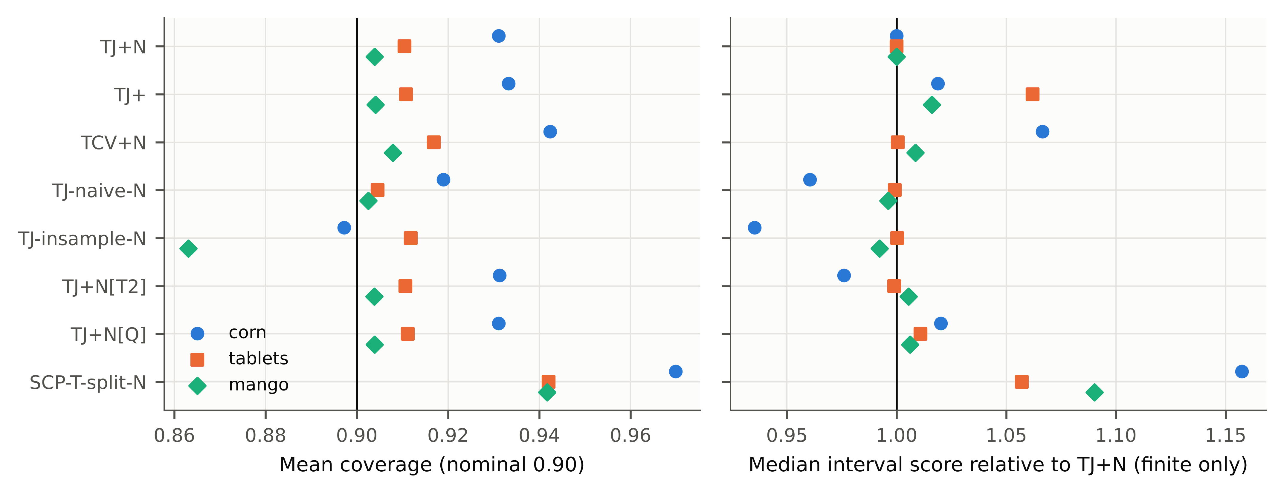
Fig. S1. Ablation of TJ+N: mean coverage (left) and median interval score relative to TJ+N (right).

Fig. S2
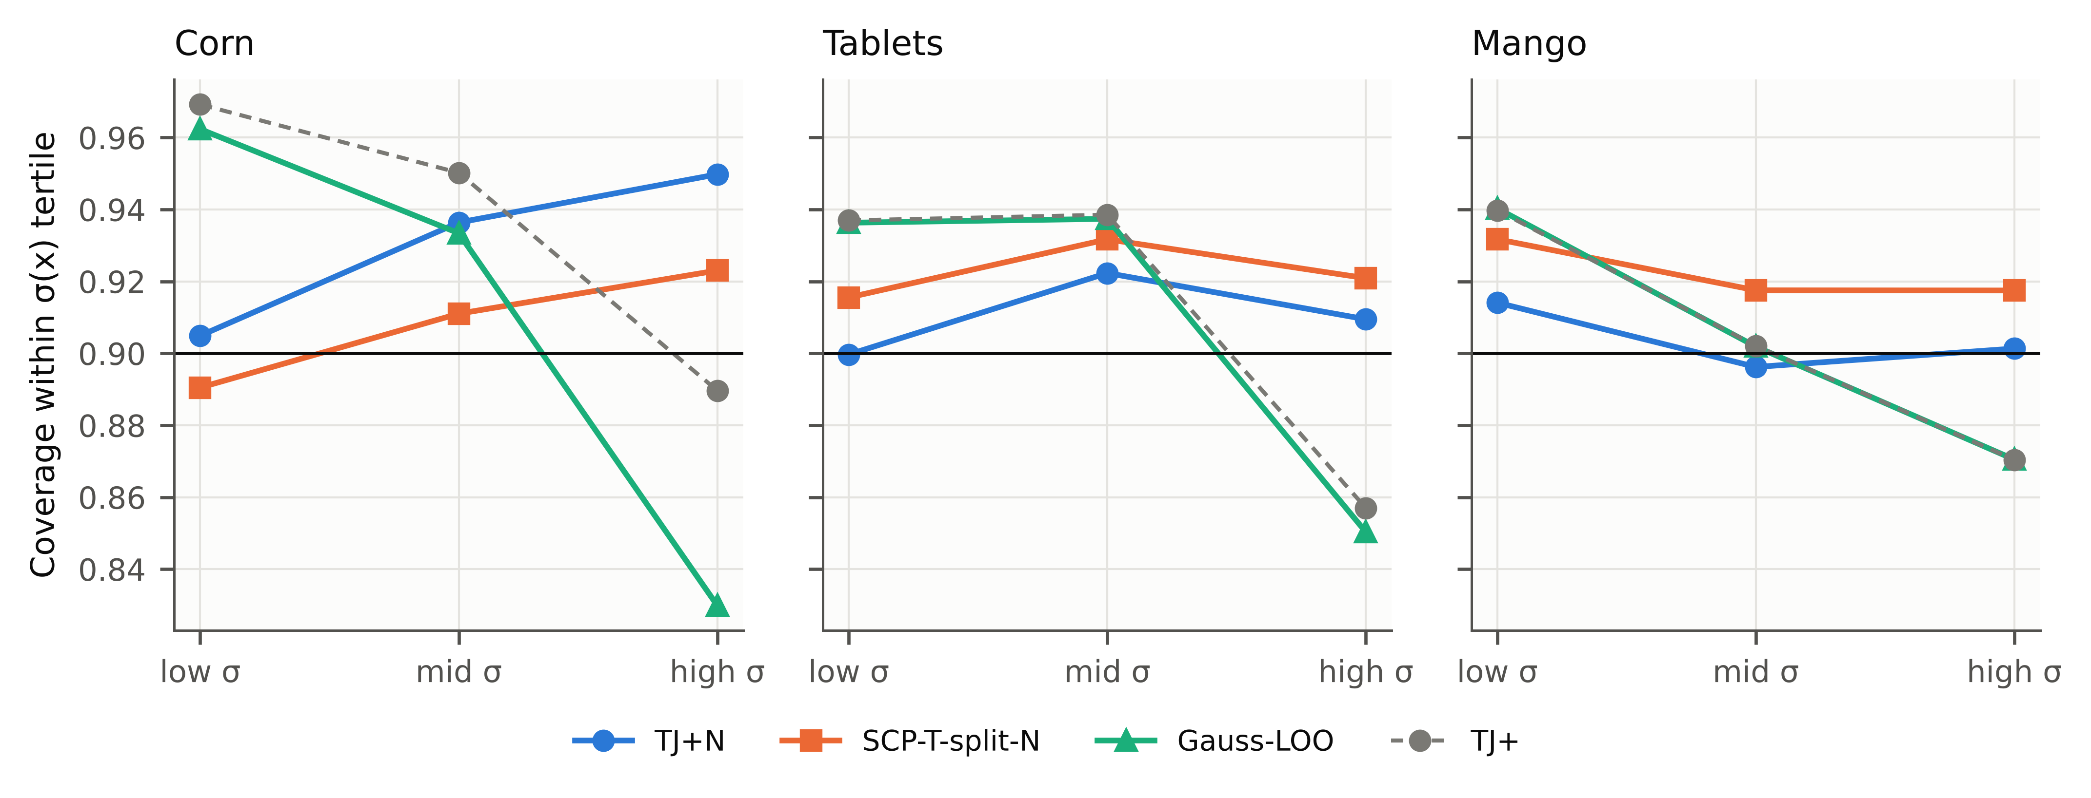
Fig. S2. Coverage within thirds of the difficulty σ(x) of the test spectra (main pipelines, α = 0.10).

Fig. S3
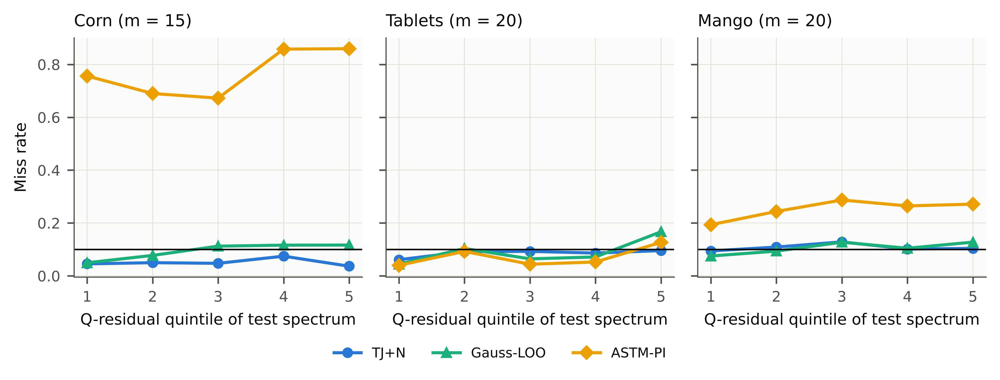
Fig. S3. Miss rate by Q-residual quintile of the test spectra (first 100 repetitions).

Fig. S4
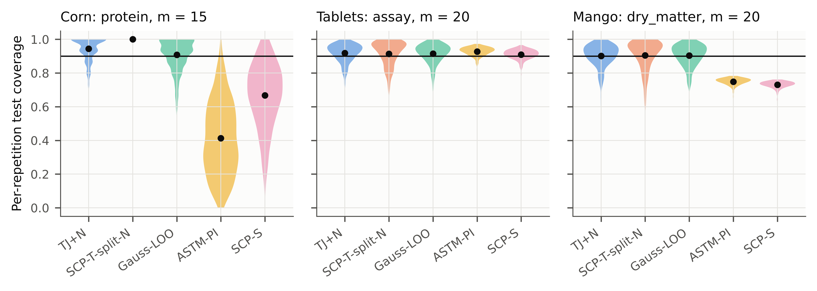
Fig. S4. Distribution over repetitions of the realised coverage for one scenario per data set; the guarantee concerns the mean.

Fig. S5
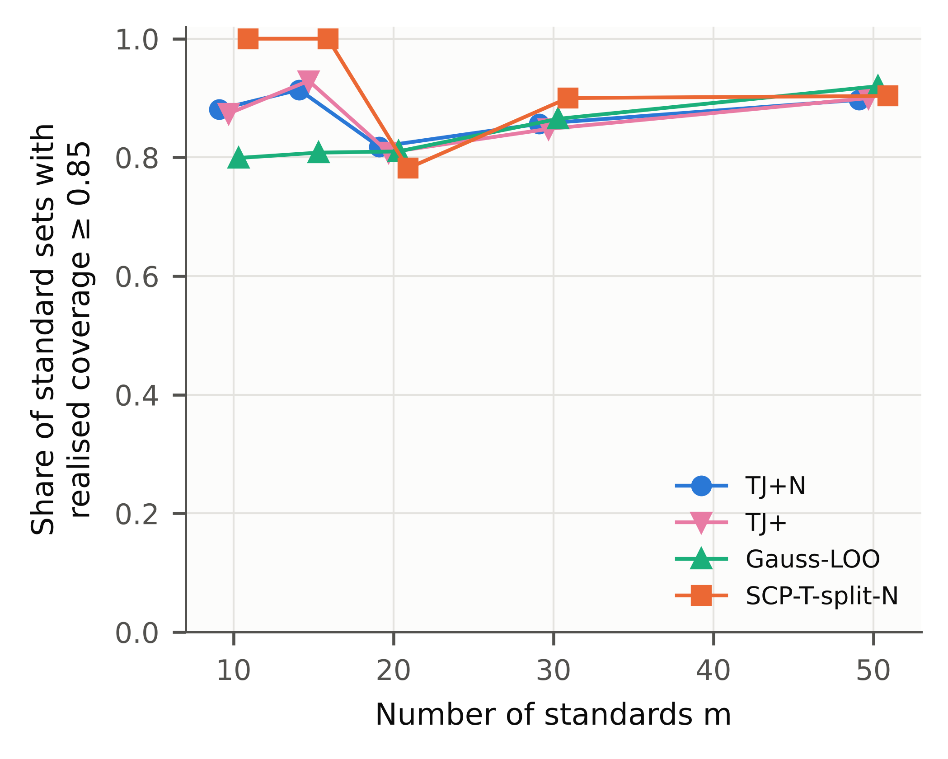
Fig. S5. Share of standard sets whose realised coverage reached 0.85, by number of standards (median over scenarios).

Fig. S6
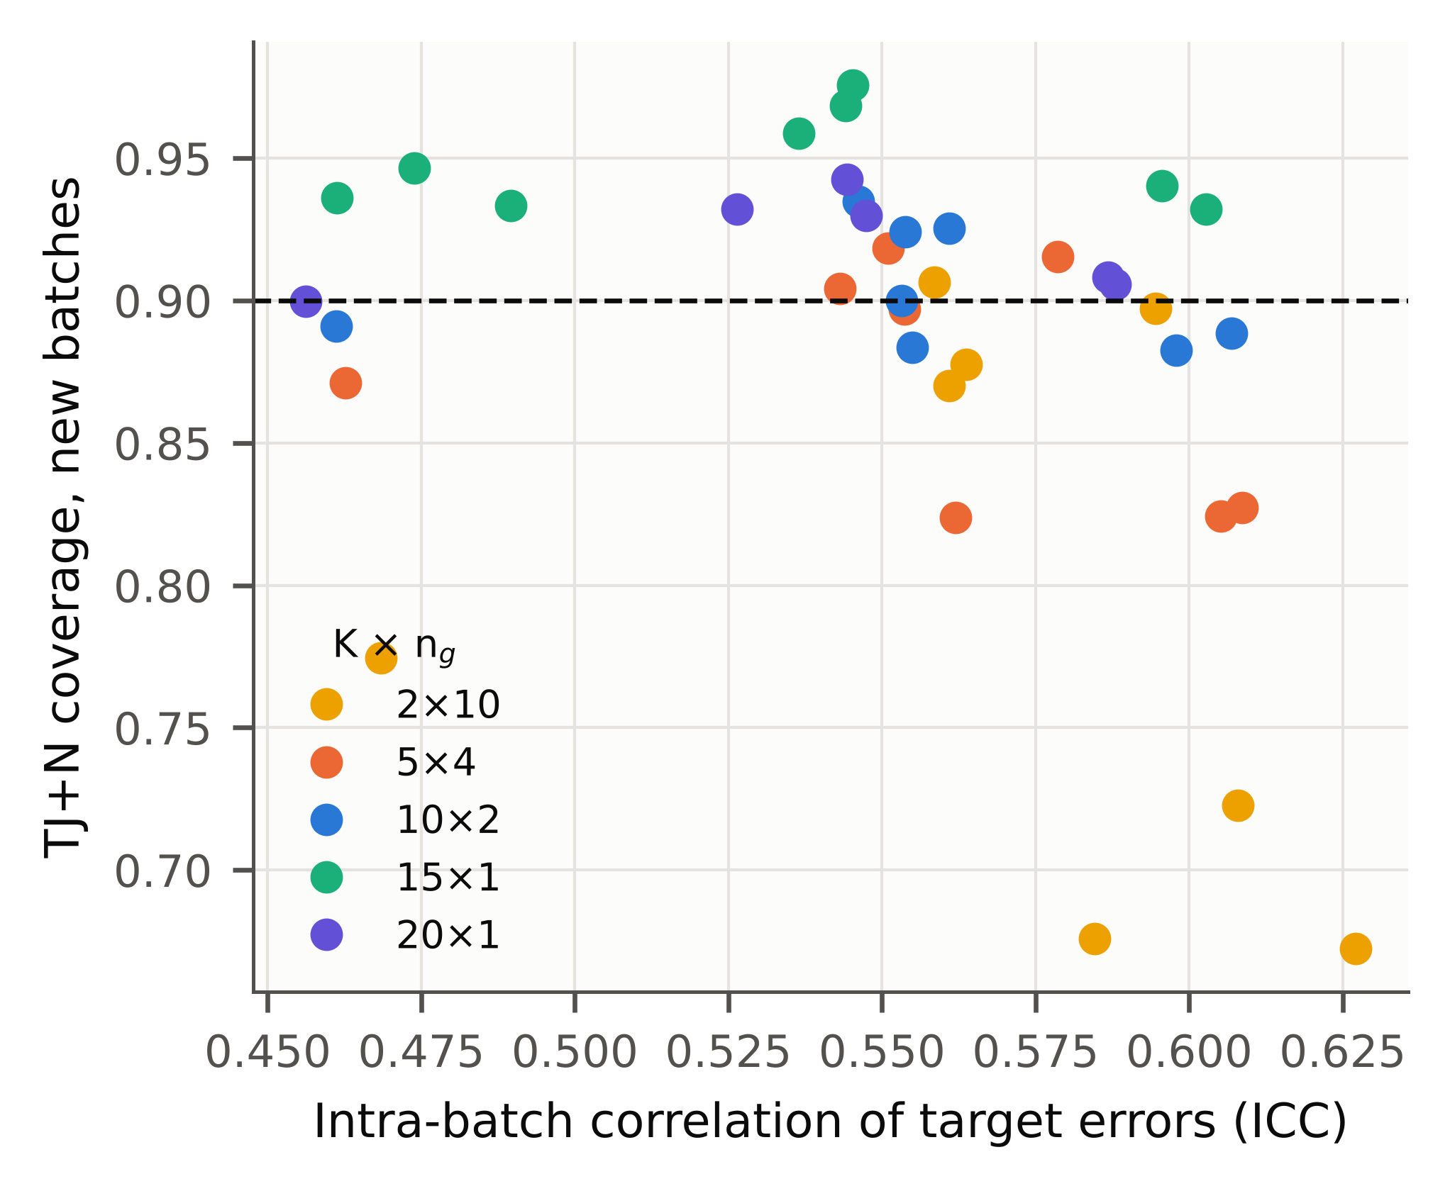
Fig. S6. TJ+N coverage for new consignments against the intra-consignment correlation of the errors, by design. Within the narrow ICC range observed, the design (number of consignments) rather than the ICC determined coverage.

Fig. S7
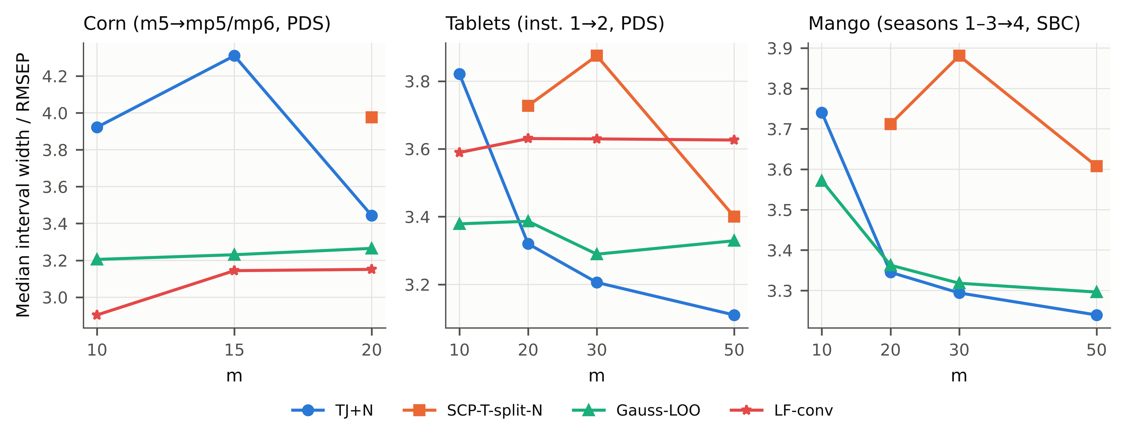
Fig. S7. Median interval width relative to RMSEP for methods that were not too narrow.

Fig. S8
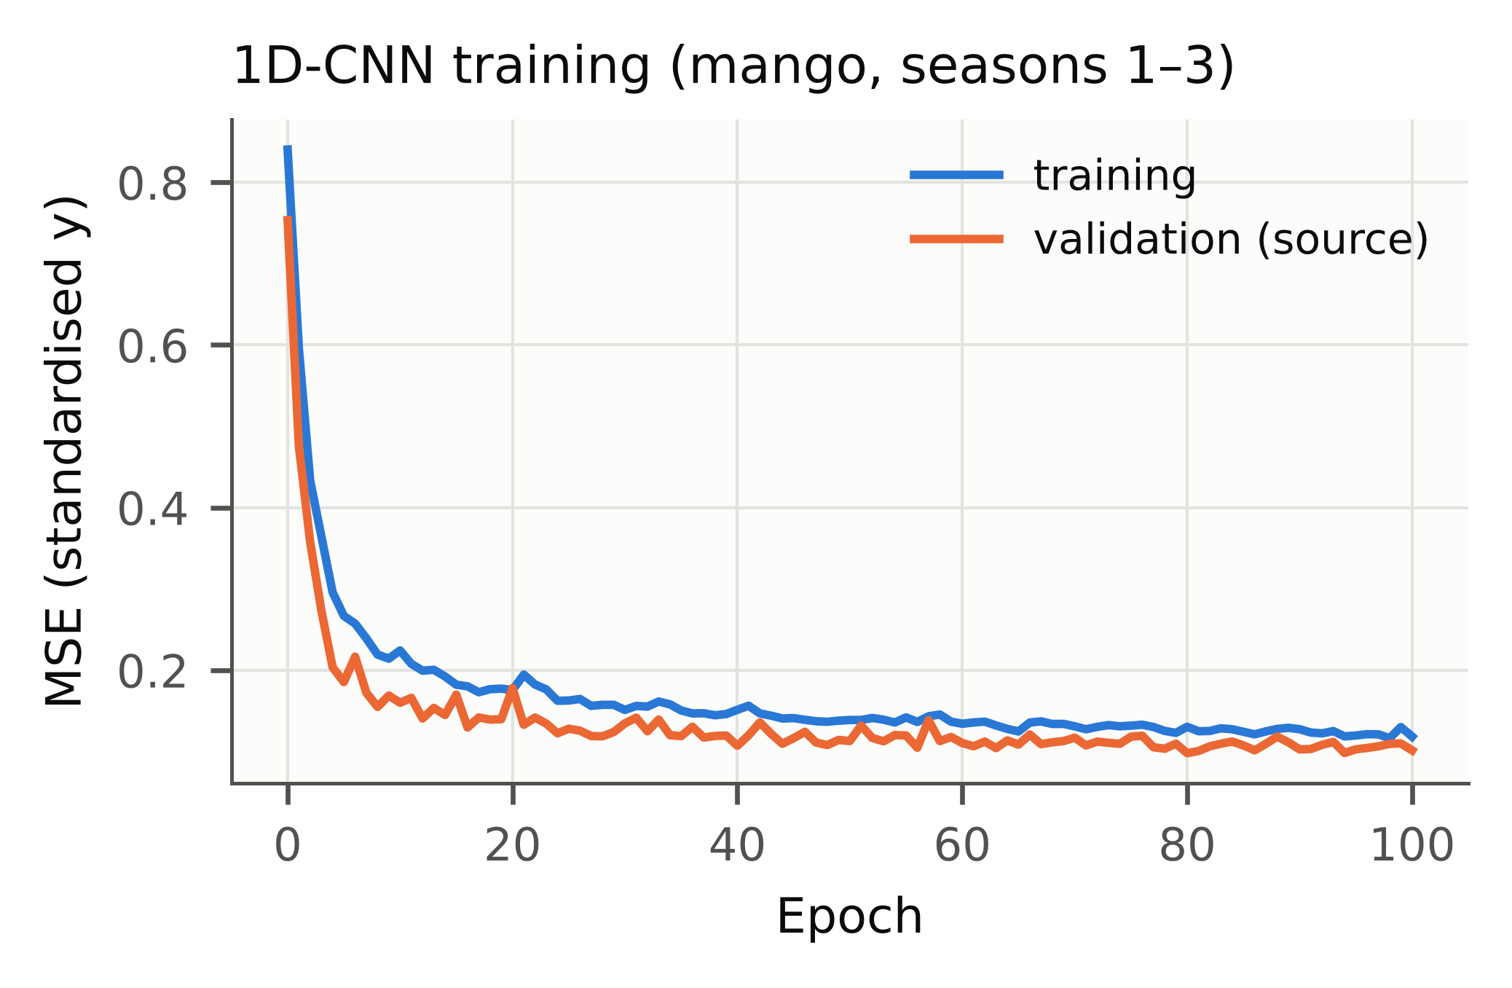
Fig. S8. Training and validation loss of the 1D-CNN (mango, seasons 1–3).

Fig. S9
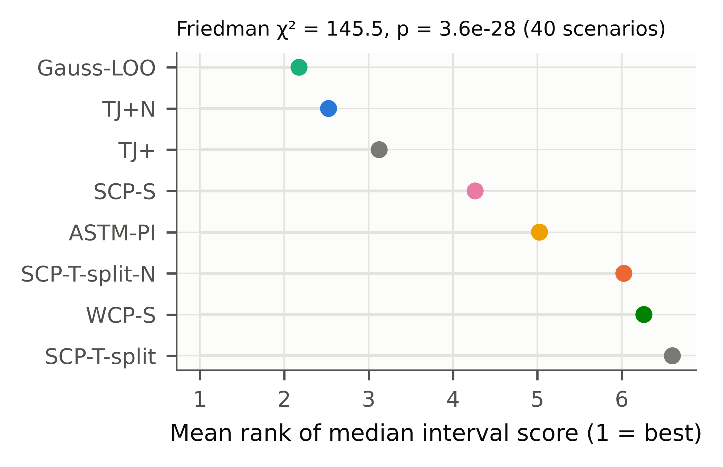
Fig. S9. Mean Friedman ranks of the scenario median interval score over the 40 main scenarios (descriptive).

Fig. S10
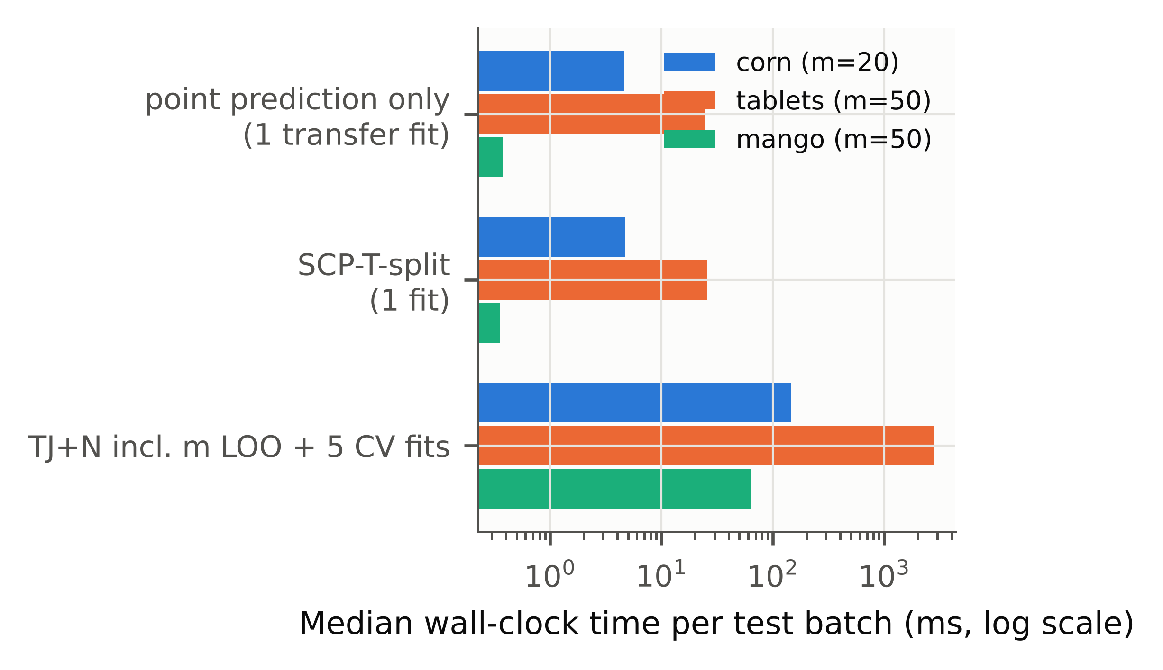
Fig. S10. Wall-clock time per test batch (one CPU core, median of 20 runs).

