Duplicate Data Rows Make Prediction Uncertainty Look Better Than It Is: A Simple Check and Fix for New Cases
Abstract
A software quality team that attaches 90% prediction sets to a defect classifier will usually check the promise on a random test split. In tabular data with repeated rows, this check is misleading. Many test rows have an exact copy in the training data, and the check averages over these easy repeats and the genuinely new cases that matter after deployment. We propose a check–fix–report routine. The check predicts, from the data alone and before any model is trained, how far coverage of new cases can fall. The fix calibrates seen and new cases separately. The report gives new-case coverage next to the usual figure. We tested the routine on 12 application data sets (software defects, network intrusion, phishing), 103 benchmark data sets, controlled copy experiments, and 47 fresh data sets collected under analysis plans fixed in advance. We used random forests, LightGBM and linear models. On NASA mc1, random-forest sets reported 91.7% coverage but covered 62.7% of new modules; with the fix, 90.3%. On the fresh data, the check flagged all 13 data sets whose new cases fell more than 2 percentage points short (95% CI for sensitivity 75–100%). With the fix, new-case coverage never fell more than 2.5 points below the target on any of them. The check is a warning and a limit, not a forecast: on the first fresh collection it did not rank data sets by the size of their shortfall. Exact matching also misses near-copies, for which calibration by distance is needed. The routine is available as an open-source tool.
Keywords: Conformal prediction, Uncertainty quantification, Duplicate records, Data leakage, Software defect prediction, Tabular data

1 Introduction
Suppose a software quality team uses a classifier to flag modules that are likely to contain defects. A yes/no answer is not enough to plan code reviews, so the team wraps the classifier in conformal prediction. For each module it then gets a small set of labels that is promised to contain the true label 90% of the time (Vovk, Gammerman, and Shafer 2022; Angelopoulos and Bates 2023). Before trusting the promise, the team checks it in the usual way: it splits its historical data at random into training, calibration and test parts and counts how often the sets were right. The answer is close to 90%, and the system goes into use.
The team may not have noticed that its data contain many repeated rows. In the public NASA defect data, large shares of modules have exactly the same metric values as other modules (Gray et al. 2011; Shepperd et al. 2013). Repeats like these are common in tabular data: the same network connection logged thousands of times, the same customer profile entered twice, identical laboratory readings. A random split then places copies of many test rows in the training part. The model has, in effect, seen those answers, so its sets are almost always right for them. The 90% the team measured is an average over these easy repeats and the cases that are really new. New modules, which are what the team will face after deployment, may be covered much less often.
This is not a hypothetical concern. On the NASA mc1 data, a random forest’s 90% sets were right for 91.7% of test modules but only for 62.7% of new ones, and 37% of the new modules received an empty set (Sect. 6.7). Repeated rows are known to inflate accuracy (Kaufman et al. 2012; Kapoor and Narayanan 2023; Li 2026; Roth 2026). Their effect on uncertainty estimates has received little attention, although here a stated guarantee, not only an estimate, is what fails without warning.

Motivation and contributions
We want a procedure that a practitioner can apply before training anything, that repairs the problem when it exists, and that costs nothing when it does not. This paper makes four contributions.
- A label-aware check that needs no model (Sect. 4.2). Two closed-form quantities, the expected share of seen test rows and the share whose training copies carry the same label, give a predicted worst-case shortfall for new cases. The first quantity is elementary. The closed form of the second and the resulting shortfall formula are, to our knowledge, new.
- A fix and a reporting rule (Sect. 4.3). Calibrating seen and new cases separately is standard Mondrian conformal prediction (Vovk, Gammerman, and Shafer 2022). We show that it is the right choice of groups here, and we add a safety margin for small calibration sets and a distance-based variant for near-copies.
- An evaluation under plans fixed in advance (Sects. 5–6). The evaluation covers 12 application data sets in three domains, 103 benchmark data sets, controlled experiments with exact and noisy copies, and two fresh collections of 20 and 27 data sets analysed under time-stamped plans. Negative results are reported with the positive ones.
- An open-source tool, covercheck (Sect. 4.5). It runs the routine from the command line or from Python and writes a one-page report. It reproduced the pipeline’s results on 20 data files downloaded fresh from their source.

Organization
Section 2 reviews related work. Section 3 introduces notation and assumptions. Section 4 presents the routine and its theory. Section 5 describes the data, metrics, baselines and hypotheses. Section 6 reports the results, including ablations, cost, a case study and a discussion with limitations. Section 7 concludes. Proofs, per-data-set tables and the full deviation log are in the Supplementary Material.

2 Literature review

2.1 Conformal prediction and what it guarantees
Split (inductive) conformal prediction turns any fitted model into prediction sets or intervals with a finite-sample coverage guarantee, provided calibration and test data are exchangeable (Papadopoulos et al. 2002; Lei et al. 2018; Vovk, Gammerman, and Shafer 2022). Standard nonconformity scores include $1−{\hat{p}}_{y}$ for classification (Sadinle, Lei, and Wasserman 2019), adaptive scores (Romano, Sesia, and Candès 2020), absolute residuals and conformalized quantile regression (Romano, Patterson, and Candès 2019). The guarantee is marginal: it holds on average over test cases. Coverage for every input cannot be guaranteed without further assumptions (Vovk 2012; Foygel Barber et al. 2021). When test data differ from calibration data, weighted or shift-aware methods are needed (Tibshirani et al. 2019; Barber et al. 2023). Conformal prediction is increasingly used in applied work, for example in drug discovery and toxicology (Norinder et al. 2014; Morger et al. 2021; Hernandez-Hernandez, Guo, and Ballester 2026). Introductions are given by Angelopoulos and Bates (2023) and Vovk, Gammerman, and Shafer (2022).

2.2 Group-wise and conditional calibration
Coverage within a fixed set of groups can be obtained by calibrating each group separately (Mondrian conformal prediction; (Vovk, Gammerman, and Shafer 2022)) or by more general and localized conditional calibration (Guan 2023; Gibbs, Cherian, and Candès 2025; Bastani et al. 2022). Group-wise calibration has been used for protected groups (Romano et al. 2020), for classes (Löfström et al. 2015; Ding et al. 2023), for difficulty bins (Boström and Johansson 2020), for two-level group structures (Dunn, Wasserman, and Ramdas 2023), for conformal predictive systems (Zhang and Zhou 2026), for spatial regions (Seo, Jeon, and Kim 2026) and for demographic strata in clinical screening (Tareaf et al. 2026). Training-conditional guarantees, which hold with high probability over the calibration draw, go back to Vovk (2012). Locally adaptive scores, such as residuals normalized by a nearest-neighbour difficulty estimate (Papadopoulos, Vovk, and Gammerman 2011), give tighter intervals in easy regions. All of these are tools that we use. None of these works asks which groups are needed when a data set contains repeated rows, or how to tell in advance whether it matters.

2.3 Repeated rows, leakage and evaluation
Information that leaks from evaluation data into training is a well-known source of over-optimism (Kaufman et al. 2012; Kapoor and Narayanan 2023). Overlap between training and test data has been documented for images (Barz and Denzler 2020), text (Lee et al. 2022; Lewis, Stenetorp, and Riedel 2021; Elangovan, He, and Verspoor 2021) and source code (Allamanis 2019), and for tabular software-defect and intrusion-detection data (Gray et al. 2011; Shepperd et al. 2013; Tavallaee et al. 2009). Time-based splits are one remedy when records arrive over time (Sheridan 2013). Three recent preprints study repeated rows across many tabular data sets. Li (2026) shows that random splits inflate accuracy and can change which model looks best. Roth (2026) finds that this kind of leakage grows with model flexibility. Deng (2026) audits anomaly-detection benchmarks and builds a detector whose false-alarm rate, calibrated with split conformal prediction, does not change when rows are replicated. These studies concern accuracy, ranking or unsupervised false-alarm control.

2.4 Benchmarks and tools
Our evaluation uses the OpenML platform (Vanschoren et al. 2014) and its curated suites (Bischl et al. 2021; Fischer, Feurer, and Bischl 2023), two further benchmark collections (Gijsbers et al. 2024; Grinsztajn, Oyallon, and Varoquaux 2022) and the UCI repository (Kelly, Longjohn, and Nottingham 2026). Models are fitted with scikit-learn (Pedregosa et al. 2011), random forests (Breiman 2001) and LightGBM (Ke et al. 2017).

2.5 Motivations
Table 1 compares the closest work with ours. The comparison leads to five motivations.
- Conformal coverage is checked on random splits, but no work examines what that check means when test rows have training copies.
- The groups that need separate calibration are usually chosen by the analyst, such as classes, protected groups or regions. Here they are implied by the data, through the seen/new split.
- Practitioners need to know before training whether a problem exists. No existing tool predicts the size of the shortfall from the data alone.
- Studies of duplicates measure accuracy or ranking. They do not propose a repair that keeps the data and gives a guarantee for new cases.
- Claims about evaluation practice should be tested on data that were not used to develop them, under a plan fixed in advance.
Table 1 The closest prior work compared with this paper. ✓: the property is a main subject of the work; –: not addressed. Properties: Rep., studies repeated rows; Cov., gives a conformal coverage guarantee; New, examines coverage for new (unseen) records; Pre., predicts the risk before training; Fix, proposes a repair; Tab., tabular data; Tool, released as a usable tool
Work | Rep. | Cov. | New | Pre. | Fix | Tab. | Tool
Split conformal prediction (Lei et al. 2018; Vovk, Gammerman, and Shafer 2022) | – | ✓ | – | – | – | ✓ | –
Class-conditional CP (Löfström et al. 2015; Ding et al. 2023) | – | ✓ | – | – | – | ✓ | –
Conditional guarantees (Gibbs, Cherian, and Candès 2025; Bastani et al. 2022) | – | ✓ | – | – | – | ✓ | –
Difficulty Mondrian CP (Boström and Johansson 2020) | – | ✓ | – | – | – | ✓ | –
Normalized nearest-neighbour scores (Papadopoulos, Vovk, and Gammerman 2011) | – | ✓ | – | – | – | ✓ | –
Spatial Mondrian CP (Seo, Jeon, and Kim 2026) | – | ✓ | – | – | – | ✓ | –
Leakage in ML science (Kaufman et al. 2012; Kapoor and Narayanan 2023) | ✓ | – | – | – | ✓ | ✓ | –
Duplicates in code and text (Allamanis 2019; Lee et al. 2022) | ✓ | – | ✓ | – | ✓ | – | –
Defect and intrusion data quality (Shepperd et al. 2013; Tavallaee et al. 2009) | ✓ | – | – | – | ✓ | ✓ | –
Duplicates in tabular benchmarks (Li 2026; Roth 2026) | ✓ | – | – | – | – | ✓ | –
Replication-robust anomaly detection (Deng 2026) | ✓ | ✓ | – | – | ✓ | ✓ | –
Leakage and Mondrian CP in screening (Tareaf et al. 2026) | – | ✓ | – | – | ✓ | ✓ | –
This paper | ✓ | ✓ | ✓ | ✓ | ✓ | ✓ | ✓

3 Preliminary concepts

3.0.0.1 Data and splits.
A data set $D=\{\left(x_{i},y_{i}\right)\}_{i=1}^{N}$ is split uniformly at random into a training part $T$ with $n_{T}$ rows, a calibration part $C$ with $n_{C}$ rows and a test part $E$ (60/20/20 in all our experiments). Rows with exactly the same feature vector form a record group; $m_{j}$ is the size of the group of row $j$. A calibration or test row is seen if some training row has the same feature vector, and new otherwise. We write $κ_{T}\left(x\right)∈\{S,N\}$ for this label. It depends only on the training features.

3.0.0.2 Split conformal prediction.
A model fitted on $T$ yields a nonconformity score $s\left(x,y\right)$. We use $s=1−{\hat{p}}_{y}\left(x\right)$ for classification and $s=\left|y−\hat{y}\left(x\right)\right|$ for regression. With target miscoverage $α$ (we use $α=0.1$, a 90% target), the prediction set is
$$C\left(x\right)=\{y: s\left(x,y\right)≤\hat{q}\}, \hat{q}=\text{the }⌈\left(n_{C}+1\right)\left(1−α\right)⌉\text{-th smallest calibration score.}$$

3.0.0.3 Coverage of seen and new cases.
Write $π$ for the share of test rows that are seen, $c$ for overall coverage, and $c_{S}$ and $c_{N}$ for the coverage of seen and new rows. Because a test row is either seen or new,
$$c=πc_{S}+\left(1−π\right)c_{N}, \text{so} c_{N}=\frac{c−πc_{S}}{1−π}.$$
Split conformal prediction keeps $c$ near $1−α$. New cases are therefore under-covered exactly when seen cases are over-covered. If every seen row is covered ($c_{S}=1$), the miss rate on new cases is $α/\left(1−π\right)$ instead of $α$. With half of the test rows seen, one new case in five is missed while the usual check still reports 90%.

3.0.0.4 Assumptions.
The guarantees and predictions below rest on three assumptions, which we test.

3.0.0.5 Assumption A1 (Random split).
$T$, $C$ and $E$ are a uniformly random partition of $D$. Given $T$, the remaining rows are therefore still assigned to $C$ and $E$ at random, and $κ_{T}$ is a fixed function.

3.0.0.6 Assumption A2 (Memorization).
A row whose training copies all carry exactly its label (or target value) receives the lowest possible score.

3.0.0.7 Assumption A3 (Equal difficulty).
All other rows, both new rows and seen rows whose copies disagree on the label, have scores from one common continuous distribution $F$.
Assumption A1 is the standard condition for split conformal prediction and holds by construction in our experiments. Assumptions A2 and A3 are idealizations used only for the predicted shortfall. Flexible models approach A2, and regularized models do not. Assumption A3 fails when repeated rows disagree slightly but are still easy, and when seen rows with conflicting labels are harder than new ones. We report both failure modes (Sect. 6.2).

4 Proposed methodology

4.1 Overview
The routine has three steps (Fig. 1, Algorithm 1). The check uses only the features and labels of the full data set: it predicts how many test rows a random split will place next to a training copy, and how much this can depress coverage for new cases. The fix calibrates seen and new rows separately, which restores the promise for new cases whatever the model. The report states coverage on new cases next to the usual overall figure. Which parts are standard and which are new is stated with each result.
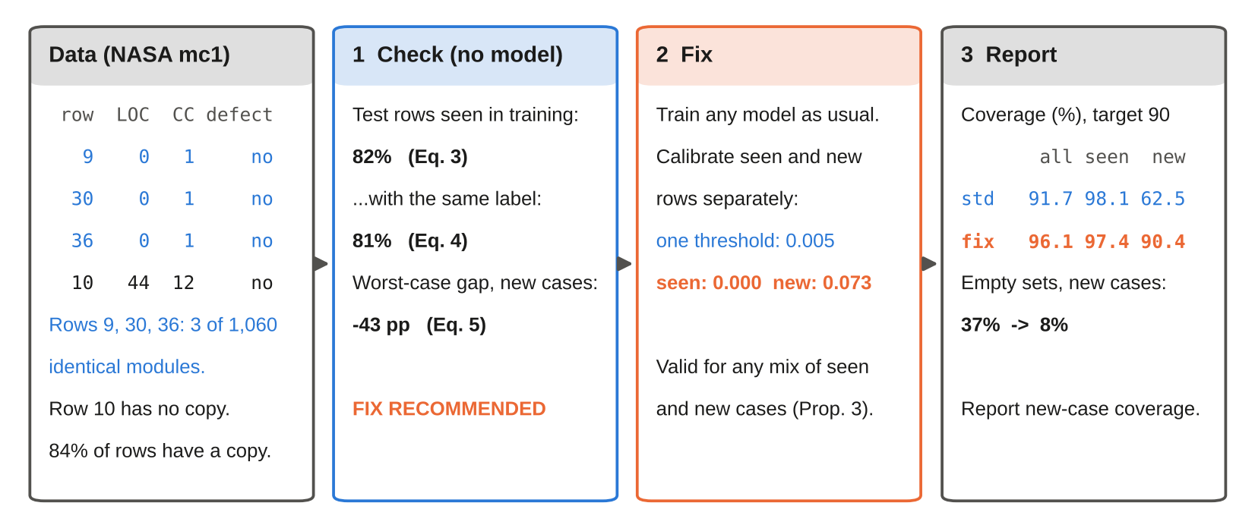
Fig. 1 The check–fix–report routine, shown with real rows of the NASA mc1 defect data. The check predicts a large shortfall before any model is trained, and the fix restores new-case coverage. The rows shown follow a fixed rule: the first three rows of the largest group of identical modules, and the first row with no copy. All numbers come from the experiment files (random forest, 10 random splits). LOC: lines of code; CC: cyclomatic complexity

4.1.0.1 Algorithm 1: Check, fix and report conformal coverage for new cases
- data $D$, target miscoverage $α$, training share $f$
- x tolerances $τ_{g}=0.02$ and $τ_{π}=0.10$
- Check (no model): hash every feature vector; for each row $j$ count its copies $m_{j}−1$ and the copies with a different label $d_{j}$
- compute $\overset{‾}{π}$ (Eq. 3), ${\overset{‾}{π}}_{P}$ (Eq. 4) and $g^{*}=−α{\overset{‾}{π}}_{P}/\left(1−{\overset{‾}{π}}_{P}\right)$ (Eq. 5)
- if $g^{*}<−τ_{g}$ or $\overset{‾}{π}≥τ_{π}$ then flag the data set
- split $D$ at random into $T$, $C$, $E$; fit any model on $T$
- Fix: label each calibration and test row seen or new by exact match with $T$
- compute one threshold per group: ${\hat{q}}_{k}=$ the $⌈\left(n_{k}+1\right)\left(1−α\right)⌉$-th smallest calibration score in group $k$ ($+∞$ if $n_{k}<1/α−1$)
- optionally use the safety-margin rank (Eq. 6) or distance groups instead of seen/new
- Report: coverage on all, seen and new test rows; for deployment use $C\left(x\right)=\{y:s\left(x,y\right)≤{\hat{q}}_{κ_{T}\left(x\right)}\}$

4.2 Step 1: the check

4.2.0.1 Exposure.
If a test row belongs to a group of $m_{j}$ identical rows, and $n_{T}$ of the other $N−1$ rows go to training, the chance that none of its $m_{j}−1$ copies lands in training is $\left({N−m_{j} \atop n_{T}}\right)/\left({N−1 \atop n_{T}}\right)$. The expected share of seen test rows is therefore
$$\overset{‾}{π}=\frac{1}{N}\sum_{j=1}^{N}{\left[1−\left({N−m_{j} \atop n_{T}}\right)/\left({N−1 \atop n_{T}}\right)\right]}.$$
This is elementary combinatorics; Li (2026) gives the analogous probability for cross-validation.

4.2.0.2 Label purity.
Exposure alone can mislead. If repeated rows disagree on the label (identical survey profiles with different outcomes, for example), memorizing them does not help the model. Let $d_{j}$ be the number of copies of row $j$ whose label (or target value) differs from $y_{j}$. Row $j$ is label-pure seen if at least one copy, but no differently labelled copy, lands in training. Its expected share is
$${\overset{‾}{π}}_{P}=\frac{1}{N}\sum_{j=1}^{N}{\left[\left({N−1−d_{j} \atop n_{T}}\right)−\left({N−m_{j} \atop n_{T}}\right)\right]}/\left({N−1 \atop n_{T}}\right).$$

4.2.0.3 Proposition 1 (Closed-form label-pure exposure).
Under Assumption A1, the expected share of test rows that are label-pure seen equals ${\overset{‾}{π}}_{P}$ in Eq. (4).
The proof is in Sect. S1 of the Supplementary Material. On five data sets, the closed form agreed with an average over 30 random splits to within 0.005.

4.2.0.4 Predicted shortfall.
Under Assumptions A2 and A3, calibration scores come from a mixture with mass $π_{P}$ at zero and mass $1−π_{P}$ spread by $F$.

4.2.0.5 Proposition 2 (Memorization limit).
Under Assumptions A1–A3, as $n_{C}→∞$ the coverage of new cases under standard calibration tends to $1−α/\left(1−π_{P}\right)$ for $π_{P}<1−α$, so the coverage gap is
$$g^{*}=−\frac{α π_{P}}{1−π_{P}}.$$
For $π_{P}≥1−α$, new cases are almost never covered.
We call $g^{*}$ the predicted gap. It is a worst case for models that memorize their training rows. In practice it is computed with ${\overset{‾}{π}}_{P}$. A data set is flagged if $g^{*}<−2$ percentage points (pp) or if at least 10% of test rows are expected to be seen. The second condition guards against failures of Assumption A3. This combined rule was written down before either fresh collection was analysed (Sect. 5).

4.3 Step 2: the fix
Compute one threshold from the seen calibration rows and one from the new calibration rows, and apply each to the matching test rows. This is Mondrian conformal prediction (Vovk, Gammerman, and Shafer 2022) with the categories “seen” and “new”.

4.3.0.1 Proposition 3 (Validity for any mix; standard).
Under Assumption A1, for $k∈\{S,N\}$, $Pr\{Y∈C\left(X\right)∣κ_{T}\left(X\right)=k\}≥1−α$. Coverage therefore holds for any mix of seen and new cases at deployment, including one where every case is new.
This follows from the standard Mondrian argument because $κ_{T}$ depends only on the training rows (Sect. S1). If fewer than $1/α−1$ new calibration rows exist, the threshold is $+∞$ and new cases receive the full set. This is the honest answer when there is no evidence.

4.3.0.2 Safety margin (standard).
With few new calibration rows, coverage varies from split to split. Using the smallest rank $r$ with
$$Pr\{Beta\left(r,n−r+1\right)<1−α\}≤δ$$
gives coverage of at least $1−α$ with probability at least $1−δ$ over the calibration draw (Vovk 2012). We use $δ=0.1$.

4.3.0.3 Calibration by distance.
Exact matching cannot see near-copies. As a variant, calibration and test rows are grouped by the distance to their nearest training row: exact copies form one group, and new rows form five groups at training-only distance quantiles. Each group is then calibrated separately, as in difficulty-based Mondrian calibration (Boström and Johansson 2020).

4.4 Step 3: the report
Report coverage on new cases, the share of seen test rows, and the set size for new cases next to the usual overall coverage. A reader can then judge the evaluation without rerunning it.

4.5 The covercheck tool
We packaged the routine as an open-source Python library and command-line tool. check(X, y) computes Eqs. (3)–(5) and returns a verdict with reasons. SeenNewConformal wraps any scikit-learn estimator and implements the fix, the safety margin and the distance variant. evaluate reports coverage on all, seen and new cases over repeated random splits. The command covercheck data.csv –target label –html report.html runs all three steps. The tool has its own test suite, which includes a simulation check of Eq. (4) and of the fix.

5 Experimental framework

5.1 Setup
All experiments use random 60/20/20 splits into training, calibration and test parts, and a 90% target ($α=0.1$). The benchmarks also use 80% and 95%. We used random forests (200 trees; (Breiman 2001)), LightGBM (300 trees; (Ke et al. 2017)) and logistic or ridge regression with fixed default settings, plus 5-nearest neighbours and a small neural network on the benchmarks. No hyperparameter was tuned. Preprocessing was fitted on training rows only. Each configuration was repeated over 10 random splits (20 for the fresh collections). Data sets, not splits, are the unit of analysis. All runs used one machine with 4 logical CPUs (Intel(R) Xeon(R) Processor @ 2.10GHz) and 16 GB of memory, under Python 3.13.16. The code, every per-split result file and one command that rebuilds every number, table and figure are in the repository.

5.1.0.1 Plans fixed in advance.
The benchmark study followed a protocol committed before the full runs. Each fresh collection was selected and analysed under an amendment committed before its data were downloaded. The selection used no labels and no models: it kept data sets in which at least 1% of test rows are expected to be seen (Eq. 3) and dropped data sets already used. Every change to these plans is logged as D1–D17 (Supplementary Sect. S3). Analyses added after results were seen are labelled post hoc.

5.1.0.2 Use of AI tools.
The study design, code, experiments, statistical analysis and drafting of this manuscript were carried out with substantial assistance from an AI system (a large language model with code-execution tools), under the direction of the authors. All numbers were produced by executed code whose outputs are archived with the repository. The authors checked the work and take full responsibility for it.

5.2 Data
Table 2 lists the data. The applications are all ten NASA Metrics Data Program defect sets on OpenML with at least 300 modules, the 10% KDD Cup’99 intrusion data (reduced at random to 30,000 connections; (Tavallaee et al. 2009)) and the PhishingWebsites data. The benchmarks are the 103 tabular data sets of OpenML-CC18 (Bischl et al. 2021) and OpenML-CTR23 (Fischer, Feurer, and Bischl 2023). The fresh collections come from sources the study had not used: the AutoML Benchmark (Gijsbers et al. 2024) and the benchmark of Grinsztajn, Oyallon, and Varoquaux (2022) (wave 1), and the UCI repository (Kelly, Longjohn, and Nottingham 2026) (wave 2). Data sets larger than 30,000 rows were reduced by sampling whole groups of identical rows, or uniformly when one group exceeded 6,000 rows.
Table 2 Data used in the study. The fresh collections were selected by a label-free rule under plans committed before their data were downloaded. Cls/reg: classification/regression data sets; learners: RF random forest, LGBM LightGBM, LR logistic or ridge regression, kNN, MLP neural network
Role | Source | Sets | Cls/reg | Learners | Splits
Applications | NASA MDP, KDD Cup’99, PhishingWebsites (OpenML) | 12 | 12/0 | RF, LGBM, LR | 10
Benchmarks | OpenML-CC18 and CTR23 | 103 | 68/35 | all five | 10
Copies added | duplicate-free benchmarks, $≥$1,000 rows | 37 | 21/16 | all five | 10
Noisy copies | same data sets | 37 | 21/16 | RF, LGBM | 3
Fresh, wave 1 | AutoML Benchmark, Grinsztajn et al. | 20 | 8/12 | RF, LGBM, LR | 20
Fresh, wave 2 | UCI repository | 27 | 25/2 | RF, LGBM, LR | 20
Tool validation | UCI files downloaded afresh | 20 | – | RF (tool default) | 10

5.3 Metrics
For a split, let $E_{N}$ be the new test rows. The main metric is the coverage of new cases and its gap from the target:
cN=1ENx,y∈EN​1{y∈Cx}, g=cN−1−α.
Gaps are reported in percentage points (pp) and averaged over splits within a data set. We also report:
- the mean set size $\frac{1}{\left|E_{N}\right|}∑\left|C\left(x\right)\right|$ (or interval width);
- the empty-set rate for new cases;
- the bad-split rate, the share of splits with $c_{N}<0.87$.
For the check, a data set is positive if its new-case gap is below $−2$ pp for random forest or LightGBM, and we report
$$\text{sensitivity}=\frac{\#\{\text{flagged}∩\text{positive}\}}{\#\{\text{positive}\}}, \text{specificity}=\frac{\#\{\text{not flagged}∩\text{not positive}\}}{\#\{\text{not positive}\}}.$$

5.4 Baselines
We compare the fix against the strongest simple alternatives, all on the same splits and models:
- standard split conformal prediction;
- remove repeats, then calibrate: duplicate rows are dropped from training and calibration;
- group split: identical rows always fall in the same part;
- a normalized residual score for regression (Papadopoulos, Vovk, and Gammerman 2011);
- calibration by distance.
In the noisy-copy experiment, an oracle that knows which records were copied serves as an upper reference.

5.5 Hypotheses and tests
Table 3 lists the hypotheses with their tests and pass criteria, each fixed before the corresponding data were analysed. We use one-sided Wilcoxon signed-rank tests (Wilcoxon 1945) with Holm correction (Holm 1979), Spearman correlations, exact binomial intervals and percentile bootstrap intervals (1,000–10,000 resamples of data sets).
Table 3 Hypotheses, tests and outcomes. Each hypothesis was fixed in a commit before its data were analysed (Supplementary Sect. S2). $g$: new-case gap (Eq. 7); $g^{*}$: predicted gap (Eq. 5)
 | Hypothesis | Test and criterion | Outcome
H1 | The typical benchmark data set with repeats under-covers new cases | Wilcoxon of $g<0$ per family, Holm, $p<0.05$ | Not supported
H2 | The gap grows with the share of seen rows (copies added on purpose) | Spearman $ρ<0$, $p<0.05$ | Supported (RF, LGBM)
H3 | The fix keeps new-case coverage at the target | Bootstrap CI of median $g$ above $−1$ pp | Supported (3 settings)
H4 | The fix costs little in set size | Median size ratio | Supported
H5 | $g^{*}$ is a lower limit: $g≥g^{*}−2$ pp | Share $≥$80%, exact CI | Supported (both waves)
H6 | $g^{*}$ ranks data sets by their gap | Spearman $ρ>0$, one-sided | Wave 1 no; wave 2 yes
H7 | The check flags every real shortfall | Sensitivity $≥$0.8; binomial test, Holm | Supported
H8 | The safety margin reduces bad splits | Paired Wilcoxon, Holm | Not significant
H9 | Purity beats exposure alone for ranking | Bootstrap CI of $Δρ$ above 0 | Not established

6 Results and analysis

6.1 Real-world applications
Figure 2 and Table 4 show the three applications. In the two largest NASA defect sets, mc1 and pc2, about 82% and 81% of test modules have an exact copy in the training data. The usual check looks fine: the random forest’s 90% sets covered 91.7% and 91.0% of all test modules. New modules were covered only 62.7% and 62.5% of the time. The check flags both data sets before training, with predicted gaps of −42.8 and −38.8 pp. The observed gaps are smaller than this worst case, as expected for a model that does not memorize perfectly, but of the same order. Separate calibration brought new-module coverage to 90.3% and 89.4%. In the intrusion data, 61% of test connections have a training copy. New connections were covered 88.6% of the time, and 91.6% with the fix. In the phishing data the figures were 84.8% and 90.1%. The check flagged six of the 12 application data sets. Among the flagged sets, new-case coverage ranged from 62.5–89.8% without the fix and from 89.4–94.5% with it.
The check is a warning, not a certainty, and it can miss. It flagged kc3 (predicted gap −4.9 pp), but kc3’s new modules were covered at 89.8% even without the fix. The check did not flag kc2 on its predicted gap (−1.4 pp), yet new modules there were covered at 86.7%. Its exposure (30% of test rows seen) does trigger the combined rule. In the five other small defect sets, new-case coverage stayed within about 2 pp of the target (88.1–89.6%).
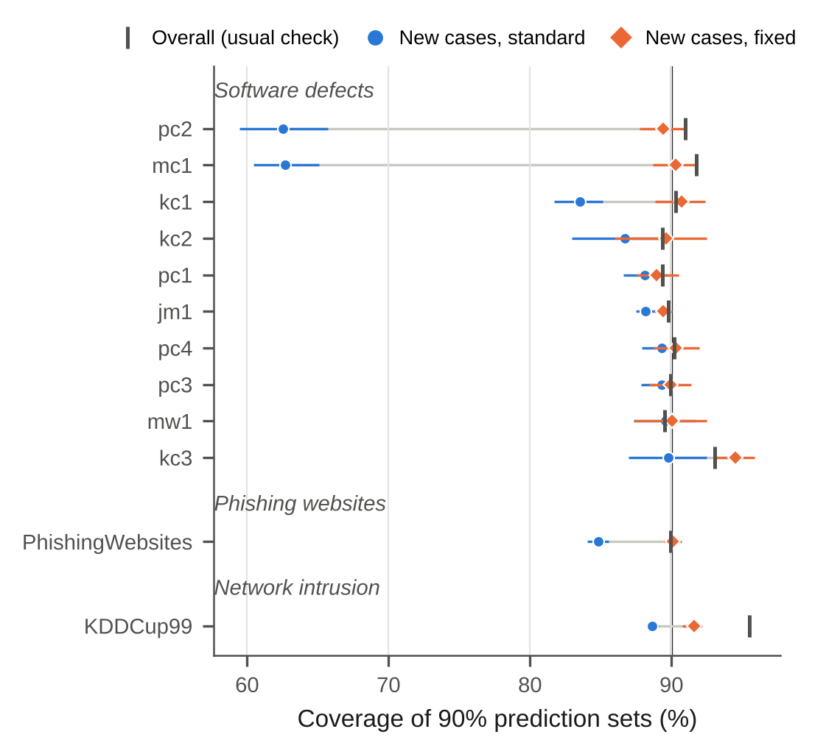
Fig. 2 In the three applications, the usual check reports about 90% coverage while new cases are covered much less often, and separate calibration restores the target. Random forest, 90% target, 10 random splits; error bars are 95% bootstrap intervals of the mean over splits
Table 4 Applications at a 90% target (random forest, RF, and LightGBM, LGBM; means over 10 random splits). Seen: share of test rows with an exact training copy. $g^{*}$: predicted gap from the check (no model). Overall: coverage reported by the usual check. New, std / New, fix: coverage of new cases without and with separate calibration. Size: mean set size for new cases, standard and fixed
Data | Model | Seen (%) | $g^{*}$ (pp) | Overall | New, std | New, fix | Size std / fix
Network intrusion
KDDCup99 | RF | 61 | −15.7 | 95.5 | 88.6 | 91.6 | 0.89 / 0.92
KDDCup99 | LGBM | 61 | −15.7 | 98.0 | 95.9 | 96.0 | 9.40 / 7.30
Phishing websites
PhishingWebsites | RF | 57 | −12.0 | 89.9 | 84.8 | 90.1 | 0.85 / 0.92
PhishingWebsites | LGBM | 57 | −12.0 | 89.9 | 90.4 | 90.0 | 0.91 / 0.91
Software defects
mc1 | RF | 82 | −42.8 | 91.7 | 62.7 | 90.3 | 0.63 / 0.91
mc1 | LGBM | 82 | −42.8 | 90.5 | 70.1 | 90.3 | 0.71 / 0.92
pc2 | RF | 81 | −38.8 | 91.0 | 62.5 | 89.4 | 0.63 / 0.91
pc2 | LGBM | 81 | −38.8 | 89.8 | 72.8 | 89.6 | 0.74 / 0.91
kc1 | RF | 48 | −6.1 | 90.3 | 83.5 | 90.7 | 1.23 / 1.48
kc1 | LGBM | 48 | −6.1 | 90.4 | 83.3 | 90.3 | 1.25 / 1.50
kc3 | RF | 33 | −4.9 | 93.1 | 89.8 | 94.5 | 1.10 / 1.25
kc3 | LGBM | 33 | −4.9 | 92.6 | 89.3 | 94.7 | 1.12 / 1.33
kc2 | RF | 30 | −1.4 | 89.3 | 86.7 | 89.6 | 1.26 / 1.33
kc2 | LGBM | 30 | −1.4 | 88.7 | 85.6 | 89.9 | 1.25 / 1.36
jm1 | RF | 22 | −1.8 | 89.8 | 88.2 | 89.4 | 1.28 / 1.33
jm1 | LGBM | 22 | −1.8 | 89.4 | 87.8 | 89.7 | 1.28 / 1.34
pc1 | RF | 17 | −1.9 | 89.4 | 88.1 | 88.9 | 0.93 / 0.94
pc1 | LGBM | 17 | −1.9 | 89.3 | 87.9 | 89.1 | 0.93 / 0.95
pc3 | RF | 10 | −1.1 | 89.9 | 89.3 | 90.0 | 1.01 / 1.02
pc3 | LGBM | 10 | −1.1 | 90.1 | 89.4 | 90.3 | 1.02 / 1.04
pc4 | RF | 10 | −1.0 | 90.2 | 89.3 | 90.3 | 1.01 / 1.03
pc4 | LGBM | 10 | −1.0 | 89.6 | 88.7 | 89.4 | 0.99 / 1.00
mw1 | RF | 8 | −0.7 | 89.5 | 89.6 | 90.0 | 1.00 / 1.00
mw1 | LGBM | 8 | −0.7 | 89.9 | 90.1 | 89.6 | 1.01 / 0.99

6.2 Statistical analysis by hypothesis

6.2.0.1 H1: the typical benchmark is not affected.
Repeated rows are common: 53 of the 103 benchmark data sets contain at least one, and in 11 at least 30% of rows belong to a group of identical rows. Exposure (Eq. 3) predicted the observed share of seen test rows almost exactly (mean absolute error 0.0012). The planned test of a general shortfall was negative. The median new-case gap was between −0.8 and +2.6 pp across learner–score families, and no family was significant after Holm correction (smallest adjusted $p$ = 0.092). Shortfalls were concentrated where many test rows are seen. Where at least 30% are seen, 31% of data set–learner pairs fell more than 2 pp short and 19% more than 5 pp. The worst gaps were −6.9 pp (classification) and −16.9 pp (regression).

6.2.0.2 H2: copies cause the shortfall.
Appending exact copies to the 37 duplicate-free data sets raised exposure as Eq. (3) predicts, and the gap grew with it (Fig. 3). For random forests in classification, the median gap went from +0.1 pp without copies to −6.1 pp with half of the rows copied and −12.8 pp with all rows copied. The regression figure with all rows copied was −11.8 pp. LightGBM behaved similarly. Regularized linear models, which do not memorize rows, were barely affected (−0.8 pp). Separate calibration stayed at the target at every rate.
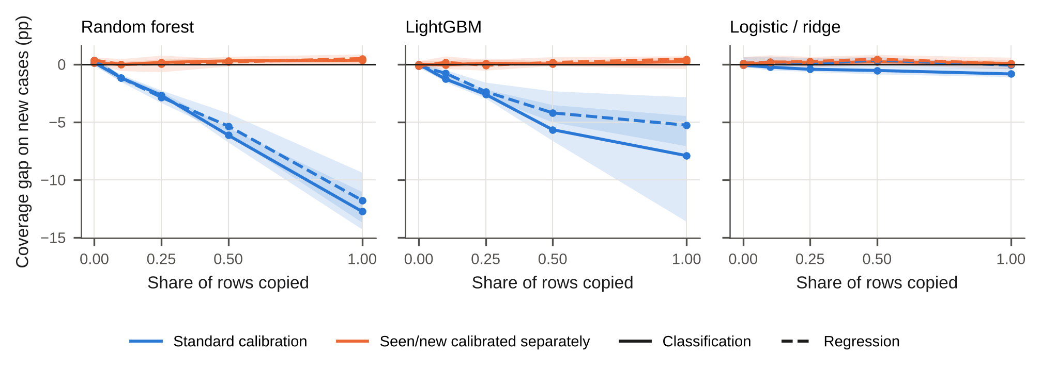
Fig. 3 Copying rows on purpose creates the shortfall for flexible learners, in proportion to the share copied, while separate calibration stays on target. Median new-case gap over the 37 duplicate-free benchmark data sets; bands are 95% bootstrap intervals of the median

6.2.0.3 H3 and H4: the fix keeps its promise at little cost.
On the benchmarks with repeats, the median new-case gap of separate calibration ranged from −0.1 to +0.3 pp, and the confidence interval of the median stayed above $−1$ pp in all learner–score combinations. Figure 4a shows target against achieved coverage at three target levels. The overall coverage of standard calibration matches the target and its new-case coverage falls below it, while separate calibration matches the target for new cases. On the 47 fresh data sets (Fig. 4b), the worst data set’s gap with the fix was −0.7 (wave 1) and −1.7 pp (wave 2) for random forests. For LightGBM it was −0.9 and −2.5 pp, and for linear models −0.5 and −0.4 pp. Without the fix, the worst gaps were −27.5 and −27.7 pp. The cost was small. On the benchmarks, sets for new cases grew by a median factor of 0.995–1.044, and on the wave-1 data by 1.00.
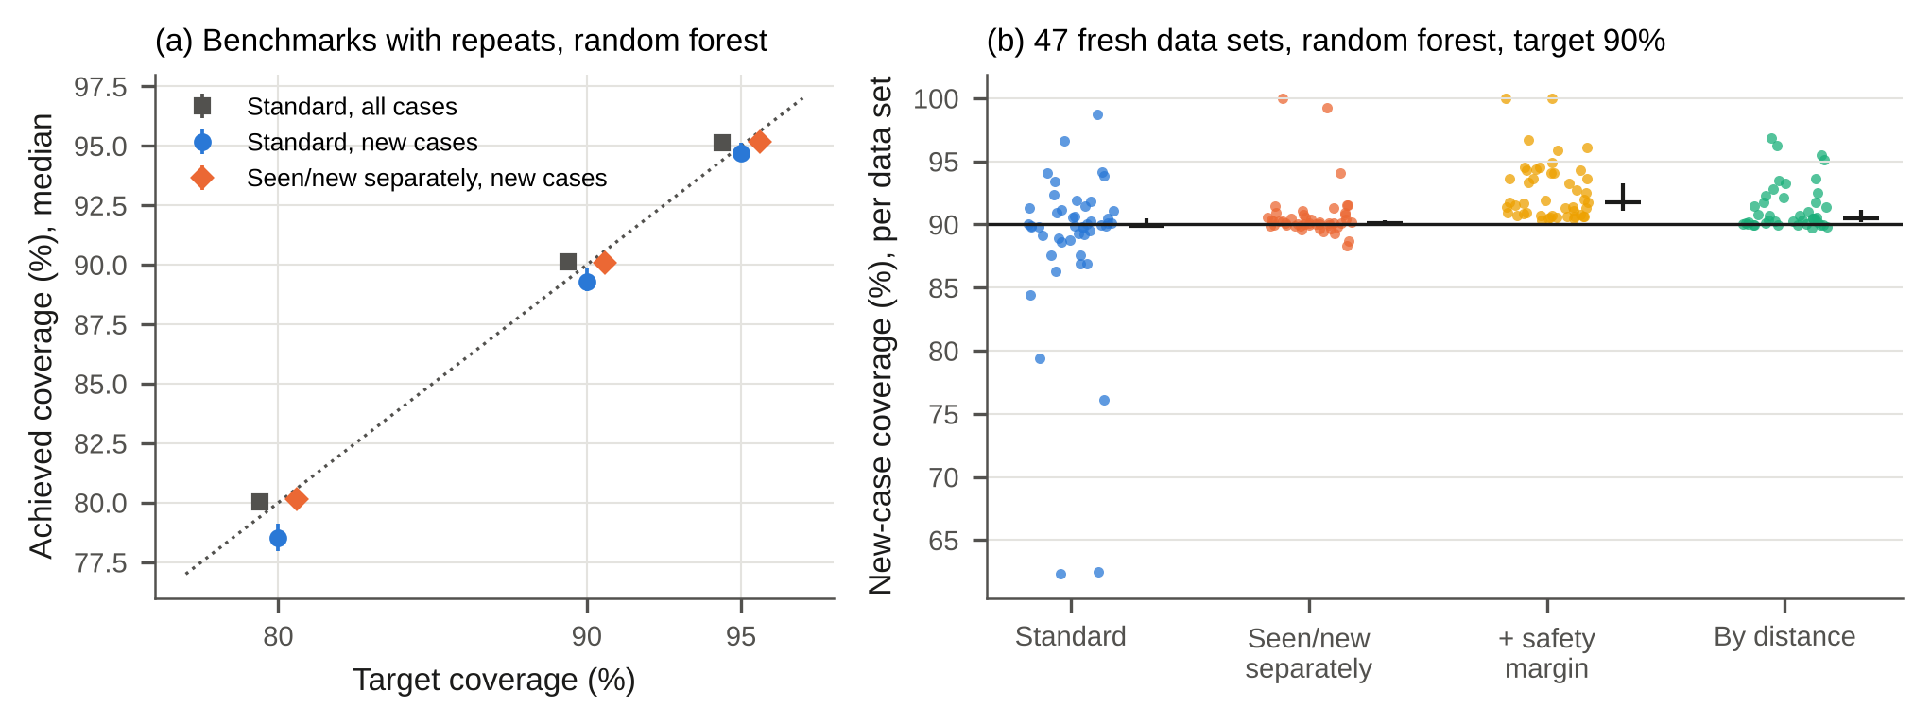
Fig. 4 Target versus achieved coverage. (a) Benchmark data sets with repeats, random forest: standard calibration meets the target overall but not for new cases, while separate calibration meets it for new cases. Medians over data sets with 95% bootstrap intervals. (b) The 47 fresh data sets at a 90% target: new-case coverage per data set (dots) and medians with 95% bootstrap intervals (black)

6.2.0.4 H5–H7: the check on fresh data.
Figure 5 plots the predicted gap against the observed gap for all 47 fresh data sets.
- H5 (limit). The predicted gap held as a limit. The random forest’s gap stayed above $g^{*}−2$ pp in 100.0% of wave-1 data sets (95% CI 83.2–100.0%) and in 96.3% of wave-2 data sets (95% CI 81–100%). The exception was Congressional Voting Records.
- H6 (ranking). The predicted gap did not rank the wave-1 data sets ($ρ$ = 0.12, Holm-adjusted $p$ = 0.307). Most of them have essentially no shortfall, so their ranks are decided by noise. It did rank the wave-2 data sets, which contain more real shortfalls ($ρ$ = 0.60, $p$ < 0.001).
- H7 (screening), the primary test of wave 2. The combined flag caught all 9 wave-2 data sets with a real shortfall (sensitivity 100%, 95% CI 66–100%; Holm-adjusted $p$ = 0.002). Pooled over both waves, it caught 13 of 13 (95% CI 75–100%). Among the 21 unflagged data sets, the worst gap for any learner was −1.4 pp. The price is false alarms: specificity was 62%, but a false alarm only means applying a fix that costs almost nothing.
The flagged shortfalls come from many domains. In wave 2 the random forest’s gap was −27.7 pp on skin segmentation, −13.9 pp on Android malware permissions, −10.6 pp on early diabetes risk and −5.6 pp on voting records. LightGBM’s gap on maternal health risk was −7.6 pp.
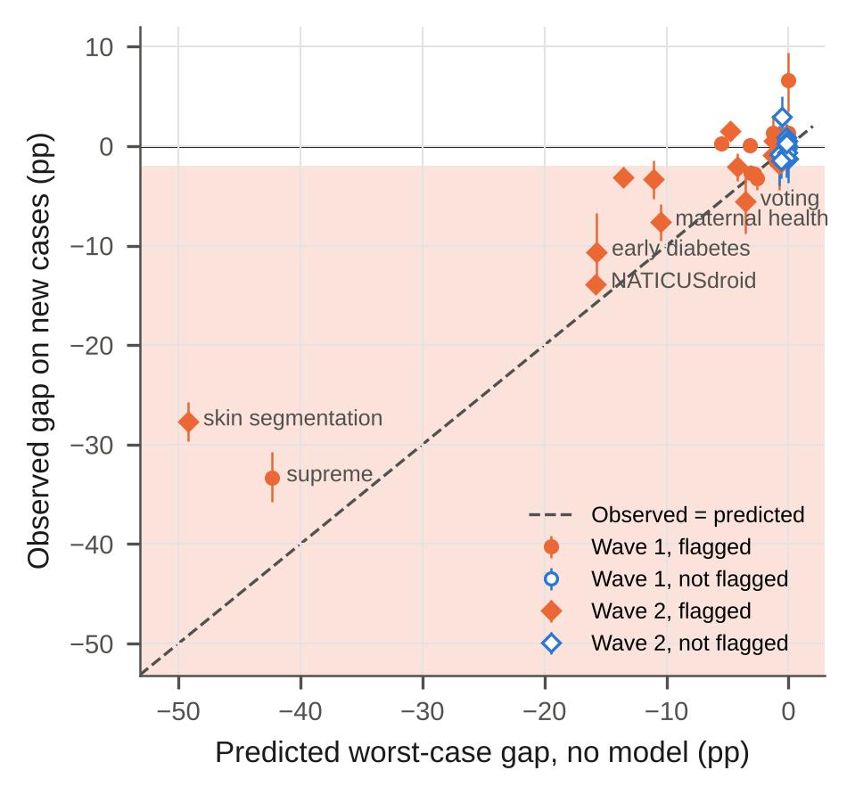
Fig. 5 On the 47 fresh data sets, every data set with a real shortfall (shaded, worse than $−2$ pp) was flagged by the check before training. Observed gap: the worse of random forest and LightGBM, mean over 20 splits with a 95% bootstrap interval. Filled markers: flagged; open markers: not flagged
Label purity mattered in both directions. In black_friday (63% of test rows seen), seattlecrime6 (99.9%) and superconduct (33%), repeated rows almost never agree on the exact target. Exposure alone predicts gaps of −17.1, −90.0 and −5.0 pp, while purity predicts none. The random forest’s gaps were +1.8, +6.7 and −0.9 pp. Over-coverage of new cases also has an explanation. On airlines, the predicted worst case was −5.5 pp but the observed gap was +8.7 pp. We had first attributed this to tied scores. The pre-specified tie-breaking test refuted that: with random tie-breaking, airlines’ gap stayed at +8.7 pp. Across the 26 highly exposed data sets, mean over-coverage fell only from 1.4 to 1.3 pp ($p$ = 0.008). The data point instead to the mirror image of memorization. Seen airlines rows were covered only 86.3% of the time, because identical flight profiles carry conflicting delay labels. By Eq. (2), new rows must then be over-covered (98.7%). Diabetes130US behaved the same way (seen 74.9%, new 94.2%).

6.2.0.5 H8: the safety margin.
With separate calibration, 4.2% of wave-1 splits had new-case coverage below 87% (random forest). With the safety margin this fell to 0.5%; in wave 2 it fell from 12.4% to 2.6%. Because most data sets had no unlucky splits at all, the planned wave-1 test was not significant after Holm correction ($p$ = 0.062). The margin enlarged sets by a factor of about 1.04.

6.2.0.6 H9: purity against exposure.
The advantage of purity over exposure alone for ranking was not established on wave 1 (difference in $ρ$, 95% CI −0.06 to 0.83). Its value lies in the screening decision, where it removes false alarms, as described above.

6.2.0.7 Is the variation just noise?
Post hoc. Under exchangeability, the coverage of a split follows a known Beta–binomial law given the numbers of new calibration and test rows. We simulated it for every fresh split and compared the expected number of bad splits with the observed number (Supplementary Table S6). For separate calibration with random forests, 84 bad splits were observed against 79 expected from pure noise (ratio 1.06, $p$ = 0.289). For standard calibration the ratio was 2.11 ($p$ < 0.001), so its shortfalls are real, not chance. LightGBM showed a small excess even with the fix (ratio 1.17, $p$ = 0.047), which we report but cannot explain with the data at hand.

6.3 Qualitative analysis
Post hoc. Table 5 shows mc1 test modules chosen by a fixed rule, never by hand. The rule takes the first seen module, the first four new modules in data-set order, the first new defective module and the first new module that the fix misses. The standard threshold is very strict (0.005) because most calibration rows are memorized copies with score zero. The new-case threshold of the fix is 0.073. Module 44 shows the typical repair: an empty set becomes a correct set. The failure cases are as instructive. The first new defective module receives an empty set from both methods.
Table 5 mc1 test modules chosen by a fixed rule (random forest, first random split, 90% target). LOC: lines of code; CC: cyclomatic complexity; $\hat{p}$: predicted defect probability; sets: N, no defect; D, defect; $∅$, empty. ✓/✗: set contains / misses the true label
Rule | Row | Type | LOC | CC | True | $\hat{p}$ | Standard | Fixed
(a) first seen | 3 | seen | 80 | 13 | no defect | 0.258 | $∅$ ✗ | $∅$ ✗
(b) first new | 44 | new | 16 | 2 | no defect | 0.010 | $∅$ ✗ | {N} ✓
(b) first new | 73 | new | 27 | 6 | no defect | 0.005 | {N} ✓ | {N} ✓
(b) first new | 89 | new | 13 | 3 | no defect | 0.005 | {N} ✓ | {N} ✓
(b) first new | 93 | new | 8 | 2 | no defect | 0.000 | {N} ✓ | {N} ✓
(c) first new defective | 2947 | new | 148 | 1 | defect | 0.184 | $∅$ ✗ | $∅$ ✗
(d) first miss of the fix | 305 | new | 106 | 1 | no defect | 0.105 | $∅$ ✗ | $∅$ ✗
This points to a limitation that matters for defect triage. Only 0.7% of mc1 modules are defective, so a coverage promise over all new modules says little about the defective ones. Over 10 splits, new defective modules (83 in total) were never covered, by standard calibration (0.0%) or by the fix (0.0%). Calibrating by seen/new and by class, which is label-conditional Mondrian calibration (Löfström et al. 2015; Vovk, Gammerman, and Shafer 2022), covered them 100.0% of the time. The cost is that most new modules then receive both labels (mean set size 1.90 against 0.93): the model admits that it cannot tell. For rare but important classes, the fix should therefore be combined with class-wise calibration.

6.4 Ablation study
Table 6 removes one part of the routine at a time. For the check, exposure alone flags 26 of the 47 fresh data sets and purity alone 15. The combined rule flags 26 and catches all 13 real shortfalls. Purity alone misses one, black_friday with a linear model, because a linear model cannot memorize rows and the shortfall there has a different cause. For the fix, removing separate calibration brings the shortfall back (Fig. 4). Robustness checks against the most obvious alternative explanations come next.
- Target level. The pattern holds at 80%, 90% and 95% (Fig. 4a).
- Tied scores. Random tie-breaking does not remove the effect (above).
- Hyperparameters. Making random forests less flexible lowered seen-row coverage, but the change in the gap was too small to detect at benchmark exposures (trend $p$ = 0.948). We therefore rely on the learner comparison of Fig. 3 for the role of flexibility.
- Near-copies. Copies with noise of 0.1% of a standard deviation are invisible to exact matching: the planted-leak test flagged 0% of them, but 100% of 2,541 exact copies with no false positives. The shortfall persisted: the random forest’s gap on truly new cases was −5.8 pp with exact copies and −4.3, −3.6 and −2.7 pp with noise of 0.1%, 1% and 10% of a standard deviation (Fig. 6). Calibration by distance stayed at the target (+0.5, +0.2, +0.1 and +0.5 pp at the four noise levels) and matched an oracle that knows the true record identity.
Table 6 Ablation of the check on the 47 fresh data sets, against the 13 data sets with a real shortfall (random forest or LightGBM gap below $−2$ pp). Flag rules: exposure only ($\overset{‾}{π}≥0.10$ or exposure-based gap below $−2$ pp); purity only ($g^{*}<−2$ pp); combined (either)
Flag rule | Flagged | Shortfalls caught | Correct no-flags | False alarms
Exposure only | 26 | 13/13 | 21/34 | 13
Purity only ($g^{*}$) | 15 | 12/13 | 31/34 | 3
Combined (used) | 26 | 13/13 | 21/34 | 13
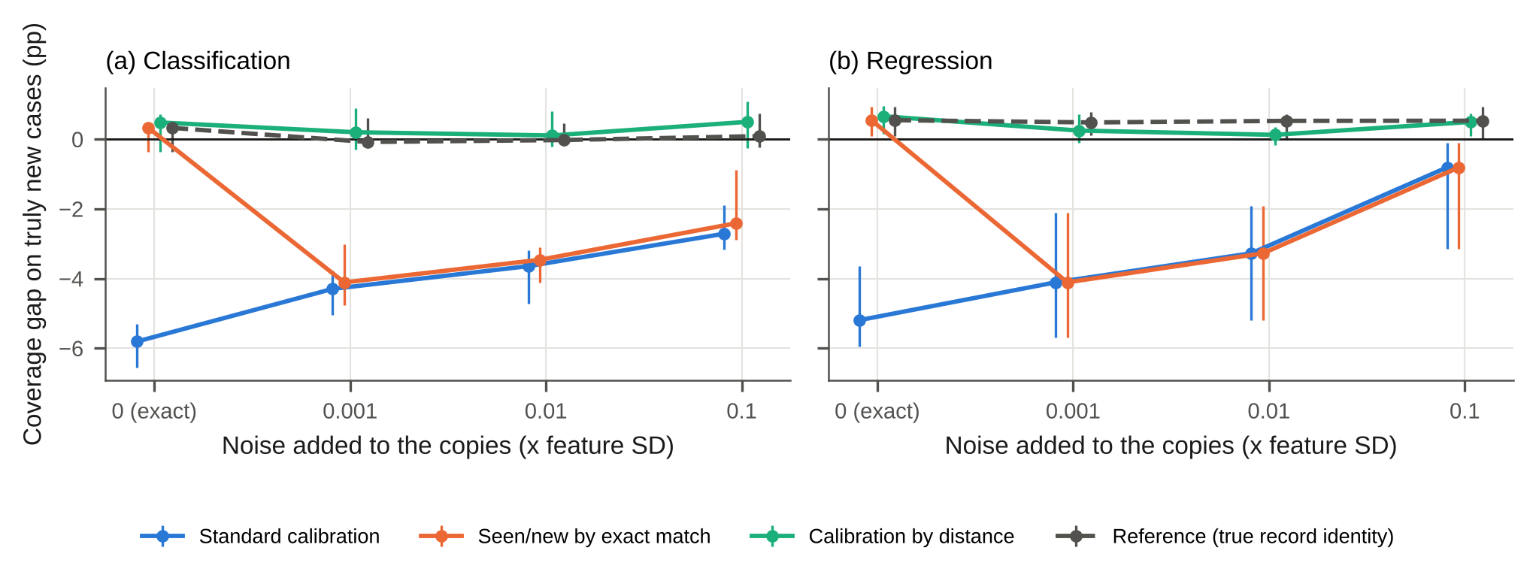
Fig. 6 Copies with a little noise defeat the exact-match check, and the shortfall persists; calibration by distance to the training rows stays on target and matches the oracle. Random forest, half of the rows copied, median over 37 data sets with 95% bootstrap intervals

6.5 Comparative analysis of remedies
Figure 7 and Table 7 compare six options on the twelve application data sets, with the same splits and random forests (pre-specified, exploratory). What matters is which rows the calibration uses. Every remedy that calibrates on new rows brings new-case coverage to the target, and standard calibration does not. Removing repeats works about as well for new cases (90.2% median), but it discards data: on mc1 the model is trained on 1,367 instead of 5,680 modules. It also gives seen cases the sets calibrated for new ones, so they are over-covered (96.8%) with larger sets (1.00 against 0.95 labels). A group split gives honest new-case coverage but says nothing about seen cases. On KDD Cup’99 it was infeasible in 4 of 10 splits, because a single group of identical connections exceeds the test part. Separate calibration keeps all data, works with any split and is valid for seen and new cases at once. In one small data set (mw1) fewer than nine seen calibration rows were available, so seen cases received the full set (Fig. 7b).
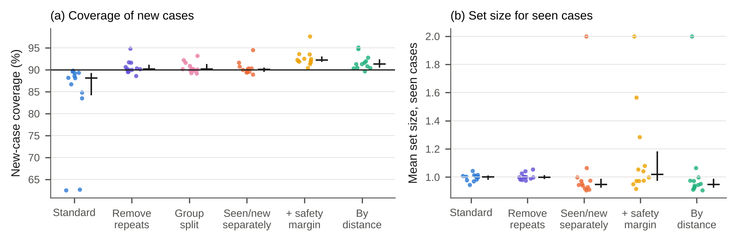
Fig. 7 Every remedy that calibrates on new rows reaches the target for new cases (a). Separate calibration does so without discarding data and gives seen cases smaller sets than removing repeats (b). Twelve application data sets, random forest, 10 splits; dots are data sets; black marks are medians with 95% bootstrap intervals. The three points at 2.0 in (b) are mw1, where too few seen calibration rows exist
Table 7 Remedies on the twelve application data sets (random forest, 90% target, 10 random splits). New-case coverage: median and worst data set. Seen: coverage and mean set size for test rows with a training copy. Data used: median share of training rows kept
Method | New-case coverage (%) |  | Empty sets | Seen cases |  | Data used
 | median | worst | new (%) | cov. (%) | size | (%)
Standard (no fix) | 88.1 | 62.5 | 1.2 | 96.8 | 1.00 | 100
Remove repeats, then calibrate | 90.2 | 88.6 | 1.4 | 96.8 | 1.00 | 74
Group split | 90.1 | 89.2 | 3.3 | – | – | 100
Seen/new calibrated separately | 90.1 | 88.9 | 1.0 | 92.7 | 0.95 | 100
+ safety margin ($δ=0.1$) | 92.2 | 90.4 | 0.0 | 97.2 | 1.02 | 100
Calibration by distance | 91.3 | 89.7 | 3.4 | 92.7 | 0.95 | 100

6.6 Computational complexity
The check hashes every row once and counts group sizes and label agreements. This is $O\left(N\right)$ hashing plus $O\left(NlogN\right)$ grouping, with memory linear in $N$. The fix adds one sort per group of calibration scores, $O\left(n_{C}logn_{C}\right)$, the same order as standard split conformal prediction. Table 8 gives measured times on the stated machine. The check took at most 0.46 s and 20 MB on 30,000 rows. Calibration with the fix took the same time as standard calibration (at most 0.43 against 0.36 s), because model inference dominates.
Table 8 Measured run time (median of five repetitions, seconds) and peak memory of the check, on 4 logical CPUs (Intel(R) Xeon(R) Processor @ 2.10GHz). Model: fitting the random forest once. Calibration times include model inference on the calibration rows
 |  |  | Check |  | Model | Calibration |  |  | Predict
Data | Rows | Feat. | s | MB | fit (s) | std | seen/new | distance | (s)
KDD Cup’99 | 30,000 | 41 | 0.46 | 20 | 1.05 | 0.36 | 0.43 | 0.54 | 0.41
mc1 | 9,466 | 38 | 0.12 | 8 | 0.80 | 0.22 | 0.25 | 0.26 | 0.21
Skin Segmentation | 30,000 | 3 | 0.15 | 4 | 0.70 | 0.19 | 0.24 | 0.23 | 0.24

6.7 Case study: the tool on NASA mc1
A practitioner who runs covercheck mc1.csv –target defective sees Fig. 8. The check takes 0.03 s and needs no model. It predicts a worst-case gap of −43.3 pp, because 81% of test modules will have a training copy with the same label, and it recommends the fix. The report then shows the problem directly: overall coverage of 91.7%, but 62.5% for new modules, 37% of which receive an empty set. With the fix, new modules are covered 90.4% of the time.
Real-world check of the tool. Post hoc. We ran the installed command-line tool, with its defaults, on 20 wave-2 data files downloaded fresh from the UCI repository. These were all wave-2 data sets with at most 30,000 rows, and the cached research pipeline was not used. The tool’s exposure equalled the pipeline’s to within ${10}^{−12}$. Its verdicts agreed with the paper’s rule on 20 of 20 files. Its new-case coverage agreed with the pipeline within two standard errors on 20 of 20 files (median difference 0.6 pp), although preprocessing and seeds differ.
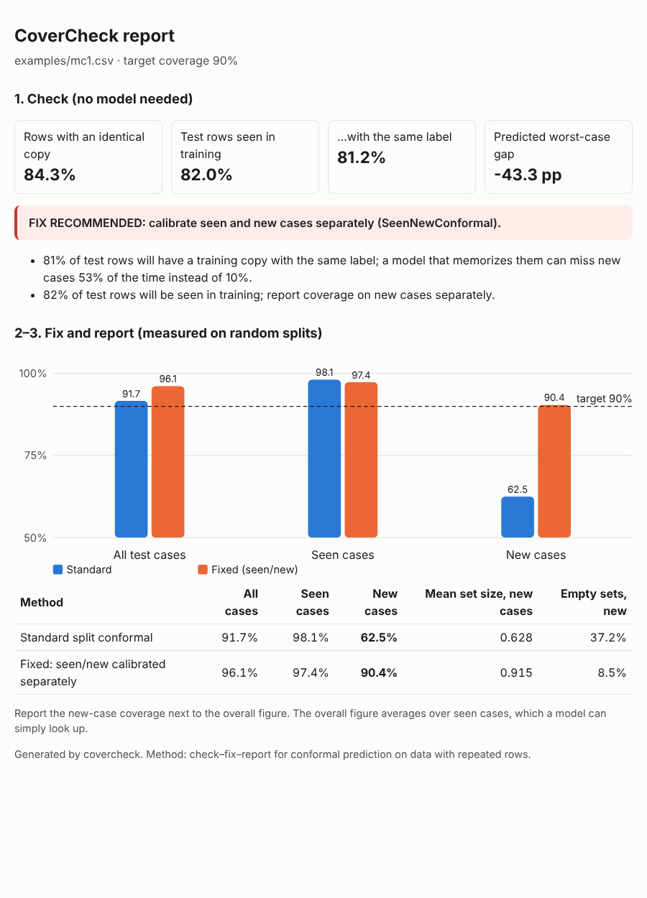
Fig. 8 The one-page report written by covercheck for the NASA mc1 defect data: the check before training, its verdict, and measured coverage on all, seen and new cases with and without the fix. Random forest, 10 random splits

6.8 Discussion

6.8.0.1 What a practitioner should do.
First, run the check before training. In our data, a predicted gap no worse than $−2$ pp together with fewer than 10% seen test rows meant that nothing needed to change; this rule was written down before the fresh data were analysed. Second, if the data set is flagged, calibrate seen and new cases separately. Add the safety margin when fewer than a few hundred new calibration rows exist, and use calibration by distance when near-copies are plausible. Third, report new-case coverage next to the overall figure. In defect triage, intrusion detection or clinical screening, the reported coverage decides how many cases go to manual review. An empty set for a new defect-prone module is a silent failure that no overall figure reveals.

6.8.0.2 Should one simply remove duplicates?
Not always. If the same input recurs in deployment, such as a frequent connection pattern, repeats are part of the population. Removing them discards data and gives over-cautious sets to recurring cases (Table 7). Separate calibration keeps the data and gives a valid promise for both kinds of case.

6.8.0.3 Limitations.
- Exact matching only. The check sees only identical feature vectors. Near-copies need calibration by distance (Fig. 6), and choosing a coarser match, such as rounding, is a modelling decision.
- The predicted gap is a limit and a screen, not a forecast. It did not rank the wave-1 data sets (H6). It also fails in both directions when Assumption A3 fails: a much larger shortfall when slightly differing repeats are still easy (solar_flare in the benchmarks), and over-coverage when seen rows with conflicting labels are hard (airlines).
- The typical benchmark is not affected (H1), and varying flexibility within one learner was inconclusive. The problem is real but concentrated, which is why a check is useful.
- Marginal over new cases, not per class. A promise over all new cases does not protect a rare class (mc1 defects). Class-wise calibration is needed there, at the cost of larger sets.
- Small calibration groups. With few new calibration rows, coverage varies from split to split. The safety-margin effect was not significant after correction (H8), and LightGBM showed a small excess of bad splits that we cannot explain.
- Same population. Coverage on held-out new rows equals coverage on future records only if they come from the same population. Distribution shift needs other tools (Tibshirani et al. 2019; Barber et al. 2023).
- Study conduct. Several analyses were added after results were seen and are labelled post hoc, and the plans were amended during the study (D1–D17). The work was done with substantial AI assistance (Sect. 5).

7 Conclusion and future scope

7.0.0.1 What was shown.
When tabular data contain repeated rows, the usual random-split check of conformal prediction can report 90% coverage while new cases are covered much less often: 62.7% on NASA mc1. A check that needs no model flagged every fresh data set with a real shortfall (13 of 13). With seen and new cases calibrated separately, new-case coverage never fell more than 2.5 points below the target on any of the 47 fresh data sets, at almost no cost. Most standard benchmarks are not affected, and the check says so.

7.0.0.2 What was not shown.
The predicted gap is a limit and a screen, not a forecast of the exact shortfall. The fix promises coverage over all new cases, not over each class. Exact matching misses near-copies. All evidence comes from random splits of public data sets, not from a deployed system.

7.0.0.3 Next steps.
- Extend the check from exact to near-identical records with a principled choice of matching resolution.
- Combine the seen/new split with class-wise calibration for rare classes.
- Test the routine on time-ordered deployments, where future records are new by construction.
- Integrate the check into common conformal libraries, so that new-case coverage is reported by default.

7.0.0.4 Acknowledgements
Use of AI tools: the study design, code, experiments, statistical analysis and drafting of this manuscript were carried out with substantial assistance from an AI system, as described in Sect. 5. The authors checked the work and take full responsibility for its content. [AUTHOR TO COMPLETE: other acknowledgements, added after review to preserve anonymity.]

Declarations

7.0.0.5 Funding
[AUTHOR TO CONFIRM: No funding was received for conducting this study.]

7.0.0.6 Competing interests
[AUTHOR TO CONFIRM: The authors have no relevant financial or non-financial interests to disclose.]

7.0.0.7 Ethics approval and consent to participate
Not applicable. The study uses only public, de-identified data sets and involves no human participants or animals.

7.0.0.8 Data availability
All data sets are public. OpenML data sets are identified by their OpenML identifiers and UCI data sets by their UCI identifiers in the Supplementary Material, which also lists every excluded data set with its reason.

7.0.0.9 Code availability
The method is available as the open-source Python package covercheck (MIT licence). The complete research pipeline is in a version-controlled repository with one command that reproduces every number, table and figure. [AUTHOR TO COMPLETE: archive the repository with a DOI (e.g. Zenodo) and provide an anonymized link for double-anonymous review.]

7.0.0.10 Author contributions
[AUTHOR TO COMPLETE, e.g. in CRediT format.]
Allamanis, M. 2019. “The Adverse Effects of Code Duplication in Machine Learning Models of Code.” In Proceedings of the 2019 ACM SIGPLAN International Symposium on New Ideas, New Paradigms, and Reflections on Programming and Software (Onward! 2019), 143–53. https://doi.org/10.1145/3359591.3359735.
Angelopoulos, A. N., and S. Bates. 2023. “Conformal Prediction: A Gentle Introduction.” Found Trends Mach Learn 16 (4): 494–591. https://doi.org/10.1561/2200000101.
Barber, R. F., E. J. Candès, A. Ramdas, and R. J. Tibshirani. 2023. “Conformal Prediction Beyond Exchangeability.” Ann Stat 51 (2): 816–45. https://doi.org/10.1214/23-AOS2276.
Barz, B., and J. Denzler. 2020. “Do We Train on Test Data? Purging CIFAR of Near-Duplicates.” J Imaging 6 (6): 41. https://doi.org/10.3390/jimaging6060041.
Bastani, O., V. Gupta, C. Jung, G. Noarov, R. Ramalingam, and A. Roth. 2022. “Practical Adversarial Multivalid Conformal Prediction.” In Advances in Neural Information Processing Systems 35, 29362–73. https://doi.org/10.52202/068431-2129.
Bischl, B., G. Casalicchio, M. Feurer, P. Gijsbers, F. Hutter, M. Lang, R. G. Mantovani, J. N. van Rijn, and J. Vanschoren. 2021. “OpenML Benchmarking Suites.” In Proceedings of the Neural Information Processing Systems Track on Datasets and Benchmarks 1.
Boström, H., and U. Johansson. 2020. “Mondrian Conformal Regressors.” In Proceedings of the Ninth Symposium on Conformal and Probabilistic Prediction and Applications, 128:114–33. PMLR.
Breiman, L. 2001. “Random Forests.” Mach Learn 45 (1): 5–32. https://doi.org/10.1023/A:1010933404324.
Deng, J. 2026. “When Identical Rows Disagree: From Benchmark Identifiability to Replication-Robust Anomaly Detection.”
Ding, T., A. N. Angelopoulos, S. Bates, M. I. Jordan, and R. J. Tibshirani. 2023. “Class-Conditional Conformal Prediction with Many Classes.” In Advances in Neural Information Processing Systems 36.
Dunn, R., L. Wasserman, and A. Ramdas. 2023. “Distribution-Free Prediction Sets for Two-Layer Hierarchical Models.” J Am Stat Assoc 118 (544): 2491–2502. https://doi.org/10.1080/01621459.2022.2060112.
Elangovan, A., J. He, and K. Verspoor. 2021. “Memorization Vs. Generalization: Quantifying Data Leakage in NLP Performance Evaluation.” In Proceedings of the 16th Conference of the European Chapter of the Association for Computational Linguistics, 1325–35. https://doi.org/10.18653/v1/2021.eacl-main.113.
Fischer, S. F., M. Feurer, and B. Bischl. 2023. “OpenML-CTR23 – a Curated Tabular Regression Benchmarking Suite.” In AutoML Conference 2023 (Workshop Track).
Foygel Barber, R., E. J. Candès, A. Ramdas, and R. J. Tibshirani. 2021. “The Limits of Distribution-Free Conditional Predictive Inference.” Inf Inference 10 (2): 455–82. https://doi.org/10.1093/imaiai/iaaa017.
Gibbs, I., J. J. Cherian, and E. J. Candès. 2025. “Conformal Prediction with Conditional Guarantees.” J R Stat Soc Ser B Stat Methodol 87 (4): 1100–1126. https://doi.org/10.1093/jrsssb/qkaf008.
Gijsbers, P., M. L. P. Bueno, S. Coors, E. LeDell, S. Poirier, J. Thomas, B. Bischl, and J. Vanschoren. 2024. “AMLB: An AutoML Benchmark.” J Mach Learn Res 25 (101): 1–65.
Gray, D., D. Bowes, N. Davey, Y. Sun, and B. Christianson. 2011. “The Misuse of the NASA Metrics Data Program Data Sets for Automated Software Defect Prediction.” In 15th Annual Conference on Evaluation & Assessment in Software Engineering (EASE 2011), 96–103. https://doi.org/10.1049/ic.2011.0012.
Grinsztajn, L., E. Oyallon, and G. Varoquaux. 2022. “Why Do Tree-Based Models Still Outperform Deep Learning on Typical Tabular Data?” In Advances in Neural Information Processing Systems 35 (Datasets and Benchmarks Track). https://doi.org/10.52202/068431-0037.
Guan, L. 2023. “Localized Conformal Prediction: A Generalized Inference Framework for Conformal Prediction.” Biometrika 110 (1): 33–50. https://doi.org/10.1093/biomet/asac040.
Hernandez-Hernandez, S., Q. Guo, and P. J. Ballester. 2026. “Conformal Prediction of Molecule-Induced Cancer Cell Growth Inhibition Challenged by Strong Distribution Shifts.” Pattern Recognit 172: 112501. https://doi.org/10.1016/j.patcog.2025.112501.
Holm, S. 1979. “A Simple Sequentially Rejective Multiple Test Procedure.” Scand J Stat 6 (2): 65–70.
Kapoor, S., and A. Narayanan. 2023. “Leakage and the Reproducibility Crisis in Machine-Learning-Based Science.” Patterns 4 (9): 100804. https://doi.org/10.1016/j.patter.2023.100804.
Kaufman, S., S. Rosset, C. Perlich, and O. Stitelman. 2012. “Leakage in Data Mining: Formulation, Detection, and Avoidance.” ACM Trans Knowl Discov Data 6 (4): 1–21. https://doi.org/10.1145/2382577.2382579.
Ke, G., Q. Meng, T. Finley, T. Wang, W. Chen, W. Ma, Q. Ye, and T. Y. Liu. 2017. “LightGBM: A Highly Efficient Gradient Boosting Decision Tree.” In Advances in Neural Information Processing Systems 30, 3146–54.
Kelly, Markelle, Rachel Longjohn, and Kolby Nottingham. 2026. “The UCI Machine Learning Repository.” https://archive.ics.uci.edu.
Lee, K., D. Ippolito, A. Nystrom, C. Zhang, D. Eck, C. Callison-Burch, and N. Carlini. 2022. “Deduplicating Training Data Makes Language Models Better.” In Proceedings of the 60th Annual Meeting of the Association for Computational Linguistics, 8424–45. https://doi.org/10.18653/v1/2022.acl-long.577.
Lei, J., M. G’Sell, A. Rinaldo, R. J. Tibshirani, and L. Wasserman. 2018. “Distribution-Free Predictive Inference for Regression.” J Am Stat Assoc 113 (523): 1094–1111. https://doi.org/10.1080/01621459.2017.1307116.
Lewis, P., P. Stenetorp, and S. Riedel. 2021. “Question and Answer Test-Train Overlap in Open-Domain Question Answering Datasets.” In Proceedings of the 16th Conference of the European Chapter of the Association for Computational Linguistics, 1000–1008. https://doi.org/10.18653/v1/2021.eacl-main.86.
Li, H. 2026. “Rows Are Not Samples: Duplicate Records, Evaluation Bias, and Ranking Distortion in Standard Tabular Benchmarks.” Zenodo (preprint, not peer reviewed). https://doi.org/10.5281/zenodo.23119065.
Löfström, T., H. Boström, H. Linusson, and U. Johansson. 2015. “Bias Reduction Through Conditional Conformal Prediction.” Intell Data Anal 19 (6): 1355–75. https://doi.org/10.3233/IDA-150786.
Morger, A., F. Svensson, S. Arvidsson McShane, N. Gauraha, U. Norinder, O. Spjuth, and A. Volkamer. 2021. “Assessing the Calibration in Toxicological in Vitro Models with Conformal Prediction.” J Cheminform 13: 35. https://doi.org/10.1186/s13321-021-00511-5.
Norinder, U., L. Carlsson, S. Boyer, and M. Eklund. 2014. “Introducing Conformal Prediction in Predictive Modeling. A Transparent and Flexible Alternative to Applicability Domain Determination.” J Chem Inf Model 54 (6): 1596–1603. https://doi.org/10.1021/ci5001168.
Papadopoulos, H., K. Proedrou, V. Vovk, and A. Gammerman. 2002. “Inductive Confidence Machines for Regression.” In Machine Learning: ECML 2002, 2430:345–56. Lecture Notes in Computer Science. https://doi.org/10.1007/3-540-36755-1_29.
Papadopoulos, H., V. Vovk, and A. Gammerman. 2011. “Regression Conformal Prediction with Nearest Neighbours.” J Artif Intell Res 40: 815–40. https://doi.org/10.1613/jair.3198.
Pedregosa, F., G. Varoquaux, A. Gramfort, et al. 2011. “Scikit-Learn: Machine Learning in Python.” J Mach Learn Res 12: 2825–30.
Romano, Y., R. F. Barber, C. Sabatti, and E. J. Candès. 2020. “With Malice Toward None: Assessing Uncertainty via Equalized Coverage.” Harv Data Sci Rev. https://doi.org/10.1162/99608f92.03f00592.
Romano, Y., E. Patterson, and E. J. Candès. 2019. “Conformalized Quantile Regression.” In Advances in Neural Information Processing Systems 32.
Romano, Y., M. Sesia, and E. J. Candès. 2020. “Classification with Valid and Adaptive Coverage.” In Advances in Neural Information Processing Systems 33.
Roth, S. 2026. “Which Leakage Types Matter? A Quantitative Landscape Across 2,047 Benchmark Datasets.”
Sadinle, M., J. Lei, and L. Wasserman. 2019. “Least Ambiguous Set-Valued Classifiers with Bounded Error Levels.” J Am Stat Assoc 114 (525): 223–34. https://doi.org/10.1080/01621459.2017.1395341.
Seo, J.-I., Y. E. Jeon, and Y. Kim. 2026. “Calibrated Mondrian Conformal Prediction for Uncertainty Quantification in Spatial Modeling.” Pattern Recognit 180: 114113. https://doi.org/10.1016/j.patcog.2026.114113.
Shepperd, M., Q. Song, Z. Sun, and C. Mair. 2013. “Data Quality: Some Comments on the NASA Software Defect Datasets.” IEEE Trans Softw Eng 39 (9): 1208–15. https://doi.org/10.1109/TSE.2013.11.
Sheridan, R. P. 2013. “Time-Split Cross-Validation as a Method for Estimating the Goodness of Prospective Prediction.” J Chem Inf Model 53 (4): 783–90. https://doi.org/10.1021/ci400084k.
Tareaf, R. B., M. Al-Rajab, S. Loucif, S. Ellaham, and C. Schmitz. 2026. “Target Leakage, Not Model Class, Explains Reported Accuracy in Survey-Based Cardiovascular Screening.”
Tavallaee, M., E. Bagheri, W. Lu, and A. A. Ghorbani. 2009. “A Detailed Analysis of the KDD CUP 99 Data Set.” In 2009 IEEE Symposium on Computational Intelligence for Security and Defense Applications, 1–6. https://doi.org/10.1109/CISDA.2009.5356528.
Tibshirani, R. J., R. F. Barber, E. J. Candès, and A. Ramdas. 2019. “Conformal Prediction Under Covariate Shift.” In Advances in Neural Information Processing Systems 32.
Vanschoren, J., J. N. van Rijn, B. Bischl, and L. Torgo. 2014. “OpenML: Networked Science in Machine Learning.” SIGKDD Explor 15 (2): 49–60. https://doi.org/10.1145/2641190.2641198.
Vovk, V. 2012. “Conditional Validity of Inductive Conformal Predictors.” In Proceedings of the Asian Conference on Machine Learning, 25:475–90. PMLR.
Vovk, V., A. Gammerman, and G. Shafer. 2022. Algorithmic Learning in a Random World. 2nd ed. Cham: Springer. https://doi.org/10.1007/978-3-031-06649-8.
Wilcoxon, F. 1945. “Individual Comparisons by Ranking Methods.” Biometrics Bull 1 (6): 80–83. https://doi.org/10.2307/3001968.
Zhang, R., and P. Zhou. 2026. “A Mondrian Conformal Predictive System with Improved Decision Trees for Uncertainty Quantification Under Heteroscedasticity.” Pattern Recognit 172: 112338. https://doi.org/10.1016/j.patcog.2025.112338.

