Forecasting a journal's time to acceptance under cohort shift: a calibrated, strictly out-of-time method evaluated on 774 journals
[Author names, affiliations, ORCID iDs and corresponding-author details to be supplied by the authors]

Abstract
Background: Authors and evaluators use a journal's recent time to acceptance to predict the wait for a new paper, but such forecasts are rarely scored against later outcomes, and the simplest is over-confident.
Methods: We used publisher-deposited received and accepted dates for 1,737,272 articles in 800 Springer Nature, Wiley and Taylor & Francis journals. Forecasts used only papers visible at each quarterly origin, and parameters learned from earlier data used only cohorts whose outcomes were complete at the origin. We propose CV0, which smooths a journal's last 12 months of durations by the cohort-to-cohort shift variance estimated from earlier cohorts, and compared it with empirical quantiles, width inflation, quantile recalibration and adaptive conformal updating over six origins (4,486 journal-origins). Hypotheses were prespecified; the duration cap was changed after the first run, so both caps are reported. The method, with parameters learned on the frame, was tested on 117 external PubMed journals.
Results: Journal history lowered forecast loss by 15.7% against pooled forecasts (two original origins). Under the strict protocol, empirical 80% intervals covered 1.9 points less than nominal, and the apparent shortfall depended on how slow papers were truncated (+2.2 to −2.4 points across caps of 270 days to none). CV0 moved coverage to +0.5 points and lowered mean absolute coverage error from 7.2 to 6.8 points (about 4.5 by chance), with lower pinball loss. It beat width inflation, recalibration and adaptive updating by about 0.3 points, but was better than F0 at 42% of journal-origins and worse at 38%, and over-covered Taylor & Francis journals. The pre-specified mechanism test was weak (r = 0.15) and failed at the 365-day cap. On external journals CV0 beat empirical quantiles at both caps but width inflation only at the 365-day cap. The 72-day calibration slope rose from 0.89 to 0.92.
Conclusions: A journal's recent history is a useful forecast whose intervals should be widened for cohort shift; learning the widening from earlier complete cohorts gives a small improvement that is not uniform across journals or publishers. Evaluations must handle truncation of slow papers. An open-source package and browser tool are provided.
Keywords: peer review; time to acceptance; probabilistic forecasting; calibration; distribution shift; conformal prediction; editorial process

Background
Journals advertise speed, and authors, funders and evaluators use a journal's past time to acceptance, usually a median or the share of papers accepted within a limit, to set expectations for the next paper. Reporting of such statistics is inconsistent and seldom accompanied by uncertainty [1, 2, 3], and aggregator pages already offer planning tools built on historical medians [4]. Whether a journal's own recent history is a calibrated forecast of the next paper, and how to correct it if not, is not settled by descriptive work on publication delay [5, 6, 7, 8, 9, 10, 11, 12, 13]. A registered plan for a PubMed-wide model of acceptance lag with a random training/test split exists [14]; its registration states that it was not preregistered, it was evaluated at MetaROR in April 2026, and we found no results in October 2026.
The statistical problem is forecasting under distribution shift with delayed outcomes. At the time of forecast, the papers that have been accepted are a biased sample (slow papers are not yet accepted), and papers submitted next may differ from those accepted recently in volume, mix and editorial practice. Conformal methods give distribution-free coverage under exchangeability, and extensions handle shift by weighting or by adaptively updating the miscoverage level [15, 16, 17]; they presuppose that coverage feedback is available, whereas here an outcome becomes known only after the paper is accepted, up to a year later.
We ask (RQ1) how much a journal's own history improves on pooled forecasts; (RQ2) how calibrated the simple empirical forecast is under a strictly out-of-time protocol, and how sensitive that conclusion is to the treatment of slow papers; (RQ3) whether a forecaster that estimates the cohort-to-cohort shift from earlier complete cohorts is better calibrated than empirical quantiles and than three standard corrections; (RQ4) whether the method transfers to journals of other publishers; and (RQ5) how reliable event probabilities such as 'accepted within 72 days' are. The study is empirical and makes no causal claims.

Methods

Data
Received and accepted dates are deposited in Crossref by Springer Nature, Wiley and Taylor & Francis. For each publisher we took the 1,000 ISSNs with most articles in 2023, merged print and online ISSNs and kept journals in which at least 80% of 40 random 2023 records carried both dates and the number of dated 2023 articles was 150–3,000 (802 entries, 800 distinct journals). All records published from 1 January 2021 to 20 October 2026 were downloaded. The estimand is D, days from received to accepted, conditional on acceptance. After cleaning (duplicate DOIs, D < 1 or > 1,460 days, acceptance more than seven days after first online publication, non-research items by title or fewer than five references), 1,737,272 of 1,829,907 records remained; median D was 124 days. Journals were assigned to an imprint by the modal DOI prefix. External data were PubMed History received and accepted dates of 127 journals of other publishers (Elsevier, Cell Press, Oxford and Cambridge University Presses, PLOS and society journals; none from Springer Nature, Wiley, Taylor & Francis or MDPI), selected by a journal list fixed in the collection script before any records were fetched, and kept if at least 600 dated records were returned (121 journals; 310,288 clean records). PubMed entry date served as the first-online date.

Forecasting protocol and the strict out-of-time rule
Origins are quarterly. At an origin t0 the visible set of a journal is its papers first online within the preceding 12 months and already received and accepted before t0. The target is the set of papers received in the following 91 days. A journal-origin is evaluated with at least 100 visible and 30 target papers. Durations are capped at 480 days for training and scoring (see Results for why the cap matters). A method at origin t0 may use for learning only earlier origins o whose targets were complete at t0, that is o + 91 + 480 days ≤ t0; with the data ending on 20 October 2026 the evaluation origins are 1 October 2023 to 1 January 2025 (six origins, with one to six earlier complete origins). This rule prevents information about outcomes that would not yet have been known from reaching any forecast. The first Part D run used a 365-day cap and nine origins; it is reported alongside (see Order of events).
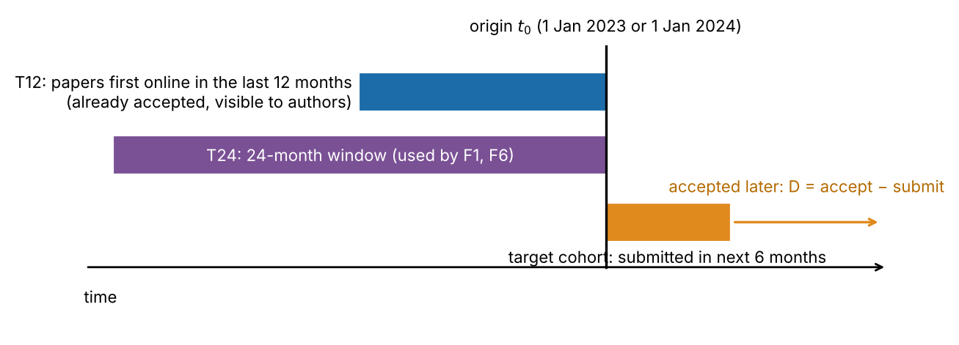
Figure 1. Conceptual schematic (not data) of the out-of-time protocol: forecasts use only the visible training set at the origin and are scored against papers received afterwards; parameters use only earlier cohorts whose outcomes are complete.

Forecasters
All forecasts are for the 0.1, …, 0.9 quantiles of ln D. F0: empirical quantiles of the visible 12-month sample (Hazen definition [18]). F6: exponentially time-decayed quantiles (half-life 182.5 days). V: half-widths about the median multiplied by one constant (grid 1.000 to 1.400 in steps of 0.025) that gives 80% pooled coverage on earlier complete origins. R: F0 with quantile levels replaced through the empirical distribution of probability-integral-transform values on earlier complete origins. ACI: adaptive update of the miscoverage level of the F0 80% interval, α ← α + γ(0.20 − m), with γ = 0.05 and m the pooled miscoverage on each earlier complete origin in time order [15]; it yields an interval only. F2, publisher-pooled quantiles that ignore journal identity, is a deliberately weak baseline used to measure the value of journal information.
CV0 (proposed). Let y_1, …, y_n be the visible ln-durations, s² their variance. The predictive distribution is G(q) = (1/n) Σ Φ((q − y_i)/h) with h² = τ² + s²/n; quantiles are found by bisection. The term s²/n is the sampling variance of the journal's location; τ² is the variance of the location shift between the visible sample and the next cohort. τ² is estimated per publisher from earlier complete origins by the method of moments, τ̂² = max(0, Var_j(Δ_j) − mean_j(s²_tr/n_tr + s²_te/n_te)), where Δ_j is the difference between the mean ln-duration of the realised target cohort and of the visible sample of journal-origin j. CV0 is thus the empirical forecast convolved with a normal location shift. Variants: CVb adds the publisher-mean shift of Δ to the visible sample; CVg uses one τ̂² for all publishers.

Metrics, hypotheses and inference
Primary metrics: (a) the journal-mean absolute error of 80% interval coverage, |coverage − 0.80|; (b) mean pinball loss over nine quantile levels [19, 20]; (c) the mean 80% interval score [21]. Because a journal-origin has 30 or more target papers, the absolute coverage error has an irreducible sampling component. Under exchangeability (visible and target samples drawn from the same distribution, simulated by bootstrapping each visible sample at the observed sizes) its expectation is 4.5 points; the binomial error of the target alone gives a lower bound of 3.6 points. We report errors relative to the simulated value. Hypotheses fixed before the run: HD1, CV0 has lower absolute coverage error than F0; HD2, CV0's pinball loss is not more than 0.5% above F0's; HD3, CV0's pooled signed coverage lies within ±1.5 points of 80%; HD4, CV0 has lower absolute coverage error than each of V, R and ACI (Holm adjusted); HD5, the shortfall predicted for each journal-origin from CV0's distribution with earlier-cohort τ̂², G(q90_F0) − G(q10_F0) − 0.80, correlates positively with the observed shortfall across journals; HD6, with parameters frozen from the frame, CV0 has lower absolute coverage error than F0 and V on external journals. Uncertainty used journal-cluster bootstraps (3,000 draws, journal averaged first), t intervals with 6 degrees of freedom on the means of the seven imprints, publisher-level sign checks, and a moving-block bootstrap (block length 2) over the ordered origins [22, 23].

Order of events and amendments
The cycle-3 protocol (Part D), the external journal list and the code were committed to the project's git history before any Part D result existed; this is a pre-specification by the analyst, not a registered report. Two programming errors and one arithmetic slip stopped runs before any output and were corrected. After the first complete run (cap 365 days; nine origins), the pre-specified HD5 failed and CV0 over-covered by 1.2 points. An exploratory sensitivity analysis then showed that F0's shortfall depends on the cap, because a capped value lies inside the interval of any journal whose upper quantile reaches the cap, so a short cap inflates coverage. The analysis was therefore repeated with a 480-day cap (amendment D-A2, committed before any cap-480 result), which is the primary analysis here; the cap-365 results are reported alongside. The choice of 480 days was made from the cap sensitivity of F0 alone, but the cap-365 outcomes (HD5 failed, CV0 over-covered) had been seen, and a 480-day cap had been used on the same frame data in an earlier cycle. The hypotheses are therefore pre-specified and the cap is a post-hoc design choice: we treat both caps as co-primary evidence and call a result confirmed only where it holds at both. Analyses after the review of the manuscript (the exchangeable-null floor, paper-weighted coverage, win/tie/loss counts, a τ² = 0 ablation, Brier-score intervals, the external outlier sensitivity and the external run at cap 365) are post hoc and labelled as such. Earlier cycles of this project are documented in the repository; their results on dependence, article-level covariates and drift are not repeated here.

Use of AI
The analysis code, the package and drafts of this manuscript were produced with an AI system (Claude, Anthropic) acting as an autonomous research assistant in a sandboxed environment; separately launched instances of the same model family performed adversarial reviews, a prior-art search and reproducibility audits. No human expert has reviewed the work.

Results

Journal history has value, and the shortfall of empirical intervals (RQ1, RQ2)
Between-journal differences explained 26.5% of the variance of ln D (95% CI 24.7%–28.3%); 69.1% lay between articles within a journal. On the two original origins (1,531 journal-origins, 781 journals, 298,469 target papers; 182-day targets), journal-specific empirical forecasts lowered pinball loss by 15.7% relative to publisher-pooled forecasts, and their 80% intervals covered 77.0% of later papers (journal average), −3.0 points from nominal. In the strict six-origin analysis (774 journals, 4,486 journal-origins, 482,065 papers) F0 gave −1.9 points (journal-cluster CI −2.3 to −1.5); paper-weighted it was −2.7 points; by origin the shortfall ranged from −1.3 to −2.5 points, and it was negative in all three publishers (−2.1 Springer Nature, −2.0 Wiley, −0.7 Taylor & Francis).
The size of the shortfall depended strongly on the treatment of slow papers (Figure 2a). At origins where every setting had complete targets, F0's signed coverage error with 91-day targets was +2.2 points with a 270-day cap, −0.9 with 365, −2.0 with 480 and −2.4 with no cap, whereas 182-day target cohorts gave the same values within 0.2 points. A cap sets slow papers to the cap value, which lies inside the interval of every journal whose upper quantile reaches it. Evaluations of turnaround forecasts on capped or censored durations can therefore overstate calibration; we use a 480-day cap, whose estimate differs from the 1,460-day cap by about 0.4 points (the intervals overlap), and report the 365-day results as co-primary. This sensitivity clips training and target durations together, so it does not separate their effects, and the 1,460-day setting is right-censored at the end of the data.
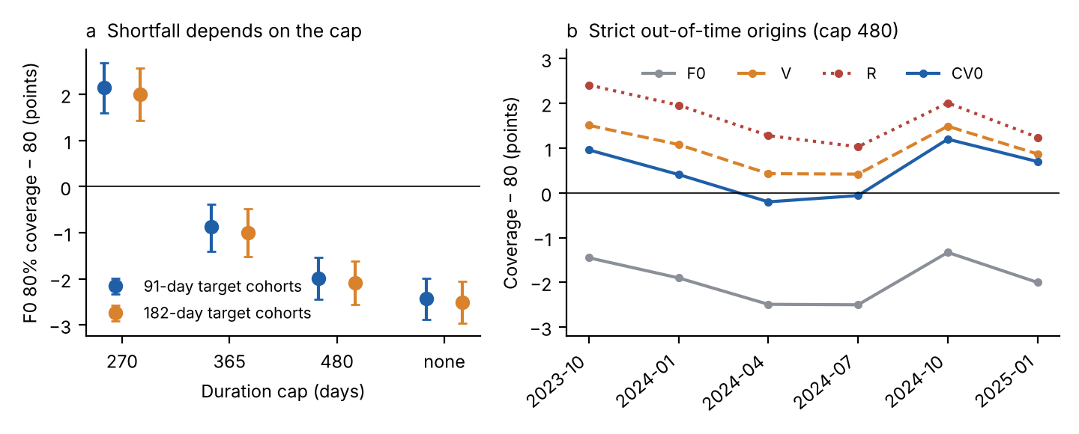
Figure 2. (a) Coverage error of the empirical 80% interval (F0) as a function of the duration cap, for 91- and 182-day target cohorts (exploratory analysis, origins 2023-07 to 2024-07; journal-cluster 95% CIs). (b) Signed coverage error by origin for F0, constant width inflation (V), quantile recalibration (R) and the proposed CV0 in the primary strict analysis.

A cohort-shift forecaster improves calibration modestly (RQ3)
Table 1. Strict out-of-time evaluation, cap 480 days (6 origins, 774 journals, 4,486 journal-origins, 482,065 papers). Expected absolute error under exchangeability 4.5 points (binomial lower bound 3.6).
Forecaster | Signed coverage − 80 (points) [CI] | Mean |coverage − 80| (points) [CI] | Pinball loss | Interval score | Width (ln-days)
F0 empirical | −1.9 [−2.3, −1.5] | 7.18 [6.88, 7.49] | 0.2026 | 2.409 | 1.58
F6 time-decayed | −1.5 [−1.9, −1.1] | 6.96 [6.68, 7.25] | 0.2019 | 2.398 | 1.59
V width inflation | +1.0 [+0.6, +1.4] | 7.05 [6.79, 7.32] | 0.2027 | 2.413 | 1.70
R recalibration | +1.7 [+1.3, +2.1] | 7.03 [6.79, 7.28] | 0.2024 | 2.400 | 1.70
ACI adaptive α | −1.5 [−1.9, −1.0] | 7.11 [6.82, 7.42] | – | 2.409 | 1.60
CV0 (proposed) | +0.5 [+0.1, +0.9] | 6.75 [6.51, 7.02] | 0.2024 | 2.403 | 1.68
CVb (CV0 + mean shift) | +1.0 [+0.6, +1.4] | 6.71 [6.48, 6.97] | 0.2022 | 2.400 | 1.68

CV0 moved signed coverage from −1.9 to +0.5 points (CI +0.1 to +0.9), within the ±1.5 points of HD3, and reduced the mean absolute coverage error from 7.18 to 6.75 points, a difference of −0.42 points (journal-cluster CI −0.54 to −0.30; imprint-level t(6) CI −0.70 to −0.02; negative in 3 of 3 publishers and 6 of 7 imprints; moving-block CI over origins −0.57 to −0.28) (HD1). Relative to the 4.5 points expected under exchangeability, CV0 removed 16% of F0's excess error. This is a modest gain, because most of the per-journal error is sampling noise from 30 to a few hundred target papers. It is not uniform: CV0 had lower absolute error than F0 at 42% of the 4,486 journal-origins, equal at 20% and higher at 38%; paper-weighted its signed coverage was −0.2 points; and it over-covered Taylor & Francis journals by +2.0 points (F0: −0.7), outside the ±1.5 points of HD3, while Springer Nature and Wiley were at +0.5 and +0.1. Only the 80% interval was assessed. Pinball loss did not increase (lower by 0.0003 ln-days, −0.14%; CI −0.15% to −0.09%) and the interval score fell by 0.007 (CI -0.009 to -0.004) (HD2).
Table 2. Contrasts of CV0 with the comparators on absolute coverage error (negative favours CV0). Journal-level p values treat journals as independent and are optimistic; the imprint-level intervals are the more conservative statement.
Contrast in mean |coverage − 80| (points) | Difference [journal-cluster 95% CI] | Imprint t(6) 95% CI | Publishers with same sign | Holm p (journal level, optimistic)
CV0 − V width inflation | −0.30 [−0.39, −0.21] | [−0.45, −0.12] | 3/3 | <0.001
CV0 − R recalibration | −0.28 [−0.38, −0.17] | [−0.47, −0.13] | 3/3 | <0.001
CV0 − ACI adaptive α | −0.36 [−0.47, −0.26] | [−0.58, −0.07] | 3/3 | <0.001
CV0 − F0 | −0.42 [−0.54, −0.30] | [−0.70, −0.02] | 3/3 | –

CV0 had lower absolute coverage error than width inflation, recalibration and adaptive conformal updating (HD4; Table 2), by about 0.3 points. ACI is effectively F0 here: with γ = 0.05 and pooled miscoverage errors of a few points, its level moved by about 0.001 per earlier origin (α = 0.193 at the last origin), so it should be read as a test of a tiny update rather than of conformal methods in general. V and R apply one pooled correction to all journals, whereas CV0 adds each journal's own sampling variance to the learned shift. An ablation (post hoc) shows that the learned shift is what matters: smoothing with the sampling variance alone (τ² = 0) gave signed coverage −2.5 points and absolute error 7.09, like F0, whereas one constant τ² of 0.040 for all publishers gave +0.5 points and 6.73, the same as the publisher-specific τ̂² (6.75); publisher-specific values add nothing, and the shipped tool uses the global value. The time-decayed F6 had slightly lower pinball loss (0.2019 vs 0.2024) and interval score (2.398 vs 2.403) than CV0 while under-covering (−1.5), so a combination of the two is a natural next step. The mean-shift variant CVb had similar absolute error (6.71). The fitted τ̂² were 0.041 (Springer Nature), 0.038 (Wiley) and 0.041 (Taylor & Francis) log-days squared when learned from all complete cohorts, so a typical cohort mean moves by about 0.20 ln-units (roughly 22%) between the visible sample and the next cohort.

Does the mechanism hold? (HD5)
The shortfall that CV0's own distribution predicts for F0, computed with τ̂² from earlier complete cohorts only (so not circular), correlated with the observed shortfall across journals (r = 0.15, journal-cluster CI 0.03 to 0.26; Spearman 0.20), and the observed-on-predicted slope was 0.46 (CI 0.09 to 0.94; Figure 3a). The prediction was directionally right but too large (mean predicted −3.2 vs observed −1.9 points), so the model overstates the shift variance that matters for coverage, and the relation is weak. In the first run with a 365-day cap the same pre-specified test failed (r = -0.12). The criterion (r > 0) is lenient, the sign depends on the cap, and the 'cohort shift' estimated here also contains differences of definition between the visible set (selected by first-online date and prior acceptance) and the target (selected by received date), including truncation of slow papers; the positive mean shifts that CVb adds point the same way. We therefore do not regard the mechanism as established.
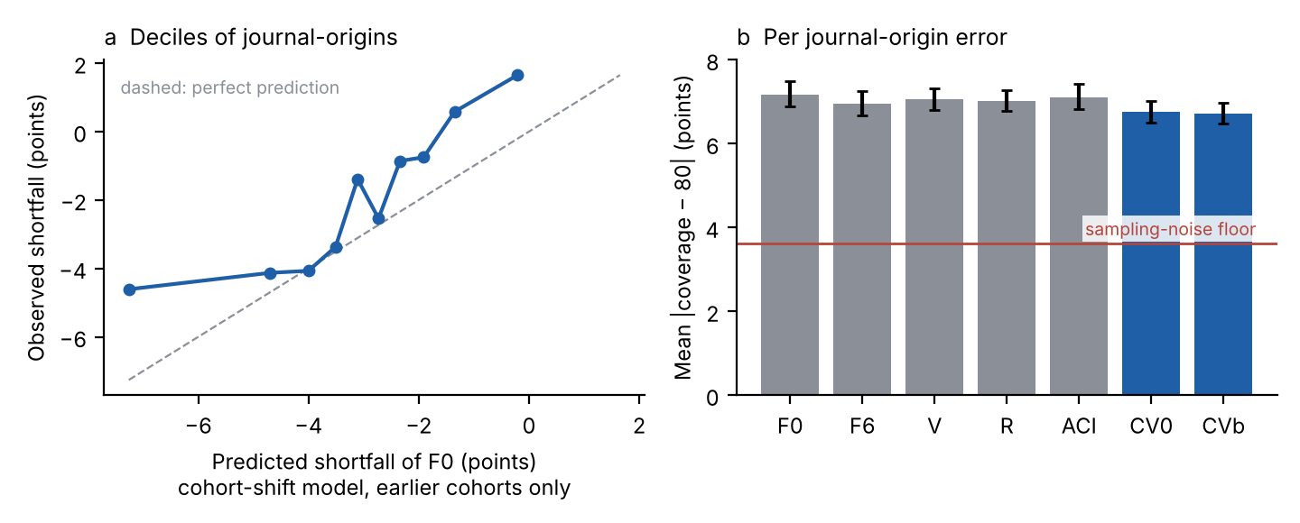
Figure 3. (a) Observed against predicted shortfall of F0, by decile of journal-origins (predictions use only earlier complete cohorts). (b) Mean absolute coverage error by forecaster with journal-cluster 95% CIs; the line is the expected error under perfect calibration given the target sizes.

Event probabilities and 'within X days' claims (RQ5)
Table 3. Brier-type score (mean squared error between the forecast probability and the realised share of each journal-origin) and calibration slope (realised share regressed on forecast probability; 1 is perfect), journal-origins as in Table 1. Slopes below 1 partly reflect error in the forecast probabilities.
Event D ≤ T | F0: Brier / slope | CV0: Brier / slope | CVb: Brier / slope
72 days | 0.00915 / 0.89 | 0.00900 / 0.92 | 0.00853 / 0.94
120 days | 0.01384 / 0.91 | 0.01330 / 0.96 | 0.01305 / 0.96
180 days | 0.01285 / 0.90 | 0.01217 / 0.94 | 0.01229 / 0.92

Empirical probabilities of acceptance within 72, 120 and 180 days were too extreme (slope 0.89, 0.91 and 0.90); CV0 lowered the Brier-type scores (differences from F0 -0.00015, -0.00053 and -0.00064; journal-cluster CIs excluding zero at all three horizons) and moved the slopes towards one (Table 3); CVb was lowest at 72 and 120 days and CV0 at 180 days. On the original origins, 12.0% of 1,531 journal-origins accepted at least half of their papers within 72 days and 1.6% at least 80% (journal-cluster CIs 9.9%–14.2% and 0.9%–2.4%); the shares fell to 9–13% after excluding fast-lane journals, batch acceptances and low-reference articles, so a claim that a journal accepts most papers within 72 days describes a minority of journals.

External validation (RQ4)
Table 4. External journals (117 journals, 652 journal-origins, 74,787 papers) with parameters learned on frame data only (the frame's complete earlier cohorts at each origin; nothing is re-fitted to the external journals).
Forecaster | Signed coverage − 80 (points) [CI] | Mean |coverage − 80| (points) [CI] | Pinball loss | Interval score
F0 empirical | −2.0 [−3.3, −0.8] | 7.40 [6.44, 8.54] | 0.2108 | 2.526
F6 time-decayed | −1.6 [−2.9, −0.5] | 7.05 [6.15, 8.14] | 0.2101 | 2.518
V width inflation (frame c) | +1.0 [−0.3, +2.1] | 7.14 [6.25, 8.19] | 0.2109 | 2.533
CV0 (global frame τ²) | +1.1 [−0.1, +2.2] | 6.90 [6.05, 7.90] | 0.2105 | 2.519
CVb (frame τ², mean shift) | +1.3 [+0.2, +2.4] | 6.91 [6.10, 7.86] | 0.2104 | 2.516

On 117 journals of publishers outside the frame (652 journal-origins, 74,787 papers), F0 under-covered by 2.0 points (CI −3.3 to −0.8 on the signed scale), close to the 1.9 points in the frame. With the frame's pooled τ̂² applied unchanged, CV0 had lower absolute coverage error than F0 (−0.50 points; CI −0.91 to −0.11) and slightly lower pinball loss (difference -0.00025; CI -0.00044 to -0.00008), but its difference from width inflation with the frame's constant was −0.25 points (CI −0.51 to 0.03), compatible with zero. HD6, which required superiority over both F0 and V, is therefore supported against F0 and not against V. The signed coverage of CV0 and V was +1.1 and +1.0 points; the Brier-type score for the 72-day event improved (0.01105 to 0.01088; slope 0.87 to 0.90). Two caveats limit this result. Five journals (Int J Biol Macromol, J Hazard Mater, Food Chem, Biochem Pharmacol, Bioresour Technol) had F0 coverage 20 to 37 points below nominal and account for about half of the mean shortfall; without them F0 was −0.9 points, CV0 +2.0 (over-covering), and the differences of CV0 from F0 and V were −0.32 (CI −0.68 to 0.05) and −0.17 (CI −0.43 to 0.10) points, both compatible with zero (post hoc). At the 365-day cap (119 journals, 992 journal-origins, 117,142 papers) CV0 was better than both F0 (−0.63; CI −0.95 to −0.33) and V (−0.49; CI −0.76 to −0.24), so HD6 holds at that cap. The external set is a non-random list of high-volume journals, the first-online date is a PubMed entry-date proxy, and the intervals are wide.
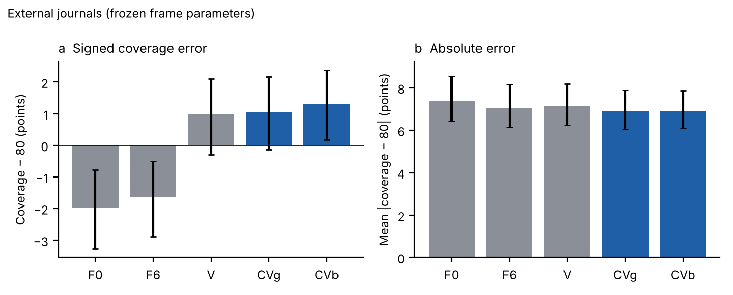
Figure 4. External validation: signed (a) and absolute (b) coverage error with parameters learned on the frame; journal-cluster 95% CIs (cap 480).

The first complete run (cap 365 days)
Table 5. Pre-specified hypotheses and outcomes at the two caps (both co-primary; see Order of events). A result is regarded as confirmed only where it holds at both.
Hypothesis | Cap 480, six origins | Cap 365, nine origins
HD1 CV0 lower absolute error than F0 | −0.42 [−0.54, −0.30]: supported | −0.37 [−0.47, −0.26]: supported
HD2 pinball not > 0.5% above F0 | −0.14%, upper CI −0.09%: supported | −0.11%, upper CI −0.01%: supported
HD3 signed coverage within ±1.5 points | +0.5 [+0.1, +0.9]: supported pooled; Taylor & Francis +2.0 | +1.2 [+0.8, +1.6]: point estimate within, CI upper bound beyond
HD4 lower error than V, R, ACI | all three supported | all three supported
HD5 predicted vs observed shortfall, positive | r = 0.15: weakly supported | r = -0.12: not supported
HD6 external: lower error than F0 and V | vs F0 supported; vs V −0.25 [−0.51, 0.03]: not supported | vs F0 −0.63 [−0.95, −0.33]; vs V −0.49 [−0.76, −0.24]: supported

Validity of the received date
Of 4,018 Springer Nature articles with a Research Square preprint, 95% were received no later than 14 days after the preprint was posted (journal-weighted 82%) and 2.6% more than 90 days after. The pre-set criterion of 70% within ±14 days was not met (47%), because these preprints are posted about two weeks after receipt; the other two statistics are post hoc and show compatibility, not confirmation, with the received date being the original submission date, within a resolution of 14 days. For Wiley and Taylor & Francis the probe is uninformative.

Software
The method is implemented in an open-source Python package (turnaround_forecast) with command-line interface and tests, including a test that reproduces the pipeline's CV0 quantiles for more than 20 journal-origins, and in a self-contained browser tool that runs the same formulas locally and checks 'accepted within X days' claims against the forecast. The shipped τ̂² is the global value (0.040 log-days squared; CVg, which performed like CV0 in the frame) and was learned from all quarterly cohorts from 2022-01 to 2025-01, whose outcomes are complete.

Discussion
A journal's own last year of papers is a useful forecast of its next papers, worth about 16% of loss over ignoring journal identity within a publisher, but its 80% intervals are too narrow by about two points of coverage once slow papers are handled properly, and its event probabilities are too extreme. Widening the forecast by the cohort-to-cohort shift variance estimated from earlier complete cohorts moves the average coverage of the 80% interval to nominal and improves the Brier-type scores, with no loss of pinball loss or interval score. The improvement over simpler corrections is small, about 0.3 points of absolute coverage error against about 4.5 points expected from sampling alone; CV0 was better than F0 at only 42% of journal-origins; it over-covers Taylor & Francis journals; and on external journals it beat constant width inflation at one cap but not the other. Only the 80% interval was assessed. We think the practical message is less 'use CV0' than 'a journal's turnaround distribution should be widened for cohort shift, and the widening can be learned from the journal's peers using only information that is complete at the time'; a simple constant τ² performs as well as publisher-specific values.
Two methodological points have wider use. First, evaluations that cap or censor slow papers can show calibrated intervals where the uncensored intervals are not, because capped values fall inside any interval whose upper quantile reaches the cap; our cap sensitivity moves the same forecaster's apparent coverage by more than four points. Second, parameters that correct coverage must be learned from cohorts whose outcomes are complete at the origin; a first-pass recalibration in an earlier cycle of this project that used cohorts not yet complete looked better than it was. Conformal updating with delayed feedback is a natural extension we did not tune: with a single global level it barely moved the pooled coverage.
For authors and evaluators, statements of the form 'X% of papers are accepted within T days' should give the cohort (accepted or submitted), the period, the treatment of article types with fast lanes and an uncertainty interval; the browser tool shows how far such a claim moves when the forecast is calibrated. The results concern published, accepted papers and say nothing about the probability that a submission is accepted.

Limitations
- Conditioning on acceptance: only accepted papers have dates; rejected and withdrawn submissions are unobserved.
- Date semantics: received dates are publisher-defined and validated only for Springer Nature journals through Research Square preprints; the external journals use PubMed History dates and an entry-date proxy for first-online date.
- Frame and effect size: three publishers (the highest-level clusters), journals with about 150–3,000 dated articles per year; the external set is a non-random list of high-volume journals. The improvement of CV0 over simpler corrections is small and, on external journals, not distinguishable from width inflation; the mechanism test (HD5) is weakly supported at cap 480 and failed at cap 365, and the model overstates the size of the shortfall.
- Design history: the cap-480 analysis follows an amendment made after the first full run, after its outcomes were seen; both caps are reported as co-primary. Parameters were learned from one to six earlier cohorts at the evaluation origins; τ̂² estimated from more cohorts may differ. A duration cap of 480 days still biases coverage slightly relative to no cap.
- Inference: journal-cluster intervals treat journals as independent and are optimistic, and the very small journal-level p values should not be read literally; the seven imprints are nested in three publishers, one is a residual 'other' group, and Holm adjustment was applied only to the journal-level p values; a block bootstrap over six ordered origins is indicative only. Origins overlap in information.
- Strictness: 'strictly out-of-time' refers to the fitted parameters. The cap, the 12-month window, γ and the width grid were fixed by us on the same data, completeness is defined by acceptance rather than by what was publicly observable, and the frame and eligibility rules use information from after the origins. Journal-averaged and paper-weighted coverage differ (F0 −1.9 vs −2.7; CV0 +0.5 vs −0.2), and the exchangeability floor does not account for dependence within cohorts such as batch acceptances.
- Comparators: ACI was run with one untuned small step size and is effectively the empirical forecast here; no other online or weighted conformal method was run, and a combination of CV0 with time decay was not tried.
- Process: the whole study was carried out by AI instances with automated reviews and audits and no human review; novelty is stated as 'we found no' because the literature search was not systematic.
- Scope: the study concerns editorial-process statistics, not peer review itself.

Conclusions
A journal's recent acceptance times are a useful but over-confident forecast of its next papers. Estimating the cohort-to-cohort shift from earlier complete cohorts and widening the forecast accordingly improves calibration modestly and consistently in a strictly out-of-time evaluation and transfers to external journals against empirical quantiles, though not clearly against constant width inflation. Evaluations of turnaround forecasts should treat slow papers explicitly, and turnaround statistics should be reported as quantiles for explicit cohorts with uncertainty.

Abbreviations
CV0, cohort-shift smoothed empirical forecaster; F0–F6, V, R, ACI, comparator forecasters defined in Methods; D, days from received to accepted; CI, confidence interval.

Declarations
Ethics approval and consent to participate: not applicable; the study analyses public article metadata.
Consent for publication: not applicable.
Availability of data and materials: raw Crossref and PubMed records, processing code, configuration, the package and all results are in the project repository (https://github.com/Bhargavteja-9779/rp_c_8, branch claude/autonomous-research-institute-nz8co5), which is not yet archived with a persistent identifier; a DOI-bearing deposit (for example Zenodo) must be created before submission. Live API data change over time; SHA-256 hashes of the cleaned frame files are in results/data_manifest.json.
Competing interests: [to be completed by the authors].
Funding: [to be completed by the authors; none is recorded].
Authors' contributions: [to be completed by the authors].
Acknowledgements: [to be completed].
Authors' information: [to be completed].
Use of AI: described in Methods.

References
1. Phillips K, Horn D. Review and Publication Times and Reporting Across Journals on Health Policy. JAMA Network Open. 2025;8(5):e2512545. https://doi.org/10.1001/jamanetworkopen.2025.12545
2. Bilalli B, Munir R, Abelló A. A framework for assessing the peer review duration of journals: case study in computer science. Scientometrics. 2021;126(1):545-563. https://doi.org/10.1007/s11192-020-03742-9
3. Andersen M, Fonnes S, Rosenberg J. Time from submission to publication varied widely for biomedical journals: a systematic review. Current Medical Research and Opinion. 2021;37(6):985-993. https://doi.org/10.1080/03007995.2021.1905622
4. Manusights. Peer review timelines by journal (version 2026.2) [vendor web page, not peer reviewed]. https://manusights.com/review-timelines (page read 2026-10-21).
5. Björk B, Solomon D. The publishing delay in scholarly peer-reviewed journals. Journal of Informetrics. 2013;7(4):914-923. https://doi.org/10.1016/j.joi.2013.09.001
6. Ellison G. The Slowdown of the Economics Publishing Process. Journal of Political Economy. 2002;110(5):947-993. https://doi.org/10.1086/341868
7. Argilés‐Bosch J, Ravenda D, Garcia‐Blandon J. Empirical analysis of factors influencing delay in article acceptance in accounting journals. Learned Publishing. 2023;36(4):517-532. https://doi.org/10.1002/leap.1564
8. Sebo P, Fournier J, Ragot C, Gorioux P, Herrmann F, Maisonneuve H. Factors associated with publication speed in general medical journals: a retrospective study of bibliometric data. Scientometrics. 2019;119(2):1037-1058. https://doi.org/10.1007/s11192-019-03061-8
9. Luwel M, van Eck N, van Leeuwen T. Characteristics of Publication Delays Over the Period 2000–2016. Evaluative Informetrics: The Art of Metrics-Based Research Assessment. 2020;89-114. https://doi.org/10.1007/978-3-030-47665-6_4
10. Hadavand A, Hamermesh D, Wilson W. Publishing Economics: How Slow? Why Slow? Is Slow Productive? How to Fix Slow?. Journal of Economic Literature. 2024;62(1):269-293. https://doi.org/10.1257/jel.20221653
11. Himmelstein D. The history of publishing delays [blog post]. 2016. https://blog.dhimmel.com/history-of-delays/ (not peer reviewed; page read 2026-10-21).
12. Hanson M, Barreiro P, Crosetto P, Brockington D. The strain on scientific publishing. Quantitative Science Studies. 2024;5(4):823-843. https://doi.org/10.1162/qss_a_00327
13. Horbach S. Pandemic publishing: Medical journals strongly speed up their publication process for COVID-19. Quantitative Science Studies. 2020;1(3):1056-1067. https://doi.org/10.1162/qss_a_00076
14. Dianovics D, Varga M, Bognar M, Aczel B. Acceptance and publication lags in scholarly journals between 2016 and 2025. Lifecycle Journal. 2025. https://doi.org/10.71240/lcyc.084124
15. Gibbs I, Candès E. Adaptive conformal inference under distribution shift. arXiv:2106.00170. 2021. https://arxiv.org/abs/2106.00170 (preprint).
16. Barber RF, Candès EJ, Ramdas A, Tibshirani RJ. Conformal prediction beyond exchangeability. The Annals of Statistics. 2023;51(2):816-845. https://doi.org/10.1214/23-aos2276
17. Angelopoulos AN, Bates S. Conformal Prediction: A Gentle Introduction. Foundations and Trends® in Machine Learning. 2023;16(4):494-591. https://doi.org/10.1561/2200000101
18. Hyndman R, Fan Y. Sample Quantiles in Statistical Packages. The American Statistician. 1996;50(4):361-365. https://doi.org/10.1080/00031305.1996.10473566
19. Koenker R, Bassett G. Regression Quantiles. Econometrica. 1978;46(1):33. https://doi.org/10.2307/1913643
20. Gneiting T, Raftery A. Strictly Proper Scoring Rules, Prediction, and Estimation. Journal of the American Statistical Association. 2007;102(477):359-378. https://doi.org/10.1198/016214506000001437
21. Winkler R. A Decision-Theoretic Approach to Interval Estimation. Journal of the American Statistical Association. 1972;67(337):187-191. https://doi.org/10.1080/01621459.1972.10481224
22. Efron B. Bootstrap Methods: Another Look at the Jackknife. The Annals of Statistics. 1979;7(1):1-26. https://doi.org/10.1214/aos/1176344552
23. Field C, Welsh A. Bootstrapping Clustered Data. Journal of the Royal Statistical Society Series B: Statistical Methodology. 2007;69(3):369-390. https://doi.org/10.1111/j.1467-9868.2007.00593.x
Note: journal titles are not abbreviated according to Index Medicus because the style guide could not be applied automatically; the authors should abbreviate them.

