How well do a journal's recent acceptance times predict the next paper's? An out-of-time evaluation of 781 journals from three publishers
[Author names, affiliations, ORCID iDs and corresponding-author details to be supplied by the authors]

Abstract
Background: Authors and evaluators use a journal's past time to acceptance as a forecast for new submissions, but such statistics, and claims that a journal accepts papers 'within X days', have not been tested out of time.
Methods: We used publisher-deposited received and accepted dates for 1,737,272 research articles in 800 Springer Nature, Wiley and Taylor & Francis journals (781 evaluable). At forecast origins in January 2023 and January 2024, and in a rolling quarterly panel, forecasts built only from papers already visible were scored against the 298,469 papers submitted in the following six months. Inference used journal-cluster bootstraps with imprint- and publisher-level checks. The received date was checked against preprint posting dates, and miscalibration was examined with null simulations.
Results: Journal identity explained 26.5% (95% CI 24.7%–28.3%) of the variance of log acceptance time. Journal-specific forecasts lowered loss by 15.7% relative to publisher-pooled forecasts, but 80% intervals spanned about five-fold in days and covered 77.0% of later papers (journal average; imprint-level interval for the shortfall −4.2 to −1.1 points). The shortfall was absent under random splitting and in a stationary simulation, but random cohort-level shifts of the size of the journal × year variance reproduced its order of magnitude (−2.8 to −4.9 points). Lognormal, shrinkage and learned forecasters did not beat empirical quantiles. Recalibration and width inflation learned strictly from earlier cohorts over-corrected (+1.9 and +1.1 points). 12.0% of journal-origins accepted at least half of their papers within 72 days and 1.6% at least 80%; forecast probabilities for this event were too extreme (reliability slope 0.91). In Springer Nature journals with Research Square preprints, 95% of received dates were no later than 14 days after the preprint was posted (journal-weighted 82%), compatible with the received date being the submission date; other publishers' dates could not be tested.
Conclusions: A journal's last year of acceptance times is a useful but wide and slightly over-confident forecast, and simple empirical quantiles are hard to beat. Reports of editorial-process statistics should give quantiles, cohort definitions and uncertainty, and 'within X days' claims should not be read as guarantees. Findings are conditional on acceptance, on three publishers (the effective number of independent clusters) and on publisher-defined dates.
Keywords: peer review; publication delay; time to acceptance; probabilistic forecasting; calibration; editorial process; research reporting

Background
Journals and publishers advertise speed, and authors, funders and evaluators repeat such statements when choosing where to publish or when setting expectations about time to acceptance. Whether the statistics behind these statements—usually a median or average of past papers—are a usable forecast of the experience of the next paper has not, to our knowledge, been tested. The question is a matter of reporting integrity in editorial processes: statistics that are defined inconsistently or presented without uncertainty can mislead the people who rely on them [1, 2, 3].
Empirical work has described how long peer review and publication take. In a stratified sample of 2,700 papers from 135 journals, most of the variance in submission-to-acceptance time lay among articles within a journal [4]. Studies have documented trends and determinants of delay in economics, accounting, medicine and across PubMed [5, 6, 7, 8, 9, 10, 11], a COVID-19 speed-up [12], a strain on publishing capacity [13], and the fact that the definition and reporting of review times differ across journals and from article-level values [1, 2, 3]. Stage-wise models of one editorial workflow exist [14]. A registered-style plan for a PubMed-wide analysis intends to predict article-level acceptance lag with a random training/test split [15]; its registration states that the study was not preregistered, it was evaluated at MetaROR in April 2026, and we found no results when we searched in October 2026. Commercial tools already present historical medians as planning aids [16]; we found no validation of them, and the vendor page itself states that a journal median cannot predict an individual paper's wait.
What we did not find is an evaluation of journal-level turnaround statistics as forecasts: scored against later outcomes, using only information visible when the forecast is made, and reporting calibration. We ask: (RQ1) how much of the variance of acceptance time lies between journals, between years and between articles; (RQ2) how accurate and calibrated are forecasts built from a journal's visible past, and which simple estimator is best; (RQ3) why do such forecasts miscalibrate; (RQ4) how often is a claim that a journal accepts a given share of papers within 72 days supported, and are such claims reliable out of time; (RQ5) do features available around submission add information; and (RQ6) is the publisher-deposited received date a valid measure of original submission? RQ1 extends earlier work to a larger and more recent dataset; RQ2–RQ6 are, as far as a non-systematic search could establish, new. The study is empirical meta-research and makes no causal claims.

Methods

Design, pre-specification and order of events
The first-cycle protocol (frame, cleaning rules, cohorts, forecasters, metrics, seven contrasts and five hypotheses) was committed to the project's git history before any forecast error was computed; this is a pre-specification by the analyst, not a registered report, and no external time stamp exists. In a second cycle, an independent review identified weaknesses and further experiments were added. Their order is disclosed: the received-date probe, a recalibration experiment and a learned-forecaster experiment were designed in code and run once before their protocol text was written, and the recalibration labels in that run were not restricted to cohorts that were complete at the forecast origin; a second adversarial review found this, and the strict re-analysis (see 'Calibration and its causes') replaces it as the reported result. The dependence, data-quality and calibrated-probability experiments, the follow-up panel, the null/simulation, robustness and article-level experiments and the corrective experiments (Z1–Z6 in the repository protocol) were specified and committed before being run. All amendments, post-hoc analyses and failed or mis-specified thresholds are logged in the repository (deviations D1–D11 and cycle-2 log). Five first-cycle hypotheses (H1–H5) were confirmatory and two (H6–H7) exploratory; results that did not support them are reported.

Data
Article-level received and accepted dates are deposited in Crossref by Springer Nature, Wiley and Taylor & Francis. For each publisher we took the 1,000 ISSNs with most journal articles published in 2023, merged print and online ISSNs (1,684 journals), and kept journals in which at least 80% of 40 random 2023 records carried both dates and the estimated number of dated 2023 articles was 150–3,000 (802 entries; two ISSN pairs were not merged, leaving 800 distinct journals with data). All records published from 1 January 2021 to 20 October 2026 were downloaded. The estimand is D, the number of days from received to accepted, conditional on acceptance. Records were cleaned with rules fixed in advance: duplicate DOIs, D<1 or >1,460 days, acceptance more than seven days after first online publication, and non-research items by title or fewer than five references. Of 1,829,907 dated records, 1,737,272 remained; median D was 124 days. Journals were assigned to an imprint by the modal DOI prefix of their articles (Springer, BioMed Central, Nature, Wiley, Blackwell, Taylor & Francis, other).

Validity of the received date
Published articles that Crossref links to a preprint were sampled (up to 30 per journal; 6,829 articles in 388 journals; the collection was interrupted and uses the part written). Research Square 'In Review' preprints are posted when a manuscript enters review at a Springer Nature journal; if the received date is the original submission date, received minus posting date should be near zero or slightly negative, and rarely large and positive. We report the share with received no later than 14 days after posting and the share more than 90 days after posting. Wiley and Taylor & Francis articles with Research Square preprints are independent postings and cannot validate their dates.

Forecasting task
Origins were 1 January 2023 and 1 January 2024 (Figure 1). At an origin the author's information set contains papers that were first online before the origin and already received and accepted. The target cohort comprises all papers received in the following 182 days. A journal-origin was eligible with at least 100 visible papers in the preceding 12 months and 50 target papers. Forecasters of the distribution of ln D were evaluated at 19 quantile levels: F0, empirical quantiles of the last 12 months (Hazen definition [17]); F1, the same over 24 months; F2, publisher-pooled quantiles ignoring journal identity (a deliberately weak baseline that is not a published method and serves only to measure the value of journal information); F3, a lognormal fitted by maximum likelihood; F4, an empirical-Bayes lognormal [18, 19]; F6, exponentially time-decayed empirical quantiles (half-life 182.5 days). Cycle-2 forecasters used earlier cohorts only: R, F0 with quantile levels recalibrated by the empirical distribution of probability integral transform values of earlier target cohorts; V, F0 with the interval half-widths multiplied by one constant chosen on the same earlier cohorts to reach 80% pooled coverage; and L, a gradient-boosted quantile regression [20] on journal-level features (past quantiles, size, trend, volume growth, publisher). In the strict evaluation (Z2) only cohorts whose targets were complete at the origin (cohort start + 91 + 480 days ≤ origin) were used, all durations were capped at 480 days, and origins were October 2023, January 2024 and April 2024.
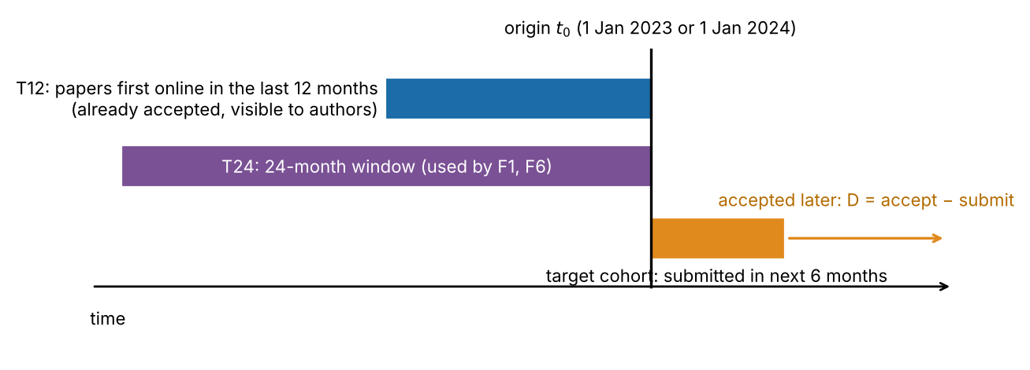
Figure 1. Conceptual schematic (not data) of the out-of-time protocol. Forecasts use only the visible training set and are scored against papers submitted after the origin.

Scoring and inference
The primary score is the mean pinball loss over quantile levels on the ln-day scale [21, 22]; secondary scores are coverage of central intervals, the interval score [23], Brier scores for the events D ≤ 72, 120 and 180 days, and probability-integral-transform histograms [24]. Journals are the unit of analysis. Because journals of one imprint are correlated and the two origins overlap, uncertainty is reported with journal-cluster bootstraps [25, 26], which treat journals as independent and are therefore optimistic. Main contrasts additionally use t-based intervals with 6 degrees of freedom on the means of the seven imprints, Holm correction over the seven contrasts and a publisher-level check (three clusters); for the rolling panel we used a two-way (imprint × origin) bootstrap and a moving-block bootstrap over ordered origins. Journal-level paired comparisons use Wilcoxon signed-rank tests [27] with Holm correction; shares use Clopper–Pearson intervals [28]. Variance components of ln D (journal, journal × year, residual) were estimated by method of moments from acceptance years 2021–2025.

Additional analyses
A rolling panel used ten quarterly origins from January 2022 to April 2024, 91-day target cohorts, a common follow-up cap of 480 days (durations were capped at 480 days), and journal-origins with at least 100 visible and at least 30 target papers. Null worlds tested the cause of any under-coverage: an exchangeable benchmark (random split within a journal's complete submission cohort at the observed sample sizes); a generative simulation without drift in which arrivals grew at each journal's observed rate, durations were drawn from the journal's own target distribution and the visibility rule was applied (this simulation assumes stationarity and is therefore a limited test); and a generative simulation with independent random cohort-level location shifts, N(0, σ²), of the training and target cohorts, with σ² the journal × year variance component from RQ1 (0.032), half and twice that value, a journal-specific proxy for σ² estimated from the same data, and an 'oracle' variant in which the target shift is halved. To check forward-selection and direction effects we also evaluated a backward oracle (F0 trained on the complete cohort submitted after the target) and eligibility rules that use only pre-origin data. Robustness variants excluded records with fewer than 10 or 15 references, records accepted on days with batch acceptances, journals with at least 10% of papers accepted within 14 days, and 75 journals flagged for fast-lane or implausibly short durations. A strictly out-of-time article-level model was trained on 2022 targets and tested on 2024 targets with author count, received month and weekday (with or without reference count), against a control with the journal quantile only.

Use of AI
The analysis code and drafts of this manuscript were produced with an AI system (Claude, Anthropic) acting as an autonomous research assistant in a sandboxed environment; separately launched instances of the same model family performed adversarial reviews, a prior-art search and a reproducibility audit. No human expert has reviewed the work.

Results

Data and validity of the received date
The cleaned data comprised 1,737,272 articles; 22.8% were accepted within 72 days. Forensic checks found little heaping of D at multiples of 30 days (ratio 1.00), 1.2% of papers with D ≤ 7 days and an expected weekday pattern. Of 4,222 articles with a Research Square preprint (a self-selected sample), 4,018 were in Springer Nature journals (212 journals): the median received date was 14 days before posting, 95% were received no later than 14 days after posting and 2.6% more than 90 days after (Figure 2). Journals whose medians looked fast (30 journals, 391 articles; median D 70 days) showed the same pattern (93% and 4.6%). The pre-set criterion that at least 70% of articles fall within ±14 days of posting was not met (47%) because these preprints are posted about two weeks after receipt; the criterion was mis-specified, so the other two statistics are post hoc and show compatibility with, not confirmation of, the received date being the original submission date. Weighting journals equally rather than papers, 82% of articles were received no later than 14 days after posting and 8.9% more than 90 days after. The median offset varied with received year (from -22 to -7 days), so the posting lag shifted over time, and a systematic offset of up to 14 days (about 11% of the median D) cannot be excluded at this resolution. For Wiley and Taylor & Francis journals the probe is uninformative (their Research Square preprints are independent postings: median received 79 and 100 days after posting).
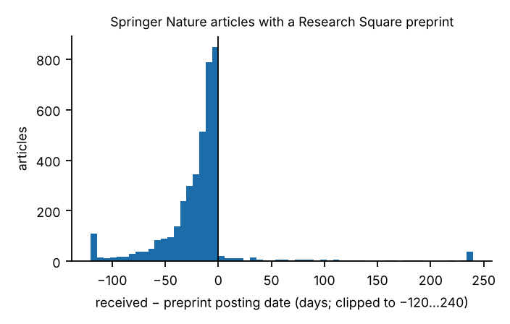
Figure 2. Received date minus Research Square preprint posting date for Springer Nature articles (days; clipped). Mass at and below zero is consistent with the received date being the original submission date.

Variance structure (RQ1)
Between-journal differences explained 26.5% of the variance of ln D (95% CI 24.7%–28.3%), journal × year differences 4.4% and residual between-article variation 69.1%. Leaving out one publisher at a time gave journal shares of 24.5%–29.0%; excluding 75 flagged journals gave 26.1%; the article-type variants gave 25.9%–27.4%. Thirty non-frame PubMed journals gave 27.4% (wide CI 17.2%–34.5%).

Forecast accuracy (RQ2)
The evaluation covered 1,531 journal-origins from 781 journals and 298,469 target papers. Journal-specific forecasts clearly beat the publisher-pooled forecast (F0 − F2 pinball difference -0.0376; imprint-cluster bootstrap CI -0.0419 to -0.0304; skill 15.7%; same sign in 7/7 imprints; imprint t(6) CI -0.0396 to -0.0267). Differences among the journal-specific forecasters were below 2% of loss (Tables 1 and 2). With t-based imprint intervals (6 degrees of freedom) and Holm adjustment over seven contrasts (Table 2), only two findings were robust at the level of the three publishers: the value of journal information (F0 − F2) and the coverage shortfall below. F0 had lower loss than the lognormal F3 and empirical-Bayes F4 in all publishers (journal-mean differences +0.0028 and +0.0025), but the Holm-adjusted imprint-level p was 0.054 and the publisher-level p about 0.2; F6 was marginally better than F0 (-0.0008; Holm p 0.009, publisher-level p 0.07); and F1 − F0 was not distinguishable from zero. We therefore treat the ranking among journal-specific forecasters as suggestive: the differences are below 2% of loss. Additional forecasters tested by an independent reviewer (skew-normal, pooled-shape and blended) and our learned forecaster L were no better than F0 (L − F0 +0.0002, 95% CI -0.0002 to +0.0007). The lognormal forecasters also overstate the chance of acceptance within 72 days.
Table 1. Out-of-time forecast performance, 1,531 journal-origins (781 journals).
Forecaster | Mean pinball (ln-days) | Skill vs F2 | 80% interval coverage − 80 (points) [journal-cluster 95% CI] | Mean interval width (ln-days)
F0 empirical, 12 mo | 0.2019 | 15.7% | −3.0 [−3.5, −2.6] | 1.60
F1 empirical, 24 mo | 0.2027 | 15.4% | −3.1 [−3.6, −2.6] | 1.61
F2 publisher-pooled | 0.2395 | 0.0% | −0.4 [−1.3, +0.5] | 1.91
F3 lognormal | 0.2047 | 14.5% | +0.8 [+0.3, +1.3] | 1.76
F4 empirical Bayes | 0.2044 | 14.6% | +1.0 [+0.5, +1.5] | 1.75
F6 time-decayed | 0.2011 | 16.0% | −2.8 [−3.3, −2.4] | 1.60

Table 2. Pairwise differences in pinball loss with journal-cluster intervals, imprint-level t intervals and publisher-level checks. Journal-cluster intervals treat journals as independent and are optimistic.
Contrast (loss A − loss B) | Mean difference | Journal-cluster 95% CI | Imprint t(6) 95% CI | Holm p (imprint level, 7 contrasts) | Publishers with same sign (publisher-level p)
F4 − F0 | +0.0025 | [+0.0020, +0.0031] | [+0.0006, +0.0054] | 0.054 | 3/3 (p = 0.20)
F3 − F0 | +0.0028 | [+0.0022, +0.0034] | [+0.0008, +0.0057] | 0.054 | 3/3 (p = 0.20)
F1 − F0 | +0.0008 | [+0.0003, +0.0013] | [-0.0001, +0.0011] | 0.071 | 2/3 (p = 0.57)
F6 − F0 | -0.0008 | [-0.0010, -0.0005] | [-0.0010, -0.0004] | 0.009 | 3/3 (p = 0.07)
F0 − F2 | -0.0376 | [-0.0414, -0.0339] | [-0.0396, -0.0267] | <0.001 | 3/3 (p < 0.01)
F4 − F6 | +0.0033 | [+0.0027, +0.0039] | [+0.0014, +0.0059] | 0.028 | 3/3 (p = 0.11)
F4 − F3 | -0.0003 | [-0.0003, -0.0002] | [-0.0004, -0.0001] | 0.025 | 3/3 (p = 0.16)

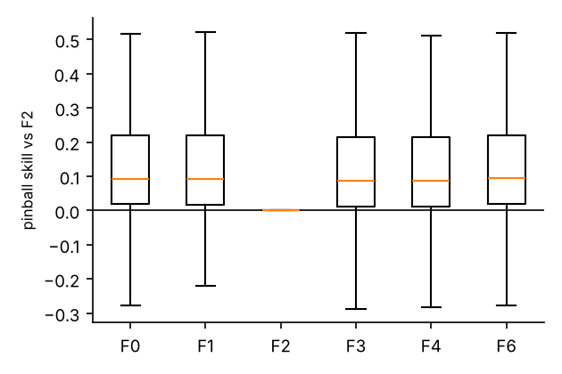 | 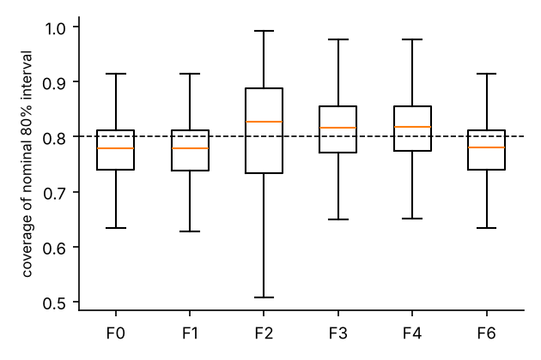
Figure 3. Left: pinball skill of each forecaster relative to F2, by journal. Right: out-of-time coverage of nominal 80% intervals by journal (dashed line = 0.80).

Calibration and its causes (RQ3)
Nominal 80% intervals from F0 covered 77.0% of later papers when averaged over journals and 76.4% when averaged over papers; the shortfall of −3.0 points had a journal-cluster CI of −3.5 to −2.6, which widened to −4.2 to −1.1 with a t(6) interval over imprints, and was −3.6 paper-weighted (journal-cluster CI −4.3 to −3.0). Under the pre-specified rule (a CI excluding ±3 points) the verdict on H2 is therefore inconclusive, not negative. The shortfall differed by imprint, from −5.6 points (largest: BioMed Central) to −1.0 points, but was negative in all 7 imprints and in all three publishers. In the rolling panel (7,417 journal-origins, 787 journals) it was −3.4 points at the first origin, −1.4 at its smallest and −2.5 at the last, a U-shaped course with strong autocorrelation between neighbouring origins (lag-1 0.76). The pooled panel shortfall was −2.4 points (moving-block bootstrap CI −2.9 to −1.8; two-way imprint × origin CI −3.4 to −1.3), and the 95% predictive interval for a future origin was −4.0 to −0.8 points (Figure 4). Skill relative to F2 in the panel was 16.2%.
Finite-sample error and a stationary process did not explain the shortfall (Figure 5, Table 3): random splitting inside a complete submission cohort gave −0.0 points (CI −0.2 to +0.2), and a simulated world with the observed volume growth, the visibility rule and no drift gave +0.1 points (CI −0.1 to +0.2), against −3.0 observed. Because that simulation assumes stationarity, it can reject finite-sample and growth explanations but cannot identify an alternative. We therefore simulated random cohort-level shifts: with independent N(0, σ²) location shifts of the training and target cohorts and σ² the journal × year variance component from RQ1 (0.032), the simulated shortfall was −4.9 points (CI −5.0 to −4.7), with σ²/2 −2.8 and with 2σ² −8.9 points; with the target shift halved (an oracle information set) it was −1.6 points, close to the −1.5 observed with the complete submission cohort. The observed −3.0 points lies between the σ²/2 and σ² simulations. This is a consistency check, not a test: it depends on σ², which was estimated from the same data, and the simulation does not identify why cohorts differ. Two features of the data were not reproduced. Observed journal-origin shortfalls varied three times as much (SD 8.6 points) as simulated ones (2.8 points), and observed differences between imprints (−5.6 to −1.0 points) were much larger than simulated ones. A journal-specific proxy for σ² correlated 0.36 with the observed journal shortfall (common σ²: 0.16) and was out-of-time unpredictive in the earlier analysis (R² 0.001).
Direction and selection checks were consistent with this reading. A backward oracle (F0 trained on the complete cohort submitted after the target) under-covered as much as the forward oracle (origin 2022-01: visible −4.1, forward −2.3, backward −2.5; origin 2023-01: −3.3, −1.4, −1.4), so the residual is not a one-way slowing, and eligibility based on pre-origin data only (789 journals) gave −3.1 points, so requiring 50 target papers did not create the shortfall. Using only recently submitted papers that have already been accepted was far worse (−12.9 points).
Table 3. Coverage shortfall of the empirical 80% interval under different information sets, a stationary null world and cohort-shift simulations (σ² = journal × year variance component). The simulations are consistency checks, not identification.
Information set / world | Coverage − 80 (points) | 95% CI (journal-cluster)
Visible set (observed) | −3.0 | [−3.5, −2.6]
Complete submission cohort (oracle) | −1.5 | [−1.9, −1.2]
Random split of the complete cohort | −0.0 | [−0.2, +0.2]
Simulated stationary world (growth and visibility, no drift) | +0.1 | [−0.1, +0.2]
Simulated cohort shifts, σ²/2 (visible) | −2.8 | [−2.9, −2.7]
Simulated cohort shifts, σ² (visible) | −4.9 | [−5.0, −4.7]
Simulated cohort shifts, 2σ² (visible) | −8.9 | [−9.2, −8.6]
Simulated cohort shifts, σ² (oracle information set) | −1.6 | [−1.7, −1.5]
Simulated cohort shifts, journal-specific σ² proxy (visible) | −2.1 | [−2.3, −1.9]
Submission cohort truncated at origin | −12.9 | [−13.7, −12.2]

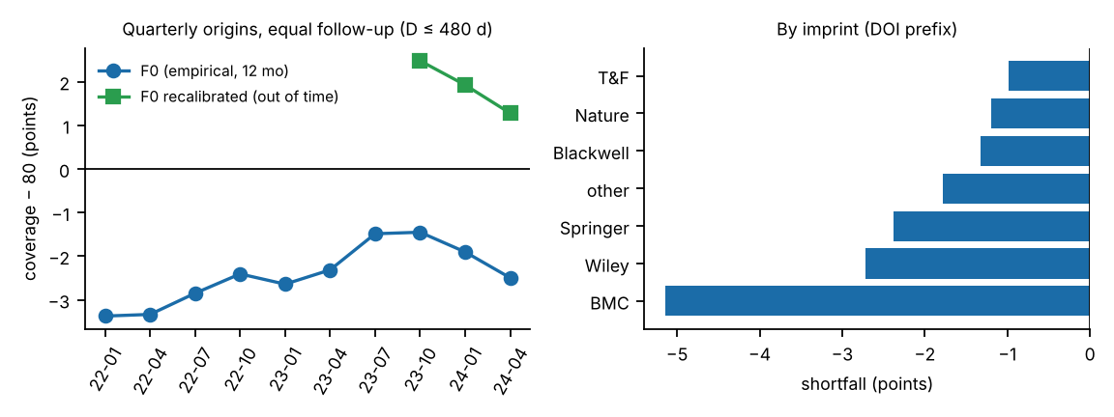
Figure 4. Left: coverage shortfall at quarterly origins with equal follow-up, for F0 and for F0 recalibrated with a map learned from earlier origins (evaluable at three origins; look-ahead variant, see text). Right: shortfall by imprint.
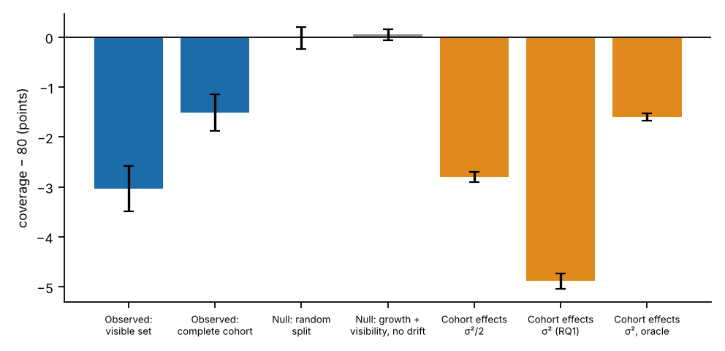
Figure 5. Shortfall under observed information sets and simulated worlds (journal-cluster 95% CIs).
Remedies were evaluated under a strict rule: only earlier cohorts whose targets were complete at the origin were used (Z2; origins October 2023, January 2024 and April 2024). There F0 under-covered by −1.9 points (CI −2.4 to −1.3). Quantile-level recalibration R gave +1.9 points (CI +1.4 to +2.4), constant width inflation V (factor 1.075) +1.1 (+0.6 to +1.6) and the empirical-Bayes F4 +1.3 (+0.8 to +1.9). All three therefore over-corrected, because the maps were learned from early origins at which the shortfall was larger (−3.4 to −2.4 points) than at the evaluation origins (−1.4 to −2.5). Pinball loss relative to F0 changed by -0.0002 for R (CI -0.0005 to +0.0000), +0.0001 for V and +0.0033 for F4; the pooled forecast F2 had near-nominal coverage (−0.0 points) but +0.041 higher loss. A first-pass recalibration whose labels were not restricted to cohorts complete at the origin (the look-ahead variant) had moved 2024–2025 coverage from −2.5 to +1.4 points; because it used information an author would not have, and the 2025 target was censored, we do not treat it as evidence for the remedy. A one-parameter correction learned from earlier cohorts is thus a partial and unstable remedy for average coverage; it is not a recommendation for practice.

Drift (exploratory)
The mean squared year-to-year change in a journal's median ln D was 7.3 times the value expected from sampling noise under a permutation null; because the top 5% of journal-year pairs carry 53% of the sum of squares, a robust (MAD-based) ratio of 5.3 is a safer summary. The median absolute change was 0.09 ln-units, and 18.8% of 3,105 pairs changed by more than 0.2 ln-units.

How often is a '≤ 72 days' claim supported? (RQ4)
The realised share of target papers accepted within 72 days was at least 0.5 in 184 of 1,531 journal-origins (12.0%; journal-cluster CI 9.9%–14.2%), at least 0.8 in 25 (1.6%; 0.9%–2.4%) and at least 0.9 in 7 (0.5%). The 72-day threshold is illustrative of maximum-time criteria; 120 and 180 days gave 48% and 80% of journal-origins reaching 0.5. Excluding batch records, fast-lane journals or low-reference articles, or all of these together, left the share between 9.5% and 12.5%; excluding 75 flagged journals gave 8.9%. A substantial part of this share is therefore due to journals with a fast lane for some article types. Fast journals were commonest, by coarse title-keyword coding (exploratory), among chemistry, materials and physics (28% of 99) and clinical medicine journals (23% of 195), and rare among engineering and computing journals (7% of 68). Forecast probabilities of acceptance within 72 days were too extreme: the reliability slope was 0.91 (95% CI 0.88–0.94; slope 1 is perfect; strict evaluation origins, 2,258 journal-origin pairs). Calibrating event probabilities with a map learned on earlier complete cohorts moved the slope to 0.97 (0.93–1.00) and lowered the Brier score by 0.0004 (CI -0.0006 to -0.0002); the improvements were similar for 120 days (slope 0.93 to 0.98) and smaller for 180 days (0.92 to 0.95). In the single highest forecast bin, 23 journal-origins (19 journals) with forecast at least 0.8 (mean forecast 86%) realised 75%, an observation too small to support a separate conclusion.
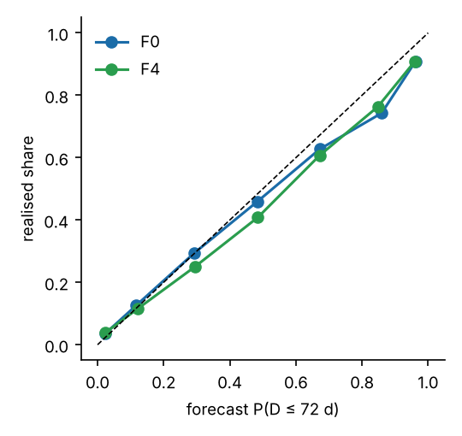 | 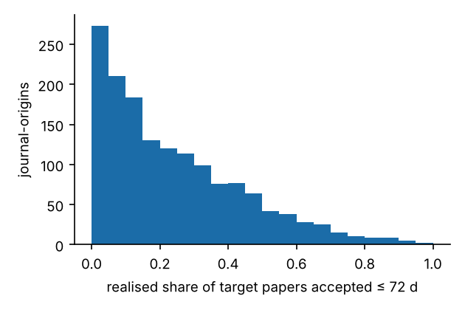
Figure 6. Left: reliability of forecast P(D ≤ 72 d) (F0, F4). Right: distribution of the realised share of papers accepted within 72 days.

Article-level information (RQ5)
In a strictly out-of-time model (trained on 2022 targets, tested on 158,735 papers of 2024 in 766 journals), author count, received month and weekday improved pinball loss by 1.0% over the control (95% CI 0.6%–1.4%); journal-demeaned features gave 0.8%. Adding reference count, which is not known before submission, raised the gain to 3.0% (2.3%–3.6%), concentrated in the fast tail (τ = 0.10: 5.8%; τ = 0.90: 0.5%), consistent with reference count identifying short article types rather than anything knowable at submission.

Robustness and external check
Table 4. Robustness of the headline quantities to article type, batches, flagged journals and single origins.
Variant | Journals | F0 shortfall (points) [CI] | Skill vs F2 | Share of journal-origins with ≥ 50% ≤ 72 d | Journal share of variance
Base | 781 | −3.0 [−3.5, −2.6] | 15.7% | 12.0% | 26.5%
References ≥ 10 | 777 | −3.1 [−3.5, −2.6] | 15.7% | 11.1% | 26.8%
References ≥ 15 | 769 | −3.2 [−3.7, −2.7] | 15.9% | 11.0% | 27.4%
No batch-accepted records | 774 | −2.9 [−3.4, −2.5] | 15.9% | 12.5% | 26.4%
No fast-lane journals | 733 | −3.1 [−3.5, −2.6] | 15.2% | 9.5% | 25.9%
Combined | 714 | −3.0 [−3.5, −2.5] | 15.8% | 9.9% | 27.2%
Excluding 75 flagged journals | 708 | −3.0 [−3.5, −2.6] | 15.7% | 8.9% | 26.1%
Single origin 2023 | 765 | −3.3 [−4.0, −2.8] | 15.4% | – | –
Single origin 2024 | 766 | −2.7 [−3.3, −2.1] | 16.2% | – | –

Leave-one-publisher-out estimates of the F0 shortfall ranged from −3.5 to −2.5 points. Crossref and PubMed dates agreed for 99.997% of 59,885 shared DOIs, which shows only that two channels carrying the same publisher data agree. In 58 journal-origins from 30 eligible PubMed journals outside the frame (a non-random set), journal-specific forecasts beat the pooled forecast by 14.8%, but the shortfall (−0.7 points, CI −3.6 to +2.1) was compatible with both zero and the main result; this is not a replication.
Table 5. Hypotheses and outcomes (H1–H5 confirmatory and H6–H7 exploratory, specified in cycle 1; X1–X3 specified in cycle 2, see Methods for order of events).
ID | Hypothesis | Outcome | Estimate
H1 | Journal share of variance < 50% | Supported | 26.5% [24.7%, 28.3%]
H2 | F0 80% coverage differs from 80% by > 3 points | Inconclusive | journal mean −3.0; paper-weighted −3.6; imprint t(6) CI [−4.2, −1.1]
H3 | Shrinkage (F4) beats F0 in small journals only | Not supported (small-n regime untestable) | F4 − F0 +0.0025 (Holm p 0.05); F7/F8, learned L no better
H4 | < 5% of journal-origins have ≥ 50% accepted ≤ 72 d | Not supported | 12.0%; variants 9.5%–12.5%; flagged-excluded 8.9%
H5 | Article covariates improve loss by < 2% | Specification-dependent | pre-submission features 1.0% (supported); with references 3.0% (not supported)
H6 (expl.) | Drift exceeds sampling noise | Supported | robust ratio 5.3
H7 (expl.) | 12-month window beats 24-month window | Not supported | F1 − F0 +0.0008; imprint t(6) CI -0.0001 to +0.0011
X1 | Received ≈ original submission (Research Square) | Pre-set criterion not met; post-hoc statistics compatible (Springer Nature only); untestable elsewhere | 95% ≤ +14 d (journal-weighted 82%); 2.6% > +90 d
X2 | Recalibration brings coverage within ±1.5 points at no loss | Not supported under strict rule (over-corrects) | R +1.9 points, V +1.1; look-ahead variant +1.4 (demoted)
X3 | Learned forecaster no better than F0 | Supported | +0.0002 [-0.0002, +0.0007]

Discussion
Three findings stand out. First, a journal's own recent history is informative but modestly so: it cuts forecast loss by about 16% relative to ignoring journal identity within a publisher, yet 69% of the variance lies between articles, so 80% intervals span roughly a five-fold range of days. The variance partition agrees with the earlier finding that most variance lies among articles within a journal [4] on a much larger and more recent dataset, and is not claimed as new. Second, simple forecasts are over-confident by about two to three points of coverage. Finite-sample error and a stationary process with growth and delayed visibility do not account for this, whereas random cohort-to-cohort shifts of the size of the journal × year variance component produce a shortfall of the same order; we read the shortfall as a variance-inflation effect (a forecast that ignores the variance of the next cohort's location is too narrow) but we cannot say why cohorts differ, and the correspondence rests on a variance estimated from the same data. Strictly out-of-time recalibration and width inflation over-corrected, because the shortfall was larger at the early origins than at the evaluation origins, so a simple correction is not a dependable remedy. Third, the simplest estimator was hard to beat: lognormal, shrinkage and learned forecasters did not improve on empirical quantiles of the last 12 months, in line with the left-skewed, heavy-tailed shape of within-journal log durations (median skewness -0.79); but only the value of journal information and the existence of a shortfall were robust when the three publishers are treated as the independent units, so the ranking among journal-specific forecasters should be regarded as suggestive.
For authors, evaluators and publishers the practical message is about reporting. Medians alone hide a wide and drifting distribution; statements of the form 'X% of papers are accepted within T days' should name the cohort (accepted or submitted), the period, whether desk rejections and article types with fast lanes are included, and should give quantiles with uncertainty. Phillips and Horn found inconsistent reporting among health-policy journals [1], and our results quantify how much a single past statistic can mislead: forecast probabilities of acceptance within 72 days were too extreme (reliability slope below one), so past shares overstate how reliably a fast journal stays fast. These are statistics about published, accepted papers only, and they should not be read as guarantees or as probabilities that a submission is accepted.
The study complements descriptive analyses of publication delay and the planned PubMed-wide model [10, 15, 29] by testing forecasts out of time, across three publishers and all fields, and by showing why single past statistics should be reported as quantiles for explicit cohorts with uncertainty.

Limitations
- Conditioning on acceptance: only accepted papers have dates; rejected and withdrawn submissions, which may differ in duration, are unobserved, so results do not describe the time or chance of a given submission being accepted.
- Date semantics: the received date is publisher-defined. It is validated only for Springer Nature journals through Research Square preprints (a self-selected subset); Wiley and Taylor & Francis dates, and the finding that a minority of journals accept most papers within 72 days, rest on unverified definitions. Crossref–PubMed agreement does not verify them. Attempts to compare with publisher article pages were blocked.
- Frame and generalisation: three publishers, journals with about 150–3,000 dated articles per year, 56% Springer Nature among evaluated journals; Elsevier, IEEE and others are outside the frame; the external check (30 journals, non-random) is inconclusive. The frame was defined from 2023 volumes, which may favour journals active in 2023; an eligibility rule using only pre-origin data gave a similar shortfall.
- Inference and design: two confirmatory origins (ten in an exploratory panel), overlapping information sets, and only three independent publishers, so journal-cluster intervals are optimistic and imprint-level t(6) intervals are approximate; at publisher level only the value of journal information and the shortfall were clearly nonzero. Several tests are post hoc or exploratory. The explanation of the shortfall is characterised rather than identified: the cohort-shift simulation depends on a variance component estimated from the same data, the stationary simulation assumes the process it tests, and neither reproduces the observed spread across journals or imprints.
- Article types and batches: durations mix article types and fast lanes; our variants reduce but do not remove this, and article type is not observed.
- Remedy: under the strict out-of-time rule recalibration and width inflation were evaluated at three origins and over-corrected; the first-pass look-ahead variant is not evidence for them. The posting-lag validation of the received date may itself be shifted by up to 14 days and by calendar time.
- Prior work and novelty: the literature search was not systematic and most full texts were not read; the claim of novelty is therefore stated as 'we found no'. No human reviewer has examined the work.
- Scope: the study analyses statistics about editorial processes, not peer review itself.

Conclusions
A journal's acceptance times over the last year are a useful but wide, slightly over-confident forecast for its next papers. Simple empirical quantiles were as accurate as more elaborate forecasters, simple recalibration learned from earlier cohorts over-corrected, and 'within 72 days' claims were supported for a minority of journals, with forecast probabilities that were too extreme. Turnaround statistics should be reported as drifting distributions with explicit cohorts and uncertainty.

Abbreviations
ICC, intraclass correlation (journal share of variance); D, days from received to accepted; CI, confidence interval; F0–F6, R, V, L, forecasters defined in Methods.

Declarations
Ethics approval and consent to participate: not applicable; the study analyses public article metadata.
Consent for publication: not applicable.
Availability of data and materials: raw Crossref and PubMed records, processing code, configuration and all results are in the project repository (https://github.com/Bhargavteja-9779/rp_c_8, branch claude/autonomous-research-institute-nz8co5), which is not yet archived with a persistent identifier; a DOI-bearing deposit (for example Zenodo) must be created before submission. Live API data change over time; SHA-256 hashes of the cleaned files used are in results/data_manifest.json.
Competing interests: [to be completed by the authors].
Funding: [to be completed by the authors; none is recorded].
Authors' contributions: [to be completed by the authors].
Acknowledgements: [to be completed].
Authors' information: [to be completed].
Use of AI: described in Methods.

References
1. Phillips K, Horn D. Review and Publication Times and Reporting Across Journals on Health Policy. JAMA Network Open. 2025;8(5):e2512545. https://doi.org/10.1001/jamanetworkopen.2025.12545
2. Bilalli B, Munir R, Abelló A. A framework for assessing the peer review duration of journals: case study in computer science. Scientometrics. 2021;126(1):545-563. https://doi.org/10.1007/s11192-020-03742-9
3. Andersen M, Fonnes S, Rosenberg J. Time from submission to publication varied widely for biomedical journals: a systematic review. Current Medical Research and Opinion. 2021;37(6):985-993. https://doi.org/10.1080/03007995.2021.1905622
4. Björk B, Solomon D. The publishing delay in scholarly peer-reviewed journals. Journal of Informetrics. 2013;7(4):914-923. https://doi.org/10.1016/j.joi.2013.09.001
5. Ellison G. The Slowdown of the Economics Publishing Process. Journal of Political Economy. 2002;110(5):947-993. https://doi.org/10.1086/341868
6. Argilés‐Bosch J, Ravenda D, Garcia‐Blandon J. Empirical analysis of factors influencing delay in article acceptance in accounting journals. Learned Publishing. 2023;36(4):517-532. https://doi.org/10.1002/leap.1564
7. Sebo P, Fournier J, Ragot C, Gorioux P, Herrmann F, Maisonneuve H. Factors associated with publication speed in general medical journals: a retrospective study of bibliometric data. Scientometrics. 2019;119(2):1037-1058. https://doi.org/10.1007/s11192-019-03061-8
8. Luwel M, van Eck N, van Leeuwen T. Characteristics of Publication Delays Over the Period 2000–2016. Evaluative Informetrics: The Art of Metrics-Based Research Assessment. 2020;89-114. https://doi.org/10.1007/978-3-030-47665-6_4
9. Hadavand A, Hamermesh D, Wilson W. Publishing Economics: How Slow? Why Slow? Is Slow Productive? How to Fix Slow?. Journal of Economic Literature. 2024;62(1):269-293. https://doi.org/10.1257/jel.20221653
10. Himmelstein D. The history of publishing delays [blog post]. 2016. https://blog.dhimmel.com/history-of-delays/ (not peer reviewed; page read 2026-10-21).
11. Royle S. Hold on hope: publication lag times at cell biology journals [blog post]. quantixed. 2026. https://doi.org/10.59350/j755k-m0247 (not peer reviewed).
12. Horbach S. Pandemic publishing: Medical journals strongly speed up their publication process for COVID-19. Quantitative Science Studies. 2020;1(3):1056-1067. https://doi.org/10.1162/qss_a_00076
13. Hanson M, Barreiro P, Crosetto P, Brockington D. The strain on scientific publishing. Quantitative Science Studies. 2024;5(4):823-843. https://doi.org/10.1162/qss_a_00327
14. Mrowinski M, Fronczak A, Fronczak P, Nedic O, Ausloos M. Review time in peer review: quantitative analysis and modelling of editorial workflows. Scientometrics. 2016;107(1):271-286. https://doi.org/10.1007/s11192-016-1871-z
15. Dianovics D, Varga M, Bognar M, Aczel B. Acceptance and publication lags in scholarly journals between 2016 and 2025. Lifecycle Journal. 2025. https://doi.org/10.71240/lcyc.084124
16. Manusights. Peer review timelines by journal (version 2026.2) [vendor web page, not peer reviewed]. https://manusights.com/review-timelines (page read 2026-10-21).
17. Hyndman R, Fan Y. Sample Quantiles in Statistical Packages. The American Statistician. 1996;50(4):361-365. https://doi.org/10.1080/00031305.1996.10473566
18. DerSimonian R, Laird N. Meta-analysis in clinical trials. Controlled Clinical Trials. 1986;7(3):177-188. https://doi.org/10.1016/0197-2456(86)90046-2
19. Efron B, Morris C. Stein's Estimation Rule and its Competitors—An Empirical Bayes Approach. Journal of the American Statistical Association. 1973;68(341):117-130. https://doi.org/10.1080/01621459.1973.10481350
20. Ke G, Meng Q, Finley T, Wang T, Chen W, Ma W, et al. LightGBM: a highly efficient gradient boosting decision tree. Advances in Neural Information Processing Systems. 2017;30.
21. Koenker R, Bassett G. Regression Quantiles. Econometrica. 1978;46(1):33. https://doi.org/10.2307/1913643
22. Gneiting T, Raftery A. Strictly Proper Scoring Rules, Prediction, and Estimation. Journal of the American Statistical Association. 2007;102(477):359-378. https://doi.org/10.1198/016214506000001437
23. Winkler R. A Decision-Theoretic Approach to Interval Estimation. Journal of the American Statistical Association. 1972;67(337):187-191. https://doi.org/10.1080/01621459.1972.10481224
24. Gneiting T, Balabdaoui F, Raftery A. Probabilistic Forecasts, Calibration and Sharpness. Journal of the Royal Statistical Society Series B: Statistical Methodology. 2007;69(2):243-268. https://doi.org/10.1111/j.1467-9868.2007.00587.x
25. Efron B. Bootstrap Methods: Another Look at the Jackknife. The Annals of Statistics. 1979;7(1):1-26. https://doi.org/10.1214/aos/1176344552
26. Field C, Welsh A. Bootstrapping Clustered Data. Journal of the Royal Statistical Society Series B: Statistical Methodology. 2007;69(3):369-390. https://doi.org/10.1111/j.1467-9868.2007.00593.x
27. Wilcoxon F. Individual Comparisons by Ranking Methods. Biometrics Bulletin. 1945;1(6):80. https://doi.org/10.2307/3001968
28. Clopper C, Pearson E. The use of confidence or fiducial limits illustrated in the case of the binomial. Biometrika. 1934;26(4):404-413. https://doi.org/10.1093/biomet/26.4.404
29. Petrou C. Reading the leaves of publishing speed: the cases of Hindawi, Frontiers and PLOS [blog post]. The Scholarly Kitchen. 2025. https://scholarlykitchen.sspnet.org/2025/05/29/guest-post-reading-the-leaves-of-publishing-speed-the-cases-of-hindawi-frontiers-and-plos/ (not peer reviewed).
Note: journal titles are not abbreviated according to Index Medicus because the style guide could not be applied automatically; the authors should abbreviate them.

