How well do a journal's past turnaround times predict the next paper's? A pre-specified out-of-time evaluation across 800 journals
[Author names, affiliations, ORCID iDs and corresponding-author details to be supplied by the authors]
Manuscript prepared for submission to Accountability in Research (best-available target; see cover letter). Word count: 4,317 words (title page to conclusion, excluding tables, captions in tables, declarations and references).

Abstract
Authors, funders and evaluators routinely use a journal's stated or past turnaround as a forecast of how long a newly submitted paper will take, but such statistics have not been tested out of time. We pre-specified an evaluation using publisher-deposited submission and acceptance dates for 1,737,272 research articles from 800 Springer Nature, Wiley and Taylor & Francis journals. At two forecast origins (1 January 2023 and 2024), forecasts built only from papers already visible were scored against all 298,469 papers submitted to 781 journals in the following six months, using pinball loss, interval coverage and event-probability scores. Journal identity explained 26.5% (95% CI 24.7%–28.3%) of the variance of log acceptance time; 69.1% lay between articles within a journal-year. Journal-specific empirical forecasts lowered pinball loss by 15.7% relative to publisher-pooled forecasts, yet nominal 80% intervals covered only 77.0% of later papers and the average interval spanned a five-fold range of days. Parametric and shrinkage forecasters did not improve on simple empirical quantiles; a post-hoc diagnostic indicated that roughly half of the under-coverage arises because slow papers are not yet visible. Only 12.0% of journal-origins had at least half of their papers accepted within 72 days and 1.6% at least 80%; when past data indicated at least 80%, 75% was realised. Author and reference counts improved forecasts by about 3% (1.4% with strictly pre-submission features). A check on 58 journal-origins from a non-random set of PubMed-indexed journals outside the frame gave a similar picture, with a smaller coverage shortfall (-0.8 points). Journal-level turnaround statistics are informative but should be reported and used as wide, drifting distributions rather than point guarantees. Conclusions are conditional on acceptance and on publisher-defined submission dates.
Keywords: peer review; publication delay; acceptance time; probabilistic forecasting; scholarly publishing; research evaluation

1. Introduction
Time to publication is a material cost of choosing a journal. Delays affect careers, funding decisions and the currency of findings (Powell, 2016; Ellison, 2002), and journals increasingly advertise speed. Previous work has documented how long review and publication take: Björk and Solomon (2013) sampled 2,700 papers from 135 journals and found large differences between fields, with most of the variance in submission-to-acceptance time lying among articles within a journal; Huisman and Smits (2017) surveyed authors; Mrowinski et al. (2016) modelled the stages of one journal's editorial workflow; and a systematic review found that reported submission-to-publication times in biomedical journals vary widely and are defined inconsistently (Andersen et al., 2021). Bilalli et al. (2021) showed, for ten computer-science journals, that publisher-reported averages can differ greatly from values computed from article metadata. Turnaround is also not stationary: it fell sharply for COVID-19 papers (Horbach, 2020), and has lengthened in economics (Ellison, 2002) and accounting (Argilés-Bosch et al., 2023).
What these studies do not provide is a test of the use to which turnaround statistics are put: as a forecast for a paper that has not yet been submitted. A forecast must use only information available when the choice is made, must be scored against later outcomes, and should convey uncertainty. The question matters because authors act on quantities such as a journal's median or ‘average days to acceptance’, and because evaluative or funder policies sometimes require a stated maximum time to acceptance. A concurrent registered bibliometric study of about 6.6 million PubMed-indexed articles plans a machine-learning model of acceptance lag with a random train–test split (Dianovics et al., 2026); a random split mixes past and future and so does not address forecasting.
We therefore ask five questions. RQ1: how much of the variance of acceptance time lies between journals, between years within journals, and between articles? RQ2: how accurate and calibrated are out-of-time forecasts of a journal's acceptance-time distribution built from its visible past, and which simple estimator is best? RQ3: how large is drift relative to sampling noise? RQ4: how often does past evidence support a claim that a given share of papers is accepted within 72 days, and how reliable are such claims out of time? RQ5: do article features observable around submission improve on the journal-level forecast? RQ1 extends the variance partition of Björk and Solomon (2013) to a larger and more recent dataset; RQ2–RQ5 are, as far as our searches (which did not include reading every full text) could establish, not addressed in earlier work. The study is empirical meta-research. It makes no causal claims and does not propose new theory.

2. Methods

2.1 Pre-specification and transparency
The protocol (frame, cleaning rules, cohorts, forecasters, metrics, seven confirmatory contrasts and five confirmatory hypotheses) was committed to the project's git history before any forecast error was computed (protocol v1.0, 20 October 2026). This is a pre-specification by the analyst, not a registered report: there is no external registry entry or independent time stamp. Eleven amendments, documentation corrections and post-hoc additions (D1–D11) are logged in the repository, including several that came after results were seen (D5–D7, D10; exploratory). Hypothesis thresholds were set in advance; unsupported hypotheses are reported as such. A first research direction (duplicate contamination in tabular machine-learning benchmarks) was abandoned before any model was run after a prior-art search found overlapping work; the audit trail is in the repository.

2.2 Data
Article-level submission (‘received’) and acceptance dates are deposited in Crossref metadata by Springer Nature, Wiley and Taylor & Francis. For each of these three members we took the 1,000 ISSNs with most journal articles published in 2023, merged print and online ISSNs (1,684 journals), and kept journals in which at least 80% of 40 random 2023 records carried both dates and the estimated number of dated 2023 articles was between 150 and 3,000. All 802 resulting entries were downloaded (census of the frame; two ISSN pairs were not merged and appear as duplicates, so the cleaned data contain 800 distinct journals; publication dates 1 January 2021 to 20 October 2026; data cutoff 20 October 2026). The frame excludes small and very large journals and all publishers that do not deposit dates (notably Elsevier and IEEE). The estimand is D, the number of days from received to accepted, conditional on acceptance; rejected papers are not observable.
Records were cleaned with rules fixed in advance: duplicate DOIs (5,519); D < 1 or D > 1,460 days (10,530); acceptance more than seven days after first online publication (13,595); and non-research items by title pattern or fewer than five references (62,990). Of 1,829,907 dated records, 1,737,272 remained (800 journals). Median D was 124 days (5th–95th percentiles 32–372); 22.8% of papers were accepted within 72 days.

2.3 Forecasting task
Forecast origins were 1 January 2023 and 1 January 2024 (Figure 1). At an origin, the information set of an author contains papers that were first online before the origin and had already been received and accepted (visibility rule). The target cohort comprises all papers received in the following 182 days, all of which are observed by the cutoff (follow-up at least 2.8 years). A journal-origin was eligible if at least 100 papers were visible in the preceding 12 months and at least 50 papers were in the target cohort. The code asserts, for every journal-origin, that no target paper is visible at the origin.
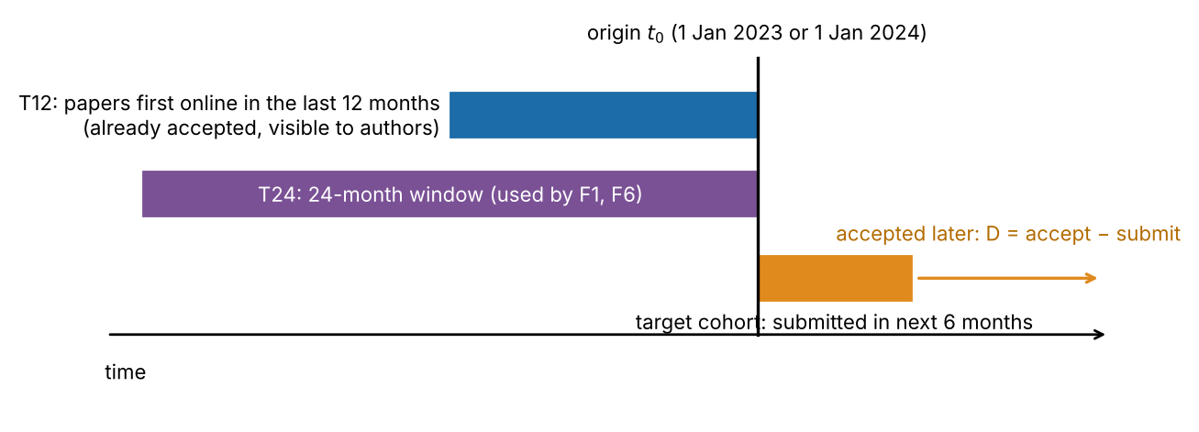
Figure 1. Conceptual schematic (not data) of the out-of-time protocol. Forecasts use only the visible training set; they are scored against papers submitted after the origin.
Six forecasters of the distribution of ln D were evaluated at 19 quantile levels (0.05–0.95): F0, empirical quantiles of the last 12 months of visible papers; F1, the same over 24 months; F2, publisher-pooled quantiles that ignore journal identity (each journal weighted equally); F3, a lognormal fitted by maximum likelihood; F4, an empirical-Bayes lognormal in which journal means and log standard deviations are shrunk towards cross-journal values (DerSimonian & Laird, 1986; Efron & Morris, 1973) estimated only from visible data; F6, exponentially time-decayed empirical quantiles (half-life 182.5 days) over 24 months. F5, an interval-only forecaster, takes quantiles from the older nine months and widens them by a conformal adjustment (Angelopoulos & Bates, 2023) computed on the latest three months. Empirical quantiles use the Hazen definition (Hyndman & Fan, 1996).

2.4 Scoring and inference
The primary score is the mean pinball loss over the 19 quantile levels on the ln-day scale (Koenker & Bassett, 1978), a proper score for quantile forecasts approximating the continuous ranked probability score (Gneiting & Raftery, 2007). Secondary scores are coverage of central 80% and 50% intervals, the Winkler interval score (Winkler, 1972), Brier scores for the events D ≤ 72, 120 and 180 days, and probability-integral-transform histograms (Gneiting et al., 2007). Journals are the unit of analysis: scores are averaged over origins within journal. Uncertainty comes from journal-cluster bootstraps (5,000 resamples for forecast comparisons, 1,000 for variance components, 2,000 for the article-level and post-hoc analyses; seed 20261020; Efron, 1979; Field & Welsh, 2007); paired comparisons use Wilcoxon signed-rank tests (Wilcoxon, 1945) with Holm correction over seven pre-specified contrasts, reported with rank-biserial effect sizes. Realised shares of papers accepted within T days carry Clopper–Pearson intervals (Clopper & Pearson, 1934).
Variance components of ln D (journal, journal × acceptance year, residual) were estimated by method of moments from acceptance years 2021–2025 with at most 300 records per journal-year; the estimator was checked on simulated data with known components (unit tests) and intervals come from bootstrapping journals. Drift was measured as the change in a journal's median ln D between consecutive acceptance years relative to a permutation null. For RQ5, LightGBM quantile regressions (Ke et al., 2017) were trained to predict ln D from the journal's F4 quantile plus the number of authors, received month, received weekday and log references, with five-fold cross-validation grouped by journal; the comparator was the same learner without article covariates and the F4 quantile alone. Reference count is a property of the final version and is therefore only a proxy for information known at submission. Software: Python 3.13, NumPy, pandas, SciPy and LightGBM (Harris et al., 2020; Virtanen et al., 2020).
Post-hoc analyses (exploratory, logged as deviations D6–D7). After internal review we (i) added a journal-cluster bootstrap for the share of journals reaching a given realised share of papers within 72 days, because the two origins of a journal are dependent; (ii) coded journals coarsely into fields by title keywords (chemistry/materials/physics, clinical medicine, engineering/computing, other; not validated); and (iii) ran a diagnostic that retrains F0 on three information sets—the visible set, the submission cohort of the preceding 12 months truncated at the origin (only papers already accepted), and an oracle submission cohort that includes papers accepted after the origin—to separate information truncation from change over time.
External checks: (E8) agreement of Crossref and PubMed (History field) dates for DOIs present in both; (E9) the same forecasting protocol applied to 32 PubMed-indexed journals of publishers outside the frame (Elsevier, Oxford University Press, Frontiers, Cell Press and others), after excluding journals whose records overlap the Crossref frame. Sensitivity analyses varied the non-research filter and the eligibility thresholds (60/30).

3. Results

3.1 Variance structure (RQ1)
Between-journal differences explained 26.5% of the variance of ln D (95% CI 24.7%–28.3%); year-to-year differences within a journal added 4.4%, and 69.1% was residual between-article variation (Table 1, Figure 2). H1 (journal share below 50%) was supported. The non-frame PubMed journals gave a similar journal share (27.4%, 17.2%–34.5%; 32 journals).
Table 1. Variance components of ln acceptance time (800 journals, acceptance years 2021–2025).
Component | Variance of ln D | Share
Between journals | 0.193 | 0.265
Journal × acceptance year | 0.032 | 0.044
Residual (between articles) | 0.503 | 0.691

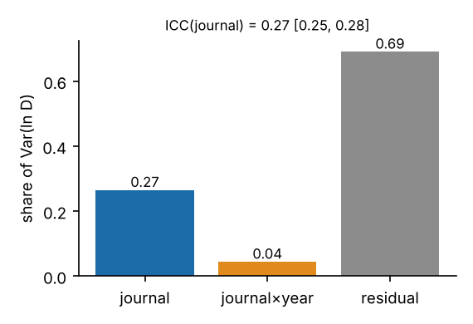
Figure 2. Share of the variance of ln D by component. Whiskers are not drawn; the 95% CI of the journal share is in the panel title.

3.2 Out-of-time accuracy and calibration (RQ2)
The evaluation covered 1,531 journal-origins from 781 journals and 298,469 target papers. Journal-specific forecasts clearly beat the publisher-pooled forecast (F0 minus F2 pinball difference -0.0376, 95% CI -0.0414 to -0.0339; skill 15.7%; Table 2, Figure 3). Differences between the journal-specific forecasters were small. The simple empirical forecaster (F0) outperformed the lognormal (F3) and the empirical-Bayes lognormal (F4); F4 was worse than F0 in all three size strata (significantly in the two larger ones, 579 and 173 journals, Holm-adjusted p < 0.001 and 0.003; borderline in the 29 journals with fewer than 150 visible papers, p = 0.053), so H3 was not supported. Because the eligibility rule (at least 100 visible papers) removes the small-sample regime where shrinkage should matter, and because a lognormal is a poor description of these data, this is not a general test of shrinkage: an exploratory shrinkage of the empirical quantiles themselves (F7) and a six-month persistence forecaster (F8) also failed to improve on F0 in any stratum (overall difference F7 − F0 +0.0001, F8 − F0 +0.0004); only 6 journals had 30–99 visible papers, too few for a conclusion in that regime. Time-decayed weighting (F6) was marginally better than F0 and a 24-month window (F1) marginally worse; all these differences were below 2% of loss (Table 3).
Table 2. Out-of-time forecast performance (ln-day scale; lower pinball and Winkler are better). F5 is interval-only.
Forecaster | Journals | Mean pinball | Skill vs F2 | Coverage of 80% interval − 0.80 [95% CI] | 80% width | Winkler 80%
F0 empirical (12 mo) | 781 | 0.202 | 0.157 | -0.030 [-0.035, -0.026] | 1.604 | 2.529
F1 empirical (24 mo) | 781 | 0.203 | 0.154 | -0.031 [-0.036, -0.026] | 1.608 | 2.546
F2 publisher-pooled | 781 | 0.239 | 0.000 | -0.004 [-0.013, +0.005] | 1.909 | 3.038
F3 lognormal MLE | 781 | 0.205 | 0.145 | +0.008 [+0.003, +0.013] | 1.756 | 2.566
F4 empirical-Bayes lognormal | 781 | 0.204 | 0.146 | +0.010 [+0.005, +0.015] | 1.755 | 2.565
F5 recent-holdout interval | 778 | – | – | -0.022 [-0.027, -0.017] | 1.674 | 2.570
F6 time-decayed empirical | 781 | 0.201 | 0.160 | -0.028 [-0.033, -0.024] | 1.603 | 2.518

Calibration was imperfect in a consistent direction. Nominal 80% intervals from F0 covered 77.0% of later papers (−3.0 percentage points; 95% CI −2.6 to −3.5); the confidence interval straddles the pre-specified −3-point boundary, so the deviation was not shown to exceed 3 points and H2 was not supported by its pre-specified rule. The top probability-integral-transform decile contained 13.1% of later papers (nominal 10%), i.e. more papers than expected were slower than the 90th percentile of the visible past (Figure 4). The lognormal forecasters were closer to nominal coverage on average (81.0% for F4) but less sharp in loss terms. The 80% intervals were wide: their mean width on the log scale was 1.60, so the upper limit was on average about 5.0 times the lower limit. The recent-holdout conformal adjustment (F5) raised coverage only to 77.8%, consistent with the exchangeability assumption failing under drift.
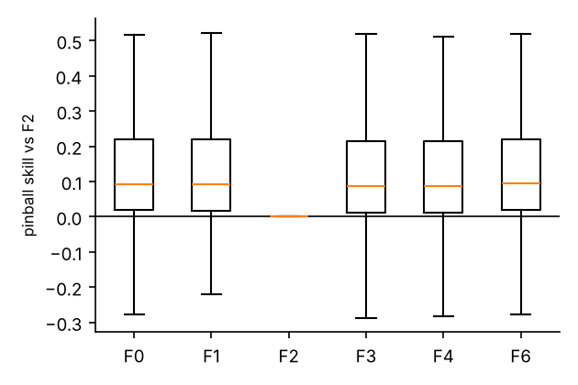 | 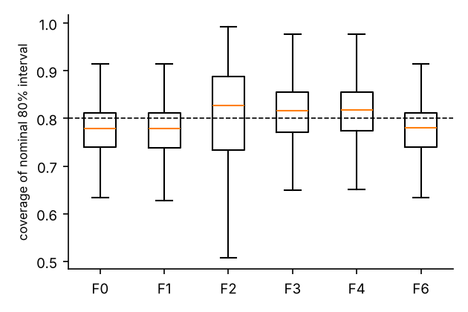
Figure 3. Left: pinball skill of each forecaster relative to the publisher-pooled forecast (F2), by journal. Right: out-of-time coverage of nominal 80% intervals by journal (dashed line = 0.80). Boxes show quartiles, whiskers 1.5 × IQR.
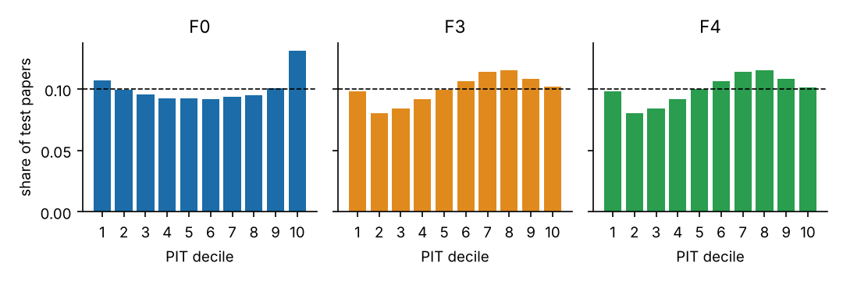
Figure 4. Probability-integral-transform histograms (deciles) for F0, F3 and F4 pooled over journal-origins; the dashed line is the uniform expectation.

3.3 Why do intervals under-cover? A post-hoc diagnostic
Training F0 on the visible set gave coverage -3.0 points (as in Table 2). The oracle complete submission cohort, which uses papers accepted after the origin and is therefore not available to an author, still under-covered, by -1.5 points (95% CI -1.9 to -1.2) and lowered pinball loss by 1.8%. Roughly half of the shortfall therefore arises because slow papers have not yet been accepted when the forecast is made, and half remains when that information is supplied, which is consistent with change between the training and target cohorts (drift) but could also reflect compositional changes we cannot observe. Finite-sample variability under independent sampling at the observed training sizes would account for only -0.3 points (simulation), and journal ln D rose by 0.074 ln-units (7.7%) between acceptance years 2021 and 2025, so a mild secular slowing is one candidate for the remainder. The shortfall was stable across four origins (2022–2025; F0 coverage -4.1, -3.3, -2.7 and -2.3 points; pooled -3.1, CI -3.4 to -2.7; the 2022 and 2025 origins are exploratory, with truncated windows and shorter follow-up respectively). A tempting shortcut—using only recently submitted papers that have already been accepted—was far worse: coverage -12.9 points (CI -13.7 to -12.2) and training medians 17% below the realised target medians.

3.4 Drift (RQ3, exploratory)
The mean squared year-to-year change in a journal's median ln D was 7.3 times the value expected from sampling noise alone (permutation null; 3,105 journal-year pairs). The median absolute change was 0.09 ln-units (about 9%); 18.8% of pairs changed by more than 0.2 ln-units (about 22%) and 1.9% by more than 0.5. Change over time is therefore a first-order feature of these data, consistent with the coverage shortfall that remains in the oracle diagnostic (Figure 5).
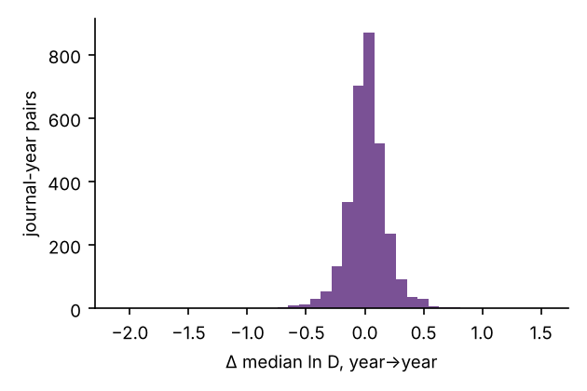 | 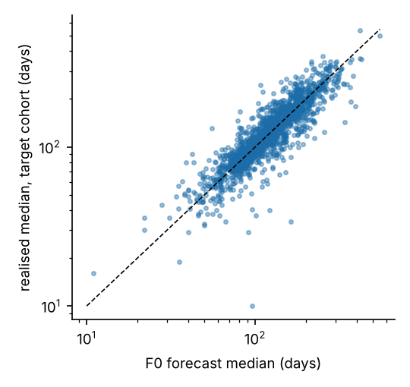
Figure 5. Left: distribution of year-to-year changes in journal median ln D. Right: forecast median (F0) against the realised median of the target cohort for each journal-origin (log axes; dashed line = identity).

3.5 How often is a 72-day claim supported? (RQ4)
In the target cohorts, the realised share of papers accepted within 72 days was at least 0.5 in 184 of 1,531 journal-origins (12.0%; 95% CI 10.4%–13.8%), at least 0.8 in 25 (1.6%) and at least 0.9 in 7 (0.5%; Table 3). The threshold of 72 days (about ten weeks) is illustrative of the maximum-time criteria used in some policies; 120 and 180 days are reported alongside. H4 (fewer than 5% of journal-origins reaching 0.5) was therefore not supported. Because the two origins of a journal are dependent, we also computed a journal-cluster bootstrap interval for the share reaching 0.5 (9.9%–14.2%) and for the share reaching 0.8 (0.9%–2.4%); 15.2% of journals reached 0.5 at one or both origins. A minority of journals did accept most papers within 72 days; by coarse title-keyword coding (exploratory, not validated) they were commonest among chemistry, materials and physics journals (28% of 99) and clinical-medicine journals (23% of 195), and rarer among engineering and computing journals (7% of 68) and other or unclassified journals (10% of 419). Excluding the six journals whose forecast or realised median was below 30 days, which may reflect re-submission dates, left the shares essentially unchanged (11.3% reaching 0.5). Even so, past evidence overstated future speed at the fast end: for the 23 journal-origins (19 journals; no interval, and subject to selection of extreme forecasts) whose F0 forecast of P(D ≤ 72) was at least 0.8 (mean forecast 86%), the realised share was 75%. Brier skill relative to the pooled forecast was 17.2% for the 72-day event.
Table 3. Number and proportion of journal-origins whose realised share of target papers accepted within T days reaches a given level.
T (days) | Realised share accepted ≤ T is at least | Journal-origins (of 1,531) | Proportion [95% CI]
72 | 0.500 | 184 | 0.120 [0.104, 0.138]
72 | 0.800 | 25 | 0.016 [0.011, 0.024]
72 | 0.900 | 7 | 0.005 [0.002, 0.009]
120 | 0.500 | 737 | 0.481 [0.456, 0.507]
120 | 0.800 | 216 | 0.141 [0.124, 0.160]
120 | 0.900 | 83 | 0.054 [0.043, 0.067]
180 | 0.500 | 1230 | 0.803 [0.783, 0.823]
180 | 0.800 | 651 | 0.425 [0.400, 0.450]
180 | 0.900 | 373 | 0.244 [0.222, 0.266]

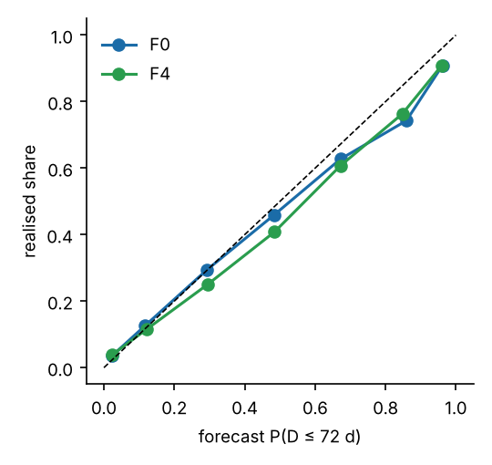 | 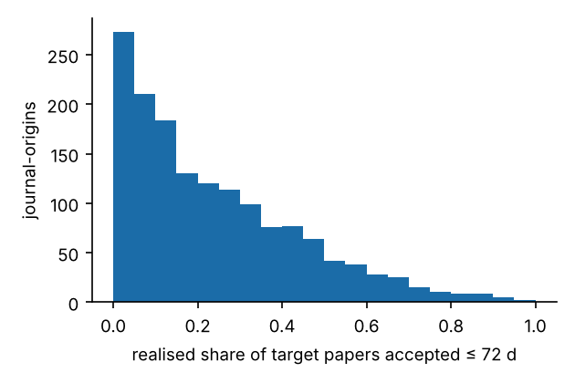
Figure 6. Left: reliability of forecast P(D ≤ 72 d) (F0, F4); points below the diagonal indicate forecasts that were too optimistic. Right: distribution over journal-origins of the realised share of papers accepted within 72 days.
In an exploratory descriptive cut of the most recent acceptance cohort (accepted 2025-04-20..2026-10-20), 61 of 773 journals with at least 100 recent papers had a median of 72 days or less and 6 had at least 80% of papers within 72 days. None of them was a computing, information-science or meta-research journal.

3.6 Article-level information (RQ5)
Adding the number of authors, received month, received weekday and log references to the journal-level quantile reduced pooled pinball loss by 3.2% (95% CI 2.5%–3.9%) relative to the same learner without covariates, and by 3.4% (2.6%–4.1%) relative to the F4 quantile alone. H5 (gain below 2%) was therefore not supported, although the gain is small. Because reference count is not strictly known before submission, we refitted with author count, received month and weekday only: the gain was 1.4% over the control (95% CI 1.0%–1.9%) and 1.6% over the F4 quantile (1.1%–2.1%); against the 2% threshold this is below it for the control comparison and straddles it for the F4 comparison. Removing the non-research filter raised the full-covariate gain to 5.4%, suggesting that reference count also acts as a proxy for article type. An exploratory ablation (different quantile levels, single run) attributed the gain to author count and reference count (gain over the control when used alone: 0.9% and 1.3%); received month and weekday contributed essentially nothing (0.01%, 0.01%).

3.7 External validation and sensitivity
Crossref and PubMed dates agreed exactly for 99.997% (received) and 99.998% (accepted) of 59,885 shared DOIs; because both channels originate from the publishers' feeds this is a consistency check rather than independent verification. In 58 journal-origins from 32 PubMed journals outside the frame (a non-random set taken from the Step-0 screening list; some belong to frame publishers but fall outside the volume window), journal-specific forecasters again beat the pooled forecast by a similar margin (pinball skill of F0 over F2 14.8%; F0 80%-interval coverage 79.2%, i.e. a smaller shortfall than in the main data; F0 and F6 were practically tied, 0.1523 versus 0.1525, and F3 and F4 were less accurate). Removing the non-research filter or relaxing eligibility to 60/30 changed no conclusion (journal share 26.5% and 26.5%; F0 coverage shortfall 3.0 and 3.0 points; share of journal-origins with at least half within 72 days 13.2% and 11.9%). Independent re-execution of the pipeline in a scratch copy reproduced every result table, JSON and figure file byte for byte apart from run-time metadata.
Table 4. Pre-specified hypotheses and outcomes.
ID | Hypothesis | Outcome | Estimate [95% CI]
H1 | Journal share of variance < 50% | Supported | 26.5% [24.7%, 28.3%]
H2 | F0 80%-interval coverage differs from 0.80 by > 3 points | Not supported (borderline) | −3.0 points [−2.6, −3.5]
H3 | Shrinkage (F4) beats F0 in small journals only | Not supported | F4 worse than F0 in all strata
H4 | < 5% of journal-origins have ≥ 50% of papers ≤ 72 d | Not supported | 12.0% [CP 10.4%–13.8%; cluster 9.9%–14.2%]
H5 | Article covariates improve loss by < 2% | Not supported | 3.4% [2.6%, 4.1%]
H6 (expl.) | Drift exceeds sampling noise (ratio > 1.5) | Supported | ratio 7.3
H7 (expl.) | 12-month window beats 24-month window | Supported (tiny) | F1 − F0 = +0.0008

4. Discussion
Three findings stand out. First, a journal's own history is genuinely informative but only moderately so: using it cuts forecast loss by about 16% relative to ignoring journal identity within a publisher, yet 69% of the variance lies between articles, so the resulting 80% intervals span roughly a five-fold range. The variance partition agrees with Björk and Solomon (2013) on a much larger and more recent dataset. Second, forecasts are biased towards optimism about speed: coverage is below nominal, more later papers fall beyond the 90th percentile than expected, and the fastest-looking journals did not keep their pace (which may partly reflect regression to the mean after selecting extreme journals). The post-hoc diagnostic suggests that about half of the coverage shortfall comes from the visible set lacking slow papers that are accepted later, and that half persists even with oracle information, consistent with change over time; the conformal adjustment, which assumes exchangeability, repaired only part of the shortfall. Turnaround statistics computed only from recently submitted papers that have already been accepted are far more optimistic still. Third, the simplest estimators were hard to beat. The lognormal and shrinkage forecasters, which improve small-sample stability in principle, were no better, probably because a normal distribution on ln D is a poor description of the data: in an exploratory check, within-journal ln D was left-skewed (median skewness -0.79; 61% of 787 journals below −0.5) with excess kurtosis 2.1, possibly reflecting a minority of very quick acceptances (not tested). With at least 100 visible papers per journal, shrinkage had little to add.
These results have practical implications. Authors comparing journals should read turnaround as a distribution with a long right tail, prefer recent (about 12-month) data and quantiles to means, and expect an additional upward shift. Publishers that report a single median or ‘average’ should state the cohort (acceptance or submission), whether desk rejections are included, and give quantiles; Bilalli et al. (2021) and Andersen et al. (2021) show that current practice is inconsistent. Evaluators or funders who require a maximum time to acceptance as a selection criterion should recognise that no past statistic supports a guarantee at the level of the individual paper: even for the minority of journals that accepted most papers within 72 days, the realised share was lower than forecast, and a share of 0.5 or 0.8 is not a promise.
The study complements the registered PubMed-wide plan of Dianovics et al. (2026) by evaluating forecasts out of time and in three publishers' journals across all fields, rather than modelling lag within a random split of biomedical articles.

4.1 Limitations
- Conditioning on acceptance: only accepted papers have dates. Statements about ‘papers accepted within 72 days’ do not describe the chance that a submission is accepted at all, and rejected or withdrawn submissions, which may differ in duration, are unobserved.
- Publisher-defined dates: the meaning of ‘received’ is not harmonised and cannot be verified here. Some journals show medians of 10–30 days that are hard to reconcile with a full peer-review cycle and may reflect re-submission dates; findings about the fastest journals should be treated with particular caution. Attempts to check deposited dates against publisher article pages were blocked, and Crossref–PubMed agreement is not independent verification.
- Frame: three publishers, journals with roughly 150–3,000 dated articles per year, and journals that deposit dates. Elsevier, IEEE and other publishers are outside the frame; the PubMed check includes some of them but covers only 32 journals. Results may not generalise to small journals or to journals of other publishers.
- Design: two origins and six-month cohorts; the ranking among near-identical forecasters (differences below 2% of loss) is statistically detectable with 781 journals but of little practical consequence. Reference count is an after-the-fact covariate.
- Hypotheses H2–H5 were not supported; H2 failed its pre-specified rule narrowly, and the pre-specified Clopper–Pearson interval for H4 ignores the dependence of a journal's two origins (see the cluster bootstrap above). The pre-specified ±3-point and 5% thresholds were judgement calls made before seeing data.
- The frame was defined from 2023 volumes and journal-origins require at least 50 target papers; both use information that post-dates the earlier origin or the outcome, a mild selection effect. Only two confirmatory origins were used (four in exploratory checks).
- Baselines are simple: we did not evaluate richer forecasters (e.g., quantile regression on journal-level trend and size features), and the empirical-Bayes forecaster relies on a normal-theory sampling variance that is inappropriate for heavy-tailed data (excess kurtosis about 2).
- Full texts of most prior studies could not be read (abstract-level reading only), and the literature search was not systematic; probability-integral-transform histograms pool dependent journal-origins and carry no interval; the post-hoc analyses (D6–D7) were prompted by the results and are exploratory.
- No causal claim is made about why turnaround differs or drifts.

5. Conclusion
Past journal-level turnaround is a useful but wide and slightly optimistic forecast of the next paper's time to acceptance. Simple empirical quantiles from the last year perform as well as more elaborate forecasters, drift is large, and statements that a journal accepts a given share of papers within a fixed number of days cannot be treated as guarantees. Reporting and evaluation practices should present turnaround as drifting distributions with explicit definitions and uncertainty.

Declarations
Author contributions: [to be completed by the authors]. The analysis code and a first draft of this manuscript were produced with the assistance of an AI system (Claude, Anthropic); the authors must review, take responsibility for and disclose this use in line with the journal's policy.
Funding: [to be completed by the authors; none is declared in the project record].
Conflicts of interest: [to be completed by the authors].
Ethics: the study analyses publicly available article metadata and involves no human participants or personal data beyond bibliographic author counts; no ethics approval was sought [authors to confirm].
Data availability: raw records are retrievable from the public Crossref and PubMed APIs; collection and processing scripts, cleaned-data generation, configuration and all derived results are in the project repository (private at the time of writing). A public, DOI-bearing deposit (e.g. Zenodo) has NOT yet been made and must be created before submission.
Code availability: as above; entry point code/run_all.py (modes quick/full), unit tests in code/tests.
Originality: submission-originality and not-under-consideration statements require author confirmation.

References
Andersen, M.; Fonnes, S.; Rosenberg, J. (2021). Time from submission to publication varied widely for biomedical journals: a systematic review. Current Medical Research and Opinion, 37(6), 985-993. https://doi.org/10.1080/03007995.2021.1905622
Angelopoulos, A.; Bates, S. (2023). Conformal Prediction: A Gentle Introduction. Foundations and Trends® in Machine Learning, 16(4), 494-591. https://doi.org/10.1561/2200000101
Argilés‐Bosch, J.; Ravenda, D.; Garcia‐Blandon, J. (2023). Empirical analysis of factors influencing delay in article acceptance in accounting journals. Learned Publishing, 36(4), 517-532. https://doi.org/10.1002/leap.1564
Bilalli, B.; Munir, R.; Abelló, A. (2021). A framework for assessing the peer review duration of journals: case study in computer science. Scientometrics, 126(1), 545-563. https://doi.org/10.1007/s11192-020-03742-9
Björk, B.; Solomon, D. (2013). The publishing delay in scholarly peer-reviewed journals. Journal of Informetrics, 7(4), 914-923. https://doi.org/10.1016/j.joi.2013.09.001
Clopper, C.; Pearson, E. (1934). The use of confidence or fiducial limits illustrated in the case of the binomial. Biometrika, 26(4), 404-413. https://doi.org/10.1093/biomet/26.4.404
DerSimonian, R.; Laird, N. (1986). Meta-analysis in clinical trials. Controlled Clinical Trials, 7(3), 177-188. https://doi.org/10.1016/0197-2456(86)90046-2
Dianovics, D., Varga, M. A., Bognar, M., & Aczel, B. (2026). Acceptance and publication lags in scholarly journals between 2016 and 2025 [Research plan]. MetaROR. https://metaror.org/article/acceptance-and-publication-lags-in-scholarly-journals-between-2016-and-2025/
Efron, B. (1979). Bootstrap Methods: Another Look at the Jackknife. The Annals of Statistics, 7(1), 1-26. https://doi.org/10.1214/aos/1176344552
Efron, B.; Morris, C. (1973). Stein's Estimation Rule and its Competitors—An Empirical Bayes Approach. Journal of the American Statistical Association, 68(341), 117-130. https://doi.org/10.1080/01621459.1973.10481350
Ellison, G. (2002). The Slowdown of the Economics Publishing Process. Journal of Political Economy, 110(5), 947-993. https://doi.org/10.1086/341868
Field, C.; Welsh, A. (2007). Bootstrapping Clustered Data. Journal of the Royal Statistical Society Series B: Statistical Methodology, 69(3), 369-390. https://doi.org/10.1111/j.1467-9868.2007.00593.x
Gneiting, T.; Balabdaoui, F.; Raftery, A. (2007). Probabilistic Forecasts, Calibration and Sharpness. Journal of the Royal Statistical Society Series B: Statistical Methodology, 69(2), 243-268. https://doi.org/10.1111/j.1467-9868.2007.00587.x
Gneiting, T.; Raftery, A. (2007). Strictly Proper Scoring Rules, Prediction, and Estimation. Journal of the American Statistical Association, 102(477), 359-378. https://doi.org/10.1198/016214506000001437
Harris, C.; Millman, K.; van der Walt, S., et al. (2020). Array programming with NumPy. Nature, 585(7825), 357-362. https://doi.org/10.1038/s41586-020-2649-2
Horbach, S. (2020). Pandemic publishing: Medical journals strongly speed up their publication process for COVID-19. Quantitative Science Studies, 1(3), 1056-1067. https://doi.org/10.1162/qss_a_00076
Huisman, J.; Smits, J. (2017). Duration and quality of the peer review process: the author’s perspective. Scientometrics, 113(1), 633-650. https://doi.org/10.1007/s11192-017-2310-5
Hyndman, R.; Fan, Y. (1996). Sample Quantiles in Statistical Packages. The American Statistician, 50(4), 361-365. https://doi.org/10.1080/00031305.1996.10473566
Ke, G., Meng, Q., Finley, T., Wang, T., Chen, W., Ma, W., Ye, Q., & Liu, T.-Y. (2017). LightGBM: A highly efficient gradient boosting decision tree. Advances in Neural Information Processing Systems, 30.
Koenker, R.; Bassett, G. (1978). Regression Quantiles. Econometrica, 46(1), 33. https://doi.org/10.2307/1913643
Mrowinski, M.; Fronczak, A.; Fronczak, P., et al. (2016). Review time in peer review: quantitative analysis and modelling of editorial workflows. Scientometrics, 107(1), 271-286. https://doi.org/10.1007/s11192-016-1871-z
Powell, K. (2016). Does it take too long to publish research?. Nature, 530(7589), 148-151. https://doi.org/10.1038/530148a
Virtanen, P.; Gommers, R.; Oliphant, T., et al. (2020). SciPy 1.0: fundamental algorithms for scientific computing in Python. Nature Methods, 17(3), 261-272. https://doi.org/10.1038/s41592-019-0686-2
Wilcoxon, F. (1945). Individual Comparisons by Ranking Methods. Biometrics Bulletin, 1(6), 80. https://doi.org/10.2307/3001968
Winkler, R. (1972). A Decision-Theoretic Approach to Interval Estimation. Journal of the American Statistical Association, 67(337), 187-191. https://doi.org/10.1080/01621459.1972.10481224
Note on reference style: the target journal's current reference style could not be retrieved; author–date format is used provisionally.

