Prediction intervals for alloys from unseen families: family-calibrated conformal prediction for machine-learned alloy properties
[Author 1]^{a,*}, [Author 2]ª
ª [Department, Institution, City, Country]
* Corresponding author: [e-mail address]

Abstract
Machine-learning models are used to screen alloys from never-measured chemical systems, yet their uncertainty estimates are validated on randomly held-out alloys. We show that this practice fails under alloy-family extrapolation. Across 6 public datasets (multi-principal-element alloy hardness and yield strength, steel yield strength, three inorganic-compound properties), nominal 90% conformal intervals calibrated on random splits covered only 85–87% of alloys from unseen chemical systems and 72–86% from unseen composition clusters. We propose family-calibrated conformal prediction (FCP): CV+ intervals whose calibration folds hold out whole alloy families, with scores normalized by a leakage-free scale built from family-bagged ensemble disagreement and compositional novelty. A family-subsampled variant has a finite-sample family-level coverage guarantee. In 180 runs (6 datasets × 3 split protocols × 10 seeds) against eight interval methods, FCP restored mean coverage to 0.922 and 0.902, reducing the coverage shortfall relative to seven baselines and the interval score relative to six (Holm-corrected Wilcoxon tests). Family-grouped calibration is the decisive component. In multi-principal-element alloys, random-split intervals failed most between the BCC and FCC valence-electron-concentration thresholds (yield-strength coverage 0.73; FCP 0.85). A pre-registered confirmatory study on five new tasks reproduced both the failure (SCP 0.85 and 0.78) and the remedy (FCP 0.92 and 0.91). Family-level calibration of random-forest tree spread, found post hoc, met its pre-registered criteria: forest efficiency without in-distribution over-coverage. In a chronological test, FCP held nominal coverage for new chemical systems but, like all methods, failed for new processing routes of known systems. All results are reproducible from public data.
Keywords: Alloy design; High-entropy alloys; Machine learning; Uncertainty quantification; Conformal prediction; Out-of-distribution generalization; Materials informatics

1. Introduction
Machine-learning (ML) models that map alloy composition and processing to properties are now routinely used to screen candidate alloys before synthesis, including high-entropy and other multi-principal-element alloys (MPEAs) [1–3]. The candidates of greatest interest are usually not close relatives of the alloys in the training data: a design campaign typically moves into chemical systems, or regions of composition space, that have never been measured. For such decisions a point prediction is insufficient. An alloy designer needs an interval that contains the true property with a stated probability, so that design margins, screening thresholds and experimental budgets can be set rationally [4,5].
Conformal prediction converts any point predictor into prediction intervals with a finite-sample, distribution-free coverage guarantee [6–8]. The guarantee rests on one assumption: the calibration data and the new case must be exchangeable. In the usual workflow, calibration alloys are drawn at random from the same database as the training alloys. When the new alloy belongs to a family that is absent from that database, exchangeability fails at precisely the point where the prediction is most needed [9]. Materials studies have shown that randomly split cross-validation overstates accuracy for new chemistries [10–13]. Recent work on polymers has shown that split-conformal coverage falls well below nominal when whole chemical classes are held out [14,15]. For composition-based alloy property models, however, the size of this coverage loss has not been quantified, and no calibration procedure has been proposed and tested that restores coverage when the test alloy comes from an unseen alloy family.
This paper addresses that gap. We treat the alloy family (the chemical system of an alloy, or a cluster of similar compositions) as the unit of exchangeability, following the hierarchical view of Dunn et al. [16]. On this basis we construct family-calibrated conformal prediction (FCP). FCP calibrates a cross-validation-plus (CV+) interval [17] on residuals of whole held-out families. The scores are normalized by a scale that grows with ensemble disagreement and compositional novelty, and the scale model is fitted only on family-out-of-bag residuals, so calibration labels are never reused. A family-weighted variant (FCP-W) targets equal coverage across families instead of across alloys. We evaluate both against eight established interval methods on six public datasets, under three split protocols of increasing extrapolation difficulty. None of the ingredients is new on its own: grouped cross-validation, CV+, normalized scores and hierarchical exchangeability are all established. What this work adds is their combination for the alloy-family deployment shift, an explicit statement of what is (and is not) guaranteed, a scale model that cannot leak calibration labels, and evidence across datasets of how large the problem is and which component solves it.
The contributions are:
- A calibration procedure, FCP / FCP-W, whose calibration step reproduces the deployment shift of alloy design (prediction for an unseen alloy family). It states its estimand explicitly (alloy-level vs family-level coverage) and the finite-sample condition under which the family-level interval is finite (Section 4).
- A benchmark of interval coverage under alloy-family extrapolation: 6 tasks, 3 split protocols, 10 outer-split seeds and 17 interval methods. It shows how far random-split calibration and model-based uncertainty fall below nominal coverage (Section 7).
- Evidence of the practical consequence for alloy screening (false discoveries among lower-bound selections) and a chronological deployment test that delineates what family-level calibration can and cannot correct (Sections 7.5 and 9.3).
- Ablation, robustness, sensitivity and efficiency experiments that isolate which component matters and what it costs, together with an error analysis of the alloy families on which intervals still fail (Sections 8–11).
- A fully reproducible code base in which every number, table and figure is regenerated from public data by a single command.

2. Related work

2.1. Uncertainty quantification for materials property models
Uncertainty estimates for materials ML are most often model-based. They include the spread of random-forest trees or bootstrap ensembles [5,18], Gaussian-process (GP) posterior variances [19], and the dispersion of neural-network ensembles, Monte-Carlo dropout or evidential heads [13,20,21]. Comparative studies report that such estimates are frequently miscalibrated, and they recommend recalibrating them on held-out data [22,23]. Recalibration uses randomly held-out data, however, so it inherits the exchangeability problem examined here. Benchmarks of out-of-distribution (OOD) prediction for crystal structures [12,13] and for out-of-range property values [24] document accuracy losses and moderate uncertainty–error correlations. They do not evaluate the coverage of prediction intervals.

2.2. Conformal prediction in materials science
Conformal prediction has recently been applied to materials data. Boruah [25] used split, normalized, Mondrian and quantile-based conformal methods for the fatigue strength of steels. That study showed that marginal validity can hide under-coverage in the highest-strength quartile, but all of its evaluations used random splits of a single dataset. For polymers, Akdoğan [15] and Han et al. [14] evaluated split conformal prediction under scaffold, cluster and class holdouts. Han et al. reported that coverage fell from 0.899 under random splits to 0.683 under class holdout, and that a similarity-based applicability gate gave little protection. Neither study proposed a calibration procedure that restores coverage under the holdout. The closest precedent is in cheminformatics. Morger et al. [26,27] observed that conformal predictors for toxicity lost validity on temporally later or external data, and that exchanging the calibration set for data resembling the new domain restored validity without retraining. That remedy requires labelled data from the shifted domain. In alloy discovery such data do not exist until the new family has been synthesized and tested. The approach studied here instead constructs the shift inside the training data, by calibrating on whole held-out families.

2.3. Conformal prediction beyond exchangeability
Statistical work offers several routes beyond exchangeability. Weighted conformal prediction reweights calibration scores by an estimated density ratio under covariate shift [28,29]. Bounds on the coverage lost under non-exchangeability are available [9]. Methods also exist that target conditional or group-wise coverage [30,31]. Dunn et al. [16] studied two-layer hierarchical data, in which groups are exchangeable but observations within a group are not exchangeable with those of other groups, and constructed prediction sets for observations from a new group. Locally adaptive (normalized) conformal scores [7,32,33] and cross-conformal / CV+ constructions [17,34] make intervals adaptive and data-efficient. To our knowledge these tools have not been combined and tested for the alloy-family extrapolation problem.

3. Research gap and motivation
Three observations motivate this work. (i) Alloy design is an extrapolation problem at the level of families: new chemical systems, or new regions of composition space. (ii) The standard calibration step of conformal prediction draws calibration alloys at random, so it measures interpolation error. Its guarantee therefore does not transfer to new families, and the size of the resulting shortfall for alloy property models is unknown. (iii) Weighted conformal prediction corrects covariate shift only when the test distribution has support inside the calibration distribution. A genuinely new chemical system violates that condition, so it is unclear whether density-ratio weighting helps.
We therefore ask five research questions. RQ1: do random-calibrated conformal methods and model-based intervals keep their nominal coverage on unseen chemical systems and composition clusters? RQ2: does family-level calibration close the coverage shortfall, and at what cost in interval width? RQ3: which component of FCP is responsible: grouping, normalization or weighting? RQ4: is the procedure robust to label noise, smaller training sets, the miscoverage level and its own hyper-parameters? RQ5: does it generalize across datasets and shift types, including a mis-specified family definition? Each question is answered by a pre-specified experiment (Section 6), and the design was fixed before the main results were inspected.

4. Proposed method: family-calibrated conformal prediction

4.1. Problem formulation
Let D = {(x_{i}, y_{i}, g_{i})}, i = 1, …, n, be the training data. Here x_{i} describes the composition (and, where available, the processing and test conditions) of alloy i, y_{i} is the measured property, and g_{i} ∈ {1, …, G} is the alloy family to which the composition belongs. Families are defined from composition alone (Section 5.2), so the family of a new alloy is known before it is measured. A new alloy x_{n+1} is drawn from a family g_{n+1} that does not occur in D. For a miscoverage level α we seek an interval Ĉ(x) with
$P\left(Y_{n+1} ∈ Ĉ\left(X_{n+1}\right)\right) ≥ 1 − α$ (1)
where the probability is taken over a new family and an alloy within it. Following Dunn et al. [16], we regard the families as exchangeable units, while alloys of one family may be arbitrarily dependent. Eq. (1) then describes alloy-level coverage on unseen families. The family-level estimand averages coverage over families with equal weight.

4.2. Family-bagged base predictor and difficulty signals
The point predictor is an ensemble of M gradient-boosted tree regressors (LightGBM [35]). Member m is trained on the alloys of a random subset containing a fraction φ of the families (row subsampling is used instead if fewer than three families are available). Family subsampling has two purposes. First, the member spread
$μ_{k}(x) = \frac{1}{M}∑f_{k,m}(x), s_{k}(x) = sd{\left\{f_{k,m}(x)\right\}}_{m=1..M}$ (2)
measures how much the prediction depends on which families were seen. Second, every training alloy has family-out-of-bag (FOOB) predictions, made only by the members that did not see its family. These mimic the error made on a new family. In Eq. (2) the index k denotes the inner cross-fitting fold whose training part the ensemble was fitted on (Section 4.3). A second difficulty signal is compositional novelty. It is the mean Euclidean distance from x to its k_{nn} nearest training alloys in a standardized, principal-component-reduced feature space:
$d_{k}(x) = \frac{1}{k_{nn}}∑_{j ∈ N_k(x)}‖z(x) − z(x_{j})‖$ (3)
For a training alloy, FOOB novelty is computed against alloys of other families only.

4.3. Normalized scores with a leakage-free scale model
Scores are normalized by a difficulty scale σ_{k}(x), which is log-linear in the two signals and constrained to be non-decreasing in each:
$log σ_{k}(x) = a_{k} + b_{k} log s_{k}(x) + c_{k} log d_{k}(x), b_{k}, c_{k} ≥ 0$ (4)
The coefficients are fitted by bounded least squares of log|FOOB residual| on the two log-signals. The fit uses only the training part D_{−k} of fold k: the spread entering the fit is the FOOB spread (standard deviation over the members that did not see the alloy's family) and the novelty is the FOOB novelty. If ten or fewer alloys have FOOB residuals, σ_{k} ≡ 1. When σ_{k} is evaluated, both signals are clamped to the range observed in the fit, so the log-linear model is never extrapolated, and σ_{k} is floored at the 5th percentile of its fitted values. The non-negativity constraints encode a physical prior: larger model disagreement or greater compositional distance should never narrow an interval. Because the scale model never sees the labels of fold k, the normalized score
$S_{i} = \left|y_{i} − μ_{k(i)}(x_{i})\right| / σ_{k(i)}(x_{i})$ (5)
of a calibration alloy i in fold k(i) is computed exactly as a test score would be.

4.4. Family-grouped CV+ interval
The training families are partitioned at random into K folds. No family is split across folds. For each fold, the ensemble, novelty scorer and scale model are fitted on the other K − 1 folds, and the scores of Eq. (5) are computed on the held-out families. A new alloy then receives the CV+ interval [17], with weights:
$L(x) = Q_{α}^{lo}\left[μ_{k(i)}(x) − S_{i} σ_{k(i)}(x)\right]$ (6)
$U(x) = Q_{1−α}^{hi}\left[μ_{k(i)}(x) + S_{i} σ_{k(i)}(x)\right]$ (7)
so that Ĉ(x) = [L(x), U(x)]. Here the brackets denote the multiset of n values, one per training alloy i, and the weighted upper quantile of values v_{i} with weights w_{i} is
$Q_{β}^{hi} = inf\left\{t : ∑ w_{i} 1[v_{i} ≤ t] ≥ β \left(∑ w_{i} + w_{∞}\right)\right\}$ (8)
where the sum runs over the training alloys and the extra mass w∞ sits at +∞. Q^{lo}_{α} is the corresponding lower quantile, with w∞ placed at −∞. Two weighting schemes define the two estimands:
$FCP: w_{i} = 1; FCP-W: w_{i} = \frac{1}{n_{g(i)}}; w_{∞} = 1$ (9)
where n_{g} is the number of training alloys of family g. With unit weights, Eqs. (6)–(7) give the normalized CV+ interval with family-grouped folds, and it targets alloy-level coverage on new families. With weights 1/n_{g}, every training family carries unit mass and the test alloy is treated as one new family. This is the pooled construction of Dunn et al. [16], and it targets family-level coverage. A finite-sample consequence is that the upper quantile of Eq. (8) is finite only if G/(G + 1) ≥ 1 − α, that is
$G ≥ \frac{1 − α}{α} (G ≥ 9 for α = 0.1)$ (10)
With fewer training families, FCP-W correctly returns an unbounded interval: so few families cannot certify a 90% family-level statement. We report this case explicitly rather than hiding it.
Finite-sample guarantee at the family level. A guarantee follows if each family contributes a single, randomly drawn calibration alloy (family-subsampled FCP, FCP-S). Let the families be exchangeable, let each fold model depend on the set of training families symmetrically, and let the test alloy be drawn uniformly from a new family. Then each unit (family, sampled alloy) is exchangeable with the test unit, and FCP-S is exactly the K-fold CV+ procedure of Barber et al. [17] applied to G data points with the normalized score of Eq. (5). Hence
$P\left(Y ∈ Ĉ(X)\right) ≥ 1 − 2α − min\left\{\frac{2(1 − 1/K)}{G/K + 1}, \frac{1 − K/G}{K + 1}\right\}$ (11)
(Proposition 1; proof in Supplementary Note S1). FCP-W replaces the single random draw by its expectation (weights 1/n_{g}), which is the pooled construction of Dunn et al. [16]. The unweighted FCP targets alloy-level coverage. Neither is literally covered by Proposition 1, so both are assessed empirically below, and FCP-S itself is evaluated in Section 9.6. Proposition 1 also explains why random-split calibration fails: a randomly held-out calibration alloy shares its family with training alloys, so its score is not exchangeable with that of an alloy from a new family, and the coverage loss is bounded only by the distance between the two score distributions [9].

4.5. Algorithm and complexity
FCP requires K ensembles of M members, i.e. KM tree-ensemble fits, plus K nearest-neighbour indices. Forming the interval for n_{t} test alloys costs O(n_{t} n log n) for sorting the n candidate bounds per test alloy. Random-split CV+ has the same cost. Split conformal prediction requires M fits but uses only part of the data for training. Measured costs are reported in Section 10. Fig. 1 summarizes the procedure.
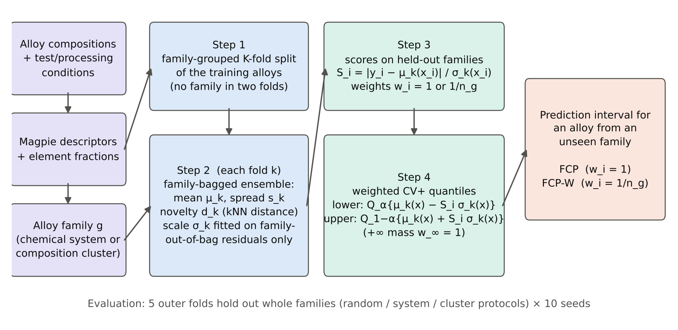
Fig. 1. Family-calibrated conformal prediction (FCP). Training alloys are split into folds that never share a family (Step 1); each fold's family-bagged ensemble, novelty scorer and scale model are fitted without the fold (Step 2); scores of the held-out families (Step 3) form weighted CV+ quantiles around each fold model's prediction (Step 4).

5. Experimental setup

5.1. Datasets
Six regression tasks from public sources were used (Table 1). Two come from the MPEA database of Borg et al. [36]: Vickers hardness, and yield strength with test temperature, test type (tension/compression) and processing route as additional inputs. One is the yield strength of 312 steels from Matbench [37]. Three are inorganic-compound tasks, used to test generalization beyond alloys: the bulk modulus training set of Mansouri Tehrani et al. [38] (rows flagged as suspect removed), experimental formation enthalpies compiled by Kingsbury et al. [39], and superconducting critical temperatures from the SuperCon-derived dataset of Hamidieh [40]. Identical inputs (same formula and, for MPEA tasks, same processing and test conditions) were merged by the median target before any split. The superconductor set was reduced to 4007 compounds by sampling whole chemical systems with a fixed seed, to fit the computational budget. Fig. 2 shows the target distributions and the strongly skewed sizes of the chemical-system families: most systems contain one or a few alloys, a few contain dozens.
Table 1. Datasets after cleaning (identical inputs merged by median). Systems: number of F1 alloy families (elements ≥ 1 at.%); every task also has 10 F2 composition clusters.
Task | Unit | Source | n | Features | Systems | Mean ± SD | Range
MPEA hardness | HV | Borg et al. [36] | 418 | 155 | 134 | 497 ± 211 | 109 to 1183
MPEA yield strength | MPa | Borg et al. [36] | 760 | 154 | 149 | 909 ± 577 | 24.0 to 3410
Steel yield strength | MPa | Matbench [37] | 312 | 97 | 49 | 1421 ± 301 | 1006 to 2510
Bulk modulus | GPa | Mansouri Tehrani et al. [38] | 2319 | 188 | 1651 | 118 ± 71.0 | 3.59 to 385
Formation enthalpy | eV/atom | Kingsbury et al. [39] | 2135 | 210 | 1319 | -1.01 ± 0.987 | -4.49 to 0.328
Superconductor Tc | K | Hamidieh [40] | 4007 | 209 | 830 | 32.8 ± 33.7 | 0.001 to 137

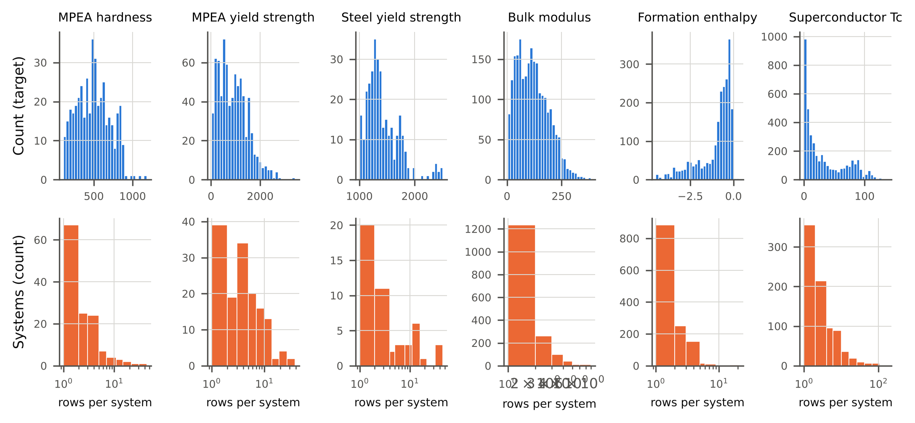
Fig. 2. Target distributions (top) and number of alloys per chemical system (bottom, logarithmic axis) for the six tasks.

5.2. Features and alloy families
Each composition was described by the 132 Magpie elemental-property statistics [41], computed with matminer [42] and pymatgen [43], together with the atomic fraction of every element present in the task. For the MPEA tasks, one-hot processing route and test type and the numeric test temperature were added. Constant columns were removed. No feature uses the target. Two family definitions were used. F1 (chemical system): the set of elements present at ≥ 1 at.%, so that trace additions in steels do not create spurious systems. F2 (composition cluster): k-means with k = 10 on atomic-fraction vectors, in the spirit of leave-one-cluster-out cross-validation [10].

5.3. Evaluation protocols
Each task was evaluated with five outer folds under three protocols. Random: rows grouped by formula, an in-distribution control. System: whole F1 families held out. Cluster: whole F2 clusters held out, the hardest extrapolation. Every outer test alloy was predicted exactly once per seed. Ten seeds (0–9, fixed in advance) re-randomized the outer folds and all internal randomness. Every method was fitted and calibrated on the outer training part only. Grouped methods used the families of the protocol internally (F1 in the random protocol). Experiment 5 deliberately mis-specifies this choice.

5.4. Compared methods
All methods share the same family-bagged LightGBM base learner (Section 4.2), so differences reflect calibration rather than accuracy, except for the GP and random-forest baselines, which have their own models. Random-calibrated conformal baselines: split conformal prediction (SCP, 75/25 random split [7]); CV+ with random folds (CV+ [17]); normalized CV+ with random folds (NCV+, the conformal analogue of recalibrating ensemble uncertainties on randomly held-out data [23], and of the normalized method of [25]); conformalized quantile regression with LightGBM quantile models (CQR [44]); and weighted split conformal prediction with a logistic-regression density-ratio estimate between calibration and test features (WCP [28]); and Mondrian split conformal prediction with separate calibration quantiles in tertiles of compositional novelty (MCP [6], Section 9). Model-based intervals: a GP with an automatic-relevance-determination RBF kernel plus white noise on 16 principal components (GP [19], at most 800 training alloys); random-forest tree spread [18] (RF-z, μ ± z·s); and the base ensemble's member spread (Ens-z). Family-calibrated baseline: split conformal prediction with 25% of the training families held out for calibration (GSCP), the simplest way to calibrate on new families. Proposed: FCP and FCP-W. Ablations (Section 8) vary grouping, the scale model (none / spread / novelty / both) and weighting within the same CV+ code path (10 variants). Deviations from the original descriptions of the baselines, made to keep a common base learner and budget, were as follows. CQR used LightGBM quantile regressors with the same hyper-parameters as the point model. WCP estimated density ratios with an L2-regularized logistic-regression classifier on 16 principal components. The GP was trained on at most 800 alloys (a random subset for the three larger tasks). RF-z used 300 trees with max_features = 1/3. No baseline was tuned on test folds, and neither was FCP.

5.5. Metrics and statistical analysis
For each run the following were recorded:
- empirical coverage, the fraction of test alloys inside their interval, and family coverage, the mean of within-family coverage;
- the mean finite interval width divided by the standard deviation of y, and the fraction of infinite intervals;
- the Winkler interval score [45], IS_{α} = (u − l) + (2/α)(l − y)·1{y < l} + (2/α)(y − u)·1{y > u}, divided by SD(y), which rewards narrow intervals and penalizes misses;
- coverage within tertiles of test-alloy novelty;
- the R² of the shared point predictor.
The primary level was α = 0.1, with α = 0.05 and 0.2 secondary. The unit of statistical analysis is a cell: one task under one shift protocol, averaged over the ten seeds. Seeds re-partition the same data, so they describe split-to-split variability, not independent replicates. Pre-specified hypotheses were tested with Wilcoxon signed-rank tests over the 12 shift cells (6 tasks × 2 shift protocols), and Holm correction was applied across the eight baselines. H1 tested one-sided under-coverage of random-calibrated methods against 0.90. H2 tested FCP against each baseline on the coverage shortfall max(0, 0.9 − coverage). H3 tested the same comparisons on the interval score. Effect sizes are matched-pairs rank-biserial correlations, and 95% confidence intervals for the median paired difference were obtained by bootstrap (10,000 resamples). The two shift protocols of a task share data, so the 12 cells are not fully independent. Each test is therefore also reported separately per protocol (6 cells), and at the task level (6 independent units, each averaging its two shift protocols). The families of F2 are obtained by unsupervised clustering of compositions of all alloys in a task. This uses no target values, and the definition of what counts as 'new' is fixed before any split.

5.6. Implementation
Pre-specified settings: LightGBM with 200 trees, learning rate 0.07, 15 leaves, row and column subsampling 0.8 and 0.5, minimum 5 alloys per leaf, L2 penalty 1; M = 6 members; φ = 0.7; K = 5 inner folds; k_{nn} = 5; 16 principal components. None of these was tuned on test folds, and their influence is examined in Section 9.6. All computations ran on CPUs (4 cores, no GPU) with Python, scikit-learn [46] and LightGBM. A single command (run_all.py) regenerates every number, table and figure from the public data.

6. Research questions and experiments
Each research question was mapped to one pre-specified experiment, and each claim in Sections 7–11 refers to one of them. Exp. 1 (main evaluation, RQ1–RQ2): all methods × 6 tasks × 3 protocols × 10 seeds × α ∈ {0.05, 0.1, 0.2}. Exp. 2 (baselines): the eight comparison methods of Section 5.4 within Exp. 1. Exp. 3 (ablation, RQ3): ten CV+ variants that differ only in fold grouping, scale model and weights. Exp. 4 (robustness, RQ4): Gaussian label noise of 0.10 and 0.25 SD(y), and training on 50% of the training families (system protocol, 5 seeds). Exp. 5 (generalization, RQ5): a mis-specified family definition in which FCP calibrates on chemical systems while the test shift is composition clusters, together with a base-learner swap to random-forest members and a random (unbalanced) assignment of clusters to outer folds. Exp. 6 (computational cost): wall time and peak memory per outer fold. Exp. 7 (sensitivity): one-factor-at-a-time variation of K, M, φ and k_{nn}. Exp. 8 (error analysis): per-family coverage against novelty, property extremity and family size.

7. Results

7.1. Severity of the distribution shift
Holding out whole families degraded the shared point predictor in every task (Table 2). Mean R² over tasks fell from 0.847 (random) to 0.769 (unseen chemical system) and 0.516 (unseen composition cluster). The largest losses occurred for steel yield strength (R² 0.74 → 0.12) and superconductor Tc (0.89 → 0.22). The two protocols therefore represent moderate and severe extrapolation, respectively.
Table 2. R² of the shared point predictor (family-bagged LightGBM ensemble fitted on the whole outer training part) on the outer test folds, mean ± SD over 10 seeds.
Task | Random | Unseen system | Unseen cluster
MPEA hardness | 0.790 ± 0.006 | 0.732 ± 0.012 | 0.519 ± 0.035
MPEA yield strength | 0.754 ± 0.003 | 0.668 ± 0.010 | 0.590 ± 0.016
Steel yield strength | 0.738 ± 0.015 | 0.499 ± 0.065 | 0.121 ± 0.052
Bulk modulus | 0.935 ± 0.002 | 0.933 ± 0.002 | 0.876 ± 0.001
Formation enthalpy | 0.972 ± 0.001 | 0.966 ± 0.001 | 0.766 ± 0.010
Superconductor Tc | 0.891 ± 0.002 | 0.818 ± 0.005 | 0.224 ± 0.071

7.2. RQ1: random-split calibration does not transfer to unseen families
In the random protocol, every conformal method attained its nominal 90% coverage (Fig. 3, left; Table 3). Mean coverage was 0.901 for SCP, 0.917 for CV+, 0.899 for CQR and 0.905 for WCP. The same methods under-covered as soon as whole families were held out: 0.851, 0.869, 0.851 and 0.874 for unseen chemical systems, and 0.719, 0.743, 0.747 and 0.863 for unseen composition clusters. The worst cell fell to 0.637 (SCP). Over the 12 shift cells, the one-sided Wilcoxon test rejected nominal coverage for all four methods (H1: p = 0.0002, 0.0012, 0.0002 and 0.0171). Their median cell coverages were 0.803, 0.824, 0.826 and 0.871, respectively.
Density-ratio weighting (WCP) reduced the shortfall, but only by producing unbounded intervals: 9.5% (system) and 41.5% (cluster) of its intervals were infinite. This happens because the classifier assigns the test alloys of a new family density ratios that dominate all calibration weights. Weighting cannot repair a support mismatch; it can only make it visible. Among the model-based intervals, the GP covered 0.887 and 0.821, and the base ensemble's own spread (Ens-z) covered only 0.481 and 0.454. Family-subsampled bagging thus does not by itself produce calibrated uncertainty. Random-forest tree spread (RF-z) is discussed in Section 7.4.
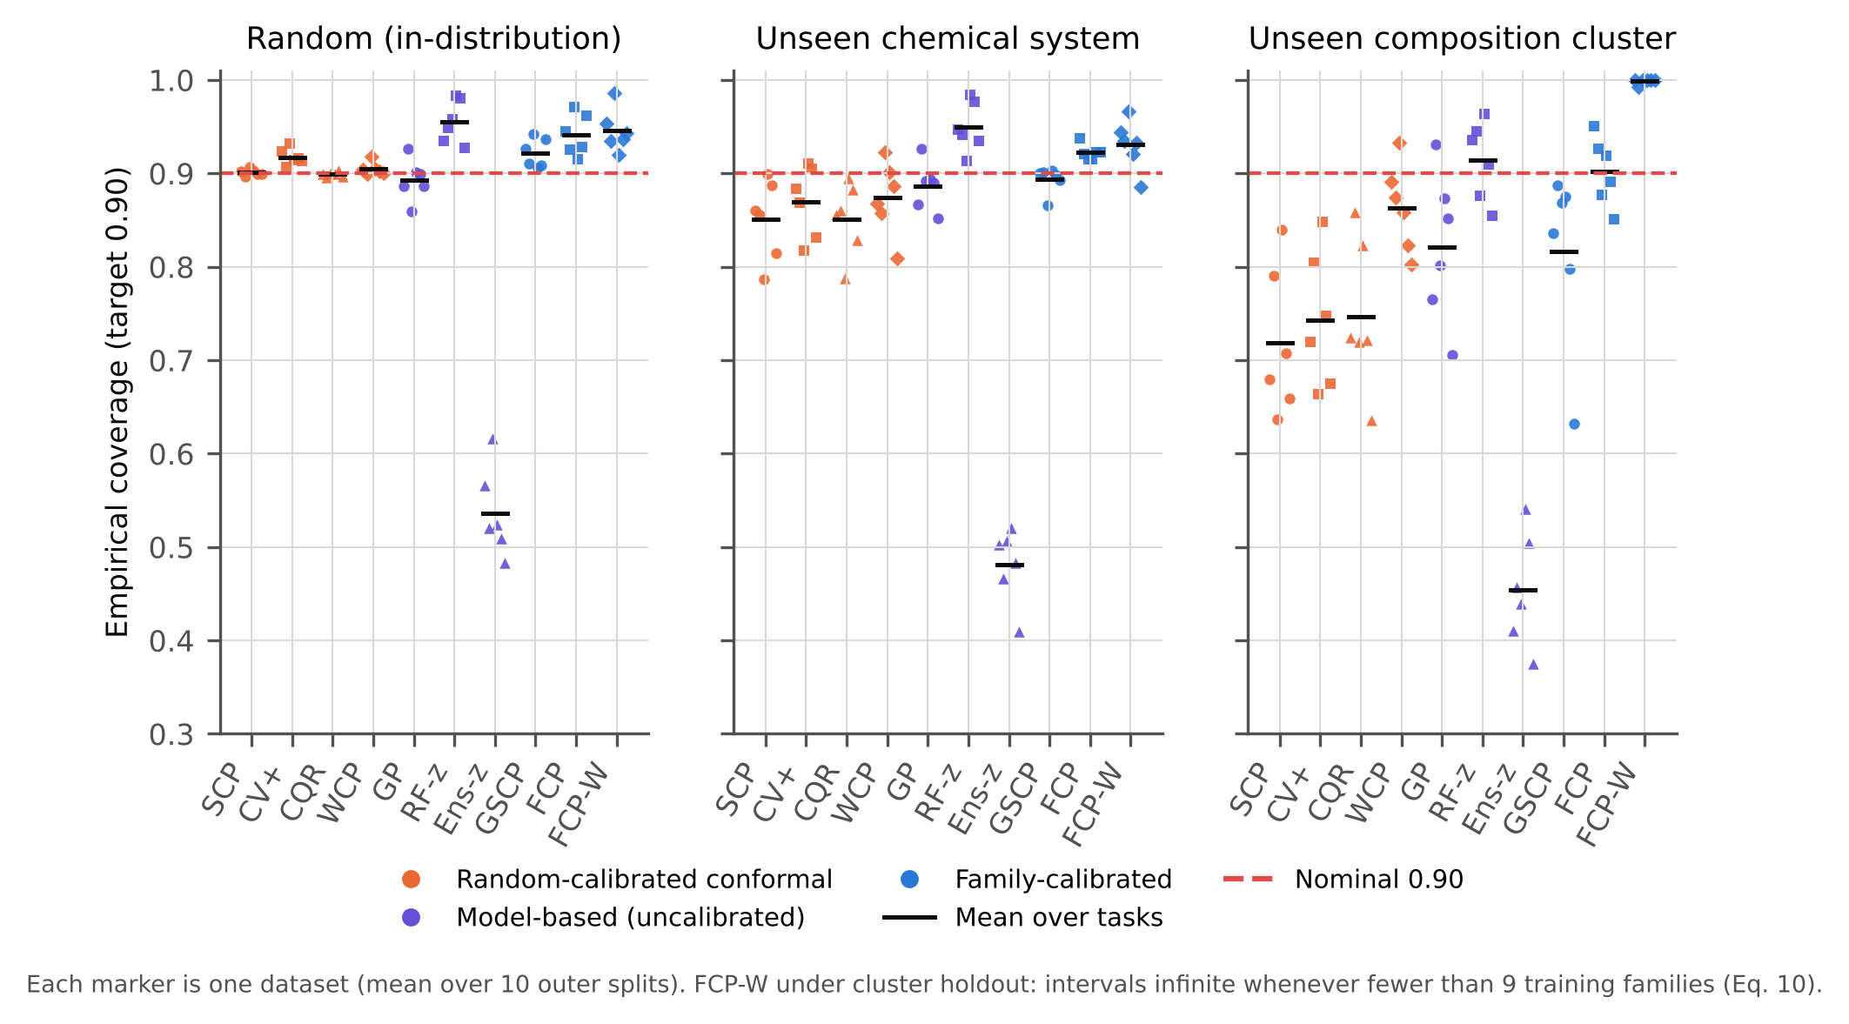
Fig. 3. Empirical coverage of 90% prediction intervals (α = 0.1) for ten methods under the three protocols. Each marker is one dataset, averaged over 10 outer-split seeds. Horizontal bars are means over datasets; the dashed line is the nominal level. Colour encodes the method group and marker shape the individual method.

7.3. RQ2: family-level calibration restores coverage
FCP attained mean coverage 0.922 on unseen chemical systems and 0.902 on unseen composition clusters. Its worst cells were 0.915 and 0.851. In the random protocol it was conservative (0.941), as expected: calibrating on whole held-out families measures extrapolation error even when the test alloys are not extrapolations. FCP-W, which targets family-level coverage, attained family coverage 0.925 under the system protocol, against 0.912 for FCP and 0.837 for SCP. Under the cluster protocol only eight training clusters remain per outer fold, below the bound of Eq. (10), so 64% of its intervals were infinite by construction.
Over the 12 shift cells, FCP's coverage shortfall max(0, 0.9 − coverage) was significantly smaller than that of seven of the eight baselines after Holm correction (H2, Table 4; p_Holm ≤ 0.020; rank-biserial r = −1 for six of them). The median paired reductions ranged from 1.0 to 42.5 percentage points. Compared with the simplest family-calibrated alternative, GSCP, which holds out 25% of the families for split calibration, the median reduction was small (1.0 points) but consistent (p_Holm = 0.012). Its effect was concentrated in the cluster protocol, where GSCP covered only 0.816 because it calibrates on a few held-out clusters, whereas CV+ uses every training family once. The only baseline whose shortfall did not differ from FCP's was RF-z (p_Holm = 0.50).
Coverage alone can be bought with width. The interval score, which penalizes both width and misses, was significantly better (lower) for FCP than for SCP, CV+, CQR, GP, Ens-z and GSCP (H3; p_Holm ≤ 0.042). WCP could not be scored because it returned infinite intervals in 11 of the 12 cells. FCP's intervals were wider than those of the random-calibrated methods (mean width 1.47 vs 1.20 SD(y) for CV+ under the system protocol; 2.64 vs 1.31 under the cluster protocol; Fig. 4). The extra width is the price of covering extrapolation error that the narrower intervals miss: their miss penalties outweigh the width saving.
Because the two shift protocols of a task share data, the comparison was repeated at the task level, with six fully independent units, each averaging its two shift protocols. FCP's shortfall was smaller than that of SCP, CV+, CQR, Ens-z and GSCP in all six tasks (exact Wilcoxon p = 0.031, the smallest attainable with six units). It was smaller than WCP's in 5 and GP's in 5 of six tasks (p = 0.062 and 0.062). For the interval score, the task-level advantage was consistent against SCP, GP, Ens-z and GSCP (six of six tasks), but not significant against CV+ (p = 0.094) or CQR (p = 0.062). The coverage benefit is therefore robust at every level of analysis. The efficiency benefit over the best random-calibrated baselines is consistent in direction but limited by the number of independent datasets.
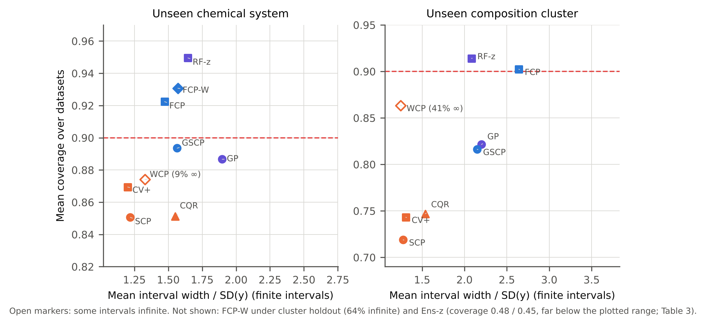
Fig. 4. Coverage versus mean interval width (in units of SD(y)) under the two shift protocols, averaged over datasets (α = 0.1). Methods above the dashed line meet the nominal level on average; points further left are more efficient.
Table 3. Summary over the six datasets (α = 0.1; 10 seeds per dataset). Cov: mean coverage; Min: worst dataset; W: mean finite interval width / SD(y); IS: mean interval score / SD(y). *Some intervals infinite (WCP: density-ratio weights; FCP-W: fewer than 9 training families).
Method | Cov | Min | W | IS | Cov | Min | W | IS | Cov | Min | W | IS
 | Random |  |  |  | Unseen system |  |  |  | Unseen cluster
SCP | 0.901 | 0.896 | 1.23 | 1.88 | 0.851 | 0.787 | 1.22 | 2.28 | 0.719 | 0.637 | 1.28 | 4.26
CV+ | 0.917 | 0.907 | 1.22 | 1.73 | 0.869 | 0.817 | 1.20 | 2.10 | 0.743 | 0.664 | 1.31 | 3.91
CQR | 0.899 | 0.896 | 1.52 | 1.99 | 0.851 | 0.787 | 1.55 | 2.35 | 0.747 | 0.636 | 1.54 | 3.75
WCP | 0.905 | 0.899 | 1.26* | ∞ | 0.874 | 0.809 | 1.33* | ∞ | 0.863 | 0.802 | 1.25* | ∞
GP | 0.893 | 0.860 | 1.62 | 2.43 | 0.887 | 0.852 | 1.90 | 2.82 | 0.821 | 0.705 | 2.20 | 4.23
RF-z | 0.955 | 0.927 | 1.35 | 1.60 | 0.950 | 0.913 | 1.64 | 1.93 | 0.914 | 0.854 | 2.08 | 2.69
Ens-z | 0.536 | 0.483 | 0.48 | 2.34 | 0.481 | 0.410 | 0.52 | 3.12 | 0.454 | 0.375 | 0.66 | 5.41
GSCP | 0.922 | 0.906 | 1.51 | 2.01 | 0.894 | 0.866 | 1.57 | 2.29 | 0.816 | 0.632 | 2.15 | 4.21
FCP | 0.941 | 0.915 | 1.35 | 1.70 | 0.922 | 0.915 | 1.47 | 1.95 | 0.902 | 0.851 | 2.64 | 3.54
FCP-W | 0.946 | 0.920 | 1.44 | 1.76 | 0.931 | 0.886 | 1.57 | 2.00 | 0.999 | 0.992 | 7.52* | ∞

Table 4. Paired comparisons over the 12 shift cells (6 tasks × 2 shift protocols; Wilcoxon signed-rank, Holm-corrected over 8 baselines). Δ: median paired difference (FCP − baseline) with bootstrap 95% CI; r: matched-pairs rank-biserial correlation. Negative Δ favours FCP. n_eff: cells with a non-zero shortfall difference (the signed-rank test ignores ties). For RF-z the shortfall is zero in most cells for both methods, so Δ and its CI are 0.
Comparison | n_eff | Δ shortfall | 95% CI | r | p_Holm | Δ IS | 95% CI | r | p_Holm
FCP vs SCP | 12 | -0.097 | [-0.187, -0.042] | -1.00 | 0.0039 | -0.266 | [-0.686, -0.179] | -1.00 | 0.0034
FCP vs CV+ | 10 | -0.076 | [-0.159, -0.024] | -1.00 | 0.0098 | -0.113 | [-0.370, -0.052] | -0.74 | 0.0420
FCP vs CQR | 12 | -0.074 | [-0.163, -0.041] | -1.00 | 0.0039 | -0.460 | [-0.514, -0.121] | -0.79 | 0.0366
FCP vs WCP | 10 | -0.029 | [-0.045, -0.005] | -0.89 | 0.0195 | n/a (∞) | – | – | –
FCP vs GP | 10 | -0.030 | [-0.061, -0.007] | -1.00 | 0.0098 | -0.780 | [-0.941, -0.573] | -1.00 | 0.0034
FCP vs RF-z | 3 | +0.000 | [+0.000, +0.000] | +0.67 | 0.5000 | +0.146 | [-0.071, +0.757] | +0.59 | 0.0771
FCP vs Ens-z | 12 | -0.425 | [-0.460, -0.390] | -1.00 | 0.0039 | -1.535 | [-2.155, -0.672] | -1.00 | 0.0034
FCP vs GSCP | 9 | -0.010 | [-0.049, -0.001] | -1.00 | 0.0117 | -0.372 | [-0.487, -0.185] | -1.00 | 0.0034

7.4. A strong heuristic competitor: random-forest tree spread
RF-z deserves separate discussion. Its coverage was as high as FCP's under both shifts (0.950 and 0.914), and its interval score was lower on average, although the difference was not significant (median paired difference +0.146 SD in favour of RF-z, p_Holm = 0.077). RF-z is not calibrated, however. It over-covered in the random protocol (0.955 at a nominal 0.90; 0.911 at a nominal 0.80, against 0.873 for FCP; Supplementary Fig. S1), and individual datasets reached 0.98. Its apparent robustness therefore comes from intervals that are systematically too wide in-distribution. That inflation happens to offset the extrapolation error under shift, but nothing guarantees it. It depends on forest hyper-parameters such as max_features and leaf size, and it cannot be dialled to a requested level. Section 9.4 asks the constructive question, whether family-level calibration of the forest's own tree spread combines its efficiency with calibrated coverage, and finds that it does.

7.5. Consequences for alloy screening
Interval validity matters for decisions. A common use of intervals in alloy design is to accept a candidate only if even its pessimistic (lower-bound) prediction exceeds a target. We emulated this under unseen-chemical-system holdout: an alloy was 'selected' when its lower bound exceeded the upper quartile τ of the property (Table 5). Pooled over five tasks and ten seeds, 4.6% of the alloys selected with SCP and 3.4% of those selected with CV+ were false discoveries, against 1.2% with FCP. For MPEA yield strength the false-discovery proportion fell from 18% (SCP) to 7% (FCP). The gain is not free: FCP recovered 28% of the true high performers against 38% for SCP. RF-z was more conservative still (false discoveries 0.3%, recall 20%), and CQR's wide quantile intervals almost never cleared the threshold. Pooled over tasks, all methods kept the false-discovery proportion below the 5% that a 95% one-sided lower bound would suggest, but this hides large task-level differences: for MPEA yield strength, SCP's 18% far exceeds it. Relative to FCP, SCP and CV+ admitted 3.8 and 2.9 times as large a proportion of false discoveries.
Table 5. Screening for high performers under unseen-chemical-system holdout (α = 0.1). An alloy is selected if the lower bound of its interval exceeds the upper quartile τ of the task's property. Per task: mean number selected per seed / false-discovery proportion (selected alloys with measured property < τ). Pooled over 5 tasks × 10 seeds: false-discovery proportion (FDP) and recall of all alloys with property ≥ τ.
Method | MPEA HV | MPEA YS | Steel YS | Bulk mod. | Tc | Pooled FDP | Recall
SCP | 10.5 / 0% | 27.2 / 18% | 9.1 / 12% | 333.7 / 1% | 406.0 / 7% | 4.6% | 0.38
CV+ | 5.1 / 0% | 29.1 / 18% | 3.9 / 5% | 334.1 / 1% | 382.1 / 5% | 3.4% | 0.37
CQR | 0.0 / – | 0.0 / – | 0.1 / 0% | 0.3 / 0% | 0.0 / – | 0.0% | 0.00
GP | 30.5 / 4% | 0.4 / 75% | 19.9 / 16% | 263.2 / 3% | 187.5 / 7% | 4.9% | 0.24
RF-z | 14.1 / 0% | 1.9 / 0% | 1.4 / 0% | 182.8 / 0% | 200.5 / 1% | 0.3% | 0.20
GSCP | 3.2 / 0% | 16.9 / 14% | 4.5 / 11% | 327.7 / 1% | 260.0 / 4% | 2.7% | 0.30
FCP | 0.0 / – | 7.5 / 7% | 0.7 / 14% | 331.1 / 1% | 214.3 / 2% | 1.2% | 0.28

7.6. Metallurgical interpretation
Where do random-split intervals fail, metallurgically? For the MPEA tasks, coverage under unseen-chemical-system holdout was broken down by alloy class, reported phase, valence-electron concentration (VEC) and atomic-size mismatch δ [47] (Fig. 5; Supplementary Material). The failures were concentrated where the composition–property relation is least smooth. In the VEC band 6.87–8, between the empirical BCC- and FCC-stability limits of high-entropy alloys [3,48], SCP covered only 0.73 (yield strength) and 0.82 (hardness), against 0.90 and 0.89 for BCC- and FCC-favoured yield-strength alloys. Alloys reported as multiphase were the hardest phase class (SCP 0.80), and 3d-transition-metal alloys were harder than refractory ones (SCP 0.78 vs 0.91). This is the regime of Al- or Ti-alloyed CoCrFeNi-type systems, where small composition changes move the alloy from FCC through FCC + BCC to BCC and the strength changes abruptly [49]; a new system in this band is extrapolation across a phase boundary that random calibration alloys rarely represent. FCP raised coverage in the transition band to 0.85 and 0.91 (FCP-RFσ 0.89 and 0.94), but its yield-strength intervals there were hardly wider than elsewhere (1.97 vs 1.84 and 1.87 SD), because neither of its difficulty signals encodes proximity to a phase boundary. A physically informed difficulty signal, such as the distance of VEC from the transition band, is a natural extension that should be tested prospectively rather than tuned here.
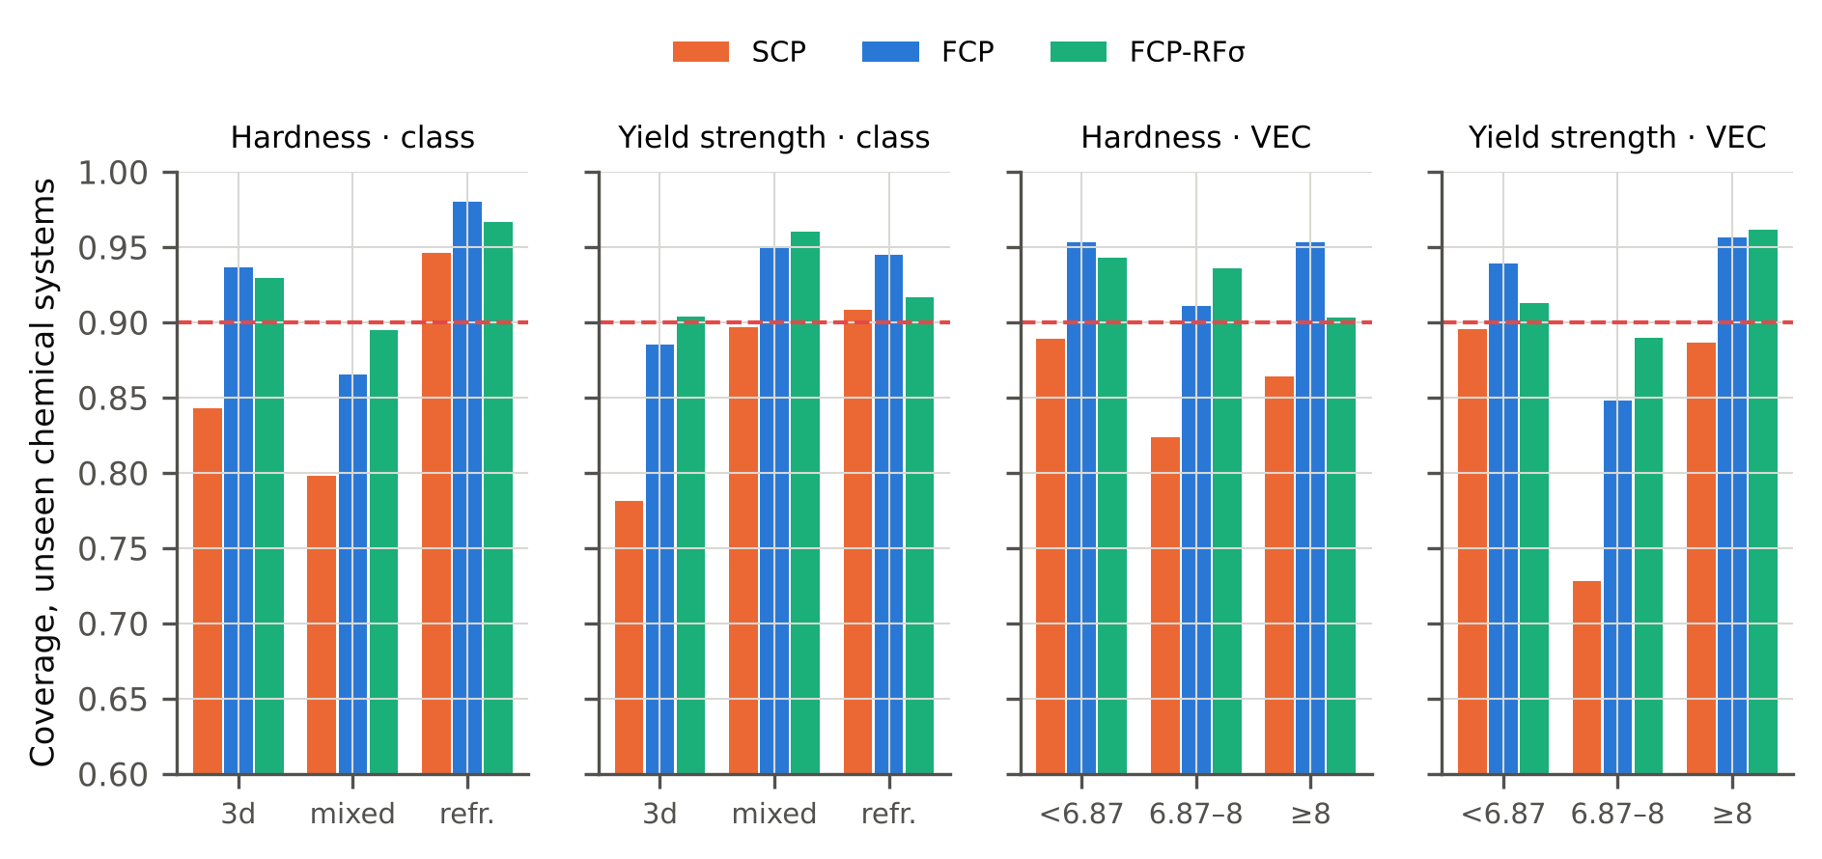
Fig. 5. Coverage of 90% intervals for MPEA alloys from unseen chemical systems by alloy class (3d-transition, mixed, refractory) and VEC regime (< 6.87 BCC-favoured, 6.87–8 transition, ≥ 8 FCC-favoured); means over 10 seeds (FCP-RFσ: 5 seeds).

8. Ablation study
Table 6 and Fig. 6 decompose FCP into its three design choices: family-grouped folds, the scale model (none, spread only, novelty only, both) and family weights. Grouping is the decisive component. Switching CV+ from random to family-grouped folds, with nothing else changed, raised mean coverage from 0.869 to 0.920 (system) and from 0.743 to 0.893 (cluster). Over the 12 shift cells the median gain was 9.1 percentage points (Wilcoxon p = 0.0005). Normalization without grouping (NCV+, analogous to the normalized conformal method used for steels with random splits [25]) narrowed the intervals but did not fix coverage (0.884 and 0.857). FCP covered more than NCV+ in the paired comparison (median +4.0 points, p = 0.016).
The two difficulty signals play different roles. The ensemble spread improved efficiency: the interval score of GCV+[spread] was 1.937 vs 2.082 (system) and 3.324 vs 3.457 (cluster) for the unnormalized grouped CV+. Compositional novelty instead improved coverage for the most novel alloys. In the highest novelty tertile under cluster holdout, coverage was 0.932 for FCP against 0.878 for GCV+ (12-cell median difference +3.7 points, p = 0.0015; Fig. 7). Novelty also widened the intervals, so that under the cluster protocol FCP's interval score (3.539) was worse than spread-only normalization (3.324). Over the 12 cells, the FCP vs GCV+ interval-score difference was not significant (p = 0.47). Hence the pre-specified 'both' scale buys more uniform coverage across novelty levels at a modest efficiency cost. A user who values average efficiency over conditional coverage should prefer the spread-only scale.
Family weights (the -W variants) raised family-level coverage (FCP-W vs FCP: median +4.4 points, p = 0.0049) at the cost of wider intervals. They also became unbounded when fewer than nine training families were available, as Eq. (10) predicts.
Revision history of the scale model. The first version of the scale model (v1) extrapolated the log-linear fit beyond the range of the difficulty signals seen during fitting. It produced a few extremely wide intervals for test alloys with rare processing categories or compositions. Clamping the signals to their fitting range (v2, used throughout) left coverage unchanged (FCP, alloy tasks, cluster protocol: 0.919 vs 0.918) and left the median width unchanged (2.82 vs 2.81 SD). It reduced the mean width from 6.64 to 2.93 SD and the interval score from 7.36 to 3.70 (Supplementary Table S1). The change was made after the interim analysis, and it is documented together with the original results.
Table 6. Ablation (α = 0.1, mean over datasets). Cov: coverage; IS: interval score / SD(y); Cov_{hi}: coverage in the highest novelty tertile.
Variant | Folds | Scale | Weights | Cov | IS | Cov_hi | Cov | IS | Cov_hi
 |  |  |  | Unseen system |  |  | Unseen cluster
CV+ | random | – | 1 | 0.869 | 2.10 | 0.866 | 0.743 | 3.91 | 0.687
NCV+ | random | spread+novelty | 1 | 0.884 | 1.95 | 0.906 | 0.857 | 3.13 | 0.869
GCV+ | family | – | 1 | 0.920 | 2.08 | 0.912 | 0.893 | 3.46 | 0.878
GCV+[spread] | family | spread | 1 | 0.923 | 1.94 | 0.913 | 0.896 | 3.32 | 0.882
GCV+[novelty] | family | novelty | 1 | 0.919 | 2.09 | 0.935 | 0.901 | 3.67 | 0.932
FCP | family | spread+novelty | 1 | 0.922 | 1.95 | 0.936 | 0.902 | 3.54 | 0.932
GCV+-W | family | – | 1/n_g | 0.929 | 2.14 | 0.929 | 1.000 | ∞ | 1.000
FCP-W | family | spread+novelty | 1/n_g | 0.931 | 2.00 | 0.945 | 0.999 | ∞ | 1.000

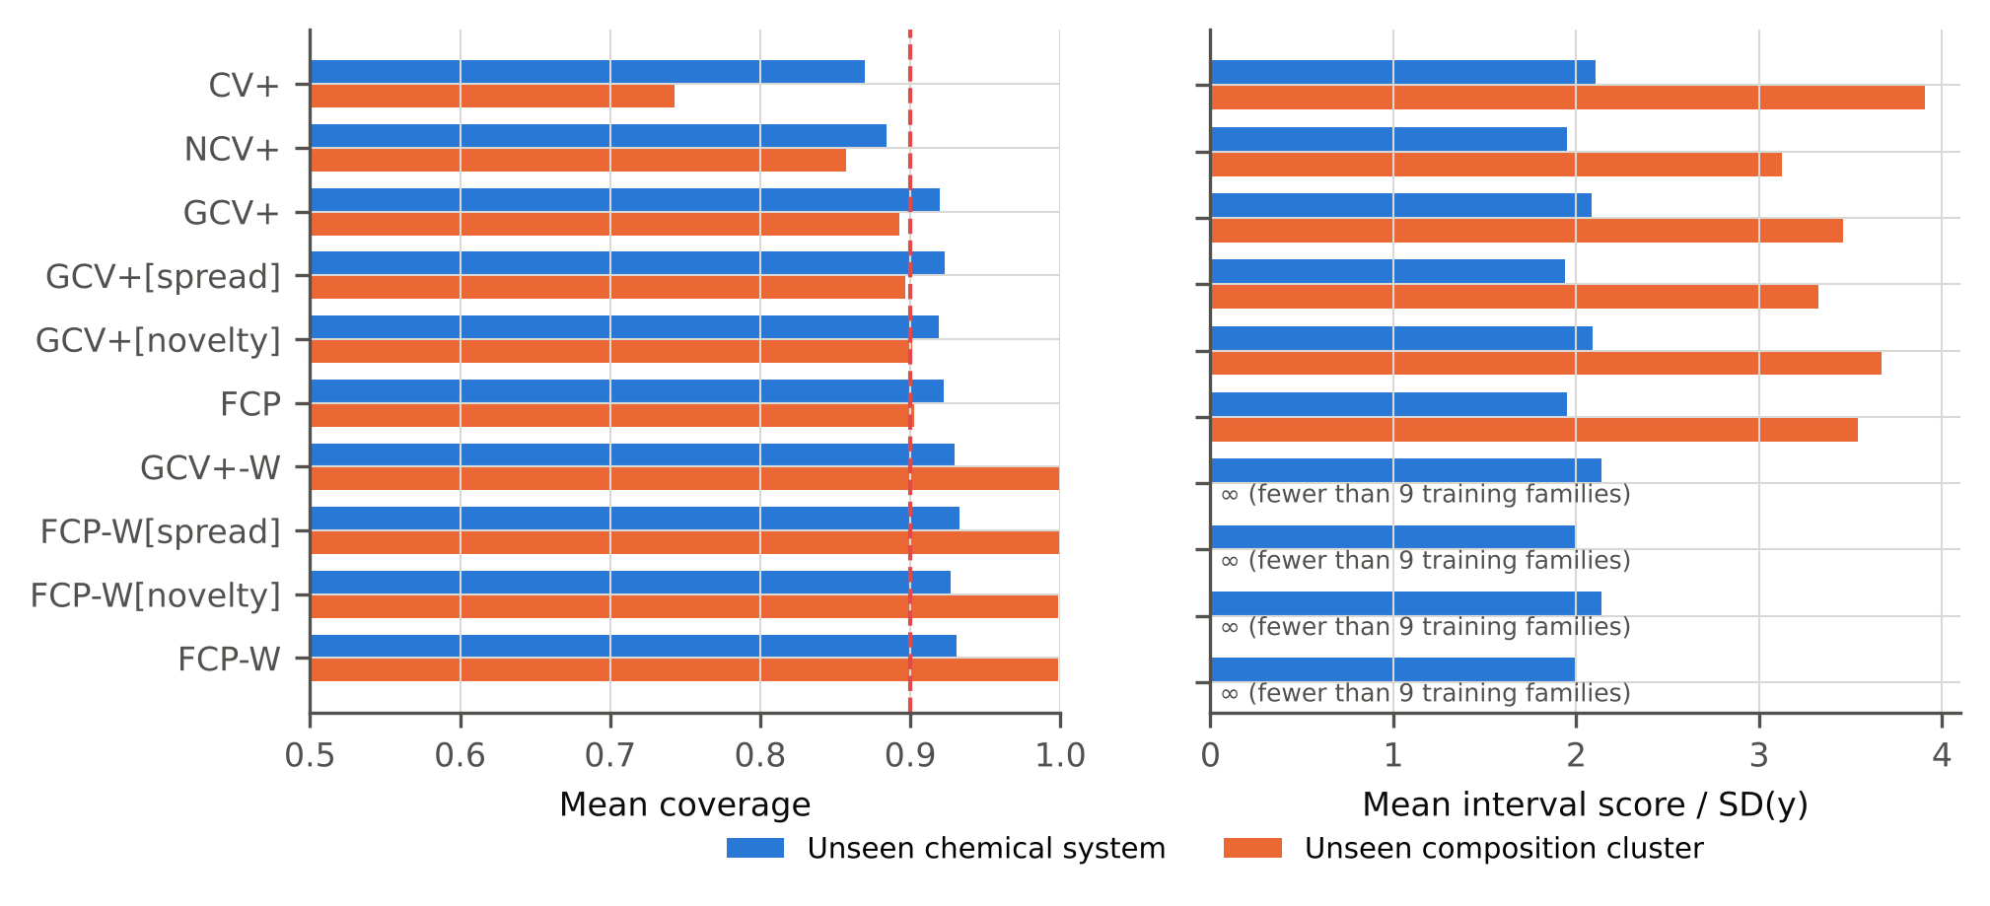
Fig. 6. Ablation of FCP under the two shift protocols: mean coverage (left) and interval score (right) over datasets. GCV+: family-grouped CV+ without normalization; [spread] / [novelty]: scale model with one signal; -W: family weights; NCV+: normalization with random folds.
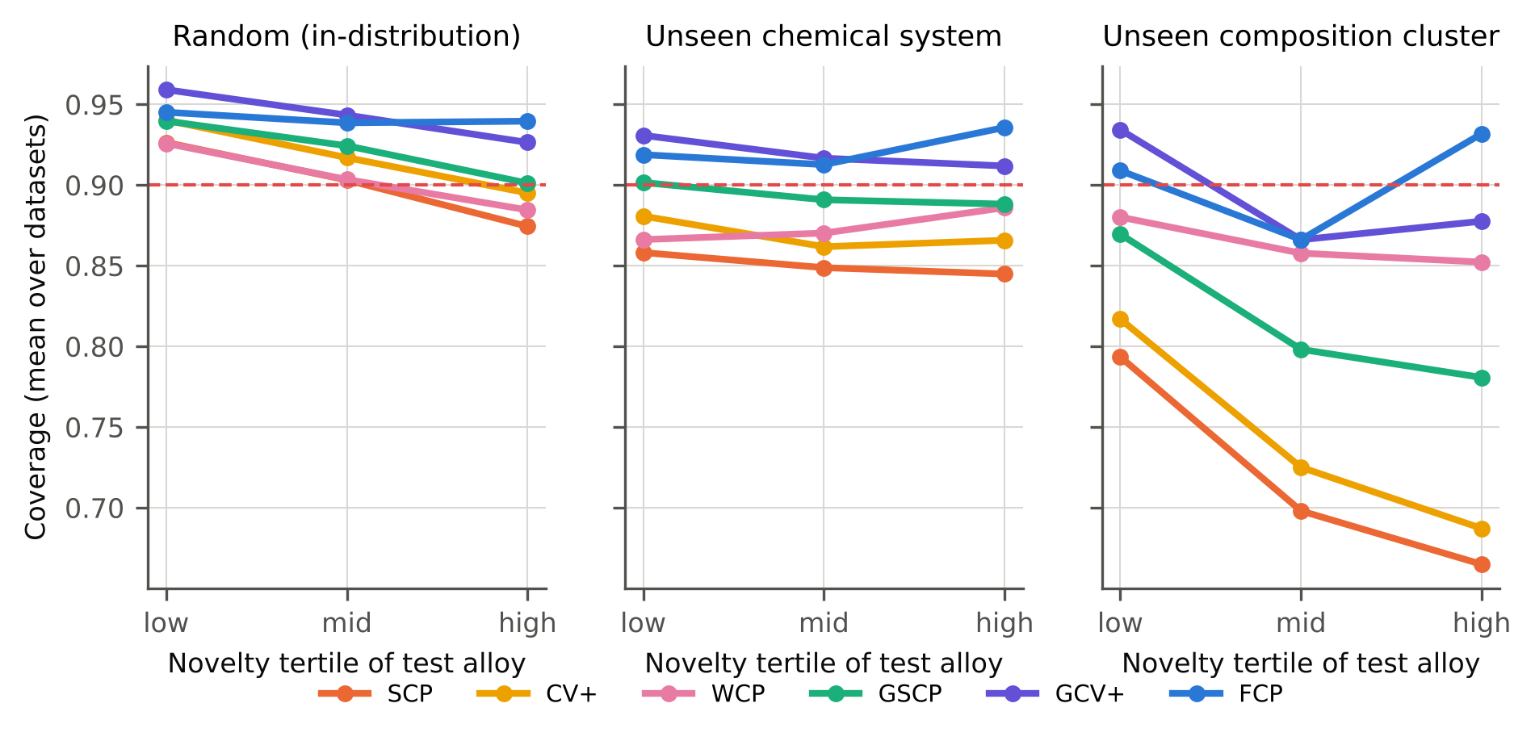
Fig. 7. Coverage within tertiles of test-alloy novelty (k-nearest-neighbour distance to the training alloys), averaged over datasets.

9. Robustness and generalization

9.1. Label noise and reduced training data (RQ4)
Fig. 8 reports coverage under the unseen-chemical-system protocol (5 seeds, all tasks except the superconductors) when Gaussian noise of 0.10 or 0.25 SD(y) was added to the labels, or when only half of the training families were available. FCP's mean coverage stayed at 0.923, 0.920 and 0.922, and its worst dataset at 0.824 or above. SCP (0.864, 0.868, 0.840) and CV+ (0.878, 0.883, 0.865) remained below nominal, and the shortfall of SCP grew when training data were halved. Label noise widens all intervals but does not change the ranking: the calibration mismatch, not the noise level, drives the under-coverage. RF-z again covered well (0.947–0.936) with a slightly lower interval score than FCP.
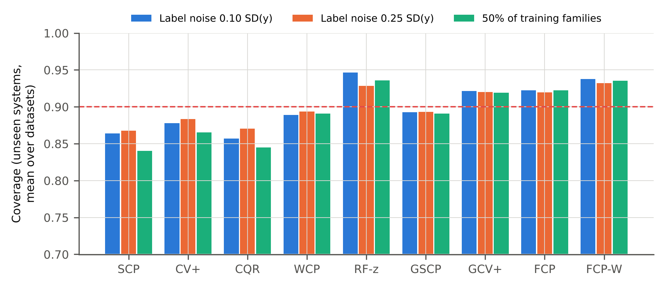
Fig. 8. Coverage under label noise and reduced training data (unseen-chemical-system protocol, α = 0.1, mean over five datasets and five seeds).

9.2. Mis-specified family definition (RQ5)
In practice the family definition used for calibration may not match the novelty that is actually explored. We calibrated FCP on chemical systems (F1) while the test alloys came from unseen composition clusters (F2), a coarser and harder shift. Mean coverage then fell to 0.814 for FCP and 0.838 for FCP-W, against 0.902 when calibration used the matching cluster families. The random-calibrated methods fell further (SCP 0.700, CV+ 0.715), and so did the family-held-out split GSCP (0.762). The task-wise minimum for FCP was 0.703 (Superconductor Tc). FCP thus degrades gracefully, remaining the best of the methods compared, but it is not a substitute for choosing a family definition at least as coarse as the intended exploration. A practical rule follows: when in doubt, calibrate on the coarser family definition.

9.3. Chronological deployment test
Family holdouts are constructed shifts. A more realistic test trains on alloys published before 2019 and predicts those first reported in 2019, the most recent year in the MPEA database (10 seeds; Table 7). For yield strength, 63% of the 2019 alloys belong to chemical systems absent from earlier years. FCP covered 0.903 of them overall and 0.910 of those in new systems, against 0.794 and 0.767 for SCP and 0.806 overall for CV+. The uncalibrated RF-z (0.902) and the GP (0.934) also reached the nominal level in this test, so FCP was not unique here. Under a genuine chronological shift whose main component is family novelty, family-level calibration delivered nominal coverage where random-split calibration did not.
Hardness behaved differently. Every method failed (FCP 0.614, SCP 0.557, CV+ 0.541). The failure was concentrated in chemical systems that were present in the training years (FCP: 0.463 in seen vs 0.781 in unseen systems). The predictions were biased by +82 HV on average, and the 2019 entries included more powder-processed alloys and more entries with unreported processing. This is a shift in the composition–property relation within known families, plausibly caused by new processing routes and measurement practice. No calibration on historical data, family-level or otherwise, can anticipate it. It marks the boundary of what FCP addresses: novelty of the alloy family, not changes in how alloys of known families are made or measured.
Table 7. Chronological test on MPEA data (train: publication year < 2019; test: 2019). Coverage (mean ± SD over 10 seeds) overall and for test alloys whose chemical system does or does not occur in the training years.
Task | Method | Coverage | Seen systems | Unseen systems
MPEA hardness | SCP | 0.557 ± 0.089 | 0.435 | 0.693
MPEA hardness | CV+ | 0.541 ± 0.020 | 0.448 | 0.644
MPEA hardness | CQR | 0.547 ± 0.037 | 0.438 | 0.667
MPEA hardness | WCP | 0.731 ± 0.144 | 0.664 | 0.805
MPEA hardness | GP | 0.662 ± 0.000 | 0.531 | 0.808
MPEA hardness | RF-z | 0.644 ± 0.004 | 0.469 | 0.838
MPEA hardness | GSCP | 0.604 ± 0.084 | 0.496 | 0.723
MPEA hardness | FCP | 0.614 ± 0.025 | 0.463 | 0.781
MPEA hardness | FCP-W | 0.642 ± 0.020 | 0.481 | 0.821
MPEA yield strength | SCP | 0.794 ± 0.066 | 0.841 | 0.767
MPEA yield strength | CV+ | 0.806 ± 0.008 | 0.876 | 0.765
MPEA yield strength | CQR | 0.861 ± 0.036 | 0.876 | 0.852
MPEA yield strength | WCP | 0.763 ± 0.080 | 0.813 | 0.734
MPEA yield strength | GP | 0.934 ± 0.000 | 0.914 | 0.945
MPEA yield strength | RF-z | 0.902 ± 0.006 | 0.869 | 0.922
MPEA yield strength | GSCP | 0.869 ± 0.044 | 0.907 | 0.847
MPEA yield strength | FCP | 0.903 ± 0.014 | 0.890 | 0.910
MPEA yield strength | FCP-W | 0.898 ± 0.016 | 0.888 | 0.903

9.4. Base-learner swap and random-forest tree spread
Is the effect of family-level calibration specific to LightGBM, and can it be combined with the efficiency of random forests? FCP and the main baselines were re-run with the ensemble members replaced by random forests (6 members of 50 trees, all tasks and protocols, seeds 0–4). Coverage with forest members was practically unchanged: FCP covered 0.918 (system) and 0.892 (cluster), against 0.923 and 0.899 with LightGBM members. Random-fold CV+ with the same forests under-covered just as before (0.866 and 0.743). FCP[RF]'s shortfall was smaller in the paired comparison (12 cells, p = 0.0010). The failure of random-split calibration and its repair by family-level calibration are therefore properties of the calibration, not of the regressor. However, FCP with forest members did not match RF-z's interval score: RF-z was better in the paired comparison (median difference +0.18 SD, p = 0.0005).
We then tested a specific explanation (hypothesis recorded before the run; Supplementary iteration log): RF-z's efficiency comes from its per-tree spread, so family-grouped CV+ normalized directly by that spread (FCP-RFσ) should be both calibrated and efficient. FCP-RFσ covered 0.920 (system) and 0.912 (cluster), with interval scores 1.85 and 2.81, against RF-z's 0.950 / 0.914 and 1.92 / 2.70 (paired interval-score test p = 0.6772). The random-fold version covered 0.888 / 0.813. The hypothesis was supported. FCP-RFσ's interval score was statistically indistinguishable from RF-z's and better than that of the LightGBM-based FCP in 11 of 12 shift cells (p = 0.0015). Unlike RF-z, it stayed calibrated in-distribution: 0.936 and 0.865 at nominal 0.90 and 0.80, against 0.954 and 0.909 for RF-z. Because this variant was formulated after the main results, it was tested afterwards in a pre-registered confirmatory study on new tasks (Section 9.5).

9.5. Pre-registered confirmatory study
To test whether the conclusions, and the post hoc FCP-RFσ, hold beyond the data that shaped them, a confirmatory study was pre-registered (hypotheses, success criteria and a promotion rule committed to the repository before any run; Supplementary Material) on five tasks never used in the exploratory work: experimental band gap [50], MPEA tensile elongation [36], MPEA ultimate tensile strength [36], steel tensile strength (Citrine steel data distributed with matminer [42]), shear modulus [38]. Four of them are new properties of alloys or compounds already present in Section 7; the band-gap set is an independent material class. The configuration was unchanged (10 seeds, three protocols; 10 new shift cells). C1 (random-calibrated methods under-cover; one-sided Wilcoxon) was met: SCP covered 0.846 and 0.782 (p = 0.0010), CV+ 0.858 and 0.796 (p = 0.0049), CQR 0.852 and 0.809 (p = 0.0010). C2 (smaller shortfall for FCP than SCP, CV+, CQR and GSCP; Holm) was met (p_Holm SCP 0.0078, CV+ 0.0078, CQR 0.0078, GSCP 0.0078). C3 (FCP ≥ 0.88 under both shifts) was met: 0.919 and 0.909. For FCP-RFσ, C4 (coverage ≥ 0.88) was met (0.911 and 0.917), C5 (lower interval score than FCP) was met (median paired difference −0.221 SD, p = 0.0488), and C6 (better in-distribution calibration than RF-z) was met (0.935 vs 0.950 at nominal 0.90; 0.852 vs 0.900 at 0.80). Two qualifications apply. C5 was met narrowly (p = 0.049 over 10 cells that come from only 5 tasks), and C6 held for the mean but not for every task: FCP-RFσ was closer to nominal than RF-z on 3 of 5 tasks at α = 0.1 and 3 of 5 at α = 0.2, over-covering for steel tensile strength. By the pre-registered rule, FCP-RFσ is nevertheless promoted from a post hoc observation to the recommended variant for random-forest models; Table 8 gives the per-protocol results.
Table 8. Pre-registered confirmatory study on five new tasks (α = 0.1, 10 seeds). Cov: mean coverage over tasks; Min: worst task; IS: mean interval score / SD(y); ∞: some intervals unbounded (FCP-W under cluster holdout has G = 8 < 9 training families, Eq. 10; WCP when density-ratio weights concentrate on a few calibration alloys).
Method | Cov | Min | IS | Cov | Min | IS | Cov | Min | IS
 | Random |  |  | Unseen system |  |  | Unseen cluster
SCP | 0.898 | 0.886 | 2.57 | 0.846 | 0.760 | 3.05 | 0.782 | 0.686 | 4.20
CV+ | 0.915 | 0.908 | 2.36 | 0.858 | 0.775 | 2.87 | 0.796 | 0.712 | 4.00
CQR | 0.899 | 0.887 | 2.44 | 0.852 | 0.752 | 2.89 | 0.809 | 0.733 | 3.77
WCP | 0.905 | 0.888 | ∞ | 0.886 | 0.850 | ∞ | 0.914 | 0.862 | ∞
GP | 0.893 | 0.879 | 3.07 | 0.889 | 0.878 | 3.53 | 0.864 | 0.800 | 4.22
RF-z | 0.950 | 0.929 | 2.03 | 0.936 | 0.898 | 2.42 | 0.920 | 0.879 | 3.22
GSCP | 0.924 | 0.905 | 2.73 | 0.888 | 0.872 | 3.07 | 0.848 | 0.754 | 3.99
MCP | 0.911 | 0.904 | 2.60 | 0.878 | 0.831 | 2.96 | 0.819 | 0.764 | 3.92
FCP | 0.939 | 0.916 | 2.26 | 0.919 | 0.911 | 2.58 | 0.909 | 0.903 | 3.61
FCP-W | 0.943 | 0.913 | 2.30 | 0.927 | 0.896 | 2.66 | 0.999 | 0.996 | ∞
FCP-RFσ | 0.935 | 0.910 | 2.03 | 0.911 | 0.906 | 2.39 | 0.917 | 0.903 | 3.32

In the pre-registered chronological test (train < 2019, test 2019), MPEA tensile strength showed little shift: SCP, CV+, FCP and FCP-RFσ all covered at least 0.92 (FCP 0.981), although WCP (0.809) and RF-z (0.867) did not. For elongation, FCP (0.928) and FCP-RFσ (0.917) reached nominal coverage, whereas SCP (0.883), CV+ (0.873) and RF-z (0.855) fell short (Supplementary Material).

9.6. Additional checks
Four further checks are summarized here; full results are in the Supplementary Material. (i) Sensitivity. Varying the number of folds (K ∈ {3, 10}), ensemble members (M ∈ {3, 12}), family fraction (φ ∈ {0.5, 0.9}) and k_{nn} ∈ {1, 15} one at a time kept FCP's coverage between 0.921 and 0.937 (interval score 2.66–2.87; Supplementary Fig. S2), so validity does not hinge on tuning. (ii) Randomized cluster-to-fold assignment. The size-balanced assignment of ten clusters to five outer folds is identical for every seed; with a fully random assignment per seed, mean coverage was 0.904 for FCP (balanced: 0.902), 0.716 for SCP and 0.744 for CV+. (iii) Novelty-conditional (Mondrian) calibration with random splits (MCP, separate quantiles in novelty tertiles) covered 0.878 (system) and 0.767 (cluster), between SCP (0.719) and FCP (0.902) under cluster holdout: conditioning on distance helps, but a randomly held-out alloy that looks novel still has relatives of its own family in the training data, which a genuinely new family does not.
(iv) Proposition 1 in practice. FCP-S, the family-subsampled variant covered by Proposition 1, was run on the six tasks under unseen-system holdout (10 seeds; G = 39–1321 training families, for which the bound evaluates to 0.655–0.794 at α = 0.1). Its family-level coverage averaged 0.922 (worst task 0.914), against 0.925 for FCP-W and 0.912 for FCP; every task-level mean exceeded the bound. The interval scores of FCP-S and FCP-W were 1.99 and 2.00 (paired Wilcoxon over task–seed cells, p = 0.63), so in these data the guarantee comes without a detectable loss of efficiency.

10. Computational cost
FCP's cost is dominated by fitting K = 5 family-bagged ensembles of M = 6 members, i.e. 30 LightGBM models per outer fold. It was therefore within 2% of random-fold CV+, which fits the same number of models, and 5.2–7.0 times as expensive as split conformal prediction (Supplementary Material). In absolute terms, one outer fold took 2.1–11.9 s on a single CPU thread for about 249–3,205 training alloys (80% of each task), less than the Gaussian process on the four larger tasks. Forming the intervals is a weighted quantile over the n calibration bounds per test alloy, which adds O(n log n) per alloy and is negligible at these sizes. No GPU is required. The extra cost relative to split conformal prediction is incurred once per model update, not per prediction, which matters little in alloy design, where each new measurement costs hours to days. Measured in isolated processes, the peak resident memory of FCP was 345 MB, against 445 MB for the GP (Supplementary Fig. {SFIG['efficiency']}).

11. Error analysis
To see where intervals still fail, coverage was computed for every test family with at least five alloys in the system protocol (all seeds pooled; Fig. 9). The dominant failure mode was property extremity, not compositional novelty. For FCP, within-family coverage decreased with the family's mean distance from the median target (|y − median|/IQR) in 5 of 6 tasks (Spearman ρ from -0.44 to 0.05). The families in the most extreme sextile were covered 0.82 of the time by FCP, against 0.64 by SCP. FCP therefore reduced this failure substantially but did not remove it. The association with novelty was weaker and of inconsistent sign, which suggests that, once calibration is family-level, the remaining misses are dominated by regression toward the mean of the training labels for families with unusually high or low properties. Supplementary Fig. S4 illustrates this for MPEA hardness: the uncovered alloys concentrate above about 800 HV.
The families with the lowest FCP coverage are listed in the Supplementary Material. Several are metallurgically distinctive within their datasets. Examples in the MPEA yield-strength data are the Cr–Fe–Ni–Ti and Al–Co–Cr–Fe–Mo–Ni systems and the refractory Nb–Ta–Ti and Al–Mo–Nb–Ta–Ti–Zr systems. The ensemble predicted their strength levels poorly: the mean absolute error of the worst family exceeded 1159 MPa. An Fe–As–O–Sm (iron-pnictide) family appears among the superconductors, and maraging-type Co–Fe–Mo–Ni–Ti steels among the steels. These are cases in which a new strengthening or pairing mechanism, absent from the training families, governs the property. No calibration of residuals can anticipate such a mechanism. FCP's intervals are honest about the average extrapolation error over families, not about every individual family.
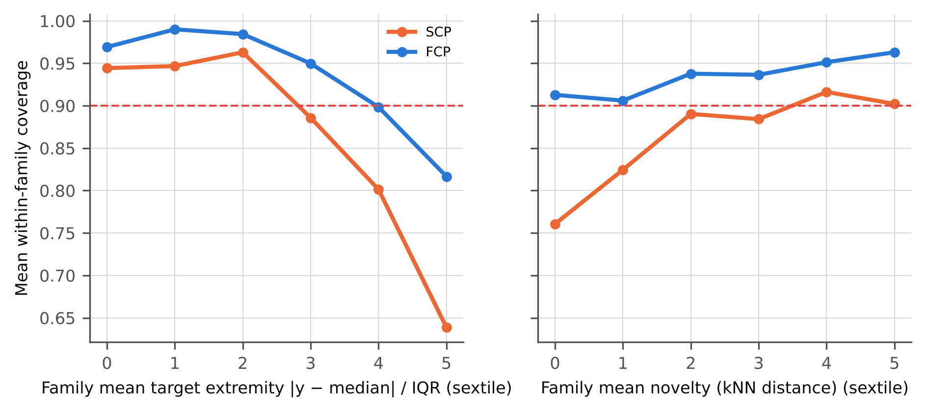
Fig. 9. Within-family coverage (system holdout, families with ≥ 5 alloys, all tasks and seeds pooled) against the family's mean target extremity (left) and mean novelty (right), in sextiles.

12. Discussion
What the results mean for alloy design. A materials-informatics workflow that reports 'conformal' 90% intervals calibrated on random held-out alloys delivered, on average, 85–87% coverage on new chemical systems and 72–86% on new regions of composition space (the upper ends belong to WCP, which reached them only by returning infinite intervals for part of the alloys). In the worst datasets coverage was close to two-thirds. The nominal level is therefore not a property of the method alone. It is a property of the method and of how the calibration data relate to the deployment data. The remedy studied here is simple to state: calibrate on whole held-out families, so that the calibration residuals measure the kind of error the model will make in use. With that change, coverage on unseen families returned to the nominal level on average. The price is intervals about 23% (system) and 102% (cluster) wider than the under-covering random-calibrated ones. Measured by the interval score, which accounts for both width and misses, FCP was better than every baseline except random-forest tree spread at the level of the 12 dataset-protocol cells. At the level of the six independent datasets, the advantage over CV+ and CQR was consistent in direction but not statistically significant.
Choosing the family definition. The family is the unit of novelty against which coverage is certified. Chemical systems are natural for HEA/MPEA design campaigns that open new element combinations. Composition clusters are natural when moving to distant regions of an existing system. Section 9.2 shows that calibrating on a finer definition than the actual shift costs coverage. Section 9.3 shows that FCP cannot correct shifts that are not family novelty at all, such as new processing routes. Practitioners should calibrate at the level of novelty they intend to explore. With few families, they should prefer unweighted FCP, whose interval stays finite, over FCP-W, whose interval correctly becomes unbounded.
Relation to prior work. The coverage collapse reported for polymer chemistry holdouts [14,15] is reproduced here for alloys and inorganic compounds, across six datasets and two kinds of family shift. Normalized scores, which restore label-conditional coverage under random splits in steels [25], do not restore coverage under family shift unless the calibration folds are grouped (NCV+ vs FCP, Section 8). Recalibration with labelled data from the new domain [26,27] is effective when such data exist; FCP is the corresponding remedy before any alloy of the new family has been measured. Density-ratio weighting [28] is unsuitable when the test family lies outside the support of the calibration data, as is typical of alloy discovery. The family-level construction follows the hierarchical view of Dunn et al. [16], adapted to cross-fitting, normalized scores and a leakage-free scale model.
Is the extra cost worth it? FCP costs about as much as CV+ and a few times as much as split conformal prediction (Section 10). The cheapest family-calibrated alternative, GSCP, came close to FCP when many families were available (unseen systems: 0.894 vs 0.922). It failed when only a few families existed (unseen clusters: 0.816 vs 0.902), because a single calibration split then contains only one or two families. Because FCP uses every family once for calibration, its benefit grows as the number of families shrinks, which is exactly the situation of a new alloy class with few explored systems. For databases with hundreds of families and tight compute budgets, GSCP is a defensible and cheaper choice.
Practical recommendation. For screening alloys from unexplored families, (i) define families from composition before modelling; (ii) calibrate with family-grouped folds (FCP; with random-forest models, normalized by the forest's tree spread, FCP-RFσ), or with a family-held-out calibration split (GSCP) when many families and little compute are available; (iii) report the coverage obtained under a family-holdout evaluation, not under random cross-validation; and (iv) treat alloys with predicted properties far outside the training range, and alloys in the VEC transition band between BCC- and FCC-stable compositions, with extra caution, because that is where the remaining misses concentrate (Sections 7.6 and 11).

13. Limitations
- No new finite-sample theorem is proved for the full normalized, family-weighted CV+ construction. Validity on new families is assessed empirically on six datasets, and it rests on the families being approximately exchangeable units. A design campaign that deliberately moves away from all known families (adaptive or feedback shift [29]) violates this assumption.
- Coverage is marginal over alloys (FCP) or over families (FCP-W), not conditional on an individual alloy. Families with extreme properties remained under-covered (Section 11).
- Under the cluster protocol only ten families exist per dataset. Family-level (FCP-W) statements at α = 0.1 are then impossible (Eq. 10), and the outer partition of the balanced protocol is identical across seeds (Section 9.6).
- All datasets are public compilations. MPEA entries from different publications differ in processing and testing details that are only partly encoded, and inter-laboratory bias cannot be separated from model error.
- Features are composition-based (plus processing and test conditions for MPEA). Microstructure, defect and thermomechanical-history descriptors, which govern many mechanical properties, were not available.
- Superconductor data were subsampled to about 4,000 compounds by whole chemical systems to fit the computational budget (4 CPU cores). Results for the full set may differ quantitatively.
- Energy consumption was not measured. All runs used CPUs only, and per-fold costs are reported as wall time. Interval formation scales as O(n log n) per test alloy, which was negligible here but would call for an approximation (e.g. a pooled quantile of normalized scores) for databases with 10⁵ or more alloys.
- No prospective validation was performed: no new alloy was synthesized and tested. The chronological test (Section 9.3) is the closest available proxy.
- FCP-RFσ was formulated after the main results (Section 9.4); its pre-registered confirmation (Section 9.5) used new properties of partly the same alloys plus one independent material set, so confirmation on further independent alloy data remains desirable. The alloy-family threshold (1 at.%) and the number of composition clusters (10) were fixed and not varied.
- In the superconductor data, 199 compositions appear under more than one formula spelling. They cannot cross folds in the family-holdout protocols, but can in the random protocol; excluding them changed random-protocol coverage by at most 0.004 (code/scripts/audit_duplicate_spellings.py).
- Hyper-parameters were fixed defaults and were not tuned per dataset. Tuning would raise point accuracy for every method alike and is unlikely to change the calibration comparison, but this was not tested.

14. Conclusions
Prediction intervals for machine-learned alloy properties were examined in the setting that matters for discovery: prediction for alloys from families absent from the training data. The main conclusions are:
- Conformal intervals calibrated on randomly held-out alloys lose their guarantee under alloy-family extrapolation. Nominal 90% intervals covered 85–87% of alloys from unseen chemical systems and 72–86% from unseen composition clusters.
- Family-calibrated conformal prediction (FCP), i.e. CV+ with family-grouped folds and a leakage-free, novelty-aware scale model, restored mean coverage to 0.922 and 0.902. It reduced the coverage shortfall relative to seven of eight baselines and improved the interval score relative to six (12 dataset-protocol cells, Holm-corrected). In a lower-bound screen for high-performing alloys it cut false discoveries three- to four-fold relative to split conformal prediction, at the cost of lower recall.
- Grouping the calibration folds by family is the decisive ingredient. The ensemble-spread scale improves efficiency, and the compositional-novelty scale equalizes coverage across novelty levels at a small efficiency cost.
- Random-forest tree-spread intervals were an unexpectedly strong but uncalibrated competitor; their robustness comes from systematic over-coverage in-distribution. Normalizing family-grouped CV+ by that tree spread (FCP-RFσ, formulated post hoc) reached the same efficiency with calibrated coverage and is the best-performing calibrated variant found here, a finding that met all of its pre-registered criteria on five new tasks.
- Remaining failures concentrate in families with extreme property values and, metallurgically, in multiphase alloys and the VEC band between BCC- and FCC-stable compositions, where small composition changes alter the phase constitution. Interval estimates for such candidates should be treated with additional caution, and a phase-boundary-aware difficulty signal is a natural next step.
- FCP certifies coverage against the novelty encoded by the family definition, and nothing beyond it. Calibrating on a finer family definition than the actual shift lowered coverage. A chronological test showed nominal coverage when newly reported alloys came from new chemical systems, but no method, FCP included, covered a shift caused by new processing routes within known systems.

CRediT authorship contribution statement
[Author 1]: Conceptualization, Methodology, Software, Formal analysis, Investigation, Data curation, Visualization, Writing – original draft. [Author 2]: Supervision, Validation, Writing – review & editing. (To be completed by the authors.)

Declaration of competing interest
The authors declare that they have no known competing financial interests or personal relationships that could have appeared to influence the work reported in this paper.

Data and code availability
All six datasets are public (Table 1). The complete code is provided as supplementary material and will be deposited in a public repository with a DOI upon acceptance [repository URL to be inserted]. It includes data download, cleaning, featurization, all methods, the experiment driver (run_all.py), statistical analysis and figure/table generation. Every number in this article is regenerated by `python run_all.py --mode full`.

Declaration of generative AI and AI-assisted technologies in the writing process
During the preparation of this work the author(s) used an AI assistant (Claude, Anthropic) to assist with code development, data analysis and drafting of the manuscript. After using this tool, the author(s) reviewed and edited the content as needed and take(s) full responsibility for the content of the published article.

Acknowledgements
[To be completed by the authors.] The authors thank the creators of the MPEA, Matbench, SuperCon/UCI and matminer datasets for making their data public.

Funding
[To be completed by the authors.]

References
[1] C. Wen, Y. Zhang, C. Wang, D. Xue, Y. Bai, S. Antonov, L. Dai, T. Lookman, Y. Su, Machine learning assisted design of high entropy alloys with desired property, Acta Materialia 170 (2019) 109-117. https://doi.org/10.1016/j.actamat.2019.03.010
[2] Z. Rao, P.-Y. Tung, R. Xie, Y. Wei, H. Zhang, A. Ferrari, T. Klaver, F. Körmann, P. T. Sukumar, A. Kwiatkowski da Silva, Y. Chen, Z. Li, D. Ponge, J. Neugebauer, O. Gutfleisch, S. Bauer, D. Raabe, Machine learning–enabled high-entropy alloy discovery, Science 378 (2022) 78-85. https://doi.org/10.1126/science.abo4940
[3] D. Miracle, O. Senkov, A critical review of high entropy alloys and related concepts, Acta Materialia 122 (2017) 448-511. https://doi.org/10.1016/j.actamat.2016.08.081
[4] T. Lookman, P. V. Balachandran, D. Xue, R. Yuan, Active learning in materials science with emphasis on adaptive sampling using uncertainties for targeted design, npj Computational Materials 5 (2019) 21. https://doi.org/10.1038/s41524-019-0153-8
[5] J. Ling, M. Hutchinson, E. Antono, S. Paradiso, B. Meredig, High-Dimensional Materials and Process Optimization Using Data-Driven Experimental Design with Well-Calibrated Uncertainty Estimates, Integrating Materials and Manufacturing Innovation 6 (2017) 207-217. https://doi.org/10.1007/s40192-017-0098-z
[6] Algorithmic Learning in a Random World, Springer-Verlag, 2005. https://doi.org/10.1007/b106715
[7] J. Lei, M. G’Sell, A. Rinaldo, R. J. Tibshirani, L. Wasserman, Distribution-Free Predictive Inference for Regression, Journal of the American Statistical Association 113 (2018) 1094-1111. https://doi.org/10.1080/01621459.2017.1307116
[8] A. N. Angelopoulos, S. Bates, Conformal Prediction: A Gentle Introduction, Foundations and Trends® in Machine Learning 16 (2023) 494-591. https://doi.org/10.1561/2200000101
[9] R. F. Barber, E. J. Candès, A. Ramdas, R. J. Tibshirani, Conformal prediction beyond exchangeability, The Annals of Statistics 51 (2023) 816-845. https://doi.org/10.1214/23-AOS2276
[10] B. Meredig, E. Antono, C. Church, M. Hutchinson, J. Ling, S. Paradiso, B. Blaiszik, I. Foster, B. Gibbons, J. Hattrick-Simpers, A. Mehta, L. Ward, Can machine learning identify the next high-temperature superconductor? Examining extrapolation performance for materials discovery, Molecular Systems Design & Engineering 3 (2018) 819-825. https://doi.org/10.1039/C8ME00012C
[11] Z. Xiong, Y. Cui, Z. Liu, Y. Zhao, M. Hu, J. Hu, Evaluating explorative prediction power of machine learning algorithms for materials discovery using <mml:math xmlns:mml="http://www.w3.org/1998/Math/MathML" altimg="si1.svg"> <mml:mrow> <mml:mi>k</mml:mi> </mml:mrow> </mml:math> -fold forward cross-validation, Computational Materials Science 171 (2020) 109203. https://doi.org/10.1016/j.commatsci.2019.109203
[12] S. S. Omee, N. Fu, R. Dong, M. Hu, J. Hu, Structure-based out-of-distribution (OOD) materials property prediction: a benchmark study, npj Computational Materials 10 (2024) 144. https://doi.org/10.1038/s41524-024-01316-4
[13] L. Tan, P. Chen, M. Liu, X. Wang, J. Cen, Q. Zou, Benchmarking GNNs for OOD materials property prediction with uncertainty quantification, arXiv preprint arXiv:2511.11697, 2025.
[14] D. Han, Y. Shao, X. Zhong, Z. Song, Q. Zhang, C. Wang, D. Han, L. Wang, What Random Splits Measure in Polymer Glass-Transition Prediction: Chemistry Holdouts, Applicability Domains, and Prior Integration, Polymers 18 (2026) 2445. https://doi.org/10.3390/polym18192445
[15] M. Akdoğan, Trust Beyond Accuracy: Conformal Uncertainty Quantification Reveals the Generalization Gap in Polymer Glass Transition Temperature Prediction, ACS Omega 11 (2026) 44926-44941. https://doi.org/10.1021/acsomega.6c02607
[16] R. Dunn, L. Wasserman, A. Ramdas, Distribution-Free Prediction Sets for Two-Layer Hierarchical Models, Journal of the American Statistical Association 118 (2023) 2491-2502. https://doi.org/10.1080/01621459.2022.2060112
[17] R. F. Barber, E. J. Candès, A. Ramdas, R. J. Tibshirani, Predictive inference with the jackknife+, The Annals of Statistics 49 (2021) 486-507. https://doi.org/10.1214/20-AOS1965
[18] L. Breiman, Random Forests, Machine Learning 45 (2001) 5-32. https://doi.org/10.1023/A:1010933404324
[19] C.E. Rasmussen, C.K.I. Williams, Gaussian Processes for Machine Learning, MIT Press, Cambridge, MA, 2006.
[20] L. Hirschfeld, K. Swanson, K. Yang, R. Barzilay, C. W. Coley, Uncertainty Quantification Using Neural Networks for Molecular Property Prediction, Journal of Chemical Information and Modeling 60 (2020) 3770-3780. https://doi.org/10.1021/acs.jcim.0c00502
[21] D. Varivoda, R. Dong, S. S. Omee, J. Hu, Materials property prediction with uncertainty quantification: A benchmark study, Applied Physics Reviews 10 (2023) 021409. https://doi.org/10.1063/5.0133528
[22] K. Tran, W. Neiswanger, J. Yoon, Q. Zhang, E. Xing, Z. W. Ulissi, Methods for comparing uncertainty quantifications for material property predictions, Machine Learning: Science and Technology 1 (2020) 025006. https://doi.org/10.1088/2632-2153/ab7e1a
[23] G. Palmer, S. Du, A. Politowicz, J. P. Emory, X. Yang, A. Gautam, G. Gupta, Z. Li, R. Jacobs, D. Morgan, Calibration after bootstrap for accurate uncertainty quantification in regression models, npj Computational Materials 8 (2022) 115. https://doi.org/10.1038/s41524-022-00794-8
[24] N. Segal, A. Netanyahu, K. P. Greenman, P. Agrawal, R. Gómez-Bombarelli, Known Unknowns: Out-of-Distribution Property Prediction in Materials and Molecules, npj Computational Materials 11 (2025) 345. https://doi.org/10.1038/s41524-025-01808-x
[25] I. Boruah, Distribution-free conformal prediction for steel fatigue strength: marginal validity is not enough, arXiv preprint arXiv:2608.07589, 2026.
[26] A. Morger, F. Svensson, S. Arvidsson McShane, N. Gauraha, U. Norinder, O. Spjuth, A. Volkamer, Assessing the calibration in toxicological in vitro models with conformal prediction, Journal of Cheminformatics 13 (2021) 35. https://doi.org/10.1186/s13321-021-00511-5
[27] A. Morger, M. Garcia de Lomana, U. Norinder, F. Svensson, J. Kirchmair, M. Mathea, A. Volkamer, Studying and mitigating the effects of data drifts on ML model performance at the example of chemical toxicity data, Scientific Reports 12 (2022) 7244. https://doi.org/10.1038/s41598-022-09309-3
[28] R.J. Tibshirani, R. Foygel Barber, E.J. Candès, A. Ramdas, Conformal prediction under covariate shift, in: Advances in Neural Information Processing Systems 32 (NeurIPS 2019), 2019. arXiv:1904.06019.
[29] C. Fannjiang, S. Bates, A. N. Angelopoulos, J. Listgarten, M. I. Jordan, Conformal prediction under feedback covariate shift for biomolecular design, Proceedings of the National Academy of Sciences 119 (2022) e2204569119. https://doi.org/10.1073/pnas.2204569119
[30] I. Gibbs, J. J. Cherian, E. J. Candès, Conformal prediction with conditional guarantees, Journal of the Royal Statistical Society Series B: Statistical Methodology 87 (2025) 1100-1126. https://doi.org/10.1093/jrsssb/qkaf008
[31] A. Bhattacharyya, R. F. Barber, Group-weighted conformal prediction, Electronic Journal of Statistics 20 (2026) 1171-1199. https://doi.org/10.1214/26-EJS2506
[32] H. Papadopoulos, V. Vovk, A. Gammerman, Regression Conformal Prediction with Nearest Neighbours, Journal of Artificial Intelligence Research 40 (2011) 815-840. https://doi.org/10.1613/jair.3198
[33] U. Johansson, H. Boström, T. Löfström, H. Linusson, Regression conformal prediction with random forests, Machine Learning 97 (2014) 155-176. https://doi.org/10.1007/s10994-014-5453-0
[34] V. Vovk, Cross-conformal predictors, Annals of Mathematics and Artificial Intelligence 74 (2015) 9-28. https://doi.org/10.1007/s10472-013-9368-4
[35] G. Ke, Q. Meng, T. Finley, T. Wang, W. Chen, W. Ma, Q. Ye, T.-Y. Liu, LightGBM: a highly efficient gradient boosting decision tree, in: Advances in Neural Information Processing Systems 30 (NIPS 2017), 2017, pp. 3146–3154.
[36] C. K. H. Borg, C. Frey, J. Moh, T. M. Pollock, S. Gorsse, D. B. Miracle, O. N. Senkov, B. Meredig, J. E. Saal, Expanded dataset of mechanical properties and observed phases of multi-principal element alloys, Scientific Data 7 (2020) 430. https://doi.org/10.1038/s41597-020-00768-9
[37] A. Dunn, Q. Wang, A. Ganose, D. Dopp, A. Jain, Benchmarking materials property prediction methods: the Matbench test set and Automatminer reference algorithm, npj Computational Materials 6 (2020) 138. https://doi.org/10.1038/s41524-020-00406-3
[38] A. Mansouri Tehrani, A. O. Oliynyk, M. Parry, Z. Rizvi, S. Couper, F. Lin, L. Miyagi, T. D. Sparks, J. Brgoch, Machine Learning Directed Search for Ultraincompressible, Superhard Materials, Journal of the American Chemical Society 140 (2018) 9844-9853. https://doi.org/10.1021/jacs.8b02717
[39] R. S. Kingsbury, A. S. Rosen, A. S. Gupta, J. M. Munro, S. P. Ong, A. Jain, S. Dwaraknath, M. K. Horton, K. A. Persson, A flexible and scalable scheme for mixing computed formation energies from different levels of theory, npj Computational Materials 8 (2022) 195. https://doi.org/10.1038/s41524-022-00881-w
[40] K. Hamidieh, A data-driven statistical model for predicting the critical temperature of a superconductor, Computational Materials Science 154 (2018) 346-354. https://doi.org/10.1016/j.commatsci.2018.07.052
[41] L. Ward, A. Agrawal, A. Choudhary, C. Wolverton, A general-purpose machine learning framework for predicting properties of inorganic materials, npj Computational Materials 2 (2016) 16028. https://doi.org/10.1038/npjcompumats.2016.28
[42] L. Ward, A. Dunn, A. Faghaninia, N. E. Zimmermann, S. Bajaj, Q. Wang, J. Montoya, J. Chen, K. Bystrom, M. Dylla, K. Chard, M. Asta, K. A. Persson, G. J. Snyder, I. Foster, A. Jain, Matminer: An open source toolkit for materials data mining, Computational Materials Science 152 (2018) 60-69. https://doi.org/10.1016/j.commatsci.2018.05.018
[43] S. P. Ong, W. D. Richards, A. Jain, G. Hautier, M. Kocher, S. Cholia, D. Gunter, V. L. Chevrier, K. A. Persson, G. Ceder, Python Materials Genomics (pymatgen): A robust, open-source python library for materials analysis, Computational Materials Science 68 (2013) 314-319. https://doi.org/10.1016/j.commatsci.2012.10.028
[44] Y. Romano, E. Patterson, E.J. Candès, Conformalized quantile regression, in: Advances in Neural Information Processing Systems 32 (NeurIPS 2019), 2019. arXiv:1905.03222.
[45] T. Gneiting, A. E. Raftery, Strictly Proper Scoring Rules, Prediction, and Estimation, Journal of the American Statistical Association 102 (2007) 359-378. https://doi.org/10.1198/016214506000001437
[46] F. Pedregosa, G. Varoquaux, A. Gramfort, V. Michel, B. Thirion, O. Grisel, M. Blondel, P. Prettenhofer, R. Weiss, V. Dubourg, J. Vanderplas, A. Passos, D. Cournapeau, M. Brucher, M. Perrot, E. Duchesnay, Scikit-learn: machine learning in Python, J. Mach. Learn. Res. 12 (2011) 2825–2830.
[47] Y. Zhang, Y. J. Zhou, J. P. Lin, G. L. Chen, P. K. Liaw, Solid‐Solution Phase Formation Rules for Multi‐component Alloys, Advanced Engineering Materials 10 (2008) 534-538. https://doi.org/10.1002/adem.200700240
[48] S. Guo, C. Ng, J. Lu, C. T. Liu, Effect of valence electron concentration on stability of fcc or bcc phase in high entropy alloys, Journal of Applied Physics 109 (2011) 103505. https://doi.org/10.1063/1.3587228
[49] W.-R. Wang, W.-L. Wang, S.-C. Wang, Y.-C. Tsai, C.-H. Lai, J.-W. Yeh, Effects of Al addition on the microstructure and mechanical property of AlxCoCrFeNi high-entropy alloys, Intermetallics 26 (2012) 44-51. https://doi.org/10.1016/j.intermet.2012.03.005
[50] Y. Zhuo, A. Mansouri Tehrani, J. Brgoch, Predicting the Band Gaps of Inorganic Solids by Machine Learning, The Journal of Physical Chemistry Letters 9 (2018) 1668-1673. https://doi.org/10.1021/acs.jpclett.8b00124

