DT-CARGO Vehicle Telemetry Anomaly Detection Report
Full-dataset analysis of cluster-specific Isolation Forest predictions
Analysis basis: all_track_predictions.csv | 151,598 track records

1. Executive summary
The inference output contains 151,598 rows and 151,598 unique track IDs. 148,359 tracks have supported cluster assignments and anomaly scores; 3,239 tracks are unassigned and were not scored. The models flagged 4,185 assigned tracks (2.82% of scored tracks) for analyst review.
The largest overall cluster-level flag rate is in Cluster 2 (3.81%), followed by Cluster 1 (2.72%) and Cluster 0 (2.27%). Vehicle 19 is a prominent vehicle-level review candidate: 675 of 2,325 assigned tracks were flagged (29.03%), with flagged tracks present in all eight months in which it appears. These are statistical review signals, not confirmed faults or causal findings.
Total tracks | 151,598
Scored tracks | 148,359
Flagged tracks | 4,185 (2.82%)
Unassigned tracks | 3,239
Processing errors | 0
Duplicate track IDs | 0

2. Dataset coverage and integrity
The observed track start-time range is 2021-08-26 to 2024-02-06 (UTC-normalized for analysis). The output contains 163 distinct vehicle IDs. Track IDs are unique: 0 duplicate IDs were found. There are 0 processing errors.
The three supported cluster assignments cover 148,359 tracks. The remaining 3,239 tracks have no cluster assignment, no model version, and no anomaly score. They must not be counted as non-anomalous; they are outside the scoring population.

Quality-status distribution
Quality status | Tracks | Scored | Flagged
eligible | 100,370 | 100,370 | 3,899
eligible_with_warnings | 47,989 | 47,989 | 286
unassigned_cluster | 3,239 | 0 | 0
Among supported clusters, the modelling-dataset quality-status counts reconcile with inference. All 3,239 unassigned tracks are assigned the inference status 'unassigned_cluster'; this intentionally supersedes their earlier quality labels for the purpose of reporting scoring eligibility.

3. Anomaly distribution by cluster
Each cluster has its own Isolation Forest and its own training-derived threshold. Consequently, raw anomaly scores and thresholds should not be compared directly across clusters. Flag rates are more interpretable as within-cluster descriptive summaries.
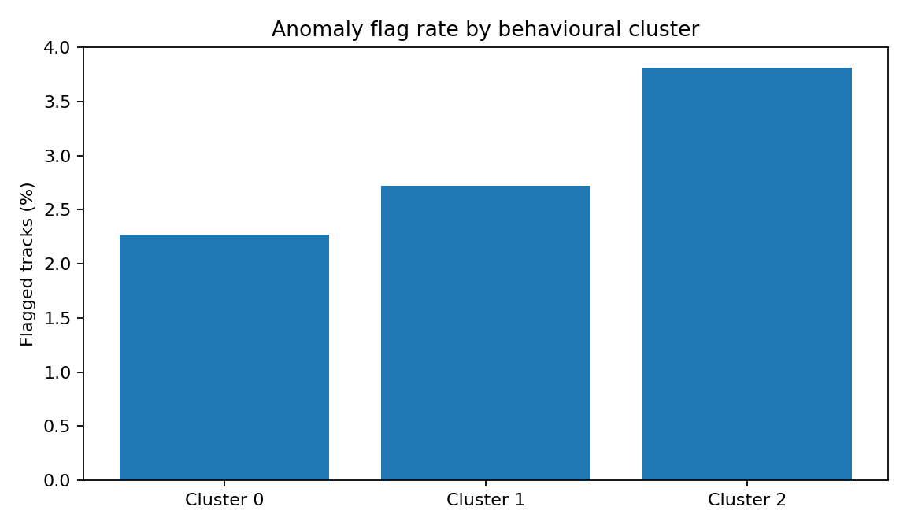
Cluster | Tracks | Flagged | Flag rate | Threshold
0 | 53,133 | 1,205 | 2.27% | 0.106925
1 | 59,590 | 1,621 | 2.72% | 0.165261
2 | 35,636 | 1,359 | 3.81% | 0.190944
Cluster 2 has the highest within-cluster flag rate (3.81%). It contributes 1,359 flags (32.5% of all flags), while Cluster 1 contributes 1,621 (38.7%) and Cluster 0 contributes 1,205 (28.8%). The highest rate does not imply Cluster 2 is intrinsically worse; the clusters represent different behavioural groups and their model thresholds differ.

4. Feature patterns: flagged versus not flagged
The following table compares medians of the four model input features. These are descriptive associations because the same features were used by the Isolation Forest to generate the flags; they are not independent validation of anomaly causes.
Feature | Not flagged median | Flagged median
Raw speed mean (km/h) | 0.434 | 7.002
Raw speed standard deviation | 0.742 | 8.377
Time below 0.3 m/s (%) | 91.218 | 62.477
Stop episodes (count) | 1.000 | 3.000
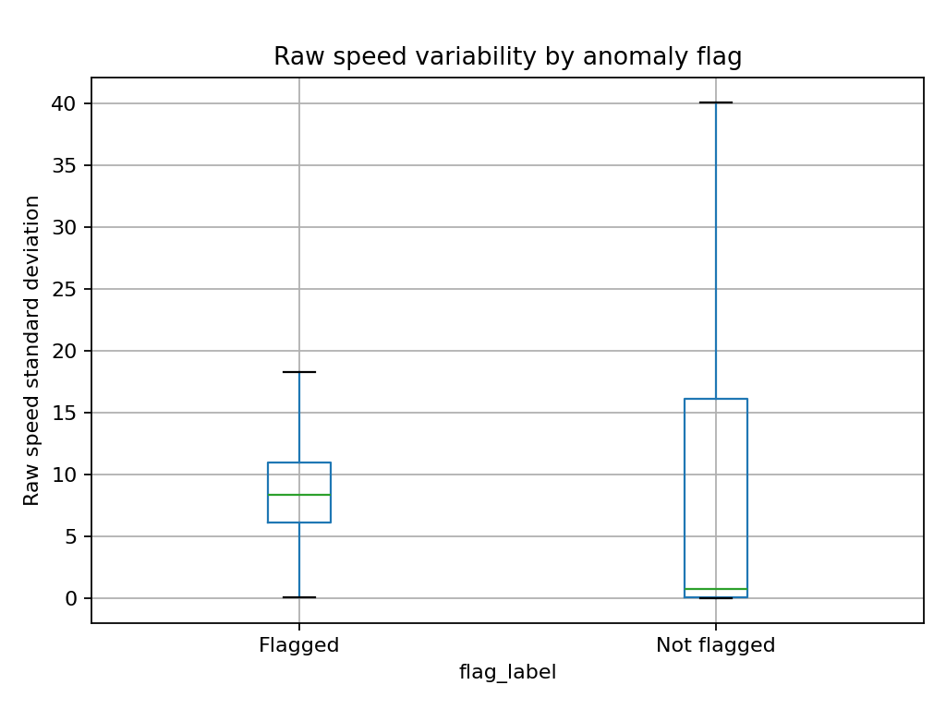
Flagged tracks have a higher median raw speed mean (7.00 versus 0.43 km/h), higher median raw speed standard deviation (8.38 versus 0.74), lower median low-speed-time percentage (62.48% versus 91.22%), and more median stop episodes (3 versus 1). This indicates the model tends to flag tracks with a combination of higher movement/speed variability and more stop episodes in this dataset. Feature relationships may also be affected by track length and observation context.

5. Temporal patterns
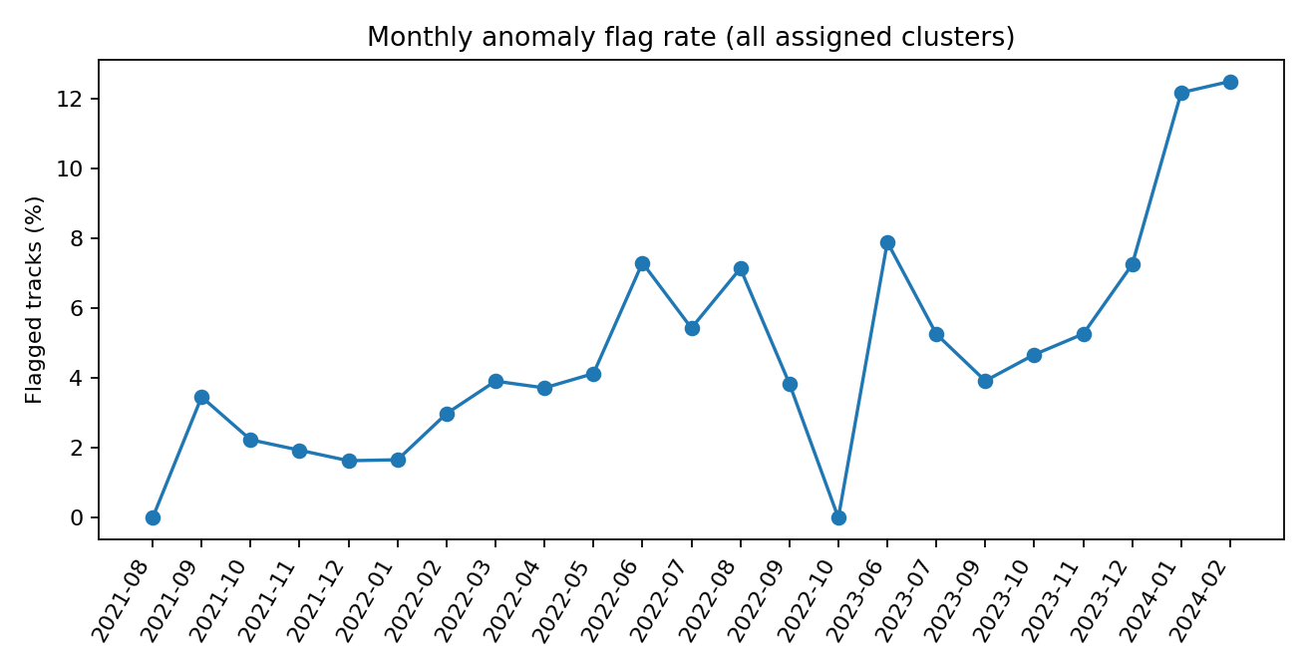
Monthly rates vary over the observation period. Among months with at least 100 scored tracks, January 2024 has the highest rate (12.18%, 71 of 583), followed by June 2022 (7.30%, 91 of 1,246) and December 2023 (7.26%, 113 of 1,557). These months have different vehicle populations and cluster compositions. Several late-period months also have relatively small denominators, so rates should be interpreted cautiously.
Month | Tracks | Flagged | Rate
2021-09 | 4,622 | 160 | 3.46%
2021-10 | 11,987 | 268 | 2.24%
2021-11 | 19,475 | 377 | 1.94%
2021-12 | 23,366 | 382 | 1.63%
2022-01 | 28,582 | 475 | 1.66%
2022-02 | 17,858 | 533 | 2.98%
2022-03 | 10,730 | 420 | 3.91%
2022-04 | 3,467 | 129 | 3.72%
2022-05 | 2,082 | 86 | 4.13%
2022-06 | 1,246 | 91 | 7.30%
2022-07 | 368 | 20 | 5.43%
2023-09 | 3,952 | 155 | 3.92%
2023-10 | 12,194 | 570 | 4.67%
2023-11 | 6,000 | 316 | 5.27%
2023-12 | 1,557 | 113 | 7.26%
2024-01 | 583 | 71 | 12.18%
The increase in flag rates over some periods may reflect temporal distribution shift, changes in the mix of clusters/vehicles, operational differences, or sampling variation. The present analysis does not establish which explanation is responsible. The validation periods also differed by cluster in the earlier chronological model split; this is a reason to monitor temporal stability separately.

6. Vehicle-level review candidates
For a more stable shortlist, this report uses a descriptive screening rule: at least 30 scored tracks and flagged tracks in at least two distinct months. This is a review filter, not a statistically calibrated risk threshold or a final priority classification.
Vehicle | Tracks | Flagged | Flag rate | Active months | Flagged months
19 | 2,325 | 675 | 29.03% | 8 | 8
121 | 289 | 52 | 17.99% | 4 | 4
116 | 329 | 59 | 17.93% | 4 | 4
72 | 303 | 34 | 11.22% | 5 | 2
30 | 591 | 65 | 11.00% | 7 | 7
66 | 173 | 18 | 10.40% | 8 | 6
29 | 798 | 81 | 10.15% | 7 | 7
133 | 323 | 30 | 9.29% | 6 | 5
65 | 613 | 55 | 8.97% | 2 | 2
130 | 337 | 29 | 8.61% | 6 | 4
131 | 321 | 27 | 8.41% | 6 | 6
97 | 323 | 27 | 8.36% | 3 | 2
101 | 304 | 25 | 8.22% | 5 | 4
144 | 92 | 7 | 7.61% | 3 | 2
157 | 306 | 23 | 7.52% | 6 | 5
Vehicle 19 is the strongest review candidate by both rate and count: 675/2,325 (29.03%), with flagged tracks in all eight active months. Other candidates by rate include Vehicles 121 (52/289; 17.99%) and 116 (59/329; 17.93%), each with flagged tracks in four active months. Vehicle 30 has a lower rate (10.998%) but 65 flags across seven months. Vehicle 59 contributes 212 flags across eight months, but its rate is 6.58%; this illustrates why counts and rates should be considered together.
Vehicle IDs 121 and 116 have comparatively fewer observations than Vehicle 19. Their rates warrant review, but conclusions should account for sample size and operating exposure. Vehicle-level flag rates are not directly comparable if their tracks differ in length, route, duty cycle, or cluster mix.

7. Operational interpretation and recommended workflow
- Use a flagged track as a review trigger, not as a confirmed incident or fault.
- For each reviewed track, inspect the raw speed trace, timestamps, track distance, duration, telemetry coverage, and quality flags.
- For recurring vehicle patterns, compare flagged and non-flagged tracks from the same vehicle and, where possible, the same cluster and comparable operating context.
- Prioritize repeated patterns with adequate observations rather than a single high anomaly score.
- Record analyst outcomes (explained by route/duty pattern, data issue, operationally unusual, or unresolved) to support later evaluation.
- Monitor cluster-specific monthly flag rates and score distributions for temporal drift; do not pool raw scores across clusters.

8. Limitations
- Isolation Forest is unsupervised; the dataset does not provide ground-truth labels confirming operational anomalies.
- The 2.82% overall flag rate is a model output, not an estimate of the true prevalence of operational problems.
- Cluster-specific models use different thresholds; raw scores are not directly comparable across clusters.
- Unassigned tracks (3,239) are not scored and must not be treated as normal.
- The four features are telemetry-derived and may be influenced by track duration, distance, sampling, and route/operating context.
- Monthly and vehicle comparisons are observational; changes in fleet composition and observation volume can alter rates.
- The data do not support causal claims about driver behaviour, mechanical faults, fuel consumption, or monetary operating costs.
- The analysis is based on the supplied inference CSV; no independent operational incident records or analyst adjudications were provided.

9. Conclusion
The full inference output contains 148,359 scored tracks and 4,185 model-flagged tracks (2.82%). The most notable descriptive signals are the higher flag rate in Cluster 2, the temporal variation in monthly rates, and the recurring concentration of flags for Vehicle 19. These findings provide a defensible shortlist for operational investigation. They should be validated against raw telemetry and contextual records before any operational action is taken.

Appendix A. Model and output notes
Models: dt_cargo_iforest_cluster_0_v1, dt_cargo_iforest_cluster_1_v1, dt_cargo_iforest_cluster_2_v1. Model inputs: raw_speed_mean_kmh, raw_speed_std, low_speed_time_pct_03, stop_episode_count_03. The anomaly score is the negative Isolation Forest decision function; higher values indicate more unusual observations within the relevant model. Each model uses its own threshold.
Source file: all_track_predictions.csv. Track start timestamps were parsed and normalized to UTC for monthly grouping. The report's monthly labels use YYYY-MM.

