Bug Reports
Summary: Category names are overlapping in the Electronics and Accessories menu
Description: Category names are overlapping with each other in the Electronics and Accessories menu, making the category names difficult to read and select.
Issue type: UI
Priority: Medium
Module: Electronics and accessories
Severity: Medium
Steps to Reproduce:
- Open https://www.amazon.com/
- Navigate to the Electronics and Accessories menu.
- View the list of available categories.
- Observe the category names.

Actual Result: Category names are overlapping in the Electronics and Accessories menu.
Expected Result: Category names should be displayed clearly with proper spacing and alignment. They should not overlap with each other.
Attachments/Evidence:
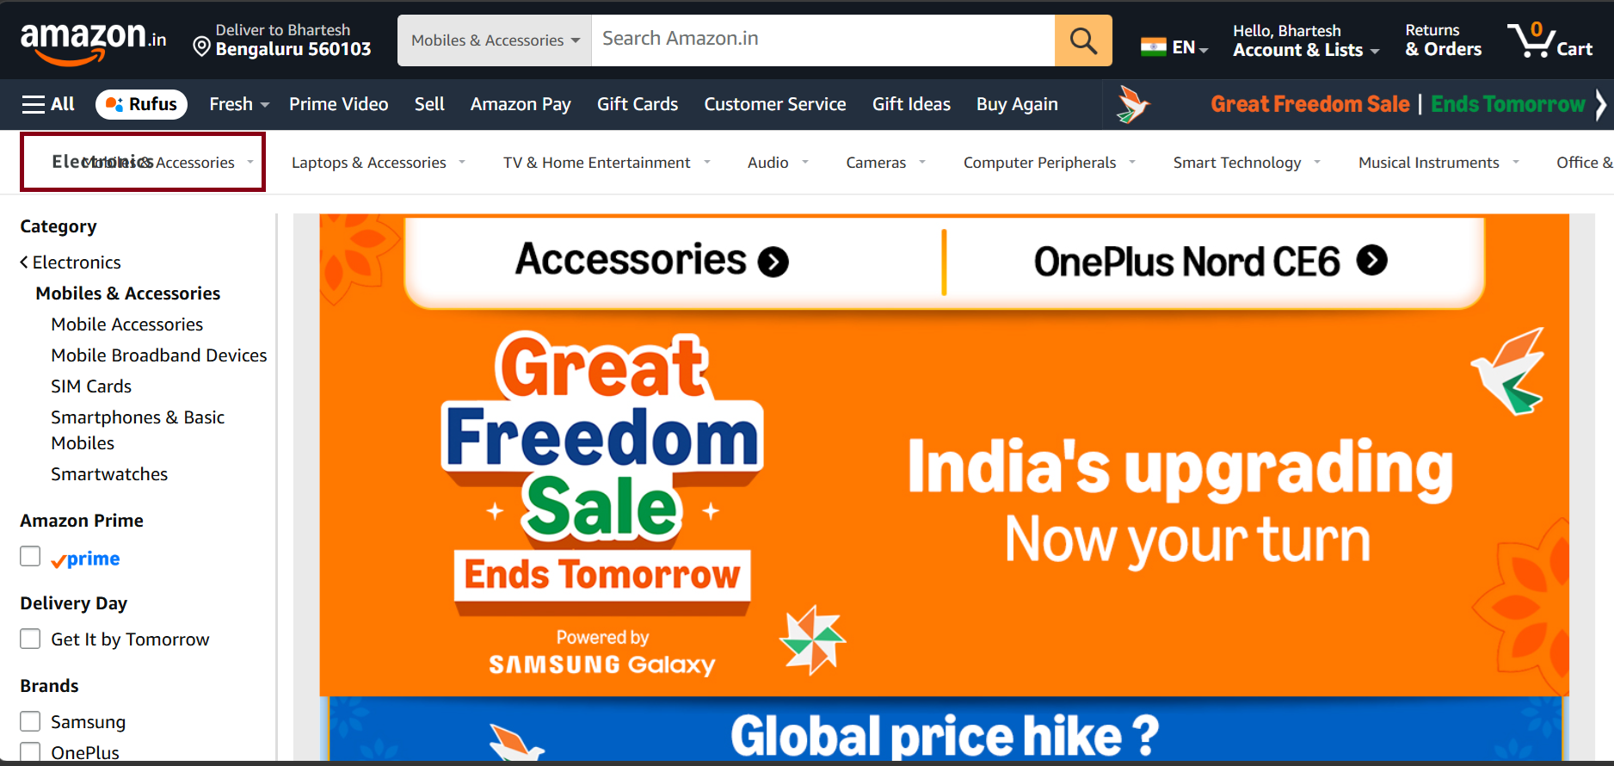

Summary: Category names are displayed with incomplete text in the navigation menu
Description: Some category names are displayed with incomplete or truncated text in the navigation menu. This makes it difficult for users to identify the full category name.
Issue type: UI
Priority: Medium
Module: Electronics and accessories
Severity: Medium
Steps to Reproduce:
- Open https://www.amazon.com/
- Navigate to the Electronics and Accessories menu.
- View the list of available categories.
- Observe the category names displayed in the navigation menu.

Actual Result: Category names are displayed with incomplete text in the navigation menu.
Expected Result: All category names should be displayed completely and clearly without any text being cut off or truncated.
Attachments/Evidence:
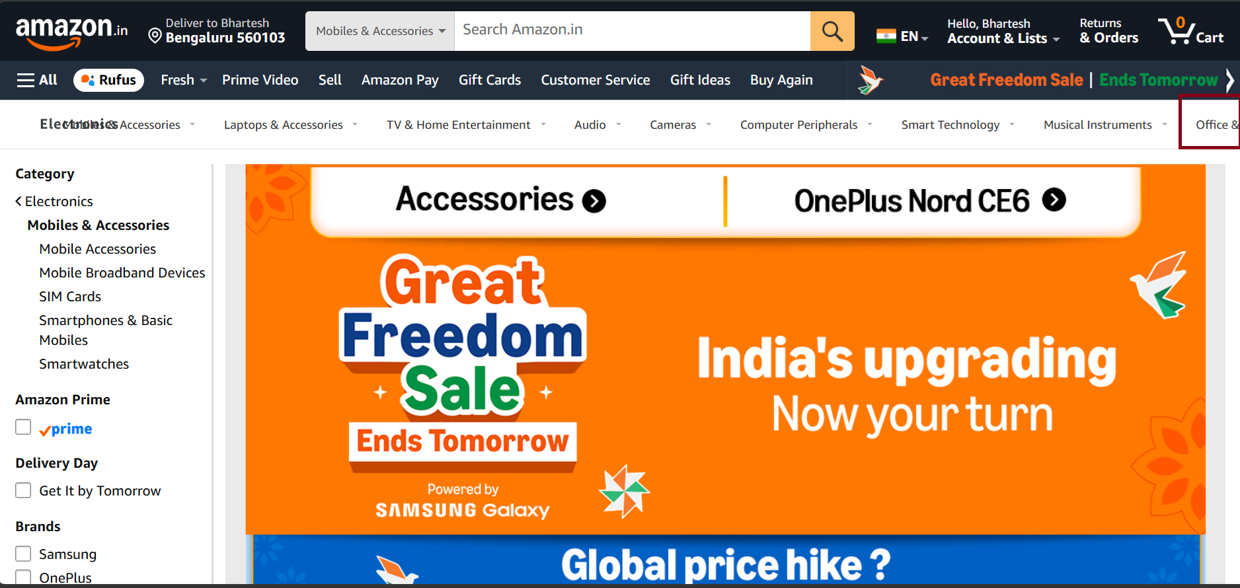

Summary: Product cards are misaligned in the Pricing and Delivery section
Description: Product cards are not properly aligned in the Pricing and Delivery section. The cards appear unevenly positioned, resulting in an inconsistent layout and affecting the overall visual appearance.
Issue type: UI
Priority: Medium
Module: Mobiles
Severity: Medium
Steps to Reproduce:
- Open https://www.amazon.com/
- Navigate to the Pricing and Delivery section.
- View the product cards.
- Observe the alignment of the cards.

Actual Result: Product cards are misaligned in the Pricing and Delivery section.
Expected Result: All product cards should be consistently aligned with equal spacing and proper positioning.
Attachments/Evidence:
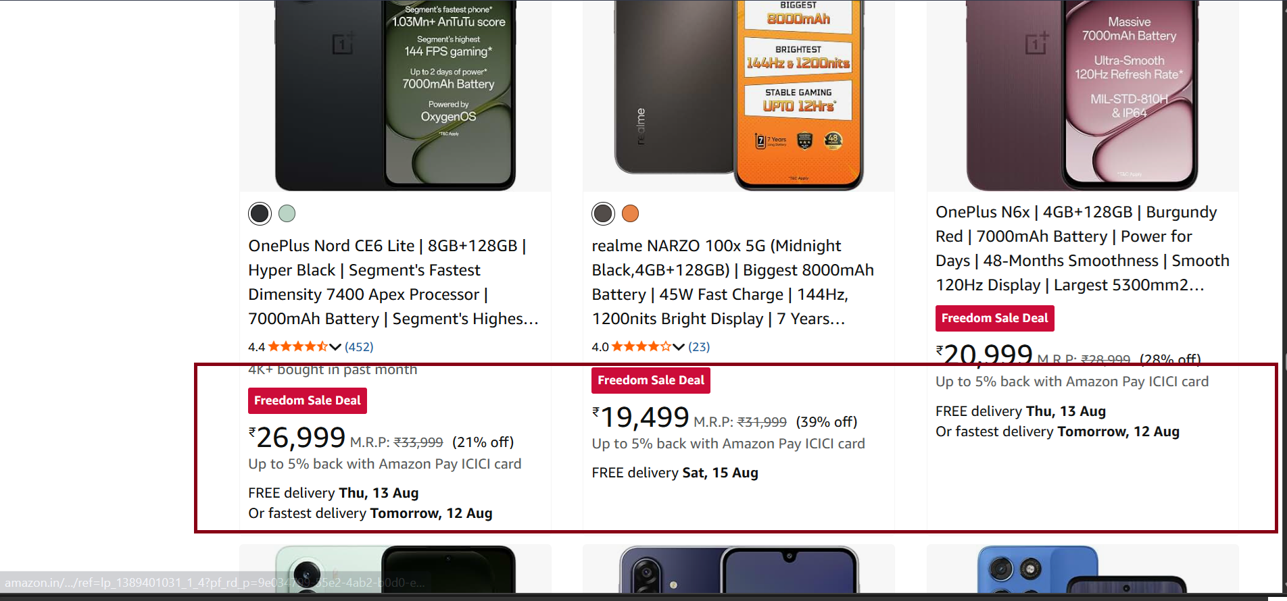

Summary: Quantity controls are cropped on the right side of the Cart section
Description: The quantity controls in the right-side Cart section are partially cropped, preventing the controls from being displayed properly and making them difficult to use.
Issue type: UI
Priority: Medium
Module: Add to chart .
Severity: Medium
Steps to Reproduce:
- Open https://www.amazon.com
- Add a product to the cart.
- Open the right-side Cart section.
- Observe the right side of the quantity control.
Actual Result: The quantity controls are partially cropped on the right side of the Cart section.
Expected Result: The quantity controls should be fully visible and properly aligned within the Cart section.
Attachments/Evidence:
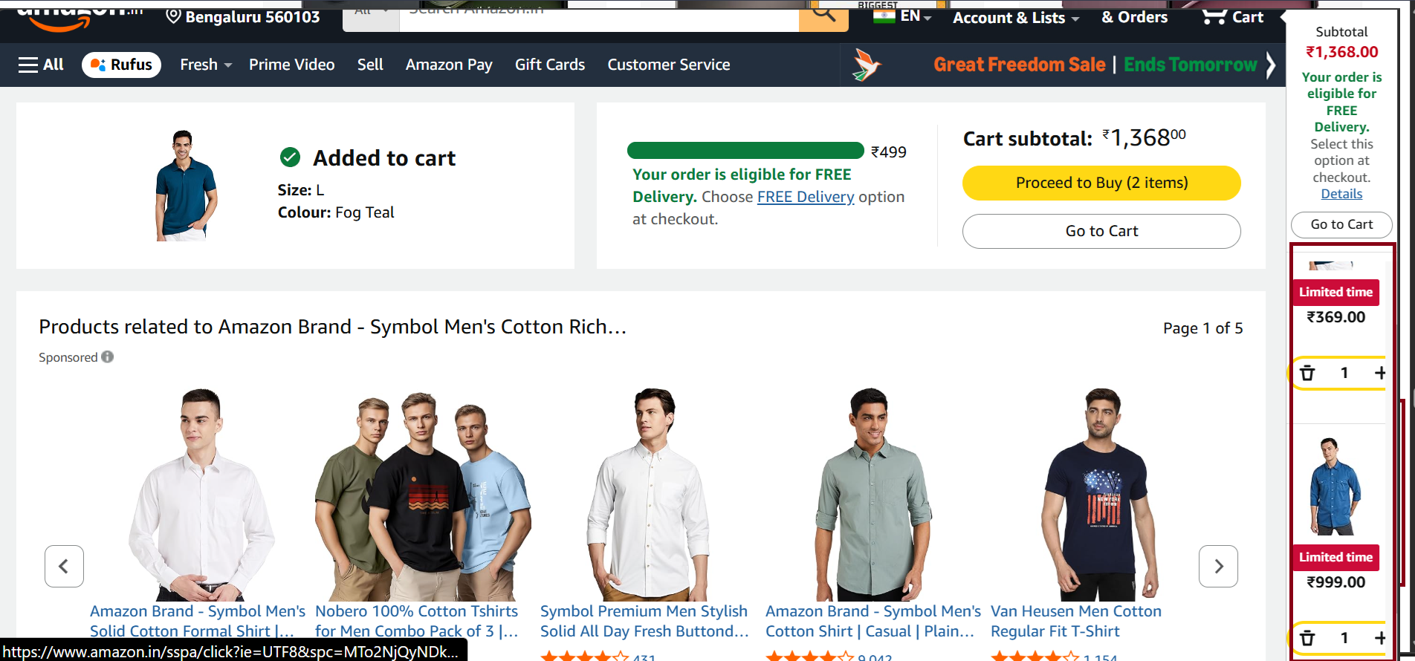

Summary: Movie rail is displayed in the Sports tab
Description: A Movie rail is incorrectly displayed within the Sports tab. This is irrelevant to the Sports category and may cause confusion for users.
Issue type: Functional
Priority: Medium
Module: Sports.
Severity: Medium
Steps to Reproduce:
- Open https://moviesandtv.myvi.in
- Navigate to the Sports tab.
- Scroll through the available content rails.
- Observe the displayed rails.
Actual Result: A Movie rail is present in the Sports tab.
Expected Result: Only sports-related content rails should be displayed in the Sports tab. Movie-related content should not appear.
Attachments/Evidence:
