RESULTS AND DISCUSSION

A. Customer Segmentation Analysis
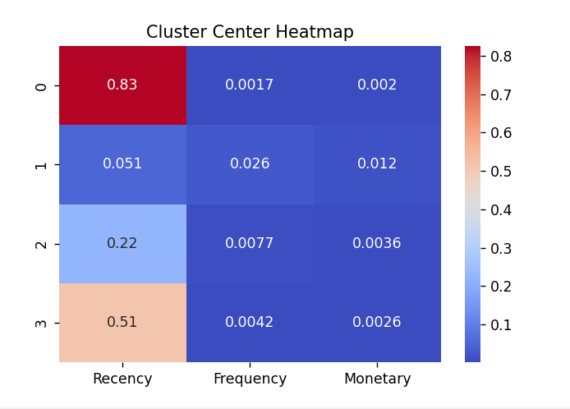

Figure 1(a) presents the heatmap of cluster centers for the normalized RFM (Recency, Frequency, Monetary) variables. The clusters reveal distinct patterns:
• Cluster 0: Very high Recency and extremely low Frequency and Monetary values, indicating inactive customers with minimal engagement.
• Cluster 1: Low Recency with low Frequency and Monetary values, representing recently active customers who have not yet developed strong spending patterns.
• Cluster 2: Moderate Recency and low transaction behavior, representing occasional buyers.
• Cluster 3: High Recency and slightly better Monetary values than Cluster 0, indicating previously engaged but now inactive customers.

B. RFM Variable Distribution Across Clusters
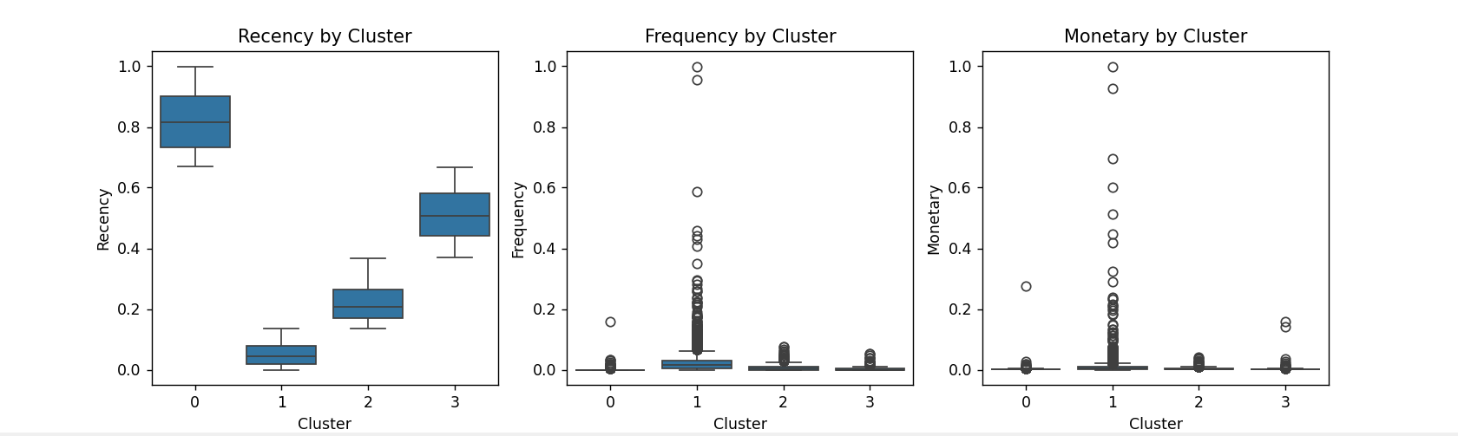

Figure 1(b) presents boxplots for Recency, Frequency, and Monetary values across clusters.
• Recency: Cluster 1 shows the lowest Recency values, indicating recent activity. Clusters 0 and 3 show high Recency, indicating inactive or churn-prone users.
• Frequency: All clusters show low Frequency values, with Cluster 1 having a broader distribution.
• Monetary: Monetary values remain low across clusters, with significant outliers indicating the presence of rare high-value customers.

C. Customer Segment Interpretation
Based on the centroid and distribution analysis, customer segments can be understood as follows:
1. Cluster 0 – Lost or Inactive Customers.
2. Cluster 1 – Recent but Low-Value Customers.
3. Cluster 2 – Occasional Buyers.
4. Cluster 3 – Previously Active but Fading Customers.

D. Summary of Customer Segmentation
The RFM-based clustering successfully identifies customer groups with varying engagement levels, enabling targeted marketing and retention strategies.

VI. CUSTOMER CHURN PREDICTION ANALYSIS

A. Confusion Matrix Evaluation
The confusion matrix in Figure 2(a) illustrates the logistic regression model’s performance:
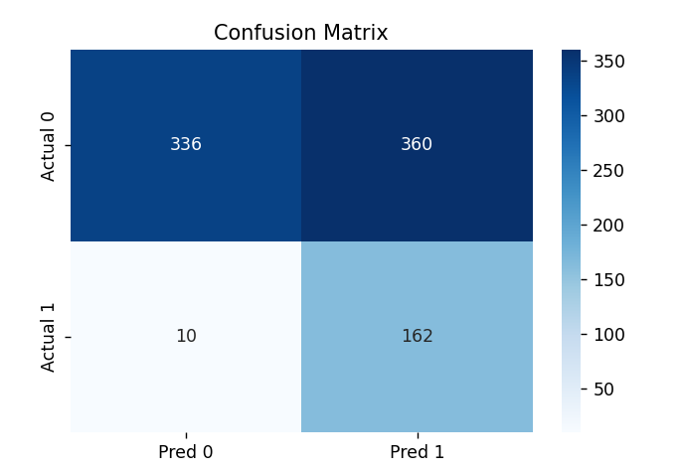
• True Negatives (336): Correctly identified non-churn customers.
• False Positives (360): Non-churn customers incorrectly predicted as churners, indicating moderate specificity.
• True Positives (162): Correctly identified churn customers, demonstrating strong sensitivity.
• False Negatives (10): Very few churners misclassified, minimizing revenue risk.
The model shows high sensitivity but tends to overpredict churn.

B. ROC Curve and AUC Interpretation

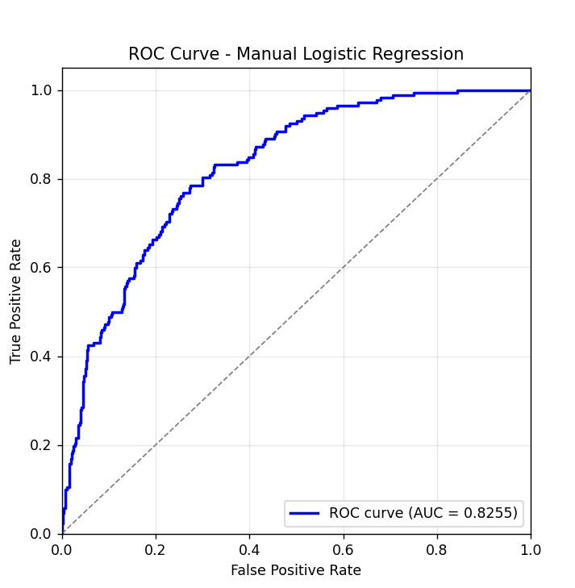

The ROC curve in Figure 2(b) produces an AUC value of 0.8255, indicating strong discriminative capability. The model reliably separates churners from non-churners across varying probability thresholds, making it suitable for real-world churn detection scenarios.

C. Business Implications
Key implications include:
• Low false negatives ensure high recall for churners, enabling effective retention campaigns.
• High false positives may increase retention costs, requiring threshold optimization.
• Strong AUC performance supports the use of logistic regression as a baseline churn model.

D. Summary of Churn Prediction
The churn prediction model demonstrates strong ability to detect churners with a high AUC score. However, specificity improvements may reduce unnecessary retention actions.

