Bhasheyam Krishnan

A20380078

Magic number used = 63666

Que1 :

Command used:

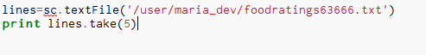

Ouput:



Que2:

Command

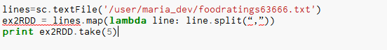

Output:



Que 3:

Command :

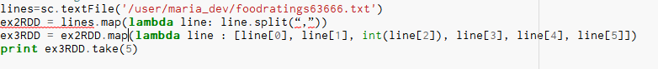

Output:



Que 4:

Command:

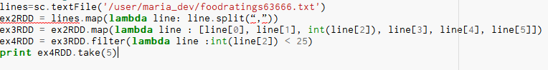

Output:



Fro Que3 we can see the three record is not present in this output as it has 40 in the Third field.

Que 5:

Command:

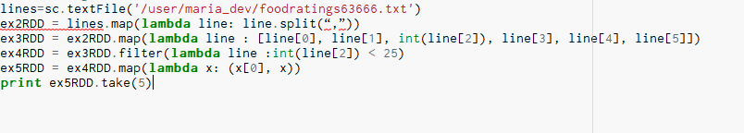

Output:



Que 6:

Command:

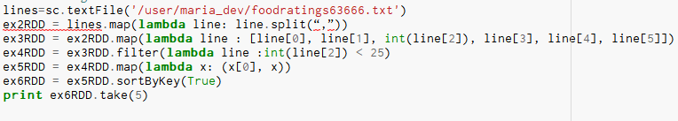

Output:

